File Comparison Tool
Author: Yongjian Liu

Revision history
Name | Date | version | Summary of changes
Yongjian Liu | May 3rd,2011 | 1.0 | First version
Mike Zhao  Yongjian Liu | May 13th,2011 | 2.0 | 1. Optimize forward and backward comparison algorithm.  Greatly improve work efficiency for big size file.  2. Fixed some bugs.
Yongjian Liu | June 2nd, 2011 | 3.0 | Two new enhancements :  First: User can provide a config file to indicate what line should be excluded for comparison. Details like:  1. Excluded line = 1, 3, 8 - Means line 1, 3, 8 are excluded for comparison.  2. Excluded line = 3 - 8 - Means from line3 to line8 are excluded for comparison.  3. Excluded line contains = aaa, bbb, ccc - Means line that contains aaa or bbb or ccc are excluded for comparison.  Second: The tool will export original line number as details for user when comparison failure.
Yongjian Liu | July 27th, 2011 | 4.0 | Support wildcard matching.
Yongjian Liu | Aug 31st,2011 | 5.0 | 1. Add a switch for single-side VS double-sides comparison.  2. More details about comparison statistics info.  3. Optimize process. Better support big size file comparison.
Yongjian Liu | Sep 20th,2011 | 6.0 | Support message block comparison.

Introduction

This tool will open 2 specified files and compare the content of them, list comparison details.

Usage
FileComparison, <Specified file1 complete path>, < Specified file2 complete path >, <Show details?>(y/n), <Exactly match?>(y/n), <OPTION>, <Configure File complete path>

The last two parameters are optional.

Description
< Specified file1 complete path > & < Specified file2 complete path >
You need to specify the file full path. " " is required for the path which contains space.

< Show details?>
You can choose whether to Show comparison details or not. If at least one of files are not Text format, this parameter is not useful. But it must exist.

<Exactly match?>
You can choose whether to check 2 files exactly, line by line. If at least one of files are not Text format, this parameter is not useful. But it must exist.

< OPTION >
There are 2 OPTION you can select.
-s. If you need single-side comparison, you should select “-s”. And you can choose whether to use a configure file to exclude some lines you want.
-p. If you need double-side comparison and configure file, you should select “-p”.
Here are some tips you may pay attention to:
- “-s” option is only useful in fuzzy match mode.
- In “-s” mode, the file1 is mainly file to compare, which means file1 should not be bigger than file2 if you want comparison pass.
- If you only need double-side comparison without configure file, you should not use this option.

< Configure File complete path >
This file contains 3 parts. The first is the line number you want to exclude. The head is <L>.
The second is the line group you want to exclude. The head is <G>.
The third is the key words which you want to exclude the lines contain. The head is <K>
The fourth is the title’s key word which bond title and body together. The head is <B>
For example, the configure file is :
<L>1,2,3
<G>4-7,10-14
<K>FrmLen,Time Date.*ComputerName
<B><Message>
It means the tool will exclude line 1,2,3 and lines from 4 to 7 and from 10 to 14, and the lines which contain the word “FrmLen” or “Time Date.*ComputerName”, and a block of message which starts with <Message> and ends with </Message>.
You should obey 2 rules: 1. The <L>, <G>, <K>, <B> must be Capital or don’t use. It means you can only have one or two parts in the file and you can write more lines in the file as long as they have correct head. 2. In the line group you must use “-” between start line and end line, and use “,” in other two parts between different contents.

Example
"FileComparison.exe" "C:\Documents and Settings\yongjian.liu\Desktop\test\mtp_2.xml" "C:\Documents and Settings\yongjian.liu\Desktop\test\mtp_1.xml" y n
Tip: Show the detail and fuzzy match between 2 files not match.
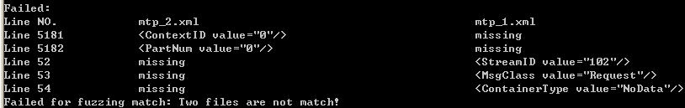

FileComparison.exe D:\TestAutomation\ERP_baseline.txt D:\ATF\TestResult\ERP.txt y n –s
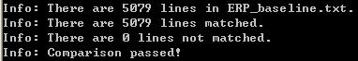

If at least file is too big, over 10,000 lines, the tool will ask you to wait. This example below is comparing to files which contain over 360,000 lines and they have the same content.

Here is an example to show usage of the configure file:
“FileComparison.exe” “D:\Project\rdc_p1.txt” “D:\Project\ rdc_p1_baseline.txt” y y
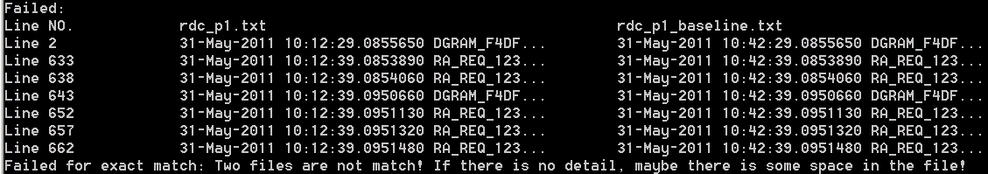
“FileComparison.exe” “D:\Project\rdc_p1.txt” “D:\Project\ rdc_p1_baseline.txt” y y –p “D:\Project\config.txt”

The config.txt is: <K>FrmLen
The result is:

If you change config.txt to: <G>633-662
The result is:
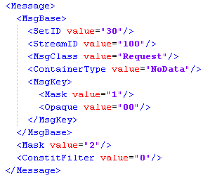
If you want to compare the message as a block for above example, you can write config.txt as <B><Message>. But there is one thing you should pay attention: you should enter the message title’s key word which only has 1 line.

If you make something wrong such as enter a wrong path or wrong file, this tool will check that before comparison.

1: Two binary files
"FileComparison.exe", "C:\Documents and Settings\yongjian.liu\Desktop\1.docx", "C:\Documents and Settings\yongjian.liu\Desktop\1.xls", y, n
2: One binary file and one text file
"FileComparison.exe", "C:\Documents and Settings\yongjian.liu\Desktop\1.docx", "C:\Documents and Settings\yongjian.liu\Desktop\full.txt", y, n
3: Wrong path
"FileComparison.exe", "C:\Documents and Settings\yongjian.liu\Desktop\1.docx", "C:\Documents and Settings\yongjian.liu\Desktop\fesss.txt", y, n

How to merge this tool into ATF(Automation Test Framework)

1. From output
You don’t need to do anything else, just add a step in test case file, ATF will detect output string for each step, when finding “Failed” or “Error” keywords, ATF will record this test step as a failed result.

2. From return value
0: Application was run successfully without any failed cases.
1: Application was run successfully with some failed cases.
-1: Application was run unsuccessfully.
You can define your own logic in script or batch file by judging the return value, if the execution result is failed, you need to output a single string contains “Error” to console window and then ATF will catch it.

