Software Requirements Specification (SRS)
EgyCinema System
Version 1.1 | May 2026

Prepared by:
Adham Ali Mohamed
Faisal Mahmoud Mohamed
Ahmed Sameh Mustafa
Ghadaa Al-Tayyeb Abd Al-Ghani
Hanaa Babiker Mohamed
Aser Ahmed Hamdi
Bakly Aziz Helmy Fahmy

Institution:
Capital University — Faculty of Computers & Artificial Intelligence

Course:
Software Engineering 2

1. Introduction

1.1 Purpose
This Software Requirements Specification (SRS) describes the functional and non-functional requirements of the EgyCinema system. It is intended for the development team, project supervisors, and evaluators. The system is a full-stack, microservices-based online cinema management and ticket booking platform.

1.2 Scope
EgyCinema is built on Spring Boot microservices backed by SQL Server, containerised with Docker, and integrated with AWS S3 for image storage. The platform covers:
- User authentication and role-based authorisation (Guest, User, Employee, Admin)
- Cinema and hall management
- Movie catalogue management with AWS S3 poster upload
- Showtime scheduling
- Ticket booking
- Payment processing

1.3 Document Conventions
All constraints are expressed in OCL (Object Constraint Language). REST endpoints follow the convention: HTTP_METHOD /resource/{id}. Role names are prefixed with ROLE_ in the JWT payload (e.g., ROLE_ADMIN).

1.4 Intended Audience
This document is intended for:
- Project supervisor and graders (primary audience)
- Backend and frontend developers on the EgyCinema team
- Quality assurance reviewers

1.5 Technologies Used
Technology | Purpose
Spring Boot | Backend microservices framework
SQL Server | Relational database
Docker | Service containerisation
AWS S3 | Movie poster / image storage
JWT (JJWT) | Stateless authentication tokens
AOP (AspectJ) | Cross-cutting logging concerns
HTML / CSS / JS | Frontend client
Maven | Dependency and build management

1.6 Definitions and Acronyms
Term | Definition
SRS | Software Requirements Specification
JWT | JSON Web Token — a signed authentication token
OCL | Object Constraint Language — UML constraint notation
AOP | Aspect-Oriented Programming
REST | Representational State Transfer — HTTP API style
ROLE_USER | Default authenticated user role
ROLE_EMPLOYEE | Staff member with movie/showtime management rights
ROLE_ADMIN | Administrator with full system access
AWS S3 | Amazon Simple Storage Service — cloud object store
DI | Dependency Injection — Spring IoC pattern

2. System Architecture

2.1 Microservices Overview
The system is decomposed into four independently deployable Spring Boot services, each with its own database schema and Docker container:
Service | Base URL / Port | Responsibility
cinema-service | Port 8080 | Auth, Users, Cinemas, Halls
showtime-service | Port 8082 | Movies (with S3), Showtimes
booking-service | Port 8081 | Ticket Bookings
payment-service | Port 8083 | Payments

2.2 Architectural & Design Patterns
- Microservices Architecture — loosely coupled, independently deployable services
- MVC Pattern — Controllers, Services (business logic), Repositories (data access)
- Repository Pattern — Spring Data JPA repositories abstract all DB operations
- Service Layer Pattern — business logic isolated from controllers
- Dependency Injection — constructor injection and @Autowired (Spring IoC)
- AOP Pattern — cross-cutting logging concerns via LoggingAspect (AspectJ @Before advice)
- Factory / Builder Pattern — JWT token construction uses the JJWT builder API

3. Functional Requirements

3.1 Authentication & User Management

Actors
Guest (unauthenticated), Customer (ROLE_USER), Employee (ROLE_EMPLOYEE), Admin (ROLE_ADMIN)

Features
ID | Feature | Description
FR-1.1 | Register | Guest submits username + password. System salts and hashes the password (SHA-256 + pepper) and stores the user with ROLE_USER.
FR-1.2 | Login | User submits credentials. System verifies hash and returns a signed JWT (24-hour expiry) containing username and role.
FR-1.3 | JWT Authorisation | JwtFilter validates the Bearer token on every protected request and populates the SecurityContext.
FR-1.4 | View All Users | Admin retrieves the full list of registered users via GET /api/admin/users.
FR-1.5 | Update User Role | Admin changes a user's role via PUT /api/admin/users/{username}/role.
FR-1.6 | Delete User | Admin removes a user account via DELETE /api/admin/users/{username}.

3.2 Cinema & Hall Management

Actors
Admin (write), Customer / Employee (read)
ID | Feature | Description
FR-2.1 | Create Cinema | Admin creates a new cinema record (name, location) via POST /api/Cinemas.
FR-2.2 | View Cinemas | Any user retrieves all cinemas via GET /api/Cinemas.
FR-2.3 | Update Cinema | Admin updates name/location of an existing cinema via PUT /api/Cinemas/{id}.
FR-2.4 | Delete Cinema | Admin deletes a cinema and its associated halls (cascade) via DELETE /api/Cinemas/{id}.
FR-2.5 | Add Hall | Admin adds a hall (name, totalSeats) to an existing cinema via POST /api/Cinemas/{id}/halls.

3.3 Movie Management

Actors
Admin / Employee (write), Customer / Guest (read)
ID | Feature | Description
FR-3.1 | Create Movie | Admin creates a movie record (title, duration, releaseDate, trailerUrl, status, categoryId) via POST /movies.
FR-3.2 | Upload Movie Poster | Admin uploads a poster image to AWS S3 and stores the returned URL on the movie via POST /movies/{id}/upload-poster.
FR-3.3 | View All Movies | Any user retrieves all movies via GET /movies.
FR-3.4 | View Single Movie | Any user retrieves one movie by ID via GET /movies/{id}.
FR-3.5 | Full Update (PUT) | Admin replaces all movie fields via PUT /movies/{id}.
FR-3.6 | Partial Update (PATCH) | Admin/Employee updates only supplied fields via PATCH /movies/{id}.
FR-3.7 | Delete Movie | Admin removes a movie record via DELETE /movies/{id}.
FR-3.8 | Search by Title | System supports case-insensitive title search via MovieRepository.findByTitleContainingIgnoreCase.

3.4 Showtime Management

Actors
Admin / Employee (write), Customer / Guest (read)
ID | Feature | Description
FR-4.1 | Create Showtime | Admin/Employee schedules a showtime (cinemaId, movieId, hallId, dateTime, price). System rejects past datetimes and duplicate hall/time combinations.
FR-4.2 | View All Showtimes | Any user retrieves all showtimes via GET /showtimes.
FR-4.3 | Filter by Movie | Any user retrieves showtimes for a specific movie via GET /showtimes/movie/{movieId}.
FR-4.4 | Filter by Cinema | Any user retrieves showtimes for a specific cinema via GET /showtimes/cinema/{cinemaId}.
FR-4.5 | Filter by Movie + Cinema | Any user retrieves showtimes filtered by both dimensions via GET /showtimes/movie/{movieId}/cinema/{cinemaId}.
FR-4.6 | Full Update (PUT) | Admin/Employee replaces showtime details via PUT /showtimes/{id}.
FR-4.7 | Partial Update (PATCH) | Admin/Employee updates specific fields via PATCH /showtimes/{id}.
FR-4.8 | Delete Showtime | Admin/Employee removes a showtime via DELETE /showtimes/{id}.

3.5 Booking Management

Actors
Customer (create), Admin (view all)
ID | Feature | Description
FR-5.1 | Create Booking | Authenticated user submits userId, showtimeId, movieId, and seat count via POST /bookings. BookingDate is auto-set to current timestamp.
FR-5.2 | View All Bookings | Retrieve all bookings via GET /bookings (admin monitoring use-case).

3.6 Payment Management

Actors
Customer (create), Admin (view all)
ID | Feature | Description
FR-6.1 | Create Payment | User submits bookingId, amount, and paymentMethod (VISA / MasterCard / Cash) via POST /payments. System auto-generates a UUID transactionId and sets status to PAID.
FR-6.2 | View All Payments | Retrieve all payment records via GET /payments.

4. Non-Functional Requirements

4.1 Security
- Passwords are hashed using SHA-256 with a per-user 16-byte random salt and a fixed application-level pepper (PEPPER constant in UserAuth).
- JWT tokens expire after 24 hours and are signed with an HS256 key generated at startup.
- Role-based access control (RBAC) is enforced via Spring Security @PreAuthorize annotations on protected endpoints.
- CORS is enabled on all endpoints to support the frontend client.
- No plaintext passwords are stored in the database at any point.

4.2 Performance
- REST endpoints should respond within 500 ms under normal load.
- Database access is optimised through Spring Data JPA repositories (prepared statements, connection pooling).
- AWS S3 poster uploads are performed asynchronously and are the only operations expected to exceed 500 ms.

4.3 Scalability
- Each microservice can be scaled horizontally by increasing its Docker replica count.
- Services share no in-process state; horizontal scaling requires only a load balancer in front of each service.

4.4 Availability
- Cloud-based image storage via AWS S3 provides high durability for movie posters.
- Docker Compose orchestration ensures all four services are restarted automatically on failure.
- DataSeeder seeds initial cinema and hall data on first startup so the system is immediately functional.

4.5 Maintainability
- Layered architecture (Controller → Service → Repository) keeps concerns strictly separated.
- AOP-based logging (LoggingAspect) captures method entry points without modifying business code.
- Custom exceptions (CustomException) centralise error handling in the showtime service.
- Lombok annotations (@Data, @Getter, @Setter) reduce boilerplate in model classes.

4.6 Clean Code Standards
- All constructor injections preferred over field injection where possible.
- Method names follow Java naming conventions and are descriptive of their action.
- Comments in Arabic and English are present throughout the codebase for team clarity.
- Each service has a clear single responsibility aligned with one bounded context.

5. Design Patterns

5.1 Repository Pattern
All database access is routed through Spring Data JPA repository interfaces, isolating persistence concerns from business logic.
Repository | Service | Notable Custom Queries
MovieRepository | MovieService | findByTitleContainingIgnoreCase, existsById
ShowTimeRepo | ShowTimeService | findByMovieId, findByCinemaId, existsByHallIdAndDateTime
CinemaRepository | CinemaService | findById, existsById, deleteById
BookingRepository | BookingService | Inherits all JpaRepository methods
PaymentRepository | PaymentService | Inherits all JpaRepository methods
UserRepository | AuthService | findByUsername
HallRepository | CinemaService | save, saveAll

5.2 Service Layer Pattern
Business rules and validation logic live exclusively in service classes, keeping controllers thin.
- ShowTimeService enforces past-datetime validation and hall/time conflict detection before persisting.
- AuthService orchestrates password hashing (UserAuth) and JWT generation (JwtAuth).
- PaymentService auto-generates transaction IDs (UUID) and timestamps.
- MovieService coordinates S3 uploads (S3Service) and database persistence.

5.3 Dependency Injection
Spring IoC container wires all components at startup using:
- Constructor injection (preferred) — used in AuthController, PaymentController, BookingController, etc.
- @Autowired field injection — used in CinemaService, ShowTimeService, MovieService.

5.4 MVC Pattern
Layer | Implementation Example
Model | Booking, Payment, Movie, ShowTimeEntity, Cinema, Hall, User (JPA entities)
View | HTML/CSS/JS frontend pages (index, home, book, payment, admin-*, etc.)
Controller | BookingController, PaymentController, UploadController, ShowTimesController, CinemaController, AuthController, AdminController

5.5 Aspect-Oriented Programming (AOP)
LoggingAspect (cinema-service) uses the @Before advice to log every controller method invocation, providing a cross-cutting audit trail without modifying controller code.
@Before("execution(* com.example.demo.controller.*.*(..))" )
public void logBefore(JoinPoint joinPoint) { ... }

5.6 Builder / Factory Pattern
JWT token creation uses the JJWT fluent builder pattern:
Jwts.builder().subject(username).claim("role", role)
.issuedAt(new Date()).expiration(...).signWith(key).compact();

6. OCL Constraints
The following Object Constraint Language invariants are enforced either by application-level validation or JPA @Column constraints.

6.1 Booking Constraints
context Booking
inv SeatsPositive: self.seats > 0

context Booking
inv ValidMovie: self.movieId <> null

6.2 Payment Constraints
context Payment
inv PositiveAmount: self.amount > 0

context Payment
inv ValidMethod: self.paymentMethod = 'VISA'
or self.paymentMethod = 'Cash'
or self.paymentMethod = 'MasterCard'

6.3 Showtime Constraints
context ShowTimeEntity
inv FutureShowtime: self.dateTime > DateTime::now()

context ShowTimeEntity
inv PositivePrice: self.price > 0

context ShowTimeEntity
inv UniqueHallSlot: ShowTimeEntity.allInstances()->isUnique(s |
Tuple{ h: s.hallId, t: s.dateTime })

6.4 Hall Constraints
context Hall
inv PositiveSeats: self.totalSeats > 0

6.5 User Constraints
context User
inv UsernameNotEmpty: self.username <> ''

7. Class Diagram
The class diagram covers all four microservices and illustrates the Controller → Service → Repository → Entity layering as well as cross-cutting security classes.
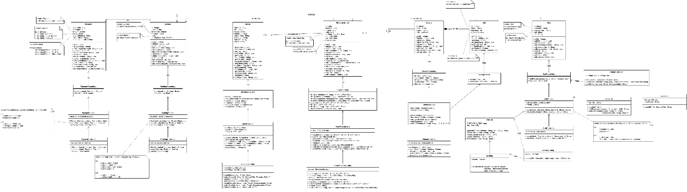

Key classes and relationships are summarised below:
Class | Service | Role
AuthController / AuthService / UserAuth / JwtAuth / JwtFilter | cinema-service | Registration, login, password hashing, JWT generation & validation
AdminController | cinema-service | User listing, role update, and deletion (Admin-only)
CinemaController / CinemaService / CinemaRepository | cinema-service | CRUD for cinemas and hall addition
Hall / HallRepository | cinema-service | Hall entity and persistence; many halls belong to one cinema
UploadController / MovieService / MovieRepository / S3Service / S3Config | showtime-service | Full movie CRUD + AWS S3 poster upload
ShowTimesController / ShowTimeService / ShowTimeRepo / ShowTimeEntity | showtime-service | Showtime scheduling with conflict-detection and multi-filter queries
BookingController / BookingService / BookingRepository / Booking | booking-service | Ticket booking creation and retrieval
PaymentController / PaymentService / PaymentRepository / Payment | payment-service | Payment creation with auto-generated transaction ID
SecurityConfig | cinema-service & showtime-service | Spring Security HTTP chain configuration (permit-list + JWT filter wiring)
DataSeeder | cinema-service | CommandLineRunner that seeds all Egyptian cinemas and halls on first startup

8. Use Case Diagram
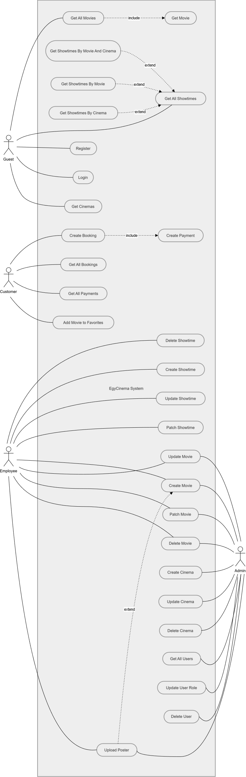

Actor Summary
Actor | Role | Key Use Cases
Guest | Unauthenticated visitor | Browse movies, View showtimes, Register, Login
Customer | Authenticated user (ROLE_USER) | All Guest use cases + Book ticket, Make payment, View bookings
Employee | Staff member (ROLE_EMPLOYEE) | Manage movies (patch), Manage showtimes (create/update/delete)
Admin | Administrator (ROLE_ADMIN) | All Employee use cases + Manage cinemas/halls, Manage users (role change, delete)

9. Activity Diagrams
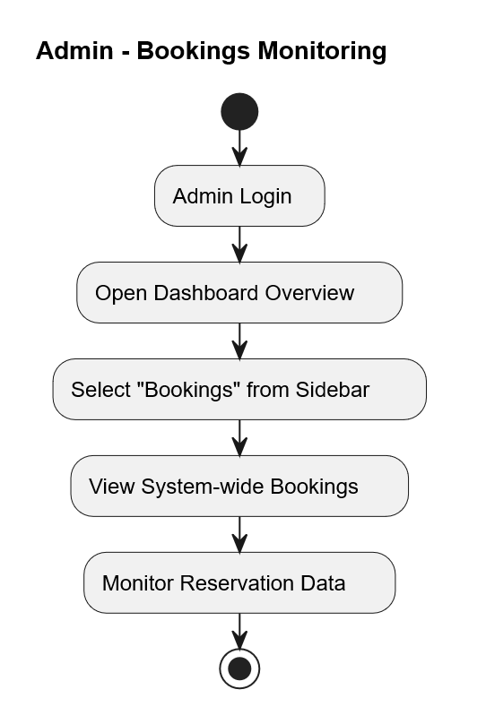

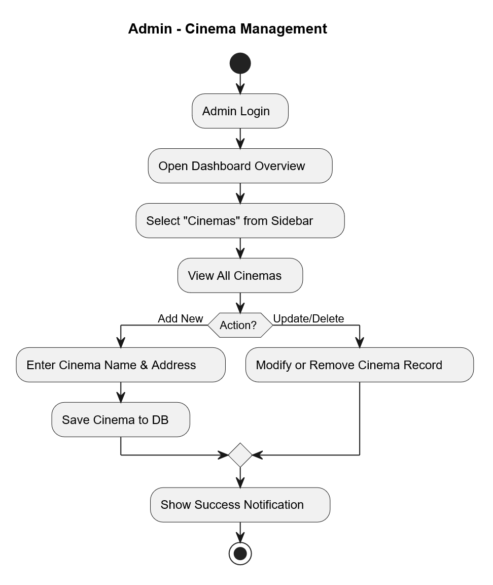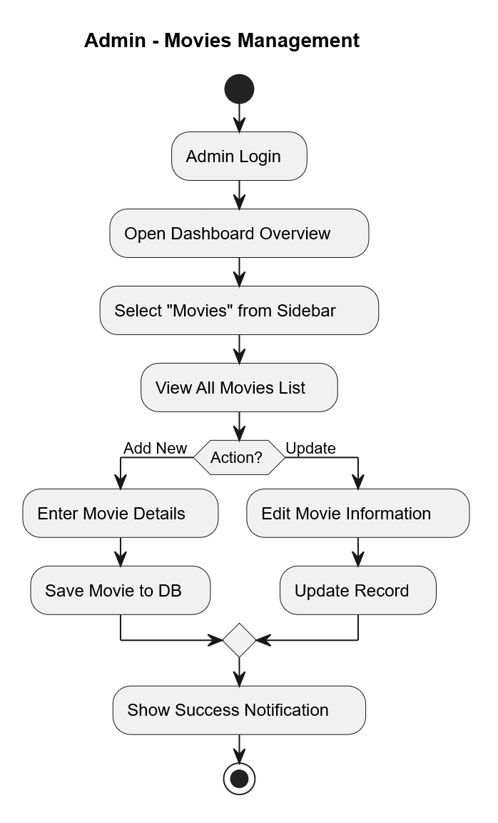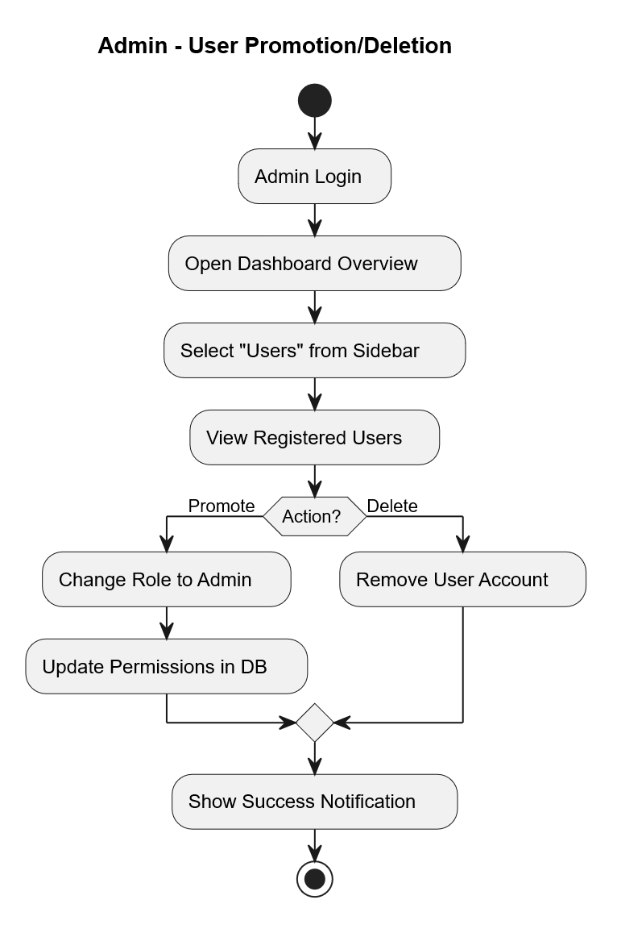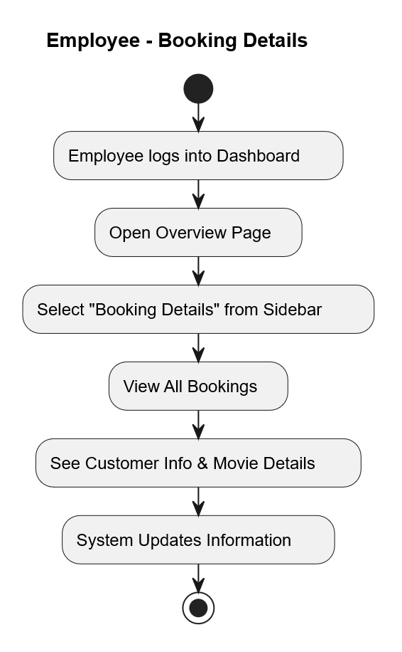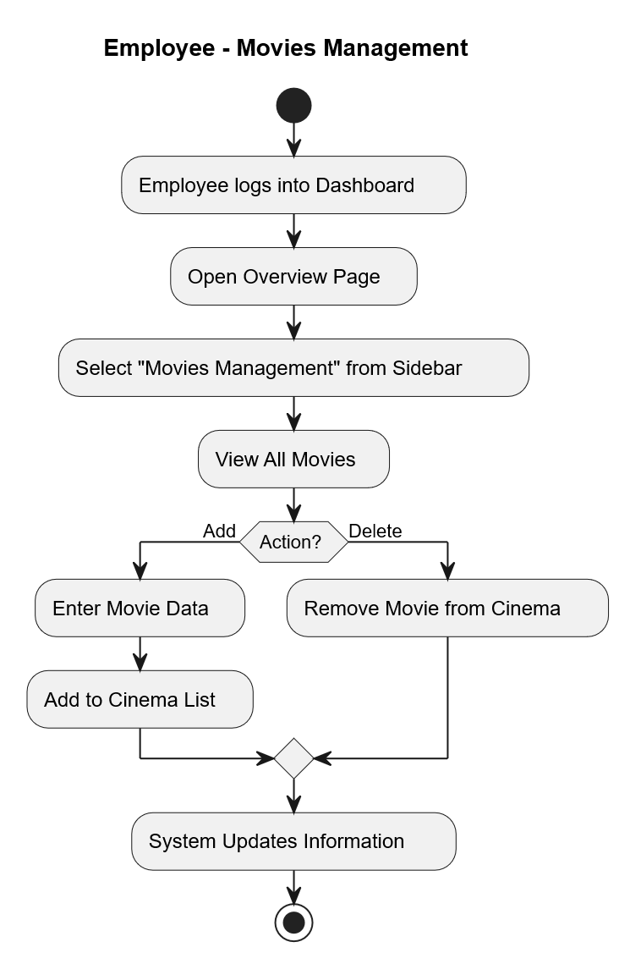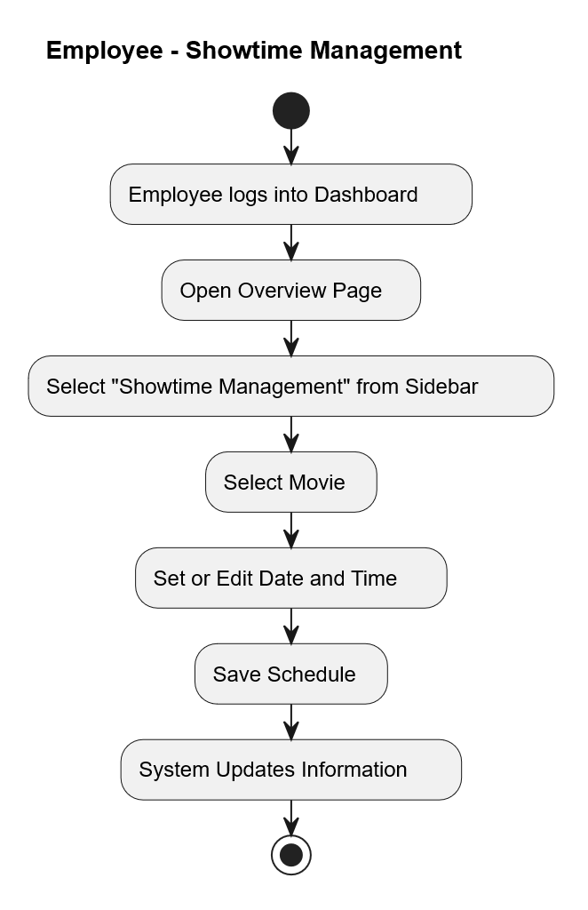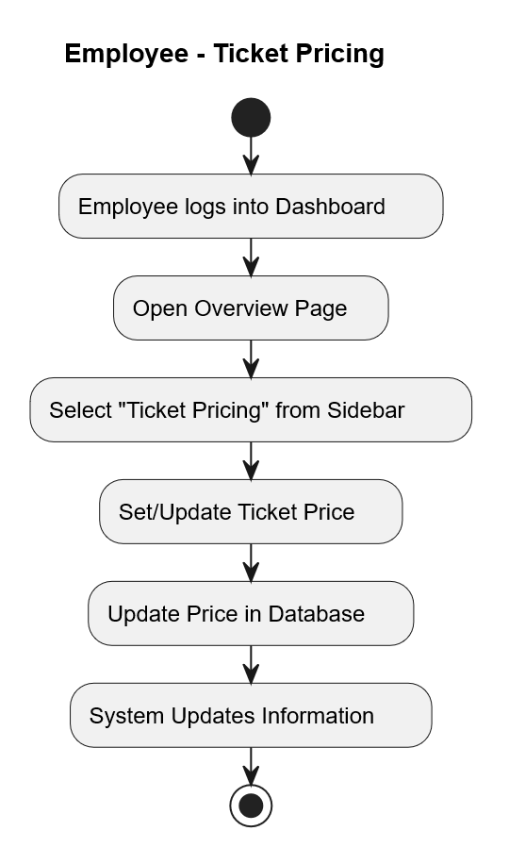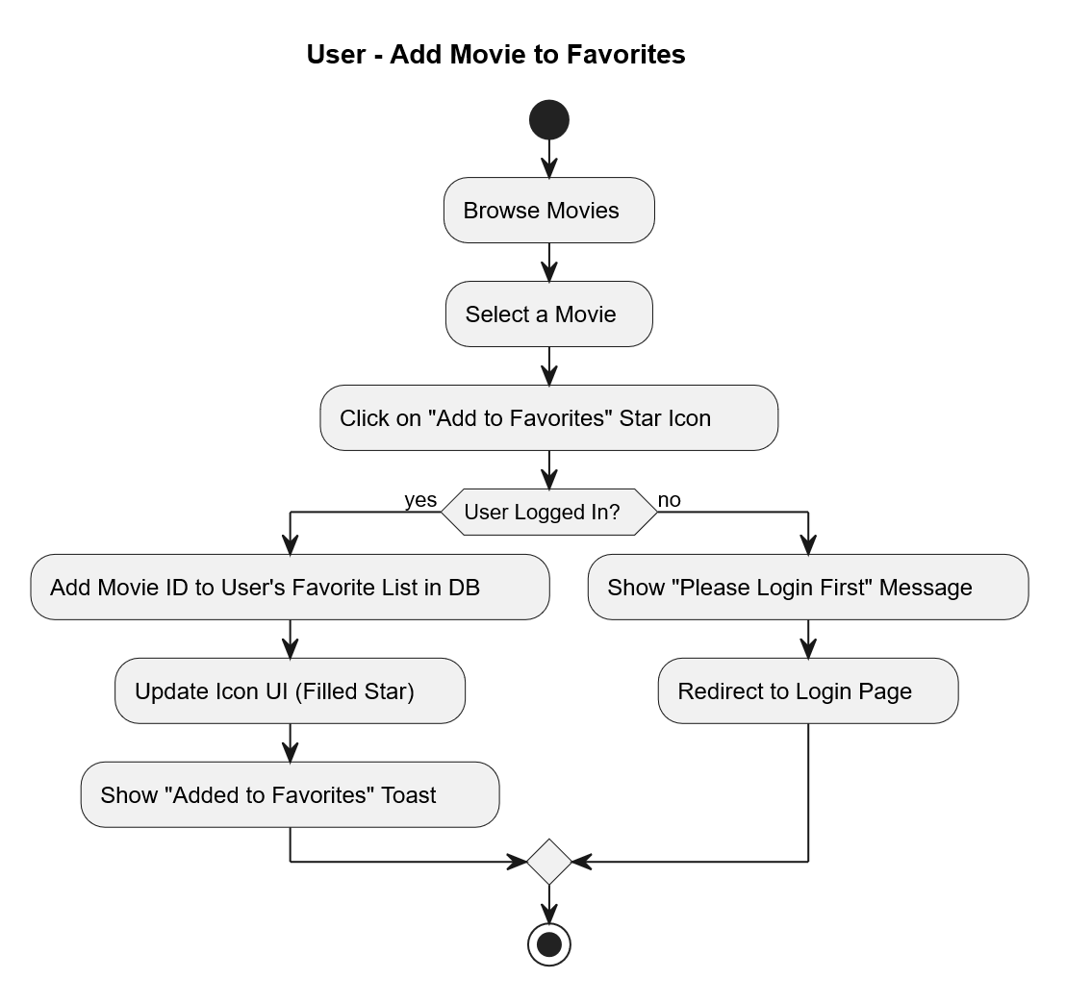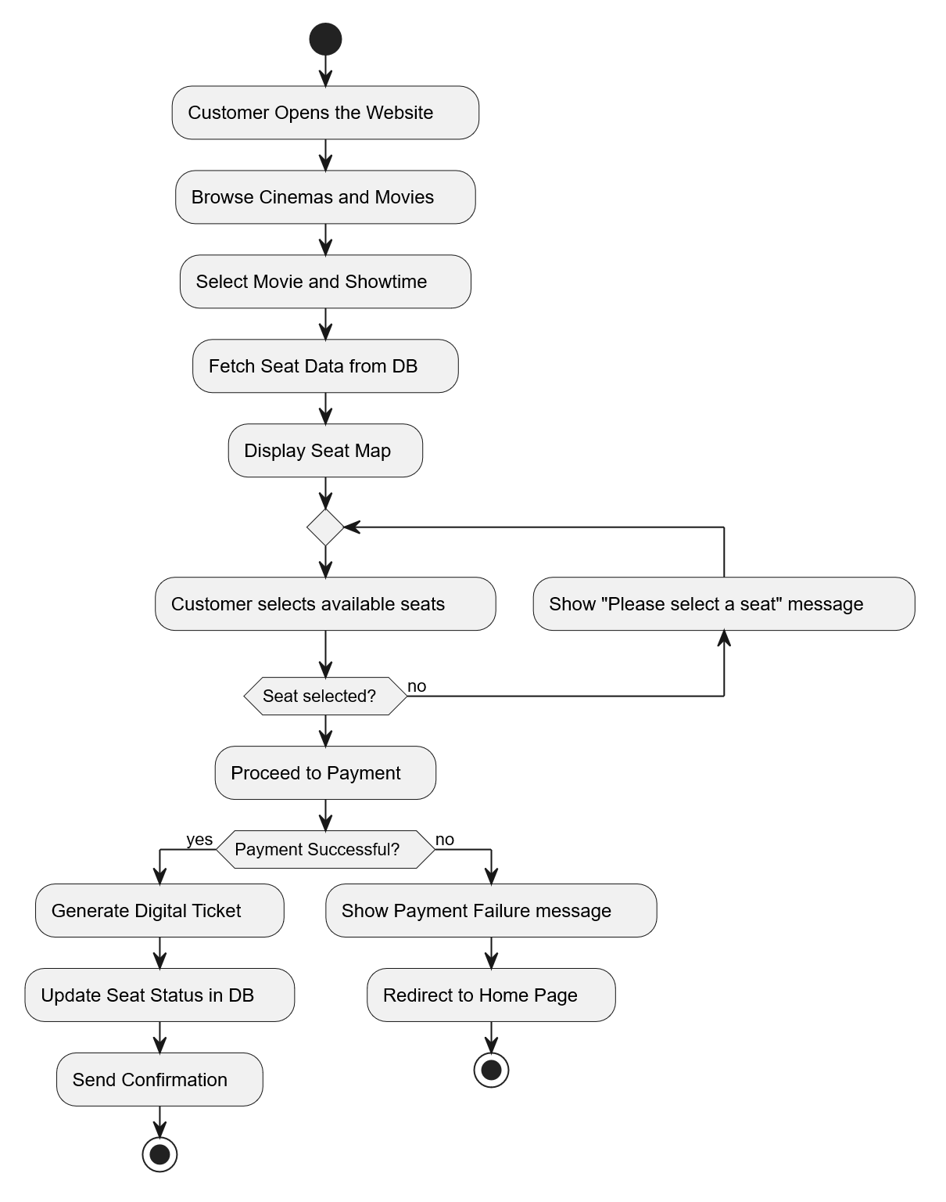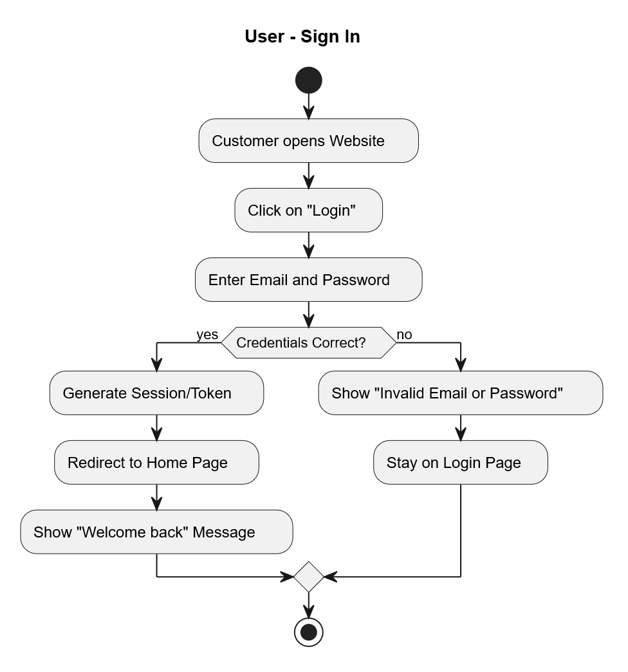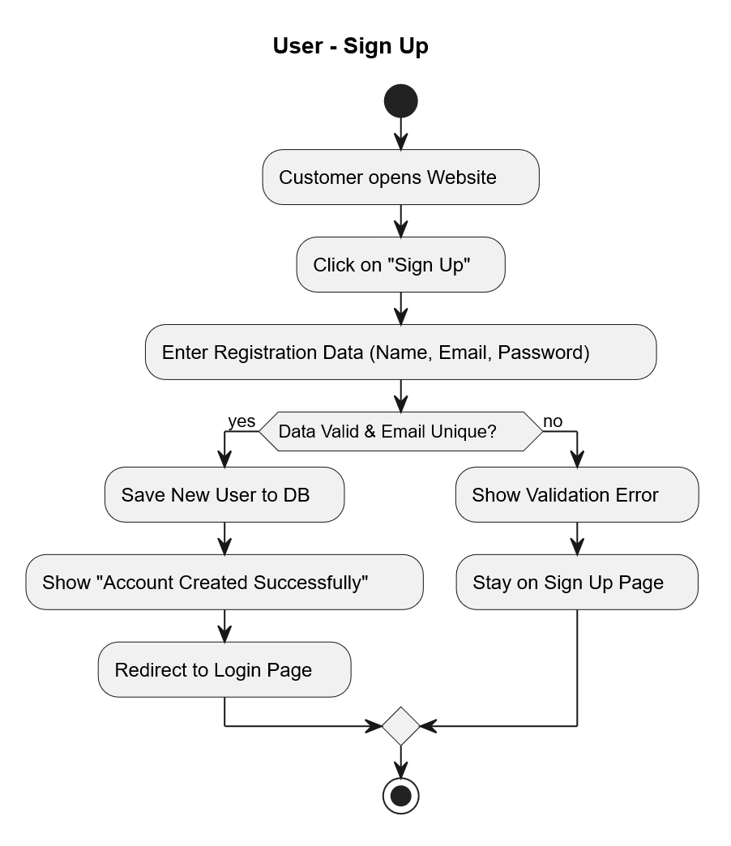

Diagram | Actors | Key Decision Points
User Sign Up | Guest → Customer | Username uniqueness check; hash & persist
User Sign In | Guest / Customer | Credential verification; JWT issuance vs. 401 Unauthorized
User Booking a Ticket | Customer | Showtime selection → seat count → POST /bookings
User Add Movie to Favorites | Customer | Toggle favourite state
Admin Movies Management | Admin | Create / Update / Delete movie; upload poster to S3
Admin Cinema Management | Admin | Create cinema → add halls → update / delete
Admin Bookings Monitoring | Admin | View all bookings in real time
Admin User Promotion & Deletion | Admin | Promote user to Employee or Admin; delete user account
Employee Movies Management | Employee | View and PATCH movie records
Employee Showtime Management | Employee | Create / Update / Delete showtimes
Employee Ticket Pricing | Employee | PATCH showtime price field
Employee Booking Details | Employee | View booking details for their cinema

10. Sequence Diagrams
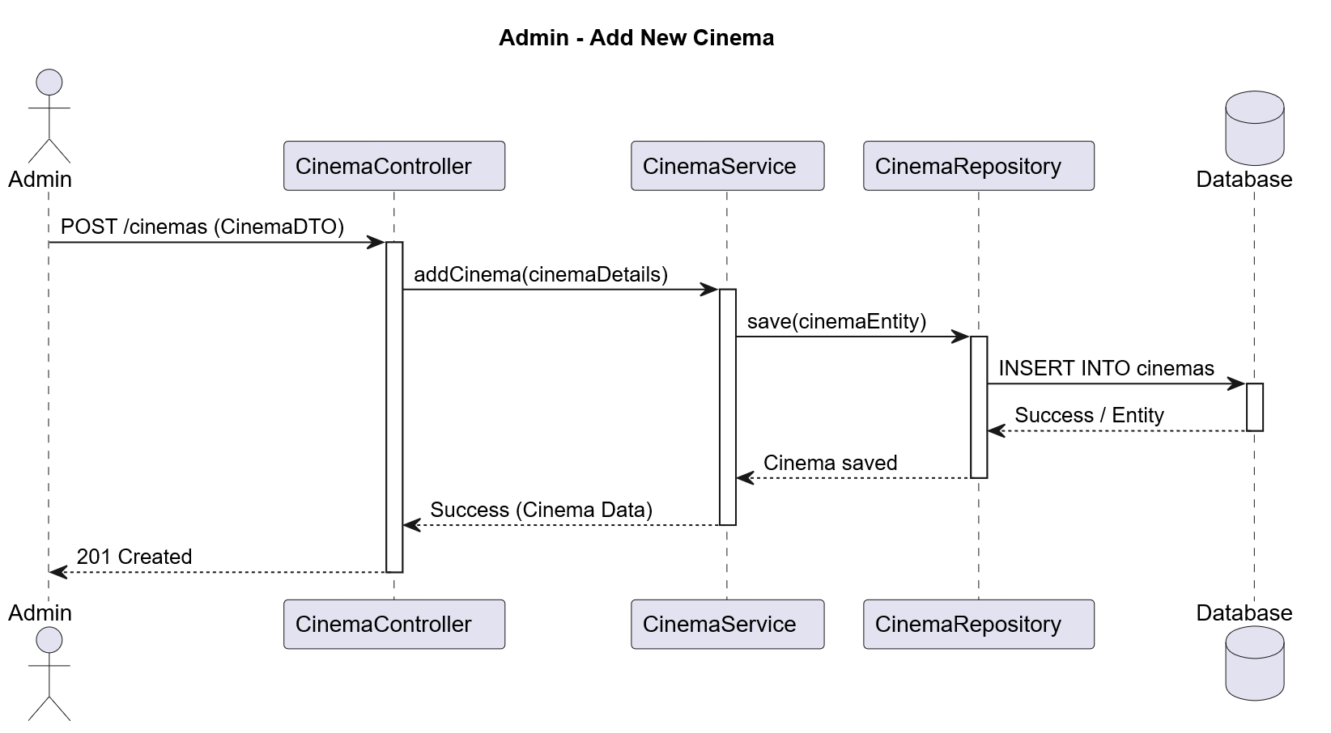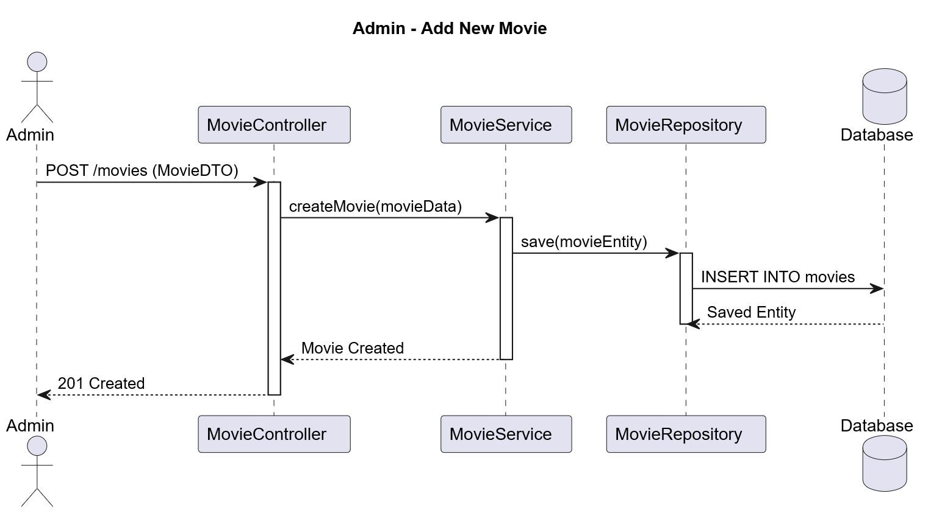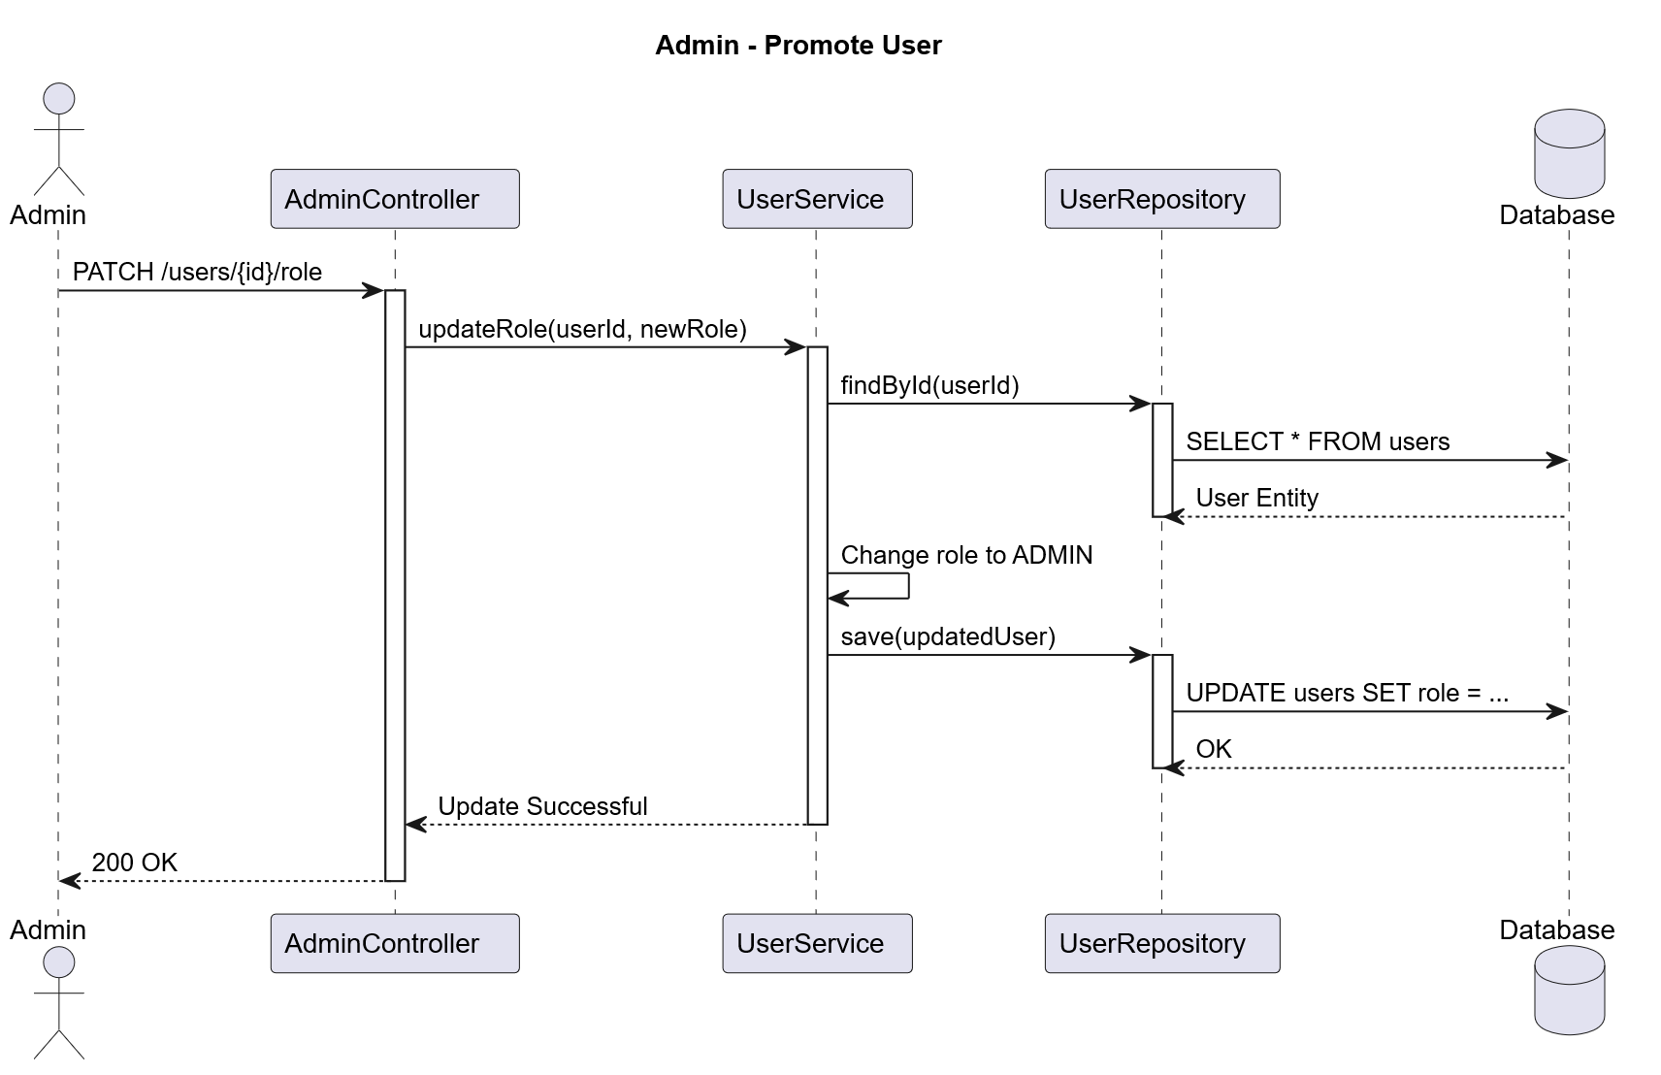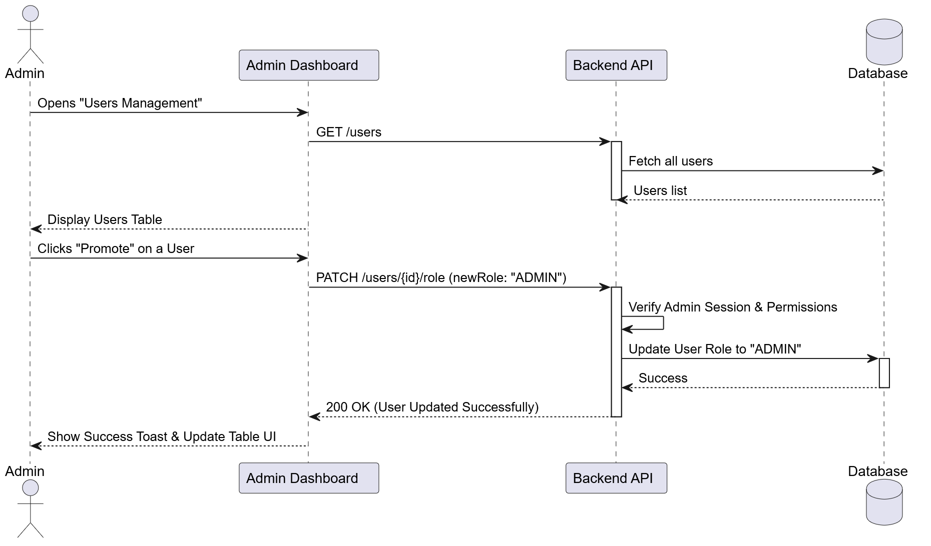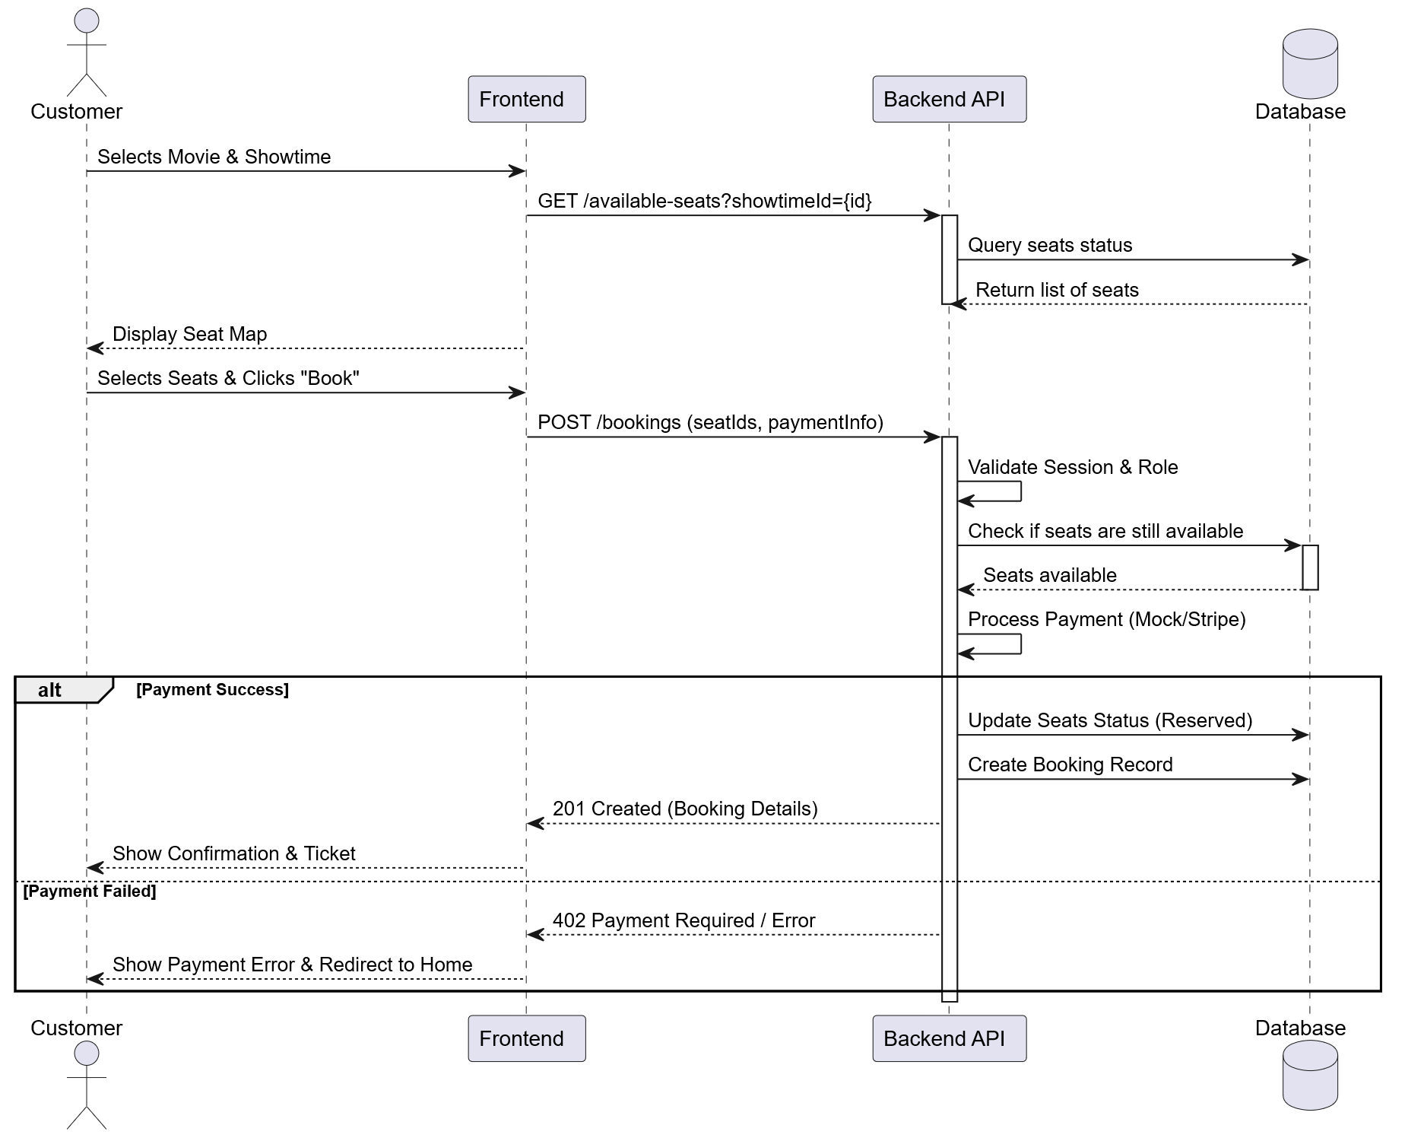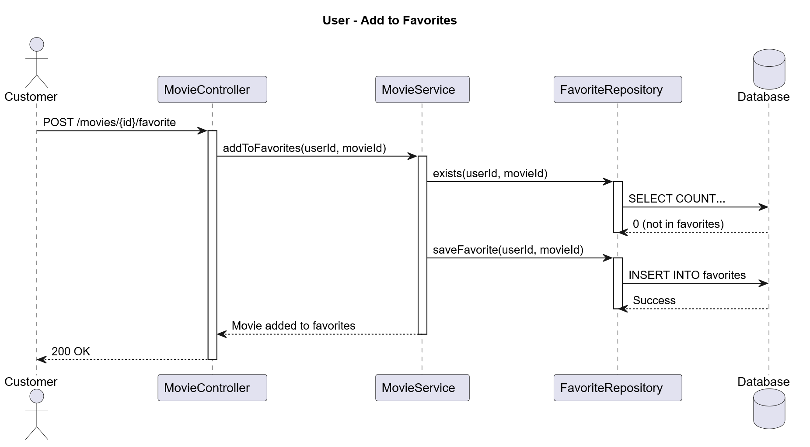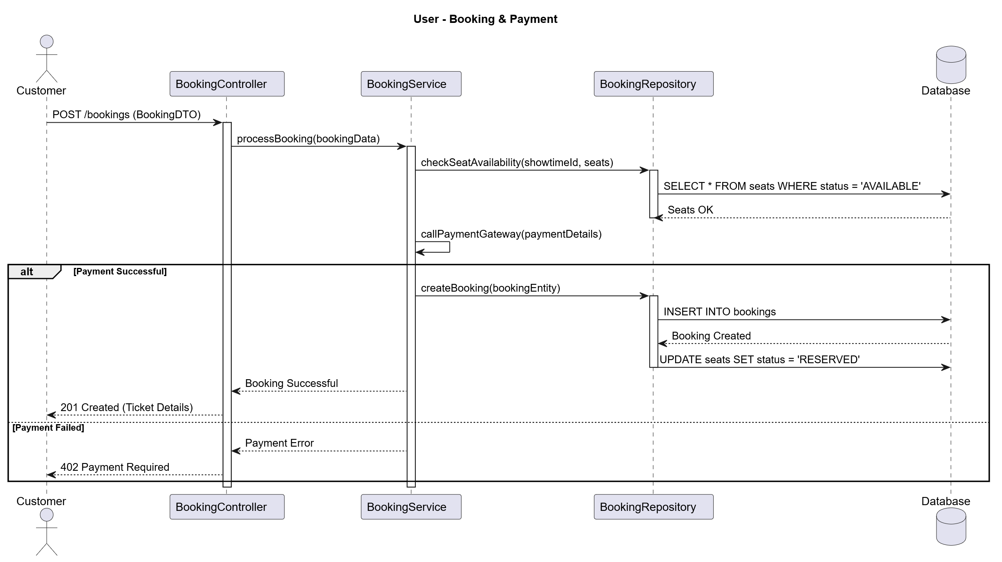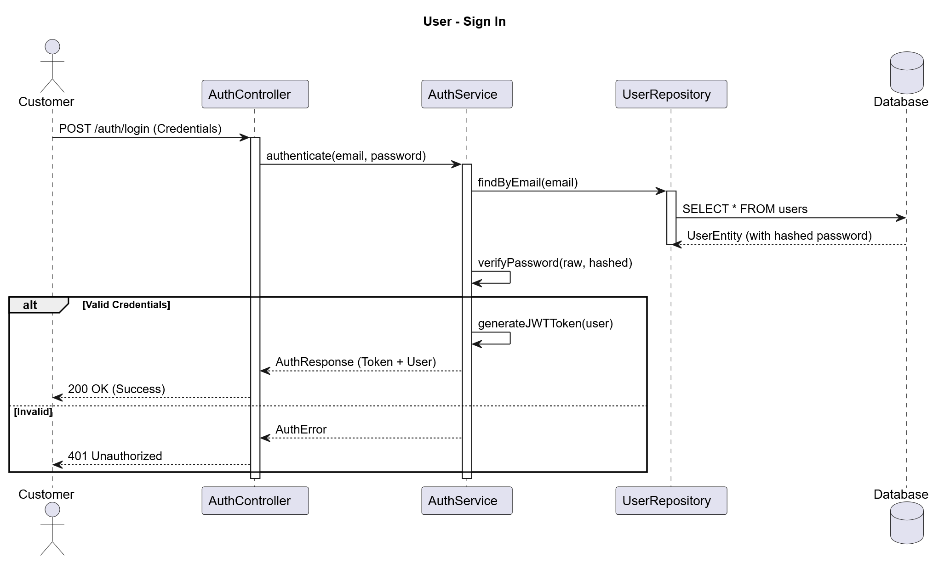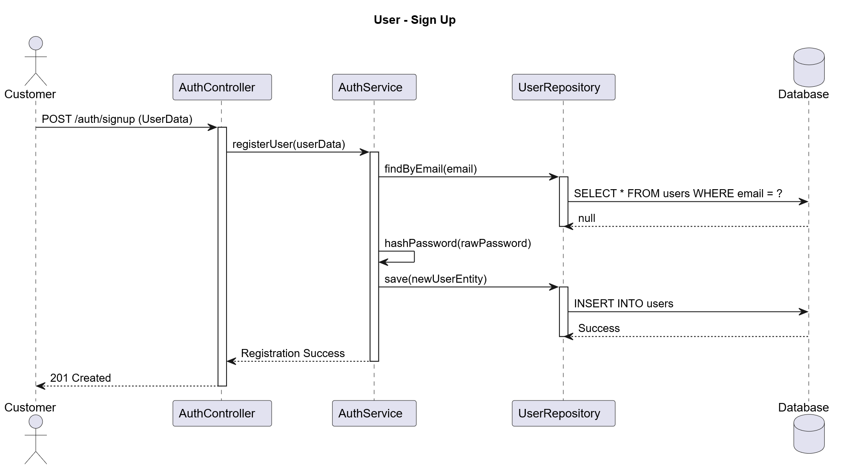

Diagram | Primary Participant Flow | File
User Sign Up | Client → AuthController → AuthService → UserAuth → UserRepository | User Sign Up.svg
User Sign In | Client → AuthController → AuthService → JwtAuth → Response (JWT) | User Sign In.svg
User Booking & Payment | Client → BookingController → BookingService → PaymentController → PaymentService | User Booking & Payment.svg
Admin Add New Cinema | Admin → CinemaController → CinemaService → CinemaRepository → Hall creation | Admin Add New Cinema.svg
Admin Add New Movie | Admin → UploadController → MovieService → S3Service → MovieRepository | Admin Add New Movie.svg
Admin Promote User to Employee | Admin → AdminController → UserRepository (role update) | Admin Promote User.svg
User Add to Favorites | Customer → Frontend → LocalStorage / API | User Add to Favorites.svg

11. Entity Relationship Diagram (ERD)
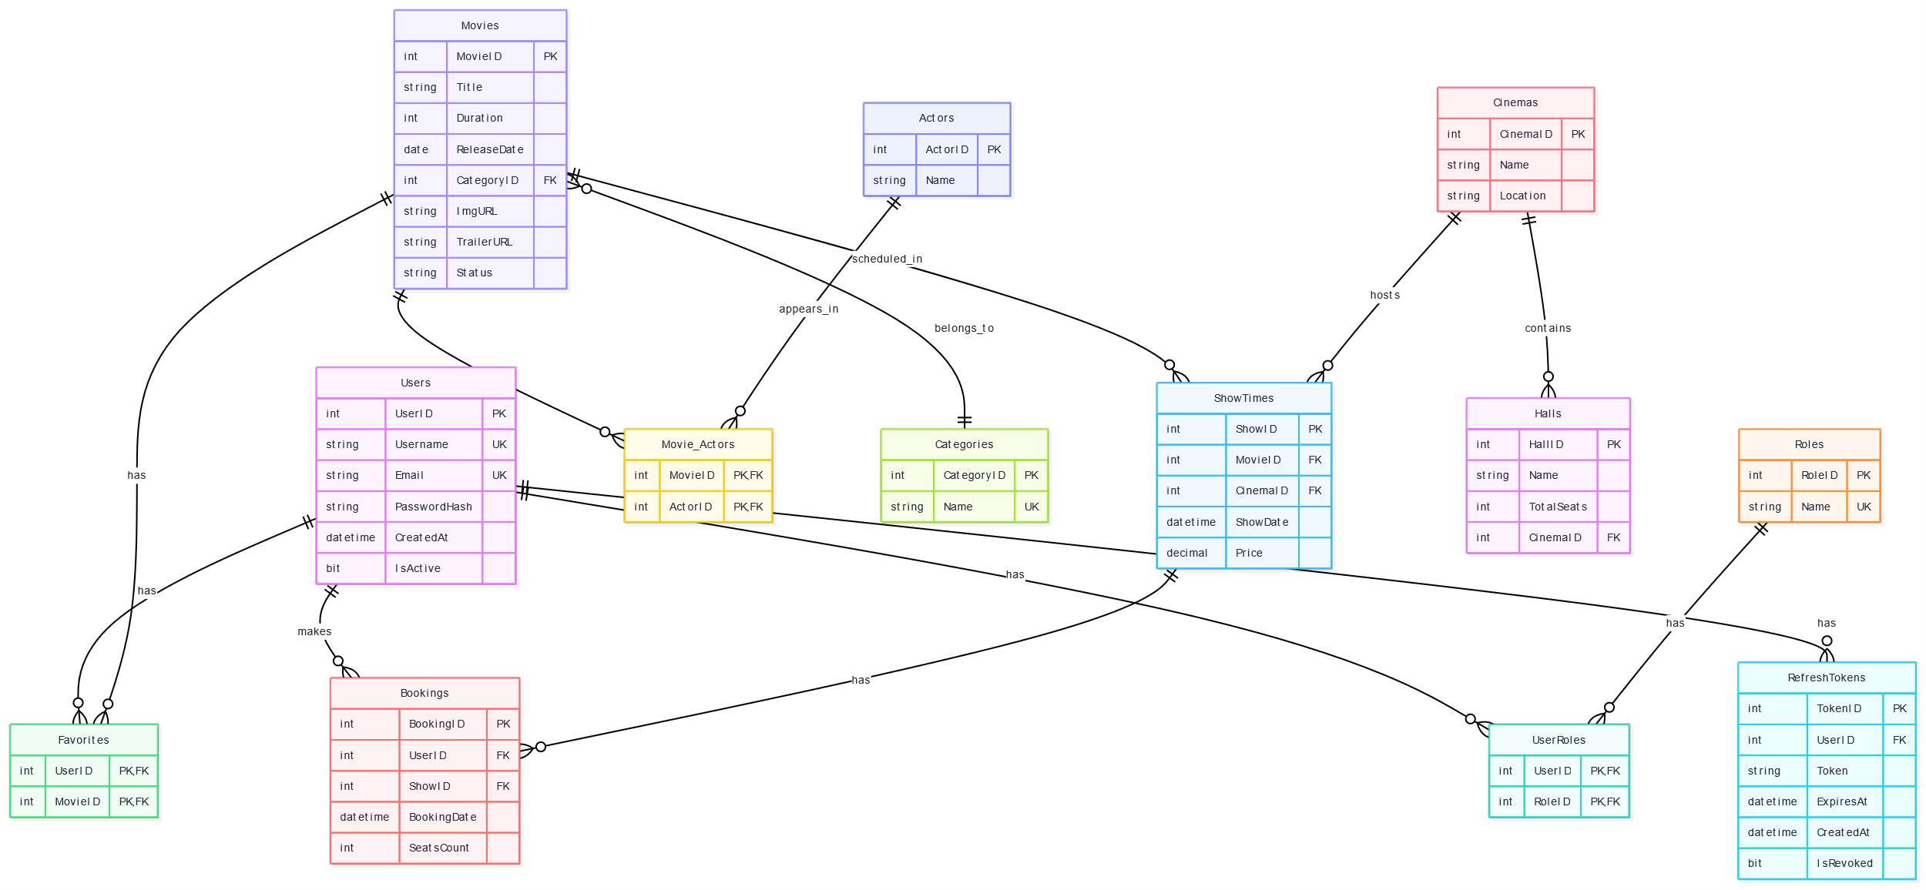

Entity Summary
Entity | Primary Key | Key Foreign Keys / Relationships
User | userid (INT IDENTITY) | —
Cinema | CinemaID (INT IDENTITY) | —
Hall | HallID (INT IDENTITY) | CinemaID → Cinema (many halls per cinema)
Movie | MovieID (BIGINT) | CategoryID (logical, no FK table shown)
ShowTimeEntity | id (BIGINT IDENTITY) | cinemaId → Cinema, movieId → Movie, hallId → Hall
Booking | BookingID (INT IDENTITY) | userId → User, showtimeId → ShowTimeEntity, movieId → Movie
Payment | PaymentID (BIGINT) | BookingID → Booking (one payment per booking)

12. Docker & Cloud Deployment

12.1 Docker Configuration
Each microservice contains a Dockerfile and a docker-compose.yml enabling isolated local deployment. A root-level docker-compose.yml orchestrates all four services together.
- All services are based on the Eclipse Temurin JDK 21 slim base image.
- Each service exposes a distinct port: cinema (8080), booking (8081), showtime (8082), payment (8083).
- Environment variables are injected via a shared .env file (AWS credentials, DB connection strings).

12.2 AWS Integration
- Movie posters are uploaded to an S3 bucket named 'project-cinema-images'.
- S3Config configures the AmazonS3Client using AwsBasicCredentials read from environment variables (AWS_ACCESS_KEY_ID, AWS_SECRET_ACCESS_KEY).
- Uploaded files receive a UUID prefix to prevent name collisions.
- DataSeeder pre-loads all major Egyptian cinema chains and their halls on application startup when the database is empty.

13. Conclusion
The EgyCinema system demonstrates a production-grade microservices architecture applying key Software Engineering 2 concepts: layered design, OCL constraints, AOP logging, Docker containerisation, JWT security, AWS cloud storage, design patterns (Repository, Service Layer, MVC, Builder), and clean code practices.

The four independently deployable services — cinema, showtime, booking, and payment — together provide a complete end-to-end cinema booking experience, from user registration and authentication through movie browsing, showtime selection, seat booking, and payment confirmation.

