

**ESPD**

**Interoperability and Diffusion**

**D5.2**

**Use Case Test Report**

|  |  |
| --- | --- |
| **Project number** | INEA/CEF/ICT/A2016/1170516 |
| **Project acronym** | ESPD |
| **Project title** | ESPD –Interoperability and Diffusion |
| **Project duration** | 24 months (01/01/2017 – 31/12/2018) |
| **Programme** | Connecting Europe Facility (CEF) |
|  |  |
| **Activity title** | Testing and Validation |
| **Deliverable number** | D5.2 |
| **Version (date)** | 0.0.1 (01/08/2018) |
| **Due date** | 31/12/2018 |
|  |  |
| **Responsible organisation** | Intercent-ER |
| **Editor** | Intercent-ER |
|  |  |
| **Abstract** | XXX |
| **Keywords** |  |

**Editor**

Intercent-ER

**Reviewers**

UnionCamere

IntercentER

AgID

Consip

ANAC

**Contributors**

**Change Log**

|  |  |  |  |  |
| --- | --- | --- | --- | --- |
| **Version** | **Date** | **Author** | **Organisation** | **Description** |
| 0.0.1 | 26/11/2018 |  | Intercent-ER | First Pre-Release |

# Table of contents

1 Table of contents 4

2 List of tables 4

3 List of figures 4

4 Introduction 6

4.1 Purpose 6

4.2 Scope 6

4.3 Document Overview 6

4.4 Definitions, Acronyms and Abbreviations 6

4.5 References 7

5 High Level Architecture 8

5.1 System Landscape 8

6 Use Case inventory 9

6.1 ESPD request and response on the Intercent-ER e-Procurement platform 11

6.1.1 Process Flow 11

6.1.2 Process steps 12

6.2 ESPD request and response on the CONSIP e-Proc platform 14

6.2.1 Process Flow 14

6.2.2 Process steps 15

6.3 Interoperability test on the INTERCENT-ER and CONSIP e-Proc platforms 17

6.3.1 Process Flow 17

6.3.2 Process steps 18

6.4 Interoperability test on the CONSIP and UNIONCAMERE platforms 19

6.4.1 Process Flow 19

6.4.2 Process steps 20

7 Test execution 23

7.1 Test planning 23

7.2 Test environments 23

7.3 Results and findings 23

8 Test scenarios and results 24

# List of tables

Tab 1 | List of Definitions, Acronyms and Abbreviations 6

# List of figures

*Figure 1 ESPD request and response on the INTERCENT-ER e-Proc platform* 11

*Figure 2 ESPD request and response on the CONSIP e-Proc platform* 14

*Figure 3 Interoperability test on the INTERCENT-ER and CONSIP e-Proc platforms* 17

*Figure 4 ESPD request and response on the INTERCENT-ER e-Proc platform* 20

# Introduction

## Purpose

## Scope

## Document Overview

In accordance with the scope defined in previous paragraph, the document has been organized as follows:

* Chapter 5 – High Level Architecture;
* Chapter 6 – Tender procedure management

Each use case detailed is graphically represented with a sequence diagram providing an end-to-end view of the entire process. The main steps in the diagram are numbered and referenced in a table containing descriptions that help the reader in getting a better undertanding of each event, from a technical and / or business standpoint.

## Definitions, Acronyms and Abbreviations

|  |  |
| --- | --- |
| Acronym | Description |
| ANAC | *Autorità Nazionale Anti-Corruzione* (National Anti-Corruption Authority) |
| CA | Contracting Authority |
| CEF | Connecting Europe Facility |
| DGUE | Documento di Gara Unico Europeo |
| ESPD | European Single Procurement Document |
| e-Certis | Online mapping tool used to identify and compare certificates requested in public procurement procedures across the EU. Available at the following link: *https://ec.europa.eu/growth/tools-databases/ecertis/* |
| GURI | Official Journal of the Italian Republic (*Gazzetta Ufficiale della Repubblica Italiana*) |
| SIMOG | *Sistema Informativo Monitoraggio Gare* (Tender Monitoring Information System): online national system that allows Contracting Authorities (CAs) to request the Contract Reference Number (CIG) required for economic operators to pay the contribution to the Authority due for participation in public tenders |
| EO | *Economic Operator* |
| UC | Use Case |
| WS | Web Service |

Tab 1 | List of Definitions, Acronyms and Abbreviations

## References

|  |  |  |
| --- | --- | --- |
| Deliverable | Document name | Author |
| Agreement | *XXX.pdf* | CEF |
| Amendment | *XXX.pdf* | CEF |

# High Level Architecture

## System Landscape

The described use cases are based on the interation between the following systems:

* **SIMOG**: XXX;
* **e-procurement platform (Intercent-ER):** RUP actives the tender procedure to generate and manage the ESPD request. EO starts the ESPD response that will be saved on the platform;
* **e-Procurement platform (Consip):** XXX;
* **e-Procurement platform (UNIONCAMERE): XXX.**

The systems that are going upgraded in ESPD project are:

* **SIMOG**: new web services are implemented to integrate the SIMOG with the e-Procurement platforms to check the ESPD data and to notify incorrect data. The webservises will developed with REST protocol.
* **E-Procurement platform (Intercent-ER):** These implementations allow the RUP to customize the ESPD request and save it on the platform. EO starts the ESPD response and the e-procurement platform checks the correctness of the ESPD data allowing the ESPD signed.
* **e-Procurement platform (CONSIP)**: XXX.
* **e-Procurement platform (UNIONCAMERE)**: XXX.

# Use Case inventory

The e-procurement platforms permits to generate and manage the ESPD for the tender procedures. These use cases are activated by the RUP of a Contracting Authority and Economic Operators following a specific operations defined on the e-procurement platform that describes the mandatory use of ESPD for the access to the eMarketplace.

The features permits to manage ESPD flow activities:

* Interoperability test on the INTERCENT-ER and Crossborder e-Proc platforms;
* Interoperability test on the CONSIP and Crossborder e-Proc platforms.

The following three use cases can be identified:

* **UC_01** – *Interoperability test on the INTERCENT-ER and Crossborder e-Proc platforms*:

The RUP configures the request with the mandatory information that must be present on the European single procurement document. The ESPD Request contains arbitrary criteria, manually added by the ESPD request author (Contracting Authority) that customization own document. After data entry, the Intercent-ER e-procurement platform submits ESPD request at the checks by SIMOG using ANAC service. The first procedure is completed successfully when the ESPD request has been saved on the Intercent-ER e-procurement platform and the request file can be downloaded.

To proceed to the next step, the EO fill in the ESPD response on the crossborder e-procurement platform and this procedure is completed successfully when the EO created the final version that can be downloaded.

At the last step, the EO research the tender on the Intercent-ER e-procurement platform and upload his ESPD response. The procedure is completed successfully when the Intercent-ER e-procurement platform checks the data and the EO signs the final version of the ESPD response in xml and PDF format, and save it on the platform.

* **UC_02** – *Interoperability test on the CONSIP and Crossborder e-Proc platforms*:

## Interoperability test on the INTERCENT-ER and Crossborder e-Proc platforms

### Process Flow

The flowchart presented below illustrates the main qualifying steps of the Use Case, in order to provide an overview of the overall process and to represent its operating logics

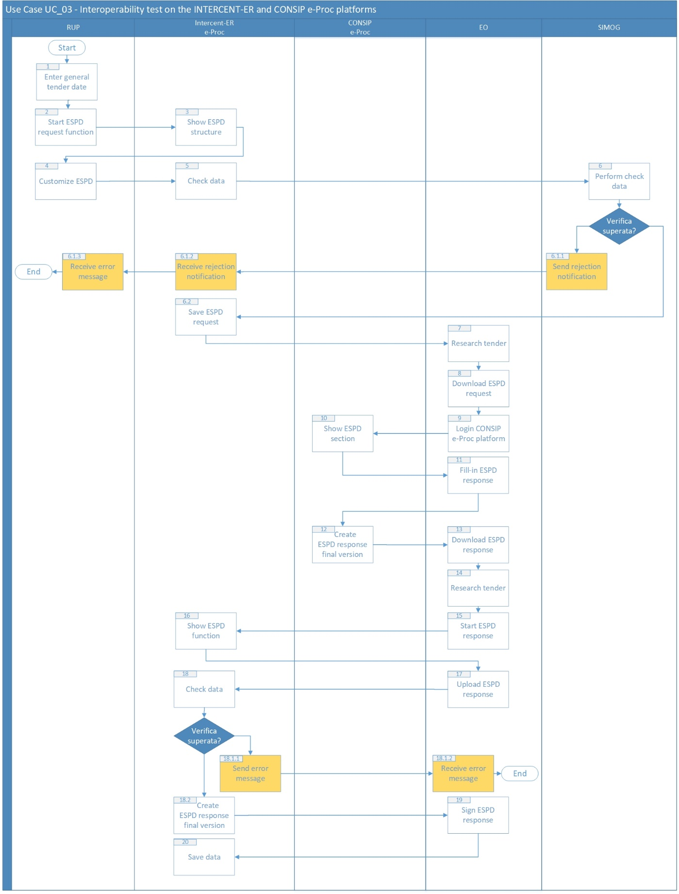

Crossbordere-Proc

*Figure 3 Interoperability test on the INTERCENT-ER and Crossborder e-Proc platforms*

### Process steps

In the following tables, we provide more insights or clarifications on each process steps and for each process variant, so as to allow a better understanding of the overall Use Case, from a functional and / or application perspective.

| **Id** | **Name** | **Role/System** | **Description** |
| --- | --- | --- | --- |
| **1** | *Enter general tender data* | RUP (Contracting Authority) | RUP log in on the e-Procurement platform and enters the tender general data |
| **2** | *Start ESPD request function* | RUP (Contracting Authority) | RUP starts the specific ESPD request function into the tender documentation section |
| **3** | *Show ESPD structure* | Intercent-ER e-Proc | The e-Procurement Platform shows the ESPD structure and provides automatic pre-filling of mandatory data |
| **4** | *Customize ESPD* | RUP (Contracting Authority) | RUP creates the own ESPD Request selecting the criteria of interesting and requires to save ESPD Request final version |
| **5** | *Check data* | Intercent-ER e-Proc | The e-Procurement Platform starts ANAC service to check the entered data |
| **6** | *Perform data check* | SIMOG | SIMOG checks the data completeness with respect current legislation |
| **6.1.1** | *Send Rejection Notification* | SIMOG | In case checks are not passed, the SIMOG system communicate to e-Procurement Platform negative verification outcome. The SIMOG sends the Rejection Notification to the e-Procurement Platform. |
| **6.1.2** | *Receive Rejection Notification* | Intercent-ER e-Proc | The e-Procurement Platform receives the Rejection Notification and sends an error message to RUP |
| **6.1.3** | *Receive error message* | RUP (Contracting Authority) | The RUP receives the error message “Incomplete required fields”. |
| **6.2** | *Save ESPD request* | Intercent-ER e-Proc | In case checks are passed by SIMOG, the e-Procurement Platform save the ESPD request, create the xml file and show the pdf file with the ESPD Request |
| **7** | *Research tender* | EO | EO log in on the Intercent-ER e-Procurement Platform  and research the tender to which EO wants to partecipate |
| **8** | *Download ESPD Request* | EO | EO actives the specific ESPD function into the tender documentation section and download ESPD Request file |
| **9** | *Login Consip e-Proc Platform* | EO | EO log in on the Consip e-Procurement Platform |
| **10** | *Show ESPD section* | Crossborder e-Proc | The Crossborder e-Procurement Platform shows the function to compile ESPD Response |
| **11** | *Fill-in ESPD Response* | EO | EO inserts request data in the ESPD Response  and save the data |
| **12** | *Create ESPD response final versione* | Crossborder e-Proc | In case checks are passed, the e-Procurement Platform create the ESPD Response in xml and pdf format, and active download function |
| **13** | *Download ESPD Response* | EO | EO actives the specific ESPD function into the tender documentation section and download ESPD Request file |
| **14** | *Research tender* | EO | EO log in on the Intercent-ER e-Procurement Platform  and research the tender to which EO wants to partecipate |
| **15** | *Start ESPD response* | EO | EO actives the specific ESPD function into the tender documentation section |
| **16** | *Show ESPD function* | Intercent-ER e-Proc | The e-Procurement platform shows form where to upload ESPD Response file |
| **17** | *Upload ESPD response* | EO | EO upload the ESPD response in xml format on the e-Procurement platform |
| **18** | *Check data* | Intercent-ER e-Proc | The e-Procurement platform checks the input data |
| **18.1.1** | *Send error message* | Intercent-ER e-Proc | In case checks are not passed, the e-Procurement Platflorm sends an error message to EO |
| **18.1.2** | *Receive error message* | EO | EO receives an error message |
| **18.2** | *Create ESPD response final versione* | Intercent-ER e-Proc | In case checks are passed, the e-Procurement Platform create the ESPD Response in xml and PDF format and active download function |
| **19** | *Sign ESPD Response* | EO | EO downloads pdf file, puts on the electronic digital signature on the document and upload on e-Procurment platform the signed file |
| **20** | *Save data* | Intercent-ER e-Proc | The e-Procurement Platform save the ESPD Response and notifies that operation is completed successfully |

# Test execution

## Test planning

## Test environments

## Results and findings

# Test scenarios and results