|  |
| --- |
|  |

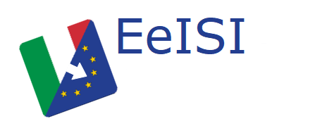

European eInvoicing Standard in Italy

|  |  |
| --- | --- |
| **Project number** | INEA/CEF/ICT/A2017/1560867 2017-IT-IA-0150 |
| **Project acronym** | EeISI |
| **Project title** | European eInvoicing Standard in Italy |
| **Starting date** | 1 May 2018 |
| **Ending date** | 31 December 2019 |
| **Programme** | Connecting Europe Facility (CEF) CEF-TC-2017-3: eInvoicing |

e-Delivery gap analysis for NoTIER

Deliverable D2.10

|  |  |
| --- | --- |
| **Related WP** | WP2 – Analysis – Task 2.5 System gap analysis |
| **Deliverable number** | D2.10 |
| **Due date** | 31/10/2018 |
| **Revision date** | 31/10/2018 |
| **Actual date** | **31/10/2018** |

This Page Intentionally Left Blank

Deliverable Info

|  |  |
| --- | --- |
| **Editor (s)** | **Intercent-ER** |
| **Contributors** |  |
|  |  |
|  |  |
| **Acknowledgement** | This work was partially supported by the European Commission (EC) through the Connecting Europe Facility (CEF) programme under project EeISI.(grant agreement no. INEA/CEF/ICT/A2017/1560867 2017-IT-IA-0150) |
| **Disclaimer** | The sole responsibility of this publication lies with the author(s). The European Union is not responsible for any use that may be made of the information contained therein. |
| **Confidentiality** | The information in this document is confidential and restricted only to the members of the EeISI consortium  (including the Commission Services). |
|  |  |
| **Note** | - |
|  |  |

**Version Control**

|  |  |  |  |
| --- | --- | --- | --- |
| Version | Date | Author | Description of change |
| 0.1 | 31/10/2018 | Intercent-ER |  |
| 0.1.1 | 31/03/2020 | Roberto Reale | Technical review and quality assessment |
|  |  |  |  |
|  |  |  |  |
|  |  |  |  |

This Page Intentionally Left Blank

Table of contents

Deliverable Info 3

Table of contents 5

Executive Summary 7

Glossary 7

1. Introduction 9

2. eDelivery infrastructure – AS2/AS4 9

2.1. Current situation in the eDelivery infrastructure 9

2.2. Software choice 9

2.3. Licensing issue 9

2.4. Proposed solutions 10

3. Inbound Scenario for NoTIER – Cross-border B2G 10

3.1. Current situation – Inbound 10

3.1.1. Notifications 11

3.2. Proposed solution – Inbound and Outbound 11

3.2.1. Notifications in a European scenario 12

4. Outbound scenario for NoTIER 12

4.1. Current situation – G2G and G2B 12

4.2. Proposed solution – B2G and the integration with SATER 13

This Page Intentionally Left Blank

Executive Summary

This document aims to describe the eDelivery Gap Analysis for NoTIER, in relation to the EeISI project. The analysis mainly interests:

* eDelivery infrastructure – AS2/AS4;
* eDelivery process, for the new scenarios:
  + inbound cross-border B2G;
  + outbound via SATER.

Glossary

|  |  |
| --- | --- |
| **B2B** | Business to Business |
| **B2C** | Business to Consumer/Citizen |
| **B2G** | Business to Government |
| **BII** | Business Interoperability Interfaces |
| **C2G** | Citizen to Government |
| **CCTS** | Core Component Technical Specification |
| **CEF** | Connecting Europe Facility |
| **CEM** | Certified Electronic Mail – Legal Mail (PEC Posta Elettronica Certificata in Italy) |
| **CEN** | European Committee for Standardisation |
| **CII** | Cross Industry electronic Invoice |
| **CIUS** | Core Invoice Usage Specification |
| **DSI** | Digital Service Infrastructures |
| **EDIFACT** | Electronic Data Interchange For Administration, Commerce and Transport |
| **EMSFEI** | European Multi-Stakeholder Forum on eInvoicing |
| **e-SENS** | Electronic Simple European Networked Services |
| **FatturaPA** | Public administration electronic invoice framework (FatturaPubblica Amministrazione) |
| **G2B** | Government to Business |
| **G2G** | Government to Government |
| **INEA** | Innovation and Networks Executive Agency |
| **NoTIER** | Nodo Telematico di Interscambio Emilia-Romagna (Telematic Interchange Node) |
| **OASIS** | Organization for the Advancement of Structured Information Standards |
| **PEPPOL** | Pan-European Public Procurement Online |
| **PEPPOL-BIS** | Pan-European Public Procurement Online Business Interoperability Specifications |
| **SATER** | Sistema Acquisti Telematici Emilia-Romagna (Telematic Purchasing System) |
| **SDI** | Electronic exchange system in Italy (Sistema Di Interscambio) |
| **UBL** | Universal Business Language |
| **UN/CEFACT** | United Nations Centre for Trade Facilitation and Electronic Business |
| **UNTDID** | UN Trade Data Interchange Directory |
| **URI** | Uniform Resource Identifier |
| **URL** | Uniform Resource Location |
| **URN** | Uniform Resource Name |
| **XML** | Extensible Mark-up Language |

1. Introduction

EeISI project proposes to integrate the Italian eDelivery processes for Invoices and Credit Notes with the European standards and PEPPOL architectural system. This involves the inclusion of SdI in a broader context with the need to adapt the eDelivery practices between the various interested parties.

As an output of the EIGOR project and as a consequence to the European Norm, the SDI (Italian Tax Revenue Agency’s hub for e-invoicing) is now able to receive and deliver e-Invoices in UBL/CII format that are compliant to the CEN TC 434 Standard.

In following section for eDelivery infrastructure – AS2/AS4 and eDelivery process new scenarios, both the current situation of the system and the solutions proposed for the correct integration of all the parties involved will be described, from a NoTIER point of view.

1. eDelivery infrastructure – AS2/AS4

The purpose of this first section is to point out the upgrades and changes needed to deploy and integrate an AS4 eSENS Access Point in the current Intercent-ER e-delivery infrastructure (NoTIER).

* 1. Current situation in the eDelivery infrastructure

Since 2014, NoTIER integrates an AS2 Access Point, namely Oxalis v.3.0, developed by DIFI (the Norwegian OpenPEPPOL Authority). The integration makes the interaction between NoTIER’s other functionalities (i.e. the web interface) and the Access Point strictly coupled. The Oxalis distribution has been modified in several different parts, following the change management needs that emerged during the five years of production activity.

* 1. Software choice

Oxalis is the current leading solution as an AS2 Access Point for the OpenPEPPOL community, and it probably will continue to be a leading solution for the AS4 protocol as well; Intercent-ER has developed an overall good knowledge of Oxalis’ architecture. The fact that DIFI has released a new version (4.0) of Oxalis, that supports both AS2 and AS4, makes this solution the ideal choice for Intercent-ER.

* 1. Licensing issue

The main issue with the use of the new software is the change in the license under which it is released. Early versions of Oxalis have been released using LGPL licensing, meaning they could be integrated and modified for use in both commercial and open-source projects; the latest versions use GPL instead, meaning they can only be integrated with open-source projects. NoTIER is not open-source, and the same low-level, highly coupled integration we had with the early versions of Oxalis can’t be pursued with the new versions.   
The same licensing issue applies to most of the other open-source solutions for an AS4 Access Point (Holodeck, Domibus…), that are release under GPL or stricter licenses.

* 1. Proposed solutions

The licensing issue shows us an opportunity to think about the integration between NoTIER and his Access Point from scratch.   
Decoupling the Access Point from the rest of the software leads to these benefits:

* the Access Point can be upgraded without the need to check for compatibility with Intercent-ER’s own modifications, allowing to keep up with the new features that will be added with every new release by DIFI;
* NoTIER does not need to be released as open source, only the communication layer does;
* leads the road to considering NoTIER a document-holding hub, that uses the Access Point as a delivery mean. This also means that in the future there could be different Access Point software solutions, for different communication protocols and networks, coexisting in Intercent-ER’s environment.

On the opposite side, keeping NoTIER and Oxalis strictly coupled as they are right now, would lead to an easier and faster implementation, but would make any future software evolution much more time consuming.   
Considering the benefits of both solutions and the aforementioned License issue, the Decoupled solution is to be preferred.

1. Inbound Scenario for NoTIER – Cross-border B2G

In this section the inbound process is going to be examined, which includes the exchange of documents coming from an Economic Operator and destined to an Italian Public Administration (Business to Government), specifically the case when the Economic Operator is from a cross-border country (B2G Cross-Border).

From a foreign Economic Operator point of view, the need to have a direct integration to the SDI or to use an SDI-enabled third-party is an issue, involving the need to adopt a specific channel to interact with a single country; with the ever-increasing usage of the Peppol Network in Europe as an e-delivery framework, allowing the Economic Operators to use this Network to deliver messages to the SDI would be an extremely interesting scenario.

The e-delivery process that enables the SDI to receive documents over the Peppol Network is actually out of the scope of this document, and will be described in the “SMP/iPA integration and PEPPOL network enablement” design document.

Specifically, attention will be paid to the role played by NoTIER in the AS-IS situation and to the proposed actions that NoTIER is going to implement in a perspective of integration with the PEPPOL network.

* 1. Current situation – Inbound

In the current Inbound situation, NoTIER acts as the receiving intermediary for Emilia-Romagna Region’s Italian Public Administrations.

The process takes place as follows in Figure 1.

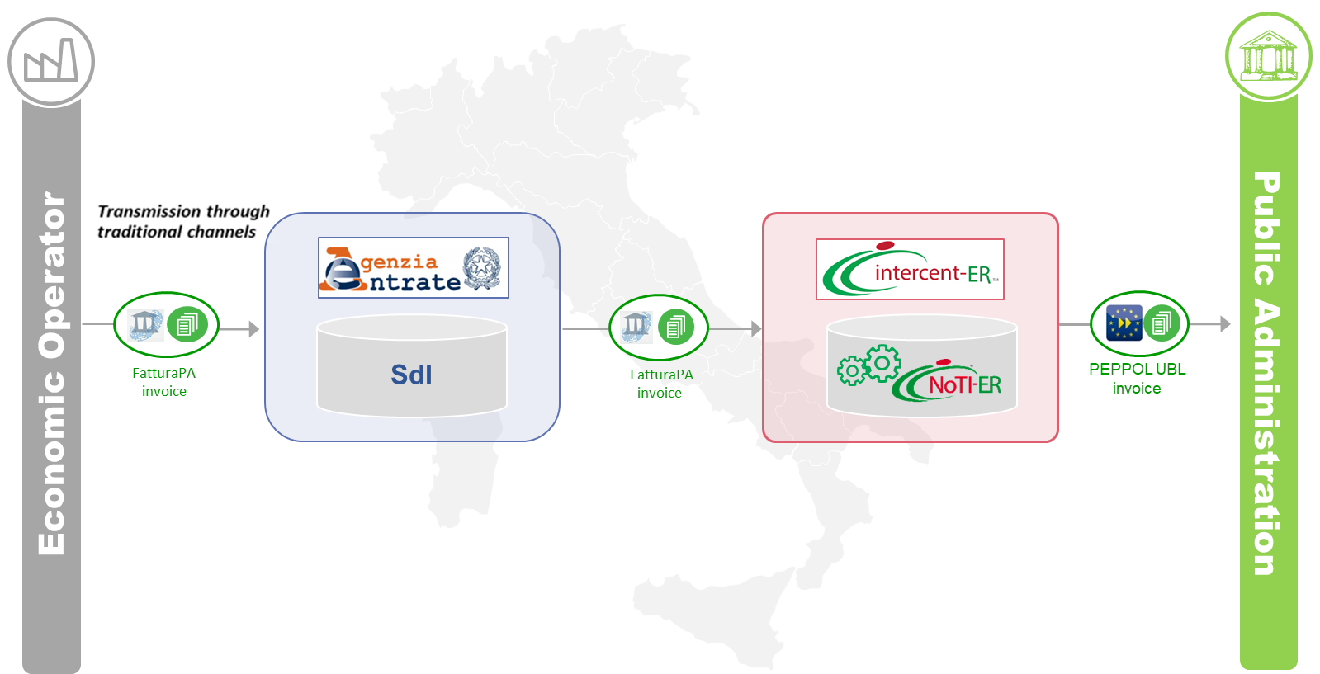

Figure 1 – Current situation

An economic operator needs to send an Invoice/Credit Note to a Public Administration of the Emilia-Romagna Region, so he sends the document to the SDI via the so-called “traditional channels” (PEC, SFTP, SdICoop), either on his own or through a third party. The sent document reaches the SdI, that carries out the necessary checks. The SdI delivers the document to NoTI-ER through the traditional channels (in this case, SPCoop). NoTIER receives the document and, before forwarding it to the competent Public Administration, it performs the conversion from the FatturaPA format to the Peppol BIS 2.1 format, which is the one elected by the Emilia-Romagna Public Administrations.

* + 1. Notifications

SdI process involves a complex asynchronous notification system that allows both the sender and the receiver to receive additional informations about the current status of the document. The notifications are created in the FatturaPA format. NoTI-ER receives the notifications from the SdI and just makes them available for retrieval by his own clients, in FatturaPA format.

* 1. Proposed solution – Inbound and Outbound

In order to integrate this process as required by EeISI project, allowing a cross-border economic operator to issue Invoices/Credit notes destined to an Italian Public Administration, it is necessary to introduce a structure that supports the use of the OpenPEPPOL Network. This structure could be implemented as shown in Figure 2

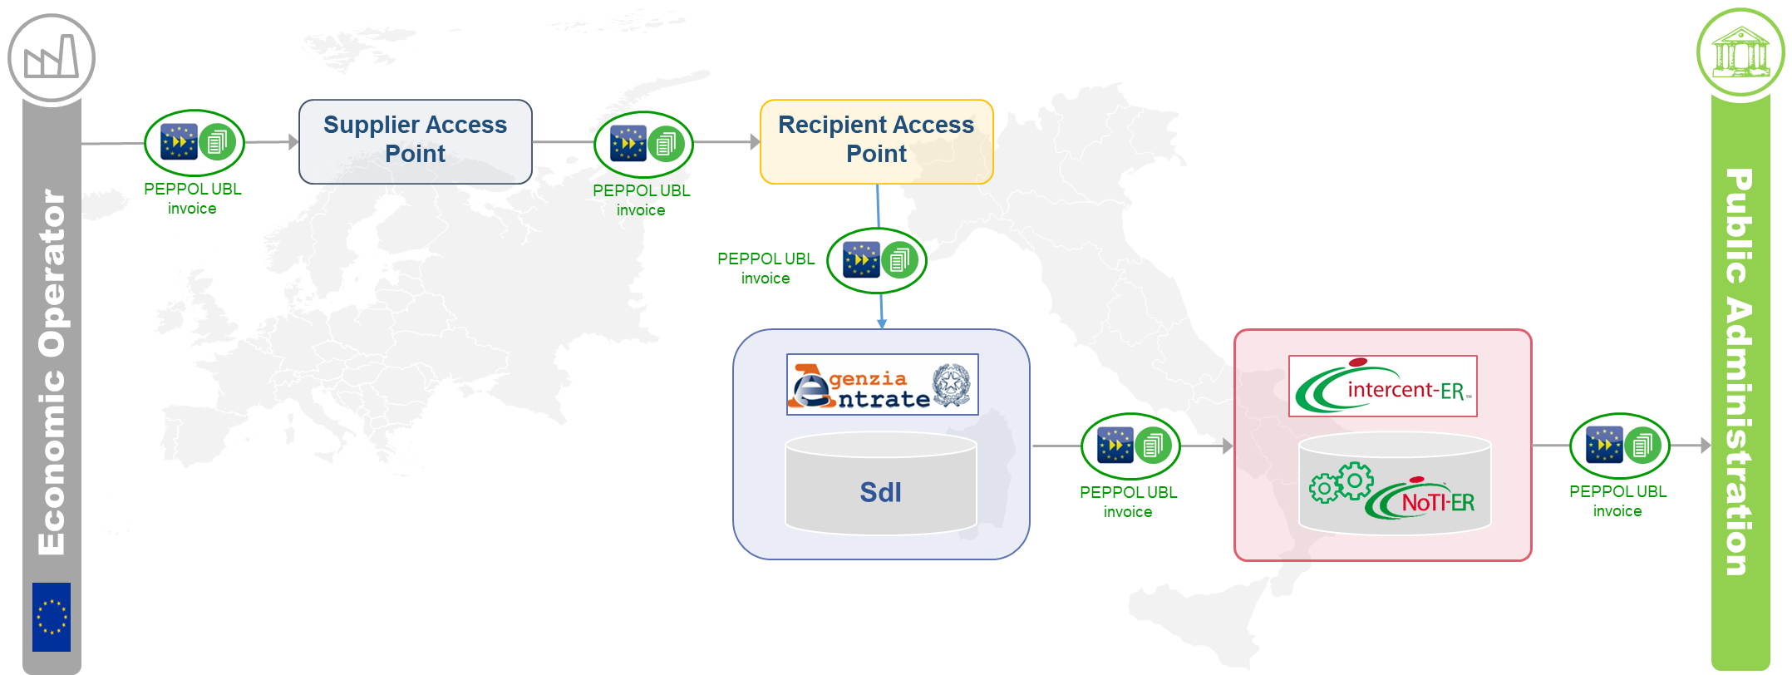

Figure 2 - Proposed solution

The 4-corner PEPPOL e-delivery with dynamic lookup model is used, so the receiving Public Administration needs to be registered via CEF SML; this requires every Public Administration to choose his own inbound Access Point; a particular effort is requested to the third corner (receiving Access Point): in addition to being a Peppol Certified Access Point, the entity identified in this role must be able to an SdI compliant intermediary. Any OpenPEPPOL Access Point Service Providers can certify themselves as a *SdI compliant intermediary* and every Public Administration will choose one of the *SdI compliant intermediaries* as their inbound channel for BIS3 invoices. The detailed description of how a Public Administration can choose his own inbound Access Point is described in the SMP/IPA Integration gap analysis.

NoTI-ER is one of those SdI compliant intermediaries, and it’s a Peppol Ceritified Access Point.

A cross-border Economic Operator will be able to send an Invoice/Credit Note, in Peppol BIS3 format, through its own Access Point, which in turn retrieves the information about the receiving Access Point via Peppol Dynamic Discovery and then will forward the document to it. The receiving Access Point, will then send the Invoice to the SdI. SdI receives the file in PEPPOL BIS3 format converting it into FatturaPA format and, if the checks are successful, it will send the Invoice to the recipient or his intermediary through SdI’s traditional channels. In the case of the Emilia-Romagna, NoTI-ER wil be the elected intermediary for all inbound invoices. The file issued by SdI is an Invoice in FatturaPA format including the original BIS3 as an attachment. After receiving the document, NoTIER will perform a conversion from FatturaPA to PEPPOL Bis2.1 format, to make the object available to the receiving Public Administration.   
According to this methodology, a double conversion will take place, and this is recognized as a possible risk. As soon as Emilia-Romagnas’s clients will be able to manage an invoice in PEPPOL BIS3 format, NoTIER will just extract the attached BIS3 original invoice from the FatturaPA document, and forward it to the receiving Public Administration.

* + 1. Notifications in a European scenario

In the above scenario, the receiving side is connected directly to the SdI via his own intermediary, so all the notifications the SdI will send to the receiving side will be delivered in the same way as the AS-IS scenario. On the sending side, though, being that the communication will happen over the Peppol network, to allow the sender to receive updates on the status of the invoice a conversion from FatturaPA notifications to an Invoice Response Peppol BIS3 document will be needed. The conversion will be carried out by the “receiving access point” (actually, the sending one for the notification process) Details on how the conversion will happen are described in the document “Message response gap analysis“.

1. Outbound scenario for NoTIER

In this section the Outbound process is going to be examined, where the documentation reaches SdI from NoTIER. The processes described in this paragraph are Government to Government (G2G), Government to Business (G2B) and Business to Government (B2G).

* 1. Current situation – G2G and G2B

Essentially, the current Outbound scenario can be outlined as follows in Figure 3

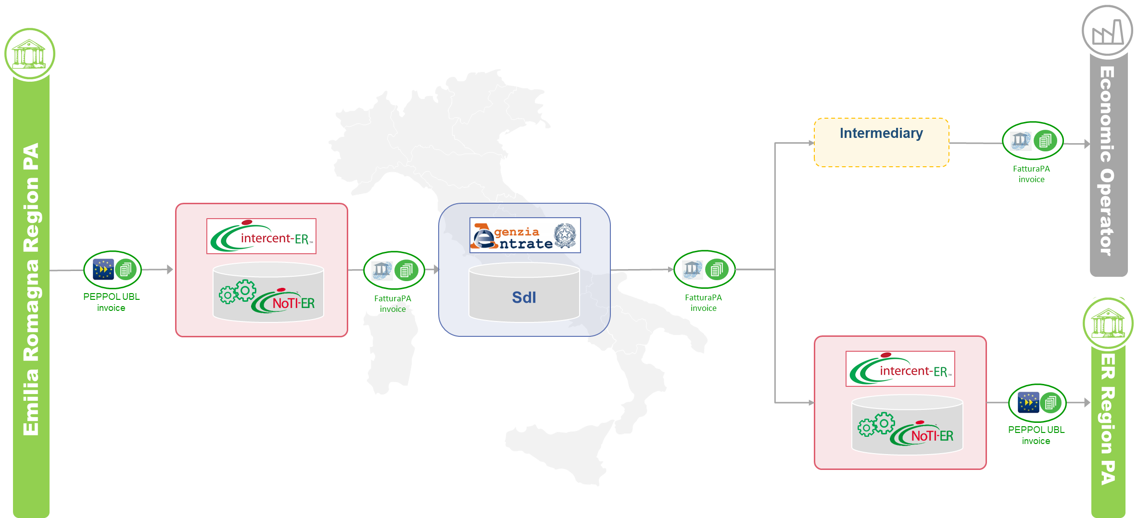

Figure 3 – Current situation G2G and G2B

When a Public Administration from the Emilia-Romagna Region issues an Invoice/Credit Note, it sends it to NoTIER in Bis2.1 format. NoTIER validates its content syntactically and semantically, converts it into FatturaPA format, signs it and sends it to SdI, which carries out the necessary checks and, having accepted the document, forwards it to the Economic Operator directly or through an intermediary. In the specific case in which the document travels from Public Administration to another Public Administration inside the Emilia-Romagna Region(G2G process), SdI sends the Invoice/Credit Note to the receiving Public Administration through NoTIER, which acts as an intermediary.

In the current situation, there is not an outbound scenario in which NoTIER acts on behalf of the Economic Operators, being a system at the service of the Emilia-Romagna Public Administrations.

* 1. Proposed solution – B2G and the integration with SATER

The main topic of this chapter is the integration of SATER in the process of issuing Invoice/Credit Note on behalf of Italian Economic Operators, thus making it possible to configure a new B2G process.   
The Outbound scenario will implemented as shown in Figure 4 , considering the new constraints.

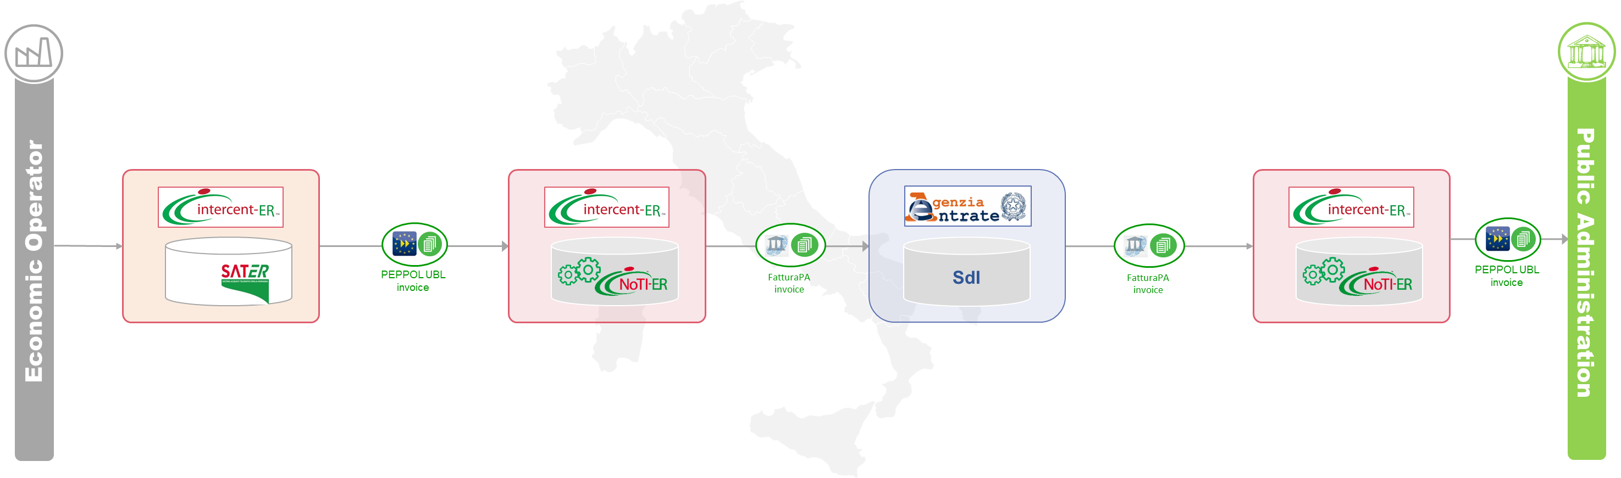

Figure 4 - B2G and the integration with SATER

In this configuration, SATER plays an essential role, as it acts as an interface for the Italian Economic Operator, allowing it to issue an Invoice/Credit note.   
SATER is in close contact with NoTIER, which is the first receiver of the documentation sent in PEPPOL BIS3 format. Once NoTIER has received the document, two scenarios are opened:

* the recipient is cross-border;
* the recipient is italian.

In the first case, NoTIER acts as an issuing Access Point in the PEPPOL 4-corner model and sends the document according to European standards, in BIS3 format.   
In the second case, NoTIER can directly interact with SdI, as already described in the previous paragraph.