|  |
| --- |
|  |



European eInvoicing Standard in Italy

|  |  |
| --- | --- |
| **Project number** | INEA/CEF/ICT/A2017/1560867 2017-IT-IA-0150 |
| **Project acronym** | EeISI |
| **Project title** | European eInvoicing Standard in Italy |
| **Starting date** | 1 May 2018 |
| **Ending date** | 31 December 2019 |
| **Programme** | Connecting Europe Facility (CEF) CEF-TC-2017-3: eInvoicing |

System gap analysis for IPA/SMP

Deliverable D2.6

|  |  |
| --- | --- |
| **Related WP** | WP2 – Analysis – Task 2.6 System gap analysis for IPA/SMP |
| **Deliverable number** | D2.12 |
| **Due date** | 31/12/2019 |
| **Revision date** | 31/12/2019 |
| **Actual date** | 31/12/2019 |

This Page Intentionally Left Blank

Deliverable Info

|  |  |
| --- | --- |
| **Editor (s)** | **Intercent-ER** |
| **Contributors** |  |
|  |  |
|  |  |
| **Acknowledgement** | This work was partially supported by the European Commission (EC) through the Connecting Europe Facility (CEF) programme under project EeISI.(grant agreement no. INEA/CEF/ICT/A2017/1560867 2017-IT-IA-0150) |
| **Disclaimer** | The sole responsibility of this publication lies with the author(s). The European Union is not responsible for any use that may be made of the information contained therein. |
| **Confidentiality** | The information in this document is confidential and restricted only to the members of the EeISI consortium  (including the Commission Services). |
|  |  |
| **Note** | - |
|  |  |

**Version Control**

|  |  |  |  |
| --- | --- | --- | --- |
| Version | Date | Author | Description of change |
| 0.1 | 31/12/2019 | Intercent-ER |  |
| 0.1.1 | 31/03/2020 | Roberto Reale | Technical review and quality assessment |
|  |  |  |  |
|  |  |  |  |
|  |  |  |  |

This Page Intentionally Left Blank

Table of contents

Deliverable Info 3

Table of contents 5

Executive Summary 7

Glossary 7

1. Introduction 8

2. Current Solution 8

3. To-Be Solution 8

3.1 Registration of certified Access Points 9

3.2 Access Points Selection 9

3.3 Sharing selections with the Centralized SMP 9

This Page Intentionally Left Blank

Executive Summary

This document aims to describe the system gap analysis for IPA/SMP carried out by Intercent-ER within EeISI project. The analysis mainly interests:

* Current solution
* Solution have to be about the implementation of web application

Glossary

|  |  |
| --- | --- |
| **B2B** | Business to Business |
| **B2C** | Business to Consumer/Citizen |
| **B2G** | Business to Government |
| **BII** | Business Interoperability Interfaces |
| **C2G** | Citizen to Government |
| **CCTS** | Core Component Technical Specification |
| **CEF** | Connecting Europe Facility |
| **CEM** | Certified Electronic Mail – Legal Mail (PEC Posta Elettronica Certificata in Italy) |
| **CEN** | European Committee for Standardisation |
| **CII** | Cross Industry electronic Invoice |
| **CIUS** | Core Invoice Usage Specification |
| **DSI** | Digital Service Infrastructures |
| **EDIFACT** | Electronic Data Interchange For Administration, Commerce and Transport |
| **EMSFEI** | European Multi-Stakeholder Forum on eInvoicing |
| **e-SENS** | Electronic Simple European Networked Services |
| **FatturaPA** | Public administration electronic invoice framework (FatturaPubblica Amministrazione) |
| **G2G** | Government to Government |
| **INEA** | Innovation and Networks Executive Agency |
| **OASIS** | Organization for the Advancement of Structured Information Standards |
| **PEPPOL** | Pan-European Public Procurement Online |
| **PEPPOL-BIS** | Pan-European Public Procurement Online Business Interoperability Specifications |
| **SDI** | Electronic exchange system in Italy (Sistema Di Interscambio) |
| **UBL** | Universal Business Language |
| **UN/CEFACT** | United Nations Centre for Trade Facilitation and Electronic Business |
| **UNTDID** | UN Trade Data Interchange Directory |
| **URI** | Uniform Resource Identifier |
| **URL** | Uniform Resource Location |
| **URN** | Uniform Resource Name |
| **XML** | Extensible Mark-up Language |

1. Introduction

This document provides a description of the functional specifications relating to the implementation of the integration between iPA and Centralized SMP, into developing new e-delivery architecture.

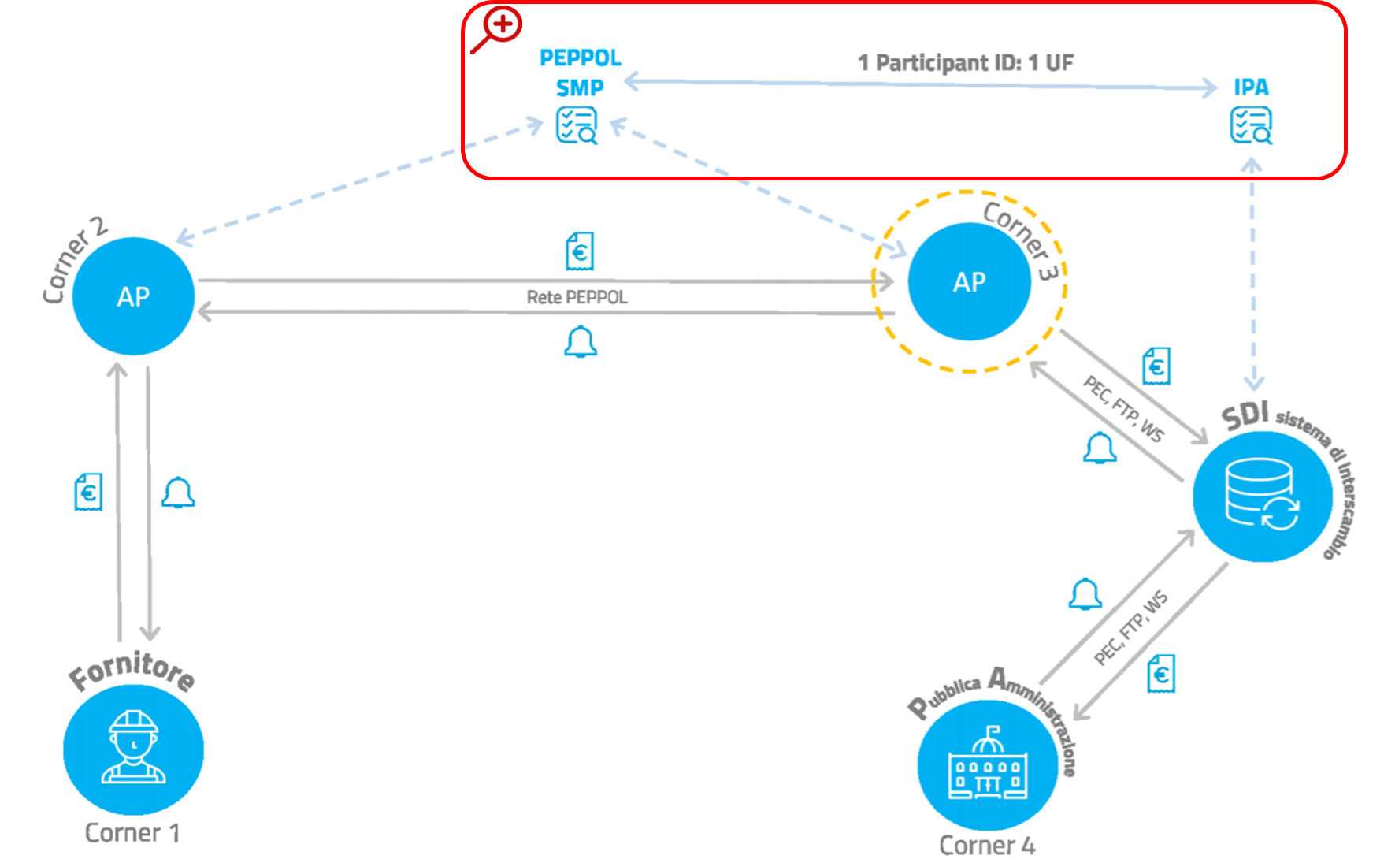

Figure 1 – Focus on iPA/SMP integration

The purpose is describe the AP Providers Management, a web application function, utilized by Administrator User to search, create, edit and delete Certified Access Point Providers enabled as intermediary issuer.

In the following, the main activities to be carry out:

* current solution description;
* to be solution description.

# 2. Current Solution

Currently, IPA and SMP are separate solutions with no kind of communication involved between the two; more specifically, there is no national SMP for italian Public Administrations as the only PAs that are as of now using Peppol delivery network are the ones in the Emilia-Romagna Region.

The SMP on which the Emilia-Romagna Region Public Administrations are registered is managed by Intercent-ER.

IPA, on the other hand, is a national registry that publishes information about all Italian PAs, both as a browsable web interface and in the form of web services available to several different systems.

To let all Italian Public Administrations be able to receive documents on the Peppol network (a request that's been raised multiple times by cross-border Economic Operators during the last years), it's crucial to register all of them on an SMP to allow Peppol Dynamic Discovery Process to work, and to let them all choose their own Access Point Provider; as Italian Public Administrations are already accustomed to using the IPA interface to register and publish all the information regarding their own e-Invoicing system and intermediaries, the IPA is the most obvious choice as a mean to publish also the information about the Access Point Provider they'll be using to receive documents via the Peppol network



# 3. To-Be Solution

The integration process between iPA and SMP involves 3 main phases:

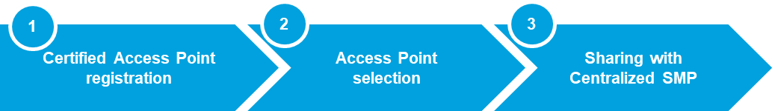

Figure 2 – Integration iPA/SMP phases

## Registration of certified Access Points

To register a certified Access Point as intermediary with the SDI (interchange system) will create a new graphical interface.

The interface implements the functions:

* "Show" to display the list of all registered Access Points;
* "Details" to display a record details;
* "New" to register a new access point;
* "Edit" to edit the information about Access Point registered;
* "Delete" to delete a record.

For each Access Point Provider, it will insert in iPA database following information:

* Id (unique code made up of 4 digits assigned at the end certification procedure);
* Company name;
* Endpoint (Access Point URL);
* Certificate (public section of x509 certificate assigned by OpenPEPPOL);
* Technical Manager (name and email address).

It will also develop a SOAP web service that iPA will invoke as a client to verify the correctness of the information inserted by the Public Administrations (see next section) with respect to what is present in the Access Point Provider database. The service will be developed in analogy with what is currently exposed by the Interchange System for the query by iPA. The request will contain the identifier of an Access Point Provider as the only parameter, and the response will contain the information that attests if the Access Point Provider is an intermediary of the Interchange System.

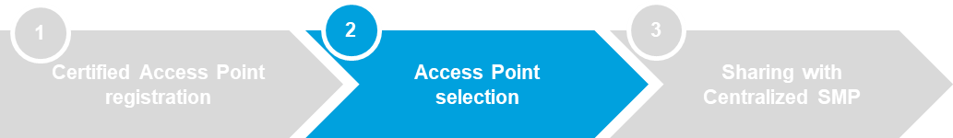

## Access Points Selection

iPA create into invoicing office registration web page a new field to allow to Public Administrations select the identifier of Access Point Provider to be used as "OpenPEPPOL Delivery Intermediary".

The information will be optional, with a maximum cardinality of 1, and it does not need to be published through the services currently displayed by iPA: the field will be visible and editable only by Public Administration users and will have to be exposed for reading exclusively through the new selection sharing service with the Centralized SMP (see next section).

Following information insert by a Public Administration, iPA will query the SOAP service (see previous section) to entered information validate, in a similar way to how it currently interrogates the service exposed by the Interchange system for intermediary verification.



## Sharing selections with the Centralized SMP

iPA, using a REST service, shows the access point selected by the Public Administrations, providing for each invoicing office the following minimum information set:

* office unique code
* id selected Access Point (see previous section)
* company name
* company tax code
* address
* manager information (if available)

It will necessary the upgrade of Centralized SMP software (For), developing a procedure what query iPA service update information with data selected from Public Administration. Every day, Centralized SMP procedure require to iPA all Public Administration selection and then, SMP inserts, deletes or updates on SML and on Peppol Directory the data to align Partecipant Identifier information assigned to Public Administration.