|  |
| --- |
|  |



European eInvoicing Standard in Italy

|  |  |
| --- | --- |
| **Project number** | INEA/CEF/ICT/A2017/1560867 2017-IT-IA-0150 |
| **Project acronym** | EeISI |
| **Project title** | European eInvoicing Standard in Italy |
| **Starting date** | 1 May 2018 |
| **Ending date** | 30 June 2019 |
| **Programme** | Connecting Europe Facility (CEF) CEF-TC-2017-3: eInvoicing |

Systems gap analysis for eInvoice Mapper Framework

Deliverable D2.5

|  |  |
| --- | --- |
| **Related WP** | WP2 – Analysis – Task 2.4 Systems gap analysis |
| **Deliverable number** | D2.5 |
| **Due date** | 31/10/2018 |
| **Revision date** | 31/10/2018 |
| **Actual date** | **31/10/2018** |

This Page Intentionally Left Blank

Deliverable Info

|  |  |
| --- | --- |
| **Editor (s)** | **InfoCert** |
| **Contributors** | **InfoCert** |
|  |  |
| **Abstract** | **This deliverable aims to describe the needed updates of eInvoice Mapper Framework (set up under Action 2015-EU-IA-0050).**  **An additional data entry module will be developed on the basis of the performed analysis which is described in this deliverable.**  **Moreover this document describes how the eInvoice Mapper framework will be integrated into InfoCert system (LegalInvoice)** |
| **Keywords** | **eInvoicing, semantic core model, Italian eInvoicing format, LegalInvoice, data entry module** |
|  |  |
| **Acknowledgement** | This work was partially supported by the European Commission (EC) through the Connecting Europe Facility (CEF) programme under project EeISI.(grant agreement no. INEA/CEF/ICT/A2017/1560867 2017-IT-IA-0150) |
| **Disclaimer** | The sole responsibility of this publication lies with the author(s). The European Union is not responsible for any use that may be made of the information contained therein. |
| **Confidentiality** | The information in this document is confidential and restricted only to the members of the EeISI consortium  (including the Commission Services). |
|  |  |
| **Note** | - |
|  |  |

**Version Control**

|  |  |  |  |
| --- | --- | --- | --- |
| Version | Date | Author | Description of change |
| 0.0.1 | 2018-08-20 | Sara Facchinetti | First draft, TOC, content |
| 0.0.2 | 2018-10-09 | Sara Facchinetti | New mapping rule for UBL MultiplierFactorNumeric. Modificed mapping rules, new mapping rules for truncate mechanism. Distributed to partners for feedback |
| 0.0.3 | 2018-10-11 | Sara Facchinetti | Added new rules |
| 0.0.4 | 2018-10-25 | Sara Facchinetti | Added new rules |
| 0.1.0 | 2018-10-31 | Donatella Montinaro | Added LI hub integration. Distributed to partner according to deadline |
| 0.1.1 | 2020-03-31 | Roberto Reale | Technical review and quality assessment |

This Page Intentionally Left Blank

Table of contents

Deliverable Info 4

Table of contents 7

List of figures 7

List of tables 7

Executive Summary 9

Glossary 11

1. Normative references 12

2. eInvoice Mapper Framework 13

2.1. System description 13

2.2. Identified updates 13

2.2.1. FROM CEN to XMLPA 13

2.2.2. FROM XMLPA to CEN 16

2.2.3. FROM CEN to Peppol BIS 3 CIUS (UBL 2.1) 17

3. Data entry module 28

3.1. Module context and description 28

3.2. High level requirements 29

3.3. Module components 29

3.4. Preliminary frontend design 30

4. InfoCert LegalInvoice integration 33

4.1. LegalInvoice system brief description 33

4.2. Integration requirements 34

List of figures

Figure 1 Semantic-syntax-format 17

Figure 2 Data entry module homepage 31

Figure 3 Example of invoice data collection (Seller category) 32

Figure 4 Example of information frame 33

Figure 5 InfoCert services positioning in the eInvoicing process in Italy 34

Figure 6 InfoCert HUB Integration 35

List of tables

Table 1 VAT category code mapping table 14

Table 2 Data entry module: high level requirements 29

Executive Summary

This document aims to describe the gap analysis carried out by InfoCert within EeISI project. The analysis mainly interests:

1. the changes to be applied to eInvoice Mapper Framework developed in eIGOR project,
2. the gap analysis on the basis of Peppol BIS 3 restrictions for the transformation CEN->PEPPOL BIS 3
3. the concept study and high level requirements of the new data entry module to be offered to economic operators to facilitate the preparation of CEN compliant invoices
4. the integration of eInvoice Mapper Framework in InfoCert services offered to economic operators (LegalInvoice Hub)

This Page Intentionally Left Blank

Glossary

|  |  |
| --- | --- |
| **B2B** | Business to Business |
| **B2C** | Business to Consumer/Citizen |
| **B2G** | Business to Government |
| **BII** | Business Interoperability Interfaces |
| **C2G** | Citizen to Government |
| **CCTS** | Core Component Technical Specification |
| **CEF** | Connecting Europe Facility |
| **CEM** | Certified Electronic Mail – Legal Mail (PEC Posta Elettronica Certificata in Italy) |
| **CEN** | European Committee for Standardisation |
| **CII** | Cross Industry electronic Invoice |
| **CIUS** | Core Invoice Usage Specification |
| **DSI** | Digital Service Infrastructures |
| **EDIFACT** | Electronic Data Interchange For Administration, Commerce and Transport |
| **EMSFEI** | European Multi-Stakeholder Forum on eInvoicing |
| **e-SENS** | Electronic Simple European Networked Services |
| **FatturaPA** | Public administration electronic invoice framework (FatturaPubblica Amministrazione) |
| **G2G** | Government to Government |
| **INEA** | Innovation and Networks Executive Agency |
| **OASIS** | Organization for the Advancement of Structured Information Standards |
| **PEPPOL** | Pan-European Public Procurement Online |
| **PEPPOL-BIS** | Pan-European Public Procurement Online Business Interoperability Specifications |
| **SDI** | Electronic exchange system in Italy (Sistema Di Interscambio) |
| **UBL** | Universal Business Language |
| **UN/CEFACT** | United Nations Centre for Trade Facilitation and Electronic Business |
| **UNTDID** | UN Trade Data Interchange Directory |
| **URI** | Uniform Resource Identifier |
| **URL** | Uniform Resource Location |
| **URN** | Uniform Resource Name |
| **XML** | Extensible Mark-up Language |

1. Normative references

The following documents, in whole or in part, are normatively referenced in this document and are indispensable for its application.

* EN 16931-1:2017 Electronic invoicing - Part 1: Semantic data model of the core elements of an electronic invoice
* CEN/TS 16931-2:2017 Electronic invoicing - Part 2: List of syntaxes that comply with EN 16931-1
* CEN/TS 16931-3-1:2017 Electronic invoicing - Part 3 - 1: Syntax bindings of the core elements of an electronic invoice - Syntax binding methodology
* CEN/TS 16931-3-2:2017 Electronic invoicing - Part 3 - 2: Syntax bindings of the core elements of an electronic invoice - Binding to ISO/IEC 19845 (UBL 2.1)
* CEN/TS 16931-3-3:2017 Electronic invoicing - Part 3 - 3: Syntax bindings of the core elements of an electronic invoice - Binding to UN/CEFACT XML
* CEN/TS 16931-3-4:2017 Electronic invoicing - Part 3 - 4: Syntax bindings of the core elements of an electronic invoice - Binding to ISO/IEC 9735 (UN/EDIFACT)
* ISO 3166 1, Codes for the representation of names of countries and their subdivisions — Part 1: Country codes
* ISO 4217, Codes for the representation of currencies
* ISO 639 2, Codes for the representation of names of languages
* ISO 8601, Data elements and interchange formats — Information interchange — Representation of dates and times
* ISO 15000-5, Electronic Business Extensible Markup Language (ebXML) — Part 5: Core Components Specification (CCS)
* ISO 6523, Information technology — Structure for the identification of organizations and organization parts
* ISO/IEC 19845, Information technology -- Universal business language version 2.1 (UBL v2.1)

Moreover the following Italian documentation is referenced in this deliverable:

* Schema del file xml FatturaPA versione 1.2 - xsd
* Specifiche tecniche del formato della FatturaPA versione 1.2.1- pdf
* Rappresentazione tabellare del tracciato FatturaPA versione 1.2.1- pdf
* Rappresentazione tabellare del tracciato FatturaPA versione 1.2.1- excel
* Foglio di stile per la visualizzazione della FatturaPA versione 1.2.1 - xslt
* generica Foglio di stile per la visualizzazione della Fattura Ordinaria versione 1.2.1 - xslt
* Elenco modifiche al tracciato FatturaPA - pdf
* Suggerimenti per la compilazione della FatturaPA versione 1.5

1. eInvoice Mapper Framework
   1. System description

eInvoice Mapper Framework has been built during eIGOR project. The analysis, design and implementation phases have been documented by eIGOR project deliverables.

* 1. Identified updates

During the analysis carried out within EeISI project some necessary changes have been identified on the eInvoice Mapper Framework developed in eIGOR project. In correlation with T2.1 and T2.2 activities changes have been categorized on the basis of affected parts: syntax, code lists, rules.

* + 1. FROM CEN to XMLPA

Syntax mapping updates

* BT-32 will be now mapped to 1.2.1.2 CodiceFiscale in case of Italian seller
* BT-41 will be now mapped to attachment
* BT-56 will be now mapped to attachment
* BT-20 will be now mapped to attachment

Code lists mapping updates

* VAT category code will be mapped with a correlation between two fields of FatturaPA: RegimeFiscale and Natura according to the following table.



Table 1 VAT category code mapping table

* If BT-3=389 Self billed invoice then 2.1.1.1 TipoDocumento=TD20autofattura (new value inserted 2018)
* BT-81 Payment means type code mapping to 2.4.2.2 ModalitaPagamento revised
* BT-3 Invoice Type code mapping to 2.1.1.1 TipoDocumento revised

Mapping rules updates

* MAPR-IM-23 will not include CodiceFiscale in case of Italian seller
* MAPR-CM-26 will map BT-32 to CodiceFiscale in case of Italian seller
* MAPR-DE-77 will put as default value RegimeFiscale=RF01 for EU seller (foreign and italian) or according to VAT category code and VAT exemption reason code mapping
* MAPR-CM-27 if not corresponding values in ModalitaPagamento list then the default value is MP01
* New mapping rule added for date format. In case UBL contains a date expressed as YYYY-MM-DD time zone only the first 10 chars shall be mapped to xmlpa (MAPR-DA-122)
* New mapping rule added for aligning allowance/charge percentage to MultiplierFactorNumeric in UBL. From ULB to CEN multiply by 100 (MAPR-UBL-123)
* MAPR-II-15 modified in: “BTs will be concatenated into a line of Causale (0..n): "BT-21 Invoice note subject code" & BT-21 value & "BT-22 Invoice note" & BT-22 value. In case longer than 200 create more than one causale”. A split mechanism shall be implemented
* MAPR-TR-124 addded: BT-27 1.2.1.3.1 Denominazione In case longer than 80 chars truncate and save in attachment the source value
* MAPR-TR-125 addded BT-35, BT-36, BT-162 1.2.2.1 Indirizzo In case longer the concatenated BTs are longer than 60 chars (including separator) truncate and save in attachment the source values
* MAPR-TR-126 addded BT-50, BT-51, BT-163 1.4.2.1 Indirizzo In case longer the concatenated BTs are longer than 60 chars (including separator) truncate and save in attachment the source values
* MAPR-TR-127 addded BT-75, BT-76, BT-165 2.1.9.12.1 Indirizzo In case longer the concatenated BTs are longer than 60 chars (including separator) truncate and save in attachment the source values
* MAPR-TR-128 addded: BT-44 1.4.1.3.1 Denominazione In case longer than 80 chars truncate and save in attachment the source value
* MAPR-TR-129 addded: BT-59 2.4.2.1 Beneficiario In case longer than 200 chars truncate and save in attachment the source value
* MAPR-TR-130 addded: BT-62 1.4.1.3.1 Denominazione In case longer than 80 chars truncate and save in attachment the source value
* MAPR-TR-131 added: BT-83 2.4.2.21 CodicePagamento In case longer than 60 chars truncate and save in attachment the source value
* MAPR-TR-132 added: BT-85 2.4.2.1 Beneficiario In case longer than 200 chars truncate and save in attachment the source value
* MAPR-TR-133 added: BT-97, BT-98 2.2.1.4 Descrizione In case longer than 1000 chars truncate and save in attachment the source value
* MAPR-TR-134 added: BT-104, BT-105 2.2.1.4 Descrizione In case longer than 1000 chars truncate and save in attachment the source value
* MAPR-TR-135 added: BT-120 2.2.2.8 RiferimentoNormativo In case longer than 100 chars truncate and save in attachment the source value
* MAPR-TR-136 added: BT-153, BT-154 2.2.1.4 Descrizione In case longer than 1000 chars truncate and save in attachment the source value
* MAPR-TR-137 added: BT-161 2.2.1.16.1 RiferimentoTesto In case longer than 60 chars truncate and save in attachment the source value
* MAPR-TR-138 added: BT-42 1.2.5.1 Telefono In case longer than 12 chars truncate and save in attachment the source value. In case shorter than 5 do not map and save in attachment the source value
* MAPR-TR-139 added: BT-43 1.2.5.3 Email In case longer than 256 chars truncate and save in attachment the source value. In case shorter than 7 do not map and save in attachment the source value
* MAPR-II-19, MAPR-II-20, MAPR-II-21 rules deleted as the BT-41, BT-56 and BT-20 will be saved in attachment
* MAPR-NM-70 rule modified: added BT-41, BT-56 and BT-20
* MAPR-TR-140 added: BT-122, BT-125-2 2.5.1 NomeAttachment In case longer than 60 chars truncate and save in attachment the source value
* MAPR-TR-141 added: BT-123, BT-125-2 2.5.4 DescrizioneAttachment In case longer than 100 chars truncate and save in attachment the source value
* MAPR-TR-142 added: BT-127 2.2.1.16.2 RiferimentoTesto In case longer than 60 chars truncate and save in attachment the source value
* MAPR-TR-143 added: BT-130, BT-149, BT-150 2.2.1.6 UnitaMisura In case longer than 10 chars truncate and save in attachment the source value
* MAPR-TR-144 added: BT-139 2.2.1.4 Descrizione In case longer than 1000 chars truncate and save in attachment the source value
* MAPR-TR-145 added: BT-144 2.2.1.4 Descrizione In case longer than 1000 chars truncate and save in attachment the source value
* MAPR-TR-146 added: BT-160 2.2.1.16.1 TipoDato In case longer than 10 chars truncate and save in attachment the source value
* MAPR-DE-147 added: BT-128, BT-128-1 2.2.1.3.1 CodiceTipo 2.2.1.3.2 CodiceValore In case BT-128 and BT-128-1 are not both present insert the ZZZ value in CodiceTipo or CodiceValore

With relation to the usage of EU invoice format (UBL and CII) for domestic invoices an analysis will be carried out by project partners and final decisions will be taken by AdE with regard to what is possible to represent in EU format and what needs to be represented only in FatturaPA format.

* + 1. FROM XMLPA to CEN

Syntax mapping updates

* 1.2.1.2 CodiceFiscale mapped to BT-32
* 1.2.1.8 RegimeFiscale not mapped to a specific BT but mapped together with Natura to a specific VAT category code

Code lists mapping updates

* RegimeFiscale and Natura will be mapped to VAT category code according to the above reported VAT category code mapping table.
* If 2.1.1.1 TipoDocumento=TD20autofattura (new value inserted 2018) then BT-3=389 Self billed invoice
* 2.4.2.2 ModalitaPagamento mapping to BT-81 revised

Mapping rules updates

* MR29 1.2.1.2 CodiceFiscale mapped to BT-32
* MR30 deleted (1.2.1.8 RegimeFiscale will not anymore mapped to BT-32)
* New mapping rule added for aligning allowance/charge percentage to MultiplierFactorNumeric in UBL. From CEN to UBL divide by 100 (MR-68)
  + 1. FROM CEN to Peppol BIS 3 CIUS (UBL 2.1)

A specific analysis is carried out concerning the updates needed to translate a CEN invoice (coming from UBL 2.1 or CII or XMLPA) into the Peppol BIS 3 CIUS (version at October 2018).

In eIGOR the mapping has been carried out towards the two syntaxes UBL 2.1 and CII as indicated by the 16931-2. At that time the Peppol format was not compliant to the EN 16931. In March 2018 a Peppol BIS 3 CIUS has been published in order to provide a CEN compliant format. One of the tasks foreseen in EeISI project is not only translate into a generic invoice UBL or CII but also translate into a specific format such as Peppol BIS 3.

It is important to note the slight differences between the two concepts: syntax and format. The format is the characterization of a syntax. Example: UBL 2.1 is a syntax. Peppol BIS 3 is a format. See picture below.



Figure 1 Semantic-syntax-format

The analysis takes into consideration all restrictions listed in Peppol BIS 3 CIUS and all the mapping solutions and restrictions identified in the Italian context for XMLPA format. This means that restrictions imposed by Italian CIUS and Peppol CIUS should be both respected in this scenario.

Restrictions imposed by Peppol BIS 3 CIUS Rel 3.0.1

In the following table all restrictions imposed by Peppol BIS 3 are listed.

|  |  |  |  |
| --- | --- | --- | --- |
| BT-ID | Business Term | Description | Rule |
| **BT-3** | **Invoice type code** | Allowed set of values can be found in [Invoice Type Code](http://docs.peppol.eu/poacc/billing/3.0/bis/#_invoice_type_code) | PEPPOL-EN16931-P0100, PEPPOL-EN16931-P0101 |
| BT-2 , BT-7 , BT-9 , BT-26, BT-72, BT-73, BT-74, BT-134, BT-135 | **All date elements** | A date shall be formatted YYYY-MM-DD | PEPPOL-EN16931-F001 |
| BT-6 | **VAT accounting currency code** | VAT accounting currency code shall be different from invoice currency code when provided. | PEPPOL-EN16931-R005 |
| BT-10, BT-13 | **Buyer reference or Purchase order** | A buyer reference or purchase order reference shall be provided. | PEPPOL-EN16931-R003 |
| BG-1 | **Invoice note** | Change cardinality from 0..n to 0..1 | PEPPOL-EN16931-R002 |
| BT-21 | **Invoice note subject code** | Changing cardinality 0..1 to 0..0 | Not applicable |
| BT-23 | **Business process type** | Changing cardinality 0..1 to 1..1 | PEPPOL-EN16931-R001 |
| BT-24 | **Specification identifier** | Specification identifier shall have the value 'urn:cen.eu:en16931:2017#compliant# urn:fdc:peppol.eu:2017:poacc:billing:3.0'. (Remove spaces before use of value) | PEPPOL-EN16931-R004 |
| BT-34 | **Seller electronic address** | Seller electronic address shall be provided | PEPPOL-EN16931-R020 |
| BT-49 | **Buyer electronic address** | Buyer electronic address shall be provided | PEPPOL-EN16931-R010 |
| BG-19 | **Payment card information** | Mandate reference shall be provided for direct debit. | PEPPOL-EN16931-R061 |
| BT-93, BT-100, BT-137, BT-142 | **Allowance/charge base amount** | Allowance/charge base amount shall be provided when allowance/charge percentage is provided. | PEPPOL-EN16931-R041 |
| BT-94, BT-101, BT-138, BT-143 | **Allowance/charge percentage** | Allowance/charge percentage shall be provided when allowance/charge base amount is provided. | PEPPOL-EN16931-R042 |
| BT-94, BT-101, BT-138, BT-143 | **Allowance/charge amount** | If base amount and percentage exists in the instance, then Allowance/charge amount=Allowance/charge amount= base amount×(percentage÷100)base amount×(percentage÷100) | PEPPOL-EN16931-R040 |
| BT-98, BT-140 | **Allowance reason code** | Reason code shall be according to subset of UNCL 5189 D.16B. | PEPPOL-EN16931-CL002 |
| BT-111 | **Invoice total VAT amount** | Only one tax total without tax subtotals shall be provided when tax currency code is provided. | PEPPOL-EN16931-R054 |
| BT-111 | **Invoice total VAT amount in accounting currency** | The currencyID for invoice total VAT in accounting currency, shall be the same as VAT accounting currency code (BT-6). | PEPPOL-EN16931-R052 |
| BG-23 | **VAT breakdown** | Only one tax total with tax subtotals shall be provided | PEPPOL-EN16931-R053 |
| BT-131 | **Invoice line net amount** | Calculation shall equal (Invoiced quantity×(Item net price÷item price base amount))(Invoiced quantity×(Item net price÷item price base amount)) +Invoice line charge amount+Invoice line charge amount −Invoice line allowance amount-Invoice line allowance amount | PEPPOL-EN16931-R120 |
| BT-134 | **Invoice line period start date** | Start date of line period shall be within invoice period. | PEPPOL-EN16931-R110 |
| BT-135 | **Invoice line period end date** | End date of line period shall be within invoice period. | PEPPOL-EN16931-R111 |
| BT-146 | **Item net price** | Item net price shall equal (Gross price - Allowance amount) when gross price is provided. | PEPPOL-EN16931-R046 |
| BT-149 | **Item price base quantity** | Base quantity shall be a positive number above zero. | PEPPOL-EN16931-R121 |
| BT-150 | **Item price base quantity unit of measure** | Unit code of price base quantity shall be same as invoiced quantity. | PEPPOL-EN16931-R130 |
| Not applicable | **All currencyID attributes** | All currencyID attributes shall have the same value as the invoice currency code (BT-5), except for the invoice total VAT amount in accounting currency (BT-111) | PEPPOL-EN16931-R051 |

1. **PEPPOL-EN16931-P0100, PEPPOL-EN16931-P0101 (BT-3) - Business processes**

*EN 16931-1:2017* core invoice model should support the following types of business processes:

— P1: Invoicing of deliveries of goods and services against purchase orders, based on a contract;

— P2: Invoicing deliveries of goods and services based on a contract;

— P3: Invoicing the delivery of an incidental purchase order;

— P4: Pre-payment;

— P5: Spot payment;

— P6: Payment in advance of delivery;

— P7: Invoices with references to a despatch advice;

— P8: Invoices with references to a despatch advice and a receiving advice;

— P9: Credit notes or invoices with negative amounts, issued for a variety of reasons including the return of empty packaging;

— P10: Corrective invoicing (cancellation/correction of an invoice);

— P11: Partial and final invoicing;

— P12: Self billing.

*Peppol BIS 3* includes the following types of business processes: P1, P2, P3, P4, P5, P6, P7P8, P9. It excludes P10, P11 and P12. Because of the following reasons:

* P10 - Corrective invoicing. The process as described for corrective invoicing was seen as unclear as to the differentiating between a corrective invoice and a credit note, and this process was set to be out of scope.
* P11 - Partial and final invoicing. Due to the fact that partial and final invoices does not require all information that is mandated, this process is out of scope for this PEPPOL BIS.
* P12 - Self billing. Directive 2006/112/EC (Article 224) requires a specific process to be observed, involving prior agreement and a procedure where the supplier is to accept each invoice. Self-billing requires a specific set-up due to the requirements for prior agreement and procedure for the acceptance of each self-bill. Specific milestones have to be observed at time of setting it up as well as in the operation of self-billing.

*Fattura PA* includes all the EN 16931-1 business processes.

| EN 16931 | Peppol BIS 3 CIUS | Italian CIUS |
| --- | --- | --- |
| P1, P2, P3, P4, P5, P6, P7, P8, P9, P10, P11, P12 | **P1,P2, P3, P4, P5, P6, P7, P8, P9** | **P1, P2, P3, P4, P5, P6, P7, P8, P9, P10, P11, P12** |
| 80 81 82 83 84 130 202 203 204 211 261 262 295 296 308 325 326 380 381 383 384 385 386 387 388 389 390 393 394 395 396 420 456 457 458 527 532 575 623 633 751 780 935 | **Invoice:**  380 383 386 393 82 80 84 395 575 623 780  **CreditNote**  381 396 81 83 532 | No restrictions |

**Mapping solution**

Values included into CEN schematron but not in Peppol CIUS will be mapped according to the following rule:

* From UBL invoice: 130->380,202 ->380, 203->380, 204->380, 211->380, 261->380,295->380, 325->380, 326->380, 384->380, 385->380, 387->380, 388->380,389->380,390->380, 394->380, 395->380, 456->380, 457->380, 527->380, 633->380, 751->380, 935->380;
* From UBL credit note: 262->381, 296->381, 308->381, 420->381, 458->381
* From CII invoice: merge the two solutions from UBL
* From XMLPA the only difference is for self billed invoice which in B2B FatturaPR is mapped to TD20, thus BT-3=389 in UBL and BT=380 in Peppol BIS 3.

Remarks:

* The CEN schematron does not check if the BT-3 corresponds to the correct “invoice” or “credit note” profile. Example InvoiceTypeCode=381 -> it should be linked to a ubl credit note profile instead of an invoice profile.
* The CEN schematron of BR-CL-01 is fatal in UBL and warning in CII
* An issue was open (<https://github.com/CenPC434/validation/issues/78> )
* The Peppol schematron checks if the correct values of BT-3 are associated to invoice or credit note.

1. **PEPPOL-EN16931-F001 (BT-2 , BT-7 , BT-9 , BT-26, BT-72, BT-73, BT-74, BT-134, BT-135) - Date format**

*EN 16931-1:2017*

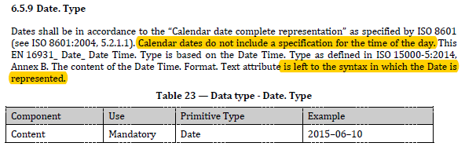

*Peppol BIS 3*: a date shall be formatted YYYY-MM-DD

*Fattura PA* includes dates in format YYYY-MM-DD

**Mapping solution**

* From UBL: keep the first 10 chars
* From CII invoice: transform to YYYY-MM-DD (already implemented)
* From XMLPA: no problem.

Remarks:

* From ubl to XMLPA see issue with CEN <https://github.com/CenPC434/validation/issues/75>. The date format is already checked through the ubl xsd (can be YYYY-MM-DD or YYYY-MM-DD timezone). In case of date with timezone it is necessary to keep the first 10 chars as date (a mapping rule has been added)

1. **PEPPOL-EN16931-R005 (BT-6) – TaxCurrency**

*EN 16931-1:2017* gives the opportunity to insert a TaxCurrency in BT-6 and only imposes that in this case BT-111 is present

*Peppol BIS 3* adds a restriction that BT-6 is only inserted if different by BT-5 (DocumentCurrency)

*Fattura PA* does not include TaxCurrency

**Mapping solution**

* From CEN: if BT-6=BT-5 only map BT-5

1. **PEPPOL-EN16931-R003 (BT-10, BT-13) – Buyer reference or Purchase order**

*EN 16931-1:2017:* optional fields

*Peppol BIS 3* : one of the two is mandatory

*Fattura PA* *:* optional field

2.1.2.2 FatturaElettronicaBody/DatiGenerali/DatiOrdineAcquisto/IdDocumento only for BT-13

**Mapping solution**

* From CEN: if BT-10 and BT-13 not present then map value BT-10=“NA”

1. **PEPPOL-EN16931-R002 (BG-1, BT-21) – Invoice note**

*EN 16931-1:2017:* 0..n composed by BT-21 and BT-22

*Peppol BIS 3* : 0..1

*Fattura PA* *:* 0..n

**Mapping solution**

* From CEN: concat all BT-21 and BT-22 into one string with “-“ as separator code

1. **PEPPOL-EN16931-R001 (BT-23) – Business process type**

*EN 16931-1:2017:* 0..1

*Peppol BIS 3* : 1..1 and imposes a value

*Fattura PA* *:* not present

**Mapping solution**

* From CEN: if not present or different set BT-23=” urn:fdc:peppol.eu:2017:poacc:billing:01:1.0”

1. **PEPPOL-EN16931-R004 (BT-24) – Specification identifier**

*EN 16931-1:2017:* 1..1 and generically indicated as “urn:cen.eu:en16931:2017”

*Peppol BIS 3* : 1..1 and imposes a value

*Fattura PA* *:* not present

**Mapping solution**

* From CEN: if not present or different set

BT-24=” urn:cen.eu:en16931:2017#compliant#urn:fdc:peppol.eu:2017:poacc:billing:3.0”

Remarks

* Trim on the string
* In case there is indication that is compliant to Italian CIUS the value should be indicated? urn:cen.eu:en16931:2017#compliant#urn:fatturapa.gov.it:CIUS-IT:1.0.0 -> to be further discussed

1. **PEPPOL-EN16931-R020 (BT-34) – Seller electronic address**

*EN 16931-1:2017:* 0..1, scheme mandatory

*Peppol BIS 3* : 1..1 Use PEPPOL Policy for identifiers because the CEF list is not yet available. The rule only checks that BT-34 is present.

*Fattura PA* *:* not present

**Mapping solution**

* From CEN: if not present BT-34=”NA”, BT-34-1=”0000” schemeID

Remarks

* The CEF list for this BT scheme is not yet defined
* To be verified if the schemeID can be “0000”

1. **PEPPOL-EN16931-R010 (BT-49) – Buyer electronic address**

*EN 16931-1:2017:* 0..1, scheme mandatory

*Peppol BIS 3* : 1..1 Use PEPPOL Policy for identifiers because the CEF list is not yet available. The rule only checks that BT-34 is present.

*Fattura PA* *:* 1..1mapped to IT:IPA or IT:PEC or IT:CODDEST

**Mapping solution**

* From UBL/CII: if not present BT-49=”NA”, BT-49-1=”0000” schemeID
* From XMLPA: “IT:IPA” ->BT-49-1=”9921” (only for B2G) in case of B2B the value will be “IT:PEC” or “IT:CODDEST”

Remarks

* The CEF list for this BT scheme is not yet defined
* To be verified if the schemeID can be “0000” in case is not a Peppol identifier because this endpoint is used also in the envelop? Further discuss
* To be verified from XMLPA what to do in case of B2B (PEC and CODDEST)

1. **PEPPOL-EN16931-R061 (BG-19) – Direct Debit**

*EN 16931-1:2017:* BG-19 0..1, BT-89 0..1

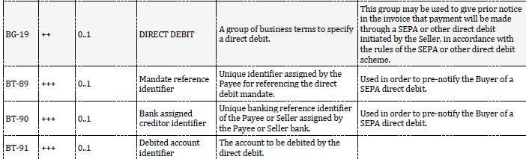

*Peppol BIS 3* : BT-89 1..1 Mandate reference shall be provided for direct debit.

*Fattura PA* *:* not present

**Mapping solution**

* From CEN: In case BG-19 is present and BT-89 empty then BT-89=”NA”

Remarks

* To be further investigated in XMLPA mapping if with card payment or SDD it could be possible to map further info.

1. **PEPPOL-EN16931-R041 (BT-93, BT-100, BT-137, BT-142) – Allowance/charge base amount, PEPPOL-EN16931-R042 (BT-94, BT-101, BT-138, BT-143) – Allowance/charge percentage,**

*EN 16931-1:2017:* no checks, only suggestion

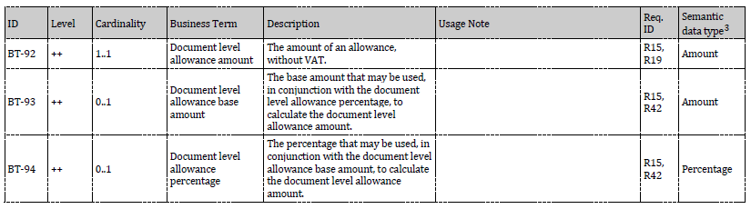

*Peppol BIS 3*: checks “Allowance/charge base amount shall be provided when allowance/charge percentage is provided” and “Allowance/charge percentage shall be provided when allowance/charge base amount is provided”

*Fattura PA* *:* doc allowance/charge can have the amount and the percentage (the base amount is always the 2.1.1.9 ImportoTotaleDocumento)

Line allowance/charge can have the amount and the percentage (the base amount is 2.2.1.9 PrezzoUnitario; in case more than one allowance/charge are in cascade the base amount is the 2.2.1.9 -+ previous line allowances/charges

**Mapping solution**

* From CEN: if percentage or base amount not present then calculate the missing value from the amount **otherwise** delete the existing value (percentage or base amount)
* From XMLPA: doc allowance/charge if 2.1.1.8.2 percentage is present then baseamount=2.1.1.9

Line allowance/charge if 2.2.1.10.2 percentage is present then baseamount=2.2.1.9 -+ previous line allowances/charges in cascade **otherwise** delete the percentage as the amount has already been calculated during the mapping

Remarks

* Requires further discussion. Is this rule really needed in Peppol?

1. **PEPPOL-EN16931-R040 (BT-92, BT-99, BT-136, BT-141) Allowance/charge amount**

*EN 16931-1:2017:* no checks are performed on calculation, only amount is considered if are both present (percentage and base amount are informative, the amount is mandatory; in case the results differs the reference is the amount

*Peppol BIS 3*: checks the calculation “If base amount and percentage exists in the instance, then Allowance/charge amount=Allowance/charge amount=base amount×(percentage÷100)base amount×(percentage÷100) “

*Fattura PA:* if percentage and amount are both present there is no checks on calculation but the amount is considered (a check is performed on the totals -> using percentage instead of amount could provide rounding problems). Suggestions are provided

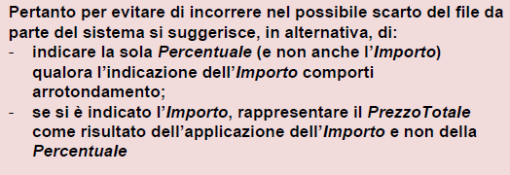

**Mapping solution**

* From CEN: if percentage and base amount are present performs calculation, if the result differs from the amount delete percentage and base amount. **Otherwise**, without performing calculation delete percentage and base amount
* From XMLPA: the Bollo mapping is ok because percentage is 0

The Ritenuta d’acconto mapping is not ok because the amount does not correspond to percentage*base amount. In this case if BT-104 starts with “Ritenuta” then the BT-101 has to be set to 0 **otherwise** do not express Ritenuta d’acconto as doc charge but only consider it in BT-113 = 2.1.1.5.2 ImportoRitenuta and BT-20 concatenate the text "BT-113 represents Withholding tax amount“

Remarks

* Perform tests for rounding problem (amount has two fraction digits)

1. **PEPPOL-EN16931-CL002 (BT-98, BT-140) – Allowance reason code**

*EN 16931-1:2017:* all values of the list are considered

*Peppol BIS 3* : only few values of the list are considered (41 42 60 62 63 64 65 66 67 68 70 71 88 95 100 102 103 104 105)

*Fattura PA* *:* allowance reason code is automatically set to 95

**Mapping solution**

* From UBL/CII: if values are not within the Peppol restricted list automatically set to 95
* From XMLPA: no problem

Remarks

* The CEN schematron considers “ZZZ” which is not part of the list
* The CEN CII schematron does not use the proper list (see issue <https://github.com/CenPC434/validation/issues/68> )

1. **PEPPOL-EN16931-R054 (BT-110) – Invoice total VAT amount**

*EN 16931-1:2017:* not checking the presence of one TaxTotal when tax currency code is present

*Peppol BIS 3* : Only one tax total without tax subtotals shall be provided when tax currency code is provided

*Fattura PA* *:* no problem as tax currency not indicated

**Mapping solution**

* From CEN: it already works

Remarks

* The Peppol rule is probably useless

1. **PEPPOL-EN16931-R054 (BT-111) – Invoice total VAT amount in tax currency**

*EN 16931-1:2017:* BR-53 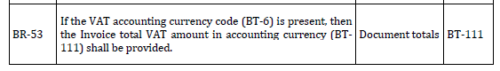

*Peppol BIS 3* : Only one tax total without tax subtotals shall be provided when tax currency code is provided

*Fattura PA* *:* no problem as tax currency is not indicated

**Mapping solution**

* From CEN: it already works because if subtotals are added to taxtotal with currency=BT-6 then errors in calculation of VAT breakdown are generated in cascade

Remarks

* The Peppol rule is useless

1. **PEPPOL-EN16931-R053 (BG-23) – VAT breakdwon**

*EN 16931-1:2017:* indirectly checked through calculation rules and taxcategory

*Peppol BIS 3* : Only one tax total with tax subtotals shall be provided

*Fattura PA* *:* no calculation

**Mapping solution**

* From CEN: it already works

Remarks

* The Peppol rule is probably useless (investigate some test cases)

1. **PEPPOL-EN16931-R052 (BT-111) – Invoice total VAT amount in accounting currency**

*EN 16931-1:2017:* BR-53 

*Peppol BIS 3* : The currencyID for invoice total VAT in accounting currency, shall be the same as VAT accounting currency code (BT-6).

*Fattura PA* *:* no problem as tax currency is not indicated

**Mapping solution**

* From CEN: it already works

Remarks

The Peppol rule is probably useless (investigate some test cases)

1. **PEPPOL-EN16931-R120 (BT-131) – Invoice line net amount**

*EN 16931-1:2017:* 

No check on lineextensionamount calculation (item price*quantity+-allowance/charge). Only BT-131 is considered for checks on totals

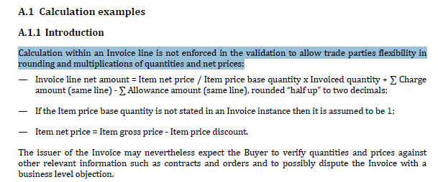

*Peppol BIS 3* : Calculation shall equal (Invoiced quantity×(Item net price÷item price base amount))(Invoiced quantity×(Item net price÷item price base amount))

+Invoice line charge amount+Invoice line charge amount

−Invoice line allowance amount-Invoice line allowance amount

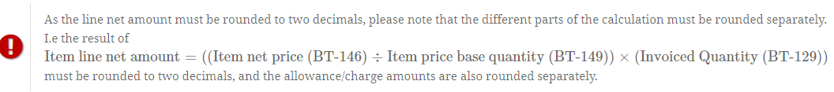

*Fattura PA* *:* checks the invoice line amount

**Mapping solution**

* From UBL/CII: in case BT-131 is not correct, leave as it is but generate the Peppol invoice and the error will be triggered
* From XMLPA: no problem as it is already checked in FatturaPA

Remarks

* Remember that in FatturaPA BT-129 shall be divided by BT-149

1. **PEPPOL-EN16931-R110 (BT-134) – Invoice line period start date and PEPPOL-EN16931-R111 (BT-135) – Invoice line period end date**

*EN 16931-1:2017:* this check is not performed

*Peppol BIS 3* : Start and end date of line period shall be within invoice period

*Fattura PA* *:* only invoice line period is present

**Mapping solution**

* From UBL/CII: in case both invoice period and line period are present and the dates are not coherent the invoice line period is the reference then delete the invoice line dates
* From XMLPA: no problem as only line period is present

Remarks

* This check can be considered at CEN level, to be suggested to CEN

1. **PEPPOL-EN16931-R046 (BT-146) – Item net price**

*EN 16931-1:2017:* this calculation is not performed

*Peppol BIS 3* : Item net price shall equal (Gross price - Allowance amount) when gross price is provided

*Fattura PA* *:* mapping charge/allowance is performed during translation and it is ok

**Mapping solution**

* From UBL/CII: in case BT-146 is not calculated correctly leave as it is but generate the Peppol invoice and the error will be triggered
* From XMLPA: no problem as calculated

1. **PEPPOL-EN16931-R0121 (BT-149) – Item price base quantity**

*EN 16931-1:2017:* not checked

*Peppol BIS 3* : Base quantity shall be a positive number above zero

*Fattura PA* : no item price base quantity

**Mapping solution**

* From UBL/CII: if negative leave as it generates the error
* From XMLPA: no problem

Remarks

* Why the same check is not performed on BT-129?

1. **PEPPOL-EN16931-R0130 (BT-150) – Item price base quantity unit of measure**

*EN 16931-1:2017:* no check but required on the semantic core model

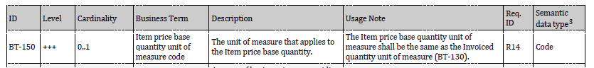

*Peppol BIS 3* : Unit code of price base quantity shall be same as invoiced quantity.

*Fattura PA* : unit of measure is free text

**Mapping solution**

* From UBL/CII: in case BT-130 different from BT-150 set BT-150=BT-130
* From XMLPA: no problem, MR63: if different from UNECE 20 and 21 BT-130 is set =EA. No values for BT-150 thus cannot be different

Remarks

* This check can be suggested toTC 434 to be added to CEN schematron

1. **PEPPOL-EN16931-R051 – currencyID**

*EN 16931-1:2017:* requested in the semantic model but not checked through the schematron

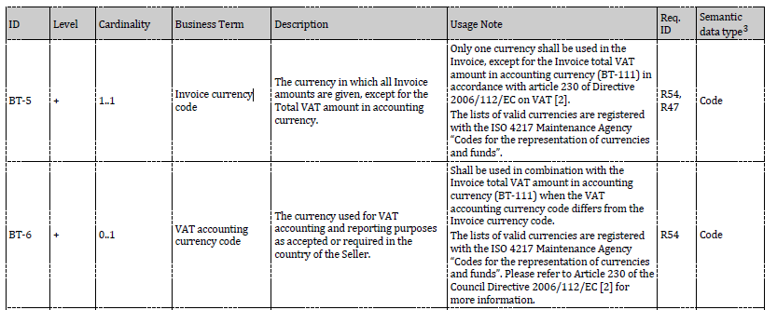

*Peppol BIS 3* : All currencyID attributes shall have the same value as the invoice currency code (BT-5), except for the invoice total VAT amount in accounting currency (BT-111).

*Fattura PA* : no currencyID for tax, only for invoice

**Mapping solution**

* From UBL/CII: leave as it is and in case generate the error
* From XMLPA: no problem

Remarks

* This check can be suggested toTC 434 to be added to CEN schematron

1. Data entry module
   1. Module context and description

The data entry module consists of an additional component to the eInvoicing mapper framework. This module can be used separately or integrated into the framework. The main goal is to provide a tool to create and validate a CEN compliant invoice. The tool is built with a CEN centered approach taking into consideration the core invoice semantic model described in EN 16931-1:2017.

The main functionalities offered to the final users are:

1. Create a CEN based invoice or a CEN based invoice compliant with Italian CIUS
2. Import an xml file (full or partial invoice expressed in XMLPA or UBL 2.1 or CII or CEN BTs-values)
3. Provide information for each BT about associated CEN business rules and Italian business rules
4. Export the CEN based invoice to an xml file (XMLPA or UBL 2.1 or CII or CEN BTs-values)
5. Validate the CEN based invoice on the basis of a specific schematron (national CIUS, community CIUS,…)
   1. High level requirements

| HLR-ID | Req name | Req description |
| --- | --- | --- |
| HLR-001 | CEN-centric | The module shall enable the creation of a CEN based invoice (built on the core invoice semantic model described by EN-16931-1:2017) |
| HLR-002 | Italian customization | The module shall enable the creation of a CEN base invoice fully compliant with Italian CIUS |
| HLR-003 | Import | The module shall have an import functionality of partial or full invoice expressed in xml (XMLPA, UBL 2.1, CII, CEN BTs-values) |
| HLR-004 | CEN information | The module shall have an information tool which provides all information related to a BT (name, description, related business rules, data values admitted, Italian CIUS restrictions,…) |
| HLR-005 | CEN validation | The module should integrate automatic validation mechanisms on the basis of CEN business rules and Italian CIUS restrictions or Italian mapping rules |
| HLR-006 | Export | The module shall have an export functionality of partial or full invoice expressed in xml (XMLPA, UBL 2.1, CII, CEN BTs-values) |
| HLR-007 | Additional validation | The module should provide a mechanism to additionally validate the full CEN compliant invoices against validation artefacts (eg. National CIUS, community CIUS,…) |
| HLR-008 | Categories | The module shall have the information grouped by identified categories (seller, header, buyer, data, vat and totals) |
| HLR-009 | Mandatory | The module shall facilitate the user identifying the mandatory information needed for a CEN compliant einvoice or an Italian CIUS compliant invoice |
| HLR-010 | Optional | The module should provide a mechanism to select the optional information required in an invoice |
| HLR-011 | Progress status | The module should provide a mechanism to clearly show the progress status of invoice preparation |
| HLR-012 | Localization | The module should provide a localization in both languages English and Italian |
| HLR-013 | Users | The module does not need a specific users management (login, profile, …) |
|  |  |  |

Table 2 Data entry module: high level requirements

* 1. Module components

The data entry module will be structured in the following component according to the offered functionalities

* Core module (core semantic data model)
* Customized module (Italian CIUS restrictions)
* Import/export module
* Validation (CEN business rules, Italian CIUS restrictions)
* Additional validation (full CEN compliant invoices validated against specific artefacts)

The information on the core module will be grouped into different categories according to a logical flow.

The categories are as follow:



* Seller (BG-4, BG-5, BG-6, BG-10, BG-11, BG-12, BG-16, BG-17, BG-18, BG-19): all info related to the seller including payee, tax representative and payment data. This info in general are repeated in almost all invoices prepared by an economic operator
* Invoice header (BT-1:BT-20, BG-1, BG-2, BG-3, BG-24): all generic info related to the invoice, to the process and the attachments
* Buyer (BG-7, BG-8, BG-9, BG-13, BG-14, BG-15): all info related to the buyer and the delivery
* Invoice data (BG-20, BG-21, BG-25:BG-32): all core invoice info related to document charge/allowances and to invoice lines
* VAT&Totals (BG-23, BG-22): all figures related to VAT breakdown and Invoice totals. This info will be automatically calculated and proposed to the user who can either modify or confirm the figures.
  1. Preliminary frontend design

The user interface will be further elaborated in WP3 Design on the basis of high-level requirements defined during the analysis phase.

A preliminary frontend design is below reported in order to give an overall idea of the data entry module functionalities.

A homepage provides the access to all available functionalities.

The user can either create a new invoice or import a full or partial invoice expressed in UBL 2.1, CII, XMLPA or CEN BTs-values.

The user can export and save a full or partial invoices expressed in UBL 2.1, CII, XMLPA or CEN BTs-values.

The user can validate a full invoice expressed in one of the two CEN selected syntaxes (UBL 2.1 or CII) against validation artefacts which are available within the system.

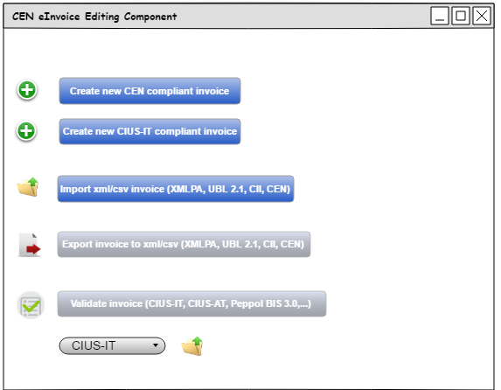

Figure 2 Data entry module homepage

A progress status bar indicates in which category the user is working on and if the categories are complete, partially or empty with a colour mechanism. In this way the data entry progress is highlighted.

Invoice information are organized according to a logical order and grouped by categories. Each category contains mandatory and optional business terms. A category is complete when all the mandatory BTs are filled in.

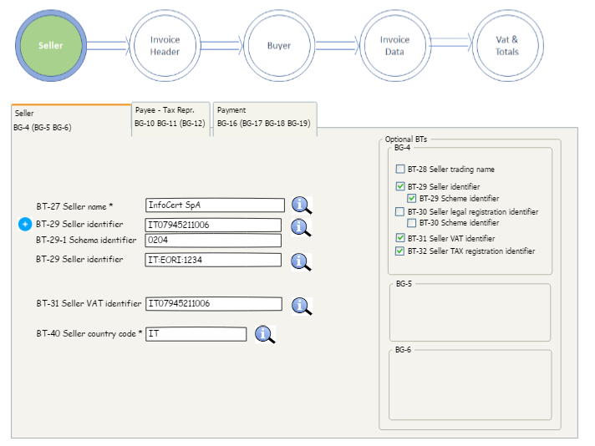

Figure 3 Example of invoice data collection (Seller category)

Each BT has an associated information frame which can be reached through a dedicated icon. The info panel contains all the data related to the BT (name, description, CEN business rules, Italian CIUS rules, examples and remarks).

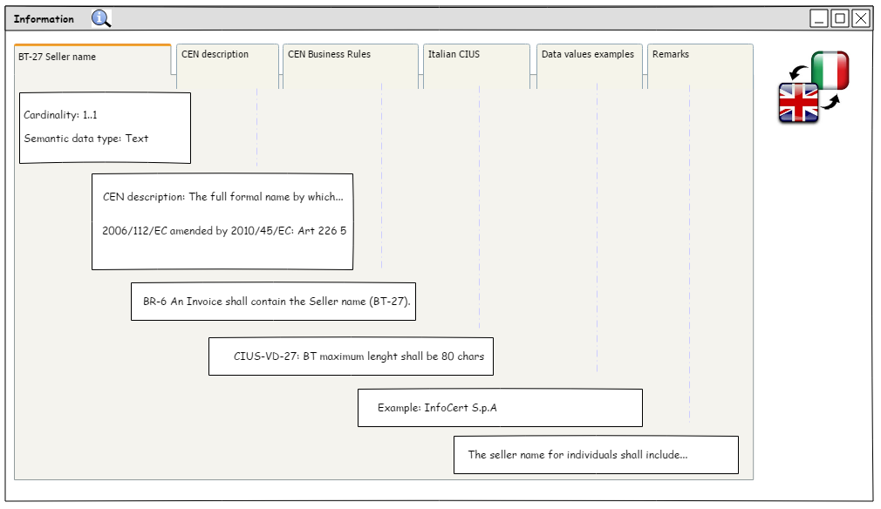

Figure 4 Example of information frame

1. InfoCert LegalInvoice integration
   1. LegalInvoice system brief description

LegalInvoice is a product offered by Infocert to Public administrations and economic operators for the eInvoicing process in G2G, B2G, B2B and B2C transactions.

LegalInvoice has different configuration according to the specific needs of the final users:

* LegalInvoice START aziende/intermediari: a web based platform for SMEs and freelances who does not have an ERP. LegalInvoice START per intermediari: a web-based platform configured for mediators who offers an eInvocing services to a certain number of clients such as SMEs or freelances
* LegalInvoice PRO aziende/intermediari: an eInvoicing platform for medium enterprises or mediators who own an ERP but are in need of additional functionalities
* LegalInvoice Standard: dedicated to economic operators for the B2G transactions
* LegalInvoice Conservazione: a tool specifically dedicated to eInvoices transmission and digital legal archive
* LegalInvoiceEnterprise: dedicated to big enterprises which already own an ERP and are in need of integration
* LegalInvoice for SAP: this tool is for SAP customers who are in need of eInvoicing functionalities in their SAP
* LegalInvoice Enti Pubblici: dedicated to Public administrations

Each LegalInvoice customization has different functionalities and services according to the needs of final users.

With LegalInvoice service InfoCert acts as intermediary between the sellers and the buyers and is in charge of eInvoces signature, validation, transmission, notification management as represented in the following figure.

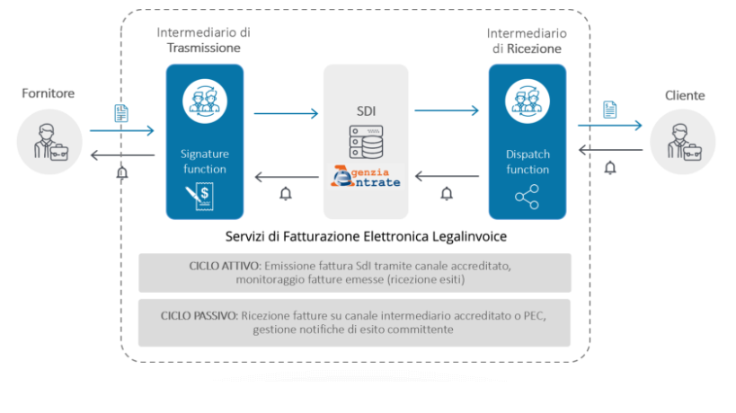

Figure 5 InfoCert services positioning in the eInvoicing process in Italy

* 1. Integration requirements

In the following diagram it is possible to identify the integration proposal of the eInvoice mapper framework in the Infocert LegalInvoice process.

CEN INVOICES FROM EUROPEAN CLIENT

In the vision of a transmission at European level, Infocert Hub prepares to receive CEN invoices (UBL or CII); this is processed to verify the correct correspondence to the CEN format and to the Italian CIUS:

* If the controls return the correspondence of the invoice data to the CEN format and the Italian CIUS, the invoice is converted into the XML-PA format and sent to the SDI or, at the customer's request, is processed by the DataEntry component for any corrections or additions of data.
* If the checks return the mismatch to the CEN and / or Italian CIUS format, the invoice must necessarily be passed from the DataEntry component to allow correction in the faulty parts, and then continue the usual conversion path in the XML-PA format and sending to the SDI.

In the European transmission vision, SDI will have the ability to receive and transmit CEN compliant invoices, we refer to the design environment the analysis on the possibility of delegating the invoice to the SDI; in this case LegalInvoice Hub would send to the SDI the original invoice received (UBL or CII), keeping the only burden of verifying its validity (CIUS IT and CEN compliant) and the translatability (mapping ok, mapping gives problems).

As can be seen from the diagram, the path is bidirectional, so in case of invoices abroad, the invoice is made CEN compliant using the functionality of the data entry component.

The DataEntry component can also be used as an insertion form by the foreign customer in order to produce a formally correct XML-PA invoice.

NB: For companies that need to view the origination of the CEN compliant invoice, they can use DataEntry for this purpose, since the foreign invoices transmitted in CEN compliant to the SDI, are returned by the SDI both in XML-PA format and in the original CEN format.

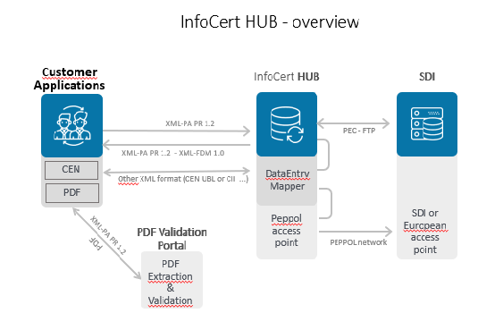

Figure 6 InfoCert HUB Integration