|  |
| --- |
|  |



European eInvoicing Standard in Italy

|  |  |
| --- | --- |
| **Project number** | INEA/CEF/ICT/A2017/1560867 2017-IT-IA-0150 |
| **Project acronym** | EeISI |
| **Project title** | European eInvoicing Standard in Italy |
| **Starting date** | 1 May 2018 |
| **Ending date** | 31 December 2019 |
| **Programme** | Connecting Europe Facility (CEF) CEF-TC-2017-3: eInvoicing |

Systems gap analysis for SATER

Deliverable D2.6

|  |  |
| --- | --- |
| **Related WP** | WP2 – Analysis – Task 2.4 Systems gap analysis |
| **Deliverable number** | D2.6 |
| **Due date** | 31/10/2018 |
| **Revision date** | 31/10/2018 |
| **Actual date** | 31/10/2018 |

This Page Intentionally Left Blank

Deliverable Info

|  |  |
| --- | --- |
| **Editor (s)** | **Intercent-ER** |
| **Contributors** |  |
|  |  |
|  |  |
| **Acknowledgement** | This work was partially supported by the European Commission (EC) through the Connecting Europe Facility (CEF) programme under project EeISI.(grant agreement no. INEA/CEF/ICT/A2017/1560867 2017-IT-IA-0150) |
| **Disclaimer** | The sole responsibility of this publication lies with the author(s). The European Union is not responsible for any use that may be made of the information contained therein. |
| **Confidentiality** | The information in this document is confidential and restricted only to the members of the EeISI consortium  (including the Commission Services). |
|  |  |
| **Note** | - |
|  |  |

**Version Control**

|  |  |  |  |
| --- | --- | --- | --- |
| Version | Date | Author | Description of change |
| 0.2.1 | 31/12/2019 | Intercent-ER |  |
| 0.2.2 | 31/03/2020 | Roberto Reale | Technical review and quality assessment |
|  |  |  |  |
|  |  |  |  |
|  |  |  |  |

This Page Intentionally Left Blank

Table of contents

Deliverable Info 3

Table of contents 5

Executive Summary 7

Glossary 7

1. Introduction 9

2. SATER eProcurement Platform 9

3. Current Solution 9

4. To-Be solution 10

This Page Intentionally Left Blank

Executive Summary

This document aims to describe the eDelivery gap analysis for SATER eProcurement Platform carried out by Intercent-ER within EeISI project. The analysis mainly concerns:

* Current solution;
* Solutions must cover the implementation of eInvoicing systems compliant with the European standard (EN) on the SATER e-Procurement platform.

Glossary

|  |  |
| --- | --- |
| **B2B** | Business to Business |
| **B2C** | Business to Consumer/Citizen |
| **B2G** | Business to Government |
| **BII** | Business Interoperability Interfaces |
| **C2G** | Citizen to Government |
| **CCTS** | Core Component Technical Specification |
| **CEF** | Connecting Europe Facility |
| **CEM** | Certified Electronic Mail – Legal Mail (PEC Posta Elettronica Certificata in Italy) |
| **CEN** | European Committee for Standardisation |
| **CII** | Cross Industry electronic Invoice |
| **CIUS** | Core Invoice Usage Specification |
| **DSI** | Digital Service Infrastructures |
| **EDIFACT** | Electronic Data Interchange For Administration, Commerce and Transport |
| **EMSFEI** | European Multi-Stakeholder Forum on eInvoicing |
| **e-SENS** | Electronic Simple European Networked Services |
| **FatturaPA** | Public administration electronic invoice framework (FatturaPubblica Amministrazione) |
| **G2G** | Government to Government |
| **INEA** | Innovation and Networks Executive Agency |
| **OASIS** | Organization for the Advancement of Structured Information Standards |
| **PEPPOL** | Pan-European Public Procurement Online |
| **PEPPOL-BIS** | Pan-European Public Procurement Online Business Interoperability Specifications |
| **SDI** | Electronic exchange system in Italy (Sistema Di Interscambio) |
| **UBL** | Universal Business Language |
| **UN/CEFACT** | United Nations Centre for Trade Facilitation and Electronic Business |
| **UNTDID** | UN Trade Data Interchange Directory |
| **URI** | Uniform Resource Identifier |
| **URL** | Uniform Resource Location |
| **URN** | Uniform Resource Name |
| **XML** | Extensible Mark-up Language |

1. Introduction

The purpose of this gap analysis document is to describe the “Gestione ordini e DDT Fornitori” functionalities for the Economic Operator, which are new features that enable a more exhaustive order’s life cycle.

In the following, the main activities to be carry out:

* Upgrade SATER e-Procurement platform;
* Billing functionalities:
  + Insertion of Invoice and Credit note
  + Outcome of Invoice and Credit note inserted
* Documents list received for Authorities associated to PEPPOL through the SATER e-Procurement platform.

1. SATER eProcurement Platform

Emilia-Romagna’s System for Telematic Purchases (SATER) is the e-procurement platform developed and managed by Intercent-ER. Active since 2015, the System is able to manage:

* Every kind of tendering procedure (tenders above and below the EU threshold, competitive dialogues, requests for offers within the Electronic Market, etc.)
* Every kind of awarding criteria (lowest price, most advantageous offer, etc.)
* Order and despatch advice
* Autonomous use by Regional Public Administration
* Autonomous use by registered Economic Operator,

Since May 2016 all tenders called by Intercent-ER have been entirely managed through SATER.

1. Current Solution

Regional Public Administrations can autonomously use SATER in order to call for their own tenders and request for offers within the Electronic Market.

SATER is the Intercent-ER eProcurement platform, it’s connected to SIMOG web services to display the list of criteria to the contracting authorities, which can also query for a specific version of a criterion. The platforms also include a Log section that is used to show all the queries and corresponding results obtained from SIMOG about e-Certis criteria. This aspect is functional to provide an assessment of tender creation and also on usage monitoring. SATER also interacts with SIMOG through web services in order to transmit all the tender information needed to obtain a CIG code. The platform, when sending a web request, can specify if the tender should include additional criteria over the mandatory requirements by the Italian law (which are included by default).

SATER e-Procurement platform receives orders and sends despatch advice to Economic Operators of the SME through specific functionalities implemented on the platform and this Economic Operators are registered on SATER without an intermediary but carrying out a registration on the PEPPOL channel through e-Procurement platform.

SATER allows consultation of the orders/despatch advice list sent by regional Healthcare Authorities and the insertion of the despatch advice associated to the order that have to send to the Public Administrations.

Billing functionalities haven’t been implemented on the SATER e-Procurement platform and the e-Invoicing life cycle isn’t operated.

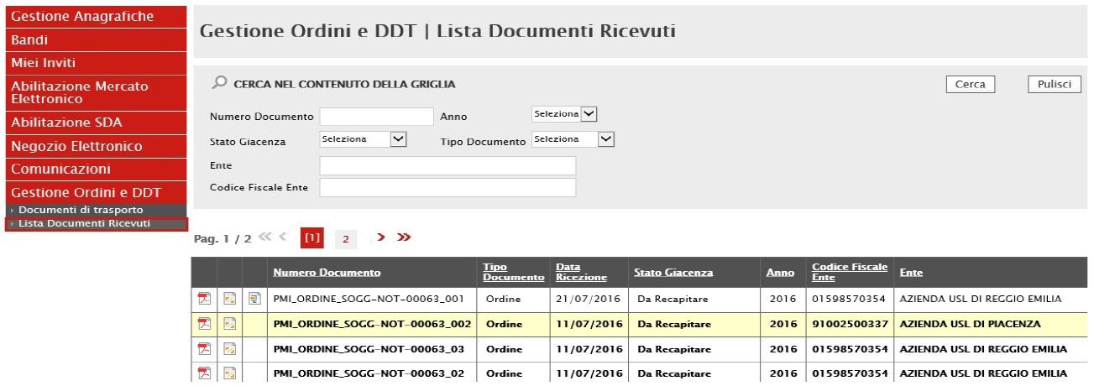

*Figure 1 - "Gestione Ordini e DDT" module*

1. To-Be solution

The key objectives of the proposed analysis are the implementation of eInvoicing systems compliant with the European standard (EN) on electronic invoicing and the integration of eDelivery services by Italian national and regional authorities.

The main topic of this chapter is the integration of SATER in the process of issuing Invoice/Credit Note on behalf of Italian Economic Operators, thus making it possible to configure a new B2G process.   
The scenario will be implemented as shown in Figure 2 below, considering the new constraints.

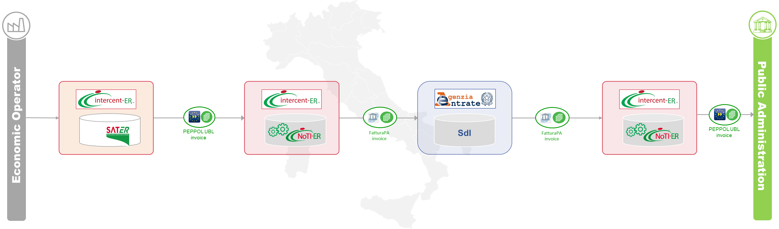

Figure 2 – SATER to be solution

In this configuration, SATER plays an essential role, as it acts as an interface for the Italian Economic Operator, allowing it to issue an Invoice/Credit note.   
SATER is in close contact with NoTIER, which is the first receiver of the documentation sent in PEPPOL BIS3 format and then sends it to SdI.

To implement new SATER interface to manage the invoice EU compliant, in the following table, for each PEPPOL BIS v3 invoice field, it’s indicated where are the information on SATER database.

| **INVOICE - UBL Peppol BIS v 3.0** | **Note** |
| --- | --- |
| /Invoice/cbc:DocumentCurrencyCode |  |
| /Invoice/cbc:AccountingCost |  |
| /Invoice/cac:OrderReference/cbc:ID |  |
| /Invoice/cac:DespatchDocumentReference | /Invoice/cac:DespatchDocumentReference/cbc:ID |
| /Invoice/cac:ContractDocumentReference | /Invoice/cac:ContractDocumentReference/cbc:ID |
| /Invoice/cac:AdditionalDocumentReference/cbc:ID |  |
| /Invoice/cac:AdditionalDocumentReference/cbc:ID/@schemeID |  |
| /Invoice/cac:AdditionalDocumentReference/cac:Attachment |  |
|  |  |
| mittente / seller / venditore | In the Account Payable Cycle, the AccountingSupplierParty is the PA (health authority) that sends the invoice to another PA (G2G) or "supplier" (G2B). In the Account Receivable Cycle, the AccountingSupplierParty is the supplier that sends the invoice to the PA (B2G) |
| /Invoice/cac:AccountingSupplierParty/cac:Party/cbc:EndpointID/@schemeID | Attention: in Peppol 3.0, this field becomes mandatory for all the BIS |
| /Invoice/cac:AccountingSupplierParty/cac:Party/cac:PartyIdentification/cbc:ID/@schemeID | The information displayed in this field could be: CF, PIVA, IPA, CODDEST. In Peppol 3.0, the PartyIdentification became optional. |
| /Invoice/cac:AccountingSupplierParty/cac:Party/cac:PartyName |  |
| /Invoice/cac:AccountingSupplierParty/cac:Party/cac:PostalAddress/cbc:StreetName |  |
| /Invoice/cac:AccountingSupplierParty/cac:Party/cac:PostalAddress/cbc:PostalAddress/AdditionalStreetName |  |
| /Invoice/cac:AccountingSupplierParty/cac:Party/cac:PostalAddress/cbc:CityName |  |
| /Invoice/cac:AccountingSupplierParty/cac:Party/cac:PostalAddress/cbc:PostalZone |  |
| /Invoice/cac:AccountingSupplierParty/cac:Party/cac:PostalAddress/cbc:CountrySubentity |  |
| /Invoice/cac:AccountingSupplierParty/cac:Party/cac:PostalAddress/cac:AddressLine |  |
| /Invoice/cac:AccountingSupplierParty/cac:Party/cac:PostalAddress/cac:Country |  |
| /Invoice/cac:AccountingSupplierParty/cac:Party/cac:PartyTaxScheme |  |
| /Invoice/cac:AccountingSupplierParty/cac:Party/cac:PartyLegalEntity/cbc:RegistrationName |  |
| /Invoice/cac:AccountingSupplierParty/cac:Party/cac:PartyLegalEntity/cbc:CompanyID/@schemeID | It’s possible to use also an ID scheme to identify the supplier’s legal registration |
| /Invoice/cac:AccountingSupplierParty/cac:Party/cac:Contact/cbc:Name |  |
| /Invoice/cac:AccountingSupplierParty/cac:Party/cac:Contact/cbc:Telephone |  |
| /Invoice/cac:AccountingSupplierParty/cac:Party/cac:Contact/cbc:ElectronicMail |  |
|  |  |
| destinatario / buyer / acquirente | In the Account Payable Cycle, the AccountingSupplierParty is the PA (health authority) that sends the invoice to another PA (G2G) or "supplier" (G2B). In the Account Receivable Cycle, the AccountingSupplierParty is the supplier that sends the invoice to the PA (B2G) |
| /Invoice/cac:AccountingCustomerParty/cac:Party/cbc:EndpointID |  |
| /Invoice/cac:AccountingCustomerParty/cac:Party/cac:PartyIdentification |  |
| /Invoice/cac:AccountingCustomerParty/cac:Party/cac:PartyName/cbc:Name |  |
| /Invoice/cac:AccountingCustomerParty/cac:Party/cac:PostalAddress/cbc:StreetName |  |
| /Invoice/cac:AccountingCustomerParty/cac:Party/cac:PostalAddress/cbc:AdditionalStreetName |  |
| /Invoice/cac:AccountingCustomerParty/cac:Party/cac:PostalAddress/cbc:CityName |  |
| /Invoice/cac:AccountingCustomerParty/cac:Party/cac:PostalAddress/cbc:PostalZone |  |
| /Invoice/cac:AccountingCustomerParty/cac:Party/cac:PostalAddress/cbc:CountrySubentity |  |
| /Invoice/cac:AccountingCustomerParty/cac:Party/cac:PostalAddress/cac:AddressLine |  |
| /Invoice/cac:AccountingCustomerParty/cac:Party/cac:PostalAddress/cac:Country |  |
| /Invoice/cac:AccountingCustomerParty/cac:Party/cac:PartyTaxScheme |  |
| /Invoice/cac:AccountingCustomerParty/cac:Party/cac:PartyLegalEntity/cbc:RegistrationName |  |
| /Invoice/cac:AccountingCustomerParty/cac:Party/cac:PartyLegalEntity/cbc:CompanyID |  |
| /Invoice/cac:AccountingCustomerParty/cac:Party/cac:Contact/cbc:Name |  |
| /Invoice/cac:AccountingCustomerParty/cac:Party/cac:Contact/cbc:Telephone |  |
| /Invoice/cac:AccountingCustomerParty/cac:Party/cac:Contact/cbc:ElectronicMail |  |
| delivery / consegna | The Shipment/Delivery/Despatch/DespatchAddress/… can be used, at your option, to insert the supplier’s sales address, meaning the warehouse where goods are despatched from |
| /Invoice/cac:Delivery/cac:DeliveryLocation/cac:Address/cbc:StreetName |  |
| /Invoice/cac:Delivery/cac:DeliveryLocation/cac:Address/cbc:AdditionalStreetName |  |
| /Invoice/cac:Delivery/cac:DeliveryLocation/cac:Address/cbc:CityName |  |
| /Invoice/cac:Delivery/cac:DeliveryLocation/cac:Address/cbc:PostalZone |  |
| /Invoice/cac:Delivery/cac:DeliveryLocation/cac:Address/cbc:CountrySubentity |  |
| /Invoice/cac:Delivery/cac:DeliveryLocation/cac:Address/cac:AddressLine |  |
| /Invoice/cac:Delivery/cac:DeliveryLocation/cac:Address/cac:Country |  |
| /Invoice/cac:Delivery/cac:DeliveryParty/cac:PartyName/cbc:Name |  |
| Righe di fatturazione |  |
| /Invoice/cac:InvoiceLine/cac:OrderLineReference/cbc:LineID |  |
| /Invoice/cac:InvoiceLine/cbc:Note |  |
| /Invoice/cac:InvoiceLine/cbc:InvoicedQuantity |  |
| /Invoice/cac:InvoiceLine/cbc:InvoicedQuantity/@unitCode |  |
| /Invoice/cac:InvoiceLine/cbc:LineExtensionAmount |  |
| /Invoice/cac:InvoiceLine/cbc:LineExtensionAmount/@currencyID |  |
| /Invoice/cac:InvoiceLine/cbc:AccountingCost |  |
| /Invoice/cac:InvoiceLine/cac:DocumentReference/* |  |
| /Invoice/cac:InvoiceLine/cac:AllowanceCharge/cbc:ChargeIndicator |  |
| /Invoice/cac:InvoiceLine/cac:AllowanceCharge/cbc:AllowanceChargeReason |  |
| /Invoice/cac:InvoiceLine/cac:AllowanceCharge/cbc:Amount |  |
| /Invoice/cac:InvoiceLine/cac:Item/cbc:Description | On DespatchAdvice line the Description field no longer exists |
| /Invoice/cac:InvoiceLine/cac:Item/cbc:Name |  |
| /Invoice/cac:InvoiceLine/cac:Item/cac:SellersItemIdentification/cbc:ID |  |
| /Invoice/cac:InvoiceLine/cac:Item/cac:StandardItemIdentification/cbc:ID |  |
| /Invoice/cac:InvoiceLine/cac:Item/cac:StandardItemIdentification/cbc:ID/@schemeID | Standard item identification code (i.e. GS1) |
| /Invoice/cac:InvoiceLine/cac:Item/cac:CommodityClassification/cbc:ItemClassificationCode |  |
| /Invoice/cac:InvoiceLine/cac:Item/cac:CommodityClassification/cbc:ItemClassificationCode/@listID | Peppol 3.0 can be used to define DM0, DM1, DM2 with the use of the generic scheme 'ZZZ' included within the code list. See "Peppol 3.0 code list" on Intercenter website |
| /Invoice/cac:InvoiceLine/cac:Item/cac:ClassifiedTaxCategory/cbc:ID | Information on the VAT rate to be applied. See "Peppol 3.0 code list" on Intercenter website |
| /Invoice/cac:InvoiceLine/cac:Item/cac:ClassifiedTaxCategory/cbc:Percent |  |
| /Invoice/cac:InvoiceLine/cac:Item/cac:ClassifiedTaxCategory/cac:TaxScheme/cbc:ID | Default: ID = 'VAT' |
| /Invoice/cac:InvoiceLine/cac:Item/cac:AdditionalItemProperty/cbc:Name | At the moment, in Peppol 3.0 the AdditionalItemProperty will be only used for Kit and packaging management. AdditionalItemProperty will not be used anymore for lot and serial number management. For these items, Peppol 3.0 has included structured fields |
| /Invoice/cac:InvoiceLine/cac:Item/cac:AdditionalItemProperty/cbc:Value | At the moment, in Peppol 3.0 the AdditionalItemProperty will be only used for Kit and packaging management. AdditionalItemProperty will not be used anymore for lot and serial number management. For these items, Peppol 3.0 has included structured fields |
| /Invoice/cac:InvoiceLine/cac:Item/cac:AdditionalItemProperty/cbc:Name | In the INVOICE 3.0 the 'Name' field is mandatory, while this field does not exist in the order and ddt. At the moment, you cannot populate the 'Name' field in the invoice. In Peppol 2.1 this field was populated with the description 'Lotto' and 'Seriale' because they were associated to the AdditionalItemProperty’s fields of the order and ddt. Today, with the structured field for lot and serial number, it is no longer possible |
| /Invoice/cac:InvoiceLine/cac:Item/cac:AdditionalItemProperty/cbc:Value | Structured field where insert serial number |
| /Invoice/cac:InvoiceLine/cac:Item/cac:AdditionalItemProperty/cbc:Name | In the INVOICE 3.0 the 'Name' field is mandatory, while this field does not exist in the order and ddt. At the moment, you cannot populate the 'Name' field in the invoice. In Peppol 2.1 this field was populated with the description 'Lotto' and 'Seriale' because they were associated to the AdditionalItemProperty’s fields of the order and ddt. Today, with the structured field for lot and serial number, it is no longer possible |
| /Invoice/cac:InvoiceLine/cac:Item/cac:AdditionalItemProperty/cbc:Value | Structured field where insert lot number |
| /Invoice/cac:InvoiceLine/cac:Price/cbc:PriceAmount |  |
| /Invoice/cac:InvoiceLine/cac:Price/cbc:PriceAmount/@currencyID |  |
| /Invoice/cac:InvoiceLine/cac:Price/cac:AllowanceCharge/cbc:ChargeIndicator |  |
| /Invoice/cac:InvoiceLine/cac:Price/cac:AllowanceCharge/cbc:Amount |  |
| /Invoice/cac:InvoiceLine/cac:Price/cac:AllowanceCharge/cbc:Amount/@currencyID |  |

