|  |
| --- |
|  |

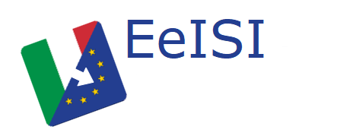

European eInvoicing Standard in Italy

|  |  |
| --- | --- |
| **Project number** | INEA/CEF/ICT/A2017/1560867 2017-IT-IA-0150 |
| **Project acronym** | EeISI |
| **Project title** | European eInvoicing Standard in Italy |
| **Starting date** | 1 May 2018 |
| **Ending date** | 30 June 2019 |
| **Programme** | Connecting Europe Facility (CEF) CEF-TC-2017-3: eInvoicing |

Systems gap analysis for “Fattura Elettronica – Il servizio delle Camere di Commercio”

Deliverable D2.7

|  |  |
| --- | --- |
| **Related WP** | WP2 – Analysis – Task 2.4 Systems gap analysis |
| **Deliverable number** | D2.7 |
| **Due date** | 31/10/2018 |
| **Revision date** | 31/10/2018 |
| **Actual date** | 31/10/2018 |

This Page Intentionally Left Blank

Deliverable Info

|  |  |
| --- | --- |
| **Editor (s)** | **Infocamere** |
| **Contributors** | **Infocamere** |
|  |  |
|  |  |
| **Acknowledgement** | This work was partially supported by the European Commission (EC) through the Connecting Europe Facility (CEF) programme under project EeISI.(grant agreement no. INEA/CEF/ICT/A2017/1560867 2017-IT-IA-0150) |
| **Disclaimer** | The sole responsibility of this publication lies with the author(s). The European Union is not responsible for any use that may be made of the information contained therein. |
| **Confidentiality** | The information in this document is confidential and restricted only to the members of the EeISI consortium  (including the Commission Services). |
|  |  |
| **Note** | - |
|  |  |

**Version Control**

|  |  |  |  |
| --- | --- | --- | --- |
| Version | Date | Author | Description of change |
| 1.0.0 | 31/10/2018 | Infocamere (Doni, Squarcina) |  |
| 1.0.1 | 31/03/2020 | Roberto Reale | Technical review and quality assessment |
|  |  |  |  |
|  |  |  |  |
|  |  |  |  |

This Page Intentionally Left Blank

Table of contents

Deliverable Info 4

Table of contents 6

Glossary 8

1 Normative references 9

2 Fattura Elettronica – il servizio delle Camere di Commercio 10

2.1 The e-invoicing portal of the Chambers of Commerce 10

2.1.1 Cross Border Invoice 10

2.1.2 Domestic Invoice 12

3 Use cases summarizing schemes 14

This Page Intentionally Left Blank

Glossary

|  |  |
| --- | --- |
| **B2B** | Business to Business |
| **B2C** | Business to Consumer/Citizen |
| **B2G** | Business to Government |
| **BII** | Business Interoperability Interfaces |
| **C2G** | Citizen to Government |
| **CCTS** | Core Component Technical Specification |
| **CEF** | Connecting Europe Facility |
| **CEM** | Certified Electronic Mail – Legal Mail (PEC Posta Elettronica Certificata in Italy) |
| **CEN** | European Committee for Standardisation |
| **CII** | Cross Industry electronic Invoice |
| **CIUS** | Core Invoice Usage Specification |
| **DSI** | Digital Service Infrastructures |
| **EDIFACT** | Electronic Data Interchange For Administration, Commerce and Transport |
| **EMSFEI** | European Multi-Stakeholder Forum on eInvoicing |
| **e-SENS** | Electronic Simple European Networked Services |
| **FatturaPA** | Public administration electronic invoice framework (FatturaPubblica Amministrazione) |
| **G2G** | Government to Government |
| **INEA** | Innovation and Networks Executive Agency |
| **OASIS** | Organization for the Advancement of Structured Information Standards |
| **PEPPOL** | Pan-European Public Procurement Online |
| **PEPPOL-BIS** | Pan-European Public Procurement Online Business Interoperability Specifications |
| **SDI** | Electronic exchange system in Italy (Sistema Di Interscambio) |
| **UBL** | Universal Business Language |
| **UN/CEFACT** | United Nations Centre for Trade Facilitation and Electronic Business |
| **UNTDID** | UN Trade Data Interchange Directory |
| **URI** | Uniform Resource Identifier |
| **URL** | Uniform Resource Location |
| **URN** | Uniform Resource Name |
| **XML** | Extensible Mark-up Language |

# Normative references

The following documents, in whole or in part, are normatively referenced in this document and are indispensable for its application.

* EN 16931-1:2017 Electronic invoicing - Part 1: Semantic data model of the core elements of an electronic invoice
* CEN/TS 16931-2:2017 Electronic invoicing - Part 2: List of syntaxes that comply with EN 16931-1
* CEN/TS 16931-3-1:2017 Electronic invoicing - Part 3 - 1: Syntax bindings of the core elements of an electronic invoice - Syntax binding methodology
* CEN/TS 16931-3-2:2017 Electronic invoicing - Part 3 - 2: Syntax bindings of the core elements of an electronic invoice - Binding to ISO/IEC 19845 (UBL 2.1)
* CEN/TS 16931-3-3:2017 Electronic invoicing - Part 3 - 3: Syntax bindings of the core elements of an electronic invoice - Binding to UN/CEFACT XML
* CEN/TS 16931-3-4:2017 Electronic invoicing - Part 3 - 4: Syntax bindings of the core elements of an electronic invoice - Binding to ISO/IEC 9735 (UN/EDIFACT)
* ISO 3166 1, Codes for the representation of names of countries and their subdivisions — Part 1: Country codes
* ISO 4217, Codes for the representation of currencies
* ISO 639 2, Codes for the representation of names of languages
* ISO 8601, Data elements and interchange formats — Information interchange — Representation of dates and times
* ISO 15000-5, Electronic Business Extensible Markup Language (ebXML) — Part 5: Core Components Specification (CCS)
* ISO 6523, Information technology — Structure for the identification of organizations and organization parts
* ISO/IEC 19845, Information technology -- Universal business language version 2.1 (UBL v2.1)

Moreover the following Italian documentation is referenced in this deliverable:

* Schema del file xml FatturaPA versione 1.2 - xsd
* Specifiche tecniche del formato della FatturaPA versione 1.2.1- pdf
* Rappresentazione tabellare del tracciato FatturaPA versione 1.2.1- pdf
* Rappresentazione tabellare del tracciato FatturaPA versione 1.2.1- excel
* Foglio di stile per la visualizzazione della FatturaPA versione 1.2.1 - xslt
* generica Foglio di stile per la visualizzazione della Fattura Ordinaria versione 1.2.1 - xslt
* Elenco modifiche al tracciato FatturaPA - pdf
* Suggerimenti per la compilazione della FatturaPA versione 1.5

# Fattura Elettronica – il servizio delle Camere di Commercio

## The e-invoicing portal of the Chambers of Commerce

The e-Invoicing service made available to Small and Medium Enterprises by the Chambers of Commerce allows to manage two different types of processes:

* sending an electronic invoice to a European public administration (Cross Border Invoice);
* sending an electronic invoice to an Italian public administration (Domestic Invoice).

If the electronic invoice is destined for an Italian Public Administration, this invoice is mediated by the Exchange System (SDI).

### Cross Border Invoice

This chapter describes the process of the Electronic Invoice managed by the Portal of Chambers of Commerce towards a European Public Administration.

The Electronic Invoice produced by the Portal of the Chambers of Commerce is initially generated in the format FatturaPA (XMLPA v1.2) and then transformed into the Peppol BIS 3 CIUS format (UBL v2.1) through the "eInvoice Mapper Framework" component (defined in D2 .5).

The Electronic Invoice is then sent to the target European Public Administration, through the Peppol Access Point of the Chambers of Commerce (defined in D2.7).

Once the Electronic Invoice has been sent, the Portal of the Chambers of Commerce analyzes the result of the transmission:

* in the case of a positive result, the MDN message of delivery is received and the transmission is notified to the Portal of the Chambers of Commerce;
* in the event of a transmission error, a notification is sent to the Portal of the Chambers of Commerce.

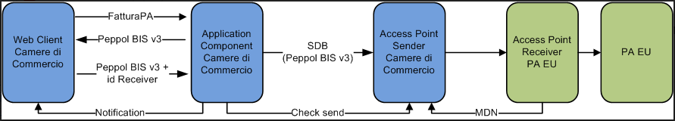

Figura 1 - Cross Border Process

In detail, the process can be represented by 3 independent and decoupled subprocesses.

In the first subprocess, if the Electronic Invoice is a Cross Border type, the Portal of the Chambers of Commerce uses the interfaces (API) of the "eInvoice Mapper Framework" service to transform the FatturaPA into Peppol BIS 3 CIUS.

In the second subprocess the Portal of the Chambers of Commerce carries out the following tasks:

* prepares the Standard Business Document (SBD) consisting of a head (SBDH Header) and Peppol BIS 3 CIUS (UBL 2.1). The SBDH header is appropriately valued with the recipient of the Electronic Invoice received from the Portal of the Chambers of Commerce;

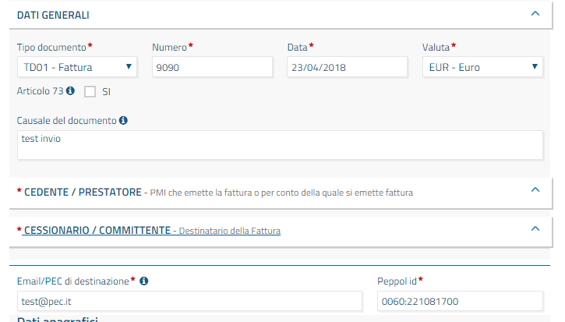

Figura 2 - Valorizzazione del Peppol-Id destinatario

* Sends the SBD message (SBDH + Peppol BIS 3 CIUS) to the Access Point Portal of Chambers of Commerce, which will forward it to the Recipient Access Point, in a decoupled way.

The third sub-process, of a batch nature, has the task of monitoring the forwarding status of the Electronic Invoice in the Access Point of the Chambers of Commerce, managing the following scenarios:

* successful transmission, receipt and registration of the MDN and notification to the Chamber of Commerce Portal of the delivery;
* error transmission and number of retry less than a maximum pre-configurable number, the subprocess tries to send again a notification of Warning to the Chambers of Commerce Portal;
* transmission in error after exceeding the maximum number of retry, the subprocess notifies an error report to the Chamber of Commerce Portal.

The following is a sequence diagram of the described subprocesses.

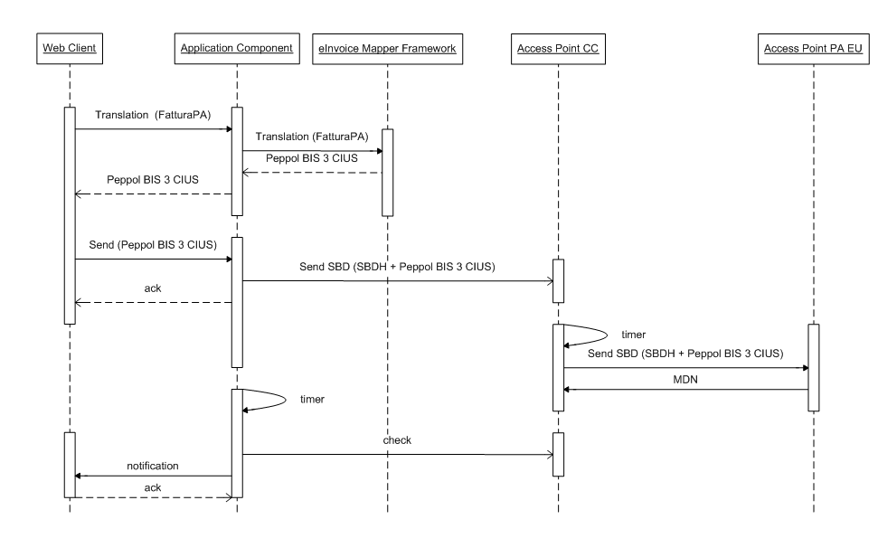

Figura 3 - Cross Border Sequence Diagram

### Domestic Invoice

This chapter describes the process of electronic invoicing managed by the Chamber of Commerce Portal [CC] to an Italian Public Administration.

In this case the Electronic Invoice is sent to the SDI through web services SOAP provided for by the SdI specifications (fatturapa.gov.it) in the Italian format FatturaPA v12.

The SDI has the task of sending the Electronic Invoice to the Italian PA through the reception channel chosen by the PA itself, and made available in the indicePA (indicepa.gov.it).

A PA has the possibility to choose how to receive an Electronic Invoice from the SDI, registering the reception channel in the IndicePA system. This channel must have been qualified by the ESI system before being used.

The Portal of the Chambers of Commerce also manages all update notifications that the SDI sends to complete the whole process of transmission of the electronic invoice to the recipient PA.

In this process there is no change to the transfer model (eDelivery) compared to the one currently adopted by the Chambers of Commerce.

In the event that the SDI extends the reception channels of the Electronic Invoice by the PPAAs, inserting also "PEPPOL eDelivery Network" (through the PEPPOL Access Point) and if an Italian PA wishes to adopt this reception channel, the SDI will provide to carry out the following operations:

* transformation of the Electronic Invoice from FatturaPA v12 format into Peppol BIS 3 CIUS. This transformation will be carried out through the "eInvoice Mapper Framework" component (defined in D2.5).
* based on the IPA code of the PA to which the Electronic Invoice will be sent, search via SML / SMP for the physical address (endpoind) of the PEPPOL Access Point to send it to;
* communication to the Chambers of Commerce Portal of the notifications about the Electronic Invoice will be transmitted through web services that comply with the SDI specifications (see fatturapa.gov.it).

Below is a summary of the 2 possible processes.

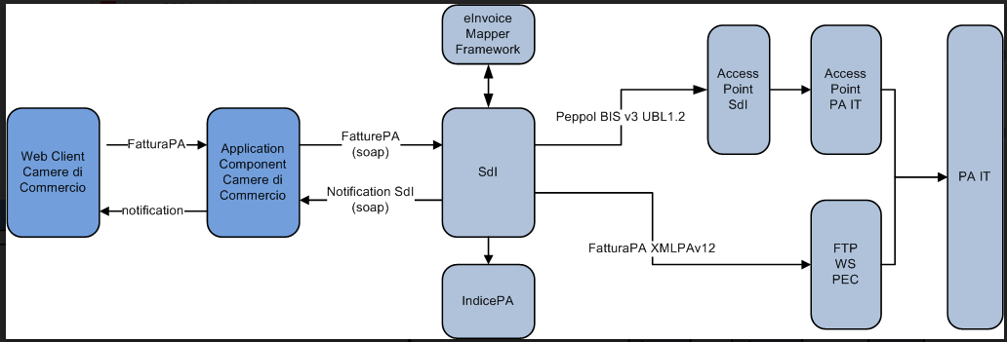

Figura 4 - Domestic Process

# Use cases summarizing schemes



