|  |
| --- |
|  |



European eInvoicing Standard in Italy

|  |  |
| --- | --- |
| **Project number** | INEA/CEF/ICT/A2017/1560867 2017-IT-IA-0150 |
| **Project acronym** | EeISI |
| **Project title** | European eInvoicing Standard in Italy |
| **Starting date** | 1 May 2018 |
| **Ending date** | 30 June 2019 |
| **Programme** | Connecting Europe Facility (CEF) CEF-TC-2017-3: eInvoicing |

eDelivery gap analysis for LegalInvoice hub

Deliverable D2.9

|  |  |
| --- | --- |
| **Related WP** | WP2 – Analysis – Task 2.5 eDelivery gap analysis |
| **Deliverable number** | D2.9 |
| **Due date** | 31/10/2018 |
| **Revision date** | 31/10/2018 |
| **Actual date** | **31/10/2018** |

This Page Intentionally Left Blank

Deliverable Info

|  |  |
| --- | --- |
| **Editor (s)** | **InfoCert** |
| **Contributors** | **InfoCert** |
|  |  |
| **Abstract** | **This deliverable aims to describethe eDelivery gap analysis for LegalInvoice hub framework of InfoCert.** |
| **Keywords** | **eInvoicing, semantic core model, Italian eInvoicing format, LegalInvoice, eDelivery, AS4, access point, SDI** |
|  |  |
| **Acknowledgement** | This work was partially supported by the European Commission (EC) through the Connecting Europe Facility (CEF) programme under project EeISI.(grant agreement no. INEA/CEF/ICT/A2017/1560867 2017-IT-IA-0150) |
| **Disclaimer** | The sole responsibility of this publication lies with the author(s). The European Union is not responsible for any use that may be made of the information contained therein. |
| **Confidentiality** | The information in this document is confidential and restricted only to the members of the EeISI consortium  (including the Commission Services). |
|  |  |
| **Note** | - |
|  |  |

**Version Control**

|  |  |  |  |
| --- | --- | --- | --- |
| Version | Date | Author | Description of change |
| 0.0.1 | 2018-10-31 | Elisa Salvagnin | First release |
| 0.0.2 | 2020-03-31 | Roberto Reale | Technical review and quality assessment |

This Page Intentionally Left Blank

Table of contents

Deliverable Info 4

Table of contents 6

List of figures 6

List of tables 6

Executive Summary 7

Glossary 9

1. Normative references 10

2. LegalInvoice Hub 10

3. InfoCert: current Access Point PEPPOL AS2 solution 11

4. InfoCert: TO BE Access Point AS4 eSENS profile solution for EeISI project 12

4.1. AS4 Introduction: what is it about? 12

4.2. New Features AS4 vs AS2 12

4.3. AS4 Architecture and messaging model 12

4.4. Message Packaging 13

4.5. Security 13

4.6. Error Handling 14

4.7. Reliability 14

List of figures

Figure 1 InfoCert HUB Integration 11

Figure 2 SATA AP architecture 11

Figure 3 AS4 Architecture 13

List of tables

**Non è stata trovata alcuna voce dell'indice delle figure.**

Executive Summary

This document aims to describe the eDelivery gap analysis for LegalInvoice Hub framework carried out by InfoCert within EeISI project. The analysis mainly interests:

* AS IS eDelivery architecture in InfoCert (SDI connection with traditional channels and AS2 Peppo network)
* TO BE eDelivery architecture in InfoCert (additional AS4 eSENS profile)

This Page Intentionally Left Blank

Glossary

|  |  |
| --- | --- |
| **AP** | Access Point |
| **AS4** | Applicability Statement 4 |
| **B2B** | Business to Business |
| **B2C** | Business to Consumer/Citizen |
| **B2G** | Business to Government |
| **BII** | Business Interoperability Interfaces |
| **C2G** | Citizen to Government |
| **CCTS** | Core Component Technical Specification |
| **CEF** | Connecting Europe Facility |
| **CEM** | Certified Electronic Mail – Legal Mail (PEC Posta Elettronica Certificata in Italy) |
| **CEN** | European Committee for Standardisation |
| **CII** | Cross Industry electronic Invoice |
| **CIUS** | Core Invoice Usage Specification |
| **DNS** | Domain Name System |
| **DSI** | Digital Service Infrastructures |
| **EDIFACT** | Electronic Data Interchange For Administration, Commerce and Transport |
| **EMSFEI** | European Multi-Stakeholder Forum on eInvoicing |
| **e-SENS** | Electronic Simple European Networked Services |
| **FatturaPA** | Public administration electronic invoice framework (FatturaPubblica Amministrazione) |
| **G2G** | Government to Government |
| **IMR** | Invoice Message Response |
| **INEA** | Innovation and Networks Executive Agency |
| **MLR** | Message Level Response |
| **OASIS** | Organization for the Advancement of Structured Information Standards |
| **PEPPOL** | Pan-European Public Procurement Online |
| **PEPPOL-BIS** | Pan-European Public Procurement Online Business Interoperability Specifications |
| **SDI** | Electronic exchange system in Italy (Sistema Di Interscambio) |
| **SML** | Service Metadata Locator |
| **SMP** | Service Metadata Publisher |
| **UBL** | Universal Business Language |
| **UN/CEFACT** | United Nations Centre for Trade Facilitation and Electronic Business |
| **UNTDID** | UN Trade Data Interchange Directory |
| **URI** | Uniform Resource Identifier |
| **URL** | Uniform Resource Location |
| **URN** | Uniform Resource Name |
| **XML** | Extensible Mark-up Language |

1. Normative references

The following documents, in whole or in part, are normatively referenced in this document and are indispensable for its application.

* EN 16931-1:2017 Electronic invoicing - Part 1: Semantic data model of the core elements of an electronic invoice

Moreover the following Italian documentation is referenced in this deliverable:

* Schema del file xml FatturaPA versione 1.2 - xsd
* Specifiche tecniche del formato della FatturaPA versione 1.2.1- pdf
* Rappresentazione tabellare del tracciato FatturaPA versione 1.2.1- pdf
* Rappresentazione tabellare del tracciato FatturaPA versione 1.2.1- excel
* Foglio di stile per la visualizzazione della FatturaPA versione 1.2.1 - xslt
* generica Foglio di stile per la visualizzazione della Fattura Ordinaria versione 1.2.1 - xslt
* Elenco modifiche al tracciato FatturaPA - pdf
* Suggerimenti per la compilazione della FatturaPA versione 1.5

1. LegalInvoice Hub

InfoCert LegalInvoice Hub framework has a connection to SDI through traditional channels exposed by AdE (WE/FTP/PEC).

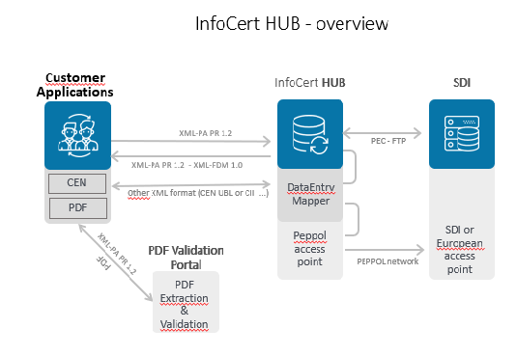

Figure 1 InfoCert HUB Integration

1. InfoCert: current Access Point PEPPOL AS2 solution

Infocert current solution for eDelivery in Peppol network consists of a Peppol AS2 Access Point, which is located in Modena and hosted by [SATA](https://www.satanet.it/).

The AS2 Access Point has been installed in 2018 by InfoCert who decided to enhance its eDelivery services and being a service provider within the OpenPeppol community. This AS2 Access Point was not foreseen as deliverable of eIGOR project but InfoCert offered it for testing purposes. It has been used during the validation phase.

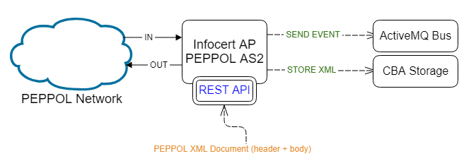

Figure 2 SATA AP architecture

The Access Point can potentially handle any type of documents, event though only **P4 profile-eEnvoices** has been tested so far.

Documents of any type can be synchronously sent in XML format through a REST API.

Documents are asynchronously received in XML format and stored in a distributed storage (CBA storage). The AP sends a notification event to a bus (ActiveMQ bus), which is handled by the application which is in charge of receiving the message.

1. InfoCert: TO BE Access Point AS4 eSENS profile solution for EeISI project

As foreseen in EeISI project InfoCert will update its eDelivery architecture with an Access Point AS4 eSENS profile. This will be an additional channel offered to customers for sending eInvoices to SDI.

The overall EeISI eDelivery architecture is under analysis by AdE. The final solution will depend on the decision of available communication channels of SDI.

At the moment the analysis carried out in InfoCert highlighted the needed steps to integrate an AS4 Access Point into the existing eDelivery architecture offered by InfoCert. The connection to SDI through this Access Point additional channel will depend on the final solution adopted by SDI (existing traditional channels WS/FTP/PEC vs extended channels WS/FTP/PEC/Access Point AS4).

* 1. AS4 Introduction: what is it about?

**AS4** (Applicability Statement 4) is a protocol that is typically used for the standardized, secure and reliable exchange of documents and data, containing one or multiple payloads.

Specifically, it is the message exchange protocol promoted by **CEF** (Connecting Europe Facility) **eDelivery**.

CEF eDelivery helps public administrations to exchange electronic data and documents with other public administrations, businesses and citizens, in an interoperable, secure, reliable and trusted way. CEF eDelivery is a network of nodes for digital communications. It is based on a distributed model where every participant becomes a node using standard transport protocols and security policies.

* 1. New Features AS4 vs AS2
* **Access Point** must be an implementation of the eDelivery AS4 eSENS Profile (vs OpenPEPPOL AS2 Profile)
* The**data exchange protocols** of CEF eDelivery are profiles. Profile of AS4 was developed by e-SENS7 (vs OpenPEPPOL)
* The eDelivery AS4 **profile** is an open technical specification for the secure and payload-agnostic exchange of data using Web Services. AS4 itself is a profile of the ebXML Messaging Services (ebMS) v.3.010, a broader specification built on top of the SOAP with attachments specification
* **Message packaging**: within AS2, the message packaging is purely MIME based. In AS4, this is governed by SOAP with Attachments, a combination of **MIME and SOAP**
* **Security**: AS2 applies security via the S/MIME specifications, whereas AS4’s security model is based on the well-known**WS-Security** standard
* **Acknowledgements**: in AS2 and AS4, reliable messaging and non-repudiation of receipt are supported. In AS2 this is done by so-called Message Disposition Notifications (MDN), AS4 uses **signed Receipts**
  1. AS4 Architecture and messaging model

AS4 profile uses the same 4-corner architecture as the previous AS2-Access-Point-based profile.

There is a clear separation between the components responsible for processing the business data, the business applications, and the components responsible for the execution of the actual message exchanges, called Message Service Handlers (MSH).

For the configuration of the message exchanges between two MSHs, **P-Modes** (processing modes) are used. A P-Mode is a set of parameters specifying details of a message exchange. For example, the identifiers of the sender and receiver of a message and the algorithm used for signing a message. When parties are going to set up a message exchange they need to agree on the P-Mode(s) to use.

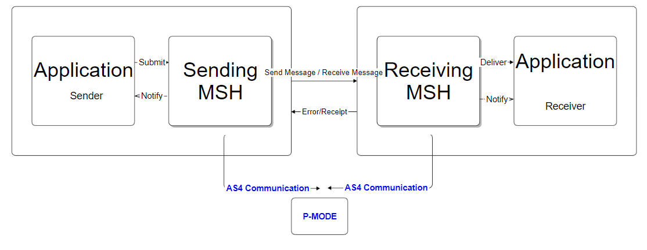

Figure 3 AS4 Architecture

* 1. Message Packaging

The **payloads** of a message may be contained in either the SOAP body or attachments. **Compression** can be applied to payloads packaged in attachments.  The GZIP compression algorithm must be used. Payloads packaged in attachments can be of any type and any number.

SOAP Header

➔ UserMessage

➔ SignalMessage (Receipt/Error/PullRequest

➔ WS-Security Headers

 SOAP Body

➔ XML Payloads only

SOAP Attachments (MIME)

➔ Any Payload

➔ GZIP compression possible

* 1. Security

The most important security features guaranteed by AS4 are **Confidentiality** (WS-Security and XML Encryption, TLS as secure communication channel), **Non-Repudiation of Receipt**and**Non-Repudation of Origin.**

* 1. Error Handling

When an Access Point detects an error in a received message the resulting error must be reported and transmitted synchronously to the Sender and should be reported to the Consumer.

* 1. Reliability

When using AS4 as the message exchange protocol, the Reception Awareness feature ensures message delivery and provide acknowledgement of reception. This feature uses the Receipt signal message to ensure that a Sending MSH is aware of whether or not a sent User Message is successfully received by the Receiving MSH.

Once-and-only-once delivery:

* retry mechanism (that guarantees “at least once”), provides robust recovery from temporary system or network failures
* duplication elimination (that guarantees “at most once”)