|  |
| --- |
|  |



European eInvoicing Standard in Italy

|  |  |
| --- | --- |
| **Project number** | INEA/CEF/ICT/A2017/1560867 2017-IT-IA-0150 |
| **Project acronym** | EeISI |
| **Project title** | European eInvoicing Standard in Italy |
| **Starting date** | 1 May 2018 |
| **Ending date** | 30 June 2019 |
| **Programme** | Connecting Europe Facility (CEF) CEF-TC-2017-3: eInvoicing |

Design technical specification for «Fattura elettronica – il servizio delle Camere di Commercio»

Deliverable D3.6

|  |  |
| --- | --- |
| **Related WP** | WP3 Design  T3.2 Systems evolution |
| **Deliverable number** | D3.6 |
| **Due date** | 30/11/2018 |
| **Revision date** | **30/11/2018** |
| **Actual date** | **30/11/2018** |

This Page Intentionally Left Blank

Deliverable Info

|  |  |
| --- | --- |
| **Editor (s)** | **Infocamere** |
| **Contributors** | **Infocamere** |
|  |  |
|  |  |
| **Acknowledgement** | This work was partially supported by the European Commission (EC) through the Connecting Europe Facility (CEF) programme under project EeISI.(grant agreement no. INEA/CEF/ICT/A2017/1560867 2017-IT-IA-0150) |
| **Disclaimer** | The sole responsibility of this publication lies with the author(s). The European Union is not responsible for any use that may be made of the information contained therein. |
| **Confidentiality** | The information in this document is confidential and restricted only to the members of the EeISI consortium  (including the Commission Services). |
|  |  |
| **Note** | - |
|  |  |

**Version Control**

|  |  |  |  |
| --- | --- | --- | --- |
| Version | Date | Author | Description of change |
| 1.0.0 | 30/11/2018 | Infocamere (Doni, Squarcina) |  |
| 1.0.1 | 31/03/2020 | Roberto Reale | Technical review and quality assessment |
|  |  |  |  |
|  |  |  |  |
|  |  |  |  |

This Page Intentionally Left Blank

Table of contents

Deliverable Info 4

Table of contents 6

Glossary 8

1 Normative references 9

2 Introduction 10

2.1 Purpose 10

2.2 Scope 10

2.3 References 11

2.4 Constraints and Assumptions 11

3 Requirements 12

3.1 Functional Requirements 12

3.2 Non-Functional Requirements 12

4 Architecture views 13

4.1 Components catalogue 13

4.2 Diagrams 14

4.3 Technology 15

5 Key Findings 16

5.1 Architectural Decision 16

This Page Intentionally Left Blank

Glossary

|  |  |
| --- | --- |
| **B2B** | Business to Business |
| **B2C** | Business to Consumer/Citizen |
| **B2G** | Business to Government |
| **BII** | Business Interoperability Interfaces |
| **C2G** | Citizen to Government |
| **CCTS** | Core Component Technical Specification |
| **CEF** | Connecting Europe Facility |
| **CEM** | Certified Electronic Mail – Legal Mail (PEC Posta Elettronica Certificata in Italy) |
| **CEN** | European Committee for Standardisation |
| **CII** | Cross Industry electronic Invoice |
| **CIUS** | Core Invoice Usage Specification |
| **DSI** | Digital Service Infrastructures |
| **EDIFACT** | Electronic Data Interchange For Administration, Commerce and Transport |
| **EMSFEI** | European Multi-Stakeholder Forum on eInvoicing |
| **e-SENS** | Electronic Simple European Networked Services |
| **FatturaPA** | Public administration electronic invoice framework (FatturaPubblica Amministrazione) |
| **G2G** | Government to Government |
| **INEA** | Innovation and Networks Executive Agency |
| **OASIS** | Organization for the Advancement of Structured Information Standards |
| **PEPPOL** | Pan-European Public Procurement Online |
| **PEPPOL-BIS** | Pan-European Public Procurement Online Business Interoperability Specifications |
| **SDI** | Electronic exchange system in Italy (Sistema Di Interscambio) |
| **UBL** | Universal Business Language |
| **UN/CEFACT** | United Nations Centre for Trade Facilitation and Electronic Business |
| **UNTDID** | UN Trade Data Interchange Directory |
| **URI** | Uniform Resource Identifier |
| **URL** | Uniform Resource Location |
| **URN** | Uniform Resource Name |
| **XML** | Extensible Mark-up Language |

# Normative references

The following documents, in whole or in part, are normatively referenced in this document and are indispensable for its application.

* EN 16931-1:2017 Electronic invoicing - Part 1: Semantic data model of the core elements of an electronic invoice
* CEN/TS 16931-2:2017 Electronic invoicing - Part 2: List of syntaxes that comply with EN 16931-1
* CEN/TS 16931-3-1:2017 Electronic invoicing - Part 3 - 1: Syntax bindings of the core elements of an electronic invoice - Syntax binding methodology
* CEN/TS 16931-3-2:2017 Electronic invoicing - Part 3 - 2: Syntax bindings of the core elements of an electronic invoice - Binding to ISO/IEC 19845 (UBL 2.1)
* CEN/TS 16931-3-3:2017 Electronic invoicing - Part 3 - 3: Syntax bindings of the core elements of an electronic invoice - Binding to UN/CEFACT XML
* CEN/TS 16931-3-4:2017 Electronic invoicing - Part 3 - 4: Syntax bindings of the core elements of an electronic invoice - Binding to ISO/IEC 9735 (UN/EDIFACT)
* ISO 3166 1, Codes for the representation of names of countries and their subdivisions — Part 1: Country codes
* ISO 4217, Codes for the representation of currencies
* ISO 639 2, Codes for the representation of names of languages
* ISO 8601, Data elements and interchange formats — Information interchange — Representation of dates and times
* ISO 15000-5, Electronic Business Extensible Markup Language (ebXML) — Part 5: Core Components Specification (CCS)
* ISO 6523, Information technology — Structure for the identification of organizations and organization parts
* ISO/IEC 19845, Information technology -- Universal business language version 2.1 (UBL v2.1)

Moreover the following Italian documentation is referenced in this deliverable:

* Schema del file xml FatturaPA versione 1.2 - xsd
* Specifiche tecniche del formato della FatturaPA versione 1.2.1- pdf
* Rappresentazione tabellare del tracciato FatturaPA versione 1.2.1- pdf
* Rappresentazione tabellare del tracciato FatturaPA versione 1.2.1- excel
* Foglio di stile per la visualizzazione della FatturaPA versione 1.2.1 - xslt
* generica Foglio di stile per la visualizzazione della Fattura Ordinaria versione 1.2.1 - xslt
* Elenco modifiche al tracciato FatturaPA - pdf
* Suggerimenti per la compilazione della FatturaPA versione 1.5

# Introduction

## Purpose

The purpose of this document is to describe the High-level Architecture for the evolution of the system «Fattura elettronica – il servizio delle Camere di Commercio ».

## Scope

Definition of a software platform that will provide a set of services related to the cross transformations of electronic invoices and sending an electronic invoice to the Access Point to send it to the to the recipient via the Peppol Network, according to these guidelines:

* Usage of open source technologies.
* Different application layers between core methods and external interfaces.
* Modularity in the internal design.
* Extendibility guaranteed by components packaged as plugins and deployed as separate modules.
* Clear logging.
* External configuration that guides the application behavior and composition.
* Integrability with interfaces in standard technologies that allow an easy discovery of the exposed methods.
* Small footprint on hardware resources.
* High scalability due to a multithreaded management of the requests.

The application will have to:

* if the electronics invoice is destined for a participant Cross Border, the Italian Electronic Invoice it is transformed into the UBL format to be sent;
* transfer the electronic invoice to the Access Point to be sent to the recipient.

## References

|  |  |  |
| --- | --- | --- |
| **Deliverable** | **Document name** | **Author** |
| D2.7 | EeISI_D2.7-Systems gap analysis for «Fattura elettronica – il servizio delle Camere di Commercio » Rel.1.0.0 | Infocamere |

Tab 1 | References list

## Constraints and Assumptions

Here are detailed some considerations regarding the major technical an functional constraints that have some impact on the software design.

|  |  |  |
| --- | --- | --- |
| **Constraint** | **Description** | |
| **Domestic eInvoice process** | | The current process used by Infocamere to manage the domestic invoice is not changed |
|  | |  |

# Requirements

## Functional Requirements

The «Fattura elettronica – il servizio delle Camere di Commercio» will provide the following functionalities:

1. Send eInvoice to domestic and cross border receiver. The domestic eInvoice   
   is sent to the Italian public administration through the SDI system.
2. If the receiver is cross border then the invoice must be transformed into UBL format before being sent via the Access Point to the recipient.
3. The Cross Border eInvoice should not be sent to the SdI.
4. The cross border eInvoice can be downloaded from the system and sent to the recipient also via alternative channels.

## Non-Functional Requirements

The application functionalities must be implemented accordingly to current Infocamere design guidelines and must provide:

* extensive logging.
* adequate technical description.
* based on open source components.
* easy to integrate with standard interfaces.
* solid and stable.

ready to operate with adequate performances.

# Architecture views

This is a high level overview of all the involved components and the relationship between them.

We have divided this section in:

* Components catalogue. In this section we list all the components that are part of the solution.
* Diagrams. We have drawn the application landscape diagram

## Components catalogue

Logical components include:

**Rest Service /convertFromPaToUblFormat**

For each portal request, the service transforms the eInvoice from the Italian e-invoice format (FatturaPA) to the Peppol Billing BIS3 format.

The service uses the "eInvoice Mapper Framework" component made available by Infocert.

This component is incorporated into the system as a package.

**Rest Service /sendToPeppol**  
The service receives an input UBL file in Peppol Billing BIS3 format. It performs the validation and sends the file to the Access Point.

Access Point sends the eInvoice into Peppol Network in a way that is decoupled from the receiving process.

The process of file acquisition and sending to the Access Point system is logged via the pre-existing notification table present in the system.

**Batch verirySendPeppol**  
The role of this batch component is to check if the invoice has been sent by the Access Point and to communicate the transmission status to the Web portal by updating the notification table.

## Diagrams

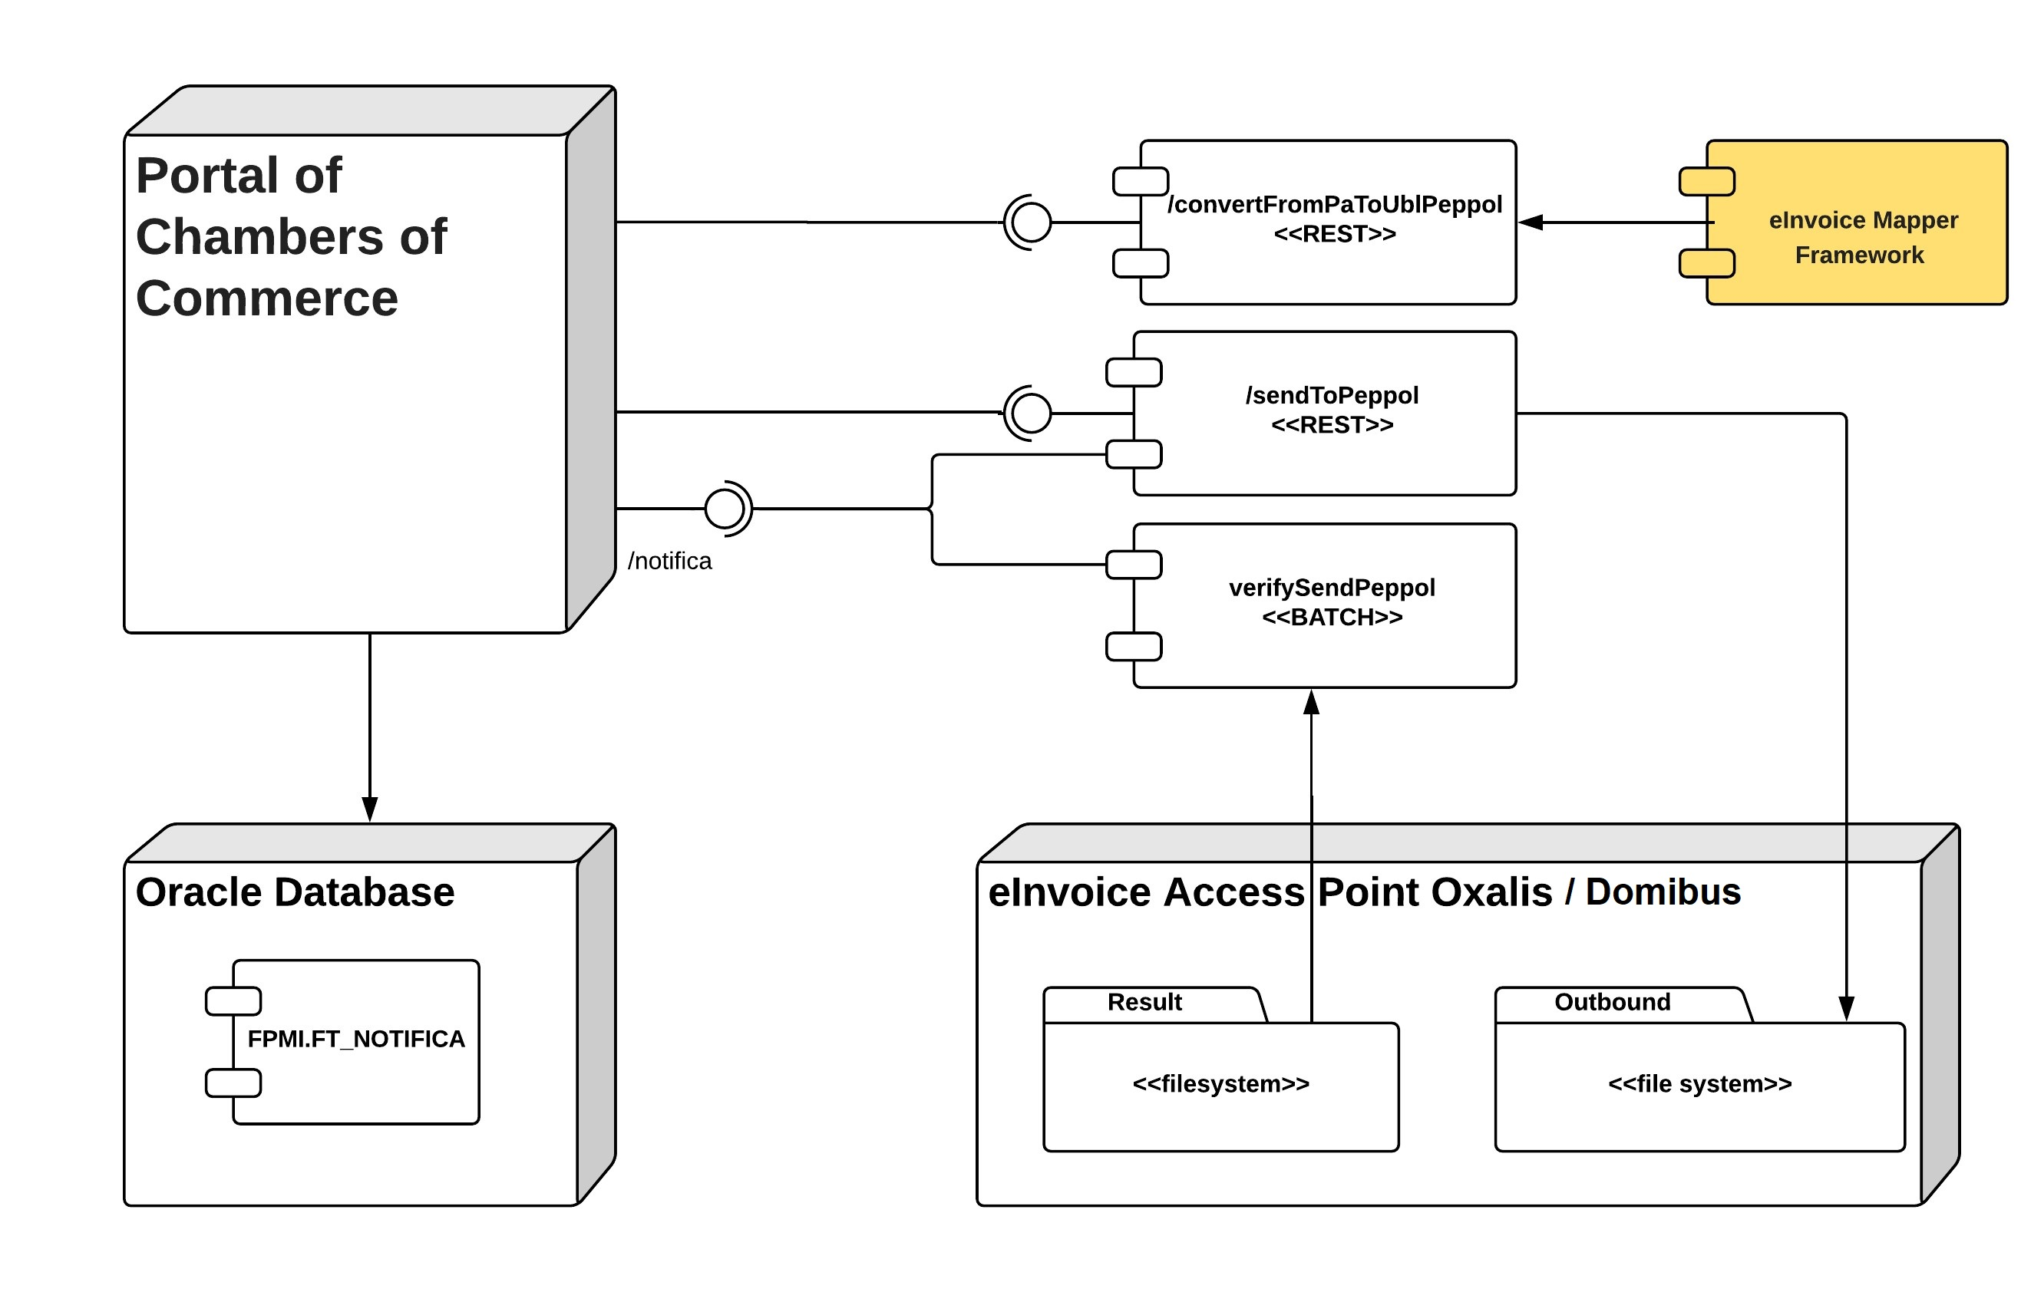

## Technology

|  |  |
| --- | --- |
| **Type** | **Technologies** |
| **DBMS** | Oracle |
| **Middleware** | N\A |
| **Develompment Language** | Java |
| **JVM build version** | 1.8 |
| **Build Software** | Maven 3+ |
| **Configuration framework** | Spring Boot |

# Key Findings

## Architectural Decision

The following issues were analyzed and solved in order to provide a consistent software design:

|  |  |
| --- | --- |
| **Title** | **Decision** |
| **Implementation environment** | As requested by the Agreement, the eInvoice mapper will be implemented using only opens source technologies; the software libraries used by the application will follow this approach. |
| **Compatibility with pre-existing SDI system software** | The Infocamere application environment is based on a Spring Boot Framework running on JDK 8 |
| **Data persistency** | The software will save any kind of transient information in actual database present in Infocamente system. |
| **Configuration strategy** | All the properties of the software are filesystem based; the local path can be added as a Property object or injected as JNDI resource. |
| **Integrability** | The API layer is made of public java methods related to the high-level functionalities (validate, transform). |
| **Log management** | As requested by the Infocamere, the logging framework SLF4J will be used by the application. |