|  |
| --- |
|  |

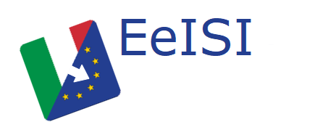

European eInvoicing Standard in Italy

|  |  |
| --- | --- |
| **Project number** | INEA/CEF/ICT/A2017/1560867 2017-IT-IA-0150 |
| **Project acronym** | EeISI |
| **Project title** | European eInvoicing Standard in Italy |
| **Starting date** | 1 May 2018 |
| **Ending date** | 30 June 2019 |
| **Programme** | Connecting Europe Facility (CEF) CEF-TC-2017-3: eInvoicing |

Design of the eDelivery architecture for LegalInvoiceHub

Deliverable D3.8

|  |  |
| --- | --- |
| **Related WP** | WP3 – Design – Task 3.3 eDelivery upgrade |
| **Deliverable number** | D3.8 |
| **Due date** | 30/11/2018 |
| **Revision date** | 30/11/2018 |
| **Actual date** | **30/11/2018** |

This Page Intentionally Left Blank

Deliverable Info

|  |  |
| --- | --- |
| **Editor (s)** | **InfoCert** |
| **Contributors** | **InfoCert** |
|  |  |
| **Abstract** | **This deliverable aims to describe the eDelivery design for LegalInvoice hub framework of InfoCert.** |
| **Keywords** | **eInvoicing, semantic core model, Italian eInvoicing format, LegalInvoice, eDelivery, AS4, access point, SDI** |
|  |  |
| **Acknowledgement** | This work was partially supported by the European Commission (EC) through the Connecting Europe Facility (CEF) programme under project EeISI.(grant agreement no. INEA/CEF/ICT/A2017/1560867 2017-IT-IA-0150) |
| **Disclaimer** | The sole responsibility of this publication lies with the author(s). The European Union is not responsible for any use that may be made of the information contained therein. |
| **Confidentiality** | The information in this document is confidential and restricted only to the members of the EeISI consortium  (including the Commission Services). |
|  |  |
| **Note** | - |
|  |  |

**Version Control**

|  |  |  |  |
| --- | --- | --- | --- |
| Version | Date | Author | Description of change |
| 0.0.1 | 2018-11-30 | Elisa Salvagnin | First draft |
| 0.0.2 | 2018-12-14 | Maurizio Polenta | Added chapter 4 |
| 0.1.0 | 2018-12-28 | InfoCert | First release |
| 0.1.1 | 2019-01-10 | InfoCert | Revision of AS4 description |
| 1.0.0 | 2019-01-15 | InfoCert | Final version |
| 1.0.1 | 2020-03-31 | Roberto Reale | Technical review and quality assessment |

This Page Intentionally Left Blank

Table of contents

Deliverable Info 4

Table of contents 6

List of figures 6

List of tables 6

Executive Summary 7

Glossary 9

1. Normative references 10

2. Communication Flow in EeISI 10

3. Design of InfoCert AS4 Access Point 12

4. Infocert LegalInvoice Hub 13

4.1. LegalInvoice Hub Overview 13

4.2. LegalInvoice Hub main scenario 14

4.3. LegalInvoice Hub components 15

4.4. LegalInvoice Hub eDelivery update 19

4.4.1. New European invoice syntaxes 19

4.4.2. New SDI channel integration (AS IS solution) 20

4.4.3. New SDI channel integration (TO BE solution not yet ready) 21

List of figures

Figure 1 – EeISI proposed AS4/SDI network channels 11

Figure 2 LIHub architetcure 13

Figure 3 LIHub processes 14

Figure 4 SDI communication channels 14

Figure 5 LegalInvoice dashboard 16

Figure 6 LegalInvoice Professional 17

Figure 7 LegalDoc Web 18

Figure 8 LIHub integration 19

Executive Summary

This document aims to describe the eDelivery solution design for LegalInvoice Hub framework carried out by InfoCert within EeISI project. The solution design mainly interests:

* eDelivery architecture in InfoCert
* eDelivery use cases in InfoCert

This Page Intentionally Left Blank

Glossary

|  |  |
| --- | --- |
| **AP** | Access Point |
| **AS4** | Applicability Statement 4 |
| **B2B** | Business to Business |
| **B2C** | Business to Consumer/Citizen |
| **B2G** | Business to Government |
| **BII** | Business Interoperability Interfaces |
| **C2G** | Citizen to Government |
| **CCTS** | Core Component Technical Specification |
| **CEF** | Connecting Europe Facility |
| **CEM** | Certified Electronic Mail – Legal Mail (PEC Posta Elettronica Certificata in Italy) |
| **CEN** | European Committee for Standardisation |
| **CII** | Cross Industry electronic Invoice |
| **CIUS** | Core Invoice Usage Specification |
| **DNS** | Domain Name System |
| **DSI** | Digital Service Infrastructures |
| **EDIFACT** | Electronic Data Interchange For Administration, Commerce and Transport |
| **EMSFEI** | European Multi-Stakeholder Forum on eInvoicing |
| **e-SENS** | Electronic Simple European Networked Services |
| **FatturaPA** | Public administration electronic invoice framework (FatturaPubblica Amministrazione) |
| **G2G** | Government to Government |
| **IMR** | Invoice Message Response |
| **INEA** | Innovation and Networks Executive Agency |
| **MLR** | Message Level Response |
| **OASIS** | Organization for the Advancement of Structured Information Standards |
| **PEPPOL** | Pan-European Public Procurement Online |
| **PEPPOL-BIS** | Pan-European Public Procurement Online Business Interoperability Specifications |
| **SDI** | Electronic exchange system in Italy (Sistema Di Interscambio) |
| **SML** | Service Metadata Locator |
| **SMP** | Service Metadata Publisher |
| **UBL** | Universal Business Language |
| **UN/CEFACT** | United Nations Centre for Trade Facilitation and Electronic Business |
| **UNTDID** | UN Trade Data Interchange Directory |
| **URI** | Uniform Resource Identifier |
| **URL** | Uniform Resource Location |
| **URN** | Uniform Resource Name |
| **XML** | Extensible Mark-up Language |

1. Normative references

The following documents, in whole or in part, are normatively referenced in this document and are indispensable for its application.

* EN 16931-1:2017 Electronic invoicing - Part 1: Semantic data model of the core elements of an electronic invoice

Moreover the following Italian documentation is referenced in this deliverable:

* Schema del file xml FatturaPA versione 1.2 - xsd
* Specifiche tecniche del formato della FatturaPA versione 1.2.1- pdf
* Rappresentazione tabellare del tracciato FatturaPA versione 1.2.1- pdf
* Rappresentazione tabellare del tracciato FatturaPA versione 1.2.1- excel
* Foglio di stile per la visualizzazione della FatturaPA versione 1.2.1 - xslt
* generica Foglio di stile per la visualizzazione della Fattura Ordinaria versione 1.2.1 - xslt
* Elenco modifiche al tracciato FatturaPA - pdf
* Suggerimenti per la compilazione della FatturaPA versione 1.5

1. Communication Flow in EeISI

Prerequisite to this paragraph: all eInvoices addressed to Italian PAs must be forwarded to SDI.

Four types of communication nodes have been defined in EeISI in order to send and receive business documents:

* **"Corner 2" Peppol Access Point,** such as **InfoCert** one, which is a document receiver and sender to/from other Peppol Access Points
* **"Corner 3" Peppol Access Point**which has the additional feature of *sending documents to SDI through web server and FTP channels*
* **SDI**, which is **not** a Peppol-access-point node but manages messages through traditional channels: web servers, FTP and PEC (according to amendment request proposed by AdE in December 2018)
* **Italian Public Administrations (PAs)**, which receive documents through traditional channels from SDI as they are registered to a "Corner 3" Peppol Access Point

The following is a sample communication flow, which is also represented in Figure 1:

1. Economic operator sends a document to the Access Point (Corner 2) where it is registered through the SMP
2. Corner 2 Access Point looks for the receiving Access Point (Corner 3) in the Address Registry (SML-SMP)
3. Corner 2 Access Point sends the document to Corner 3 Access Point
4. Corner 3 Access Point forwards the document to SDI through web servers or FTP
5. SDI checks the document and forwards it to the receiving PA through web servers, FTP or PEC
6. SDI sends notification to Corner 3/SDI service provider
7. Corner 3 sends notification to Corner 4

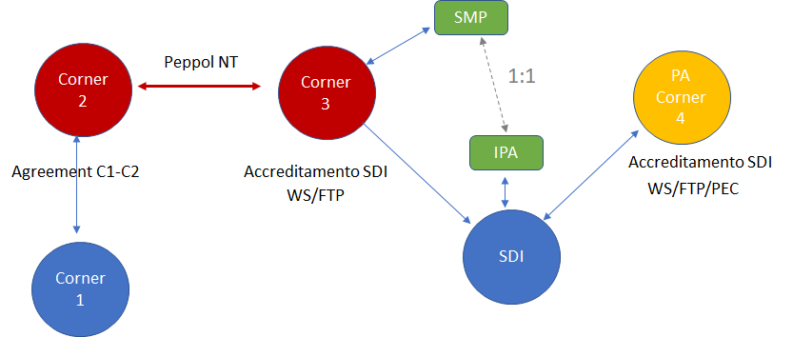

Figure 1 – EeISI proposed AS4/SDI network channels

InfoCert has chosen to implement a Corner 2 Peppol Access Point, which **does not provide**, at the moment of this project, the feature of forwarding invoices received from Peppol network to traditional SDI channels.

Hence the following use cases apply to InfoCert:

1. Italian Sender that is registered to InfoCert AP, Italian Receiver that is registered to a Corner 3 AP
2. Foreign Sender that is registered to InfoCert AP, Italian Receiver that is registered to a Corner 3 AP

Our partner **Infocamere** deals with scenarios that takes into consideration a Foreign Receiver. **Intercenter** is a potential candidate as Corner 3 Peppol Access Point/SDI service provider, hence an Italian receiving actor. **AGID** manages the SMP and updating of IPA based on SMP.

Please note that IMR/MLR notifications are not specified in the communication diagram. InfoCert has decided not to include them in the final solution as they are not mandatory in the current Peppol Business Interoperability Specifications. Current references are:

* [BIS Invoice Response](http://docs.peppol.eu/poacc/upgrade-3/profiles/63-invoiceresponse/)
* [BIS Message Level Response](http://docs.peppol.eu/poacc/upgrade-3/profiles/36-mlr/)

1. Design of InfoCert AS4 Access Point

A general approach is adopted in order to make the access point independent from the application it uses. The following components will be in place:

* **AP** is the AS4 Access Point strictly focused on receiving/sending messages that are agnostic with respect to the payload electronic business documents. It is implemented based on the **Domibus** open-source project
* **AP front end is** responsible for importing the received documents and sending the issued documents
* **SMP** is the Service Metadata Publisher registering the managed recipients and their respective APs

The **implementation plan of the eDelivery solution includes the following steps:**

* **AS4 server configuration  
  Configuration of the (virtual) server intended to host the AS4 implementation in test and production environments. The server will be provided with the Linux Debian operating system and the Oracle JDK execution environment**
* **Access point implementation  
  Development of the AS4 Access Point component, which is strictly focused on receiving/sending messages potentially including any kind of electronic (business) documents. It will be obtained by customizing the Domibus open-source project**
* **Development of the AP front end  
  Development of the AP front end with its incoming message processing and outgoing message enveloping**
* **The SMP will be implemented by our partner AGID**

1. Infocert LegalInvoice Hub
   1. LegalInvoice Hub Overview

LegalInvoice Hub (LIHub) is a layered application that allow the execution of workflow related to the electronic invoices.

Its main characteristics are:

* Fast time to solution - easy management of the application components through a Camel engine.
* Extensive connectivity – includes connectivity for the most common communication protocols: FTP, HTTP (ws, rest), jms,activeMQ,…
* Flexible configuration – Dynamic configurations enable customized solutions at every endpoint, distributor, outlet or device.
* Proven reliability and Support – track record of supporting mission-critical applications and backed by the product support

The application is built on a stack of components; some of them offer specific functionalities to the system, other are cross application nodes that allow the control and the persistence of the information flow.

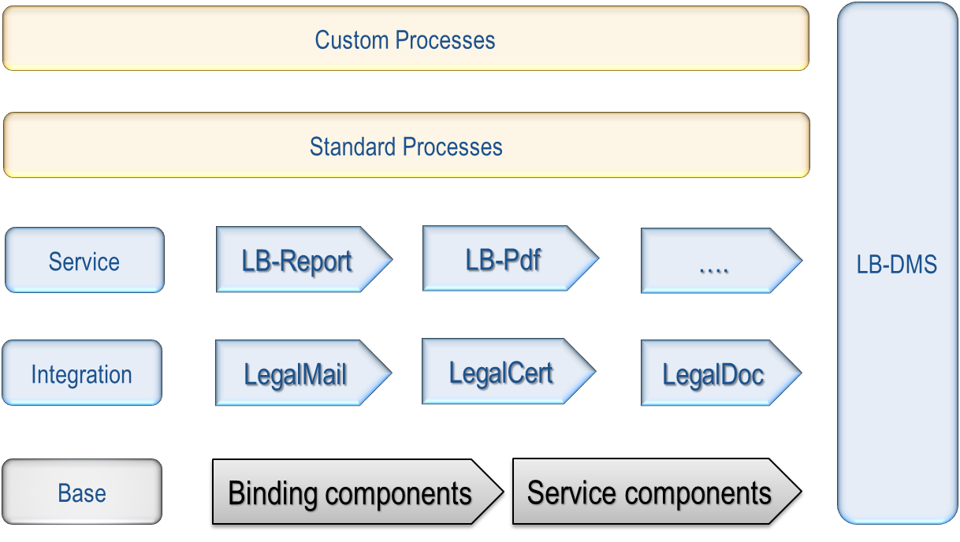

Figure 2 LIHub architetcure

The standard processes that are managed by LIHub are composed by three steps:

* 1. document acquisition,
  2. document processing,
  3. information export.

The main application nodes are related to the standard Infocert services: Digital Certification, Legal Mail, Legal Archiving.

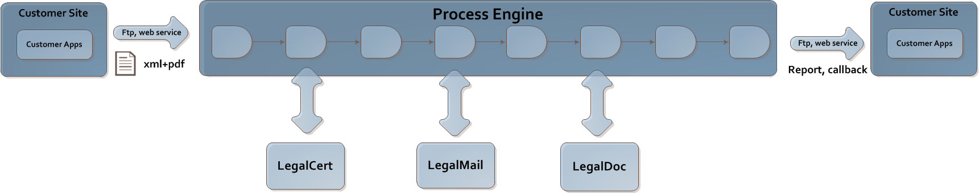

Figure 3 LIHub processes

* 1. LegalInvoice Hub main scenario

The LIHub system provides services related to the electronic invoice Italian process.

According to the Italian process, all the invoices:

* have to follow a specific semantic and have to be formatted in a xml syntax
* have to be transmitted to the Italian Tax Agency (SDI) for a first validation
* are transmitted to the receiver by the SDI if this task is expected

The SDI has defined three main communication channels: FTP, PEC (Italian legal mail), Web Service.

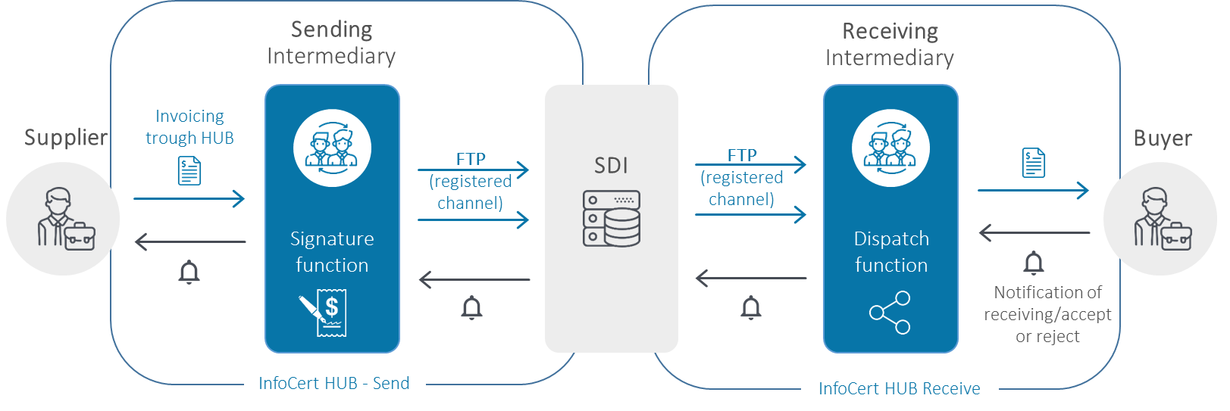

Figure 4 SDI communication channels

Infocert, with LegalInvoice Hub, acts as a technical mediator; an intermediary is the subject which receives or sends invoices on behalf of economic operators and/or Public Administrations.

Its main goals are:

1. Formal validation of the xml invoice that has been sent by the emitting company.
2. Digital signature of the invoice.
3. Exchange of data flow with the SDI through its communication channels
   1. LegalInvoice Hub components

The LIHub system is made of the following main applications:

* **LegalInvoice Hub Core Engine**: backend application and its communication interfaces (web service Rest based and FTP)
* **Legalinvoice Dashboard**: web application for the monitoring of the electronic invoices, both inbound and outbound.
* **Legalinvoice Professional:** web application for the import or manual composition of the invoice
* **LegalDoc Web**: web client for the legal archiving platform
* **PDF Portal**: web application for the transformation and delivery of invoices starting from their pdf format.

All the web modules are full integrated with the LegalInvoice Hub Core Engine:

**Legalinvoice Dashboard:**

[A screenshot of a social media post

Description generated with very high confidence](https://legalinvoice-dashboardcl.infocert.it/)

Figure 5 LegalInvoice dashboard

**Legalinvoice Professional:**

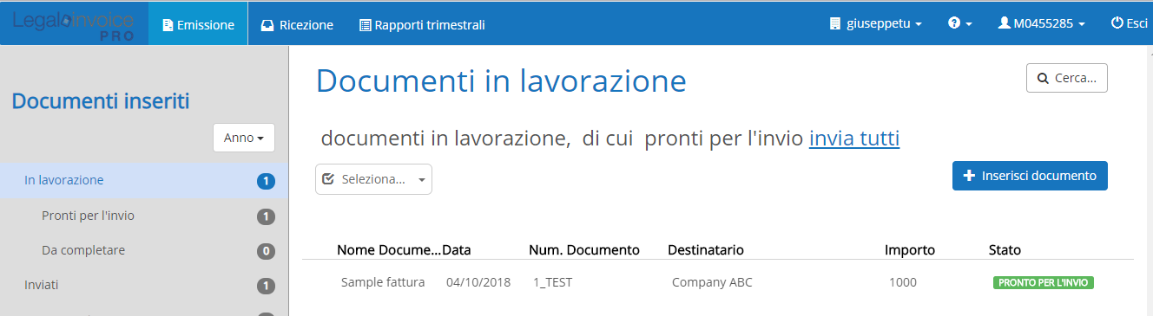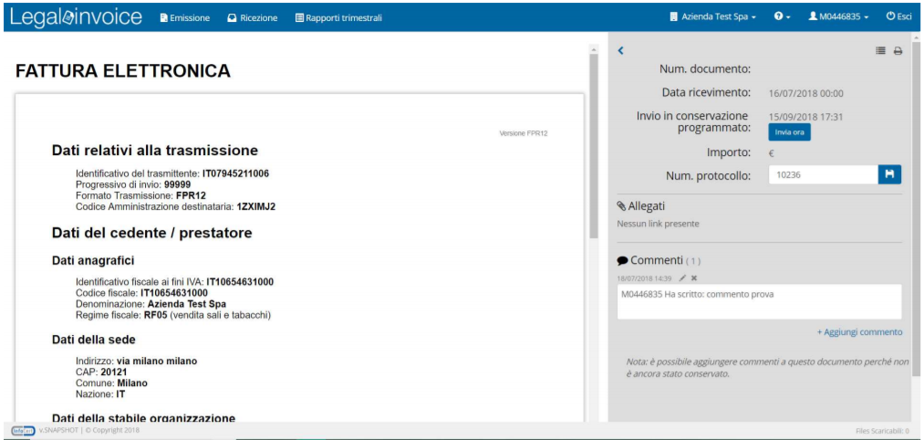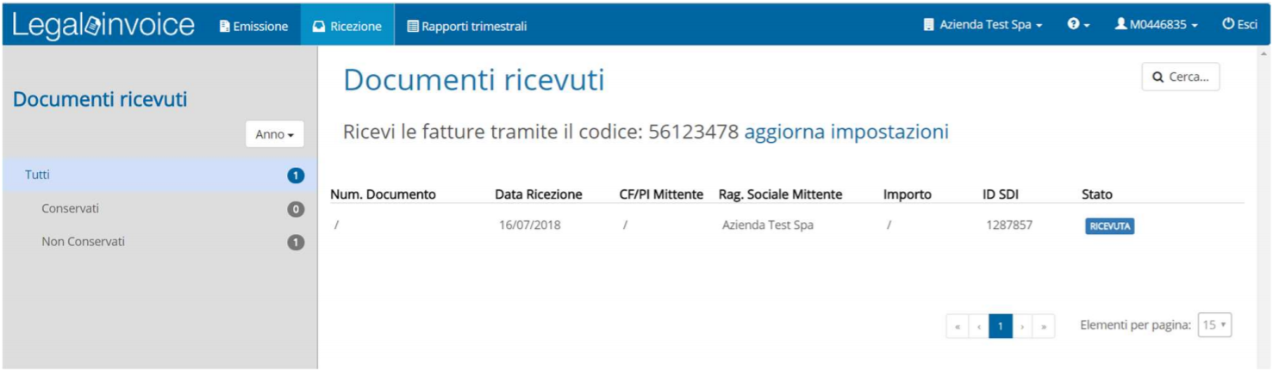

Figure 6 LegalInvoice Professional

**LegalDoc Web:**

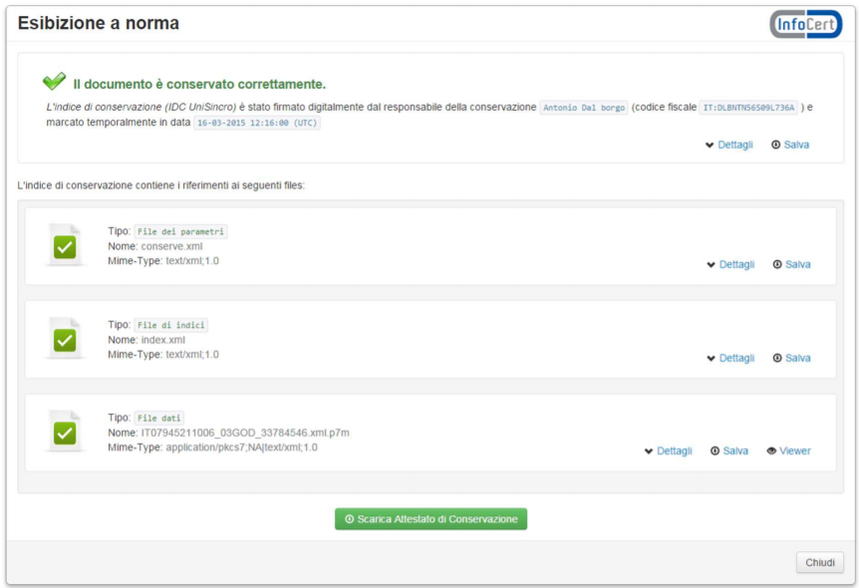

Figure 7 LegalDoc Web

* 1. LegalInvoice Hub eDelivery update

The LegalInvoice Hub system is updated in two ways:

1. The new European invoice syntaxes are managed in addition to the Italian formats.
2. A new SDI channel must be integrated to allow the transport of the invoices in European format (TO BE solution not yet ready for SDI).

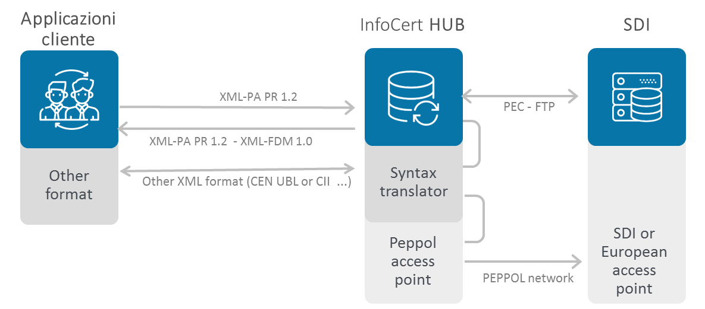

Figure 8 LIHub integration

* + 1. New European invoice syntaxes

The Invoice Mapper allows the use of the new CEN syntaxes which allows enterprises to send invoices to all European Public Administrations according Directive 2014/55/EU.

The mapper act as a syntax translator and is added to the LIHub system in both the validation node and the transformation node. According to the syntax of the invoice and the syntax that is expected by the receiver, the electronic invoice is validated and transformed in one of the three available formats:

* FattPA
* CII
* Ubl
  + 1. New SDI channel integration (AS IS solution)

Within this scenario the LIHub system has been upgraded with the aim to import, manage and forward different invoice formats.

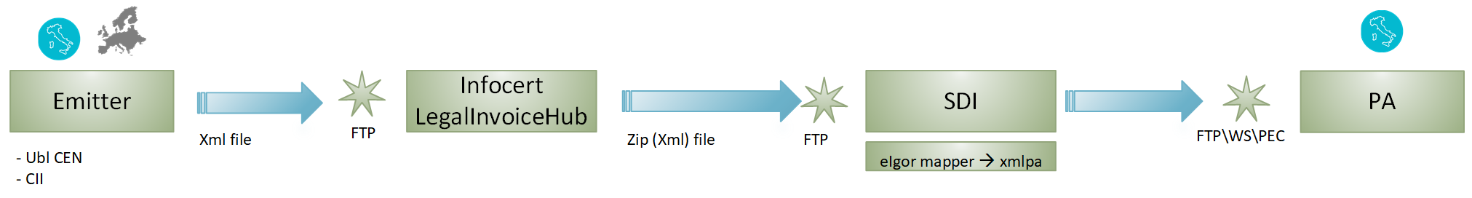

The SDI, on the other hand, has been modified to manage this new content too.

The LIHub system has been modified in all its main application layer:

1. External interfaces:   
   The FTP interface can now import xml files of the different European formats.
2. Pre-processing modules:   
   Currently we can receive Italian invoices in different formats (pdf, csv, ecc); the European invoices must be sent already in the definitive xml format.
3. Document System:   
   Due to the different metadata of the new formats, two new document classes have been defined in the DMS that underlies LIHub.
4. Validation and extraction module:   
   The input files are validated towards their main schema; some information is extracted from the invoice due to guarantee its correct routing.
5. Digital signature module:   
   The digital signature of a European invoices isn’t mandatory, this task is skipped; we’ve maintained the digital signature of the invoices just for the Italian ones.
6. Transformation modules:   
   The SDI has defined a specific rule for the naming of the invoice files in the European format; the transformation module applies this new policy.
7. Output modules:   
   Infocert owns a certified communication channel with the SDI; within this channel, due to the abstract packaging format (archive files in zip format), the European invoices can be added without modifications of the application.

The SDI will maintain the current communication channels that it uses for other fiscal documents (mainly: sFTP, HTTP web service, PEC).

When the SDI will receive an invoice in European formats, it will validate it (using Eigor mapper component) and transform it in an invoice in Italian syntax.

Some of SDI policy have been maintained due to the Italian law constraints:

* Maximum size of the invoice file (5MB)
* Valid VAT code for the Italian companies in the invoice.
* Correct amount calculations.
  + 1. New SDI channel integration (TO BE solution not yet ready)

The SDI will provide a new communication channel, an AS4 Access point in future.

The LIHub system will add this channel to its platform to allow the delivery of electronic invoices also in this way.

With both the APs provided, the AS4 channel can be used as an alternative to the classic ones.

Instead of using an FTP channel, the Infocert AP will provide an API layer (HTTPS web service) to receive invoices from the suppliers.

The Infocert AP will be tightly integrated with LIHub and will use its modules of validation and transformation.

After the validation of the invoice, the Infocert AP will send the invoice to the receiver AP (SDI AP) that will manage the communication with the Public Administration.

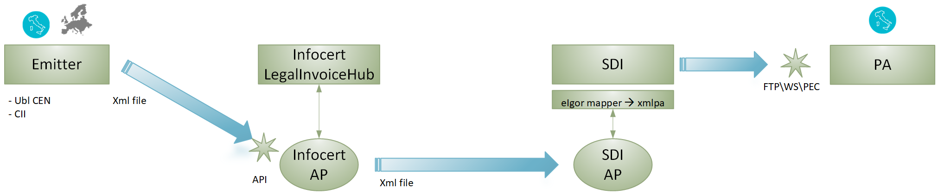

The main goal of this scenario is to allow European supplier to send invoices in a standard network without the necessity of integrate the (custom) local services of each country.

The LIHub system will maintain the standard communication channels with the SDI anyway.