|  |
| --- |
|  |



European eInvoicing Standard in Italy

|  |  |
| --- | --- |
| **Project number** | INEA/CEF/ICT/A2017/1560867 2017-IT-IA-0150 |
| **Project acronym** | EeISI |
| **Project title** | European eInvoicing Standard in Italy |
| **Starting date** | 1 May 2018 |
| **Ending date** | 30 June 2019 |
| **Programme** | Connecting Europe Facility (CEF) CEF-TC-2017-3: eInvoicing |

eDelivery Access Point implementation report

Deliverable D4.10

|  |  |
| --- | --- |
| **Related WP** | WP4 – Implementation – Task 4.10 eDelivery Access Point implementation report |
| **Deliverable number** | D4.10 |
| **Due date** | 31/01/2019 |
| **Revision date** | 31/01/2019 |
| **Actual date** | **31/01/2019** |

This Page Intentionally Left Blank

Deliverable Info

|  |  |
| --- | --- |
| **Editor (s)** | **InfoCert** |
| **Contributors** | **InfoCert** |
|  |  |
| **Abstract** | **This deliverable aims to provide the eDelivery implementation report of InfoCert AS4 eSENS profile.** |
| **Keywords** | **eInvoicing, semantic core model, Italian eInvoicing format, LegalInvoice, eDelivery, AS4, access point, SDI** |
|  |  |
| **Acknowledgement** | This work was partially supported by the European Commission (EC) through the Connecting Europe Facility (CEF) programme under project EeISI.(grant agreement no. INEA/CEF/ICT/A2017/1560867 2017-IT-IA-0150) |
| **Disclaimer** | The sole responsibility of this publication lies with the author(s). The European Union is not responsible for any use that may be made of the information contained therein. |
| **Confidentiality** | The information in this document is confidential and restricted only to the members of the EeISI consortium  (including the Commission Services). |
|  |  |
| **Note** | - |
|  |  |

**Version Control**

|  |  |  |  |
| --- | --- | --- | --- |
| Version | Date | Author | Description of change |
| 0.0.1 | 2018-01-31 | Elisa Salvagnin | First draft |
| 0.0.2 | 2018-01-31 | InfoCert | Minor revision |
| 0.0.3 | 2018-01-31 | InfoCert | Minor revision |
| 0.1.0 | 2018-03-31 | InfoCert | Final release |
| 0.1.1 | 2020-03-31 | Roberto Reale | Technical review and quality assessment |

This Page Intentionally Left Blank

Table of contents

Executive Summary 7

Glossary 8

1. Normative references 9

2. InfoCert AS4 Access Point eSENS profile – Implementation details 9

2.1. InfoCert AS4 Domibus API 10

2.1.1. Getting the list of available messages received by the Access Point 10

2.1.2. Sending a message 10

2.1.3. Retrieving a message that is available in the AP 11

2.1.4. Getting the status of a message that has been sent by the AP 11

3. SMP 13

4. InfoCert AS4 certification on OpenPeppol network 14

4.1. Processes and Documents 16

5. InfoCert AS4 certification process through CEF eDelivery connectivity test 16

List of figures

Figure 1 – Usage of certificates in Peppol and Oasis *(* from Domibus administration guide)* 11

Figure 2 – AS4 sent message status *(* from Domibus administration guide)* 13

Figure 3 – AS4 received message status *(* from Domibus administration guide)* 13

Figure 4 - InfoCert AS4 OpenPeppol testbed report 15

Figure 5 – InfoCert AS4 on OpenPeppol directory 16

Figure 6 – Number of AS2 and AS4 - OpenPeppol network (March 2019) 16

Figure 7 – Distribution per country of AS2 and AS4 – OpenPeppol netwok (March 2019) 16

Figure 8 – AS4 security process *(* from Domibus Quick Start Guide)* 18

Figure 9 – CEF eDelivery connectivity test – Static Discovery 19

Figure 10 - Email example for CEF eDelivery connectivity test - static discovery 20

Executive Summary

This document aims to provide the eDelivery implementation report for AS4 migration carried out by InfoCert within EeISI project. The implementation report mainly covers:

* AS4 Domibus implementation
* SMP temporary registration
* AS4 certification process on OpenPeppol Network
* AS4 certification process through CEF eDelivery connectivity test

Glossary

|  |  |
| --- | --- |
| **AP** | Access Point |
| **AS4** | Applicability Statement 4 |
| **B2B** | Business to Business |
| **B2C** | Business to Consumer/Citizen |
| **B2G** | Business to Government |
| **BII** | Business Interoperability Interfaces |
| **C2G** | Citizen to Government |
| **CCTS** | Core Component Technical Specification |
| **CEF** | Connecting Europe Facility |
| **CEM** | Certified Electronic Mail – Legal Mail (PEC Posta Elettronica Certificata in Italy) |
| **CEN** | European Committee for Standardisation |
| **CII** | Cross Industry electronic Invoice |
| **CIUS** | Core Invoice Usage Specification |
| **DNS** | Domain Name System |
| **DSI** | Digital Service Infrastructures |
| **EDIFACT** | Electronic Data Interchange For Administration, Commerce and Transport |
| **EMSFEI** | European Multi-Stakeholder Forum on eInvoicing |
| **e-SENS** | Electronic Simple European Networked Services |
| **FatturaPA** | Public administration electronic invoice framework (FatturaPubblica Amministrazione) |
| **G2G** | Government to Government |
| **IMR** | Invoice Message Response |
| **INEA** | Innovation and Networks Executive Agency |
| **MLR** | Message Level Response |
| **OASIS** | Organization for the Advancement of Structured Information Standards |
| **PEPPOL** | Pan-European Public Procurement Online |
| **PEPPOL-BIS** | Pan-European Public Procurement Online Business Interoperability Specifications |
| **SDI** | Electronic exchange system in Italy (Sistema Di Interscambio) |
| **SML** | Service Metadata Locator |
| **SMP** | Service Metadata Publisher |
| **UBL** | Universal Business Language |
| **UN/CEFACT** | United Nations Centre for Trade Facilitation and Electronic Business |
| **UNTDID** | UN Trade Data Interchange Directory |
| **URI** | Uniform Resource Identifier |
| **URL** | Uniform Resource Location |
| **URN** | Uniform Resource Name |
| **XML** | Extensible Mark-up Language |

1. Normative references

The following documents, in whole or in part, are normatively referenced in this document and are indispensable for its application.

* EN 16931-1:2017 Electronic invoicing - Part 1: Semantic data model of the core elements of an electronic invoice

Moreover the following Italian documentation is referenced in this deliverable:

* Schema del file xml FatturaPA versione 1.2 - xsd
* Specifiche tecniche del formato della FatturaPA versione 1.2.1- pdf
* Rappresentazione tabellare del tracciato FatturaPA versione 1.2.1- pdf
* Rappresentazione tabellare del tracciato FatturaPA versione 1.2.1- excel
* Foglio di stile per la visualizzazione della FatturaPA versione 1.2.1 - xslt
* generica Foglio di stile per la visualizzazione della Fattura Ordinaria versione 1.2.1 - xslt
* Elenco modifiche al tracciato FatturaPA - pdf
* Suggerimenti per la compilazione della FatturaPA versione 1.5

1. InfoCert AS4 Access Point eSENS profile – Implementation details

InfoCert has chosen to implement the Access Point AS4 eSENS profile using the open source **Domibus** solution, version 4.0.2 for Tomcat, based on the available CEF [documentation](https://ec.europa.eu/cefdigital/wiki/display/CEFDIGITAL/Domibus).

The chosen server installations are the following:

1. Operating System: Debian 492 (Linux)
2. Front end Application Server: Apache 2
3. Back end Application Server: Tomcat 8

InfoCert has chosen Domibus solution as fully compliant with CEF specifications for AS4 profile.

Within EeISI project InfoCert carried out the migration from AS2 to AS4 with CEF funding.

InfoCert decided to certify the AS4 both on OpenPeppol network and being able to communicate with CEF AS4 test network.

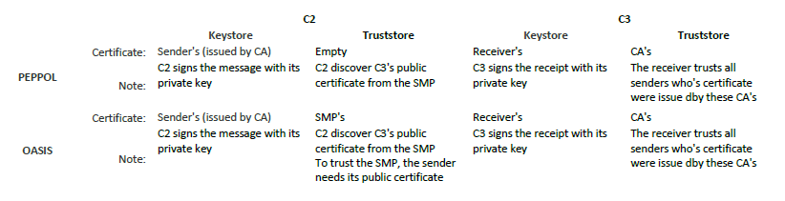

Figure 1 – Usage of certificates in Peppol and Oasis *(* from Domibus administration guide)*

The InfoCert AS4 Access Point is reachable via API Rest Services in test and production environments at the following Base URLs:

* **Test** <https://peppol-ap-collaudo.infocert.it/domibus-proxy>
* **Production** <https://peppol-ap.infocert.it/domibus-proxy>
  1. InfoCert AS4 Domibus API

The following main API are available for the usage of InfoCert AS4 Domibus:

* Get a list of pending message
* Send a message
* Retrieve a message
* Retrieve the status of a sent message
  + 1. Getting the list of available messages received by the Access Point

**GET /list-pending-messages**

The Response contains the IDs of the pending messages. Examples

*"092f53d8-b02c-4b1a-b291-43482247dffa@domibus.eu_1","953752d8-b02c-4b1a-b291-43482247dffa@domibus.eu"*

* + 1. Sending a message

**POST** [**/submit-message**](https://peppol-ap-collaudo.infocert.it/domibus-proxy/submit-message)

The **Body** has the following **mandatory** parameters:

**service**: the Process ID related to the message to be sent. Example for Billing Profile V3 “urn:fdc:peppol.eu:2017:poacc:billing:01:1.0”

**action**: the Document ID that defines the message to be sent. Example for Invoice in Billing V3 Profile “busdox-docid-qns::urn:oasis:names:specification:ubl:schema:xsd:Invoice-2::Invoice##urn:cen.eu:en16931:2017#compliant#urn:fdc:peppol.eu:2017:poacc:billing:3.0::2.1”

**conversationId**: an Identifier for the conversation, can be any string that describes the conversation

**originalSender**: the ParticipantId of the sending AP. InfoCert example: "9906:it07945211006"

**finalRecipient**: the ParticipantId of the receiving AP. InfoCert example: "9906:it07945211006"

**messagePayload**: the base64 encoding of the message to be sent

The **Response** contains the ID of the sent message. Example: [*092f53d8-b02c-4b1a-b291-43482247dffa@domibus.eu*](mailto:092f53d8-b02c-4b1a-b291-43482247dffa@domibus.eu_1)

* + 1. Retrieving a message that is available in the AP

**POST** [**/retrieve-message**](https://peppol-ap-collaudo.infocert.it/domibus-proxy/retrieve-message)

Input Query Parameter: **messageId**. Example: [092f53d8-b02c-4b1a-b291-43482247dffa@domibus.eu_1](mailto:092f53d8-b02c-4b1a-b291-43482247dffa@domibus.eu_1)

The Response contains the same fields as the Body of the submit-message API.

* + 1. Getting the status of a message that has been sent by the AP

**POST** [**/get-status**](https://peppol-ap-collaudo.infocert.it/domibus-proxy/get-status)

Input Query Parameter: **messageId**. Example: [ef9c96e9-9e7f-4acc-be7c-8d58ad76e039@domibus.eu](mailto:ef9c96e9-9e7f-4acc-be7c-8d58ad76e039@domibus.eu)

Response: a string defining the message status, which can be one of the following:

1. READY_TO_SEND
2. SEND_ENQUEUED
3. SEND_IN_PROGRESS
4. WAITING_FOR_RECEIPT
5. ACKNOWLEDGED
6. ACKNOWLEDGED_WITH_WARNING
7. SEND_ATTEMPT_FAILED
8. SEND_FAILURE
9. WAITING_FOR_RETRY
10. RECEIVED
11. RECEIVED_WITH_WARNINGS
12. REJECTED
13. DELETED
14. NOT_FOUND

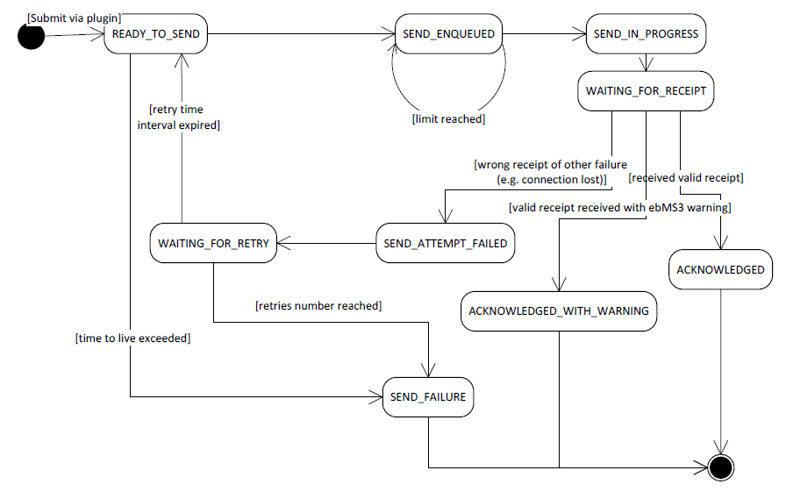

Figure 2 – AS4 sent message status *(* from Domibus administration guide)*

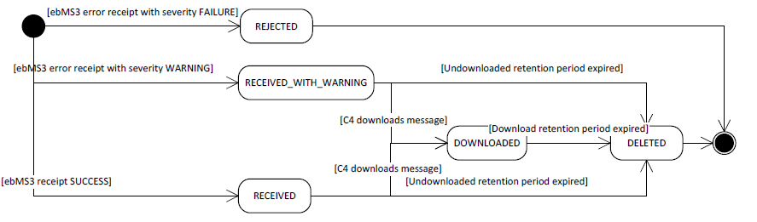

Figure 3 – AS4 received message status *(* from Domibus administration guide)*

Status from 1 to 9 refers to a sent message (Corner C2). Please see Figure 1 for specific workflow.

Status from 10 to 13 refers to a received message (Corner C3). Please see Figure 2 for specific workflow.

Status 14 refers to a non-existing message.

1. SMP

The Access Point is currently registered to the Satanet SMP as temporary solution. The services will be registered in a single national SMP made available by AgiD if InfoCert will decide to act as AP/Service provider for SDI.

At the moment the InfoCert AS4 is registered on:

* SMK test environment <http://smp-peppol-test-sia-eu.satanet.it/public/>
* SML production environment <http://smp-peppol-prod-sia-eu.satanet.it/public/>

1. InfoCert AS4 certification on OpenPeppol network

In the view of being certified as AS4 within the OpenPeppol network InfoCert carried out the certification process with Peppol central authority.

The PEPPOL certificates installed on the InfoCert AS4 Access Point are the same that were previously used by the InfoCert AS2 Access Point. The AS2 access point was installed in 2018 by InfoCert with its private funding (no CEF funding for this AS2).

The Access Point has passed Peppol Conformance Testing in March 2019 and is listed in the official list of Certified AS4 Peppol Access Points: <https://peppol.eu/who-is-who/peppol-certified-aps/>.

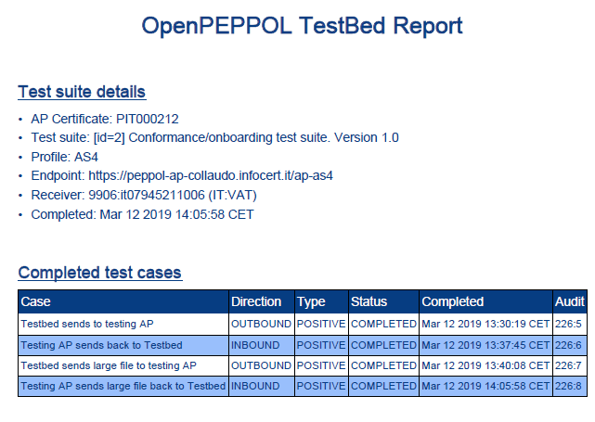

Figure 4 - InfoCert AS4 OpenPeppol testbed report

The TestBedReport is available here: <https://testbed.peppol.eu/api/report/vcE3mamQFwYZEa6L2F0I9zXSnb11zcEZsByT>.

The situation of OpenPeppol network as of March 2019 is represented in the following figures. Unfortunately, only about 8% of existing access points are AS4.

See <https://peppol.eu/who-is-who/peppol-certified-aps/> where the certification of InfoCert AS4 is documented.

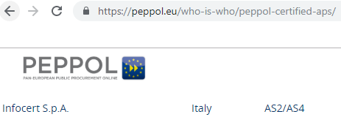

Figure 5 – InfoCert AS4 on OpenPeppol directory

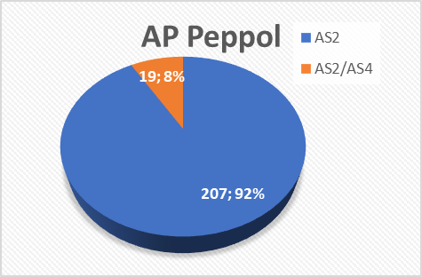

Figure 6 – Number of AS2 and AS4 - OpenPeppol network (March 2019)

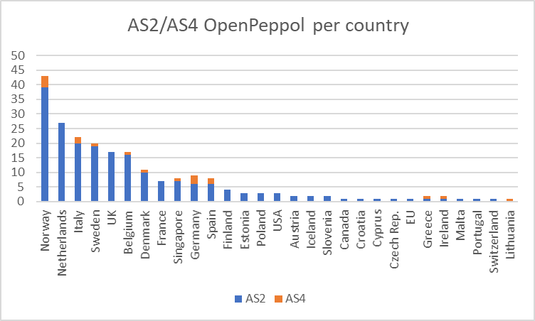

Figure 7 – Distribution per country of AS2 and AS4 – OpenPeppol netwok (March 2019)

In Italy, on March 2019, there were two AS4 on OpenPeppol network. One of these APs is the InfoCert AS4.

* 1. Processes and Documents

The InfoCert AS4 Access Point is currently registered to receive all types of documents on OpenPeppol network related to **Billing V3 BIS Profile**:

**ProcessID**: urn:fdc:peppol.eu:2017:poacc:billing:01:1.0

**DocumentIDs**:

1. **Invoice**: urn:oasis:names:specification:ubl:schema:xsd:Invoice-2::Invoice##urn:cen.eu:en16931:2017#compliant#urn:fdc:peppol.eu:2017:poacc:billing:3.0::2.1
2. **Credit Note**: urn:oasis:names:specification:ubl:schema:xsd:CreditNote-2::CreditNote##urn:cen.eu:en16931:2017#compliant#urn:fdc:peppol.eu:2017:poacc:billing:3.0::2.1
3. **Cross-Industry-Invoice**: urn:un:unece:uncefact:data:standard:CrossIndustryInvoice:100::CrossIndustryInvoice##urn:cen.eu:en16931:2017#compliant#urn:fdc:peppol.eu:2017:poacc:billing:3.0::D16B

The current registration details for the InfoCert ParticipantId **9906:it07945211006** are available on peppol-helger.com:

* Test environment link: [SMK](https://peppol.helger.com/public/locale-en_US/menuitem-tools-participant?scheme=iso6523-actorid-upis&value=9906%3Ait07945211006&sml=digittest&querybc=true&__querybc=true&action=perform)
* Production environment link: [SML](https://peppol.helger.com/public/locale-en_US/menuitem-tools-participant?scheme=iso6523-actorid-upis&value=9906%3Ait07945211006&sml=digitprod&querybc=true&__querybc=true&action=perform)

1. InfoCert AS4 certification process through CEF eDelivery connectivity test

In order to prove the InfoCert AS4 eSens profile the CEF eDelivery connectivity test has been planned to be carried out in WP5 (validation).

The CEF eDelivery connectivity test is documented here: <https://ec.europa.eu/cefdigital/wiki/display/CEFDIGITAL/eDelivery+Connectivity+testing>

To secure the exchanges between Access Points AS4 eSENS profile, it is necessary to set up each Access Point's keystore and truststore accordingly. The diagram below shows a brief explanation of the main steps of this process:

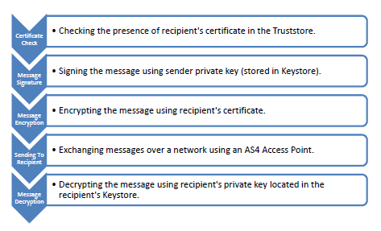

Figure 8 – AS4 security process *(* from Domibus Quick Start Guide)*

The goal of the CEF eDelivery Connectivity Testing service is to test if a newly installed AS4 Access Point, conformant with the CEF eDelivery specifications, can successfully communicate with the sample AS4 Access Point hosted by the European Commission. If successful, these tests confirm that the relevant component is in all likelihood correctly deployed and configured.

To perform the CEF eDelivery connectivity test it has been decided to carry out the **Static Discovery** procedure which implies that the Participant Access Point is configured with the static address of the European Commission Access Point and vice versa. See the following figure for the process.

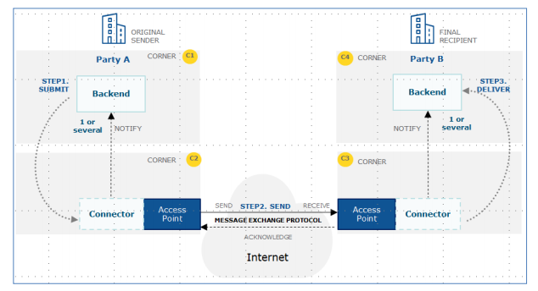

Figure 9 – CEF eDelivery connectivity test – Static Discovery

The testing process consists of different steps which will be further documented on WP5 deliverables.

After the implementation phase an email, according to the CEF guide, has been sent in order to proceed with the testing activity.

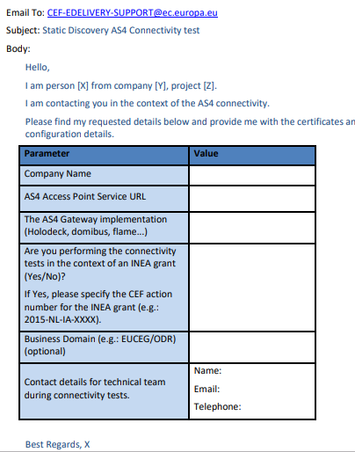

Figure 10 - Email example for CEF eDelivery connectivity test - static discovery

As a response, InfoCert received an email with:

1. The Certificate for the Access Point (Truststore and Keystore).

2. The Endpoint URL of the test AS4 Access Point.

3. The PMode settings: This is the Domibus specific PMode XML file if Domibus is used. If another Access Point Software is used, this is a generic description of the PMode settings.

4. For Domibus only: A SoapUI Project to use for sending and receiving messages using the default WS plugin. It includes a "sendMessage" request for Static Discovery.