|  |
| --- |
|  |



European eInvoicing Standard in Italy

|  |  |
| --- | --- |
| **Project number** | INEA/CEF/ICT/A2017/1560867 2017-IT-IA-0150 |
| **Project acronym** | EeISI |
| **Project title** | European eInvoicing Standard in Italy |
| **Starting date** | 1 May 2018 |
| **Ending date** | 30 June 2019 |
| **Programme** | Connecting Europe Facility (CEF) CEF-TC-2017-3: eInvoicing |

eDelivery Access Point implementation report

Deliverable D4.9

|  |  |
| --- | --- |
| **Related WP** | WP4 – Implementation – Task 4.5  eDelivery integration |
| **Deliverable number** | D4.9 |
| **Due date** | 31/01/2019 |
| **Revision date** | 31/01/2019 |
| **Actual date** | **31/01/2019** |

This Page Intentionally Left Blank

Deliverable Info

|  |  |
| --- | --- |
| **Editor (s)** | **Infocamere** |
| **Contributors** | **Infocamere** |
|  |  |
|  |  |
| **Acknowledgement** | This work was partially supported by the European Commission (EC) through the Connecting Europe Facility (CEF) programme under project EeISI.(grant agreement no. INEA/CEF/ICT/A2017/1560867 2017-IT-IA-0150) |
| **Disclaimer** | The sole responsibility of this publication lies with the author(s). The European Union is not responsible for any use that may be made of the information contained therein. |
| **Confidentiality** | The information in this document is confidential and restricted only to the members of the EeISI consortium  (including the Commission Services). |
|  |  |
| **Note** | - |
|  |  |

**Version Control**

|  |  |  |  |
| --- | --- | --- | --- |
| Version | Date | Author | Description of change |
| 1.0.0 | 31/01/2019 | Infocamere (Doni, Squarcina) |  |
| 1.0.1 | 31/03/2020 | Roberto Reale | Technical review and quality assessment |
|  |  |  |  |
|  |  |  |  |
|  |  |  |  |

This Page Intentionally Left Blank

Table of contents

Deliverable Info 3

Table of contents 5

Glossary 7

1. Executive summary 8

2. Introduction 8

3. Access Point Peppol Receiver 9

4. Access Point Peppol Sender 10

5. SMP Server 11

This Page Intentionally Left Blank

Glossary

|  |  |
| --- | --- |
| **B2B** | Business to Business |
| **B2C** | Business to Consumer/Citizen |
| **B2G** | Business to Government |
| **BII** | Business Interoperability Interfaces |
| **C2G** | Citizen to Government |
| **CCTS** | Core Component Technical Specification |
| **CEF** | Connecting Europe Facility |
| **CEM** | Certified Electronic Mail – Legal Mail (PEC Posta Elettronica Certificata in Italy) |
| **CEN** | European Committee for Standardisation |
| **CII** | Cross Industry electronic Invoice |
| **CIUS** | Core Invoice Usage Specification |
| **DSI** | Digital Service Infrastructures |
| **EDIFACT** | Electronic Data Interchange For Administration, Commerce and Transport |
| **EMSFEI** | European Multi-Stakeholder Forum on eInvoicing |
| **e-SENS** | Electronic Simple European Networked Services |
| **FatturaPA** | Public administration electronic invoice framework (FatturaPubblica Amministrazione) |
| **G2G** | Government to Government |
| **INEA** | Innovation and Networks Executive Agency |
| **OASIS** | Organization for the Advancement of Structured Information Standards |
| **PEPPOL** | Pan-European Public Procurement Online |
| **PEPPOL-BIS** | Pan-European Public Procurement Online Business Interoperability Specifications |
| **SDI** | Electronic exchange system in Italy (Sistema Di Interscambio) |
| **UBL** | Universal Business Language |
| **UN/CEFACT** | United Nations Centre for Trade Facilitation and Electronic Business |
| **UNTDID** | UN Trade Data Interchange Directory |
| **URI** | Uniform Resource Identifier |
| **URL** | Uniform Resource Location |
| **URN** | Uniform Resource Name |
| **XML** | Extensible Mark-up Language |

1. Executive summary

This document explains the deploy of the Oxalis Access Point and SMP Phoss solutions for Infocamere.

1. Introduction

The Portal of the Chambers of Commerce needs an Access Point for the management of cross border electronic invoices.

The Portal of the Chambers of Commerce uses the Infocamere Access Point service.

The technological choice adopted by the Infocamere is to make use of the Open Source Oxalis solution for AS2/AS4 Access Point Services (<https://github.com/difi/oxalis/tree/oxalis-4.0.2>), Domibus solution for AS4 Access Point Services (<https://ec.europa.eu/cefdigital/wiki/display/CEFDIGITAL/Domibus>) and Open Source Phoss SMP Server per SMP Services (<https://github.com/phax/peppol-smp-server>).

Currently for this solution is available a stable release compliant to the AS2 standard and a pre-release compliant to the AS4 standard.

For a faster start-up of the transmission system (eDelivery) it is considered necessary to install the Oxalis Access Point version 4.0.2 adhering to the AS2 protocol specification.

The migration to the AS4 protocol will be an activity after the publication of a consolidated release of the AS4 plugin made available by the Oxalis and Domibus solution.

Within the scope of this project, Infocamere Access Point must not expose any service but must be able to send only cross-border electronic invoices.

In order to achieve the qualification in the Peppol network, Infocamere owns SMP even if in the future of this project the services will be registered in a single national SMP made available by IntercentER.

1. Access Point Peppol Receiver

The receiver component of the Oxalis 4.0.2 (oxalis-inbound-4.0.2.war) was deployed on the Tomcat 8.5 Server.

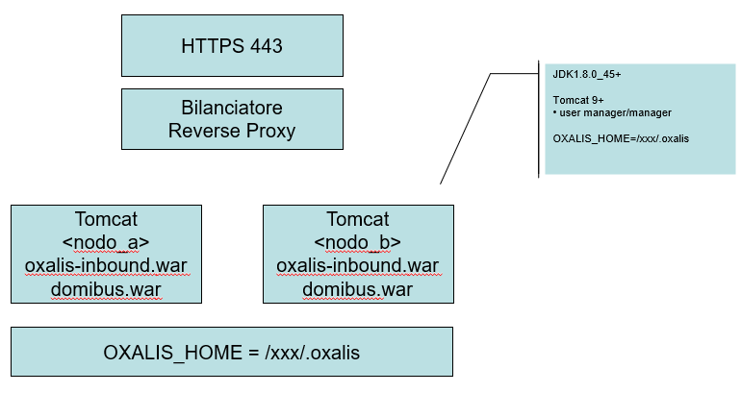

Figura 1 - Deploy Diagram AP Receiver

The Access Point Endpoint are:

* <https://peppol.infocamere.it/as2>
* <https://peppol.infocamere.it/as4>
* <https://peppolcl.infocamere.it/domibus/services/msh>

The configuration of the Access Point Receiver in the architecture of the Infocamere System is described below.

File system organization:

* **/var/opt/oxal/logs/:** the directory contains oxalis.log of the AP Peppol Receiver. The Rolling Policy is daily.
* **/opt/oxal/j/config/**: the directory contains the configutation files of AP Peppol Receiver, including also the keystore whit in the Infocamere Peppol Certificate (version 3).
* **/nas_int/var/opt/oxal/oxalis/oxalis-OUTBOUND/** : Peppol message received. The files are contained in a folder shared (nas) with the Portal to ensure their processing

1. Access Point Peppol Sender

The sender component of the Oxalis and Domibus was deployed on the Batch Server.

The Access Point sender is activated via Linux shell under schedule system (/opt/oxal/b/app/sender.sh).

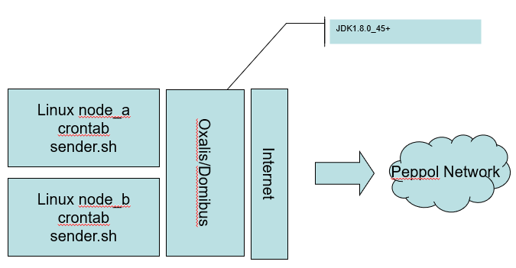

Figura 2 - Deploy Diagram AP Sender

The shell reads the Peppol messages to be sent from the /nas_int/var/opt/oxal/oxalis/oxalis-OUTBOUND/ folder. The files are contained in a folder shared (nas) with the Portal to ensure their transmission

File system organization:

* **/opt/oxal/b/app/conf** : Oxalis configuration files + keystore del certificato AP
* **/var/opt/oxal/logs/:** Contains oxalis.log with Delay Rolling Policy.

1. SMP Server

SMP (Service Metadata Publisher) server is used in the Infocamere PEPPOL transport infrastructure.

An SMP is part of the PEPPOL registry infrastructure and handles the registry Infocamere Access Points.

The configuration options for the SMP server following configuration files:

* webapp.properties for user interface properties
* smp-server.properties for SMP functionality properties
* pd-client.properties for PEPPOL Directory/TOOP Directory client configuration

All files reside **/nas_int/var/opt/oxal/oxalis/peppol-smp-conf/** folder.

The backend database configuration is XML. All database files reside **in /nas_int/var/opt/oxal/oxalis/smp-webapp-conf/conf/**