|  |
| --- |
|  |



European eInvoicing Standard in Italy

|  |  |
| --- | --- |
| **Project number** | INEA/CEF/ICT/A2017/1560867 2017-IT-IA-0150 |
| **Project acronym** | EeISI |
| **Project title** | European eInvoicing Standard in Italy |
| **Starting date** | 1 May 2018 |
| **Ending date** | 30 June 2019 |
| **Programme** | Connecting Europe Facility (CEF) CEF-TC-2017-3: eInvoicing |

Technical testing of the eInvoicing mapper framework

Deliverable D5.1

|  |  |
| --- | --- |
| **Related WP** | WP5 – Validation – Task 5.1  Domestic Task 5.2  Cross-Border |
| **Deliverable number** | D5.1 |
| **Due date** | 31/03/2019 |
| **Revision date** | 31/12/2019 |
| **Actual date** | 31/12/2019 |

This Page Intentionally Left Blank

Deliverable Info

|  |  |
| --- | --- |
| **Editor (s)** | **Infocamere, InfoCert, Agenzia delle Entrate** |
| **Contributors** | **Infocamere, InfoCert, Agenzia delle Entrate** |
|  |  |
|  |  |
| **Acknowledgement** | This work was partially supported by the European Commission (EC) through the Connecting Europe Facility (CEF) programme under project EeISI.(grant agreement no. INEA/CEF/ICT/A2017/1560867 2017-IT-IA-0150) |
| **Disclaimer** | The sole responsibility of this publication lies with the author(s). The European Union is not responsible for any use that may be made of the information contained therein. |
| **Confidentiality** | The information in this document is confidential and restricted only to the members of the EeISI consortium  (including the Commission Services). |
|  |  |
| **Note** | This document describes the technical testing on the eInvoicing mapper framework. |
|  |  |

**Version Control**

|  |  |  |  |
| --- | --- | --- | --- |
| Version | Date | Author | Description of change |
| 1.0.0 | 31/03/2019 | Infocamere (Doni, Squarcina) |  |
| 2.0.0 | 31/12/2019 | InfoCert, Agenzia delle Entrate |  |
| 2.0.1 | 31/03/2020 | Roberto Reale | Technical review and quality assessment |
|  |  |  |  |
|  |  |  |  |

This Page Intentionally Left Blank

Table of contents

Deliverable Info 4

Table of contents 6

Glossary 8

1 Executive summary 9

2 EeISI system description 9

2.1 EeISI converter 9

3 PRE-REQUISITES 13

4 TEST PLANNING 13

4.1 Test Strategy 13

4.2 Test Environment 13

4.3 Test Documentation 13

4.4 Test Script Form 13

5 TEST PROCEDURES 13

5.1 Testing Team 14

5.2 Review Team 14

5.3 Test Methodology 14

5.4 Test Coding 14

5.5 Test Execution 14

5.6 Evaluation of the Action Test Results 15

5.7 Evaluation of the Test Results 15

6 GENERAL TEST REVIEW PROCEDURE 15

6.1 TEST SCRIPT INDEX 15

7 XMLPA2PeppolBIS3 - Infocamere 30

7.1 Configuration Infocamere SMP 31

7.2 Send Invoice Cross Border 32

7.3 Send Credit Note Cross Border 38

8 Test MAP-V-1 – AdE 44

*8.1* Test MAP-V-1 – AdE: *not-mapped-values* 47

*8.2* Test MAP-V-1 – AdE: *trimmed_fields* 48

Figure 1 Mapper main steps 9

Figure 2 CEN2XMLPA 10

Figure 3 CEN2XMLPA 11

Figure 4 XMLPA2CEN 11

Figure 5 XMLPA2PeppolBIS3 12

Figure 6 UBL/CII2PeppolBIS3 12

Figure 7 - Infocamere SMP Configuration 31

Figure 8 - Invoice Editing on Chamber of Commerce Portal 32

Figure 9 – eInvoice BIS3 from Infocert Mapper 33

Figure 10 - Cross Border Invoice before sending in Peppol Network 34

Figure 11 - Cross Border Invoice after sending to Infocamere Access Point 34

Figure 12 – eInvoice ready to be sent from Infocamere Access Point 35

Figure 13 - After the scheduling of sending the AP 35

Figure 14 - eDelivery Infrastructure send callback notice to positive sending 36

Figure 15 – Message delivery notification message 37

Figure 16 – Credit Note Editing on Chamber of Commerce Portal 38

Figure 17 – Credit Note BIS3 from Infocert Mapper 39

Figure 18 - Cross Border Credit Note before sending in Peppol Network 40

Figure 19 - Cross Border Credit Note after sending to Infocamere Access Point 40

Figure 20 – Credit Note ready to be sent from Infocamere Access Point 41

Figure 21 - After the scheduling of sending to the AP 41

Figure 22 - eDelivery Infrastructure sends callback notice to positive sending 42

Figure 23– Message delivery notification message 43

This Page Intentionally Left Blank

Glossary

|  |  |
| --- | --- |
| **B2B** | Business to Business |
| **B2C** | Business to Consumer/Citizen |
| **B2G** | Business to Government |
| **BII** | Business Interoperability Interfaces |
| **C2G** | Citizen to Government |
| **CCTS** | Core Component Technical Specification |
| **CEF** | Connecting Europe Facility |
| **CEM** | Certified Electronic Mail – Legal Mail (PEC Posta Elettronica Certificata in Italy) |
| **CEN** | European Committee for Standardisation |
| **CII** | Cross Industry electronic Invoice |
| **CIUS** | Core Invoice Usage Specification |
| **DSI** | Digital Service Infrastructures |
| **EDIFACT** | Electronic Data Interchange For Administration, Commerce and Transport |
| **EMSFEI** | European Multi-Stakeholder Forum on eInvoicing |
| **e-SENS** | Electronic Simple European Networked Services |
| **FatturaPA** | Public administration electronic invoice framework (FatturaPubblica Amministrazione) |
| **G2G** | Government to Government |
| **INEA** | Innovation and Networks Executive Agency |
| **OASIS** | Organization for the Advancement of Structured Information Standards |
| **PEPPOL** | Pan-European Public Procurement Online |
| **PEPPOL-BIS** | Pan-European Public Procurement Online Business Interoperability Specifications |
| **SDI** | Electronic exchange system in Italy (Sistema Di Interscambio) |
| **UBL** | Universal Business Language |
| **UN/CEFACT** | United Nations Centre for Trade Facilitation and Electronic Business |
| **UNTDID** | UN Trade Data Interchange Directory |
| **URI** | Uniform Resource Identifier |
| **URL** | Uniform Resource Location |
| **URN** | Uniform Resource Name |
| **XML** | Extensible Mark-up Language |

# Executive summary

Purpose of this document is to define and formalize the tests executed with EeISI system integrated into SDI and into InfoCamere system in order to verify all its functionalities according to the specification documents. The testing procedure is detailed and a list of technical tests is provided. Test documentation forms to be used for each test case are part of this document as tool for testers interested in performing this activity. This document includes annexes composed by several test packages zip files. The test package contains the source invoice, the target invoice and the CEN model representation. The cases of tests carried out by Unioncamere/Infocamere on the use case of cross-border sending (invoice and credit note) are included.

# EeISI system description

## EeISI converter

The EeISI mapper allows to convert and validate electronic invoices according to CEN TS 16931-2 defined syntaxes (namely UBL and CII) to FatturaPA format and viceversia. In addition, the mapper is enriched with new entry points (intermediate CEN meta language) and a mapping to Peppol BIS 3 profile which has been published in 2018 spring.

The mapper performs the main following steps

1. **Validation**: source invoice and target invoice are validated through a set of defined constrains. This step discards the invoice if it does not adhere to the desired constraints (errors are raised)
2. **Mapping**: the information contained in source invoice syntax is converted in target invoice syntax according to the core invoice semantic model defined in EN 16931-1:2017



Figure 1 Mapper main steps

The validation phase includes different validation levels:

1. **Syntactic** validation, using schema XSD
2. **Semantic** validation, using xslt
3. (sch artifacts)
4. **Customized** Validation (for example a national or community CIUS)

The European norm EN 16931-1:2017 defines a core semantic model to represent eInvoices in a standard way. The mapper is implemented according to the semantic model and does not include, at the moment, extensions to this model. Only restrictions (CIUS core invoice usage specifications) are applied.

The mapper can be defined as “CEN meta model centric” which means that all the invoices expressed in a source syntax are mapped to the CEN semantic model and then converted into invoices expressed in a target syntax. The source invoice can only be converted if it is compliant to the CEN core semantic model. The compliance is verified through the CEN schematron artefacts.

An additional conversion functionality is foreseen using the *-- force* parameter which perform the conversion even though the validation didn’t succeed.

The mapper input and output syntaxes/formats are:

* 1. UBL invoice / UBL credit not
  2. CII
  3. Peppol BIS3 billing
  4. Fattura PA
  5. XML CEN (intermediate semantic meta model)

Please note that the Peppol BIS 3 billing is expressed in UBL syntax (invoice and credit note) and not in CII syntax. In particular it is defined as a CIUS. For this reason, if the invoice source is Peppol BIS 3, as it is CEN compliant, it is considered treated as a generic invoice CEN compliant. If Peppol BIS 3 is the target format the mapper performs a customized conversion to comply with the Peppol CIUS validation artifacts.

The following diagrams represent the different validation and mapping applied by the mapper depending on the source invoice syntax and the target invoice syntax.

Please note that the intermediate invoice-cen.xml is a java object representing a CEN invoice. In eigor-cli this is represented through an xml file.



Figure 2 CEN2XMLPA

Figure 3 CEN2XMLPA



Figure 4 XMLPA2CEN



Figure 5 XMLPA2PeppolBIS3



Figure 6 UBL/CII2PeppolBIS3

# PRE-REQUISITES

Before the execution of the tests defined in this document, the following conditions should be present:

* EeISI system is installed as CLI stand-alone version or API integrated version;
* EN 16931 core invoice semantic model is respected and the mapping towards two approved syntaxes is considered;
* CIUS Italian rules are approved;
* Transmission system (SDI integration and Peppol AP) is available.

# TEST PLANNING

## Test Strategy

Scope of technical Tests is to define and execute tests to verify the EeISI system functionalities according to the specification documents.

Strategy used for the testing is based on a bottom-up approach.

Trans codification tests

Test case invoices examples have been created as minimum or full invoices..

Transmission test

For the transmission technical test both channel (SDI and Peppol access point) are used and the validation results are reported in D5.2.

## Test Environment

Technical Tests are performed in CLI InfoCert Test environment for transcodification. Other users have performed tests in their installed environment.

For what it concerns transmission technical test the integrated SDI and AP Peppol are used.

## Test Documentation

The documentation collected during the execution of the tests are organized in a dedicated folder, which must include:

* working copy of the Test Script Form;
* identified issues tracked on the gitLab project environment.

The structure of the Test Script forms is explained below. The methodology of the test execution will be described in the following sections.

## Test Script Form

The Test Script Forms reports the test action to execute on the system and the acceptance criteria that must be verified in order to consider the test PASSED.

# TEST PROCEDURES

The following section will define the resources required for the execution of the technical Test as well their own responsibilities.

## Testing Team

The execution of each test case requires a Tester and a Witness. The Tester is responsible for the test actions that are to be executed, while the Witness is responsible for the conformity to the test specification; if it’s possible, tester should be chosen between computer system users.

Tester and witness can vary according to the testing needs.

EeISI partners are involved both as Tester and Witness according to their needs.

## Review Team

The Review Team will carry out the formal review of the test results, focusing on the non-conformance encountered during the test activities. The Reviewer can vary according to the testing needs.

EeISI partners are involved as reviewer. AdE will have a final word concerning non-conformities and decisions to be taken for an appropriate mapping and validation according to XMLPA format. InfoCert will apply needed correction to source code according to test results or new identified rules until the end of the project.

## Test Methodology

The following paragraph describes the procedures to be used during the test executions.

The test documentation must be prepared before the execution of the tests. Tests can be repeated by all EeISI partners.

## Test Coding

The tests are identified by a code with the following structure:

**Xxx2xxx-Test_EeISI_N_description**

where:

**Xxx2xxx**: it identifies EeISI context and can be ULB2XMLPA, CII2XMLPA, XMLPA2UBL, XMLPA2CII. In addition it is possible to test either UBL2CII and CII2UBL;

**Test_EeISI_N**: it refers to numbering of test in each context (N is a progressive number);

**description**: it is a short description of the content to be tested (e.g. invoiceinfo; sellerinfo, …).

## Test Execution

The execution of each Test Case requires a Testing Team, which includes a Tester and a Witness, according to “Testing Team” paragraph.

For the formal execution of the tests, the Testing Team has to follow what is defines hereunder:

* Each test action must be executed following the instruction in the related test script.
* For each action, the Tester must compare the system behavior with the related Acceptance Criteria, reported in the test script, checking corresponding result box.
* For each action, the “YES” box has to be filled with the executor initials only if actual result exactly matches relevant expected result, described in the “Acceptance Criteria” relevant column; otherwise the executor has to write his initials in the “NO” box.

When all the actions reported in the Test Script have been performed, Testing Team members must define the test result (Passed/Failed) based on what reported in section “Evaluation of Test Result”; the result must be reported in the third part of the Test Script, checking corresponding box.

## Evaluation of the Action Test Results

For each test action, relevant result is determined based on the conformance of the actual result to the expected result indicated in Acceptance Criteria.

Test actions are the steps, which must be carried out by the Tester in order to verify the operative flow being verified. Each Test action is specified in the form of an instruction or series of instructions. Test actions are numbered and each Test Action corresponds to an Acceptance Criteria of the same number.

Acceptance Criteria are the expected results, which must be satisfied in order to define the action test passed. Each Criteria is in the form of a condition, which may represent a single requisite or a series of requirements.

At the end of the execution of each action test, the actual result (that is the system behavior after the execution of the action) should be compared with the expression reported in relevant Acceptance Criteria; the box “YES” of the Test Script must be filled by the executor with his/her initials if the result action matches the expected one, otherwise the box “NO” must be filled.

## Evaluation of the Test Results

The Tester and the Witness will agree the test result (Passed or Failed) following the statements reported hereunder:

* In order a test to be PASSED, all the included actions must be passed, that is all the Acceptance Criteria for that test must be satisfied;
* If at least one Criteria is not satisfied, the test must be considered as FAILED;
* The test must be considered as FAILED even if an anomaly is observed that is not clearly related with the Acceptance Criteria.

The agreed result of the test must be recorded on the Test Script, checking the corresponding checkbox “PASSED” or “FAILED”.

The code of the executed test and relating result must be reported in the Test Progress Form.

In the following table the criteria for the evaluation of the results are described.

| **RESULT** | **DESCRIPTION** |
| --- | --- |
| **PASSED** | Test successfully completed. All acceptance criteria have been fulfilled. No problem was encountered during the execution of the test. |
| **FAILED** | Incomplete or unsuccessfully completed test. Not all acceptance criteria were met. |

# GENERAL TEST REVIEW PROCEDURE

Once all the foreseen tests have been executed, the Reviewer Team provides an overall evaluation of the testing activities.

The evaluation is based on the passed / failed tests, the original objectives and related acceptance criteria. The Review Team identifies the risks that may be associated with non-conformances or failures that were encountered.

## TEST SCRIPT INDEX

Main test cases have been carried out to cover all the functionalities offered by EeISI system according to the description of work.

1. FatturaPA -> UBL 2.1
2. UBL -> FatturaPA
3. FatturaPA -> CII
4. CII -> FatturaPA
5. PeppolBIS3 -> FatturaPA
6. FatturaPA -> PeppolBIS3

Tests have been carried out from M10 to M20 by InfoCert, UnionCamere, AdE. The command line tool has been used as testing environment in InfoCert. The API integrated system has been used in UnionCamere and AdE SDI environments. Business test cases carried out in Task 5.2 used the integrated system into the SDI environment.

In the following table, the list of Test Scripts to be executed for the Operational Test Protocol is provided.

| **STEP CODE** | **STEP TITLE** |
| --- | --- |
| **TRANSCODE** | |
| **UBL2XMLPA-Test_EeISI_1_minimumcontent** | UBL invoice CEN compliant with minimum mandatory content |
| **UBL2XMLPA-Test_EeISI_2_complete** | UBL invoice CEN compliant with full mandatory content |
|  |  |
| **CII2XMLPA-Test_EeISI_20_complete** | CII invoice CEN compliant |
|  |  |
| **XMLPA2UBL-Test_EeISI_30_complete** | FatturaPA invoice |
|  |  |
| **XMLPA2CII-Test_EeISI_40_complete** | FatturaPA invoice |
|  |  |
| **PeppolBIS32XMLPA-Test_EeISI_50_complete** | PeppolBIS3 UBL CEN compliant |
| **XMLPA2PeppolBIS3** | FatturaPA and credit note invoice – InfoCamere test |
|  |  |
| **MAP-V-01** | UBL and CII invoice with translation report - AdE |

| **Test Code** | **UBL2XMLPA-Test_EeISI_1_minimumcontent** |
| --- | --- |
| **Test Title** | UBL invoice with minimum mandatory content |
| **Test Description** | Test on process UBL2XMLPA transformation and validation |
| **Test Pre-requisites** | EeISI CLI available |

| **TEST PROCEDURE** | | | **UBL2XMLPA-Test_EeISI_1_minimumcontent** | | | | |
| --- | --- | --- | --- | --- | --- | --- | --- |
| **ID** | **Test Action/Component** | **Acceptance Criteria** | | **Verified** | | **Att. ID** | **Note** |
| **YES** | **NO** |
|  | Open CLI | The system launches the CLI | | yes |  |  |  |
|  | Write command to execute the test:  eigor.bat --input filename --source ubl --output ./reports --target fatturapa  in case the tester wants to proceed even though some error during mapping or validation occurs it is necessary to append “-- force” at the end of the command | The EeISI system starts working and execute the commands | | yes |  | Test_EeISI_1_minimumcontent.xml |  |
|  | UBL validation | The UBL invoice is correct. Source-invoice.xml is created. Tocen-errors.csv is empty or contains warning | | yes |  | UBL-Invoice-2.1.xsd |  |
|  | UBL official validation through CEF conformance test | The tested UBL invoice, as double check, is tested through the CEF conformance test tool. | | yes |  | <http://isaitb2.northeurope.cloudapp.azure.com/invoice/upload> |  |
|  | CEN schematron validation | The UBL invoice is CEN compliant. Tocen-errors.csv is empty or contains warning | | yes |  | EN16931-UBL-validation.sch |  |
|  | CIUS IT schematron validation | The UBL invoice is compliant to restriction specifications defined in CIUS – IT. Tocen-errors.csv is empty or contains warning | | yes |  | EN16931-CIUS-IT-UBLValidation.sch |  |
|  | UBL to CEN mapping | The UBL invoice is mapped to the CEN core invoice semantic model. Invoice-cen.csv is created. Tocen-errors.csv is empty or contains warning | | yes |  | EN16931 data model |  |
|  | CEN to XMLPA (one2one, one2many, many2one and customized) | The CEN core invoice semantic model is mapped to FatturaPa syntax. Target-invoice.xml is created. Fromcen-errors.csv is empty or contains warning | | yes |  | Rappresentazione_tabellare_del_tracciato_FatturaPA_versione_1.2.1.xls |  |
|  | XMLPA validation | FatturaPA invoice is compliant to the schema. Fromcen-errors.csv is empty or contains warning | | yes |  | Schema_del_file_xml_FatturaPA_versione_1.2.xsd |  |

|  |  |  |  |  |  |  |  |
| --- | --- | --- | --- | --- | --- | --- | --- |
| **TEST PROCEDURE** | | | **UBL2XMLPA-Test_EeISI_1_minimumcontent** | | | | |
| **RUN N°** | **TESTING EXECUTION RESULT** | | | **DEVIATION** | | | |
| ___1__ | _**PASSED**_ | _**FAILED**_ | | _**YES**_ | _**NO**_ | **Deviation Code: __________** | |
| **Test Comments** | | | | | | | |
| Only mandatory fields defined in the semantic model are present. | | | | | | | |
|  | **Name** | **Function** | | **Signature** | | | **Date** |
| **Tester** | Sara Facchinetti | Engineer | | Sara Facchinetti | | | 31/03/2019 |
| **Witness** | Luigi Fabbro | Engineer | | Luigi Fabbro | | | 31/03/2019 |

| **Test Code** | **UBL2XMLPA-Test_EeISI_2_complete** |
| --- | --- |
| **Test Title** | UBL invoice with full content |
| **Test Description** | Test on process UBL2XMLPA transformation and validation |
| **Test Pre-requisites** | EeISI CLI available |

| **TEST PROCEDURE** | | | **UBL2XMLPA-Test_EeISI_2_complete** | | | | |
| --- | --- | --- | --- | --- | --- | --- | --- |
| **ID** | **Test Action/Component** | **Acceptance Criteria** | | **Verified** | | **Att. ID** | **Note** |
| **YES** | **NO** |
|  | Open CLI | The system launches the CLI | | yes |  |  |  |
|  | Write command to execute the test:  eigor.bat --input filename --source ubl --output ./reports --target fatturapa  in case the tester wants to proceed even though some error during mapping or validation occurs it is necessary to append “-- force” at the end of the command | The EeISI system starts working and execute the commands | | yes |  | Test_EeISI_2_complete.xml |  |
|  | UBL validation | The UBL invoice is correct. Source-invoice.xml is created. Tocen-errors.csv is empty or contains warning | | yes |  | UBL-Invoice-2.1.xsd |  |
|  | UBL official validation through CEF conformance test | The tested UBL invoice, as double check, is tested through the CEF conformance test tool. | | yes |  | <http://isaitb2.northeurope.cloudapp.azure.com/invoice/upload> |  |
|  | CEN schematron validation | The UBL invoice is CEN compliant. Tocen-errors.csv is empty or contains warning | | yes |  | EN16931-UBL-validation.sch |  |
|  | CIUS IT schematron validation | The UBL invoice is compliant to restriction specifications defined in CIUS – IT. Tocen-errors.csv is empty or contains warning | | yes |  | EN16931-CIUS-IT-UBLValidation.sch |  |
|  | UBL to CEN mapping | The UBL invoice is mapped to the CEN core invoice semantic model. Invoice-cen.csv is created. Tocen-errors.csv is empty or contains warning | | yes |  | EN16931 data model |  |
|  | CEN to XMLPA (one2one, one2many, many2one and customized) | The CEN core invoice semantic model is mapped to FatturaPa syntax. Target-invoice.xml is created. Fromcen-errors.csv is empty or contains warning | | yes |  | Rappresentazione_tabellare_del_tracciato_FatturaPA_versione_1.2.1.xls |  |
|  | XMLPA validation | FatturaPA invoice is compliant to the schema. Fromcen-errors.csv is empty or contains warning | | yes |  | Schema_del_file_xml_FatturaPA_versione_1.2.xsd |  |

|  |  |  |  |  |  |  |  |
| --- | --- | --- | --- | --- | --- | --- | --- |
| **TEST PROCEDURE** | | | **UBL2XMLPA-Test_EeISI_2_complete** | | | | |
| **RUN N°** | **TESTING EXECUTION RESULT** | | | **DEVIATION** | | | |
| ___1__ | _**PASSED**_ | _**FAILED**_ | | _**YES**_ | _**NO**_ | **Deviation Code: __________** | |
| **Test Comments** | | | | | | | |
| Full content defined in the semantic model are present. | | | | | | | |
|  | **Name** | **Function** | | **Signature** | | | **Date** |
| **Tester** | Sara Facchinetti | Engineer | | Sara Facchinetti | | | 31/03/2019 |
| **Witness** | Luigi Fabbro | Engineer | | Luigi Fabbro | | | 31/03/2019 |

| **Test Code** | **CII2XMLPA-Test_EeISI_20_complete** |
| --- | --- |
| **Test Title** | CII invoice |
| **Test Description** | Test on process CII2XMLPA transformation and validation |
| **Test Pre-requisites** | eIGOR CLI available |

| **TEST PROCEDURE** | | | **CII2XMLPA-Test_EeISI_20_complete** | | | | |
| --- | --- | --- | --- | --- | --- | --- | --- |
| **ID** | **Test Action/Component** | **Acceptance Criteria** | | **Verified** | | **Att. ID** | **Note** |
| **YES** | **NO** |
|  | Open CLI | The system launches the CLI | | yes |  |  |  |
|  | Write command to execute the test:  eigor.bat --input filename --source cii --output ./reports --target fatturapa  in case the tester wants to proceed even though some error during mapping or validation occurs it is necessary to append “-- force” at the end of the command | The EeISI system starts working and execute the commands | | yes |  | Test_EeISI_20_complete.xml |  |
|  | CII validation | The CII invoice is correct. Source-invoice.xml is created. Tocen-errors.csv is empty or contains warning | | yes |  | CII-Invoice.xsd |  |
|  | CII official validation through CEF conformance test | The tested CII invoice, as double check, is tested through the CEF conformance test tool. | | yes |  | <http://isaitb2.northeurope.cloudapp.azure.com/invoice/upload> |  |
|  | CEN schematron validation | The CII invoice is CEN compliant. Tocen-errors.csv is empty or contains warning | | yes |  | EN16931-CII-validation.sch |  |
|  | CIUS IT schematron validation | The CII invoice is compliant to restriction specifications defined in CIUS – IT. Tocen-errors.csv is empty or contains warning | | yes |  | EN16931-CIUS-IT-CIIValidation.sch |  |
|  | CII to CEN mapping | The CII invoice is mapped to the CEN core invoice semantic model. Invoice-cen.csv is created. Tocen-errors.csv is empty or contains warning | | yes |  | EN16931 data model |  |
|  | CEN to XMLPA (one2one, one2many, many2one and customized) | The CEN core invoice semantic model is mapped to FatturaPa syntax. Target-invoice.xml is created. Fromcen-errors.csv is empty or contains warning | | yes |  | Rappresentazione_tabellare_del_tracciato_FatturaPA_versione_1.2.1.xls |  |
|  | XMLPA validation | FatturaPA invoice is compliant to the schema. Fromcen-errors.csv is empty or contains warning | | yes |  | Schema_del_file_xml_FatturaPA_versione_1.2.xsd |  |

|  |  |  |  |  |  |  |  |
| --- | --- | --- | --- | --- | --- | --- | --- |
| **TEST PROCEDURE** | | | **CII2XMLPA-Test_EeISI_20_complete** | | | | |
| **RUN N°** | **TESTING EXECUTION RESULT** | | | **DEVIATION** | | | |
| __21___ | _**PASSED**_ | _**FAILED**_ | | _**YES**_ | _**NO**_ | **Deviation Code: __________** | |
| **Test Comments** | | | | | | | |
| The CII invoice is mapped to XMLPA. | | | | | | | |
|  | **Name** | **Function** | | **Signature** | | | **Date** |
| **Tester** | Sara Facchinetti | Engineer | | Sara Facchinetti | | | 31/03/2019 |
| **Witness** | Luigi Fabbro | Engineer | | Luigi Fabbro | | | 31/03/2019 |

| **Test Code** | **XMLPA2UBL-Test_EeISI_30_complete** |
| --- | --- |
| **Test Title** | XMLPA invoice |
| **Test Description** | Test on process XMLPA2UBL transformation and validation |
| **Test Pre-requisites** | eIGOR CLI available |

| **TEST PROCEDURE** | | | **XMLPA2UBL-Test_EeISI_30_complete** | | | | |
| --- | --- | --- | --- | --- | --- | --- | --- |
| **ID** | **Test Action/Component** | **Acceptance Criteria** | | **Verified** | | **Att. ID** | **Note** |
| **YES** | **NO** |
|  | Open CLI | The system launches the CLI | | yes |  |  |  |
|  | Write command to execute the test:  eigor.bat --input filename --source fatturapa --output ./reports --target ubl  in case the tester wants to proceed even though some error during mapping or validation occurs it is necessary to append “-- force” at the end of the command | The EeISI system starts working and execute the commands | | yes |  | Test_EeISI_30_complete.xml |  |
|  | XMLPA validation | FatturaPA invoice is compliant to the schema. | | yes |  | Schema_del_file_xml_FatturaPA_versione_1.2.xsd |  |
|  | XMLPA to CEN (one2one, one2many, many2one and customized) | The FatturaPa syntax is mapped to CEN core invoice semantic model. Tocen-errors.csv is empty or contains warning. Invoice-cen.xml is created with the semantic model values | | yes |  | EN16931 data model |  |
|  | CEN to UBL (one2one, one2many, many2one and customized) | The CEN core invoice semantic model is mapped to UBL syntax. Target-invoice.xml is created. Fromcen-errors.csv is empty or contains warning | | yes |  | EN 16931-3-2 |  |
|  | UBL validation | The UBL invoice is correct. Fromcen-errors.csv is empty or contains warning | | yes |  | UBL-Invoice.xsd |  |
|  | CEN schematron validation | The UBL invoice is CEN compliant. Tocen-errors.csv is empty or contains warning | | yes |  | EN16931-UBL-validation.sch |  |
|  | UBL official validation through CEF conformance test | The tested UBL invoice, as double check, is tested through the CEF conformance test tool. | | yes |  | <http://isaitb2.northeurope.cloudapp.azure.com/invoice/upload> |  |
|  |  |  | | yes |  |  |  |

|  |  |  |  |  |  |  |  |
| --- | --- | --- | --- | --- | --- | --- | --- |
| **TEST PROCEDURE** | | | **XMLPA2UBL-Test_EeISI_30_complete** | | | | |
| **RUN N°** | **TESTING EXECUTION RESULT** | | | **DEVIATION** | | | |
| __22___ | _**PASSED**_ | _**FAILED**_ | | _**YES**_ | _**NO**_ | **Deviation Code: __________** | |
| **Test Comments** | | | | | | | |
| The XMLPA invoice is mapped to a UBL cen compliant invoice | | | | | | | |
|  | **Name** | **Function** | | **Signature** | | | **Date** |
| **Tester** | Sara Facchinetti | Engineer | | Sara Facchinetti | | | 31/03/2019 |
| **Witness** | Luigi Fabbro | Engineer | | Luigi Fabbro | | | 31/03/2019 |

| **Test Code** | **XMLPA2CII-Test_EeISI_40_complete** |
| --- | --- |
| **Test Title** | XMLPA invoice |
| **Test Description** | Test on process XMLPA2CII transformation and validation |
| **Test Pre-requisites** | eIGOR CLI available |

| **TEST PROCEDURE** | | | **XMLPA2UBL-Test_EeISI_30_complete** | | | | |
| --- | --- | --- | --- | --- | --- | --- | --- |
| **ID** | **Test Action/Component** | **Acceptance Criteria** | | **Verified** | | **Att. ID** | **Note** |
| **YES** | **NO** |
|  | Open CLI | The system launches the CLI | | yes |  |  |  |
|  | Write command to execute the test:  eigor.bat --input filename --source fatturapa --output ./reports --target cii  in case the tester wants to proceed even though some error during mapping or validation occurs it is necessary to append “-- force” at the end of the command | The EeISI system starts working and execute the commands | | yes |  | Test_EeISI_40_complete.xml |  |
|  | XMLPA validation | FatturaPA invoice is compliant to the schema. | | yes |  | Schema_del_file_xml_FatturaPA_versione_1.2.xsd |  |
|  | XMLPA to CEN (one2one, one2many, many2one and customized) | The FatturaPa syntax is mapped to CEN core invoice semantic model. Tocen-errors.csv is empty or contains warning. Invoice-cen.xml is created with the semantic model values | | yes |  | EN16931 data model |  |
|  | CEN to CII (one2one, one2many, many2one and customized) | The CEN core invoice semantic model is mapped to CII syntax. Target-invoice.xml is created. Fromcen-errors.csv is empty or contains warning | | yes |  | EN 16931-3-2 |  |
|  | CII validation | The CII invoice is correct. Fromcen-errors.csv is empty or contains warning | | yes |  | CII-Invoice.xsd |  |
|  | CEN schematron validation | The CII invoice is CEN compliant. Tocen-errors.csv is empty or contains warning | | yes |  | EN16931-CII-validation.sch |  |
|  | CII official validation through CEF conformance test | The tested CII invoice, as double check, is tested through the CEF conformance test tool. | | yes |  | <http://isaitb2.northeurope.cloudapp.azure.com/invoice/upload> |  |
|  |  |  | | yes |  |  |  |

|  |  |  |  |  |  |  |  |
| --- | --- | --- | --- | --- | --- | --- | --- |
| **TEST PROCEDURE** | | | **XMLPA2UBL-Test_EeISI_30_complete** | | | | |
| **RUN N°** | **TESTING EXECUTION RESULT** | | | **DEVIATION** | | | |
| __23___ | _**PASSED**_ | _**FAILED**_ | | _**YES**_ | _**NO**_ | **Deviation Code: __________** | |
| **Test Comments** | | | | | | | |
| The XMLPA invoice is mapped to a CII cen compliant invoice | | | | | | | |
|  | **Name** | **Function** | | **Signature** | | | **Date** |
| **Tester** | Sara Facchinetti | Engineer | | Sara Facchinetti | | | 31/03/2019 |
| **Witness** | Luigi Fabbro | Engineer | | Luigi Fabbro | | | 31/03/2019 |

| **Test Code** | **PEPPOLBIS32XMLPA-Test_EeISI_50_complete** |
| --- | --- |
| **Test Title** | PeppolBIS3 UBL invoice with full content |
| **Test Description** | Test on process UBL2XMLPA transformation and validation |
| **Test Pre-requisites** | EeISI CLI available |

| **TEST PROCEDURE** | | | **PEPPOLBIS32XMLPA-Test_EeISI_50_complete** | | | | |
| --- | --- | --- | --- | --- | --- | --- | --- |
| **ID** | **Test Action/Component** | **Acceptance Criteria** | | **Verified** | | **Att. ID** | **Note** |
| **YES** | **NO** |
|  | Open CLI | The system launches the CLI | | yes |  |  |  |
|  | Write command to execute the test:  eigor.bat --input filename --source ubl --output ./reports --target fatturapa  in case the tester wants to proceed even though some error during mapping or validation occurs it is necessary to append “-- force” at the end of the command | The EeISI system starts working and execute the commands | | yes |  | Test_EeISI_50_complete.xml |  |
|  | UBL validation | The UBL invoice is correct. Source-invoice.xml is created. Tocen-errors.csv is empty or contains warning | | yes |  | UBL-Invoice-2.1.xsd |  |
|  | UBL official validation through CEF conformance test | The tested UBL invoice, as double check, is tested through the CEF conformance test tool. | | yes |  | <http://isaitb2.northeurope.cloudapp.azure.com/invoice/upload> |  |
|  | CEN schematron validation | The UBL invoice is CEN compliant. Tocen-errors.csv is empty or contains warning | | yes |  | EN16931-UBL-validation.sch |  |
|  | CIUS IT schematron validation | The UBL invoice is compliant to restriction specifications defined in CIUS – IT. Tocen-errors.csv is empty or contains warning | | yes |  | EN16931-CIUS-IT-UBLValidation.sch |  |
|  | UBL to CEN mapping | The UBL invoice is mapped to the CEN core invoice semantic model. Invoice-cen.csv is created. Tocen-errors.csv is empty or contains warning | | yes |  | EN16931 data model |  |
|  | CEN to XMLPA (one2one, one2many, many2one and customized) | The CEN core invoice semantic model is mapped to FatturaPa syntax. Target-invoice.xml is created. Fromcen-errors.csv is empty or contains warning | | yes |  | Rappresentazione_tabellare_del_tracciato_FatturaPA_versione_1.2.1.xls |  |
|  | XMLPA validation | FatturaPA invoice is compliant to the schema. Fromcen-errors.csv is empty or contains warning | | yes |  | Schema_del_file_xml_FatturaPA_versione_1.2.xsd |  |

|  |  |  |  |  |  |  |  |
| --- | --- | --- | --- | --- | --- | --- | --- |
| **TEST PROCEDURE** | | | **PEPPOLBIS32XMLPA-Test_EeISI_50_complete** | | | | |
| **RUN N°** | **TESTING EXECUTION RESULT** | | | **DEVIATION** | | | |
| ___1__ | _**PASSED**_ | _**FAILED**_ | | _**YES**_ | _**NO**_ | **Deviation Code: __________** | |
| **Test Comments** | | | | | | | |
| The PEPPOLBIS3 UBL is considered as an UBL CEN compliant invoice | | | | | | | |
|  | **Name** | **Function** | | **Signature** | | | **Date** |
| **Tester** | Sara Facchinetti | Engineer | | Sara Facchinetti | | | 31/03/2019 |
| **Witness** | Luigi Fabbro | Engineer | | Luigi Fabbro | | | 31/03/2019 |

# XMLPA2PeppolBIS3 - Infocamere

While awaiting availability from Edicom as a foreign receiver of an invoice / credit note, the Access Point of Infocamere was configured to receive the Invoices BIS3 / credit note BIS3 simulating the cross-border sending process.

The Infocamere system has been modified to send documents cross border both via Peppol Access Point on AS2 and AS4 protocol.

At this time the use of the AS4 protocol has not yet been enabled because the onboarding procedure has not been completed at OpenPEPPOL Centralized Testbed (<https://peppol.eu/launch-openpeppol-centralized-testbed/>)

Infocamere has opened a support ticket (PEPPOL-1088) at OpenPEPPOL Centralized Testbed (https://openpeppol.atlassian.net/servicedesk/customer/portal/) to report the problem encountered.

Then the Infocamere system was configured to work on the AS2 protocol for which the onboarding phase was overcome at the OpenPEPPOL Centralized Testbed system.

The Infocamere system has been enabled to change the protocol of use of the Access Point from AS2 to AS4 through specific configuration files

The use cases are:

* Send invoice to receiver (9991:ictest)
* Send credit note to foreign receiver (9921:ictest)

Infocamere used its SMP to register the services necessary for the execution of the test cases.

## Configuration Infocamere SMP

SMP Infocamere has been configured to receive, in this test phase, the invoices and credit note on behalf of a foreign Public Administration.

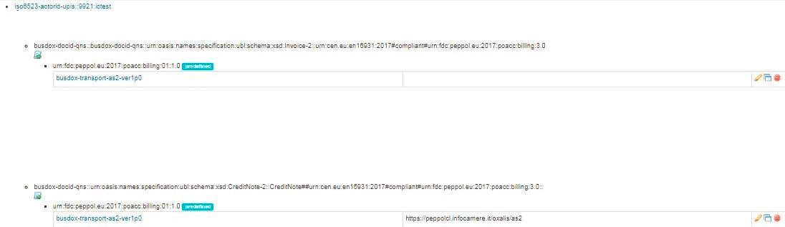

Figure 7 - Infocamere SMP Configuration

## Send Invoice Cross Border

A user of the Chamber of Commerce portal sends an invoice to a foreign public administration (cross border) which has the following party identification 9921: ictest

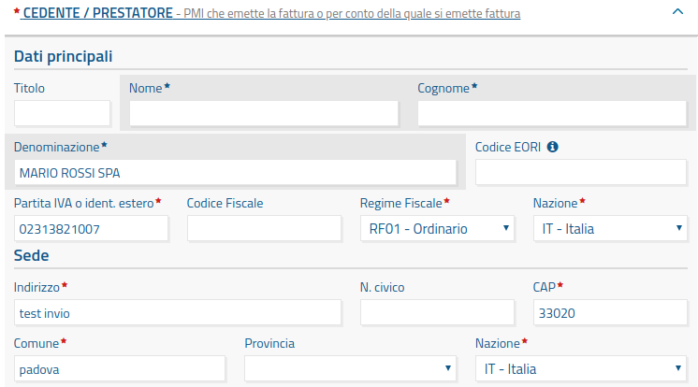

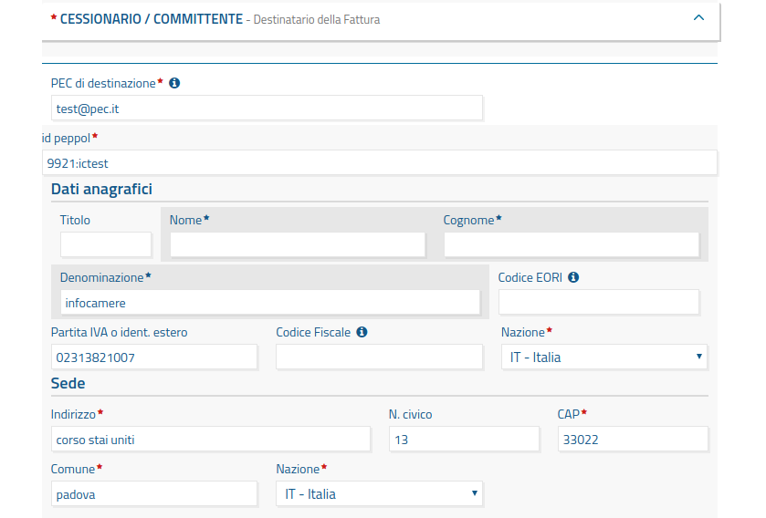

Figure 8 - Invoice Editing on Chamber of Commerce Portal

|  |
| --- |
| <?xml version="1.0" encoding="UTF-8"?>  <Invoice xmlns="urn:oasis:names:specification:ubl:schema:xsd:Invoice-2" xmlns:cac="urn:oasis:names:specification:ubl:schema:xsd:CommonAggregateComponents-2" xmlns:cbc="urn:oasis:names:specification:ubl:schema:xsd:CommonBasicComponents-2" xmlns:ccts="urn:un:unece:uncefact:documentation:2" xmlns:qdt="urn:oasis:names:specification:ubl:schema:xsd:QualifiedDataTypes-2" xmlns:udt="urn:oasis:names:specification:ubl:schema:xsd:UnqualifiedDataTypes-2">   <cbc:CustomizationID>urn:cen.eu:en16931:2017#compliant#urn:fdc:peppol.eu:2017:poacc:billing:3.0</cbc:CustomizationID>   <cbc:ProfileID>urn:fdc:peppol.eu:2017:poacc:billing:01:1.0</cbc:ProfileID>   <cbc:ID>test_eu1</cbc:ID>   <cbc:IssueDate>2019-03-28</cbc:IssueDate>   <cbc:InvoiceTypeCode>380</cbc:InvoiceTypeCode>   <cbc:DocumentCurrencyCode>EUR</cbc:DocumentCurrencyCode>   <cac:OrderReference>     <cbc:ID>NA</cbc:ID>   </cac:OrderReference>   <cac:AccountingSupplierParty>     <cac:Party>       <cbc:EndpointID schemeID="9921">NA</cbc:EndpointID>       <cac:PostalAddress>         <cbc:StreetName>test invio</cbc:StreetName>         <cbc:CityName>padova</cbc:CityName>         <cbc:PostalZone>33020</cbc:PostalZone>         <cac:Country>           <cbc:IdentificationCode>IT</cbc:IdentificationCode>         </cac:Country>       </cac:PostalAddress>       <cac:PartyTaxScheme>         <cbc:CompanyID>IT02313821007</cbc:CompanyID>         <cac:TaxScheme>           <cbc:ID>NoVAT</cbc:ID>         </cac:TaxScheme>       </cac:PartyTaxScheme>       <cac:PartyLegalEntity>         <cbc:RegistrationName>MARIO ROSSI SPA</cbc:RegistrationName>       </cac:PartyLegalEntity>     </cac:Party>   </cac:AccountingSupplierParty>   <cac:AccountingCustomerParty>     <cac:Party>       <cbc:EndpointID schemeID="9921">**XXXXXXX**</cbc:EndpointID>       <cac:PostalAddress>         <cbc:StreetName>corso stai uniti</cbc:StreetName>         <cbc:CityName>padova</cbc:CityName>         <cbc:PostalZone>33022</cbc:PostalZone>         <cac:Country>           <cbc:IdentificationCode>IT</cbc:IdentificationCode>         </cac:Country>       </cac:PostalAddress>       <cac:PartyTaxScheme>         <cbc:CompanyID>IT02313821007</cbc:CompanyID>         <cac:TaxScheme>           <cbc:ID>VAT</cbc:ID>         </cac:TaxScheme>       </cac:PartyTaxScheme>       <cac:PartyLegalEntity>         <cbc:RegistrationName>infocamere</cbc:RegistrationName>       </cac:PartyLegalEntity>     </cac:Party>   </cac:AccountingCustomerParty>   <cac:PaymentTerms>     <cbc:Note>N/A Payment Terms</cbc:Note>   </cac:PaymentTerms>   <cac:TaxTotal>     <cbc:TaxAmount currencyID="EUR">22.00</cbc:TaxAmount>     <cac:TaxSubtotal>       <cbc:TaxableAmount currencyID="EUR">100.00</cbc:TaxableAmount>       <cbc:TaxAmount currencyID="EUR">22.00</cbc:TaxAmount>       <cac:TaxCategory>         <cbc:ID>S</cbc:ID>         <cbc:Percent>22.00</cbc:Percent>         <cac:TaxScheme>           <cbc:ID>VAT</cbc:ID>         </cac:TaxScheme>       </cac:TaxCategory>     </cac:TaxSubtotal>   </cac:TaxTotal>   <cac:LegalMonetaryTotal>     <cbc:LineExtensionAmount currencyID="EUR">100.00</cbc:LineExtensionAmount>     <cbc:TaxExclusiveAmount currencyID="EUR">100.00</cbc:TaxExclusiveAmount>     <cbc:TaxInclusiveAmount currencyID="EUR">122.00</cbc:TaxInclusiveAmount>     <cbc:PrepaidAmount currencyID="EUR">0.00</cbc:PrepaidAmount>     <cbc:PayableRoundingAmount currencyID="EUR">0.00</cbc:PayableRoundingAmount>     <cbc:PayableAmount currencyID="EUR">122.00</cbc:PayableAmount>   </cac:LegalMonetaryTotal>   <cac:InvoiceLine>     <cbc:ID>1</cbc:ID>     <cbc:InvoicedQuantity unitCode="C62">1.00</cbc:InvoicedQuantity>     <cbc:LineExtensionAmount currencyID="EUR">100.00</cbc:LineExtensionAmount>     <cac:Item>       <cbc:Name>test articolo1</cbc:Name>       <cac:ClassifiedTaxCategory>         <cbc:ID>S</cbc:ID>         <cbc:Percent>22.00</cbc:Percent>         <cac:TaxScheme>           <cbc:ID>VAT</cbc:ID>         </cac:TaxScheme>       </cac:ClassifiedTaxCategory>     </cac:Item>     <cac:Price>       <cbc:PriceAmount currencyID="EUR">100.00</cbc:PriceAmount>     </cac:Price>   </cac:InvoiceLine>  </Invoice> |

Figure 9 – eInvoice BIS3 from Infocert Mapper

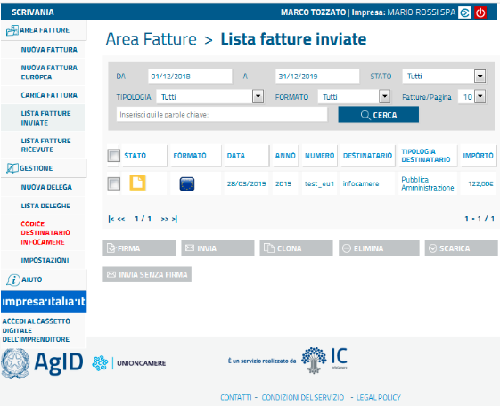

Figure 10 - Cross Border Invoice before sending in Peppol Network

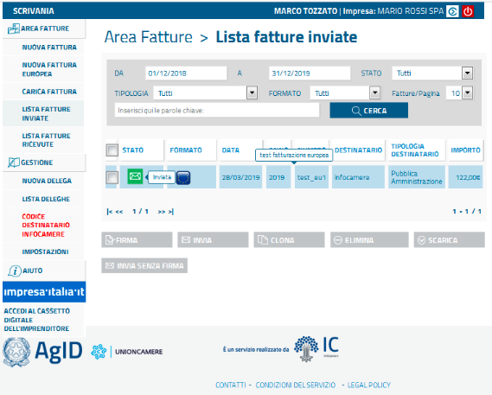

Figure 11 - Cross Border Invoice after sending to Infocamere Access Point

|  |
| --- |
| [oxal@vlcitome001 AS2]$ cd oxalis-OUTBOUND  [oxal@vlcitome001 oxalis-OUTBOUND]$ ls  **@9921@ictest@1918418.xml (<<<<< einvoice ready to be send from Infocamere Access Point)** |

Figure 12 – eInvoice ready to be sent from Infocamere Access Point

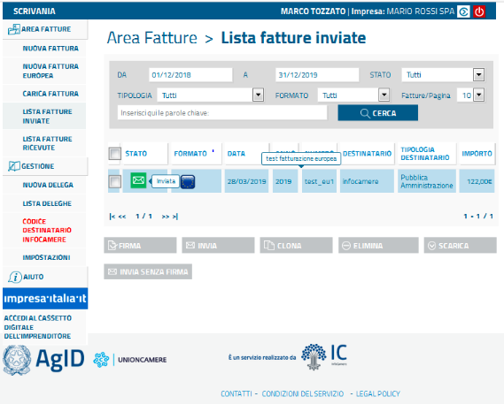

Figure 13 - After the scheduling of sending the AP

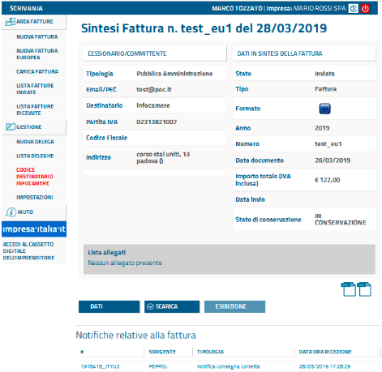

Figure 14 - eDelivery Infrastructure send callback notice to positive sending

|  |
| --- |
| <?xml version="1.0" encoding="UTF-8"?><DeliveryNonDeliveryToRecipient xmlns="http://uri.etsi.org/02640/v2#" xmlns:ns2="http://uri.etsi.org/02231/v2#" xmlns:ns3="http://www.w3.org/2000/09/xmldsig#" xmlns:ns4="http://uri.etsi.org/01903/v1.3.2#" xmlns:ns5="urn:oasis:names:tc:SAML:2.0:assertion" xmlns:ns6="http://www.w3.org/2001/04/xmlenc#" xmlns:ns7="http://peppol.eu/xsd/ticc/receipt/1.0" version="2"><EventCode>http:uri.etsi.org/02640/Event#Delivery</EventCode><EvidenceIdentifier>b56565ad-fdb2-449a-99d1-739978ba6ba1</EvidenceIdentifier><EvidenceIssuerDetails><NamesPostalAddresses><NamePostalAddress><EntityName><Name>Oxalis 4.0.4</Name></EntityName></NamePostalAddress></NamesPostalAddresses></EvidenceIssuerDetails><EventTime>2019-03-28T16:08:37Z</EventTime><SenderDetails><AttributedElectronicAddress scheme="iso6523-actorid-upis">9921:ictest</AttributedElectronicAddress></SenderDetails><RecipientsDetails><EntityDetails><AttributedElectronicAddress scheme="iso6523-actorid-upis">9921:ictest</AttributedElectronicAddress></EntityDetails></RecipientsDetails><EvidenceRefersToRecipient>1</EvidenceRefersToRecipient><SenderMessageDetails isNotification="false"><MessageSubject>urn:oasis:names:specification:ubl:schema:xsd:Invoice-2::Invoice##urn:cen.eu:en16931:2017#compliant#urn:fdc:peppol.eu:2017:poacc:billing:3.0::</MessageSubject><UAMessageIdentifier>054a5e4f-4ef4-4176-8821-88823720f8b8</UAMessageIdentifier><MessageIdentifierByREMMD>1553789316817.1.-1319330726.Oxalis@vlcibatch001.intra.infocamere.it</MessageIdentifierByREMMD><ns3:DigestMethod Algorithm="http://www.w3.org/2000/09/xmldsig#sha1"/><ns3:DigestValue>yKR4Lf3a24zUEV9gj2Ku37R0ygU=</ns3:DigestValue></SenderMessageDetails><Extensions><Extension><ns7:PeppolRemExtension><ns7:TransmissionProtocol>AS2</ns7:TransmissionProtocol><ns7:TransmissionRole>C3</ns7:TransmissionRole><ns7:OriginalReceipt type="message/disposition-notification"></ns7:OriginalReceipt></ns7:PeppolRemExtension></Extension></Extensions><Signature xmlns="http://www.w3.org/2000/09/xmldsig#"><SignedInfo><CanonicalizationMethod Algorithm="http://www.w3.org/TR/2001/REC-xml-c14n-20010315"/><SignatureMethod Algorithm="http://www.w3.org/2001/04/xmldsig-more#rsa-sha256"/><Reference URI=""><Transforms><Transform Algorithm="http://www.w3.org/2000/09/xmldsig#enveloped-signature"/></Transforms><DigestMethod Algorithm="http://www.w3.org/2001/04/xmlenc#sha256"/><DigestValue>Q6YEadv6e6MyHkToEfGMlencNjooR8NMnuutAFHK3HQ=</DigestValue></Reference></SignedInfo><SignatureValue>UlH1fSjxVNv0M2jVKgLbocV/4Hy4K+x7epYXRcAe+HRSvPjpZ1Ew2IO4dU+Vs71tv3uPcvtDI2fP&#13;  S8mDAVSgv+Jrxr8VeYEg7+HR+8y0wD25nPopBjnKvtUgizp2FhCsf9YtU9CURo1P1IWJwv2mUKnI&#13;  b36uOx9tJFlPsvZVWlzlciMPj4CON03ZlZLiZu2AviGiDqbE8QNXh8PZ4PVqQ/ffn47bHEy1j5F6&#13;  yJzgbVWUHHSwHaXEJuM0PV9ix+04Y5c+e85XJL10Lg3Nw+u14dvmEbfkh/jyrsAbe2gTUd5XGQ6b&#13;  ZY+zvtH3Gyw+m4yyo2zZ21jldaEbG88+MWlSMQ==</SignatureValue><KeyInfo><X509Data><X509SubjectName>C=IT,O=Infocamere\ ,OU=PEPPOL TEST AP,CN=PIT000252</X509SubjectName><X509Certificate>MIIFwzCCA6ugAwIBAgIQaVGTAxII7HUg/5QOnds9dTANBgkqhkiG9w0BAQsFADBrMQswCQYDVQQG&#13;  EwJCRTEZMBcGA1UEChMQT3BlblBFUFBPTCBBSVNCTDEWMBQGA1UECxMNRk9SIFRFU1QgT05MWTEp&#13;  MCcGA1UEAxMgUEVQUE9MIEFDQ0VTUyBQT0lOVCBURVNUIENBIC0gRzIwHhcNMTkwMTA5MDAwMDAw&#13;  WhcNMjAxMjI5MjM1OTU5WjBQMRIwEAYDVQQDDAlQSVQwMDAyNTIxFzAVBgNVBAsMDlBFUFBPTCBU&#13;  RVNUIEFQMRQwEgYDVQQKDAtJbmZvY2FtZXJlIDELMAkGA1UEBhMCSVQwggEiMA0GCSqGSIb3DQEB&#13;  AQUAA4IBDwAwggEKAoIBAQCKlfdI6K45Hn2yj2OkeQOeH58ITKzGyHq64OM5WHeCFB+CP6nKU+/1&#13;  Lv+9Sxg2u8E0whpgEZjdYetnfm/meQwEPz8ZGK8VvV4dXGDjhF11muXANzLzv9jDXZYcCwQB4LQr&#13;  QPFgnS5CiH1tL29qMUEBtyG9BR+mbMS74X/CJUQw95dBVDi8kNdlCy3wSJ4wfjV+VGu14comPKuz&#13;  kckYSBF253cekQx0oFmCS3XiqQk9P+VwMwtabHRxguv/VP6iBw+Uby9IeS6dNfpcJ6tYfW86K+QE&#13;  zMsJmXRzWQIFVJi5WIPvgOL6J135KMP9d2X7wvFudYaccZAI5rmCTPfQI8DfAgMBAAGjggF8MIIB&#13;  eDAMBgNVHRMBAf8EAjAAMA4GA1UdDwEB/wQEAwIDqDAWBgNVHSUBAf8EDDAKBggrBgEFBQcDAjAd&#13;  BgNVHQ4EFgQUMEiOA6/eZyMO3bo9wRYPwVIzRlMwXQYDVR0fBFYwVDBSoFCgToZMaHR0cDovL3Br&#13;  aS1jcmwuc3ltYXV0aC5jb20vY2FfNmE5Mzc3MzRhMzkzYTA4MDViZjMzY2RhOGIzMzEwOTMvTGF0&#13;  ZXN0Q1JMLmNybDA3BggrBgEFBQcBAQQrMCkwJwYIKwYBBQUHMAGGG2h0dHA6Ly9wa2ktb2NzcC5z&#13;  eW1hdXRoLmNvbTAfBgNVHSMEGDAWgBRrb0u28Te6Kzx/GM26K7K5fCo36zAtBgpghkgBhvhFARAD&#13;  BB8wHQYTYIZIAYb4RQEQAQIDAQGBqZDhAxYGOTU3NjA4MDkGCmCGSAGG+EUBEAUEKzApAgEAFiRh&#13;  SFIwY0hNNkx5OXdhMmt0Y21FdWMzbHRZWFYwYUM1amIyMD0wDQYJKoZIhvcNAQELBQADggIBACfw&#13;  qxUJpdO8NmWQiwCnvnJ7DJSZgSLJBmCvPMWemzm+hmI0hxRC59MdQXN0ABRq/7NAsd00UGl27SYC&#13;  N0jyVS0MvTtaFrvRif5DK9Wh8PZ/qPxyDS2hO3pthwOYNieo87oaS0BAhu5g5Rc7w+1FGusx2dH9&#13;  is0GnvlqNVWITG9vAIBkYS2P3iuGMsRRkp/0l0YgXH4DimnOSZhN6lIN/anxVW2mWhht503fLkoA&#13;  okS/difsw5Md9sb3kcPHGMtbLS7ItMnT8apmzRMUkffKUJ5TwM9hdTgypceRwEI0wHqaVy/opvTZ&#13;  8taqgbW4Tk1xnC+EZRpaoFLkc4Of0EZsxyiN5NBzReE9LOx+dmqJH5raYGkcvIxznj2hLhJbrjwP&#13;  qY98vflocPrf0UQ3Qptjx0/5PekWi59UKtconmDffH+tBHwvGsfkvKND1ammNkrIexF93udOg64f&#13;  v0+7lmXoFOFcns03dl0yZrTVE++GPfrfu4eYwosU8+VTO4gLHeKlQ4iOo2+Daj/Hpvi5L8c6gW4b&#13;  wOG93Y1z5n8aCMO9MydTtX0M2vbkzmtUWjmb+Tl/fLpw2FEA7dkfKYmyupCFLn+zxD6kazsml5Qi&#13;  xK+S4wJB9z7cypMAsx9fEshjVIX150je0LCzFyWQD1bywHyc4PdmVmxmejWrjhtRnWfuQ1On</X509Certificate></X509Data></KeyInfo></Signature></DeliveryNonDeliveryToRecipient> |

Figure 15 – Message delivery notification message

## Send Credit Note Cross Border

A user of the Chamber of Commerce portal sends a credit note to a foreign public administration (cross border) which has the following party identification 9921: ictest

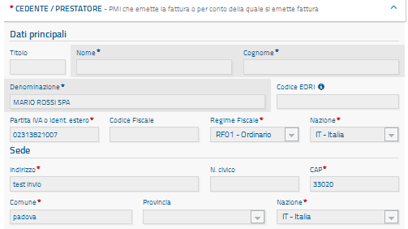

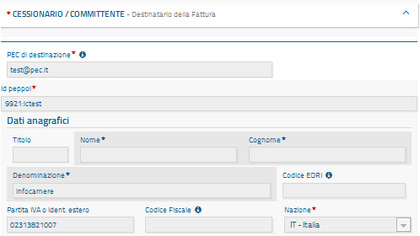

Figure 16 – Credit Note Editing on Chamber of Commerce Portal

|  |
| --- |
| <?xml version="1.0" encoding="UTF-8"?>  <CreditNote xmlns="urn:oasis:names:specification:ubl:schema:xsd:CreditNote-2" xmlns:cac="urn:oasis:names:specification:ubl:schema:xsd:CommonAggregateComponents-2" xmlns:cbc="urn:oasis:names:specification:ubl:schema:xsd:CommonBasicComponents-2">  <cbc:CustomizationID>urn:cen.eu:en16931:2017#compliant#urn:fdc:peppol.eu:2017:poacc:billing:3.0</cbc:CustomizationID>  <cbc:ProfileID>urn:fdc:peppol.eu:2017:poacc:billing:01:1.0</cbc:ProfileID>  <cbc:ID>nota_credito1</cbc:ID>  <cbc:IssueDate>2019-03-29</cbc:IssueDate>  <cbc:DocumentCurrencyCode>EUR</cbc:DocumentCurrencyCode>  <cac:OrderReference>  <cbc:ID>NA</cbc:ID>  </cac:OrderReference>  <cac:AccountingSupplierParty>  <cac:Party>  <cbc:EndpointID schemeID="9921">NA</cbc:EndpointID>  <cac:PostalAddress>  <cbc:StreetName>test invio</cbc:StreetName>  <cbc:CityName>padova</cbc:CityName>  <cbc:PostalZone>33020</cbc:PostalZone>  <cac:Country>  <cbc:IdentificationCode>IT</cbc:IdentificationCode>  </cac:Country>  </cac:PostalAddress>  <cac:PartyTaxScheme>  <cbc:CompanyID>IT02313821007</cbc:CompanyID>  <cac:TaxScheme>  <cbc:ID>NoVAT</cbc:ID>  </cac:TaxScheme>  </cac:PartyTaxScheme>  <cac:PartyLegalEntity>  <cbc:RegistrationName>MARIO ROSSI SPA</cbc:RegistrationName>  </cac:PartyLegalEntity>  </cac:Party>  </cac:AccountingSupplierParty>  <cac:AccountingCustomerParty>  <cac:Party>  <cbc:EndpointID schemeID="9921">XXXXXXX</cbc:EndpointID>  <cac:PostalAddress>  <cbc:StreetName>corso stai uniti</cbc:StreetName>  <cbc:CityName>padova</cbc:CityName>  <cbc:PostalZone>33022</cbc:PostalZone>  <cac:Country>  <cbc:IdentificationCode>IT</cbc:IdentificationCode>  </cac:Country>  </cac:PostalAddress>  <cac:PartyTaxScheme>  <cbc:CompanyID>IT02313821007</cbc:CompanyID>  <cac:TaxScheme>  <cbc:ID>VAT</cbc:ID>  </cac:TaxScheme>  </cac:PartyTaxScheme>  <cac:PartyLegalEntity>  <cbc:RegistrationName>infocamere</cbc:RegistrationName>  </cac:PartyLegalEntity>  </cac:Party>  </cac:AccountingCustomerParty>  <cac:PaymentTerms>  <cbc:Note>N/A Payment Terms</cbc:Note>  </cac:PaymentTerms>  <cac:TaxTotal>  <cbc:TaxAmount currencyID="EUR">22.00</cbc:TaxAmount>  <cac:TaxSubtotal>  <cbc:TaxableAmount currencyID="EUR">100.00</cbc:TaxableAmount>  <cbc:TaxAmount currencyID="EUR">22.00</cbc:TaxAmount>  <cac:TaxCategory>  <cbc:ID>S</cbc:ID>  <cbc:Percent>22.00</cbc:Percent>  <cac:TaxScheme>  <cbc:ID>VAT</cbc:ID>  </cac:TaxScheme>  </cac:TaxCategory>  </cac:TaxSubtotal>  </cac:TaxTotal>  <cac:LegalMonetaryTotal>  <cbc:LineExtensionAmount currencyID="EUR">100.00</cbc:LineExtensionAmount>  <cbc:TaxExclusiveAmount currencyID="EUR">100.00</cbc:TaxExclusiveAmount>  <cbc:TaxInclusiveAmount currencyID="EUR">122.00</cbc:TaxInclusiveAmount>  <cbc:PrepaidAmount currencyID="EUR">0.00</cbc:PrepaidAmount>  <cbc:PayableRoundingAmount currencyID="EUR">0.00</cbc:PayableRoundingAmount>  <cbc:PayableAmount currencyID="EUR">122.00</cbc:PayableAmount>  </cac:LegalMonetaryTotal>  <cac:CreditNoteLine>  <cbc:ID>1</cbc:ID>  <cbc:CreditedQuantity unitCode="C62">1.00000000</cbc:CreditedQuantity>  <cbc:LineExtensionAmount currencyID="EUR">100.00</cbc:LineExtensionAmount>  <cac:Item>  <cbc:Name>test articolo1</cbc:Name>  <cac:ClassifiedTaxCategory>  <cbc:ID>S</cbc:ID>  <cbc:Percent>22.00</cbc:Percent>  <cac:TaxScheme>  <cbc:ID>VAT</cbc:ID>  </cac:TaxScheme>  </cac:ClassifiedTaxCategory>  </cac:Item>  <cac:Price>  <cbc:PriceAmount currencyID="EUR">100.00</cbc:PriceAmount>  </cac:Price>  </cac:CreditNoteLine>  </CreditNote> |

Figure 17 – Credit Note BIS3 from Infocert Mapper

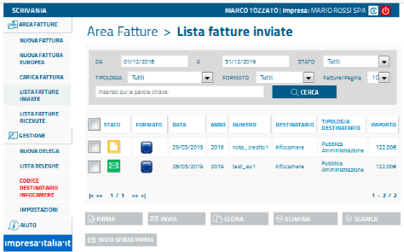

Figure 18 - Cross Border Credit Note before sending in Peppol Network

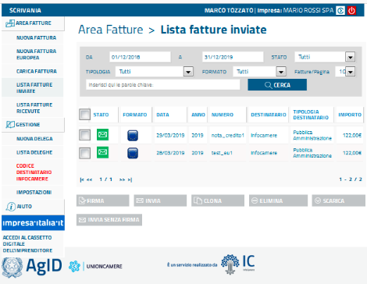

Figure 19 - Cross Border Credit Note after sending to Infocamere Access Point

|  |
| --- |
| [oxal@vlcitome001 AS2]$ cd oxalis-OUTBOUND  [oxal@vlcitome001 oxalis-OUTBOUND]$ ls  **@9921@ictest@1918419.xml (<<<<< Credit Note ready to be send from Infocamere Access Point)** |

Figure 20 – Credit Note ready to be sent from Infocamere Access Point

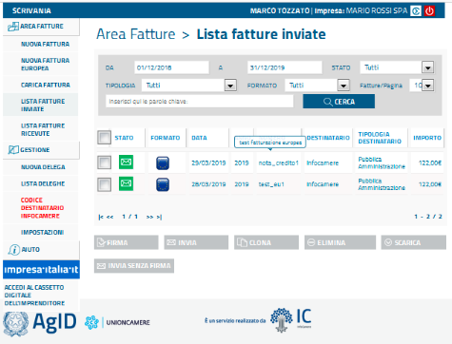

Figure 21 - After the scheduling of sending to the AP

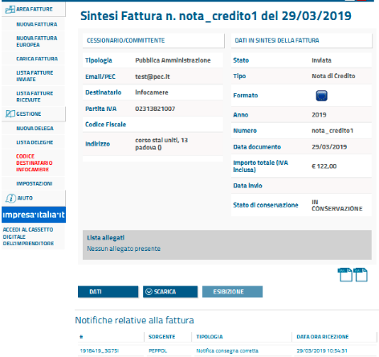

Figure 22 - eDelivery Infrastructure sends callback notice to positive sending

|  |
| --- |
| <?xml version="1.0" encoding="UTF-8"?><DeliveryNonDeliveryToRecipient xmlns="http://uri.etsi.org/02640/v2#" xmlns:ns2="http://uri.etsi.org/02231/v2#" xmlns:ns3="http://www.w3.org/2000/09/xmldsig#" xmlns:ns4="http://uri.etsi.org/01903/v1.3.2#" xmlns:ns5="urn:oasis:names:tc:SAML:2.0:assertion" xmlns:ns6="http://www.w3.org/2001/04/xmlenc#" xmlns:ns7="http://peppol.eu/xsd/ticc/receipt/1.0" version="2"><EventCode>http:uri.etsi.org/02640/Event#Delivery</EventCode><EvidenceIdentifier>6d7b1863-e420-4e12-9b28-0a4ebb2cef96</EvidenceIdentifier><EvidenceIssuerDetails><NamesPostalAddresses><NamePostalAddress><EntityName><Name>Oxalis 4.0.4</Name></EntityName></NamePostalAddress></NamesPostalAddresses></EvidenceIssuerDetails><EventTime>2019-03-29T10:38:25+01:00</EventTime><SenderDetails><AttributedElectronicAddress scheme="iso6523-actorid-upis">9921:ictest</AttributedElectronicAddress></SenderDetails><RecipientsDetails><EntityDetails><AttributedElectronicAddress scheme="iso6523-actorid-upis">9921:ictest</AttributedElectronicAddress></EntityDetails></RecipientsDetails><EvidenceRefersToRecipient>1</EvidenceRefersToRecipient><SenderMessageDetails isNotification="false"><MessageSubject>urn:oasis:names:specification:ubl:schema:xsd:CreditNote-2::CreditNote##urn:cen.eu:en16931:2017#compliant#urn:fdc:peppol.eu:2017:poacc:billing:3.0::</MessageSubject><UAMessageIdentifier>6b0b86ab-a585-4d97-aaa4-1897ff6b70c4</UAMessageIdentifier><MessageIdentifierByREMMD>1553852304747.1.2036932300.Oxalis@vlcibatch001.intra.infocamere.it</MessageIdentifierByREMMD><ns3:DigestMethod Algorithm="http://www.w3.org/2000/09/xmldsig#sha1"/><ns3:DigestValue>gC4U1m4j7huJGhBc9hO5NBfLTCM=</ns3:DigestValue></SenderMessageDetails><Extensions><Extension><ns7:PeppolRemExtension><ns7:TransmissionProtocol>AS2</ns7:TransmissionProtocol><ns7:TransmissionRole>C2</ns7:TransmissionRole><ns7:OriginalReceipt type="message/disposition-notification"></ns7:OriginalReceipt></ns7:PeppolRemExtension></Extension></Extensions><Signature xmlns="http://www.w3.org/2000/09/xmldsig#"><SignedInfo><CanonicalizationMethod Algorithm="http://www.w3.org/TR/2001/REC-xml-c14n-20010315"/><SignatureMethod Algorithm="http://www.w3.org/2001/04/xmldsig-more#rsa-sha256"/><Reference URI=""><Transforms><Transform Algorithm="http://www.w3.org/2000/09/xmldsig#enveloped-signature"/></Transforms><DigestMethod Algorithm="http://www.w3.org/2001/04/xmlenc#sha256"/><DigestValue>nRYYJxh14pEGUR/aG1zWE4S0dKyGYDU5rY5X5o2sVOU=</DigestValue></Reference></SignedInfo><SignatureValue>UUSVszX2rZLdfXNWNvBotWuBhYlLzAWBuiTo8r6d2qI4kP3KKOVVuSYyO+IK9uYNnBdjerC0t3jN  822YI8ppbd0rRlaANUZGFUPpj8q0pniq/B9EWw42bFLLkptMR27E16OQY5YfKeSJUzui0+PA9KD/  9fz/hRP7jyLrnBb53zTaAVbLNOOwE2+x9BneGqeuFeN/IjYkMy772Rpp7bUd02XGELK1ercIiN4X  P1hlDU7EJzd9okssW5Cin0CPfm0qaune22nZ/43WvKVDEbDY3xFzW8wjmD3ho+xPFss/iLZTiyIx  +IspjTrWYemaaTT501okc07Kvj4Uu2ThcyLK0A==</SignatureValue><KeyInfo><X509Data><X509SubjectName>C=IT,O=Infocamere\ ,OU=PEPPOL TEST AP,CN=PIT000252</X509SubjectName><X509Certificate>MIIFwzCCA6ugAwIBAgIQaVGTAxII7HUg/5QOnds9dTANBgkqhkiG9w0BAQsFADBrMQswCQYDVQQG  EwJCRTEZMBcGA1UEChMQT3BlblBFUFBPTCBBSVNCTDEWMBQGA1UECxMNRk9SIFRFU1QgT05MWTEp  MCcGA1UEAxMgUEVQUE9MIEFDQ0VTUyBQT0lOVCBURVNUIENBIC0gRzIwHhcNMTkwMTA5MDAwMDAw  WhcNMjAxMjI5MjM1OTU5WjBQMRIwEAYDVQQDDAlQSVQwMDAyNTIxFzAVBgNVBAsMDlBFUFBPTCBU  RVNUIEFQMRQwEgYDVQQKDAtJbmZvY2FtZXJlIDELMAkGA1UEBhMCSVQwggEiMA0GCSqGSIb3DQEB  AQUAA4IBDwAwggEKAoIBAQCKlfdI6K45Hn2yj2OkeQOeH58ITKzGyHq64OM5WHeCFB+CP6nKU+/1  Lv+9Sxg2u8E0whpgEZjdYetnfm/meQwEPz8ZGK8VvV4dXGDjhF11muXANzLzv9jDXZYcCwQB4LQr  QPFgnS5CiH1tL29qMUEBtyG9BR+mbMS74X/CJUQw95dBVDi8kNdlCy3wSJ4wfjV+VGu14comPKuz  kckYSBF253cekQx0oFmCS3XiqQk9P+VwMwtabHRxguv/VP6iBw+Uby9IeS6dNfpcJ6tYfW86K+QE  zMsJmXRzWQIFVJi5WIPvgOL6J135KMP9d2X7wvFudYaccZAI5rmCTPfQI8DfAgMBAAGjggF8MIIB  eDAMBgNVHRMBAf8EAjAAMA4GA1UdDwEB/wQEAwIDqDAWBgNVHSUBAf8EDDAKBggrBgEFBQcDAjAd  BgNVHQ4EFgQUMEiOA6/eZyMO3bo9wRYPwVIzRlMwXQYDVR0fBFYwVDBSoFCgToZMaHR0cDovL3Br  aS1jcmwuc3ltYXV0aC5jb20vY2FfNmE5Mzc3MzRhMzkzYTA4MDViZjMzY2RhOGIzMzEwOTMvTGF0  ZXN0Q1JMLmNybDA3BggrBgEFBQcBAQQrMCkwJwYIKwYBBQUHMAGGG2h0dHA6Ly9wa2ktb2NzcC5z  eW1hdXRoLmNvbTAfBgNVHSMEGDAWgBRrb0u28Te6Kzx/GM26K7K5fCo36zAtBgpghkgBhvhFARAD  BB8wHQYTYIZIAYb4RQEQAQIDAQGBqZDhAxYGOTU3NjA4MDkGCmCGSAGG+EUBEAUEKzApAgEAFiRh  SFIwY0hNNkx5OXdhMmt0Y21FdWMzbHRZWFYwYUM1amIyMD0wDQYJKoZIhvcNAQELBQADggIBACfw  qxUJpdO8NmWQiwCnvnJ7DJSZgSLJBmCvPMWemzm+hmI0hxRC59MdQXN0ABRq/7NAsd00UGl27SYC  N0jyVS0MvTtaFrvRif5DK9Wh8PZ/qPxyDS2hO3pthwOYNieo87oaS0BAhu5g5Rc7w+1FGusx2dH9  is0GnvlqNVWITG9vAIBkYS2P3iuGMsRRkp/0l0YgXH4DimnOSZhN6lIN/anxVW2mWhht503fLkoA  okS/difsw5Md9sb3kcPHGMtbLS7ItMnT8apmzRMUkffKUJ5TwM9hdTgypceRwEI0wHqaVy/opvTZ  8taqgbW4Tk1xnC+EZRpaoFLkc4Of0EZsxyiN5NBzReE9LOx+dmqJH5raYGkcvIxznj2hLhJbrjwP  qY98vflocPrf0UQ3Qptjx0/5PekWi59UKtconmDffH+tBHwvGsfkvKND1ammNkrIexF93udOg64f  v0+7lmXoFOFcns03dl0yZrTVE++GPfrfu4eYwosU8+VTO4gLHeKlQ4iOo2+Daj/Hpvi5L8c6gW4b  wOG93Y1z5n8aCMO9MydTtX0M2vbkzmtUWjmb+Tl/fLpw2FEA7dkfKYmyupCFLn+zxD6kazsml5Qi  xK+S4wJB9z7cypMAsx9fEshjVIX150je0LCzFyWQD1bywHyc4PdmVmxmejWrjhtRnWfuQ1On</X509Certificate></X509Data></KeyInfo></Signature></DeliveryNonDeliveryToRecipient> |

Figure 23– Message delivery notification message

# Test MAP-V-1 – AdE

This test has been carried out by AdE with the purpose to demonstrate the usage of EeISI mapper integrated into SDI through API interface.

The difference between previous UBL2XMPLPA and CII2XMLPA tests carried out through EeISI mapper CLI is that the SDI adds a translation report to the target file as below explained.

Invoice files that pass the mapper checks, are then passed to the translation service whose task it is to produce an output XML file in XMLPA format.

The ‘translated’ XML file is distinguished from the ‘native’ file in XMLPA format by the nomenclature.

The ‘translated’ file in XMLPA format contains, as attachments (tag <Attachment>):

­ the original invoice file, recognisable by the value contained in the <AttachmentName> (<NomeAttachment>) field:

*<AttachmentName>original_invoice</AttachmentName> (<NomeAttachment>fattura_originale</NomeAttachment>)*

­ a file in ‘.txt’ format, if applicable, containing a list of unmapped values, recognisable by the value contained in the <AttachmentName> NomeAttachment>) field:

*<AttachmentName>not-mapped-values.txt</AttachmentName>*

­ a file in ‘.csv’ format, if applicable, containing a list of values that have been trimmed as they exceeded the maximum length permitted for XMLPA format, recognisable by the value contained in the <AttachmentName> (<NomeAttachment>) field:

*<AttachmentName>trimmed_fields.csv</AttachmentName> (<NomeAttachment>trimmed_fields.csv</NomeAttachment>).*

Examples of The ‘translated’ XML file is distinguished from the ‘native’ file in XMLPA format by the nomenclature.

| MAP-V_01 | | | | | |
| --- | --- | --- | --- | --- | --- |
| |  |  |  |  |  |  |  | | --- | --- | --- | --- | --- | --- | --- | | **Sender** | **Sender channel** | **Sender format** | **Receiver** | **Receiver Intermediary** | **Receiver channel** | **Receiver format** | |  |  |  |  |  |  |  | | | | | | |
| Id | Test case | Input values | Expected values | Output values - Outcome | Date |
| 01 | Translation of an invoice file from UBL format to XMLPA format |  |  |  |  |
| A | UBL invoice file with all information submitted to stand-alone translation engine | *UBL file Name* | Invoice file in XMLPA format translated according to mapping matches | Reference:  UBL invoice with full content  (page link: 19) |  |
| B | UBL Invoice file referred to in previous point A with sample changes subjected to translation engine in stand-alone mode | *UBL file Name* | Invoice file in XMLPA format translated according to mapping matches | Reference:  Test MAP-V-1 – AdE: not-mapped-values  Test MAP-V-1 – AdE: trimmed_fields |  |
| 02 | Translation of an invoice file from CII format to XMLPA format |  |  |  |  |
| A | CII invoice file with all information submitted to stand-alone translation engine | *CII file Name* | Invoice file in XMLPA format translated according to mapping matches | Reference:  CII invoice (page link: 21) |  |
| B | CII Invoice file referred to in previous point A with sample changes subjected to translation engine in stand-alone mode | *CII file Name* | Invoice file in XMLPA format translated according to mapping matches  defined | Reference:  Test MAP-V-1 – AdE: not-mapped-values  Test MAP-V-1 – AdE: trimmed_fields |  |

## Test MAP-V-1 – AdE: *not-mapped-values*

BT0006: Iso4217CurrenciesFundsCodes{code='EUR'| num=978| numberOfDecimalDigits=2| currency='Euro'}

BT0010: BT-10 buyer reference

BT0014: SalesOrderID

BT0018: ZZZ:BT-18 Invoice object id

BT0020: BT-20 Payment terms= 5% penalties for delayed payment

BT0023: BT-23 Business Process Type

BT0028: The seller trading name

BT0033: Seller additional legal information

BT0034: mail:Seller electronic address

BT0041: Seller contact point

BT0045: The buyer trading name

BT0056: Buyer contact point

BT0057: 00393479849

BT0058: buyercontactpoint@gmail.com

BT0060: 0180:Payee identifier

BT0061: 0190:Payee legal identifier

BT0064: Street tax representative

BT0065: Additional street tax representative

BT0066: City tax representative

BT0067: 34100

BT0068: TN

BT0069: Iso31661CountryCodes{countryNameInEnglish='Italy'| iso2charCode='IT'| iso3charCode='ITA'| index=380}

BT0164: Line tax representative

BT0087: 1111

BT0088: Payment card holder name

BT0089: mandatereferenceidentifier

BT0090: SEPA:bank assigned creditor identifier

BT0091: debitaccountidentifier

BT0113: 0.00

BT0032: DESeller tax registration identifier

BT0029: 0100:Seller identifier 1BT0029: 0010:Seller identifier 3

BT0030: 0130:0130:Seller legal identifier

BT0039: Country subentity seller

BT0038: Postal zone seller

BT0046: null:IT:CF:IT07945211006

## Test MAP-V-1 – AdE: *trimmed_fields*

|  |  |  |  |  |  |  |  |
| --- | --- | --- | --- | --- | --- | --- | --- |
| XPath,MaxLength,Original value,Trimmed value |  |  |  |  |  |  |  |
| FatturaElettronicaBody/DatiBeniServizi/DettaglioLinee/AltriDatiGestionali/TipoDato,10,Hours per day,"Hours per " | | | | | | | |