



European eInvoicing Standard in Italy

|  |  |
| --- | --- |
| **Project number** | INEA/CEF/ICT/A2017/1560867 2017-IT-IA-0150 |
| **Project acronym** | EeISI |
| **Project title** | European eInvoicing Standard in Italy |
| **Starting date** | 1 May 2018 |
| **Ending date** | 31 December 2019 |
| **Programme** | Connecting Europe Facility (CEF) CEF-TC-2017-3: eInvoicing |

Technical testing of the “e-delivery” for the use cases identified

Deliverable D5.2

|  |  |
| --- | --- |
| **Related WP** | WP5 – Validation – Task 5.1  Domestic Task 5.2  Cross-Border |
| **Deliverable number** | D5.2 |
| **Due date** | 31/03/2019 |
| **Revision date** | 31/12/2019 |
| **Actual date** | 31/12/2019 |

Deliverable Info

|  |  |
| --- | --- |
| **Accountable** | AgID; AdE |
| **Responsible** | AgID |
| **Editor** | AgID |
| **Contributor** | **AgID; AdE; ICERT; IC; UNION** |
|  |  |
| **Abstract** | **This deliverable describes the different use cases related to B2G (domestic and / or cross-border) that must be tested from a functional standpoint to prove that the solution implemented is in line with the requirements tracked in the design phase** |
| **Keywords** |  |
|  |  |
| **Acknowledgement** | This work was partially supported by the European Commission (EC) through the Connecting Europe Facility (CEF) programme under project EeISI.(grant agreement no. INEA/CEF/ICT/A2017/1560867 2017-IT-IA-0150) |
| **Disclaimer** | The sole responsibility of this publication lies with the author(s). The European Union is not responsible for any use that may be made of the information contained therein. |
| **Confidentiality** | The information in this document is confidential and restricted only to the members of the EeISI consortium  (including the Commission Services). |
|  |  |
| **Note** |  |
|  |  |

**Version Control**

|  |  |  |  |
| --- | --- | --- | --- |
| Version | Date | Author | Description of change |
| 0.1.0 | 2020-02-26 | InfoCert | Update B2G-D_02_CII and ZIP-T-01 |
| 0.2.0 | 2020-03-31 | AGID | Merge |
| 0.2.1 | 2020-03-31 | AGID | Technical review and quality assessment |

# Table of contents

Deliverable Info 3

Table of contents 5

List of tables 7

List of figures 7

1 Introduction 9

1.1 Purpose 9

1.2 Scope 9

1.3 Document Overview 12

1.4 Definitions, Acronyms and Abbreviations 12

1.5 References 13

2 High Level Architecture 14

2.1 System Landscape As Is 14

2.2 System Landscape To Be 14

3 B2G Domestic Use Cases 15

3.1 Use Case inventory 15

3.2 B2G-D_01 - Transmission through traditional channels in UBL format 16

3.2.1 Process Flow 16

3.2.2 Process steps 17

3.3 B2G-D_02 - Transmission through traditional channels in CII format 18

3.3.1 Process Flow 18

3.3.2 Process steps 19

4 B2G Cross-border Use Cases 21

4.1 Use Case inventory 21

4.2 B2G-C_01 - Transmission from abroad through PEPPOL network of an invoice in UBL format 23

4.2.1 Process Flow 23

4.2.2 Process steps 24

4.3 B2G-C_02 - *Transmission of an invoice from abroad to ES (via SFTP or WS or CEM channel)* 27

4.3.1 Process Flow 27

4.3.2 Process steps 28

4.4 B2G-C_03 –B2G domestic e-invoice FatturaPA to UBL on PEPPOL channel 28

4.4.1 Process Flow 28

4.4.2 Process steps 29

4.5 B2G-C_04 – B2G domestic credit note FatturaPA to UBL on channel PEPPOL 30

4.5.1 Process Flow 30

4.5.2 Process steps 31

4.6 ZIP-T-01 - *Transmission of a ZIP file, containing several invoices in different formats, regardless of transmission channel* *(via SFTP or WS or CEM channel)* 33

4.6.1 Process Flow 33

4.6.2 Process steps 34

5 MAP-V Testing eInvoicing mapper framework 36

5.1 Use Case inventory 36

6 Test execution 38

6.1 Test planning 38

6.2 Test environments 38

6.3 Results and findings 38

7 Test scenarios and results 39

# List of tables

Tab 1 | List of Definitions, Acronyms and Abbreviations 13

Tab 2 | References list 13

# List of figures

Figure 2 Transmission from abroad through AS4 type AP 23

Figure 3 Transmission from abroad through traditional channels of an invoice in UBL or CII format 27

Figure 5 Transmission of a zip file through SDI channels 33

# Introduction

## Purpose

The “EeISI –European eInvoicing Standard in Italy” project aims to set-up a functional and technical environment evolving the existing italian public procurement eInvoicing process in compliance with the EU eInvoicing standards related to core semantic data model and syntaxes (EN 16931).

The proposed target scenario, which covers all the different uses cases detailed in the next chapter, is based on the following common requirement, stated by the italian law: each electronic invoice addressed to any italian public administration (PA) needs to be previously routed to a national technical infrastructure called Exchange System (SDI - *Sistema di Interscambio*), managed by the Italian Revenue Agency (AdE – *Agenzia delle Entrate*).

This system is able to:

* receive invoices in the form of XML files compliant with the syntax and schema of a specific national format called FatturaPA;
* make checks and validations on the received files;
* forward the processed invoices to the recipient administrations.

To stick to the above mentioned requirement and technical constraints, the eInvoices sent by an economic operator or public administration in one of the two mandatory syntaxes disciplined by the EN (UBL 2.1 or UN/CEFACT CII) must be mapped and translated in the FatturaPA intermediate format before being dispatched to the receiving PA.

This transformation is performed by a new dedicated artifact, fully integrated with existing SDI infrastructure.

## Scope

The goal of this document is to describe the different use cases that must be tested to prove that the solution implemented is in line with the requirements tracked in the design phase.

Each use case has been developed as a step by step flow explaining the interactions between a role (i.e. actor ) and a system, to achieve a specific goal. The actor can be a human or another external system. Within each use case, the steps involving one or more system operations (e.g. translations, validations, …) will be referenced in the deliverable *D51 – Technical Test Report*.

The target use cases have been grouped according to the following alternative business scenarios:

1. *Business to Government Domestic* (B2G-D): an italian Economic Operator (EO) sends an electronic invoice to an italian PA.
2. *Business to Government Cross-border* (B2G-C): a foreign european EO sends an electronic invoice to an italian PA through the PEPPOL network or over a traditional channel.

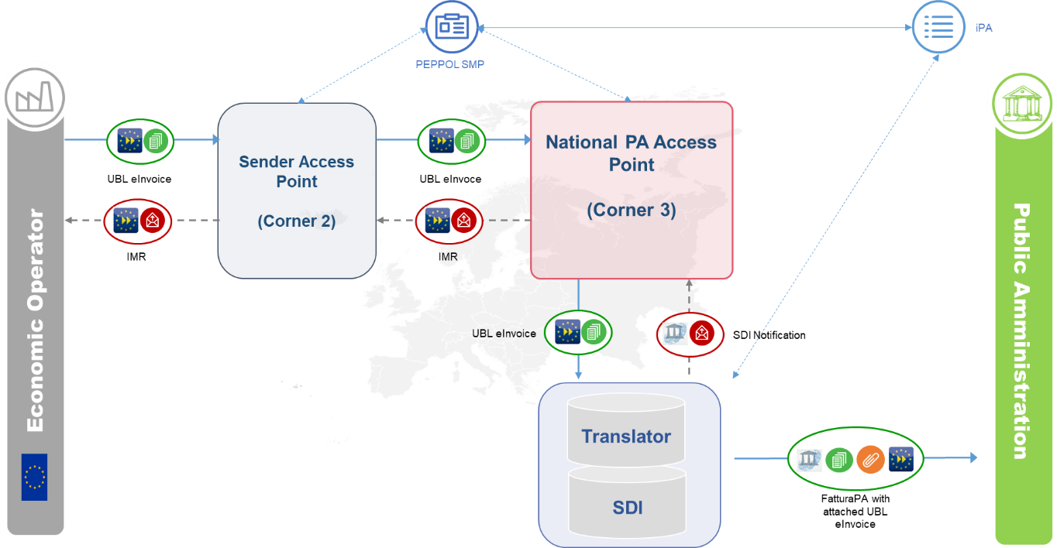

Figure 1 - A foreign EO sends an eInvoice to an Italian PA over the PEPPOL network

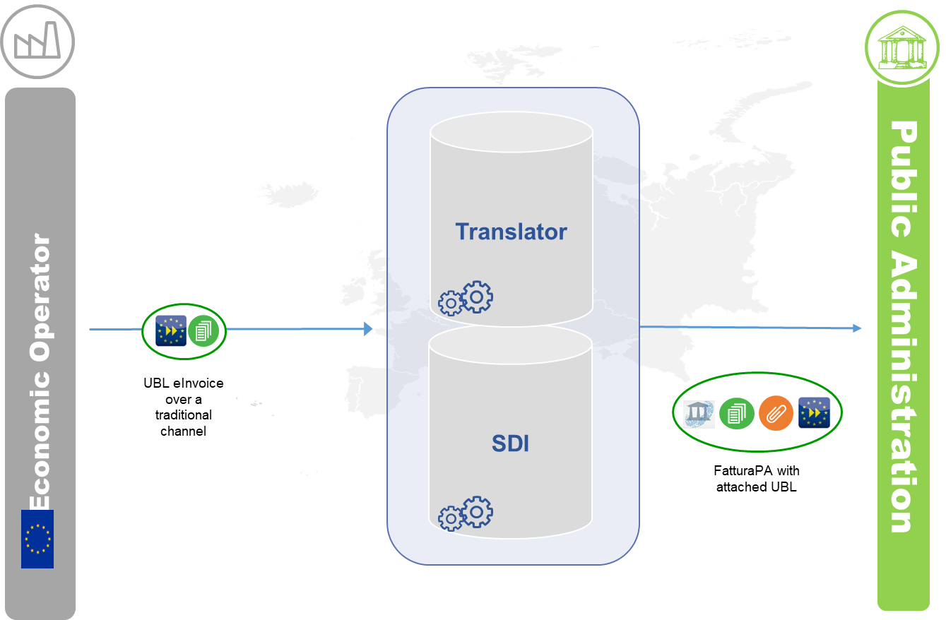

Figure 2 - A foreign EO sends an eInvoice to an Italian PA over a traditional channel

## Document Overview

In accordance with the scope defined in previous paragraph, the document has been organized as follows:

* Chapter 2 – High Level Architecture;
* Chapter 3 – B2G Domestic Use Cases;
* Chapter 4 – B2G Cross-border Use Cases;
* Chapter 5 – MAP-V Testing eInvoicing mapper framework.

## Definitions, Acronyms and Abbreviations

|  |  |
| --- | --- |
| Acronym | Description |
| B2B | Business to Business |
| B2G | Business to Government |
| BII | Business Interoperability Interfaces |
| CA | Contracting Authority |
| CEF | Connecting Europe Facility |
| CEN | European Committee for Standardisation |
| CII | Cross Industry electronic Invoice |
| CIUS | Core Invoice Usage Specification |
| DSI | Digital Service Infrastructures |
| EDI | Electronic Data Interchange |
| EDIFACT | Electronic Data Interchange For Administration, Commerce and Transport |
| EO | Economic Operator |
| ES | Exchange System (i.e. SDI – *Sistema di Interscambio*) |
| e-SENS | Electronic Simple European Networked Services |
| FatturaPA | Italian Public administration electronic invoice syntax |
| G2G | Government to Government |
| NoTI-ER | *Nodo Telematico di Interscambio della Regione Emilia Romagna* |
| OAI | The Open API Initiative |
| OASIS | Organization for the Advancement of Structured Information Standards |
| PA | Public Administration |
| PEC | *Posta Elettronica Certificata* (i.e. REM) |
| PEPPOL | Pan-European Public Procurement Online |
| PEPPOL-BIS | Pan-European Public Procurement Online Business Interoperability Specifications |
| REM | Registered Electronic Mail |
| SDI | Electronic exchange system in Italy (Sistema Di Interscambio) |
| UBL | Universal Business Language |
| UN/CEFACT | United Nations Centre for Trade Facilitation and Electronic Business |
| XML | Extensible Mark-up Language |

Tab 1 | List of Definitions, Acronyms and Abbreviations

## References

|  |  |  |
| --- | --- | --- |
| Document | Document name | Author |
| Agreement | Grant Agreement action 2017-IT-IA-0150 | INEA |
| Amendment | Amendment to the Grant Agreement | INEA |

Tab 2 | References list

# High Level Architecture

## System Landscape As Is

Curently, the italian public eProcurement infrastructure supporting the eInvoicing process is centered on the Exchange System (ES). This system is in charge to process and validate the invoices submitted electronically by the EOs (or issuing PAs) before dispatching them to the target PAs.

Different transmission channels and methods can be chosen by the EO to submit the eInvoice to ES:

* REM – Registered Electronic Mail (known in Italy as PEC – *Posta Elettronica Certificata*);
* Directly from the ES website;
* *Porta di Dominio* (PdD): set of technologies, protocols and standards ensuring proper integration of information objects (procedures and data) among all participants to a specific interoperability domain (EOs, PAs, …);
* FTP;
* WebService.

Each eInvoicing receiving office of any italian PAs is uniquely identified by a code released by the national Index of Public Administrations (IPA), that is a central information archive managed by the Italian Revenue Agency.

Through that code, the SE retrieves from IPA the information about the channel chosen by the target PA to receive the incoming eInvoices, once processed and validated.

Any of the channels enabled by ES for transmission (see list above) can be chosen by a PA as a reception channel, the only exception being the website option.

## System Landscape To Be

The objective of the project is to upgrade the existing architecture in order to support the exchange – domestic or cross-border - of eInvoices transmitted to the ES:

1. with a format different from FatturaPA (i.e. UBL and CII);
2. through a new transmission channel based on eDelivery and PEPPOL’s 4 corner model (option limited to UBL format).

**Exchange System**

New web services are implemented to integrate the ES with the new national AP (Access Point SDI) by means of webservices developed with REST protocol. These WSs allow the ES to receive and process the eInvoices submitted in UBL format through the PEPPOL network.

**Translator**

A new syntax and semantics converter is added to the landscape and integrated with the Exchange system. Whenever the eInvoice is received by the ES in CII or UBL format this component performs a translation into the FatturaPA syntax and semantics.

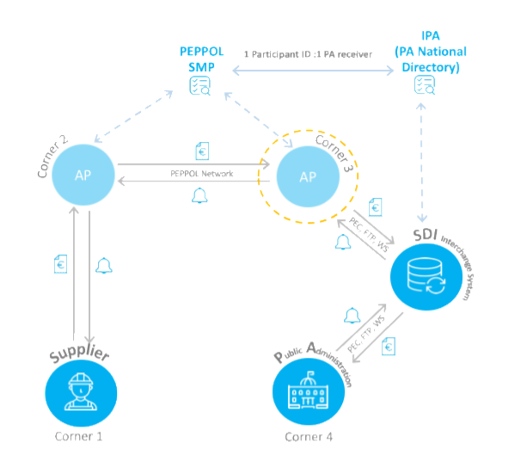

Figure 3 - Overall architecture

# B2G Domestic Use Cases

## Use Case inventory

In the B2G Domestic scenario, an Italian supplier sends an invoice in UBL, CII or FatturaPA format to an Italian PA.

Depending on the original format of the eInvoice, on the transmission / reception channel chosen and on the format expected by the receiving PA, the following four Use Cases can be identified:

* **B2G-D_01**: *Transmission through traditional channels in UBL format*:

In this use case, the eInvoice is sent by an italian Economic Operator to an italian Public Administration in UBL format using other channels allowed by national regulations but different from PEPPOL network.The invoice is forwarded by the SDI to the recipient always in XMLPA format, with the original invoice in UBL and any additional attachments for errors found possibly in translation attached.

* **B2G-D_02**: *Transmission through traditional channels in CII format*:

In this use case, the eInvoice is sent by an italian Economic Operator to an italian Public Administration in CII format using other channels allowed by national regulations but different from PEPPOL network. The invoice is forwarded by the SDI to the recipient always in XMLPA format, with the original invoice in CII and any additional attachments for errors found possibly in translation attached.

|  |  |  |  |  |  |
| --- | --- | --- | --- | --- | --- |
| UC ID | UC Name | Original Format | Transmission Channel | Reception Channel | Destination Format |
| B2G-D_01 | *Transmission through traditional channels in UBL format* |  |  |  |  |
|  |  |  |  |
| UBL | Any channel except PEPPOL | Any channel except PEPPOL | FatturaPA +  UBL attachment  +  Reports traduzione |
| B2G-D_02 | *Transmission through traditional channels in CII format* |  |  |  |  |
|  |  |  |  |
| CII | Any channel except PEPPOL | Any channel except PEPPOL | FatturaPA +  CII attachment  +  Reports traduzione |

## B2G-D_01 - Transmission through traditional channels in UBL format

### Process Flow

The flowchart presented below illustrates the main qualifying steps of the Use Case, in order to provide an overview of the overall process and to represent its operating logics



Figure 1 - Transmission through traditional channels in UBL format

### Process steps

In the following tables, we provide more insights or clarifications on each process steps and, were necessary, for each process variant, so as to allow a better understanding of the overall Use Case, from a functional and / or application perspective.

|  |  |  |  |  |  |
| --- | --- | --- | --- | --- | --- |
| Sender | Original Format | Transmission Channel | Reception Channel | Destination Format | Receiver |
| Economic Operator *(italian)* | UBL | PEPPOL network | WS | UBL | Public Administration *(italian)* |

| Step ID | Step Name | Role / System | Step Description |
| --- | --- | --- | --- |
| A | *Login into Platform and fill-in invoice* | Economic Operator | The Italian Economic Operator logs into platform and fill-in an UBL Peppol BIS 3.0 invoice |
| B | *Send eInvoice in UBL format* | Economic Operator | The Italian Economic Operator sends by Platform the electronic invoice in UBL format to the Access Point |
| C | *Receive and send eInvoice in UBL format* | Access Point EO | The Access Point receives the electronic invoice in UBL format from the Platform and transmits it in UBL format to the Exchange System by WS SDI Coop service |
| D | *Receive eInvoice in UBL format and translate it to FatturaPA* | Exchange System | The Exchange System receives the electronic invoice in UBL format and performs preliminary checks related to semantics and invoice syntax of the electronic invoice in UBL format. The validation is carried out according to the following sequence: UBL xsd, CEN schematron, CIUS-IT (*Core Invoice Usage Specification* for *Italy*) schematron.  If the formal checks are passed successfully, the Exchange System transmits the electronic invoice to the Translator, which converts it from original UBL format to FatturaPA format.  The translation is performed by means of a two-steps CEN centric approach: the eInvoice file is first translated from the original format (e.g. UBL or CII) into CEN compliant format and then from CEN compliant format to FatturaPA. |
| E | *Perform additional formal checks* | Exchange System | The Exchange System carries out additional checks on the file translated into FatturaPA format (e.g. correctness in terms of nomenclature and uniqueness, file dimension, integrity of the content and authenticity of origin, …).  This validation is performed through FatturaPA xsd and, based on its results, one or more error codes might be issued. |
| E.1 | *Send Rejection Notification* | Exchange System | In case checks are not passed, the Exchange System communicate regarding the transmission of the Rejection Notification.  The Exchange System sends the Rejection Notification to the Access Point EO |
| E.2 | *Receive Rejection Notification* | Access Point EO | The Access Point EO receives the Rejection Notification |
| E.3 | *Send Rejection Notification* | Access Point EO | The Access Point EO sends the Rejection Notification to the Access Point of the Economic Operator |
| E.4 | *Receive Rejection Notification* | Economic Operator | The Access Point EO receives the Rejection Notification |
| F | *Send the invoice with attachments* | Exchange System | The Exchange System sends translated invoice with original UBL format attachments to the Access Point PA |
| G | *Receive eInvoice and makes it available to PA* | Access Point PA | The Access Point PA receives the original electronic invoice in UBL format attached to FatturaPA invoice and makes it available to the Public Administration |

## B2G-D_02 - Transmission through traditional channels in CII format

### Process Flow

The flowchart presented below illustrates the main qualifying steps of the Use Case, in order to provide an overview of the overall process and to represent its operating logics



Figure 3 Transmission through traditional channels of an invoice in CII format

### Process steps

In the following tables, we provide more insights or clarifications on each process steps and, were necessary, for each process variant, so as to allow a better understanding of the overall Use Case, from a functional and / or application perspective.

|  |  |  |  |  |  |
| --- | --- | --- | --- | --- | --- |
| Sender | Original Format | Transmission Channel | Reception Channel | Destination Format | Receiver |
| Economic Operator *(italian)* | CII | Any channel except PEPPOL | Any channel except PEPPOL | FatturaPA +  CII attachment  +  Reports traduzione | Public Administration *(italian)* |

|  |  |  |  |
| --- | --- | --- | --- |
| Step ID | Step Name | Role / System | Step Description |
| 1 | *Send eInvoice in CII format* | Economic Operator | The Italian Economic Operator (i.e. Supplier) sends the electronic invoice in CII format through the chosen channel (e.g. Registered Electronic Mail, FTP, Web Service, …) |
| 2 | *Receive eInvoice and send to the Translator* | Exchange System | The Exchange System receives the electronic invoice in CII format and sends it to the Translator |
| 3 | *Translate eInvoice to FatturaPA* | Exchange System | The Translator converts it from original CII format to FatturaPA format |
| 4 | *Perform formal checks* | Exchange System | The Exchange System carries out specific checks on the file translated into FatturaPA format (e.g. correctness in terms of nomenclature and uniqueness, file dimension, integrity of the content and authenticity of origin, …) |
| 5.1.1 | *Send Rejection Notification* | Exchange System | In case checks are not passed, the Exchange System sends the Rejection Notification to the Economic Operator |
| 5.1.2 | *Receive Rejection Notification* | Economic Operator | The Economic Operator receives the Rejection Notification |
| 5.1.3 | *Create and send . file* | Exchange System | Provided all the checks are passed successfully, the Exchange System prepares a . file containing:   * The file translated into FatturaPA format; * The original file in CII format; * The conversion report   Then, the Exchange System forwards the . file using the reception channel to the Public Administration |
| 5.1.4 | *Receive FatturaPA* | Public Administration | The Public Administration receives the file in FatturaPA format file containing the original eInvoice and the conversion report |
| 5.1.5 | *Send Delivery Notification* | Exchange System | In case delivery is ok, the Exchange System sends the Delivery Notification to the Economic Operator |
| 5.1.6 | *Receive Delivery Notification* | Economic Operator | The Economic Operator receives the Delivery Notification |
| 5.1.7 | *Send Failed delivery Notification* | Exchange System | In case delivery is KO, the Exchange System sends the Failed delivery Notification to the Economic Operator |
| 5.1.8 | *Receive Failed delivery Notification* | Economic Operator | The Economic Operator receives the Failed delivery Notification |

# B2G Cross-border Use Cases

## Use Case inventory

In the B2G Cross-border scenario, a foreign european EO sends an electronic invoice to an italian PA via AS4 type AP or an italian EO sends an electronic invoice to a foreign european PA.

Depending on the origin of the sender / receiver (national or foreign), the following two Use Cases can be identified:

* **B2G-C_01**: *Transmission from abroad through PEPPOL network of an invoice in UBL format*:

In this use case, the eInvoice is sent by a foreign european Economic Operator to an italian Public Administration in UBL format using PEPPOL network. The invoice is always sent in XMLPA format by ES to addressee, with the original format and any files containing the not mapped values list (not-mapped-values.txt) and/or the trimmed values list (trimmed_fields.csv) in attachment;

* **B2G-C_02**: *Transmission of an invoice from abroad to ES (via SFTP or WS or CEM channel):*

In this use case, the eInvoice is sent by a foreign european Economic Operator to an italian Public Administration in UBL/CII formats via traditional channels;

* **B2G-C_03**: *Transmission of an invoice to abroad via AS4 type AP:*

In this use case, the eInvoice is sent to a foreign european Economic Operator by an italian Public Administration using PEPPOL network;

* **B2G-C_04**: *Transmission of a credit note to abroad via AS4 type AP:*

In this use case, the eInvoice is sent to a foreign european Economic Operator by an italian Public Administration;

* **ZIP-T-01**: *Transmission of a ZIP file, containing several invoices in different formats, regardless of transmission channel*

The following table provides the list of the Use Cases foreseen for this scenario, were necessary splitted in multiple variants according to the above mentioned segmentation drivers:

|  |  |  |  |  |  |  |
| --- | --- | --- | --- | --- | --- | --- |
| UC ID | UC Name | Variant | Original Format | Transmission Channel | Reception Channel | Destination Format |
| B2G-C_01 | *Transmission from abroad through PEPPOL network of an invoice in UBL format* | - | UBL | PEPPOL network | PEPPOL network | FatturaPA +  UBL attachment  +  Reports traduzione | |
|  |  |  |  |  |
|  |  |  |  |  |
| B2G-C_02 | *Transmission of an invoice from abroad to ES (via SFTP or WS or CEM channel)* | B2G-C_02-1 | UBL | Any channel except PEPPOL | Any channel except PEPPOL | FatturaPA +  UBL attachment  +  Reports traduzione |
|  |  | B2G-C_02-2 | CII | Any channel except PEPPOL | Any channel except PEPPOL | FatturaPA +  CII attachment  +  Reports traduzione |
| B2G-C_03 | *Transmission of an invoice to abroad via AS4 type AP* | - | UBL | PEPPOL network | Any channel | FatturaPA +  UBL attachment  +  Reports traduzione |
| B2G-C_04 | *Transmission of a credit note to abroad via AS4 type AP* | - | UBL | Any channel except PEPPOL | Any channel | FatturaPA +  UBL attachment  +  Reports traduzione |
| ZIP-T_01 | Transmission of a ZIP file, containing several invoices in different formats, regardless of transmission channel |  | UBL, CII, XMLPA | Any channel except PEPPOL | Any channel except PEPPOL | FatturaPA +  CII attachment  Or UBL attachment +  Reports traduzione |

## B2G-C_01 - Transmission from abroad through PEPPOL network of an invoice in UBL format

### Process Flow

The flowchart presented below illustrates the main qualifying steps of the Use Case, in order to provide an overview of the overall process and to represent its operating logics



Figure 4 Transmission from abroad through AS4 type AP

### Process steps

In the following tables, we provide more insights or clarifications on each process steps and, were necessary, for each process variant, so as to allow a better understanding of the overall Use Case, from a functional and / or application perspective.

|  |  |  |  |  |  |
| --- | --- | --- | --- | --- | --- |
| Sender | Original Format | Transmission Channel | Reception Channel | Destination Format | Receiver |
| Economic Operator *(foreign)* | UBL | PEPPOL network | PEPPOL network | FatturaPA +  UBL attachment  +  Reports traduzione | Public Administration *(italian)* |

| Step ID | Step Name | Role / System | Step Description |
| --- | --- | --- | --- |
| A | *Choose the intermediary of UBL invoices* | Italian PA | Italian PA chooses in iPA the own intermediary to receive UBL Peppol Bis 3.0 invoices |
| B | *Perform checks* | iPA | iPA calls WS SOAP service to check inserted data accurancy |
| C | *Send list of intermediaries* | iPA | iPA sends to SMP the list of all intermediaries choosen by Italian Public Administration |
| D | *Register intermediary in SML* | SMP | SMP registers in SML selected intermediary |
| E | *Receive eInvoice in UBL format and send it to Italian PA* | Sender’s AP (Corner 2) | The sender’s Access Point (Corner 2) receives the electronic invoice in UBL Peppol BIS 3.0 format from an European EO (not Italian) and forwards it to an Italian PA using Peppol network, through dynamic discovery. |
| F | *Receive eInvoice in UBL format & send to Exchange System* | Recipient’s AP (Corner 3) | The recipient’s Access Point receives the electronic invoice in UBL format and communicate with the Exchange System (ES) via WS REST |
| G | *Receive eInvoice in UBL format and translate it to FatturaPA* | Exchange System | The Exchange System receives the electronic invoice in UBL format and performs preliminary checks related to semantics and invoice syntax of the electronic invoice in UBL format. The validation is carried out according to the following sequence: UBL xsd, CEN schematron, CIUS-IT (*Core Invoice Usage Specification* for *Italy*) schematron.  If the formal checks are passed successfully, the Exchange System transmits the electronic invoice to the Translator, which converts it from original UBL format to FatturaPA format.  The translation is performed by means of a two-steps CEN centric approach: the eInvoice file is first translated from the original format (e.g. UBL or CII) into CEN compliant format and then from CEN compliant format to FatturaPA. |
| H | *Perform additional formal checks* | Exchange System | The Exchange System carries out additional checks on the file translated into FatturaPA format (e.g. correctness in terms of nomenclature and uniqueness, file dimension, integrity of the content and authenticity of origin, …).  This validation is performed through FatturaPA xsd and, based on its results, one or more error codes might be issued. |
| H.1.1 | *Send eInvoice and Delivery Receipt* | Exchange System | If ES identifies the file as correct, the ES sends the translated invoice with attachments (UBL invoice + any files with not mapped values and/or trimmed values) to PA/ PA receiver Intermediary and transmits to the AP receiver (Corner 3) the Delivery Receipt |
| H.1.2 | *Receive Delivery Receipt and translate it* | Recipient’s AP (Corner 3) | The receiver AP receives the Delivery Receipt and translates it in invoice response |
| H.1.3 | *Forward Invoice Response* | Recipient’s AP (Corner 3) | The receiver AP (corner 3) forwards the invoice response to sender AP (corner 2) |
| H.1.4 | *Receive Invoice* | Public Administration | Public Administration or PA intermediary receives the invoice and makes it available to Public Administration |
| H.1.5 | *Send Client Outcome Notice* | Public Administration | The PA sends to ES a Client Outcome Notice through own intermediary |
| H.1.6 | *Forward Notice* | Exchange System | ES forwards the Client Outcome Notice to receiver AP (corner 3) |
| H.1.7 | *Receive and translate Notice* | Receiver AP (Corner 3) | The receiver AP receives the Client Outcome Notice and translates it in invoice response |
| H.1.8 | *Forward invoice response* | Receiver AP (Corner 3) | The receiver AP (corner 3) forwards the invoice response to sender AP (corner 2) |
| H.2.1 | *Send Rejection Notification* | Exchange System | If ES rejects the file, ES verifies the reason of rejection and forwards the Rejection Notification to the receiver AP (Corner 3) |
| H.2.2 | *Receive and translate Rejection Notification* | Receiver AP (Corner 3) | Receiver AP receives the Rejection Notification and translates it in invoice response |
| H.2.3 | *Forward Invoice Response* | Receiver AP (Corner 3) | Receiver AP (corner 3) forwards the invoice response to sender AP (corner 2) |

## B2G-C_02 - *Transmission of an invoice from abroad to ES (via SFTP or WS or CEM channel)*

### Process Flow

The flowchart presented below illustrates the main qualifying steps of the Use Case, in order to provide an overview of the overall process and to represent its operating logics



Figure 5 Transmission from abroad through traditional channels of an invoice in UBL or CII format

### Process steps

In the following tables, we provide more insights or clarifications on each process steps and for each process variant, so as to allow a better understanding of the overall Use Case, from a functional and / or application perspective.

*Variant B2G-C_02-1*

|  |  |  |  |  |  |
| --- | --- | --- | --- | --- | --- |
| Sender | Original Format | Transmission Channel | Reception Channel | Destination Format | Receiver |
| Economic Operator *(italian)* | FatturaPA *(converted in UBL)* | PEPPOL network | PEPPOL network | UBL | Public Administration *(foreign)* |

|  |  |  |  |
| --- | --- | --- | --- |
| Step ID | Step Name | Role / System | Step Description |
| 1 | *Receive UBL invoice* | ES | ES receives in input a correct file (both for Translator and for ES) of type archive: identify the UBL format of incoming file |
| 2 | *Translate invoice* | ES/Translator | Verify the completion of the translation step of the received file |
| 3 | *Send translated invoice* | ES | Send the translated invoice with attachments (UBL invoice + Translation Report) |

*Variant B2G-C_02-2*

|  |  |  |  |  |  |
| --- | --- | --- | --- | --- | --- |
| Sender | Original Format | Transmission Channel | Reception Channel | Destination Format | Receiver |
| Economic Operator *(italian)* | FatturaPA *(converted in UBL)* | PEPPOL network | PEPPOL network | UBL | Public Administration *(foreign)* |

|  |  |  |  |
| --- | --- | --- | --- |
| Step ID | Step Name | Role / System | Step Description |
| 1 | *Receive CII invoice* | ES | ES receives in input a correct file (both for Translator and for ES) of type archive: identify the CII format of incoming file |
| 2 | *Translate invoice* | ES/Translator | Verify the completion of the translation step of the received file |
| 3 | *Send translated invoice* | ES | Send the translated invoice with attachments (CII invoice + Translation Report) |

## B2G-C_03 –B2G crossborder e-invoice FatturaPA to UBL on PEPPOL channel

### Process Flow

The flowchart presented below illustrates the main qualifying steps of the Use Case, in order to provide an overview of the overall process and to represent its operating logics.

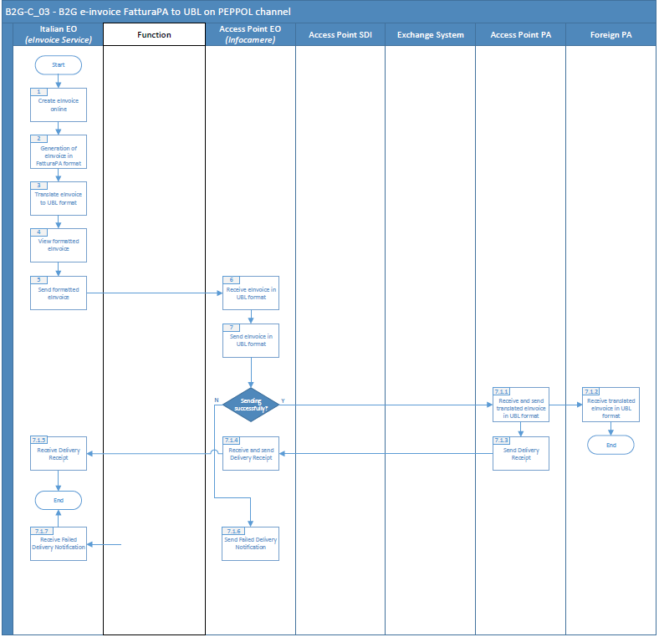

### Process steps

In the following tables, we provide more insights or clarifications on each process steps and for each process variant, so as to allow a better understanding of the overall Use Case, from a functional and / or application perspective.

|  |  |  |  |  |  |
| --- | --- | --- | --- | --- | --- |
| Sender | Original Format | Transmission Channel | Reception Channel | Destination Format | Receiver |
| Economic Operator *(italian)* | XMLPA | Peppol | Peppol | UBL | Public Administration |

|  |  |  |  |
| --- | --- | --- | --- |
| Step ID | Step Name | Role / System | Step Description |
| 1 | *Create e-invoice on line* | Italian EO | eInvoice in Unioncamere-Chamber of Commerce Portal is created for Public European PA |
| 2 | *Generation of E-invoice in fatturaPA format* | Italian EO | The eInvoice is generated in XMLPA format and is transformed into UBL via Infocert's BIS3 Mapper |
| 3 | *Translate e-invoice to UBL format* | Italian EO | Unioncamere-Chamber of Commerce Portal sends UBL BIS3 eInvoice to Infocamere Access Point to be sent via Peppol network |
| 4 | *View formatted e-invoice* | Italian EO | Check |
| 5 | *Transmission of an invoice to abroad via AS4 type AP* | Italian EO | eInvoice edited in Unioncamere-Chamber of Commerce Portal is sent to Infocamere Access Point |
| 6 | *Receive eInvoice* | Access Point EO |  |
| 7 | *Send eInvoice in UBL format* | Access Point EO | Infocamere Access Point sends eInvoice to European Access Point PA  Access Point PA receives and send translated e-invoice in UBL format  Foreign PA receives translated e-invoice in UBL format  Access Point PA sends delivery receipt to AP EO |
| 8 | *Perform formal checks* | Italian EO | Unioncamere-Chamber of Commerce Portal receives the Peppol Message Delivery Notification |

## B2G-C_04 – B2G crossborder credit note FatturaPA to UBL on channel PEPPOL

### Process Flow

The flowchart presented below illustrates the main qualifying steps of the Use Case, in order to provide an overview of the overall process and to represent its operating logics

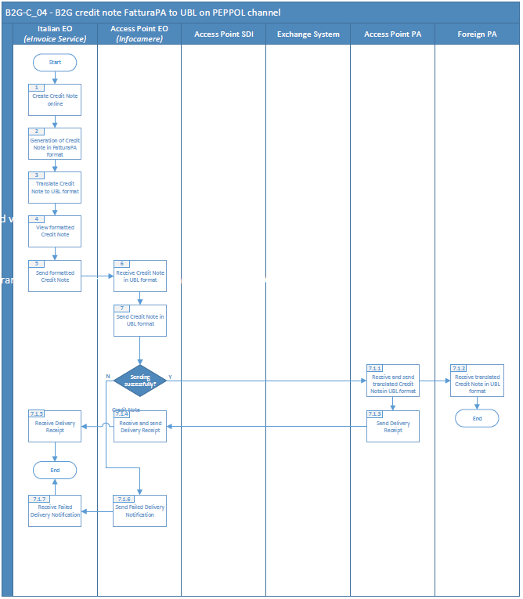

### Process steps

In the following tables, we provide more insights or clarifications on each process steps and for each process variant, so as to allow a better understanding of the overall Use Case, from a functional and / or application perspective.

|  |  |  |  |  |  |
| --- | --- | --- | --- | --- | --- |
| Sender | Original Format | Transmission Channel | Reception Channel | Destination Format | Receiver |
| Economic Operator *(italian)* | XMLPA | Peppol | Peppol | UBL | Public Administration |

.

|  |  |  |  |
| --- | --- | --- | --- |
| Step ID | Step Name | Role / System | Step Description |
| 1 | *Create credit note on line* | Italian EO | Credit note in Unioncamere-Chamber of Commerce Portal is created for Public European PA |
| 2 | *Generation of credit note fatturaPA format* | Italian EO | The credit note is generated in XMLPA format and is transformed into UBL via Infocert's BIS3 Mapper |
| 3 | *Translate credit note to UBL format* | Italian EO | Unioncamere-Chamber of Commerce Portal sends UBL BIS3 credit note to Infocamere Access Point to be sent via Peppol network |
| 4 | *View formatted credit note* | Italian EO | Check |
| 5 | *Transmission of an invoice to abroad via AS4 type AP* | Italian EO | Credit note edited in Unioncamere-Chamber of Commerce Portal is sent to Infocamere Access Point |
| 6 | *Receive credit note* | Access Point EO |  |
| 7 | *Send credit note in UBL format* | Access Point EO | Infocamere Access Point sends credit note to European Access Point PA  Access Point PA receives and send translated e- credit note in UBL format  Foreign PA receives translated e- credit note in UBL format  Access Point PA sends delivery receipt to AP EO |
| 8 | *Perform formal checks* | Italian EO | Unioncamere-Chamber of Commerce Portal receives the Peppol Message Delivery Notification |

.

## ZIP-T-01 - *Transmission of a ZIP file, containing several invoices in different formats, regardless of transmission channel* *(via SFTP or WS or CEM channel)*

### Process Flow

The flowchart presented below illustrates the main qualifying steps of the Use Case, in order to provide an overview of the overall process and to represent its operating logics



Figure 6 Transmission of a zip file through SDI channels

### Process steps

In the following tables, we provide more insights or clarifications on each process steps and for each process variant, so as to allow a better understanding of the overall Use Case, from a functional and / or application perspective.

|  |  |  |  |  |  |
| --- | --- | --- | --- | --- | --- |
| Sender | Original Format | Transmission Channel | Reception Channel | Destination Format | Receiver |
| Economic Operator *(italian)* | ZIP (with UBL, CII, XMLPA) | Any channel except PEPPOL | Any channel except PEPPOL | FatturaPA +  CII attachment  +  UBL attachment  +  Reports traduzione | Public Administration *(italian)* |

|  |  |  |  |
| --- | --- | --- | --- |
| Step ID | Step Name | Role / System | Step Description |
| 1 | *Send a zip file containing UBL, CII and XMLPA invoices* | Economic Operator | The Italian Economic Operator (i.e. Supplier) sends a zip file containing invoices in UBL, CII, XMLPA formats through the chosen channel (e.g. Registered Electronic Mail, FTP, Web Service, …) and decompresses it |
| 2 | *Receive eInvoices and send to the Translator* | Exchange System | The Exchange System receives the electronic invoices in UBL, CII format and sends it to the Translator. XMLPA invoices are not translated |
| 3 | *Translate eInvoices to FatturaPA* | Exchange System | The Translator converts it from original UBL, CII format to FatturaPA format |
| 4 | *Perform formal checks* | Exchange System | The Exchange System carries out specific checks on the file translated into FatturaPA format (e.g. correctness in terms of nomenclature and uniqueness, file dimension, integrity of the content and authenticity of origin, …) |
| 5.1.1 | *Send Rejection Notification* | Exchange System | In case checks are not passed, the Exchange System sends the Rejection Notification to the Economic Operator |
| 5.1.2 | *Receive Rejection Notification* | Economic Operator | The Economic Operator receives the Rejection Notification |
| 5.1.3 | *Create and send files* | Exchange System | Provided all the checks are passed successfully, the Exchange System prepares a . file containing:   * The file translated into FatturaPA format; * The original file in CII format; * The original file in UBL format; * The original file in XMLPA format; * The conversion report   Then, the Exchange System forwards the . file using the reception channel to the Public Administration |
| 5.1.4 | *Receive FatturaPA* | Public Administration | The Public Administration receives the file in FatturaPA format file containing the original eInvoice and the conversion report |
| 5.1.5 | *Send Delivery Notification* | Exchange System | In case delivery is ok, the Exchange System sends the Delivery Notification to the Economic Operator |
| 5.1.6 | *Receive Delivery Notification* | Economic Operator | The Economic Operator receives the Delivery Notification |
| 5.1.7 | *Send Failed delivery Notification* | Exchange System | In case delivery is KO, the Exchange System sends the Failed delivery Notification to the Economic Operator |
| 5.1.8 | *Receive Failed delivery Notification* | Economic Operator | The Economic Operator receives the Failed delivery Notification |

# MAP-V Testing eInvoicing mapper framework

## Use Case inventory

In the MAP-V scenario, the usage of EeISI mapper integrated into SDI through API interface.

The difference between previous UBL2XMPLPA and CII2XMLPA tests carried out through EeISI mapper CLI is that the SDI adds a translation report to the target file as below explained.

Invoice files that pass the mapper checks, are then passed to the translation service whose task it is to produce an output XML file in XMLPA format.

The ‘translated’ XML file is distinguished from the ‘native’ file in XMLPA format by the nomenclature.

The ‘translated’ file in XMLPA format contains, as attachments (tag <Attachment>):

* the original invoice file, recognisable by the value contained in the <AttachmentName> (<NomeAttachment>) field:

*<AttachmentName>original_invoice</AttachmentName> (<NomeAttachment>fattura_originale</NomeAttachment>)*

* a file in ‘.txt’ format, if applicable, containing a list of unmapped values, recognisable by the value contained in the <AttachmentName> NomeAttachment>) field:

*<AttachmentName>not-mapped-values.txt</AttachmentName>*

* a file in ‘.csv’ format, if applicable, containing a list of values that have been trimmed as they exceeded the maximum length permitted for XMLPA format, recognisable by the value contained in the <AttachmentName> (<NomeAttachment>) field:

<AttachmentName>trimmed_fields.csv</AttachmentName> *(<NomeAttachment>trimmed_fields.csv</NomeAttachment>).*

For all the references of this use case, please refer to the D5.1 deliverable where all the tests carried out on the translation of the mapper are punctually present.

# Test execution

## Test planning

Test were executed on a distributed basis, with each test case involving only the relevant beneficiaries. AGID supervisioned the general text execution; checkpoint meeting were held on 9/12/2019, 16/12/2019, 8/1/2020.

## Test environments

A test environment for the interoperability node, PEPPOL Access Point, Italian Revenue Agency systems, Infocert systems, IntercentER systems, Unioncamere systems has been used for testing purposes in order not to interfere with running processes in production live environment.

## Results and findings

The outcome of the test sessions will be immediately reported by mail to all the persons with an active role. At the end of the test sessions, the sheets with the test results and the findings were sent to all the contact persons. Moreover, the minutes of the checkpoint meetings were made available through AGID’s project management platform.

# Test scenarios and results

In the attached file *“Use_Case_Test_Report_1.0.xlsx”* all test scenarios and used test data are specified, as well as the encountered general and specific defects and issues.

All the test activities were completed on March 24, 2020.