|  |
| --- |
|  |



European eInvoicing Standard in Italy

|  |  |
| --- | --- |
| **Project number** | INEA/CEF/ICT/A2017/1560867 2017-IT-IA-0150 |
| **Project acronym** | EeISI |
| **Project title** | European eInvoicing Standard in Italy |
| **Starting date** | 1 May 2018 |
| **Ending date** | 30 June 2019 |
| **Programme** | Connecting Europe Facility (CEF) CEF-TC-2017-3: eInvoicing |

eDelivery AS4 InfoCert test report

Deliverable D5.3

|  |  |
| --- | --- |
| **Related WP** | WP5 – Test – Task 5.1 and Task 5.2 |
| **Deliverable number** | D5.3 |
| **Due date** | 31/03/2019 |
| **Revision date** | 31/03/2019 |
| **Actual date** | **31/03/2019** |

This Page Intentionally Left Blank

Deliverable Info

|  |  |
| --- | --- |
| **Editor (s)** | **InfoCert** |
| **Contributors** | **InfoCert** |
|  |  |
| **Abstract** | **This deliverable aims to provide the eDelivery implementation report of InfoCert AS4 eSENS profile.** |
| **Keywords** | **eInvoicing, semantic core model, Italian eInvoicing format, LegalInvoice, eDelivery, AS4, access point, SDI** |
|  |  |
| **Acknowledgement** | This work was partially supported by the European Commission (EC) through the Connecting Europe Facility (CEF) programme under project EeISI.(grant agreement no. INEA/CEF/ICT/A2017/1560867 2017-IT-IA-0150) |
| **Disclaimer** | The sole responsibility of this publication lies with the author(s). The European Union is not responsible for any use that may be made of the information contained therein. |
| **Confidentiality** | The information in this document is confidential and restricted only to the members of the EeISI consortium  (including the Commission Services). |
|  |  |
| **Note** | - |
|  |  |

**Version Control**

|  |  |  |  |
| --- | --- | --- | --- |
| Version | Date | Author | Description of change |
| 0.0.1 | 2019-03-31 | Elisa Salvagnin | First release |
| 0.1.0 | 2019-06-28 | InfoCert | Latest test updates |
| 0.2.0 | 2020-02-11 | InfoCert | Update with CEF conformance test |
| 0.2.1 | 2020-03-31 | Roberto Reale | Technical review and quality assessment |

This Page Intentionally Left Blank

Table of contents

Deliverable Info 3

Table of contents 5

List of figures 5

List of tables 5

Executive Summary 6

Glossary 8

1. Normative references 9

2. InfoCert AS4 PEPPOL Conformance Testing 9

3. InfoCert AS4 CEF Connectivity testing 13

4. InfoCert AS4 test report 15

List of figures

Figure 1 - InfoCert AS4 OpenPeppol testbed 10

Figure 2 – InfoCert AS2/AS4 registration in OpenPeppol directory 10

Figure 4 – Number of AS2 and AS4 - OpenPeppol network (March 2019) 11

Figure 5 – Distribution per country of AS2 and AS4 – OpenPeppol netwok (March 2019) 11

Figure 6 – Parameters for CEF eDelivery connectivity test 13

Figure 7 Received mail from CEF for eDelivery connectivity test SUCCESSFUL 14

Figure 8 Sent and Received message to/from AS4 CEF for eDelivery connectivity test 14

Executive Summary

This document aims to provide the eDelivery test report for AS4 migration carried out by InfoCert within EeISI project. The test report mainly covers:

* Output of PEPPOL Conformance tests
* Output of CEF Connectivity tests
* Output of eInvoicing tests with Italian/European senders/receivers
* Output of CEF conformance test with GITB platform. Sender and receiver scenarios.

This Page Intentionally Left Blank

Glossary

|  |  |
| --- | --- |
| **AP** | Access Point |
| **AS4** | Applicability Statement 4 |
| **B2B** | Business to Business |
| **B2C** | Business to Consumer/Citizen |
| **B2G** | Business to Government |
| **BII** | Business Interoperability Interfaces |
| **C2G** | Citizen to Government |
| **CCTS** | Core Component Technical Specification |
| **CEF** | Connecting Europe Facility |
| **CEM** | Certified Electronic Mail – Legal Mail (PEC Posta Elettronica Certificata in Italy) |
| **CEN** | European Committee for Standardisation |
| **CII** | Cross Industry electronic Invoice |
| **CIUS** | Core Invoice Usage Specification |
| **DNS** | Domain Name System |
| **DSI** | Digital Service Infrastructures |
| **EDIFACT** | Electronic Data Interchange For Administration, Commerce and Transport |
| **EMSFEI** | European Multi-Stakeholder Forum on eInvoicing |
| **e-SENS** | Electronic Simple European Networked Services |
| **FatturaPA** | Public administration electronic invoice framework (FatturaPubblica Amministrazione) |
| **G2G** | Government to Government |
| **IMR** | Invoice Message Response |
| **INEA** | Innovation and Networks Executive Agency |
| **MLR** | Message Level Response |
| **OASIS** | Organization for the Advancement of Structured Information Standards |
| **PEPPOL** | Pan-European Public Procurement Online |
| **PEPPOL-BIS** | Pan-European Public Procurement Online Business Interoperability Specifications |
| **SDI** | Electronic exchange system in Italy (Sistema Di Interscambio) |
| **SML** | Service Metadata Locator |
| **SMP** | Service Metadata Publisher |
| **UBL** | Universal Business Language |
| **UN/CEFACT** | United Nations Centre for Trade Facilitation and Electronic Business |
| **UNTDID** | UN Trade Data Interchange Directory |
| **URI** | Uniform Resource Identifier |
| **URL** | Uniform Resource Location |
| **URN** | Uniform Resource Name |
| **XML** | Extensible Mark-up Language |

1. Normative references

The following documents, in whole or in part, are normatively referenced in this document and are indispensable for its application.

* EN 16931-1:2017 Electronic invoicing - Part 1: Semantic data model of the core elements of an electronic invoice

Moreover the following Italian documentation is referenced in this deliverable:

* Schema del file xml FatturaPA versione 1.2 - xsd
* Specifiche tecniche del formato della FatturaPA versione 1.2.1- pdf
* Rappresentazione tabellare del tracciato FatturaPA versione 1.2.1- pdf
* Rappresentazione tabellare del tracciato FatturaPA versione 1.2.1- excel
* Foglio di stile per la visualizzazione della FatturaPA versione 1.2.1 - xslt
* generica Foglio di stile per la visualizzazione della Fattura Ordinaria versione 1.2.1 - xslt
* Elenco modifiche al tracciato FatturaPA - pdf
* Suggerimenti per la compilazione della FatturaPA versione 1.5

1. InfoCert AS4 PEPPOL Conformance Testing

In the view of AS4 certification within the OpenPeppol network InfoCert carried out the certification process with Peppol central authority.

The PEPPOL certificates installed on the InfoCert AS4 Access Point are the same that were previously used by the InfoCert AS2 Access Point. The AS2 access point was installed in 2018 by InfoCert with its private funding (no CEF funding for this AS2).

The Access Point AS4 has passed Peppol Conformance Testing in **March 2019** and is listed in the official list of Certified AS4 Peppol Access Points: <https://peppol.eu/who-is-who/peppol-certified-aps/>.

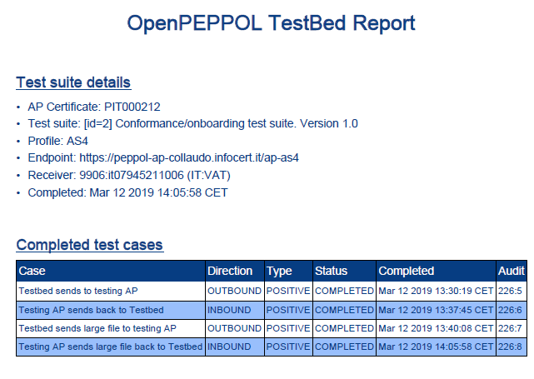

Figure 1 - InfoCert AS4 OpenPeppol testbed

The TestBedReport is available here: <https://testbed.peppol.eu/api/report/vcE3mamQFwYZEa6L2F0I9zXSnb11zcEZsByT>.

See <https://peppol.eu/who-is-who/peppol-certified-aps/> where the certification of InfoCert AS4 is documented.

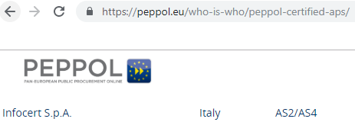

Figure 2 – InfoCert AS2/AS4 registration in OpenPeppol directory

The situation of OpenPeppol network as of March 2019 is represented in the following figures. Unfortunately, only about 8% of existing access points are AS4.

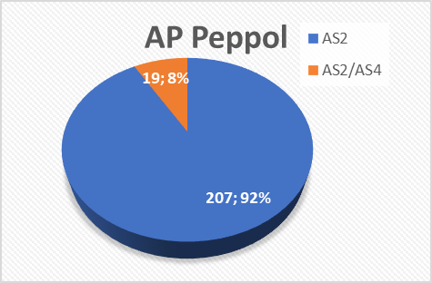

Figure 3 – Number of AS2 and AS4 - OpenPeppol network (March 2019)

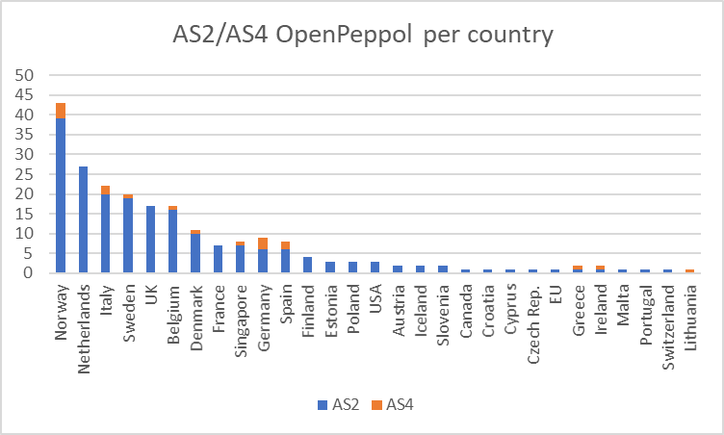

Figure 4 – Distribution per country of AS2 and AS4 – OpenPeppol netwok (March 2019)

In Italy, on March 2019, there were two AS4 on OpenPeppol network. One of these APs is the InfoCert AS4.

The InfoCert AS4 Access Point is currently registered to receive all types of documents on OpenPeppol network related to **Billing V3 BIS Profile**:

**ProcessID**: urn:fdc:peppol.eu:2017:poacc:billing:01:1.0

**DocumentIDs**:

1. **Invoice**: urn:oasis:names:specification:ubl:schema:xsd:Invoice-2::Invoice##urn:cen.eu:en16931:2017#compliant#urn:fdc:peppol.eu:2017:poacc:billing:3.0::2.1
2. **Credit Note**: urn:oasis:names:specification:ubl:schema:xsd:CreditNote-2::CreditNote##urn:cen.eu:en16931:2017#compliant#urn:fdc:peppol.eu:2017:poacc:billing:3.0::2.1
3. **Cross-Industry-Invoice**: urn:un:unece:uncefact:data:standard:CrossIndustryInvoice:100::CrossIndustryInvoice##urn:cen.eu:en16931:2017#compliant#urn:fdc:peppol.eu:2017:poacc:billing:3.0::D16B

The current registration details for the InfoCert ParticipantId **9906:it07945211006** are available on peppol-helger.com:

* Test environment link: [SMK](https://peppol.helger.com/public/locale-en_US/menuitem-tools-participant?scheme=iso6523-actorid-upis&value=9906%3Ait07945211006&sml=digittest&querybc=true&__querybc=true&action=perform)
* Production environment link: [SML](https://peppol.helger.com/public/locale-en_US/menuitem-tools-participant?scheme=iso6523-actorid-upis&value=9906%3Ait07945211006&sml=digitprod&querybc=true&__querybc=true&action=perform)

1. InfoCert AS4 CEF Connectivity testing

We have carried out the CEF eDelivery connectivity test based on the following documentation: <https://ec.europa.eu/cefdigital/wiki/display/CEFDIGITAL/eDelivery+Connectivity+testing>

The end point url of our AS4 CEF Access Point, in test environment only, is <https://cef-ap-collaudo.infocert.it>.

The Domibus Administration Console is available at [https://cef-ap-collaudo.infocert.it/domibus](https://cef-ap-collaudo.infocert.it/domibus/pmode-archive).

The Access Point's keystore and truststore have been set up at our side according to the information sent by CEF:

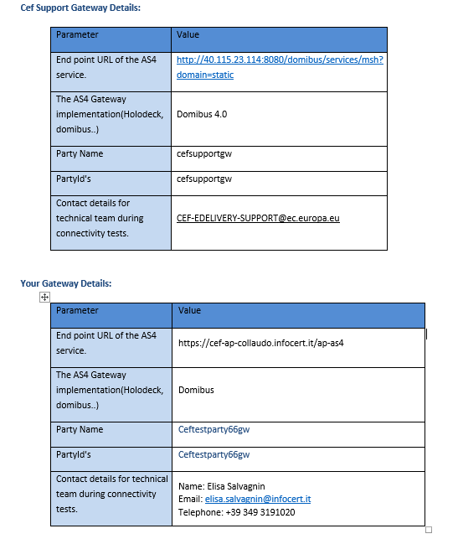

Figure 5 – Parameters for CEF eDelivery connectivity test

As part of the test, we have performed the following steps:

* sent a message from our PartyId ceftestparty66gw to the CEF PartyId cefsupportgw. The messageID is [b6d9ca49-b504-4087-839d-e47f9feace53@domibus.eu](mailto:b6d9ca49-b504-4087-839d-e47f9feace53@domibus.eu)
* CEF has confirmed that the messaged has been received at its side, and sent back a message to our PartyId
* Sent a confirmation to CEF that our Access Point has correctly received the message with ID [1c74e251-6e0c-4c69-9b00-73115e7386b1@domibus.eu](mailto:1c74e251-6e0c-4c69-9b00-73115e7386b1@domibus.eu):
* CEF has updated a report that is available to INEA for Grant purposes to certify that the test is successful

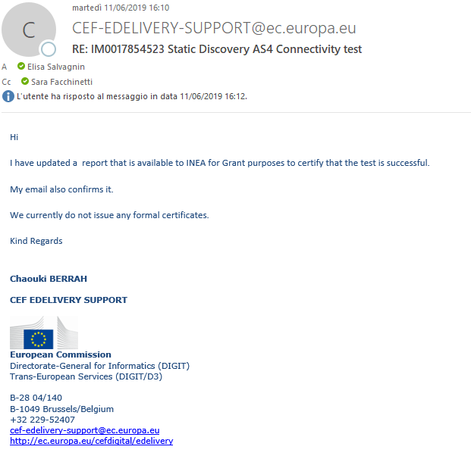

Figure 6 Received mail from CEF for eDelivery connectivity test SUCCESSFUL

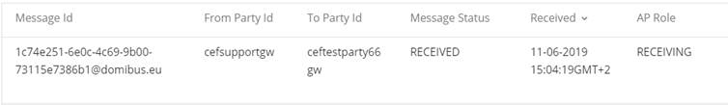



Figure 7 Sent and Received message to/from AS4 CEF for eDelivery connectivity test

1. InfoCert AS4 test report

We have carried out a set of tests between our AS4 PEPPOL Access Point and three others European AS4 PEPPOL Access Points during March – May 2019:

* Infocamere Access Point (Italy), ParticipantID **9921:ictest**
* Tradeshift (Sweden), ParticipantID **0192:983142788 (PEPPOL)** and **9908:983142788 (CEF)**
* SATA (Italy), ParticipantID **9906:it01260340482**
* The output is in Annex 1 D5.3_Annex1_Test Report.xlsx and Annex2 D5.3_Annex2_Test Report_Domibus.xlsx
* These are the messages exchanged in Annex 3 D5.3_Annex3_TestMessages.zip
* The email for eConnectivity test is in Annex 4 D5.3_Annex4_ Static Discovery AS4 Connectivity test

1. InfoCert AS4 CEF conformance test

As requested by INEA on 05/02/2020 the CEF conformance test via GITB platform has been successfully carried out by AS4 eSens profiles of InfoCert.

According to CEF conformance guide - (eInvoicing)(Conformance Testing)(SOD)(5.3).pdf – all the steps have been carried out.

1. Step 1: **Registration**

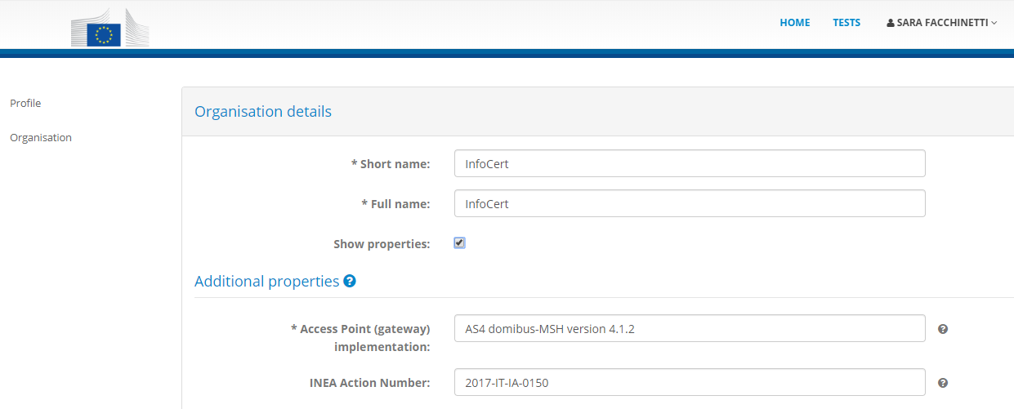

Figure 8 – GITB registration of InfoCert organization

1. Step 2: **Preparation**

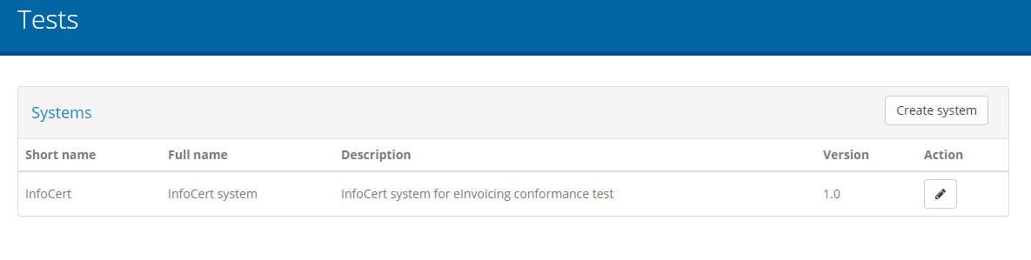

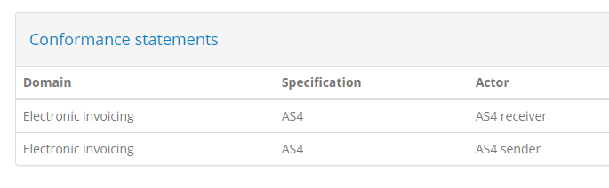

Figure 9 – GITB InfoCert test cases preparation

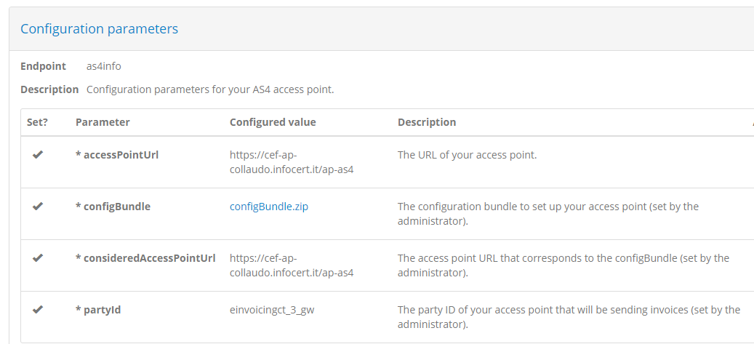

Figure 10 – GITB InfoCert test configuration parameters

This phase required several interactions with CEF eInvoicing support office due to a bug on the GITB platform related to the configBundle.zip automatic generation. The partyId and partyName were not appropriately generated.

For such reason several attempts were done to find a solution and a new registration was needed to have new certificates. The correct certificates were registered on InfoCertAS4CEF keystore and truststore, domibsu properties were updated accordingly and the Pmode were substituted.

1. Step 3: **Execution and Report feedback**

**Sender scenario**:

* UBL CEN compliant invoice (see AnnexInfoCertConformance.zip files: ZIP-T_01_UBL.XML, conformance_reportInfoCert_UBLinvoice.pdf)
* CII CEN compliant invoice (see AnnexInfoCertConformance.zip files: B2G-D_02_CII.XML, conformance_reportInfoCert_CIIinvoice.pdf)

The sender scenario has been executed with the SOAPUI project with a POST request to

<https://cef-ap-collaudo.infocert.it/domibus/services/backend>

<soap:Envelope xmlns:soap="http://www.w3.org/2003/05/soap-envelope" xmlns:ns="http://docs.oasis-open.org/ebxml-msg/ebms/v3.0/ns/core/200704/" xmlns:_1="http://org.ecodex.backend/1_1/" xmlns:xm="http://www.w3.org/2005/05/xmlmime">

<soap:Header>

<ns:Messaging>

<ns:UserMessage>

<ns:PartyInfo>

<ns:From>

<ns:PartyId type="urn:oasis:names:tc:ebcore:partyid-type:unregistered">einvoicingct_3_gw</ns:PartyId>

<ns:Role>http://docs.oasis-open.org/ebxml-msg/ebms/v3.0/ns/core/200704/initiator</ns:Role>

</ns:From>

<ns:To>

<ns:PartyId type="urn:oasis:names:tc:ebcore:partyid-type:unregistered">domibus-gitb</ns:PartyId>

<ns:Role>http://docs.oasis-open.org/ebxml-msg/ebms/v3.0/ns/core/200704/responder</ns:Role>

</ns:To>

</ns:PartyInfo>

<ns:CollaborationInfo>

<ns:Service type="tc1">bdx:noprocess</ns:Service>

<ns:Action>TC1Leg1</ns:Action>

</ns:CollaborationInfo>

<ns:MessageProperties>

<ns:Property name="originalSender">urn:oasis:names:tc:ebcore:partyid-type:unregistered:C1</ns:Property>

<ns:Property name="finalRecipient">urn:oasis:names:tc:ebcore:partyid-type:unregistered:C4</ns:Property>

</ns:MessageProperties>

<ns:PayloadInfo>

<ns:PartInfo href="cid:message">

<ns:PartProperties>

<ns:Property name="MimeType">text/xml</ns:Property>

</ns:PartProperties>

</ns:PartInfo>

</ns:PayloadInfo>

</ns:UserMessage>

</ns:Messaging>

</soap:Header>

<soap:Body>

<_1:submitRequest>

<payload payloadId="cid:message"><value>*invoice encoded in BASE64*<value></payload>

</_1:submitRequest>

</soap:Body>

</soap:Envelope>

Figure 11 – SOAP request for sender scenario

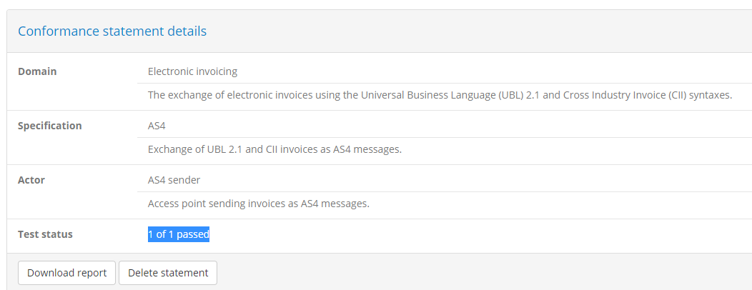

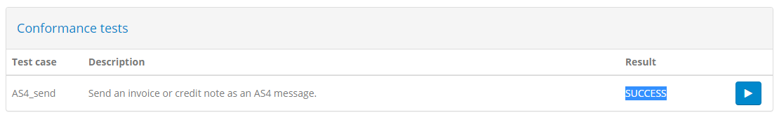

Figure 12 – Sender scenario successful result

**Receiver scenario**: according to the guide (pag 29) only one test case has to be executed for INEA grants purposes (UBL_valid_simple file was used during this test).

See AnnexInfoCertConformance.zip files: f451e7f1-8cbb-496c-a3b9-7808e0233e17@domibus.eu.zip, conformance_report_receiverUBLvalidsimple.pdf)

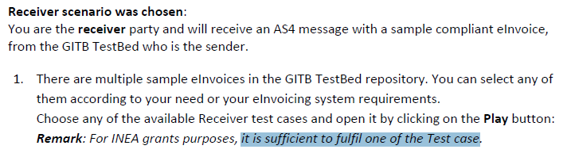

Figure 13 – CEF eInvoicing conformance test guide – receiver scenario

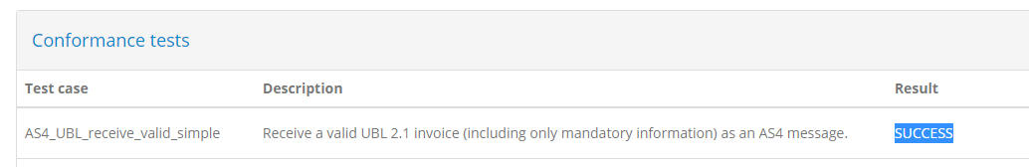

Figure 14 Receiver scenario successful result

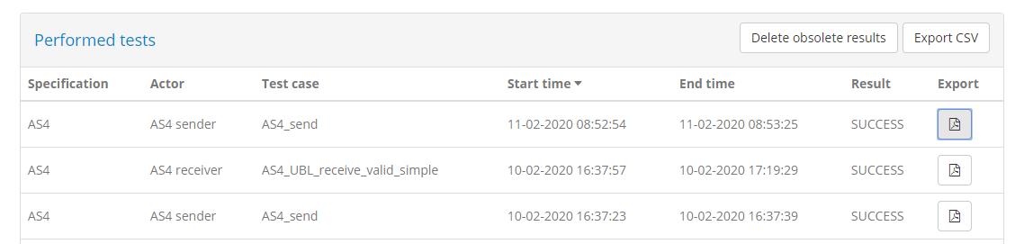

Figure 15 – GITB InfoCert performed tests

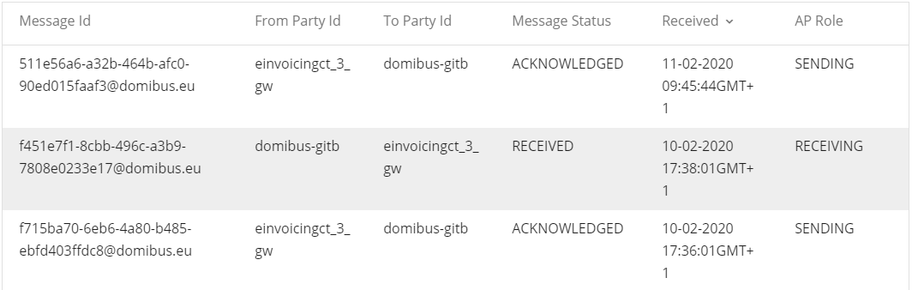

Figure 16 – InfoCert AS4 CEF sender and receiver scenario messages

During the execution phase other communication problems were encountered as the CEF GITB platform didn’t have the truststore appropriately updated.

For such reason additional attempts were done to solve this issue and, at the end, the sender and receiver scenario were both successfully executed as above reported.

Evidences of elaboration and processing of received UBL invoice in InfoCert system.

