|  |
| --- |
|  |



European eInvoicing Standard in Italy

|  |  |
| --- | --- |
| **Project number** | INEA/CEF/ICT/A2017/1560867 2017-IT-IA-0150 |
| **Project acronym** | EeISI |
| **Project title** | European eInvoicing Standard in Italy |
| **Starting date** | 1 May 2018 |
| **Ending date** | 14 Dec 2019 |
| **Programme** | Connecting Europe Facility (CEF) CEF-TC-2017-3: eInvoicing |

eDelivery AS4 Infocamere test report

Deliverable D5.3

|  |  |
| --- | --- |
| **Related WP** | WP5 – Test – Task 5.1 and Task 5.2 |
| **Deliverable number** | D5.3 |
| **Due date** | 31/03/2019 |
| **Revision date** | 31/03/2019 |
| **Actual date** | **14/12/2019** |

This Page Intentionally Left Blank

Deliverable Info

|  |  |
| --- | --- |
| **Editor (s)** | **Infocamere** |
| **Contributors** | **Infocamere** |
|  |  |
|  |  |
| **Acknowledgement** | This work was partially supported by the European Commission (EC) through the Connecting Europe Facility (CEF) programme under project EeISI.(grant agreement no. INEA/CEF/ICT/A2017/1560867 2017-IT-IA-0150) |
| **Disclaimer** | The sole responsibility of this publication lies with the author(s). The European Union is not responsible for any use that may be made of the information contained therein. |
| **Confidentiality** | The information in this document is confidential and restricted only to the members of the EeISI consortium  (including the Commission Services). |
|  |  |
| **Note** | - |
|  |  |

**Version Control**

|  |  |  |  |
| --- | --- | --- | --- |
| Version | Date | Author | Description of change |
| 1.0.0 | 14/12/2019 | Infocamere (Doni, Squarcina) |  |
| 1.0.1 | 31/03/2020 | Roberto Reale | Technical review and quality assessment |
|  |  |  |  |
|  |  |  |  |

This Page Intentionally Left Blank

Table of contents

Deliverable Info 3

Table of contents 5

Glossary 7

1. Executive summary 8

2. Oxalis AS2 onboarding on OpenPEPPOL Centralized Testbed 8

3. Oxalis AS4 onboarding on OpenPEPPOL Centralized Testbed 10

4. Domibus AS4 onboarding on OpenPEPPOL Centralized Testbed 12

5. Infocamere AS4 CEF Connectivity testing 14

This Page Intentionally Left Blank

Glossary

|  |  |
| --- | --- |
| **B2B** | Business to Business |
| **B2C** | Business to Consumer/Citizen |
| **B2G** | Business to Government |
| **BII** | Business Interoperability Interfaces |
| **C2G** | Citizen to Government |
| **CCTS** | Core Component Technical Specification |
| **CEF** | Connecting Europe Facility |
| **CEM** | Certified Electronic Mail – Legal Mail (PEC Posta Elettronica Certificata in Italy) |
| **CEN** | European Committee for Standardisation |
| **CII** | Cross Industry electronic Invoice |
| **CIUS** | Core Invoice Usage Specification |
| **DSI** | Digital Service Infrastructures |
| **EDIFACT** | Electronic Data Interchange For Administration, Commerce and Transport |
| **EMSFEI** | European Multi-Stakeholder Forum on eInvoicing |
| **e-SENS** | Electronic Simple European Networked Services |
| **FatturaPA** | Public administration electronic invoice framework (FatturaPubblica Amministrazione) |
| **G2G** | Government to Government |
| **INEA** | Innovation and Networks Executive Agency |
| **OASIS** | Organization for the Advancement of Structured Information Standards |
| **PEPPOL** | Pan-European Public Procurement Online |
| **PEPPOL-BIS** | Pan-European Public Procurement Online Business Interoperability Specifications |
| **SDI** | Electronic exchange system in Italy (Sistema Di Interscambio) |
| **UBL** | Universal Business Language |
| **UN/CEFACT** | United Nations Centre for Trade Facilitation and Electronic Business |
| **UNTDID** | UN Trade Data Interchange Directory |
| **URI** | Uniform Resource Identifier |
| **URL** | Uniform Resource Location |
| **URN** | Uniform Resource Name |
| **XML** | Extensible Mark-up Language |

1. Executive summary

This document describes the Infocamere Access Point onboarding process to OpenPEPPOL Centralized Testbed for AS2 and AS4 protocol.

The Infocamera Access Point under test procedure are:

* Oxalis 4.0.4 for AS2 and AS4 protocol
* Domibus 4.1.1 for only AS4 protocol

1. Oxalis AS2 onboarding on OpenPEPPOL Centralized Testbed

The acceptance test of the Infocamere Access Point has been carried out twice successfully.

* The first test was performed with an implementation of the Oxalis 4.0.2 Access Point with AS2 protocol
* The second test was performed with an implementation of the Oxalis 4.0.4 Access Point with AS2 protocol

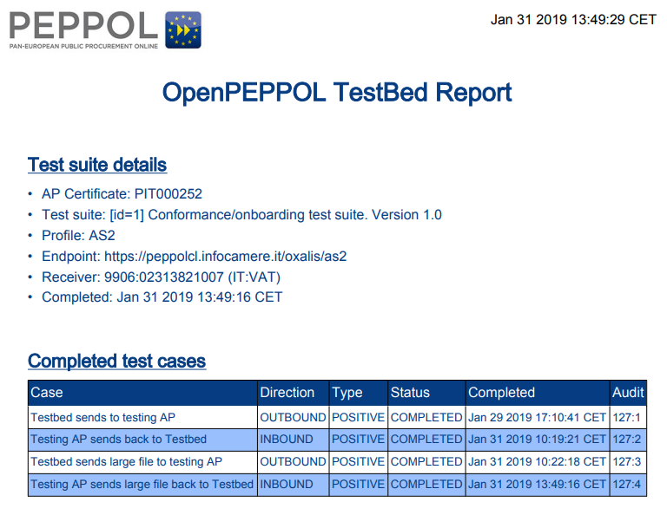

Fig. 1 – Oxalis 4.0.2 AS2 Conformance/onboarding positive test

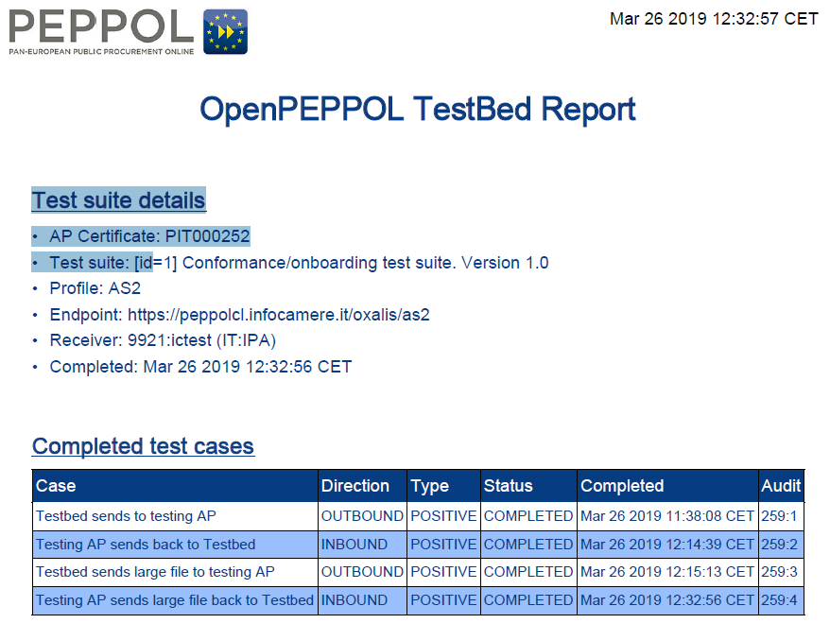

Fig. 2 – Oxalis 4.0.2 AS2 Conformance/onboarding positive test

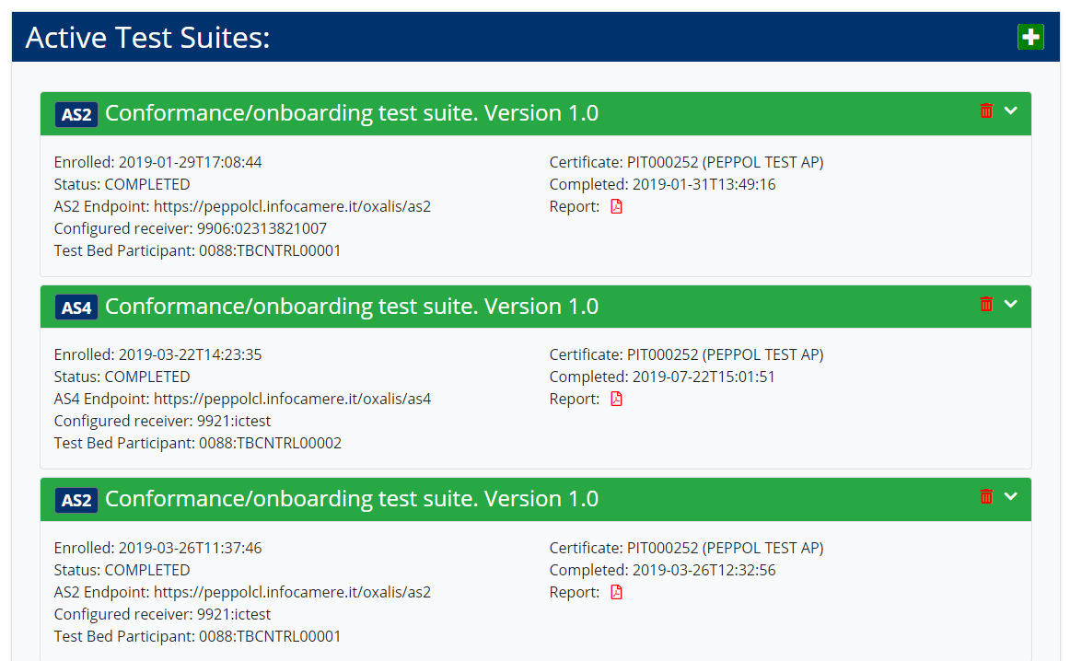

Fig. 3 - Oxalis AS4 Conformance/onboarding positive test

1. Oxalis AS4 onboarding on OpenPEPPOL Centralized Testbed

The acceptance test of the Infocamere Access Point AS4 protocol has been performed with an implementation of the Oxalis 4.0.4 Access Point and AS4-RC7 plugin.

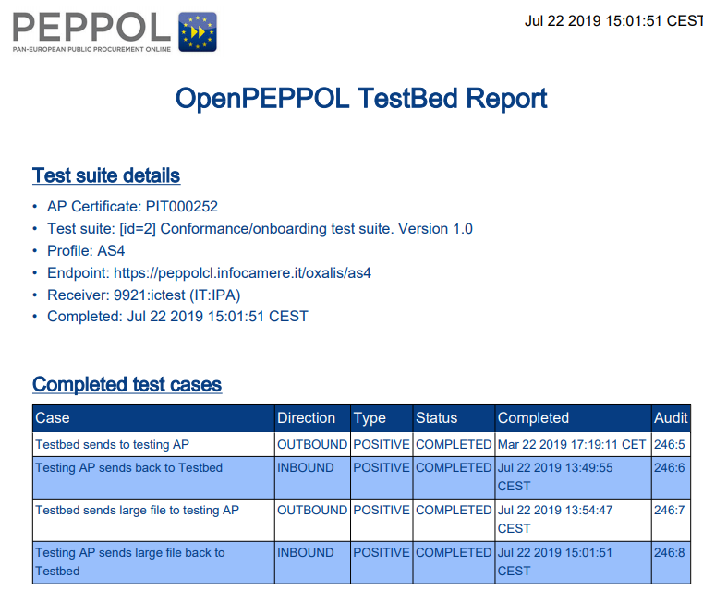

Fig. 4 – Oxalis 4.0.4 RC7 AS4 Conformance/onboarding positive test



Fig. 5 – Oxalis 4.0.4 RC7 AS4 Conformance/onboarding positive test

1. Domibus AS4 onboarding on OpenPEPPOL Centralized Testbed

The acceptance test of the Infocamere Access Point AS4 protocol has been performed with an implementation of the Domibus 4.1.1 Access Point.

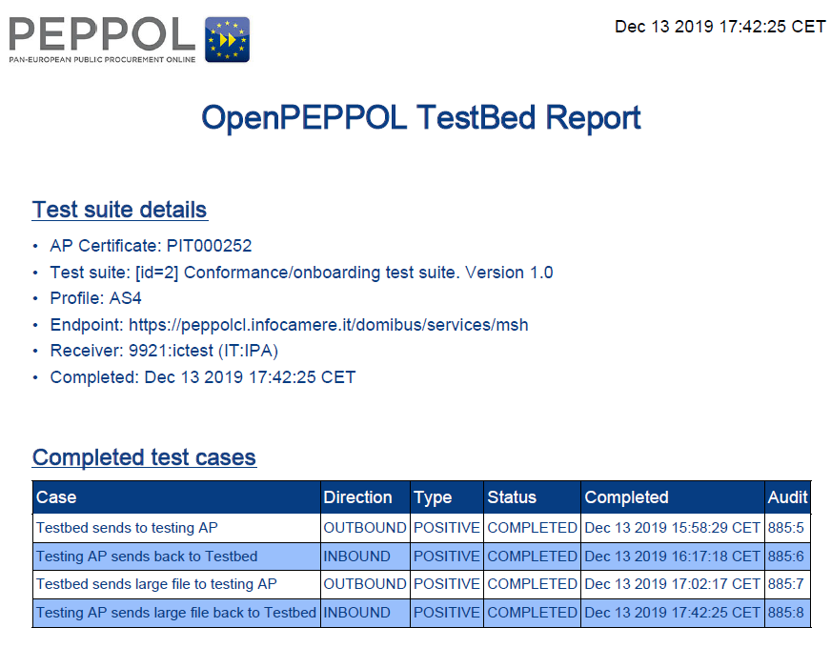

Fig. 6 – Domibus 4.1.1 AS4 Conformance/onboarding positive test

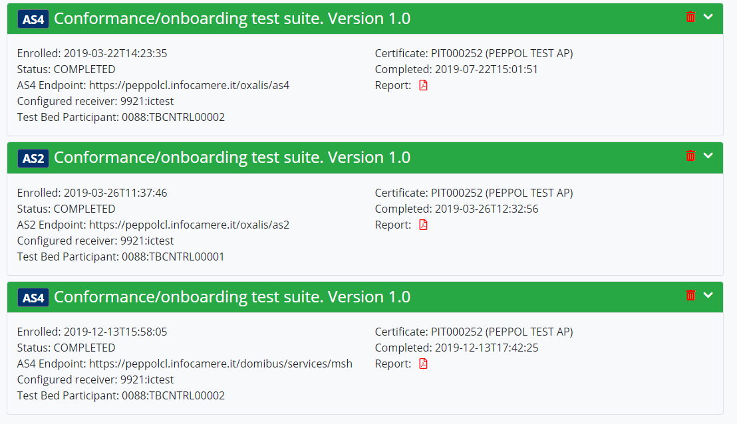

Fig. 7 – Domibus 4.1.1 AS4 Conformance/onboarding positive test

1. Infocamere AS4 CEF Connectivity testing

We have carried out the CEF eDelivery connectivity test based on the following documentation: <https://ec.europa.eu/cefdigital/wiki/display/CEFDIGITAL/eDelivery+Connectivity+testing>

The endpoint url of our AS4 CEF Access Point, in test environment only, is <https://peppolcl.infocamere.it/domibus/services/msh>.

The Domibus Administration Console is available at https://peppolcl.infocamere.it/domibus.

The Access Point's keystore and truststore have been set up at our side according to the information sent by CEF:

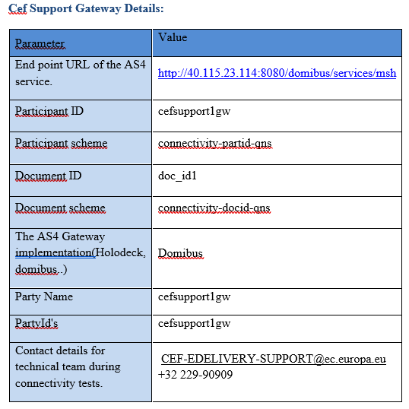

Fig. 8 – Parameters for CEF eDelivery connectivity test

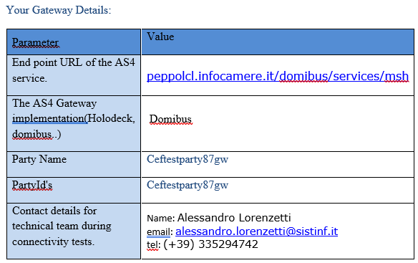

Fig. 9 – Parameters for CEF eDelivery connectivity test

As part of the test, we have performed the following steps:

* sent a message from our PartyId ceftestparty87gw to the CEF PartyId cefsupportgw. The messageID is e7e41f71-bb5e-4473-a560-8794472f08b5@domibus.eu
* CEF has confirmed that the messaged has been received at its side, and sent back a message to our PartyId
* Sent a confirmation to CEF that our Access Point has correctly received the message with ID 7da3fbec-90dd-4820-b913-c9f27e07452b@domibus.eu:
* CEF has updated a report that is available to INEA for Grant purposes to certify that the test is successful

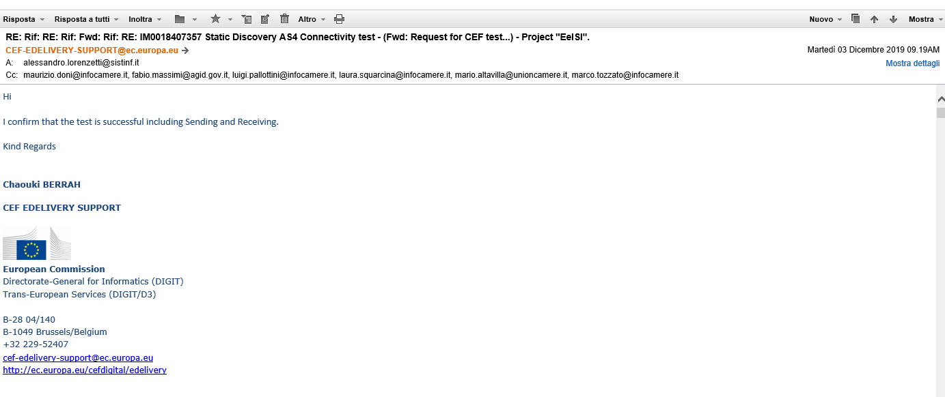

Fig. 10 - Received mail from CEF for eDelivery connectivity test SUCCESSFUL

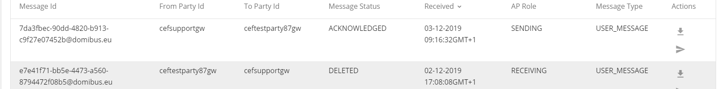

Fig. 11 - Sent and Received message to/from AS4 CEF for eDelivery connectivity test

1. Infocamere AS4 e-invoicing CEF Conformance testing

We have carried out the CEF e-invoicing conformance test based on the following documentation: <https://ec.europa.eu/cefdigital/wiki/display/CEFDIGITAL/eInvoicing+Conformance+Testing>

The endpoint url of our AS4 CEF Access Point, in test environment only, is <https://peppolcl.infocamere.it/domibus/services/msh>.

The Domibus Administration Console is available at https://peppolcl.infocamere.it/domibus.

The Access Point's keystore and truststore have been set up at our side according to the information sent by CEF

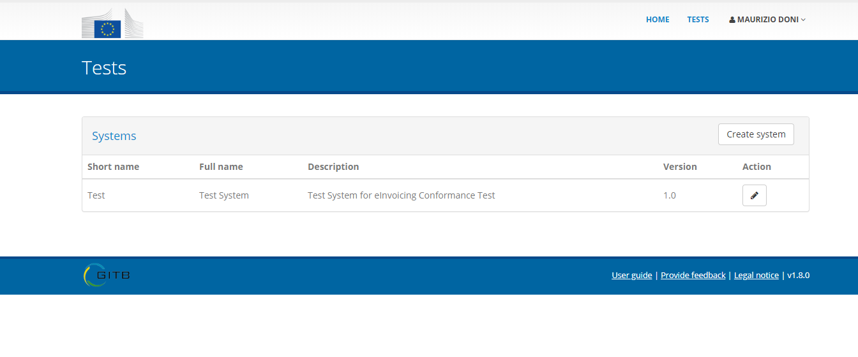

Figura 12 - Registration Infocamere User

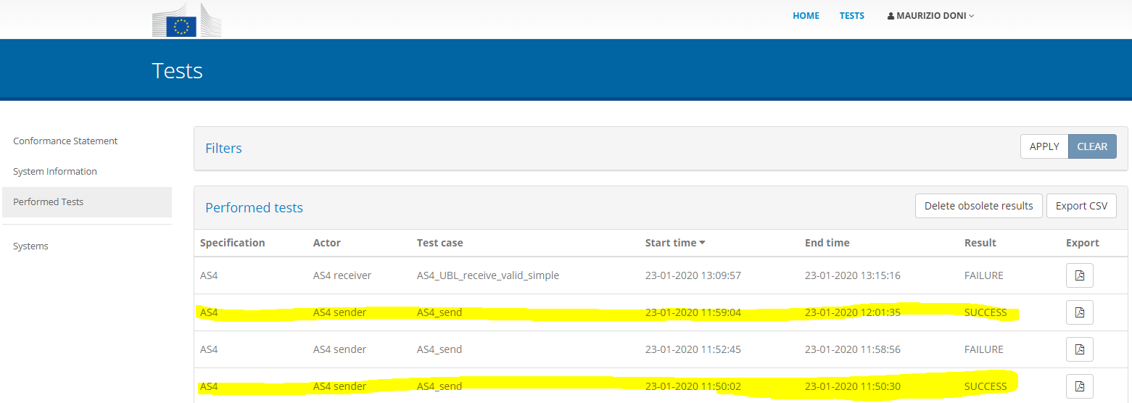

Figura 13 - Performed Tests

Test Case Report:

* Test Case Report Overview Start time: Result: 23/01/2020 11:59:04 SUCCESS End time: 23/01/2020 12:01:35 Organisation: IC Italy System: Test Domain: e-Invoicing Specification: AS4 Actor: AS4 sender Test name: AS4_send Description: Send an invoice or credit note as an AS4 message. Page 1 of 4 Time: Result: SUCCESS 23/01/2020 11:59:10 Z Step 1: Message ID Page 2 of 4 Time: Result: SUCCESS 23/01/2020 11:59:14 Z Step 2: Receive message from SUT Page 3 of 4 Time: Result: SUCCESS 23/01/2020 11:54:18 Z Errors: Warnings: Messages: 0 1 0 Details [UBL-CR-002]-A UBL invoice should not include the UBLVersionID Test: not(cbc:UBLVersionID) Location: xml:3:0
* Test Case Report Overview Start time: Result: 23/01/2020 11:50:02 SUCCESS End time: 23/01/2020 11:50:30 Organisation: IC Italy System: Test Domain: e-Invoicing Specification: AS4 Actor: AS4 sender Test name: AS4_send Description: Send an invoice or credit note as an AS4 message. Page 1 of 4 Time: Result: SUCCESS 23/01/2020 11:50:07 Z Step 1: Message ID Page 2 of 4 Time: Result: SUCCESS 23/01/2020 11:50:13 Z Step 2: Receive message from SUT Page 3 of 4 Time: Result: SUCCESS 23/01/2020 11:45:18 Z Errors: Warnings: Messages: 0 1 0 Details [UBL-CR-002]-A UBL invoice should not include the UBLVersionID Test: not(cbc:UBLVersionID) Location: xml:6:0

Email confirming successfully performed the eInvoicing AS4 conformance test:

*A: <alessandro.lorenzetti@sistinf.it>  
Da: <CEF-EINVOICING-SUPPORT@ec.europa.eu>  
Data: 29/01/2020 09.33AM  
Cc: <mariotti@agid.gov.it>, <fabio.massimi@agid.gov.it>, <albenzio.cirillo@agid.gov.it>, <maurizio.doni@infocamere.it>, <sara.facchinetti@infocert.it>, <Marc-Christopher.SCHMIDT@ext.ec.europa.eu>, <INEA-CEF-ICT@ec.europa.eu>  
Oggetto: RE: Infocamere CEF Conformance Test - Successful results - INEA/CEF/ICT/A2017/1560867 2017-IT-IA-0150*

*Hi Alessandro,*

*Sorry for the late response. We had some issues to access CEF pages yesterday.*

*You have* ***successfully performed the eInvoicing AS4 conformance test*** *with the proof you sent. I will update the same in our records.*

*One of the point you mentioned in the mail confused us : currently in AS2, soon in AS2 and AS4 and in the future AS4.*

*To clarify, We found in our records that the conformance test is requested by* [***luigi.pallottini from infocamere***](mailto:luigi.pallottini@infocamere.it) ***is only for AS4 conformance tests*** *with ticket no: IM0017689264 and this test is completed now.*

*Thank you for your co-operation.*

*Kind regards,*

*Gowtham Vaithiam,*

**CEF EINVOICING SUPPORT**cid:image002.gif@01D1E818.540555F0 **European Commission**Directorate-General for Informatics (DIGIT)

Trans-European Services (DIGIT/D3)

B28 03/P136B-1049 Brussels/Belgium+32 229-90909

[CEF-EINVOICING-SUPPORT@ec.europa.eu](mailto:CEF-EINVOICING-SUPPORT@ec.europa.eu)

<http://ec.europa.eu/cefdigital/einvoicing>

<https://ec.europa.eu/cefdigital/wiki/x/K47VAQ>