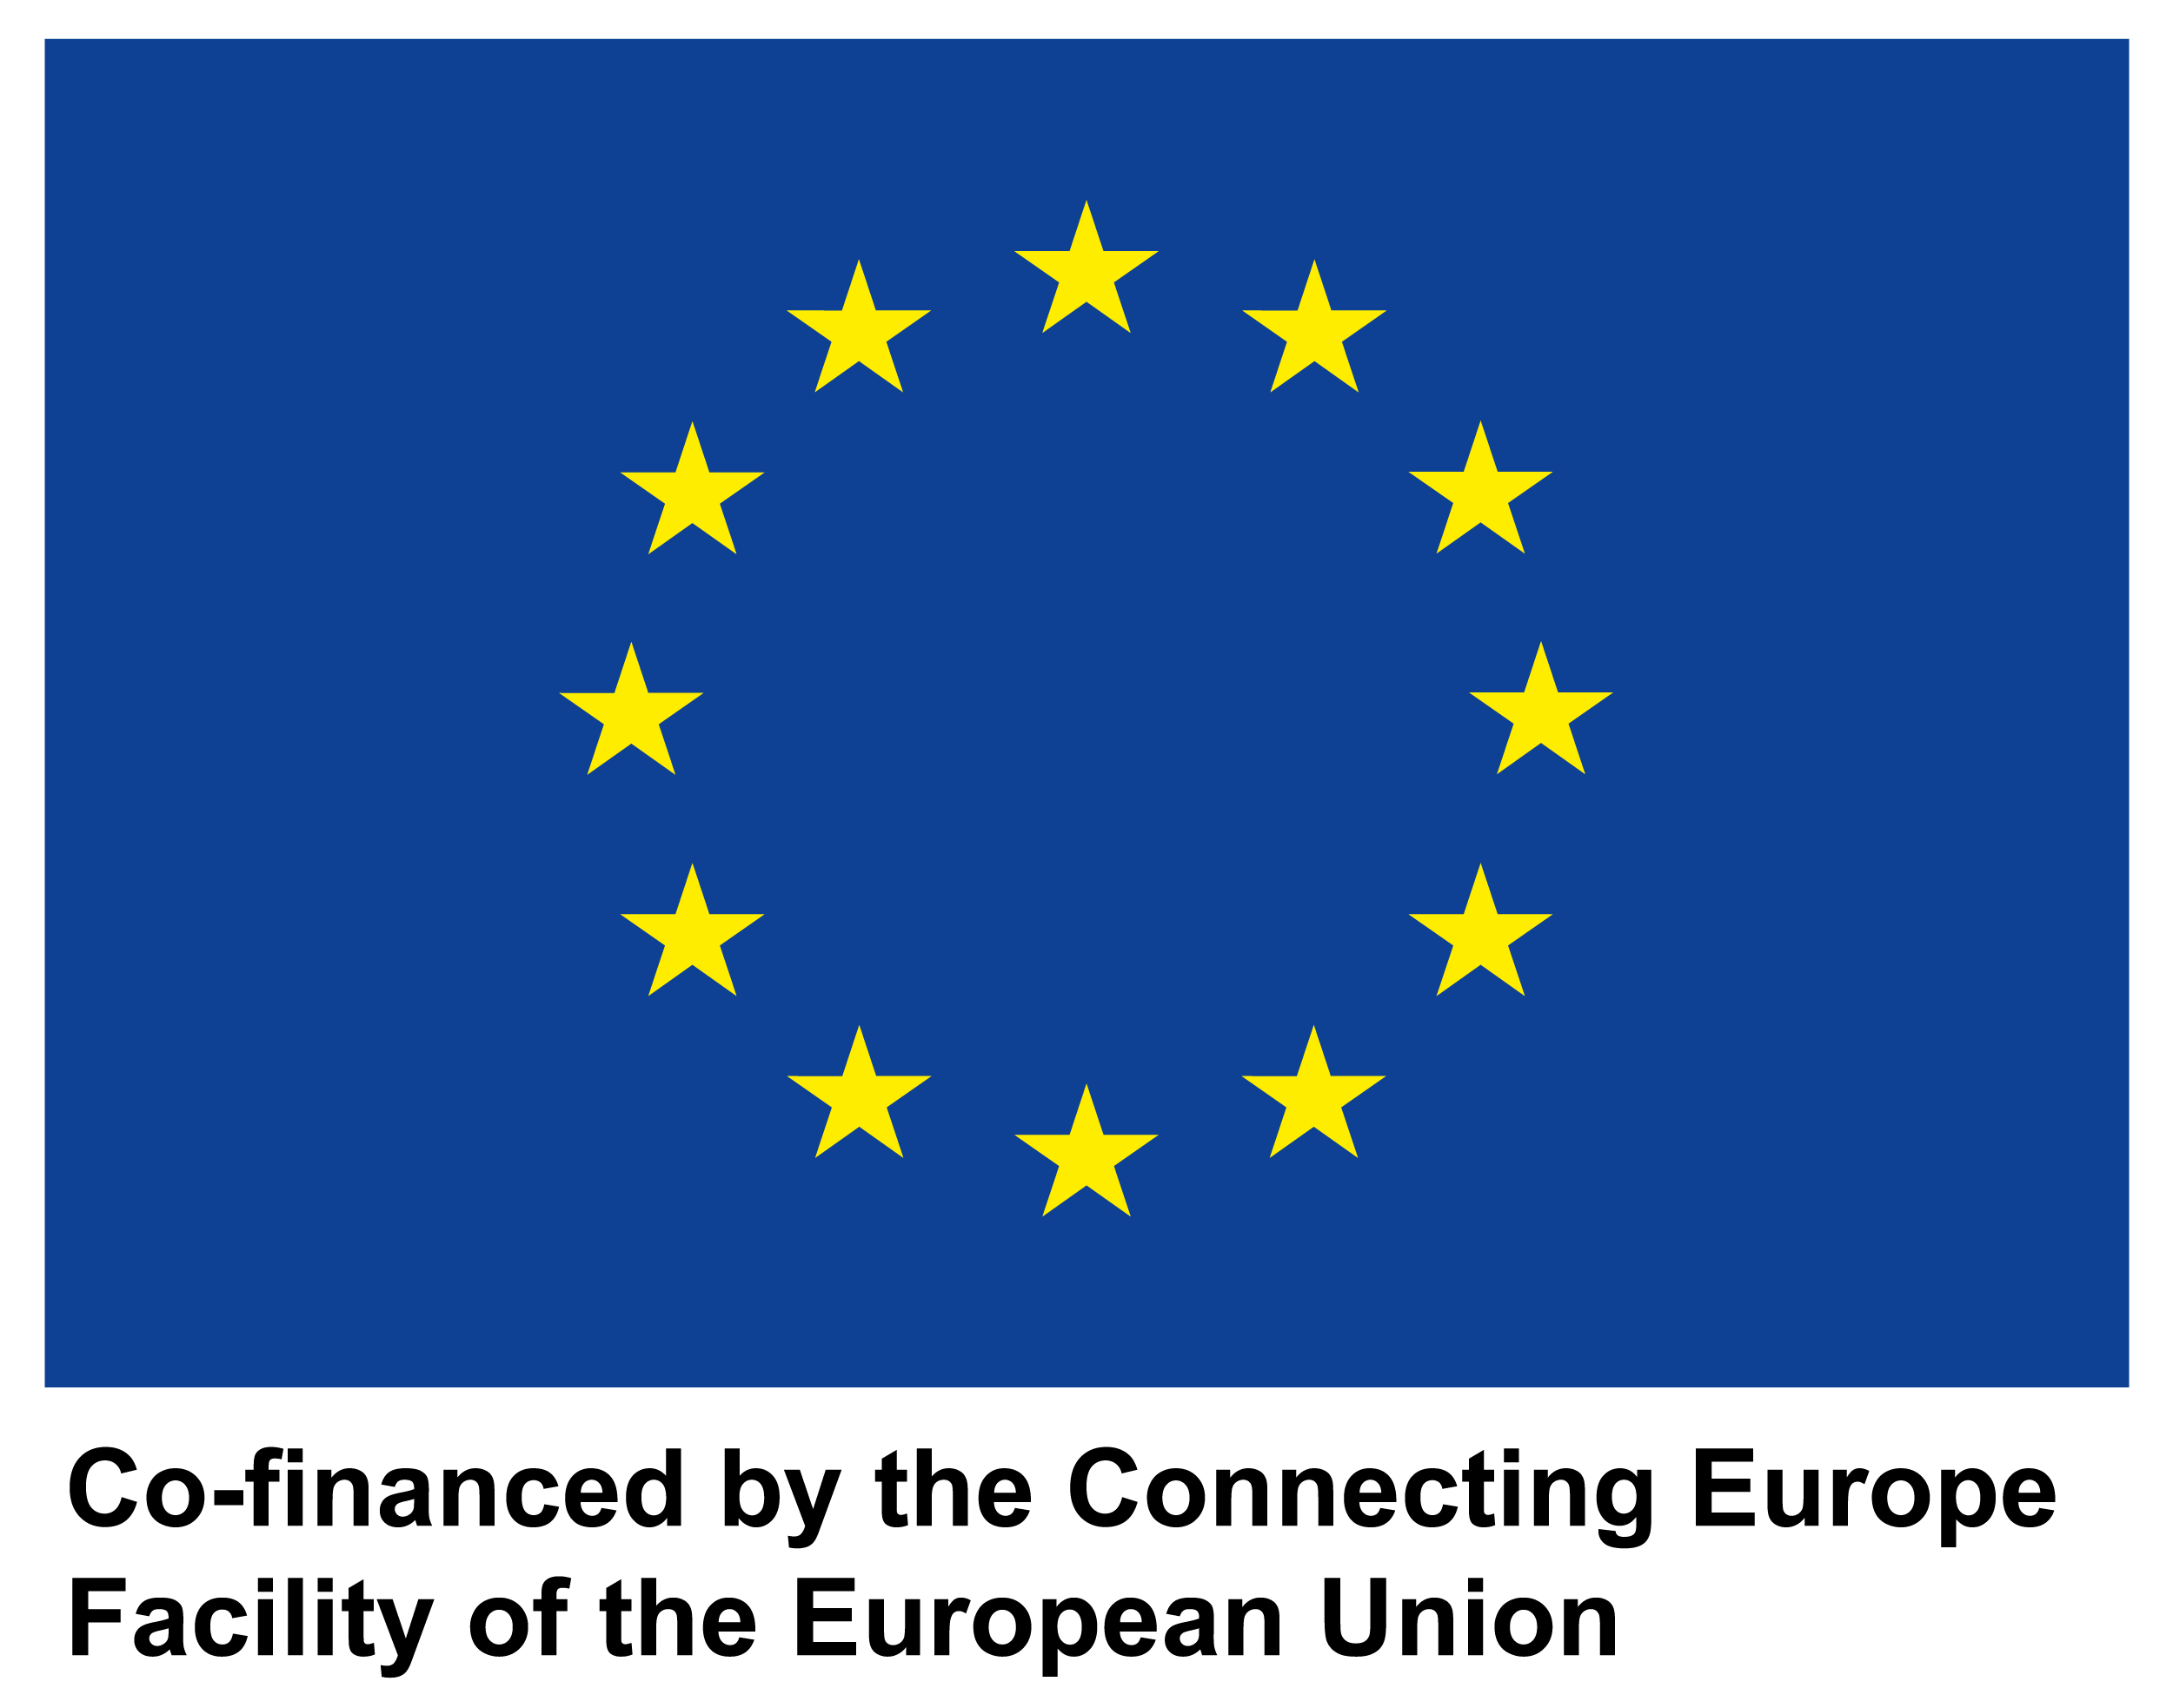

**SCALES**

**Supply Chain Architecture Leading to Enhances Services**

**D3.2**

**Supply chain enhanced services**

**framework design**

|  |  |
| --- | --- |
| **Project number** | INEA/CEF/ICT/A2018/1759084  2018-IT-IA-0053 |
| **Project acronym** | SCALES |
| **Project title** | SCALES – Supply Chain Architecture Leading to Enhances Services |
| **Project duration** | 14 months (01/09/2019 – 30/11/2020) |
| **Programme** | Connecting Europe Facility (CEF), Telecommunications sector |
|  |  |
| **Activity title** | Supply chain enhanced services framework design |
| **Deliverable number** | D3.2 |
| **Version (date)** | V.1 |
| **Due date** | 31/03/2020 |
|  |  |
| **Responsible organization** | Agenzia per l’Italia Digitale (AgID) |
| **Editor** | Politecnico di Milano |
| **Abstract** | TO DO |
| **Keywords** | TO DO |

**DELIVERABLE INFO**

|  |  |
| --- | --- |
| **Responsible organization** | AgID |
| **Editor** | Politecnico di Milano |
| **Contributors** | UNINFO |
| **Reviewers** | Consorzio Dafne, Infocert |
| **Abstract** | TO DO |
| **Keywords** | TO DO |
| **Acknowledgement** | ??? |
| **Disclaimer** | The sole responsibility of this publication lies with the author(s). The European Union is not responsible for any use that may be made of the information contained therein. |
| **Confidentiality** | The information in this document is confidential and restricted only to the members of the SCALES consortium  (including the Commission Services). |
| **Note** |  |

**CONTENTS**

The investigation: explication and areas analyzed 8

The SCALES project: the role of the Digital B2b Observatory 8

The sample distribution of the survey 8

The activities analyzed 9

The survey 11

The reference framework 12

The need for a new framework of analysis 12

The new reference framework 13

An opportunity not yet fully exploited 13

The key activities to focus on 16

The key activities 16

The following steps 18

The following optimization goes through several steps 18

Question 8 18

Question 7 21

The survey 23

**LIST OF TABLE**

[Table 1 – Number of firms in Italy 8](https://polimi365-my.sharepoint.com/personal/10390838_polimi_it/Documents/Osservatori/Digital%20B2b%202019_2020/SCALES/SCALES_D3.2_v1.docx#_Toc45643229)

Table 2 – Activities analyzed 10

**LIST OF FIGURE**

Figure 1 – The reference framework 13

Figure 2 – Q2 SMEs 14

Figure 3 – Q2 Large enterprises 14

Figure 4 – Q3 SMEs 15

Figure 5 – Q3 Large enterprises 15

Figure 6 – The key activities 16

Figure 7 – Level of automation 17

Figure 8 – Level of automation between SMEs and large enterprises 17

Figure 9 - SCALES Healthcare service Design 18

Figure 10 – Q8 20

Figure 11 – Q8 SMEs 20

Figure 12 – Q8 Large enterprises 21

Figure 13 – Q7 SMEs 22

Figure 14 – Q7 Large enterprises 22

**Page Intentionally Left Blank**

**CHANGE LOG**

|  |  |  |  |
| --- | --- | --- | --- |
| **Version** | **Date** | **Organization** | **Description** |
| 1 | 17/07/2020 | Politecnico di Milano | Document setting |
|  |  |  |  |
|  |  |  |  |
|  |  |  |  |
|  |  |  |  |
|  |  |  |  |
|  |  |  |  |
|  |  |  |  |
|  |  |  |  |
|  |  |  |  |

**Page Intentionally Left Blank**

# The investigation: explication and areas analyzed

## The SCALES project: the role of the Digital B2b Observatory

The **Digital B2b Observatory** is part of the *Digital Innovation Observatories of the School of Management of Politecnico di Milano*, which aims at raising cultural awareness in all the main areas of digital innovation through a team of nearly 100 Professors/Lecturers, Researchers, and Analysts working in over 40 different Observatories on all key topics of Digital Innovation in Companies, including SMBs, and in the Public Sector.

The Digital B2b Observatory **mission** is *pushing the Country-system towards a more significant and aware digitalization, in which the electronic invoicing is only the starting point and becoming a reference point for decision makers of enterprises and Public Administration in Italy*.

The **research** of the Digital B2b Observatory has been conducted as a contribution to the **SCALES Project**, which aims at evolving the existing e-Invoicing system in an integrated platform in which e-Invoicing, eProcurement and other services used in the post-award phase are connected.

The **role** of the Digital B2b Observatory aimed to:

* + develop a survey-based research in order to define the spread and interest of companies towards several activities, while understanding the impact of e-invoicing on the automation of some of these services;
  + define a service framework and an improvement roadmap to focus on in order to invest in the digitalization of these activities.

## The sample distribution of the survey

The Observatory has set up a survey with the following characteristics:

* **CATI** (Computer Assisted Telephone Interview)
* Target:
  + **Italian SMEs**: small enterprises (10 ≤ staff headcount < 50; € 2 m < turnover ≤ € 10 m ) and medium enterprises ( 50 ≤ staff headcount < 250; € 10 m < turnover ≤ € 50 m )
  + **Italian large enterprises** (250 ≤ staff headcount; € 50 m < turnover)
* Date and duration: 4 weeks in the Q4 of 2019

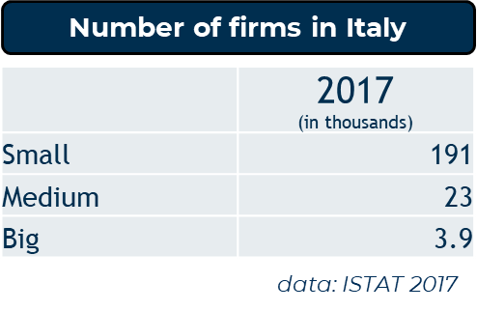The sample is representative of the Italian population of firms, with ex ante and ex post weighting of sample and results. The stratification process took into account:

Table 1 – Number of firms in Italy

* Number of employees
* Economic sector
* Geographic area

## The activities analyzed

This is the list of activities analyzed through the survey:

|  |  |
| --- | --- |
| **Activity** | **Definition** |
| Expenditure control | Having the opportunity to check regularly the allocations defined and the reserved and final balance specified |
| Benchmark on purchase prices | Allow a quick comparison between the different prices of the sources of supply to allow a conscious choice from a financial point of view |
| Expense and/or bids budget management | Knowing how to allocate the resources on expenditure correctly |
| Reconciliation of order cycle documents | Being able to obtain information relating to the order-DDT-invoice cycle so as to act promptly |
| Reconciliation of payments | Have a more precise treasury management and better management of accounting and financial aspects of payments |
| Reconciliation of amounts received | Have a more precise treasury management and better management of accounting and financial aspects of receipts |
| Reconciliation of employees’ expense reports | Improve the efficiency of the cycle related to the management of personnel expenses, improving the repayment times and the quality of the incoming data |
| Credit management | Ensure speed, precision and quality of data on the active cycle |
| Monitoring of the management of outstanding/unpaid debts | Monitor the progress of payments in relation to the active cycle |
| Treasury management | Monitor the company's cash flows, both incoming and outgoing, in a timely and updated manner |
| Cash flow planning | Predict in advance what the incoming and outgoing financial flows will be to guarantee the possible search for additional sources or uses |
| Cash management | Ensure careful management of corporate liquidity to evaluate the most appropriate uses (profitable and with different risk ratios) |
| Monitoring of fiscal management | Insert tax planning into the wider economic and financial cycle, in order to guarantee adequate coverage in relation to the needs arised |
| Vendor rating | Definition of parameters which together make it possible to express an opinion on supplier’s behavior |
| Customer rating | Definition of parameters which together make it possible to express an opinion on customers behavior |
| Warehouse inventory | Accurately have the extent and composition of warehouse stocks in relation to certain parameters (quantity, type of goods, etc ...) |
| Cost accounting | Arrange the criteria for the individual cost / revenue items regarding measurement, destination and analysis |
| Process mining to analyze company going-ons | Have tools and methodologies that allow the company to go into depth in the analysis of data and express judgments on business processes |

Table 2 – Activities analyzed

## The survey

The survey prepared by the Observatory is structured as follows:

**Q2**: Which of the following activities are carried out in your company?

* **For each ‘Yes’ in Q2 🡪 Q3**: Which activities have registered an improvement following the introduction of the e-invoicing obligation?
* **For each ‘Yes’ in Q2 🡪 Q4**: Indicate on a scale (1 to 7) how automated each of the listed activities is in your company
* **For each ‘No’ in Q2 🡪 Q5**: Which of the following activities - not currently carried out in your company - are of interest?

**Q6**: Which activities do you want to invest in over the next year?

**Q7**: What are the key characteristics of the systems you intend to introduce for the management of the activities to invest in?

**Q8**: Which tools of Supply Chain Finance are interesting for your company?

* **Invoice Financing**: *form of financing that involves the intervention of a financial operator who advances the total or partial amount of one or more invoices issued by the company but not yet collected*.
* **Factoring**: *transfer to a factor of commercial credits claimed by a company (transferor) towards its customers (debtors). The factor can take recourse to the transferor in case of non-payment (with recourse), or it can assume this risk (without recourse).*
* **Reverse factoring**: *factoring operating mode in which a customer of high credit rating activates a partnership with a factor, in order to encourage the transfer of the invoices of his suppliers (who therefore take advantage of the customer's creditworthiness to obtain more favorable conditions).*
* **Dynamic discounting**: *technological solution that allows advance payment by the customer in exchange for a discount on the invoice amount by the supplier*.
* **Invoice Trading/Auction**: *marketplace for the invoice financing, based on a technological platform that allows third parties with availability of capital (financial and non-financial institutions and, in some cases, individuals) to invest in the invoices issued by a firm, according to an auction mechanism between the several possible buyers*).

# The reference framework

## The need for a new framework of analysis

***The key concepts from Deliverable 1***

The overall analysis highlighted some fundamental concepts:

* **Large companies** focus more on management control, dealing with a wider complexity in terms of suppliers and customers. On the other hand, **SMEs** are more attentive to financial management, also having less need and urgency to manage their upstream value chain.
* Generally, the e-invoicing has not yet been perceived in an advanced way within the supply chain: for now, only the benefits of activities directly impacted by the obligation are being exploited, while there are no investments aiming at integrating it in more comprehensive digital processes. Therefore, the relational and ecosystem dimension is missing.
* However, it should be emphasized that the **pharmaceutical sector** shows greater awareness and readiness in perceiving the improvements related to the electronic invoicing, in particular in relation to those activities that characterize the supply chain relationships (*vendor and customer rating*) an those regarding internal processes analysis (*process mining*).

The **investments** in automation are towards activities that tend to be time consuming, where the company has direct visibility on the time dedicated and on the time that could be saved.

Furthermore, the willingness to invest in already medium automation activities show that that many companies are still in the process of **digitalization**: after initially investing, the company perceived the improvements in terms of efficiency and effectiveness related to automation, thus confirming further future investments for a further evolutionary step.

Most companies, on the other hand, show that they have not yet implemented a **long-term vision**: there is probably no processes point-of-view, so a specific **framework** is necessary to understand where the improvements introduced with digitalization would impact**.**

## The new reference framework

The Observatory decided to aggregate the individual activities into **macro-areas** to better appreciate the differences between the group of activities and try to prioritize the actions to be taken. From here emerged an overall **framework** of new services that can be implemented and a subsequent roadmap**.**

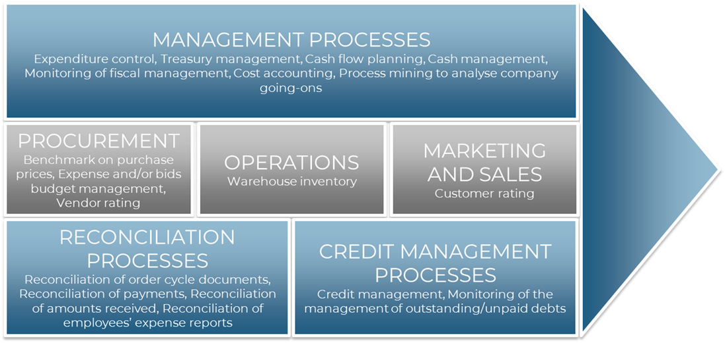

Figure 1 – The reference framework

## An opportunity not yet fully exploited

The data show that the market is not yet ready and has not yet been able to **go beyond the obligation**, exploiting the electronic invoicing to apply digitalization to new business processes, increasing efficiency and effectiveness.

The key aspect is that the use of the e-invoicing and the information contained must **go beyond the administrative area**, so that these data can travel **deeper into the company** and contribute more to the general management of the company's situation within the supply chain, this in order to create greater balance in a wider ecosystem.

Maturity is not simply having efficient administrative processes, but making sure that the data present in the e-invoicing (in a summarized way) are released in all business units to make a **greater contribution to knowledge and decision making**, in order to better fit into:

* planning processes;
* logistics;
* production;
* marketing;
* ...

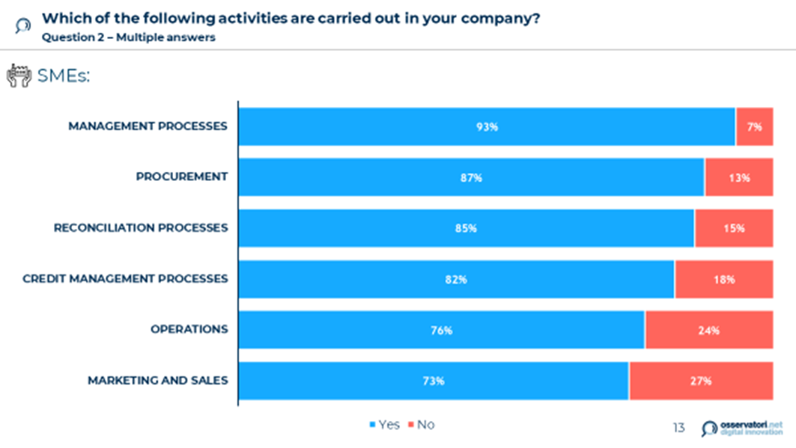

Figure 2 – Q2 SMEs

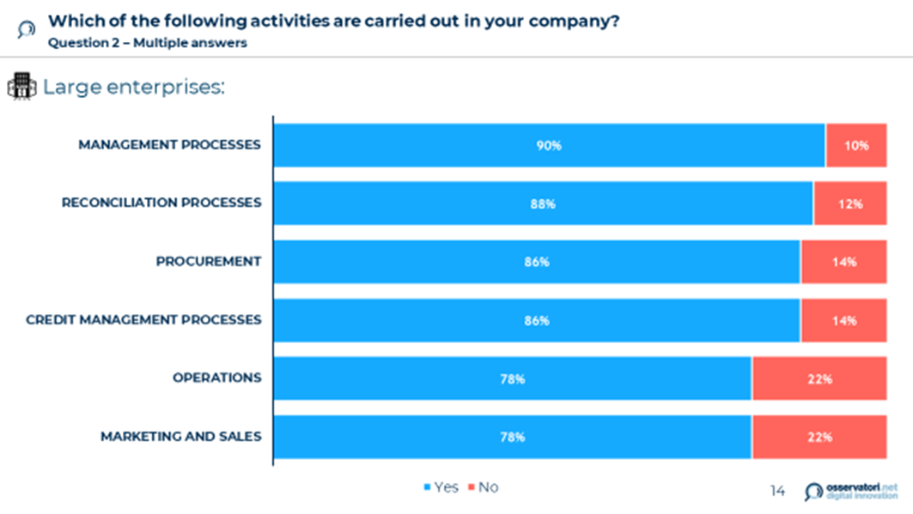

Figure 3 – Q2 Large enterprises

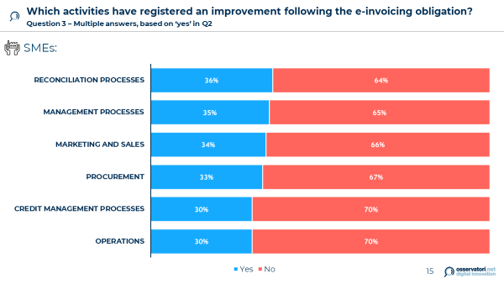

Figure 4 – Q3 SMEs

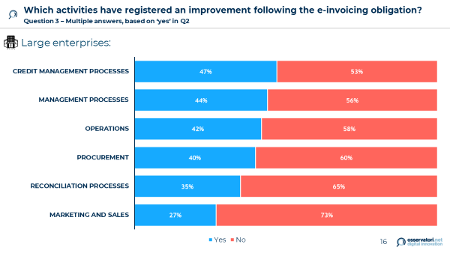

Figure 5 – Q3 Large enterprises

# The key activities to focus on

## The key activities

Companies must necessarily optimize some key activities first, in order to obtain results that can then be exploited in several, related processes.

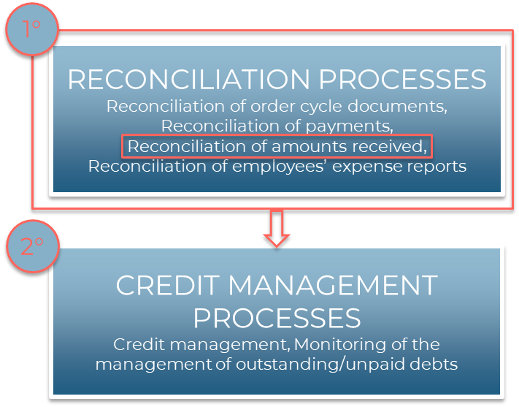

Figure 6 – The key activities

These are the activities that can gather the most immediate benefits, following the introduction of eOrder and electronic invoicing obligations.

A company can improve these processes in an optimal way only if it has first perfected the reconciliation processes, in particular the amounts received.

Therefore, we focus on these processes and activities as they can lead up to improvements and problem-solving in other areas.

***Indicate on a scale how automated each of the listed activities is in your company***

***Question 4 – Based on ‘yes’ in Q2. The term "automated" means that human contribution is minimized***

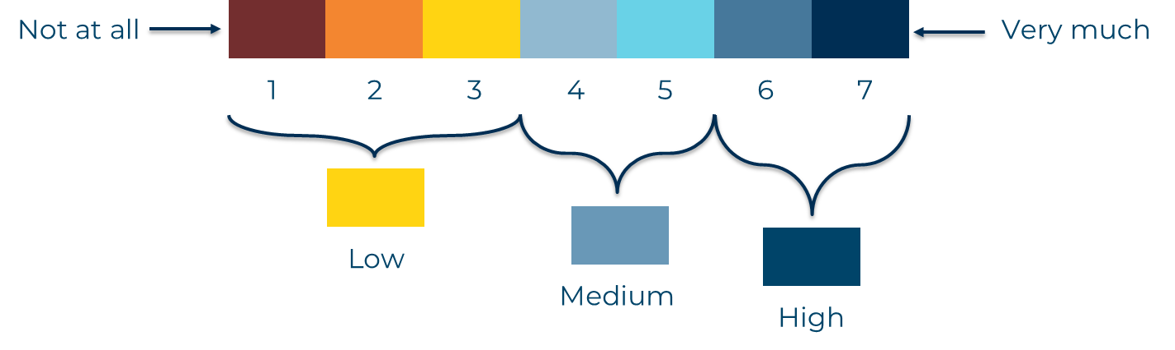

Figure 7 – Level of automation

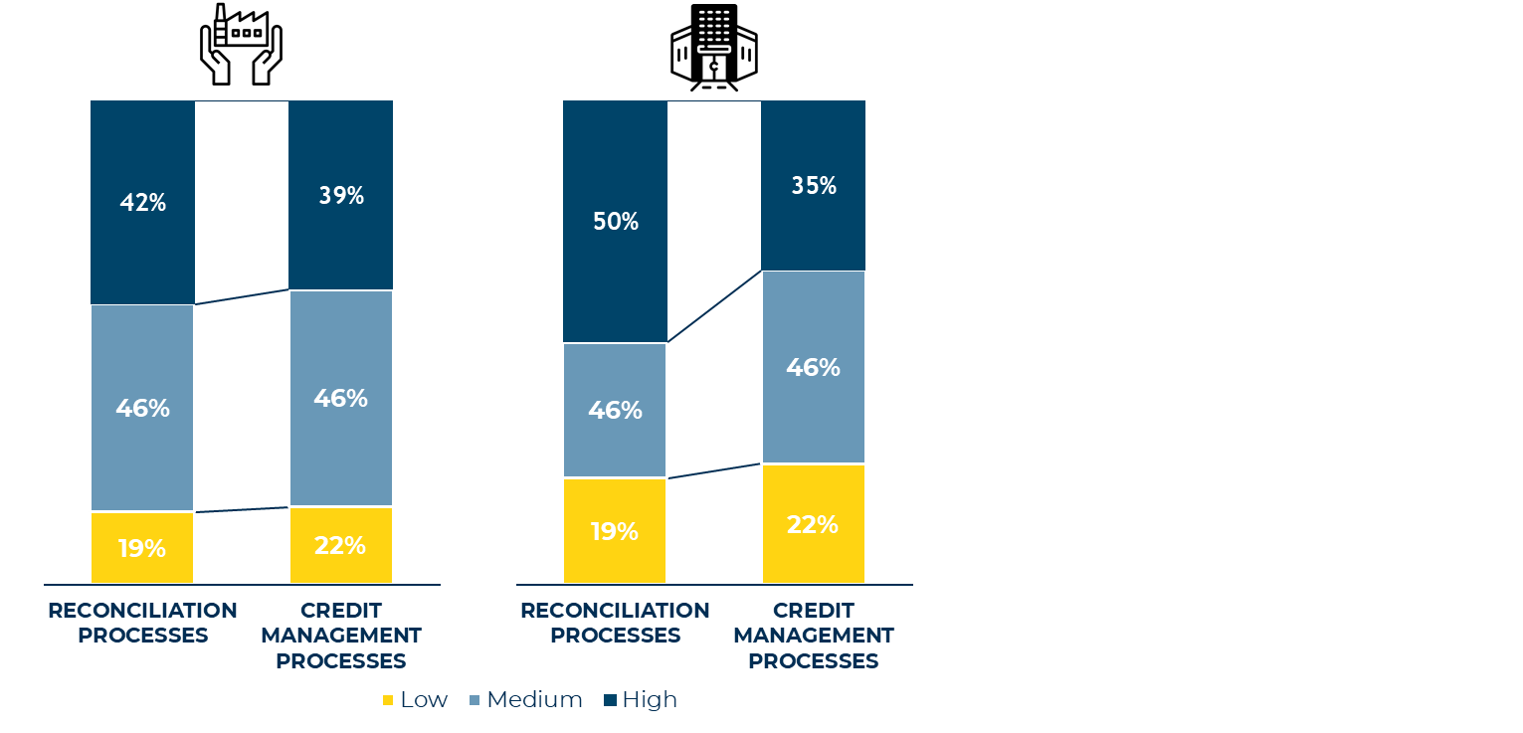

Figure 8 – Level of automation between SMEs and large enterprises

The potential market today is represented by the yellow and light blue segments, on which to act with investment and improvement plans.

The potential market is interesting, but each segment has a different level of culture and therefore it requires diversified communication strategies.

# The following steps

## The following optimization goes through several steps

What are the next steps? What are the services that need to be optimized?

Based on what emerged from previous analyses shown, the research recommended a sequence of the different areas of activity on which to step in:

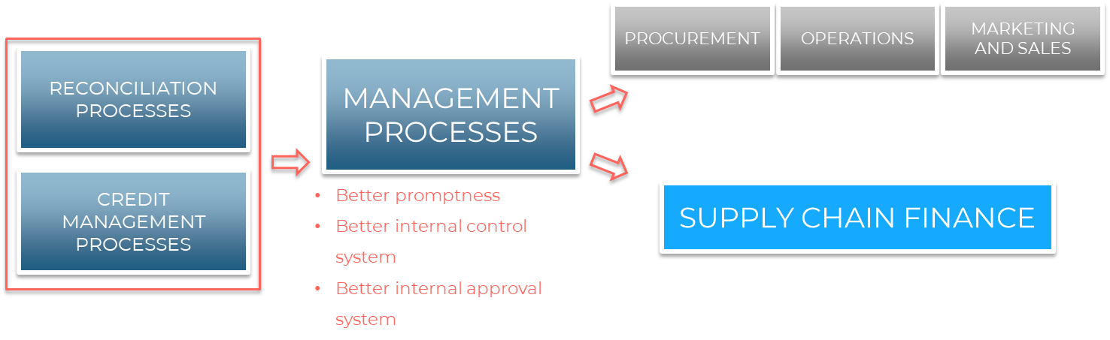

The creation and development of new services can therefore be repeated in a modular way on the different blocks of the framework. In this way, the company can exploit the experience already gained during the first steps when optimizing the reconciliation processes and credit management activities.

For a technical perspective, we can refer to the project setup described in the next deliverable.

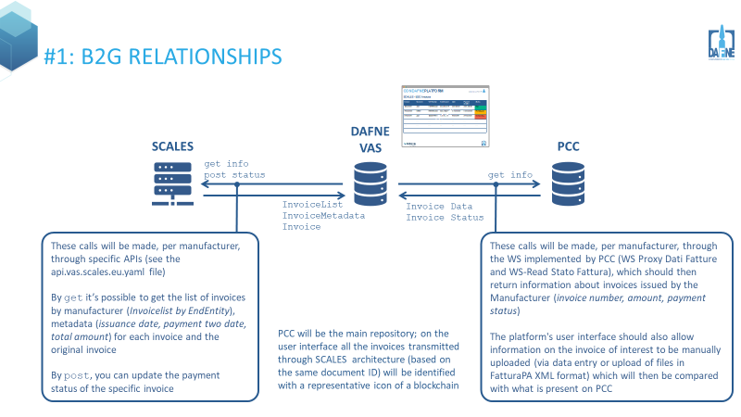

Figure 9 - SCALES Healthcare service Design

## Question 8

***Which tools of Supply Chain Finance are interesting for your company?***

***Multiple answers***

* **Invoice Financing**: *form of financing that involves the intervention of a financial operator who advances the total or partial amount of one or more invoices issued by the company but not yet collected*.
* **Factoring**: *transfer to a factor of commercial credits claimed by a company (transferor) towards its customers (debtors). The factor can take recourse to the transferor in case of non-payment (with recourse), or it can assume this risk (without recourse).*
* **Reverse factoring**: *factoring operating mode in which a customer of high credit rating activates a partnership with a factor, in order to encourage the transfer of the invoices of his suppliers (who therefore take advantage of the customer's creditworthiness to obtain more favorable conditions).*
* **Dynamic discounting**: *technological solution that allows advance payment by the customer in exchange for a discount on the invoice amount by the supplier*.
* **Invoice Trading/Auction**: *marketplace for the invoice financing, based on a technological platform that allows third parties with availability of capital (financial and non-financial institutions and, in some cases, individuals) to invest in the invoices issued by a firm, according to an auction mechanism between the several possible buyers*.

Among the most interesting SCF tools for **SMEs**, the *invoice financing* is immediately evident, certainly for reasons characteristic of the company size, the typical business management model of SMEs and the consequent financial availability / needs. It should not be underestimated that more than one in five SMEs do not know the *reverse factoring* and *dynamic discounting* tools, and even one in four SMEs do not know what the *invoice trading* activity refers to.

These tools could instead be highly effective for an **SME**: in fact, they are the options with the greatest flexibility and more easily accessible both by the users of the service and by investors. Furthermore, *dynamic discounting* and *invoice trading* go along with the agile and fast decision-making of SMEs, which tend to be higher than those of large companies, for the direct awareness of those who make decisions regarding the actual need for financial availability and the immediate convenience of choosing one of the tools.

Surprisingly, even the **large enterprises** show a certain lack of culture on SCF issues. Again, 24% of the companies interviewed do not know *dynamic discounting* and *invoice trading*, while 21% ignore *reverse factoring* tools.

Unlike SMEs, however, among the large companies we find better percentages relating to the interest in these tools: in particular, one in three companies is focused on the possibilities of *factoring*, and similarly one in four is interested in *reverse factoring*. Again the most considered tool is the *invoice financing*, with 40% of **large enterprises** declaring interested.

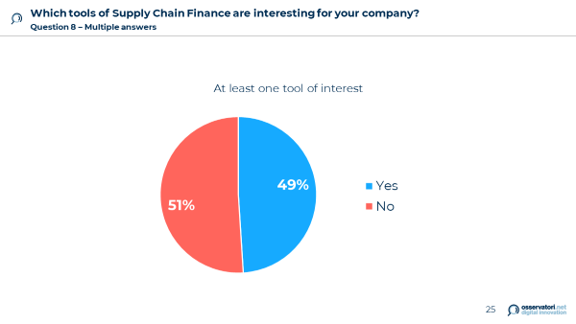

Figure 10 – Q8

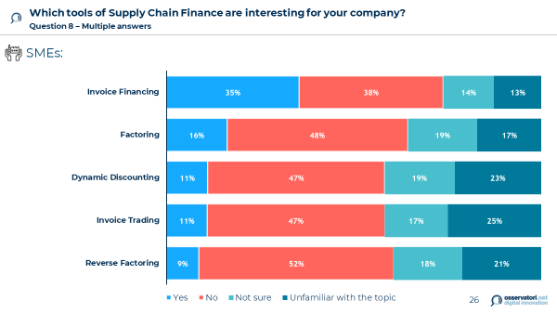

Figure 11 – Q8 SMEs

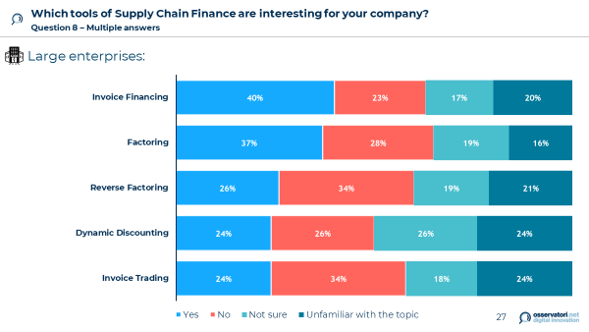

Figure 12 – Q8 Large enterprises

## Question 7

***What are the key characteristics of the systems for the management of the activities to invest in?***

***Multiple answers***

* ***Usability of the solution***
* ***Ease of integration with the firm systems***
* ***GDPR compliance***
* ***Security of data and information processed***
* ***Facilitating relations with institutions***
* ***Facilitating relations with domestic customers / suppliers***
* ***Facilitating relations with foreign customers / suppliers***
* ***Facilitating relations with banks***

For **large enterprises**, great importance is given to the possibility of having an easy integration with the systems already present in the company. This is because, being large firms, the software, management and database systems are often well integrated and well tailored to the needs and processes of the company itself, which therefore wants to maintain the same level of efficiency with the subsequent add-ons of the systems that will be introduced.

Another key feature for **large enterprises** concerns the facilitation of the relationship with domestic customers / suppliers, with the aim of optimizing flows within its supply chain. In this context, the introduction of the e-invoicing can certainly have a positive impact.

For **SMEs**, preferences are more widely distributed. In particular, it must be considered that among the features of the new systems, the facilitation of relations with domestic customers and suppliers and that with foreign customers and suppliers have almost the same weight.

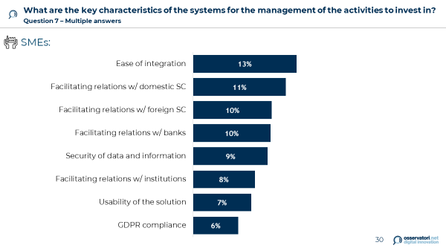

Figure 13 – Q7 SMEs

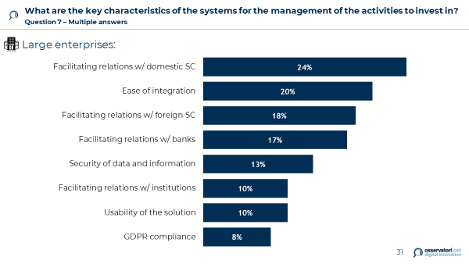

Figure 14 – Q7 Large enterprises

**ANNEX**

## The survey

**DIGITALIZZAZIONE DEI PROCESSI AZIENDALI**

**Anagrafica**: settore, fatturato, dipendenti, località geografica

1. **Sei anche un fornitore della Pubblica Amministrazione?**

* Si
* No

**NUOVI SERVIZI ABILITATI DALL’OBBLIGO DI FE**

1. **Quali delle seguenti attività sono svolte in azienda?** (*possibili più risposte*)

* Controllo della spesa
* Benchmark sui prezzi d'acquisto
* Gestione del budget di spesa e/o delle gare
* Riconciliazione dei documenti del ciclo dell’ordine (ordine-documento di trasporto-fattura)
* Riconciliazione pagamenti
* Riconciliazione degli incassi
* Riconciliazione delle note spese del personale
* Gestione del credito
* Monitoraggio della gestione di crediti insoluti/non pagati
* Gestione della tesoreria
* Pianificazione dei flussi di cassa
* Gestione della liquidità
* Monitoraggio della gestione fiscale
* Rating dei fornitori
* Rating dei clienti
* Inventario di magazzino
* Contabilità analitica
* Process mining per analizzare gli accadimenti aziendali
* Altro (*specificare*)

*Compaiono solo le opzioni scelte alla domanda precedente*

1. **Quali delle seguenti attività hanno registrato un miglioramento in seguito all’introduzione dell’obbligo di fatturazione elettronica?** (*possibili più risposte*)

* Controllo della spesa
* Benchmark sui prezzi d'acquisto
* Gestione del budget di spesa e/o delle gare
* Riconciliazione dei documenti del ciclo dell’ordine (ordine-documento di trasporto-fattura)
* Riconciliazione pagamenti
* Riconciliazione degli incassi
* Riconciliazione delle note spese del personale
* Gestione del credito
* Monitoraggio della gestione di crediti insoluti/non pagati
* Gestione della tesoreria
* Pianificazione dei flussi di cassa
* Gestione della liquidità
* Monitoraggio della gestione fiscale
* Rating dei fornitori
* Rating dei clienti
* Inventario di magazzino
* Contabilità analitica
* Process mining per analizzare gli accadimenti aziendali
* Altro *(specificare)*

*Compaiono solamente le attività scelte nella domanda 2*

1. **Indicare su una scala da 1 a 7 (con 1= per nulla e 7 = moltissimo) quanto sia automatizzata nella sua azienda ciascuna delle attività elencate** *(con il termine “automatizzate” si intende che l’apporto umano è ridotto ai minimi termini)***.**

|  |  |
| --- | --- |
| Benchmark sui prezzi d’acquisto | ⬜ 1 ⬜ 2 ⬜ 3 ⬜ 4 ⬜ 5 ⬜ 6 ⬜ 7 ⬜ non so |
| … | ⬜ 1 ⬜ 2 ⬜ 3 ⬜ 4 ⬜ 5 ⬜ 6 ⬜ 7 ⬜ non so |

*Compaiono solo le opzioni NON scelte alla domanda 2*

1. **Quali delle seguenti attività a oggi non svolte in azienda sono di interesse per la sua azienda?** *(possibili più risposte)*

* Controllo della spesa
* Benchmark sui prezzi d'acquisto
* Gestione del budget di spesa e/o delle gare
* Riconciliazione dei documenti del ciclo dell’ordine (ordine-documento di trasporto-fattura)
* Riconciliazione pagamenti
* Riconciliazione degli incassi
* Riconciliazione delle note spese del personale
* Gestione del credito
* Monitoraggio della gestione di crediti insoluti/non pagati
* Gestione della tesoreria
* Pianificazione dei flussi di cassa
* Gestione della liquidità
* Monitoraggio della gestione fiscale
* Rating dei fornitori
* Rating dei clienti
* Inventario di magazzino
* Contabilità analitica
* Process mining per analizzare gli accadimenti aziendali
* Nessuna
* Altro *(specificare)*

1. **Su quali attività si intende investire nel prossimo anno?** (*possibili più risposte*)

* Controllo della spesa
* Benchmark sui prezzi d'acquisto
* Gestione del budget di spesa e/o delle gare
* Riconciliazione dei documenti del ciclo dell’ordine (ordine-documento di trasporto-fattura)
* Riconciliazione pagamenti
* Riconciliazione degli incassi
* Riconciliazione delle note spese del personale
* Gestione del credito
* Monitoraggio della gestione di crediti insoluti/non pagati
* Gestione della tesoreria
* Pianificazione dei flussi di cassa
* Gestione della liquidità
* Monitoraggio della gestione fiscale
* Rating dei fornitori
* Rating dei clienti
* Inventario di magazzino
* Contabilità analitica
* Process mining per analizzare gli accadimenti aziendali
* Nessuna
* Altro *(specificare)*

1. **Quali sono le caratteristiche chiave dei sistemi che intendete introdurre per la gestione delle attività della domanda precedente?** *(possibili più risposte)*

* Usabilità della soluzione
* Facilità di integrazione con i sistemi presenti in azienda
* Compliance al GDPR
* Sicurezza dei dati e delle informazioni trattate
* Agevolazione della relazione con le istituzioni
* Agevolazione della relazione con i clienti/fornitori domestici
* Agevolazione della relazione con i clienti/fornitori esteri
* Agevolazione della relazione con le banche
* Altro (*specificare*)

1. **Quali strumenti di Supply Chain Finance sono di interesse della sua azienda?** *(possibili più risposte)*

* Anticipo fattura
* Invoice Trading
* Dynamic Discouting
* Factoring
* Reverse Factoring
* Altro *(specificare)*
* Nessuno
* Non conosco questi strumenti