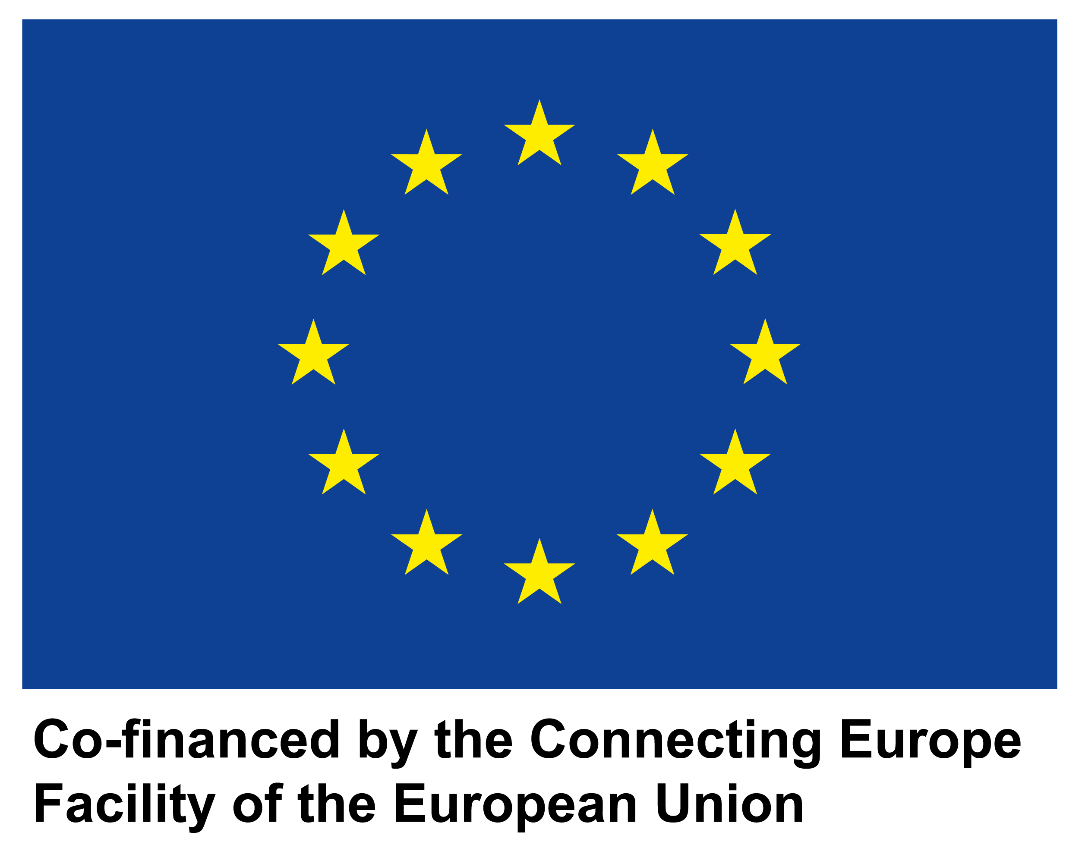

**SCALES**

**Supply Chain Architecture Leading to Enhances Services**

**D3.1**

**Report on preferences and needs of the SMEs**

|  |  |
| --- | --- |
| **Project number** | INEA/CEF/ICT/A2018/1759084  2018-IT-IA-0053 |
| **Project acronym** | SCALES |
| **Project title** | SCALES – Supply Chain Architecture Leading to Enhances Services |
| **Project duration** | 14 months (01/09/2019 – 30/11/2020) |
| **Programme** | Connecting Europe Facility (CEF), Telecommunications sector |
|  |  |
| **Activity title** | Report on preferences and needs of the SMEs |
| **Deliverable number** | D3.1 |
| **Version (date)** | V.1 |
| **Due date** | 31/03/2020 |
|  |  |
| **Responsible organization** | Agenzia per l’Italia Digitale (AgID) |
| **Editor** | Politecnico di Milano |
| **Abstract** | TO DO |
| **Keywords** | TO DO |

**DELIVERABLE INFO**

|  |  |
| --- | --- |
| **Responsible organization** | AgID |
| **Editor** | Politecnico di Milano |
| **Contributors** | UNINFO |
| **Reviewers** | Consorzio Dafne, Infocert |
| **Abstract** | TO DO |
| **Keywords** | TO DO |
| **Acknowledgement** | ??? |
| **Disclaimer** | The sole responsibility of this publication lies with the author(s). The European Union is not responsible for any use that may be made of the information contained therein. |
| **Confidentiality** | The information in this document is confidential and restricted only to the members of the SCALES consortium  (including the Commission Services). |
| **Note** |  |

**CONTENTS**

The investigation: explication and areas analyzed 8

The SCALES project: the role of the Digital B2b Observatory 8

The sample distribution of the survey 8

The activities analyzed 9

The survey 11

The results of the survey on SMEs and large enterprises 12

Question 2 12

Question 3 14

Question 4 18

Question 6 20

The results of the survey on the pharmaceutical industry 23

Conclusions and takeaways 25

**LIST OF TABLE**

[Table 1 – Number of firms in Italy 8](https://polimi365-my.sharepoint.com/personal/10390838_polimi_it/Documents/Osservatori/Digital%20B2b%202019_2020/SCALES/SCALES_D3.1_v1.docx#_Toc45641449)

Table 2 – Activities analyzed 10

**LIST OF FIGURE**

Figure 1 – Q2 SMEs 13

Figure 2- Q2 Large enterprises 13

Figure 3 – e-invoicing in Italy (invoices sent) 14

Figure 4 – e-invoicing in Italy (companies) 15

Figure 5- Q3 16

Figure 6 – Q3 SMEs 16

Figure 7 – Q3 Large enterprises 17

Figure 8 – Q4 18

Figure 9 – Q4 SMEs 19

Figure 10 – Q4 Large enterprises 19

Figure 11 – Q6 20

Figure 12 – Q6 Low automation activities 21

Figure 13 - Q6 Medium automation activities 21

Figure 14 - Q6 High automation activities 22

Figure 15 – Q2 Pharmaceutical industry 23

Figure 16 – Q3 Pharmaceutical industry 23

Figure 17 – Q4 Pharmaceutical industry 24

Figure 18 – Q6 Pharmaceutical industry 24

**Page Intentionally Left Blank**

**CHANGE LOG**

|  |  |  |  |
| --- | --- | --- | --- |
| **Version** | **Date** | **Organization** | **Description** |
| 1 | 17/07/2020 | Politecnico di Milano | Document setting |
|  |  |  |  |
|  |  |  |  |
|  |  |  |  |
|  |  |  |  |
|  |  |  |  |
|  |  |  |  |
|  |  |  |  |
|  |  |  |  |
|  |  |  |  |

**Page Intentionally Left Blank**

# The investigation: explication and areas analyzed

## The SCALES project: the role of the Digital B2b Observatory

The **Digital B2b Observatory** is part of the *Digital Innovation Observatories of the School of Management of Politecnico di Milano*, which aims at raising cultural awareness in all the main areas of digital innovation through a team of nearly 100 Professors/Lecturers, Researchers, and Analysts working in over 40 different Observatories on all key topics of Digital Innovation in Companies, including SMBs, and in the Public Sector.

The Digital B2b Observatory **mission** is *pushing the Country-system towards a more significant and aware digitalization, in which the electronic invoicing is only the starting point and becoming a reference point for decision makers of enterprises and Public Administration in Italy*.

The **research** of the Digital B2b Observatory has been conducted as a contribution to the **SCALES Project**, which aims at evolving the existing e-Invoicing system in an integrated platform in which e-Invoicing, eProcurement and other services used in the post-award phase are connected.

The **role** of the Digital B2b Observatory aimed to:

* + develop a survey-based research in order to define the spread and interest of companies towards several activities, while understanding the impact of e-invoicing on the automation of some of these services;
  + define a service framework and an improvement roadmap to focus on in order to invest in the digitalization of these activities.

## The sample distribution of the survey

The Observatory has set up a survey with the following characteristics:

* **CATI** (Computer Assisted Telephone Interview)
* Target:
  + **Italian SMEs**: small enterprises (10 ≤ staff headcount < 50; € 2 m < turnover ≤ € 10 m ) and medium enterprises ( 50 ≤ staff headcount < 250; € 10 m < turnover ≤ € 50 m )
  + **Italian large enterprises** (250 ≤ staff headcount; € 50 m < turnover)
* Date and duration: 4 weeks in the Q4 of 2019

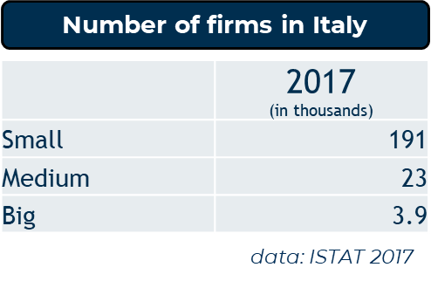The sample is representative of the Italian population of firms, with ex ante and ex post weighting of sample and results. The stratification process took into account:

Table 1 – Number of firms in Italy

* Number of employees
* Economic sector
* Geographic area

## The activities analyzed

This is the list of activities analyzed through the survey:

|  |  |
| --- | --- |
| **Activity** | **Definition** |
| Expenditure control | Having the opportunity to check regularly the allocations defined and the reserved and final balance specified |
| Benchmark on purchase prices | Allow a quick comparison between the different prices of the sources of supply to allow a conscious choice from a financial point of view |
| Expense and/or bids budget management | Knowing how to allocate the resources on expenditure correctly |
| Reconciliation of order cycle documents | Being able to obtain information relating to the order-DDT-invoice cycle so as to act promptly |
| Reconciliation of payments | Have a more precise treasury management and better management of accounting and financial aspects of payments |
| Reconciliation of amounts received | Have a more precise treasury management and better management of accounting and financial aspects of receipts |
| Reconciliation of employees’ expense reports | Improve the efficiency of the cycle related to the management of personnel expenses, improving the repayment times and the quality of the incoming data |
| Credit management | Ensure speed, precision and quality of data on the active cycle |
| Monitoring of the management of outstanding/unpaid debts | Monitor the progress of payments in relation to the active cycle |
| Treasury management | Monitor the company's cash flows, both incoming and outgoing, in a timely and updated manner |
| Cash flow planning | Predict in advance what the incoming and outgoing financial flows will be to guarantee the possible search for additional sources or uses |
| Cash management | Ensure careful management of corporate liquidity to evaluate the most appropriate uses (profitable and with different risk ratios) |
| Monitoring of fiscal management | Insert tax planning into the wider economic and financial cycle, in order to guarantee adequate coverage in relation to the needs arised |
| Vendor rating | Definition of parameters which together make it possible to express an opinion on supplier’s behavior |
| Customer rating | Definition of parameters which together make it possible to express an opinion on customers behavior |
| Warehouse inventory | Accurately have the extent and composition of warehouse stocks in relation to certain parameters (quantity, type of goods, etc ...) |
| Cost accounting | Arrange the criteria for the individual cost / revenue items regarding measurement, destination and analysis |
| Process mining to analyze company going-ons | Have tools and methodologies that allow the company to go into depth in the analysis of data and express judgments on business processes |

Table 2 – Activities analyzed

## The survey

The survey prepared by the Observatory is structured as follows:

**Q2**: Which of the following activities are carried out in your company?

* **For each ‘Yes’ in Q2 🡪 Q3**: Which activities have registered an improvement following the introduction of the e-invoicing obligation?
* **For each ‘Yes’ in Q2 🡪 Q4**: Indicate on a scale (1 to 7) how automated each of the listed activities is in your company
* **For each ‘No’ in Q2 🡪 Q5**: Which of the following activities - not currently carried out in your company - are of interest?

**Q6**: Which activities do you want to invest in over the next year?

**Q7**: What are the key characteristics of the systems you intend to introduce for the management of the activities to invest in?

**Q8**: Which tools of Supply Chain Finance are interesting for your company?

* **Invoice Financing**: *form of financing that involves the intervention of a financial operator who advances the total or partial amount of one or more invoices issued by the company but not yet collected*.
* **Factoring**: *transfer to a factor of commercial credits claimed by a company (transferor) towards its customers (debtors). The factor can take recourse to the transferor in case of non-payment (with recourse), or it can assume this risk (without recourse).*
* **Reverse factoring**: *factoring operating mode in which a customer of high credit rating activates a partnership with a factor, in order to encourage the transfer of the invoices of his suppliers (who therefore take advantage of the customer's creditworthiness to obtain more favorable conditions).*
* **Dynamic discounting**: *technological solution that allows advance payment by the customer in exchange for a discount on the invoice amount by the supplier*.
* **Invoice Trading/Auction**: *marketplace for the invoice financing, based on a technological platform that allows third parties with availability of capital (financial and non-financial institutions and, in some cases, individuals) to invest in the invoices issued by a firm, according to an auction mechanism between the several possible buyers*).

# The results of the survey on SMEs and large enterprises

## Question 2

***Which of the following activities are carried out in your company?***

***Multiple answers***

As predictable, large enterprises tend to carry out many more activities than SMEs.

The most common activities among **large enterprises** are: *reconciliation of amounts received* and *reconciliation of payments* (93%); *expenditure control*, *credit management* and *monitoring of the management of outstanding/unpaid debts* (90%).

Regarding **SMEs**, among the most widespread activities there are likewise *reconciliation of amounts received* (85%), *reconciliation of payments* (84%) and *expenditure control* (80%). In addition, however, we find *cash management* (83%) and *cash flow planning* (80%).

For both dimensions, the least widespread (and at the same time the least known) activity is the *process mining to analyse company going-ons*. Only slightly more than half of the large enterprises and just over a third of SMEs carry out this task, while in general 15% of the companies don't have enough information about the topic.

**SMEs** are also lagging behind in their ability to compare and classify their suppliers by analyzing their performance. The *vendor rating* is in fact performed only by 70% of SMEs, while the *benchmark on purchase prices* is even rarer (63%).

**Large companies** therefore show that they focus more on management control, also having to manage a wider complexity in terms of suppliers and customers than SMEs.

On the other hand, **SMEs** are more attentive to financial management, also having less need and urgency to manage their upstream value chain**.**

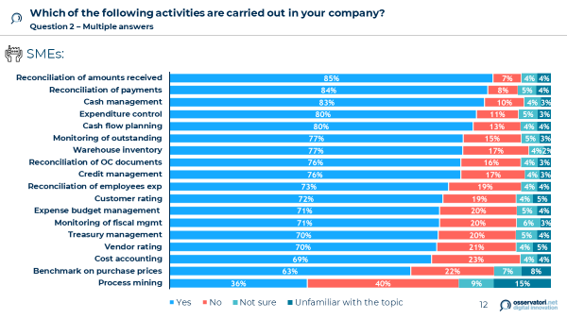

Figure 1 – Q2 SMEs

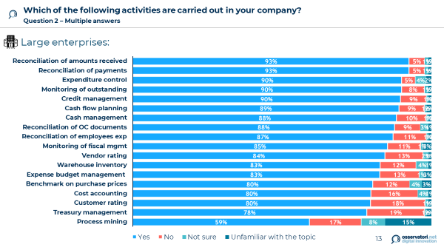

Figure 2- Q2 Large enterprises

## Question 3

***Which activities have registered an improvement following the e-invoicing obligation?***

***Question 3 – Multiple answers, based on ‘yes’ in Q2***

To better understand the results related to this question, it is necessary to first clarify what impacts had the introduction of the obligation of electronic invoicing in Italy.

In 2019, 3.9 million companies sent at least one invoice file to the SDI. 2% of these companies are not subject to the obligation because they are in a flat-rate scheme. There are two reasons behind this voluntary adoption: contractual asymmetry or search for efficiency in the relationship (a sign of a greater awareness of the benefits of digitalization that some companies already have).

The number of invoices sent between 1 January and 31 December 2019 stands at 2.09 billion. 55% is headed to private subjects (B2b), 44% to final consumers (B2c) and the remaining 1% to the Public Administration (B2g). Web Service and SFTP are the most used transmission channels (97% of invoices) and recorded the lowest reject rate, respectively 3% and 1.6%, since they are those used by the largest and most structured companies (sending a large amount of invoices)**.**

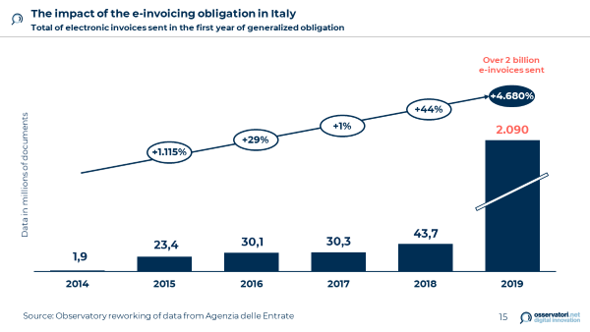

Figure 3 – e-invoicing in Italy (invoices sent)

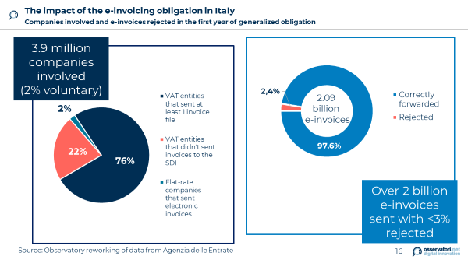

Figure 4 – e-invoicing in Italy (companies)

The reasons behind the introduction of electronic invoicing in Italy can be summarized in four main areas:

* fighting VAT evasion;
* starting a process of administrative and tax simplification;
* highlighting the Country in the international panorama;
* **pushing companies towards greater digitalization** 🡪 the reason why we focused on improvements following the introduction of the e-invoicing, analysed in Question 3.

Regarding the results of the survey, very different situations emerge:

* Among **SMEs**, only one in three companies found improvements in their activities. The most improved activity (albeit with a minimal difference on the others) is the *cost accounting* (33%), an activity not widespread among those carried out by SMEs.
* As for **large enterprises**, there have been more significant benefits, especially in the *monitoring of outstanding* and *of fiscal management*, where half of the companies have recorded improvements.
* On the other hand, activities related to supply chain relationships (*vendor and customer rating*, *benchmark on purchase prices*) were less involved, where only a third of companies managed to introduce benefits deriving from the e-invoicing. Similarly, the *reconciliation of employees expenses* is also one of the activities least affected by the new obligation.

In general, we can deduce that the e-invoicing has not yet been perceived in an advanced way within the supply chain: for now, only the benefits of activities directly impacted by the obligation are being exploited, while there are no investments aiming at integrating it in more comprehensive digital processes. Therefore, the relational and ecosystem dimension is missing.

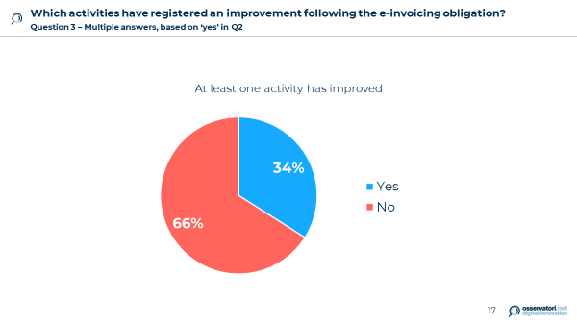

Figure 5- Q3

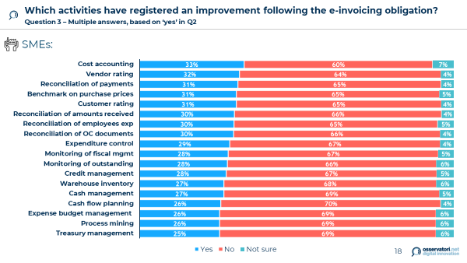

Figure 6 – Q3 SMEs

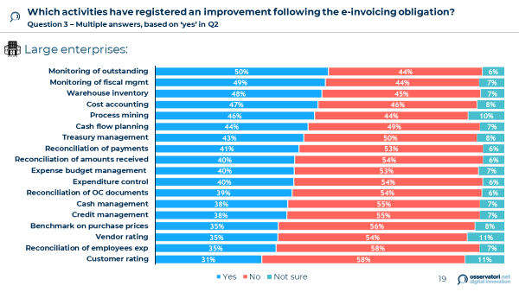

Figure 7 – Q3 Large enterprises

## Question 4

***Indicate on a scale how automated each of the listed activities is in your company***

***Question 4 – Based on ‘yes’ in Q2. The term "automated" means that human contribution is minimized***

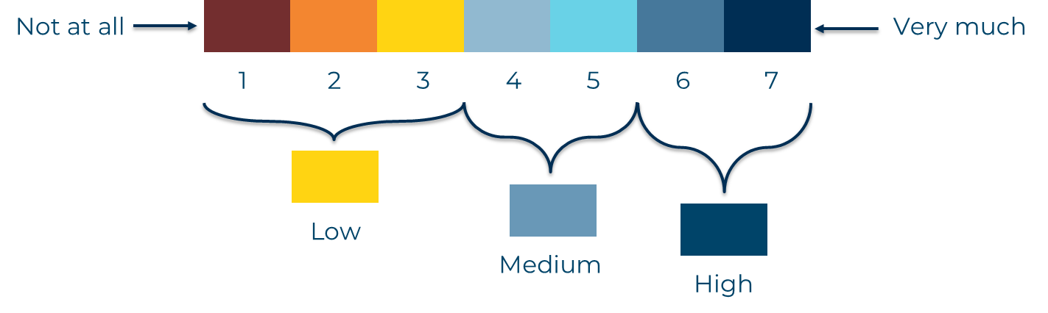

Figure 8 – Q4

In this case, there is similar trend between the two types of companies, more untethered from dimensional differences:

* It is surprising that, on average, **SMEs** have the highest automation levels in the activities they manage.
* In particular, all reconciliation activities are well automated, among which the *reconciliation of the documents of the order cycle* is the one with the highest percentage of maximum automation (and the highest aggregate percentage of levels 6 and 7), just as analytical accounting.
* Precisely the *cost accounting* and the *monitoring of fiscal management* reach good levels of automation, despite being among the activities a little less widespread among **SMEs**. This indicates that the SMEs that implemented these activities then invested in making these processes more efficient. Remember also that cost accounting was the activity most impacted by the introduction of the e-invoicing obligation.
* Among **SMEs**, *expenditure control* and, similarly, *expense budget management* are still not very automated. Even *benchmark on purchase price* is still an inefficient process.
* Among **large enterprises**, the situation is again more polarized: there are higher percentages of poor automation (less than or equal to 3), but at the same time they declare the highest percentages of maximum automation.
* Among these (level 7 of automation) the reconciliation activities stand out again (as for SMEs), with the *reconciliation of the documents of the order cycle* still in the lead. We can explain this trend with the fact that these activities tend to be time consuming, and therefore the company has direct visibility on the time to be dedicated and on the time that could be saved: they are therefore immediately chosen as the target of automation, even though they are still traditional processes.
* Two opposite situations for the *warehouse inventory* and the *customer rating*, respectively the activity with the lowest declared automation and the one among the highest automation (note that, however, the introduction of the e-invoicing had a positive impact on the activities of warehouse inventory).

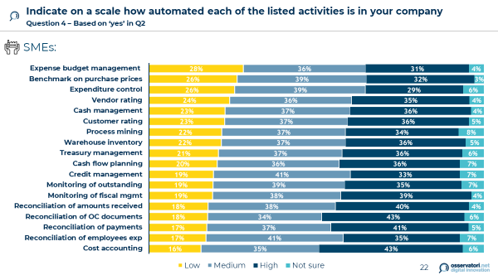

Figure 9 – Q4 SMEs

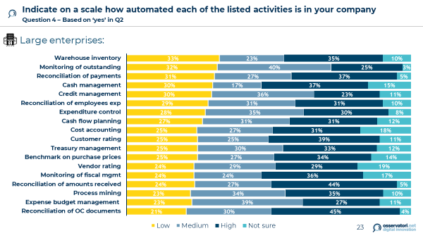

Figure 10 – Q4 Large enterprises

## Question 6

***Which activities do you want to invest in over the next year?***

***Question 6 – Multiple answers***

Only one in three companies has already identified which business to invest in next year.

Most companies, on the other hand, show that they have not yet implemented a long-term vision: there is probably no processes point-of-view, necessary to understand where the improvements introduced with digitalization would impact.

Interesting take away when crossing the level of automation of a given activity and the interest of the company for a future investment:

* The activities on which the investments will focus the most are in fact those with an **medium level of automation**, with generally much higher percentages than the already *highly automated activities* (coherent choice, as the company has already invested to achieve a high level of automation) and than the *low automation activities* carried out in a traditional way (a choice that may reflect the company's lack of perception on the benefits of automation in these activities).

The willingness to invest again in already medium automation activities can therefore indicate that the company is still in the process of digitalization: after initially investing, the company perceived the improvements in terms of efficiency and effectiveness related to automation, thus confirming further future investments for a further evolutionary step.

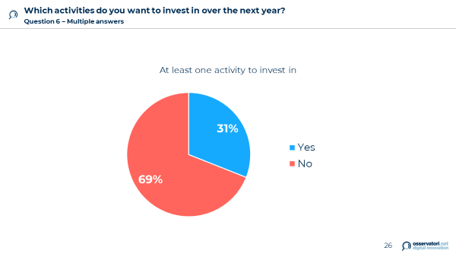

Figure 11 – Q6

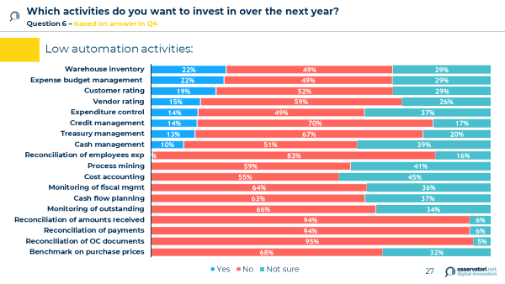

Figure 12 – Q6 Low automation activities

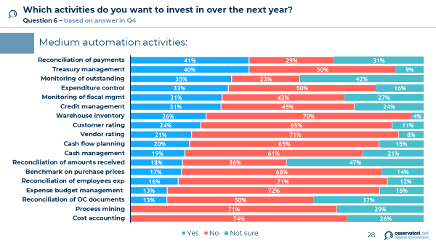

Figure 13 - Q6 Medium automation activities

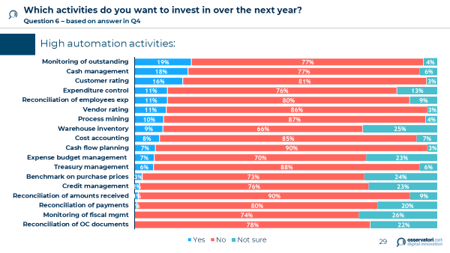

Figure 14 - Q6 High automation activities

# The results of the survey on the pharmaceutical industry

## 

Figure 15 – Q2 Pharmaceutical industry

## 

Figure 16 – Q3 Pharmaceutical industry

## 

Figure 17 – Q4 Pharmaceutical industry

## 

Figure 18 – Q6 Pharmaceutical industry

# Conclusions and takeaways

The overall analysis highlights some fundamental concepts:

* **Large companies** focus more on management control, dealing with a wider complexity in terms of suppliers and customers. On the other hand, **SMEs** are more attentive to financial management, also having less need and urgency to manage their upstream value chain.
* Generally, the e-invoicing has not yet been perceived in an advanced way within the supply chain: for now, only the benefits of activities directly impacted by the obligation are being exploited, while there are no investments aiming at integrating it in more comprehensive digital processes. Therefore, the relational and ecosystem dimension is missing.
* However, it should be emphasized that the **pharmaceutical sector** shows greater awareness and readiness in perceiving the improvements related to the electronic invoicing, in particular in relation to those activities that characterize the supply chain relationships (*vendor and customer rating*) an those regarding internal processes analysis (*process mining*).

The **investments** in automation are towards activities that tend to be time consuming, where the company has direct visibility on the time dedicated and on the time that could be saved.

Furthermore, the willingness to invest in already medium automation activities show that many companies are still in the process of **digitalization**: after initially investing, the company perceived the improvements in terms of efficiency and effectiveness related to automation, thus confirming further future investments for a further evolutionary step.

Most companies, on the other hand, show that they have not yet implemented a **long-term vision**: there is probably no processes point-of-view, so a specific **framework** is necessary to understand where the improvements introduced with digitalization would impact**.**

**ANNEX**

## The survey

**DIGITALIZZAZIONE DEI PROCESSI AZIENDALI**

**Anagrafica**: settore, fatturato, dipendenti, località geografica

1. **Sei anche un fornitore della Pubblica Amministrazione?**

* Si
* No

**NUOVI SERVIZI ABILITATI DALL’OBBLIGO DI FE**

1. **Quali delle seguenti attività sono svolte in azienda?** (*possibili più risposte*)

* Controllo della spesa
* Benchmark sui prezzi d'acquisto
* Gestione del budget di spesa e/o delle gare
* Riconciliazione dei documenti del ciclo dell’ordine (ordine-documento di trasporto-fattura)
* Riconciliazione pagamenti
* Riconciliazione degli incassi
* Riconciliazione delle note spese del personale
* Gestione del credito
* Monitoraggio della gestione di crediti insoluti/non pagati
* Gestione della tesoreria
* Pianificazione dei flussi di cassa
* Gestione della liquidità
* Monitoraggio della gestione fiscale
* Rating dei fornitori
* Rating dei clienti
* Inventario di magazzino
* Contabilità analitica
* Process mining per analizzare gli accadimenti aziendali
* Altro (*specificare*)

*Compaiono solo le opzioni scelte alla domanda precedente*

1. **Quali delle seguenti attività hanno registrato un miglioramento in seguito all’introduzione dell’obbligo di fatturazione elettronica?** (*possibili più risposte*)

* Controllo della spesa
* Benchmark sui prezzi d'acquisto
* Gestione del budget di spesa e/o delle gare
* Riconciliazione dei documenti del ciclo dell’ordine (ordine-documento di trasporto-fattura)
* Riconciliazione pagamenti
* Riconciliazione degli incassi
* Riconciliazione delle note spese del personale
* Gestione del credito
* Monitoraggio della gestione di crediti insoluti/non pagati
* Gestione della tesoreria
* Pianificazione dei flussi di cassa
* Gestione della liquidità
* Monitoraggio della gestione fiscale
* Rating dei fornitori
* Rating dei clienti
* Inventario di magazzino
* Contabilità analitica
* Process mining per analizzare gli accadimenti aziendali
* Altro *(specificare)*

*Compaiono solamente le attività scelte nella domanda 2*

1. **Indicare su una scala da 1 a 7 (con 1= per nulla e 7 = moltissimo) quanto sia automatizzata nella sua azienda ciascuna delle attività elencate** *(con il termine “automatizzate” si intende che l’apporto umano è ridotto ai minimi termini)***.**

|  |  |
| --- | --- |
| Benchmark sui prezzi d’acquisto | ⬜ 1 ⬜ 2 ⬜ 3 ⬜ 4 ⬜ 5 ⬜ 6 ⬜ 7 ⬜ non so |
| … | ⬜ 1 ⬜ 2 ⬜ 3 ⬜ 4 ⬜ 5 ⬜ 6 ⬜ 7 ⬜ non so |

*Compaiono solo le opzioni NON scelte alla domanda 2*

1. **Quali delle seguenti attività a oggi non svolte in azienda sono di interesse per la sua azienda?** *(possibili più risposte)*

* Controllo della spesa
* Benchmark sui prezzi d'acquisto
* Gestione del budget di spesa e/o delle gare
* Riconciliazione dei documenti del ciclo dell’ordine (ordine-documento di trasporto-fattura)
* Riconciliazione pagamenti
* Riconciliazione degli incassi
* Riconciliazione delle note spese del personale
* Gestione del credito
* Monitoraggio della gestione di crediti insoluti/non pagati
* Gestione della tesoreria
* Pianificazione dei flussi di cassa
* Gestione della liquidità
* Monitoraggio della gestione fiscale
* Rating dei fornitori
* Rating dei clienti
* Inventario di magazzino
* Contabilità analitica
* Process mining per analizzare gli accadimenti aziendali
* Nessuna
* Altro *(specificare)*

1. **Su quali attività si intende investire nel prossimo anno?** (*possibili più risposte*)

* Controllo della spesa
* Benchmark sui prezzi d'acquisto
* Gestione del budget di spesa e/o delle gare
* Riconciliazione dei documenti del ciclo dell’ordine (ordine-documento di trasporto-fattura)
* Riconciliazione pagamenti
* Riconciliazione degli incassi
* Riconciliazione delle note spese del personale
* Gestione del credito
* Monitoraggio della gestione di crediti insoluti/non pagati
* Gestione della tesoreria
* Pianificazione dei flussi di cassa
* Gestione della liquidità
* Monitoraggio della gestione fiscale
* Rating dei fornitori
* Rating dei clienti
* Inventario di magazzino
* Contabilità analitica
* Process mining per analizzare gli accadimenti aziendali
* Nessuna
* Altro *(specificare)*

1. **Quali sono le caratteristiche chiave dei sistemi che intendete introdurre per la gestione delle attività della domanda precedente?** *(possibili più risposte)*

* Usabilità della soluzione
* Facilità di integrazione con i sistemi presenti in azienda
* Compliance al GDPR
* Sicurezza dei dati e delle informazioni trattate
* Agevolazione della relazione con le istituzioni
* Agevolazione della relazione con i clienti/fornitori domestici
* Agevolazione della relazione con i clienti/fornitori esteri
* Agevolazione della relazione con le banche
* Altro (*specificare*)

1. **Quali strumenti di Supply Chain Finance sono di interesse della sua azienda?** *(possibili più risposte)*

* Anticipo fattura
* Invoice Trading
* Dynamic Discouting
* Factoring
* Reverse Factoring
* Altro *(specificare)*
* Nessuno
* Non conosco questi strumenti