SUPERNOTE PLUGIN
SmartNote AI
User Guide
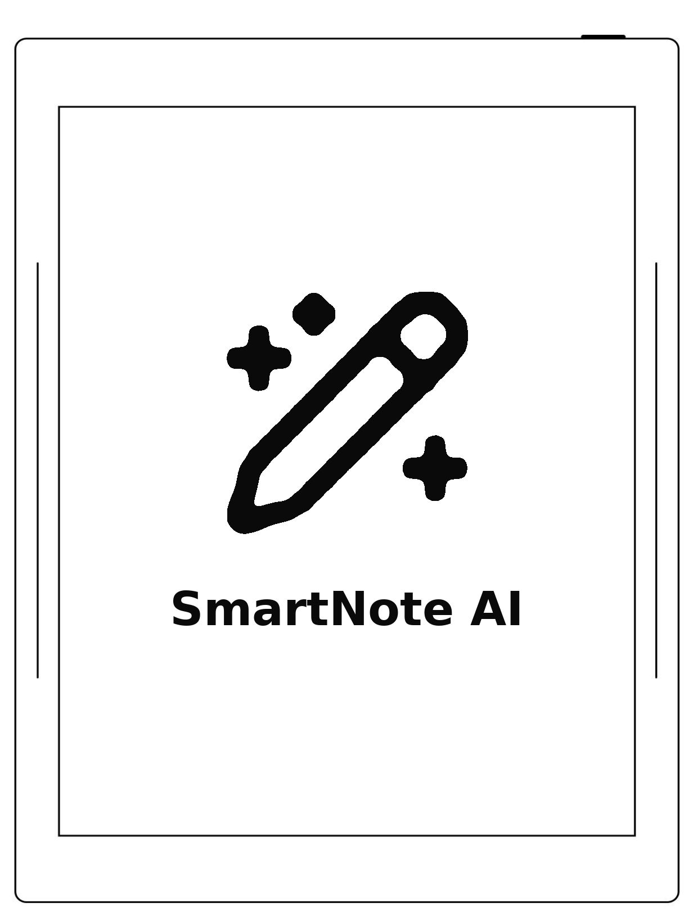
Your Supernote in the age of AI; privacy first.
AUTHOR AgP42
SOURCES AND ISSUES github.com/AgP42/SN-Plugin-SmartNoteAI
SUPPORT THE PROJECT ko-fi.com/agp42
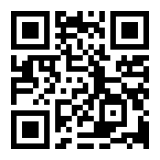

1. Welcome to SmartNote AI
Your Supernote in the age of AI; privacy first.
Write as you always do. Then supercharge your notes and thinkings with AI power. A question about the page under your pen, a summary of the meeting you just took down, a translation of the paragraph you lassoed, a search across four years of notebooks. All on the device, with your own key, without sending anything you did not choose to send.
What can you do with it, right away:
- Ask about the page you are writing. The floating assistant sits over
your note; you keep writing while it answers. Nothing has to be prepared, transcribed or stored first.
- Lasso and ask. Circle a scribbled address, a diagram, a table. "What's
the postcode?" "Explain this." "Turn this into a checklist."
- Turn a notebook into a searchable library. Transcribe what you choose.
Then search every word you ever wrote, in seconds.
- Give an assistant your documents. An agent that knows your project
notebooks, another that knows a 300-page PDF and quotes it.
- Get your text out. Export any page, notebook or folder to .md or
.txt, straight into your Supernote file browser.
And the part that is not a feature but a stance: it talks to exactly one AI provider, Mistral AI, in Europe, under GDPR privacy protection. Your key, your data, your rules. Files you mark Off never leave the tablet without your explicit agreement.
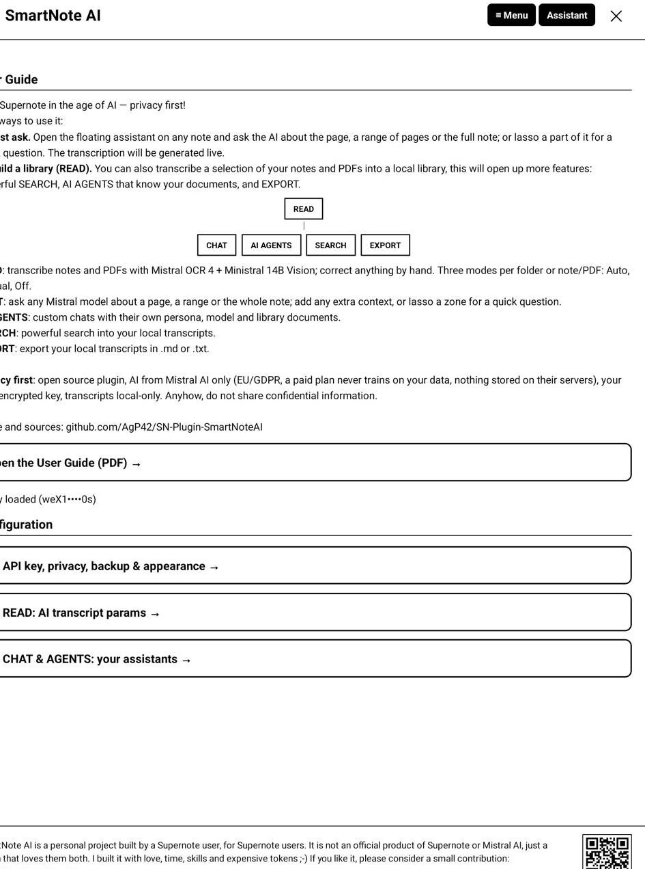
hub.jpg

2. Core concepts
Four ideas explain the whole plugin.

Transcripts: how a page becomes text
A page of handwriting is an image. To search it, quote it, or discuss it, it has to become text. That is what READ does, and every page goes through the same two steps:
- Mistral OCR 4 reads the page. It is fast, cheap and powerfull. It returns the text
plus a confidence score for each word. But... it doesn't "see" images, scheme or manual handwritten notes on PDF, it also cannot receive instruction about the content to transcript. To overcome this, after this first step, the plugin add on top :
- Vision (Ministral 14B) then reads the page image, with the OCR text
riding along as a hint. Vision is what understands layout, tables, drawings, margin notes and your own conventions, and it is the step that follows the prompt you can edit (chapter 3.3). The READ prompt drives Vision only: the OCR endpoint takes no instructions.
The result is stored on the tablet, page by page, with a fingerprint of the page it was read from. Change the ink on a page and only that page is read again. Never touch it, and it is never paid for twice.
PDFs work slightly differently. The whole file is read in one OCR call, fast and cheap for printed text, and then each page also gets a Vision pass, so schemas, figures and your handwritten annotations on top of the PDF are read too, not just the printed layer.
Low-confidence words come back underlined in the transcript: tap one to correct it. A hand-corrected page is marked as yours and is never overwritten by a later sync.
Page after page, those transcripts become a library: your own local, searchable copy of what you wrote. It is what makes SEARCH possible (one query across every notebook you ever transcribed, in seconds) and EXPORT useful (any page, notebook or folder written out as .md or .txt, ready to leave the tablet). Nothing is uploaded to build it: the library lives in the plugin's private storage, on the device.

Chat and agents
Once a page has a transcript (or on demand, live), you can chat about it. The floating assistant is a movable panel that sits over your note. It always knows what you are looking at, and you can add anything else: other pages, whole notebooks, a lassoed image.
An agent is the same chat with a memory of its own: a name, a persona, a model, and a set of library documents it always knows.
Four ready-made agents ship with the plugin and can be added in one tap: Extractor (pulls out actions, dates and figures), Writer (turns notes into clean prose), Tutor (explains and quizzes you) and Brainstorm (pushes ideas further). They are ordinary agents once added: rename them, change their model, give them documents.
And you create your own: a "Meeting notes" agent over your work notebooks, a "Recipes" agent, a "Thesis" agent that knows a long PDF and quotes it. You pick one when you start a conversation.

The menu: one button, everything behind it
The Supernote toolbar entry SmartNote AI Menu opens a compact menu over your page:
Entry | What it opens
Open the assistant | the floating chat, on the current page
Library: Sync, Search & Export | the library and the sync cockpit
Current note transcript | the note/PDF you have open, in the Library
Current page transcript | the exact page you are on
Plugin configuration | the three configuration doors
User manual (PDF) | this guide

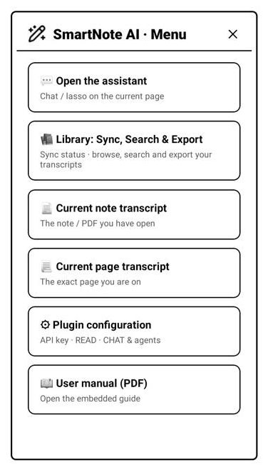
menu.jpg

Map of the plugin
┌───────────────────────┐
│ Plugin configuration │
│ 1·Key 2·READ 3·CHAT │
└───────────┬───────────┘
│ ▲ (top bar: ≡ Menu)
▼ │
User Guide ◄────────── ┌─────────────┐ ◄──────────► ┌──────────┐
(PDF) │ MENU │ │ CHAT │
└──────┬──────┘ │ assistant│
│ └────┬─────┘
▼ ▲
┌─────────────┐ │
│ LIBRARY │ ───────────────────┤
│ sync·search │ │
└──────┬──────┘ │
▼ │
┌────────────────────┐ │
│ Note / PDF pages │ ────────────────┤
└──────────┬─────────┘ │
▼ │
┌────────────────────┐ │
│ Page transcript │ ────────────────┘
└────────────────────┘
Every screen reaches the Menu from its top bar, and the Assistant button is there too. Arrows down go deeper; arrows up come back. The User Guide is a one-way trip: it opens in the Supernote reader and the plugin steps aside.

3. Configuration
Three doors, reached from Plugin configuration. Nothing here is a prerequisite: the plugin works out of the box once the Mistral API key is in. Every field is explained below.

3.1 Getting started: your Mistral API key
SmartNote AI has no server of its own and no subscription. You create a key at Mistral, paste it once, and pay Mistral directly for what you read.
Step 1: create an account at console.mistral.ai.
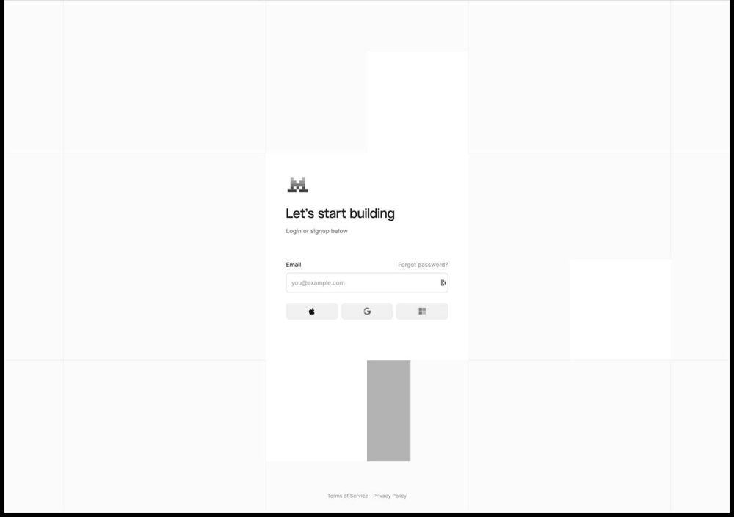
mistral1.jpg
Step 2: you land on Mistral Studio. Everything you need is in the left rail.
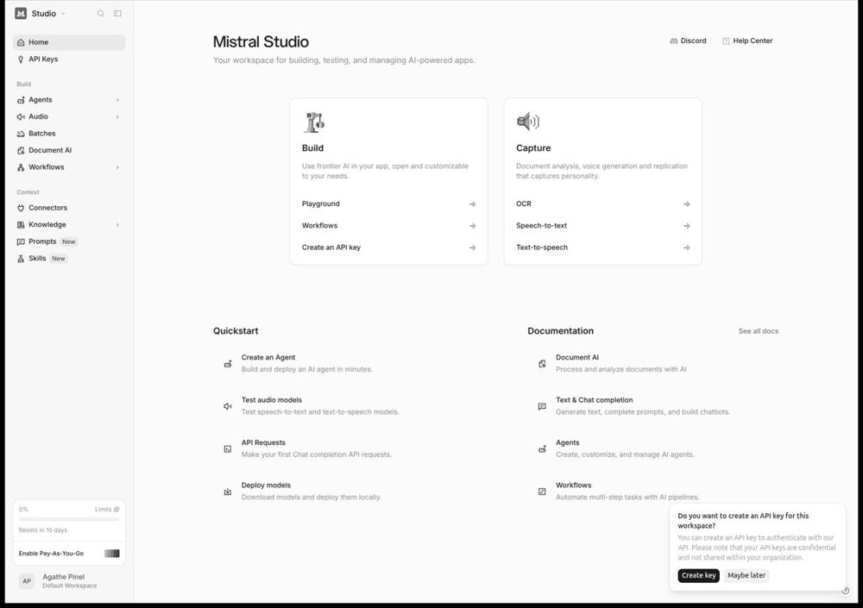
mistral2.jpg
*Step 3: open *My API Keys (via your account menu, bottom left) and choose Create new key**.
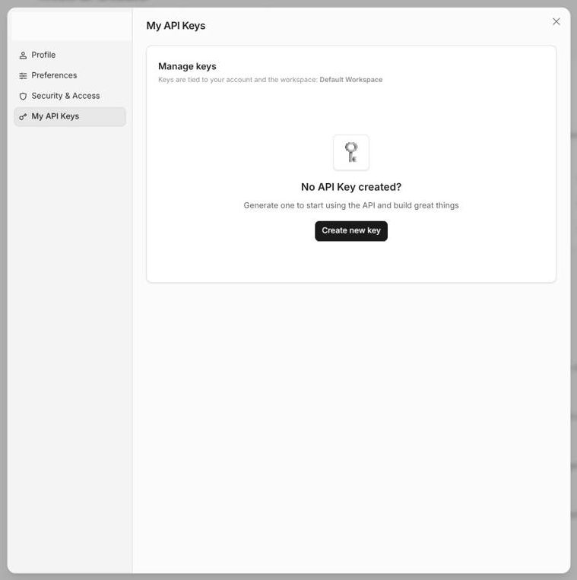
mistral3.jpg
Step 4: name the key. Anything works; "SmartNote Plugin" makes it easy to revoke later. Expiration and workspace can stay on their defaults.
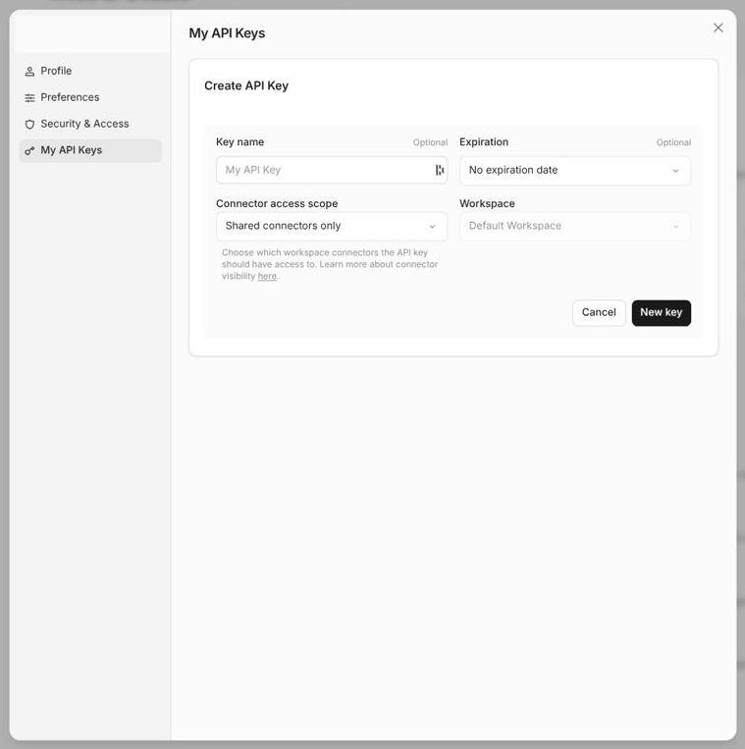
mistral4.jpg
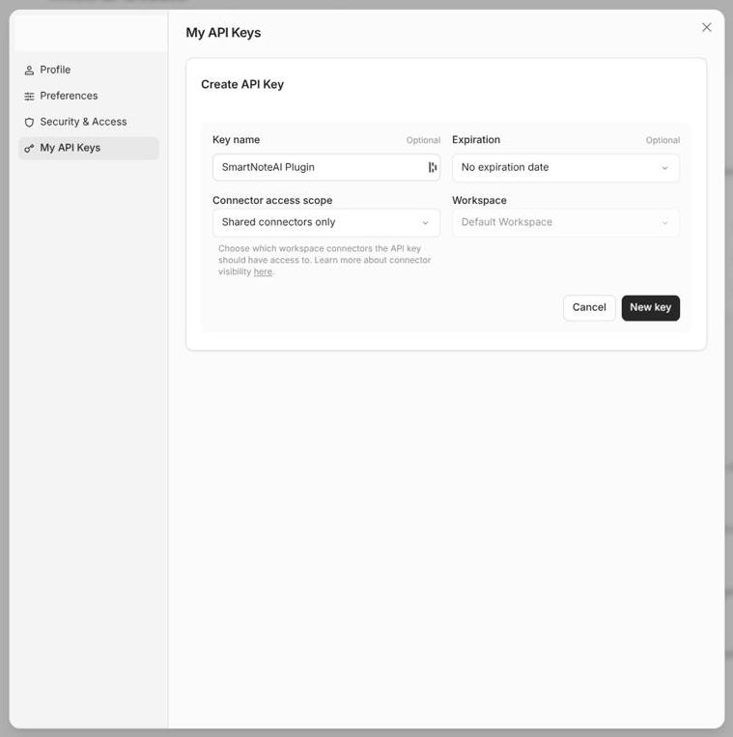
mistral5.jpg
Step 5: copy the key. It is shown once. Copy it now.
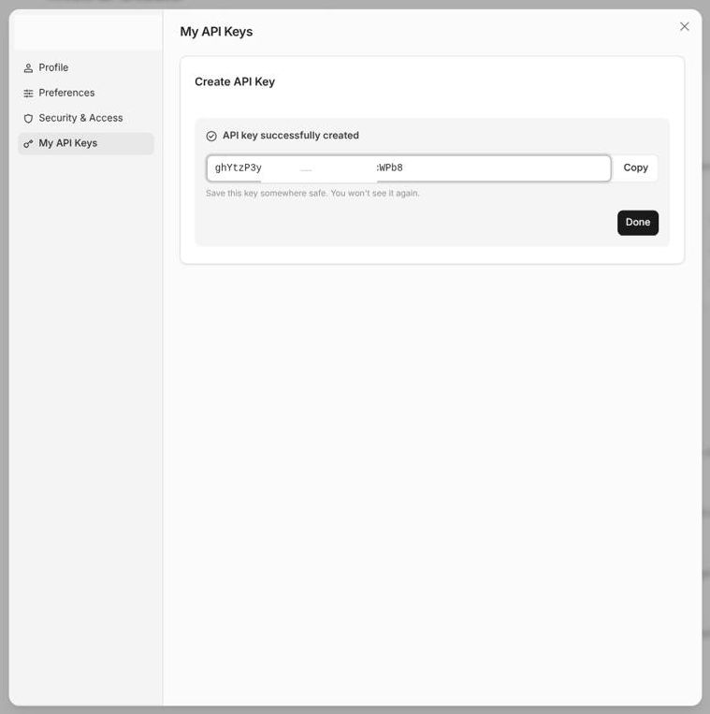
mistral6.jpg
Step 6: your key is listed and can be revoked at any time from the same screen.
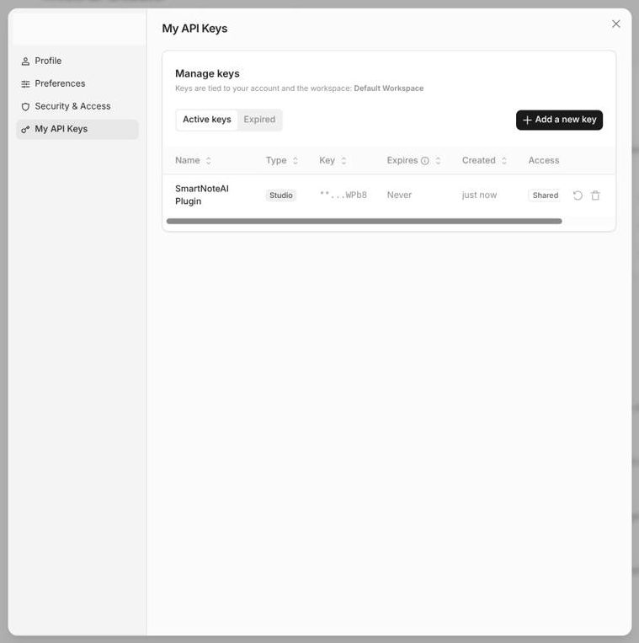
mistral7.jpg
Step 7: paste it into the plugin: Plugin configuration → 1 · API key → Paste from clipboard → Save key (encrypted).
Free tier. Every feature of the plugin works on the free tier, with
comfortable limits: all models are available, and field-testing in July
2026 gave roughly ~1300 transcribed pages per month plus a lot of chat
requests. Only a paid plan guarantees Mistral never trains on your
data. A paid plan is pay-as-you-go: a few euros last a long time : in July 2026, for ~1300 pages transcripted per months plus many chats, count ~7€/months. For 100 pages and few requests, less than 1€.

3.2 Door 1: API key, privacy, backup & appearance
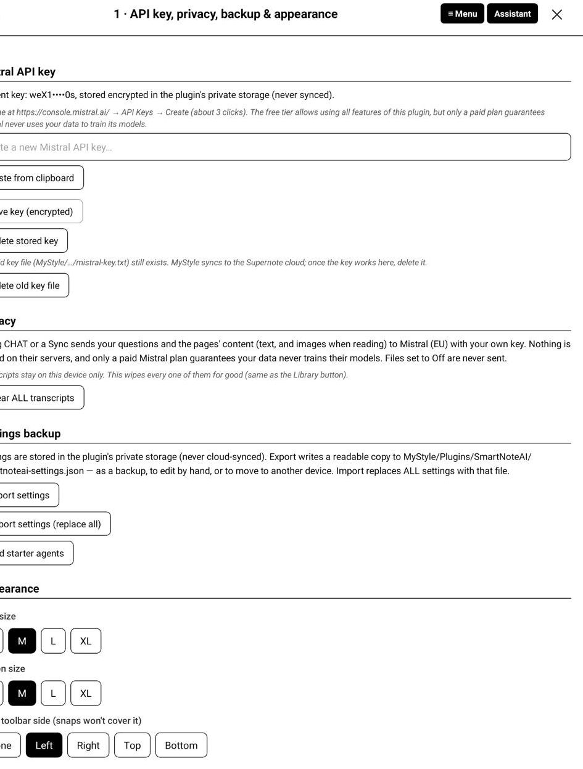
door1.jpg
Mistral API key. Shows the current key masked. Paste from clipboard fills the field (the Supernote keyboard has no paste), Save key (encrypted) stores it in the plugin's private directory, never in a cloud-synced folder. Delete stored key removes it. If an old plain-text key file from an early version is still around, a Delete old key file button appears: use it.
Privacy. Reminds you what leaves the device: your questions and the content of the pages you send. Clear ALL transcripts wipes the local library in one go (the same action exists in the Library).
Settings backup. Settings live in private storage and are never synced. Export settings writes a readable copy to MyStyle/Plugins/SmartNoteAI/ that you can edit by hand or copy to another device; Import settings replaces all settings with that file. Add starter agents adds the four ready-made agents if you removed them.
Appearance.
- Text size (S/M/L/XL) and Button size apply everywhere, floating
panel included. Set these first if you find the UI small.
- Note toolbar side tells the plugin where your Supernote pen toolbar sits,
so the floating panel and the menu position never cover it.

3.3 Door 2: READ, AI transcript params
This door shapes what the AI is told when it reads a page. It drives the Vision step; OCR takes no instructions.
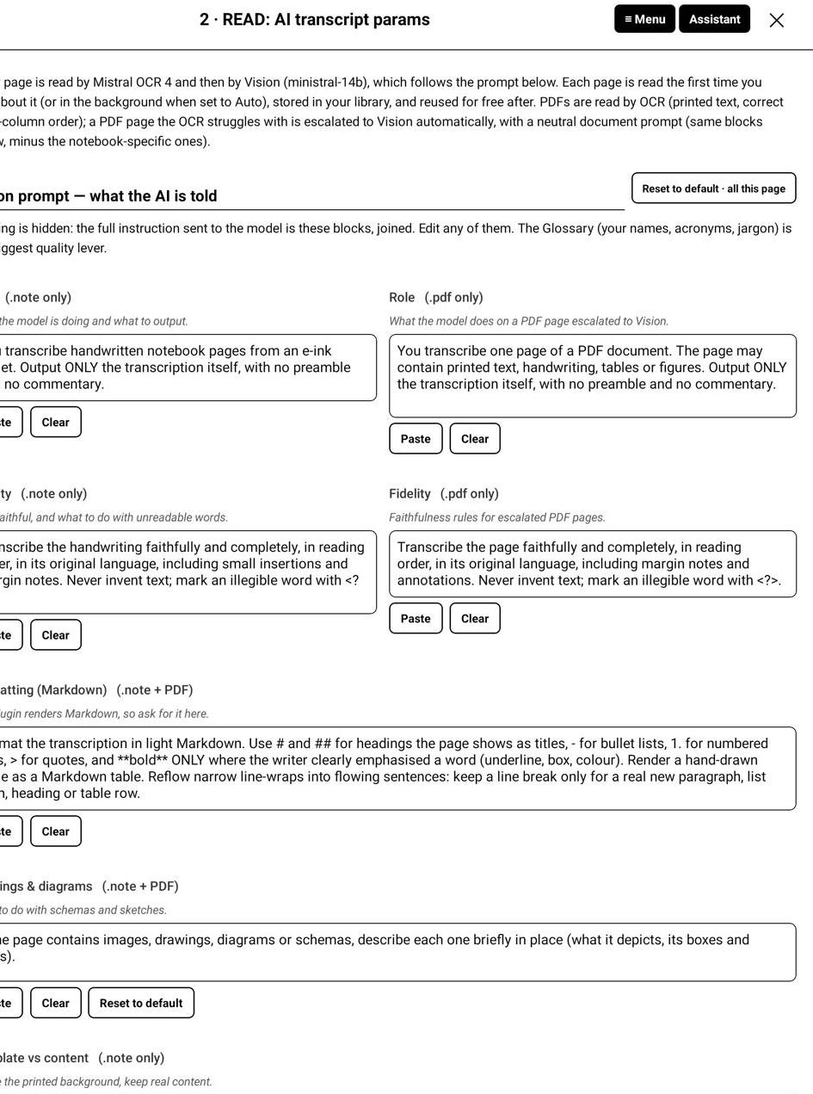
door2a.jpg
The prompt is not hidden: it is a list of blocks, each editable, joined together into the instruction actually sent. Edit any of them; an untouched block keeps following future improvements of the plugin.
You do not have to touch any of this. The shipped blocks are the result of benchmarking on real handwritten pages and give good results as they are. They are exposed because your notes are yours: if your pages have conventions of their own, you can say so. And every block has a Reset button, plus a Reset to default, all this page at the top, so you can always come back to the shipped prompts.
Block | What it controls
Role (.note / .pdf) | what the model is doing: transcribe a handwritten page, or a document page. Two variants, because a PDF is not a notebook.
Fidelity | how faithful to be, and what to do with unreadable words (mark them <?> rather than invent).
Formatting (Markdown) | headings, lists, tables, how to reflow wrapped lines into real paragraphs. The plugin renders Markdown everywhere (transcripts, chat answers, exports), so Markdown is exactly the right thing to ask the model for.
Drawings & diagrams | what to do with a sketch or a schema: describe it briefly, in place.
Template vs content | ignore the printed template (ruled lines, grids, margins) but keep anything written inside a box or a header.
Languages | which languages your notes mix. Keep each word in the language it was written in.
Money & units | currency and unit conventions (a bare £/$ next to a number is usually your currency).
Glossary (your vocabulary) | the single biggest quality lever: your names, acronyms and jargon.

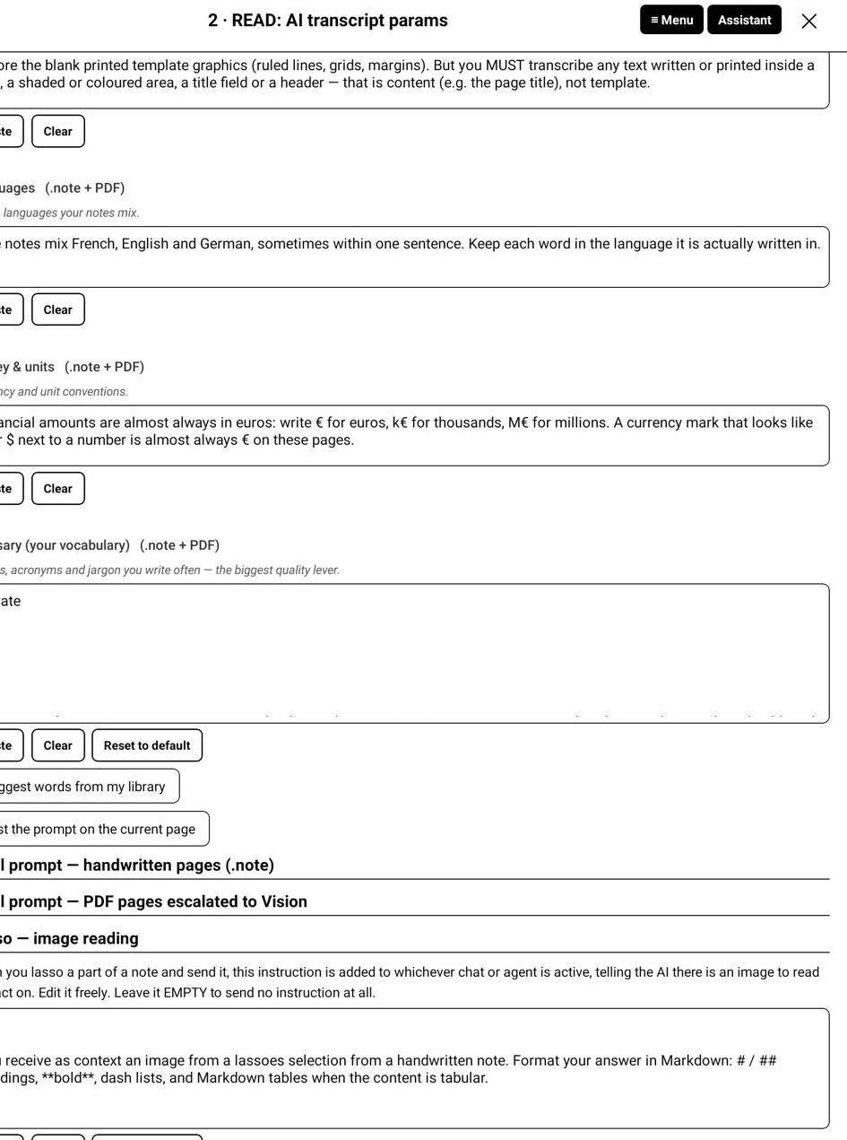
door2b.jpg
Three helpers sit under the glossary:
- Suggest words from my library mines what has already been read for
frequent and low-confidence words, so you can add them in one tap.
- Test the prompt on the current page runs a real read on the page you were
on, so you can judge a change before applying it everywhere.
- Full prompt (handwritten / PDF) unfolds the exact text that will be sent.
Lasso: image reading is at the bottom. A lasso is not text like every other context: it is an image the model has to read itself, so it needs its own instruction, and that is what this block is. Leave it empty to send no instruction at all. Note that the assistant's model must be able to see images: Ministral, Mistral Small, Medium and Large all can.
Reset to default, all this page restores every block. It asks twice: your glossary is your work.

3.4 Door 3: CHAT & AGENTS, your assistants
One page for every assistant. CHAT is the default one; its persona, model, answer style and quick actions apply everywhere unless an agent overrides them.
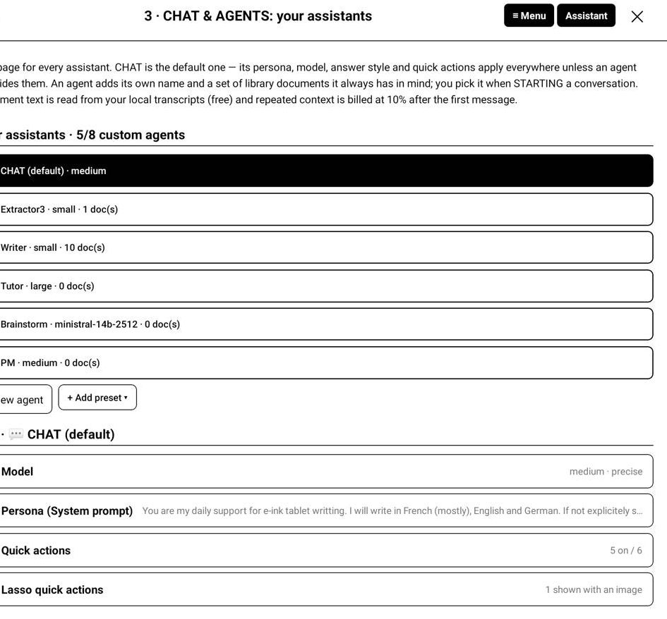
door3a.jpg
Model. Any Mistral model name works in the field; the presets are the ones that can use the chat's Web and Calc tools. Small is cheap and good for most questions, Medium is the default, currently the most expensive model from Mistral, Large for hard reasoning, but currently outdated (12.2025, a new Large is expected soon). The plugin point to the model "-latest", then it display to which model this -latest currently point. The screen shows the model's real price and description, so there is no guessing.
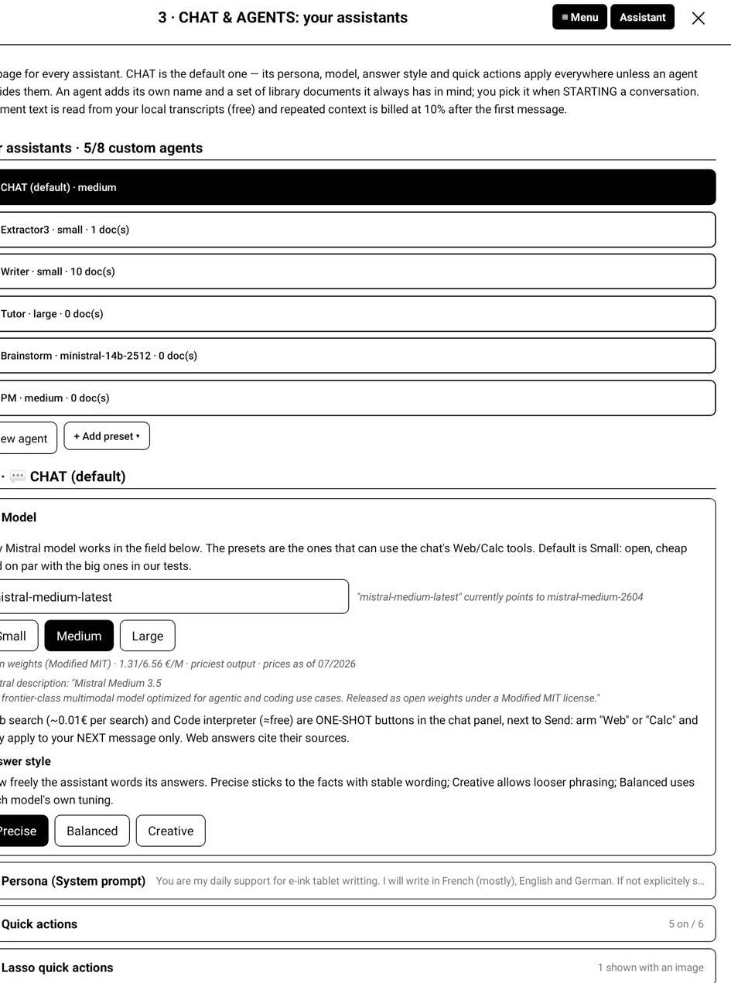
door3b.jpg
- Web search is one-shot: you arm it in the chat panel and it applies to
your next message only. Web answers cite their sources (~0.01 € per search). (The code interpreter was removed: it is no longer offered in the panel.)
- Answer style: Precise sticks to the facts, Creative allows looser
phrasing, Balanced is the model's own tuning.
- Persona (System prompt): who the assistant is and how it should talk to
you. It is prepended to every conversation.
Quick actions are the one-tap prompts under the chat input. Toggle which appear, reorder them, edit their text, add your own. They write into the input field, so you can always adapt the prompt before sending it yourself.
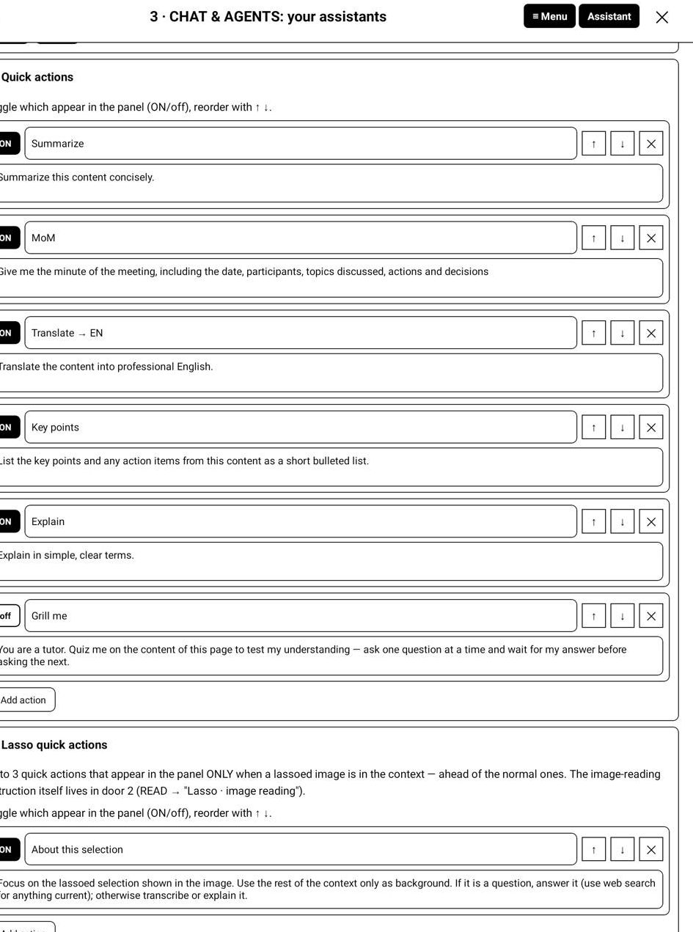
door3c.jpg
Lasso quick actions (up to 3) appear only while a lassoed image is in the context, ahead of the normal ones.
Agents. Up to 8 custom agents, plus the built-in CHAT (so 9 entries in the list). Each has its own name, icon, persona, model, answer style, quick actions and, the whole point, its own documents.
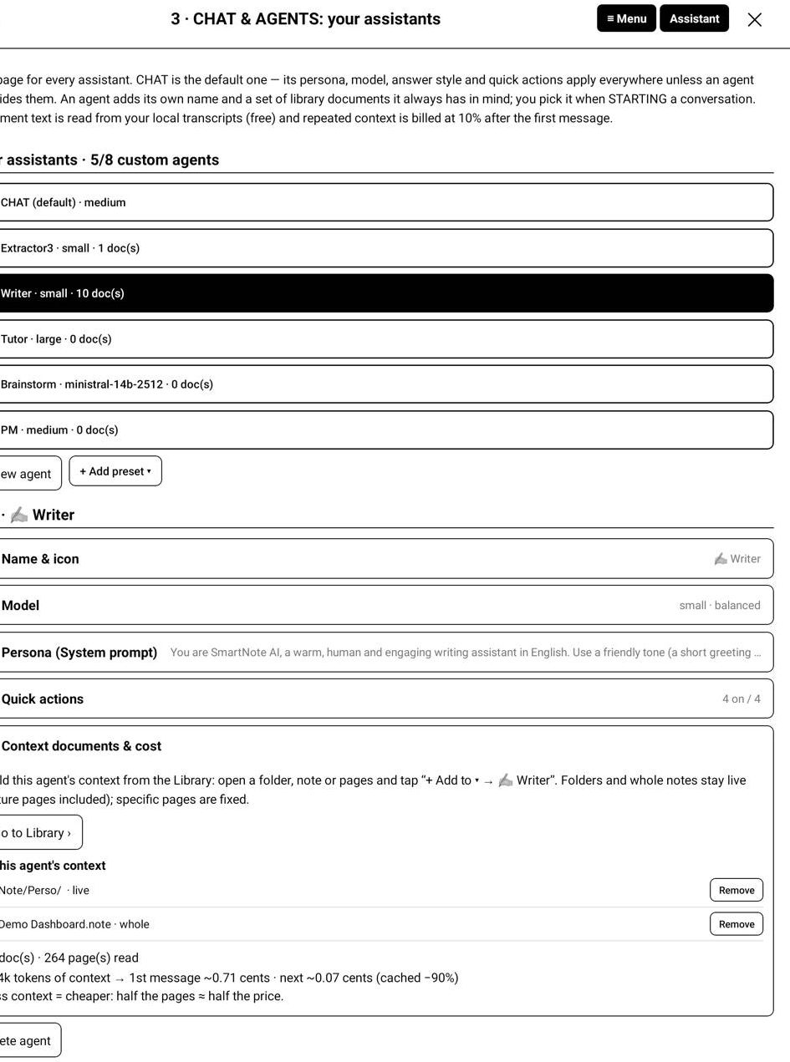
door3d.jpg
Context documents & cost: build the agent's context from the Library (+ Add to → the agent). Folders and whole notes stay live (future pages are included automatically); specific pages are fixed. The screen tells you how many pages are already read, what reading the rest would cost, and the token weight of the context, with the honest reminder that less context is cheaper: half the pages is half the price. Within a conversation, only the first message pays the full context: Mistral's caching then bills the following messages at about 10% of that context price.

4. Library
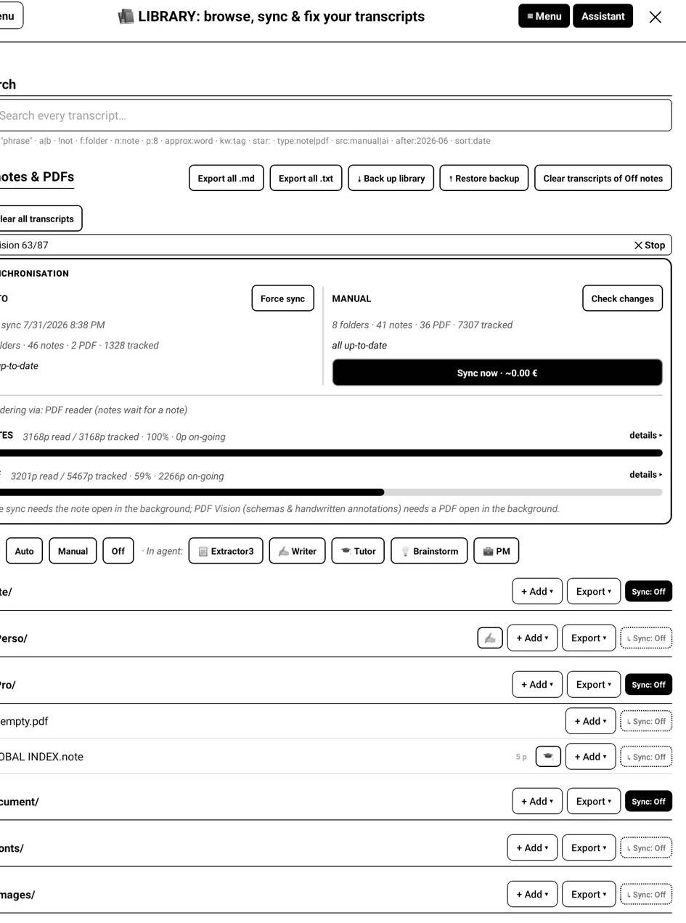
library.jpg
The Library is your local transcript store and the cockpit for syncing, searching and exporting. The tree shows your Note and Document folders, SD card included. Each row carries its sync chip, its page count, and how many pages are still to read; a badge shows every agent that knows it.
Whole-library actions live at the top: Export all (.md / .txt), Back up library / Restore backup, Clear all transcripts, and Clear transcripts of Off notes.

4.1 Synchronisation
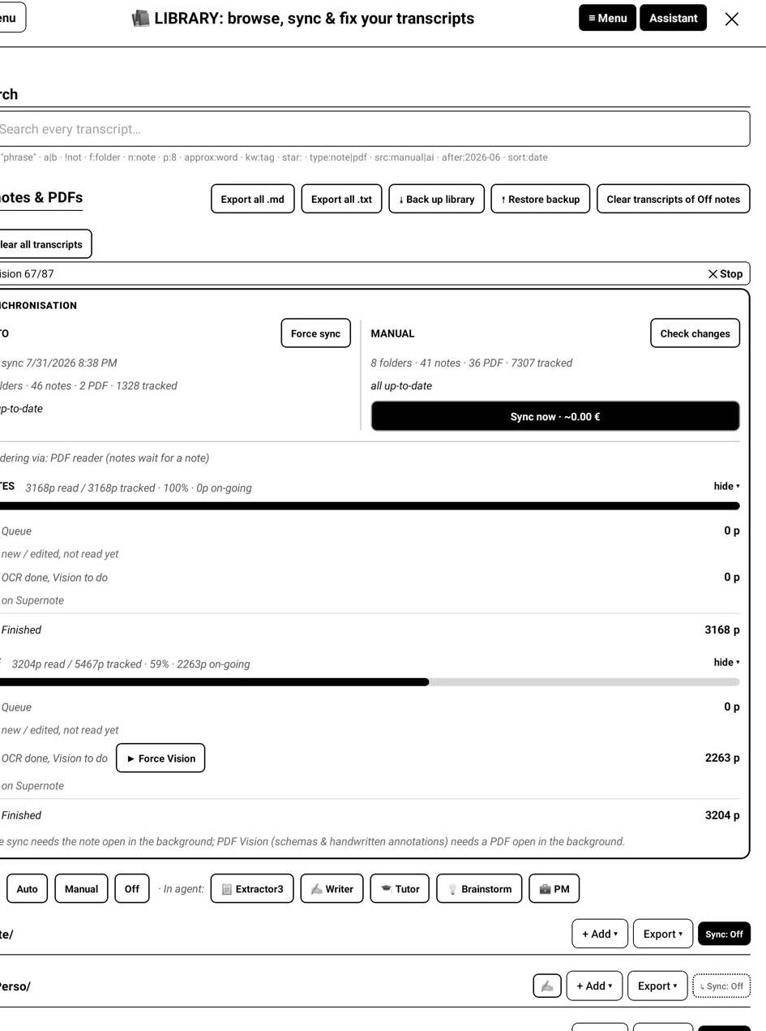
syncstatus.jpg

Three modes, set with one tap
Every folder and every note or PDF carries a mode chip. Setting a chip costs nothing: it only saves a preference. A folder's mode covers everything under it; a single document can override its folder.
- Off: never sent to the AI. The privacy switch. Asking the chat about an
Off page requires an explicit one-time consent, and that read is not stored. Switching a document to Off does not delete transcripts already stored: they stay in your library, searchable and exportable, they simply stop being updated or sent. To remove them, use Clear transcript on that document, or Clear transcripts of Off notes in the Library to wipe them all at once.
- Manual: read only when you ask: a Sync button, or a chat question
that needs the page. "Sync now" is a standing order: if the pass is interrupted (big backlog, no network, wrong app in the background), it finishes by itself on later passes, Vision included.
- Auto: read in the background, page by page, while the plugin is
running.
A good habit: active notebooks on Auto, archives on Manual, anything private on Off.

What actually triggers an Auto read
Auto is not a system service: it is the plugin working while it is alive. Two things must be separated here, because they are often confused.
What is read. A page is read only if its content actually changed since its last read, and the page you are currently writing on is deliberately left alone. So no, writing does not send anything: not on every pen stroke, not on every tick of the assistant. The .note format is append-only, which lets the plugin compare, in order and for free, the file size, then the page fingerprints, then each page's own revision. An unchanged page costs nothing and is never sent again.
When the plugin looks. Several ordinary moments make it check whether something changed:
- when you finish writing and lift your pen, or turn a page (the page
you just left may now need a read);
- while the assistant is open, on its regular pulse;
- when you come back to the plugin, or open the Library or a
configuration screen;
- every 15 minutes as a fallback, and once at start-up;
- right after a pass that could not finish a large backlog in one go.
These checks are throttled to one every 20 seconds, and most of them cost nothing at all: if no file changed, nothing is read and nothing is paid.
The page under your pen is read when it is actually needed, and never while you are on it: its render would come back blank. In practice it is read when you turn away from it, or when you open the Library (you cannot be writing on it then). And the same page is never read more than once a minute, so a page you keep editing is not billed repeatedly.
Asking the chat about the page you just wrote on works. When you send a message, the assistant checks the pages in your context and reads on the spot anything that is out of date, your current page included, before answering.

Notes and PDFs do not have the same constraints
Rendering a page is done by the Supernote app that owns it:
- note pages can only be rendered while the note app can render (a
note is the document in the background);
- PDF pages can only be rendered by the document reader, and that
applies to the Vision step of PDFs.
The OCR step of a PDF is the exception: it reads the file's bytes and works whatever is on screen.
The plugin probes what it can render at every pass and tells you in the sync frame: Rendering via: note app / PDF reader / none yet. If PDF Vision pages are waiting and rendering fails, a button appears, ▶ Resume PDF Vision · opens \<file\>, and you decide when to tap it. The plugin never opens a document by itself.

Honest limits
- Auto works while the plugin lives. Close everything and it pauses, then
resumes where it stopped.
- When the plugin is in the background, how long the system keeps it running
is not something the plugin controls: it may keep going for a while, or be frozen at any moment.
- Nothing runs while the device is off.
- A page takes roughly 8 to 30 seconds (render + OCR + Vision over your
connection). A first sync of a whole notebook is a "start it and let it run" job.

The panel, button by button
- AUTO column: last sync time, pending count, and Force sync to run the
Auto backlog now.
- MANUAL column: last sync time, pending count with its price, and
Sync now. Check changes re-scans your Manual documents for edits, for free.
- SYNC STATUS: a progress bar over your tracked pages, split by type
(notes / PDFs), with a details view: 1. Queue: new or edited, not read yet. 2. OCR done, Vision to do: the OCR landed, Vision has not (a failed attempt, or no host to render). A ▶ Force Vision button sits right there. 3. Finished: Vision transcript, or your own correction.
- A ⏹ Stop button interrupts any running pass; paid pages are kept.

4.2 Browse transcripts
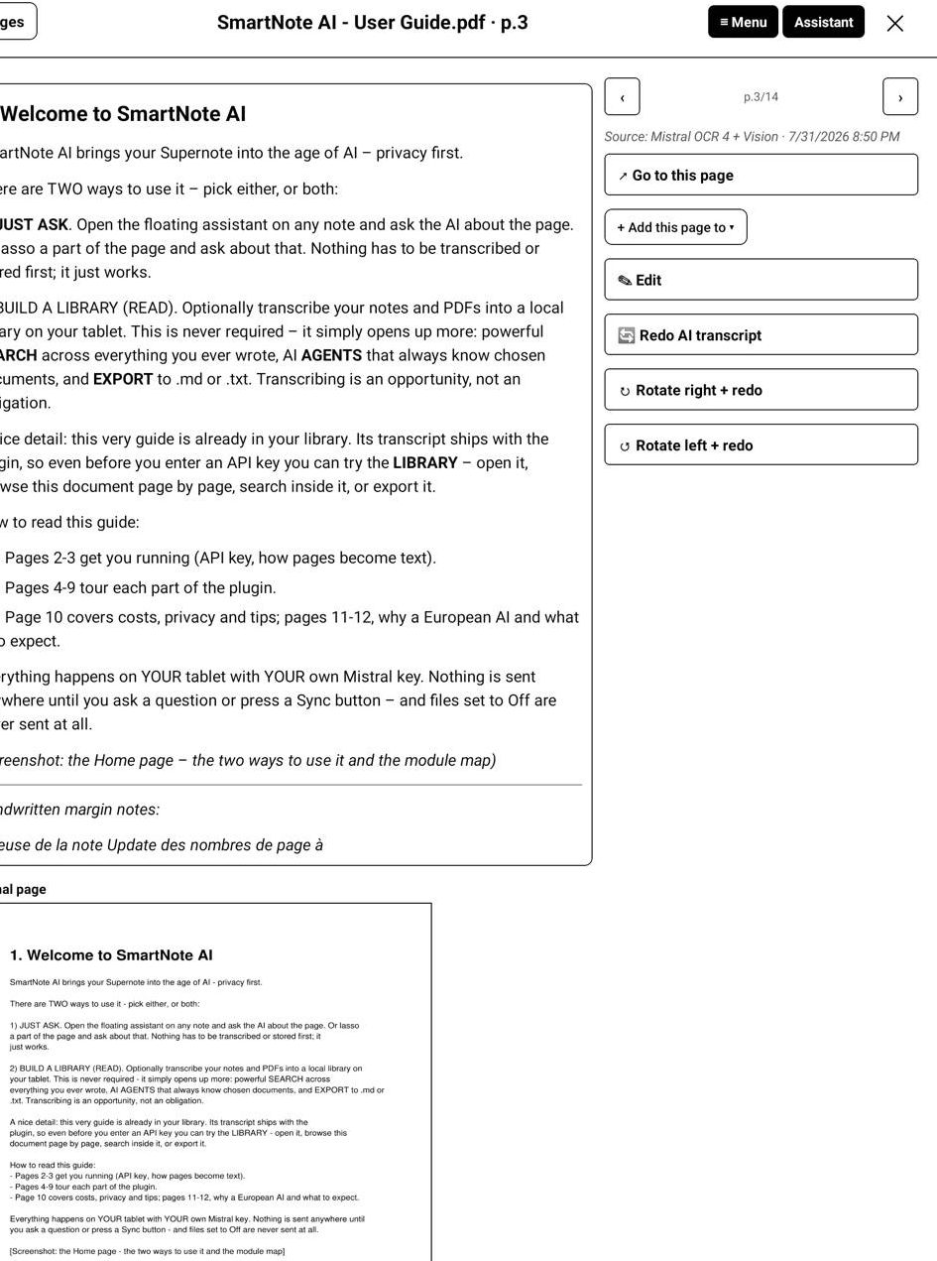
browse_a.jpg
Open a document to see every page as a tile: the first lines of its transcript, its source, or not read yet if it has never been read. A page that was read and found empty says (blank page): it is done, not pending. The header counts what is transcribed out of the total.
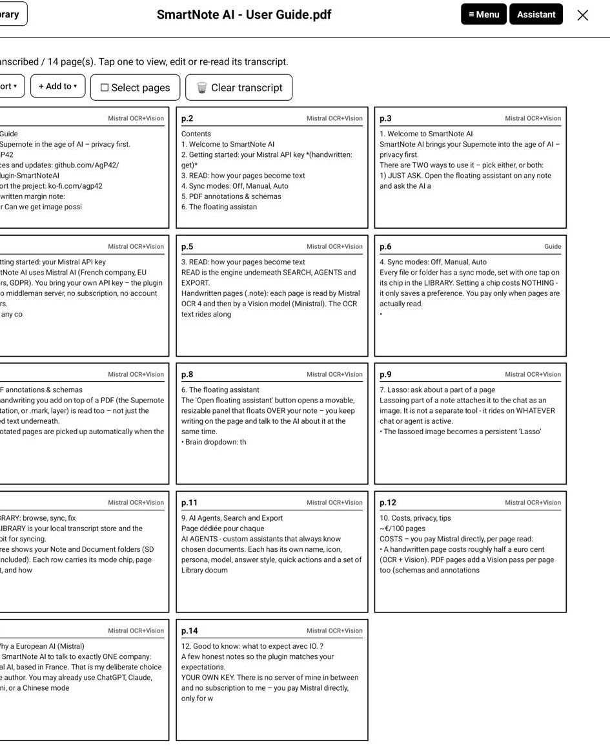
browse_b.jpg
Open a page and you get three things side by side: the transcript, the original page image, and the Supernote's own live OCR (free, for comparison).
From here you can:
- Edit the transcript by hand. A corrected page is marked as yours and is
never overwritten by a later sync;
- tap an underlined "unsure" word to fix just that word;
- Re-read the page (or Read with Vision on a PDF page, for a schema or
an annotation);
- Rotate right + redo / Rotate left + redo: re-read the page rotated by
90°. Pages written in landscape are usually flagged as such by the Supernote and straightened automatically before reading, so you rarely need this. It is there for the cases where that flag is missing and the AI read your page sideways;
- Export this page, or add it to the chat.

4.3 Search
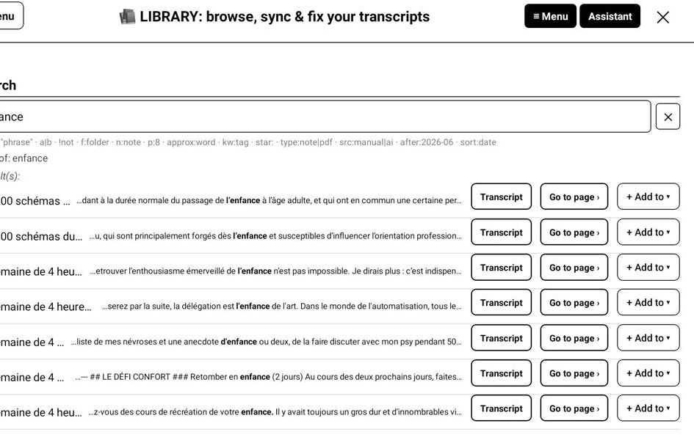
search.jpg
Search runs over your local transcripts only, that is what has already been read. An Off document, or one never synced, is invisible until you sync it. Results are capped and the line under the field always shows how your query was understood.
The grammar (separators: a space or a +):
You type | It means
budget review | both words, anywhere in the page (AND condition)
"quarterly review" | that exact phrase
budget\ | forecast\ plan any one of them (OR condition)
!draft | pages without that word
!"to do" | pages without that phrase
n:Egypt | in notes whose name contains "Egypt"
f:Perso | in that folder
type:note / type:pdf | only notes, or only PDFs
star: / star:no | pages with (or without) a starred mark
kw:invoice | pages carrying that Supernote keyword (or part of the keyword)
src:manual / src:ai | your hand-corrected pages, or AI-read ones
after:2026-01 / before:2026-06 | by read date
p:12 | page 12 (1-based)
p:first / p:last | the document's first / last transcribed page
approx:meting | tolerate spelling variants
sort:date | order by date instead of relevance

Criteria combine freely: f:Work type:note "action items" !draft after:2026-03.
On each result line you can: open the transcript, Go to page (the Supernote opens the real page), or add the page to the chat.

4.4 Export
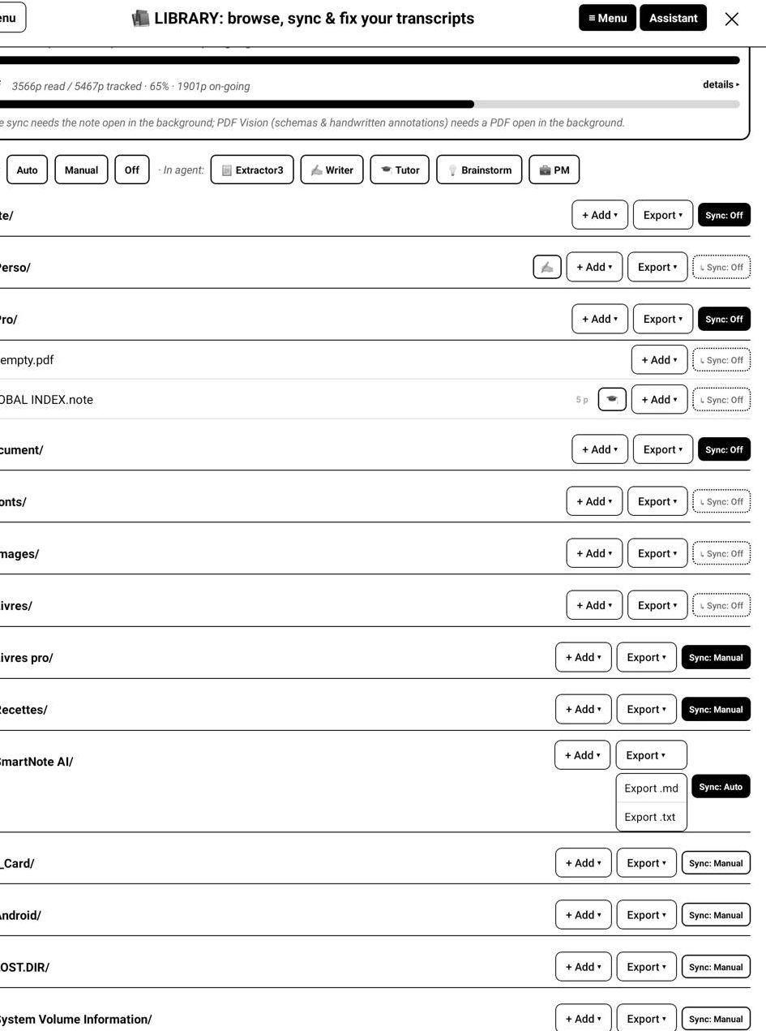
export.jpg
Transcripts become real files, .md (formatted) or .txt (plain), and you can start an export from every level:
From | Exports
Library header, Export all | the whole library
a folder row, Export ▾ | that folder and everything under it
a document row, Export ▾ | that note or PDF
the page grid, Select pages then export | only the pages you ticked
a page view | that single page
a search result | the matching page

Files land in /EXPORT/, at the root of your Supernote, mirroring your folder tree. They are visible from a PC over USB, from the Supernote Partner app, and can be synchronised to the cloud. Each file starts with a header giving the date and how complete the export is. Re-export after a sync to refresh.

5. The floating assistant
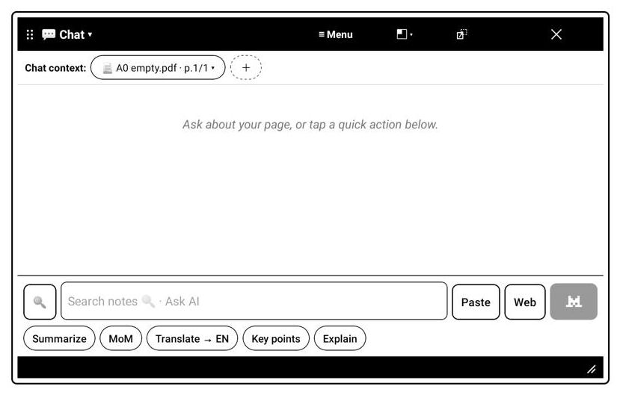
chat.jpg
Open the assistant gives you a movable, resizable panel that floats over your note: you keep writing on the page while you talk about it. Drag the header to move it, the black bar at the bottom to resize it, the ⌄ button to collapse it into a floating bubble, ⛶ to snap it to a corner or full screen, and ✕ to close it.

5.1 CHAT
- The brain dropdown (the name and arrow in the header) switches between
CHAT and your agents. It shows the current model, how many documents and pages are loaded, New chat, and your History.
- Quick actions under the input write a prompt into the field; you send it
yourself with the M button.
- Web is one-shot: arm it and it applies to the next message only. Web
answers cite their sources.
- A Stop button is always available while the assistant works.
- Asking about pages that are not read yet shows the price first. Off
files ask for a one-time consent, and their text is stored nowhere: not in your library, not at Mistral.
- Follow-up questions cost about 10% of the first, thanks to prompt caching.

5.2 Agents
Pick an agent from the brain dropdown when you start a conversation. It brings its persona, model, answer style, quick actions and its documents. You can also change agent during a conversation to change the behavior of the chat, the full history is send to the new model to allow continuying the discussion.
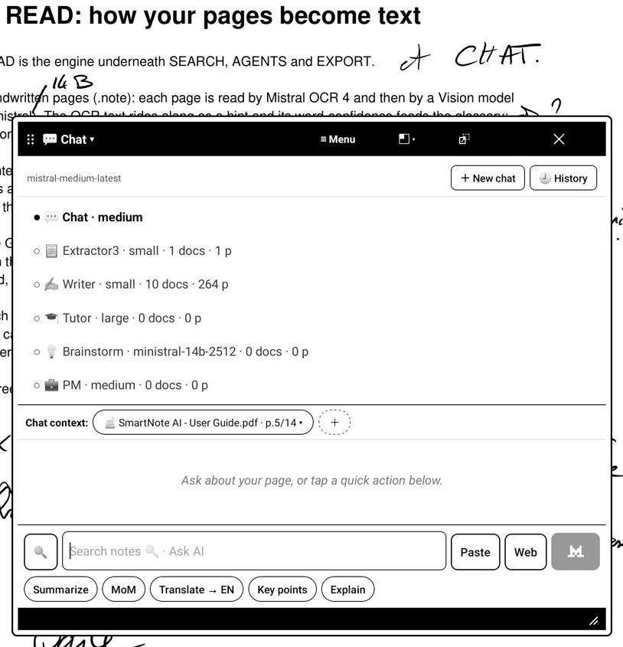
brain_agents.jpg

5.3 Search from the panel
The same search as the Library, without leaving your page. The input at the bottom of the panel does two different things, so you tell it which one you want: tap the 🔍 magnifier on its left to switch the panel into search mode (the placeholder changes to Search notes), and tap it again to go back to asking the AI. In search mode what you type is a query against your transcripts, not a question to a model, and nothing is sent anywhere.
Each hit can be opened as a transcript, jumped to with Go to page, or added to the current conversation.
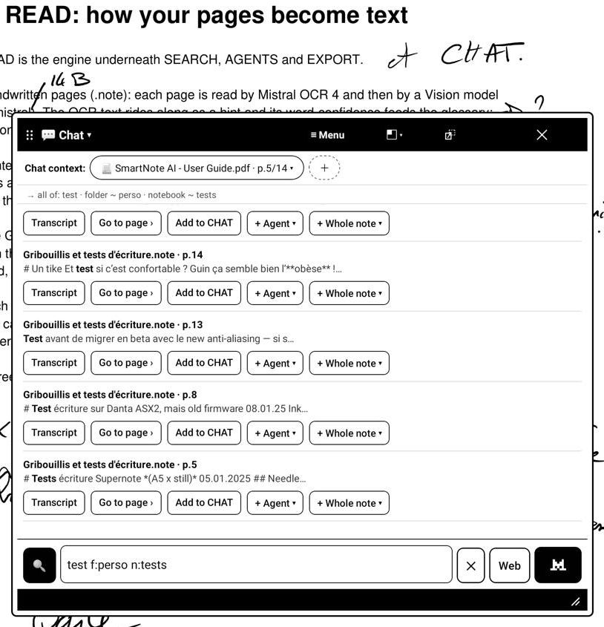
panel_search.jpg

5.4 Context management
The Chat context row under the header shows exactly what will be sent. Each chip opens its own manager:
- ⌾ Current note: choose the scope, This page, a Range, or the
Whole note. See transcript shows the transcript of this context only. You can also remove the current page from the context.
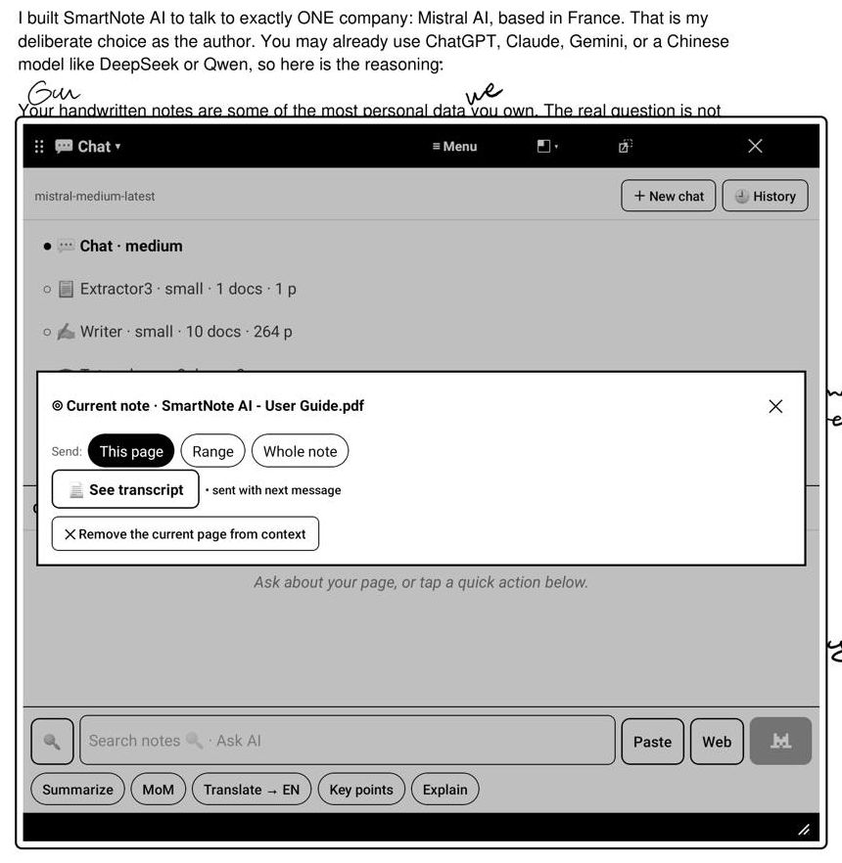
ctx_current.jpg
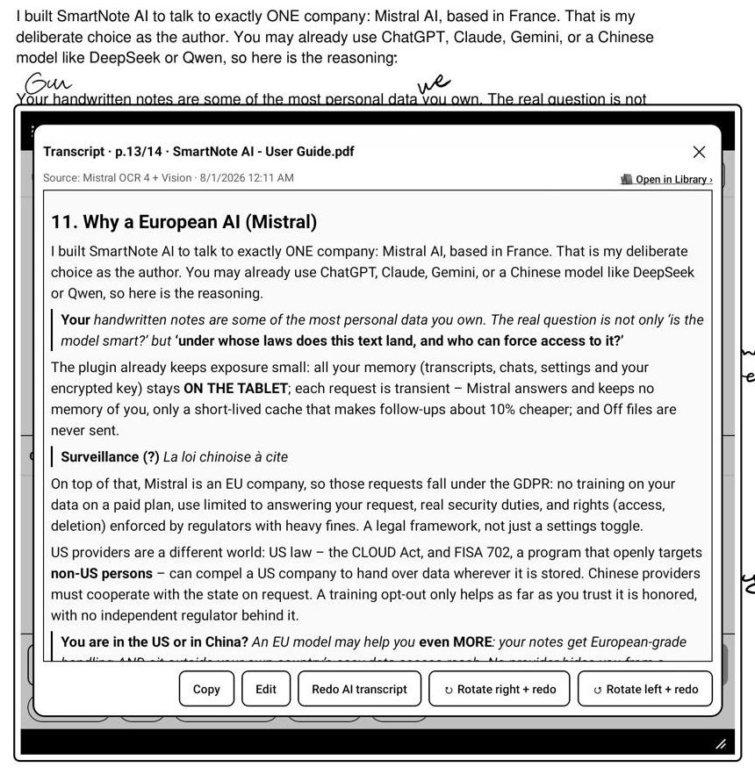
ctx_transcript.jpg
- 📄 Added pages: the pages you added from the Library or from Search, one
per line, each with a ✕ to remove it. See transcript shows the transcripts of these pages only, in order.
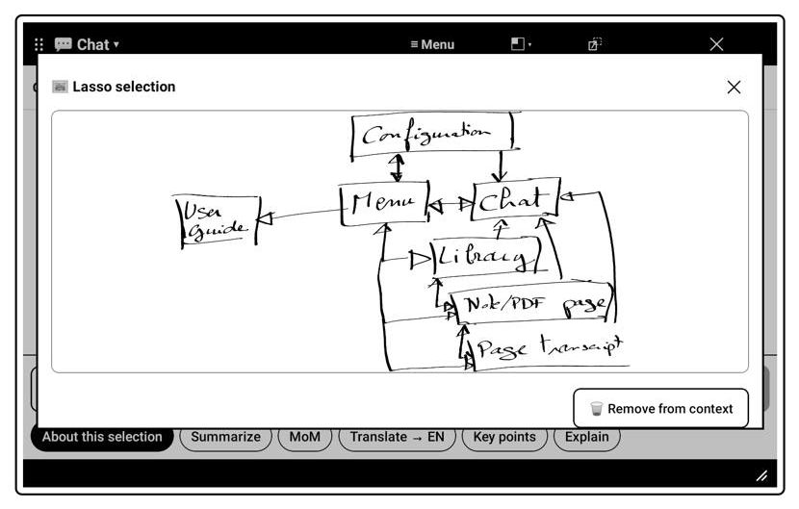
ctx_added.jpg
- 🖼 Lasso: the lassoed image itself, with Remove from context.
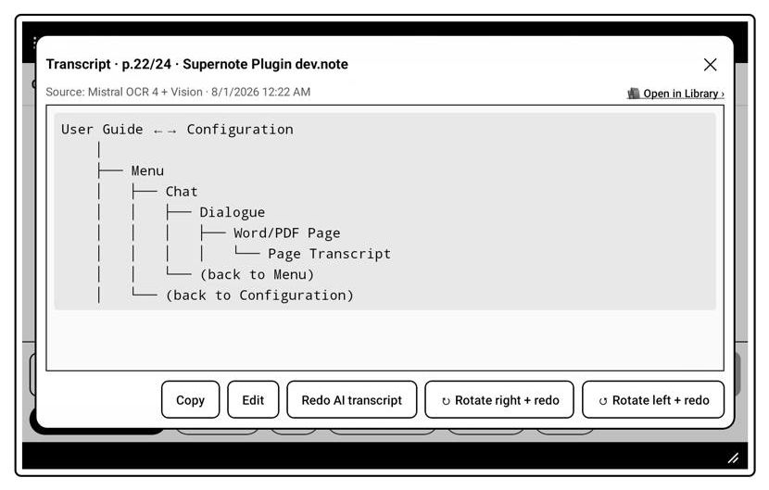
ctx_lasso.jpg
- ＋: adds more pages from the Library.
The current-page chip follows you as you turn pages.

5.5 Lasso
Select part of a page with the Supernote lasso and tap Ask SmartNote AI. The selection is attached to the conversation as an image. It is not a separate tool: it rides on whatever chat or agent is active.
- The image stays as a Lasso chip until you remove it; add several if you
want.
- The instruction sent with it is the Lasso: image reading directive
(door 2), editable, or empty for none.
- Your lasso quick actions (door 3) appear while an image is in context.
No transcription is involved: lasso a diagram and ask "explain this", lasso a to-do and ask "turn this into a checklist".

6. Extra

6.1 Costs, privacy, tips

Costs
You pay Mistral directly, for what you read or ask.
- Transcription cost : ~4€/1000 pages (prices July 2026)
- Unchanged pages are never paid twice.
- Every paid action shows its estimated price before you confirm, with one
exception: Auto, which by design reads silently in the background. If you want a hard ceiling, set a monthly budget cap in the Mistral console.
- Chat questions are billed per token; follow-ups are far cheaper (~10% of
the first) thanks to prompt caching.
- Your live usage is at https://admin.mistral.ai/organization/usage.
- Free tier: every feature works, all models are available with comfortable
limits (~1300 pages/month in field testing), but only a paid plan guarantees no training on your data.

Privacy
- Off files never leave the device (one-time consent excepted, and that
read is never stored).
- Transcripts, conversations, settings and your encrypted key live in the
plugin's private directory: not cloud-synced, not visible over USB.
- Mistral is a European company under the GDPR; a paid plan does not train on
your data.
- Still: do not put in any cloud service what you would not want to leave the
device at all. That is what Off is for.

Tips/infos
- Feed the glossary with your recurring names and jargon. Accuracy jumps.
- Active notebooks on Auto, archives on Manual, private ones on Off.
- Text and button sizes (door 1) apply everywhere, floating panel included.
- Accuracy depends on your handwriting: OCR + Vision handle most of it, but
messy pages and unusual names trip any AI. The glossary is your lever.
- The interface is in English only.
- This guide lives in Document/SmartNote AI/. Deleting it is fine: the
configuration home page reinstalls it.
- Tested on the Manta and the A5 X. Other current models on the same
plugin framework should work but are less tested. Because a plugin rides on device internals, a firmware update can briefly break it. If something stops working right after one, check for a new release.

Before uninstalling, read this
Uninstalling the plugin deletes its private directory: your transcripts, your conversations, your settings and your stored key go with it. If you want to keep them: Library → Back up library, and door 1 → Export settings. Both write to MyStyle/, which survives the uninstall and is visible over USB or from the Partner app.

6.2 Why Mistral only
I feel this design choice will be the first "blame" on my plugin : why Mistral and why Mistral only ? That is a deliberate choice, and here is the reasoning.
Our handwritten notes are among the most personal data we own, and the privacy was my key concern during this plugin development. I would personnaly not trust sharing my daily notes and personnal thinking to "I don't know whom and I don't care who will read them and why..."
The question is not only "is the model smart?" but "under whose laws does this text land, and who can compel access to it?"
The plugin already keeps exposure small: everything (transcripts, chats, settings, your encrypted key) stays on the tablet; each request is transient: Mistral answers and keeps no memory of you beyond a short-lived cache that makes follow-ups cheaper, and Off files are never sent. (On a paid plan.)
But the most significant privacy impact is the choice of the AI model used.
I choose Mistral that is an EU company (French), so all API requests fall under the GDPR: no training on your data on a paid plan, the data use is limited to answering your request, real security duties, and enforceable rights (access, deletion) with regulators and heavy fines behind them. A legal framework that have demonstrated it's strenghts, not a settings toggle.
Other jurisdictions work differently. In the US, the CLOUD Act lets authorities compel a US company to hand over data wherever it is stored, and FISA (Foreign Intelligence Surveillance Act) Section 702 openly targets surveillance of non-US persons located outside the US, and agencies such as the FBI can search that data without a warrant.
In China, the National Intelligence Law (Article 7) and the Data Security Law require companies to cooperate with the state on request. A training opt-out only helps as far as you trust it is honoured, with no independent regulator behind it.
You are in the US or in China? An EU model may help you also: your notes get European-grade handling and sit outside your own country's easiest reach. No provider hides you from a determined state, and nothing dangerous for you should go into any cloud, but for everyday notes, moving them under EU law is a real gain wherever you live.
Is the quality there? For reading your handwriting and answering about your own pages, what matters is legibility and your glossary, not frontier reasoning, and Mistral's OCR and vision models are strong at exactly that (they were chosen on measured results, not on brand). Sure, top providers models are clearly ahead than Mistral, but I consider Mistral "good enough" for Supernote users needs, and this tradeoff I make on purpose, driven by "Privacy first".

6.3 Licence
SmartNote AI is released under the GNU Affero General Public License, version 3 (AGPL-3.0).
In plain terms:
- You may read, audit, run, modify and share the code. Pull requests are
welcome.
- If you distribute a modified version, or run one as a network service,
you must publish your source code under the same licence. Improvements come back to everyone.
- There is no warranty. You run it at your own risk.
- The name and logo are not covered by the licence. "SmartNote AI" and its
icon stay mine: a fork must ship under its own name.
Why AGPL: the code is open for anyone to inspect, which matters for a plugin that handles your notes and claims to take care of your privacy, but nobody can take the work, swap a few pieces, and close it up as a product of their own. The full licence text ships with the sources (LICENSE).
Sources, issues and pull requests: github.com/AgP42/SN-Plugin-SmartNoteAI Support the project: ko-fi.com/agp42

