# gbs_prism cheat sheet: process a flowcell

## log on to iramohio-01

P:\Putty\Putty_64bit\putty.exe

Note that you can save session configurations, so that in future you don’t need to remember or enter the machine name

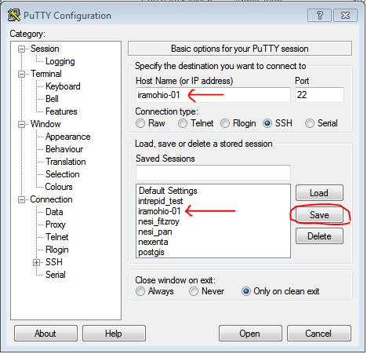

## its often useful to have two windows (e.g. to check the slurm queue while in the dialog) : click on the top left corner of an existing putty session window and select “duplicate session” as below

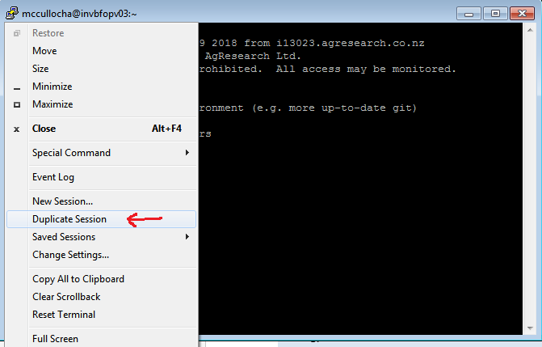

## start a screen session

It takes about 3 hours to process a flowcell. By running the script inside a screen session , you don’t need to worry about keeping a terminal window open; also you can have many screen sessions active, each doing something different, and each with its own command-history (accessible via the history command or simply by using the up arrow). You should give your screen session a meaningful name, so that you know which one to reconnect to later. The name may not include any spaces.

screen –S screen_name

(for example screen –S process_181026_D00390_0413_BCCWU8ANXX)

## start the interactive script

There should be a short-cut in your home folder so that you can start it as

./run_gbs_qc

(or you can run it using the full path /dataset/gseq_processing/active/bin/gbs_prism/run_gbs_qc)

(If at some point you get a prompt for a database password, then your account needs to be configured for access to the gbs database – contact help desk)

You can exit at any time by pressing CTRL-C

## when prompted, paste in the full name of the run

for example 181026_D00390_0413_BCCWU8ANXX

(to *copy* from a putty window, click left mouse button while highlighting the text – then release the button; to *paste* into a putty window, click the right mouse button once)

## when prompted about running on the cluster or not, check the slurm queue

in the second putty window that you started, list the queue by entering the *squeue* command

In most cases, you should simply respond to this question by pressing enter , to accept the default which is to launch the job on the slurm cluster ; however if the queue listing looks very long , and the processing is fairly urgent, you can enter N, which will result in all of the processing being launched locally on iramohio-01

For most of the other prompts, the default choice is appropriate, which you can specify just by pressing Enter.

## detach from the screen session

The run takes around 3 hours so you will probably detach from the screen session.

The key sequence to detach is CTRL-A (release) then D

You can re-attach using the command

screen –r

If you have many sessions active, they will be listed: *copy* the one you need from the putty window, and then *paste*, to complete the command

screen –r pasted-session-name

## 3 hours later . . .

re-attach, and complete the processing by answering the remaining dialog prompts, which (assuming there was no problem with the processing) ask if you want to import the results to the database – the default is Y, so you should just be able to press Enter to complete the processing

## exit the screen session

It is normally best to keep the screen session active for a few weeks, just in case there is any follow-up processing needed, as this ensures the command history etc. for the job is all kept together. (Active idle screen sessions use negligible resources, so there is no cost associated with retaining these); after this, you can finally exit the screen session, just by re-attaching to it, and typing exit, as for any other session