Assignment 2: UI / UX Design and Front-End Implementation
QueueSmart – Smart Queue Management Application
COSC 4353 – Software Design
Team: Agah Duzenli, Dang Nguyen, Derek F. Lihou, Skyler Tran

1. GitHub Repository Link
https://github.com/AgahDUZENLI/queuesmart

2. Design and Development Methodology

Has our methodology changed since Assignment 1?
Our development methodology has stayed the same since Assignment 1. We kept the Scrum process, which breaks work into sprints so we can finish tasks in the limited time we have. For Assignment 2, our sprint focused on building the front end of QueueSmart. At the start of the sprint, we turned the required screens into a backlog, and at the end we reviewed the code and screens together to decide what to improve.

How we divided the work
- Project setup and authentication: React + Vite project, Docker setup, shared components, sign in and create account screens for users and admins, and client-side validation.
- Administrator screens: Admin Dashboard, Service Management and Queue Management.
- User screens: User Dashboard, Join Queue, Queue Status and History.
- Notifications: in-app notifications for queue updates and status changes.

3. Front-End Technologies and Responsibilities

Technologies and why we chose them
Technology | Why we used it
React | Component-based UI: reusable components (Button, TextInput, Toggle, layouts, tables, notifications) shared across user and admin screens.
JavaScript (JSX) | Handles user interaction and logic, such as form validation (utils/validation.js) and the queue rules for estimated wait time and status (utils/queueRules.js).
CSS | One global stylesheet with shared colors keeps every screen consistent; admin and notification styles have their own files.
Vite | Build tool and dev server. It reloads changes instantly, so we could see updates without refreshing the page.
Docker / Docker Compose | Runs the app the same way on every team member's computer with one command.
HTML5 form validation | Proper input types (email, number, time) and attributes (required, maxLength, min/max), plus our own error messages.
Git and GitHub | Feature branches and pull requests for review and for tracking each member's contributions.

Who worked on which screens or features
Team member | Screens / features
Agah Duzenli | Project structure (React + Vite), Docker setup, shared components (AuthLayout, Button, TextInput, Checkbox, Toggle), User and Admin Sign In and Create Account screens, client-side validation, demo sign-in shortcuts, global styles. Made the user screens consistent with the rest of the app (UserLayout navigation, wait wheel, places, queue rules) and reviewed and merged pull requests.
Dang Nguyen | Administrator screens: Admin Dashboard (services, queue lengths, open/pause quick actions), Service Management (create, edit, delete with validation) and Queue Management (reorder, remove, serve next, pause/close queue), plus admin navigation and styles.
Derek F. Lihou | User screens: User Dashboard, Join Queue, Queue Status and History, and the reusable DynamicTable component used for the history table.
Skyler Tran | In-app Notifications component for queue updates and status changes, with unread count and "mark as read".

4. Screenshots of Our Front End
All screenshots were taken from the running app (docker compose up, http://localhost:5173) using mock data.

Login / Registration
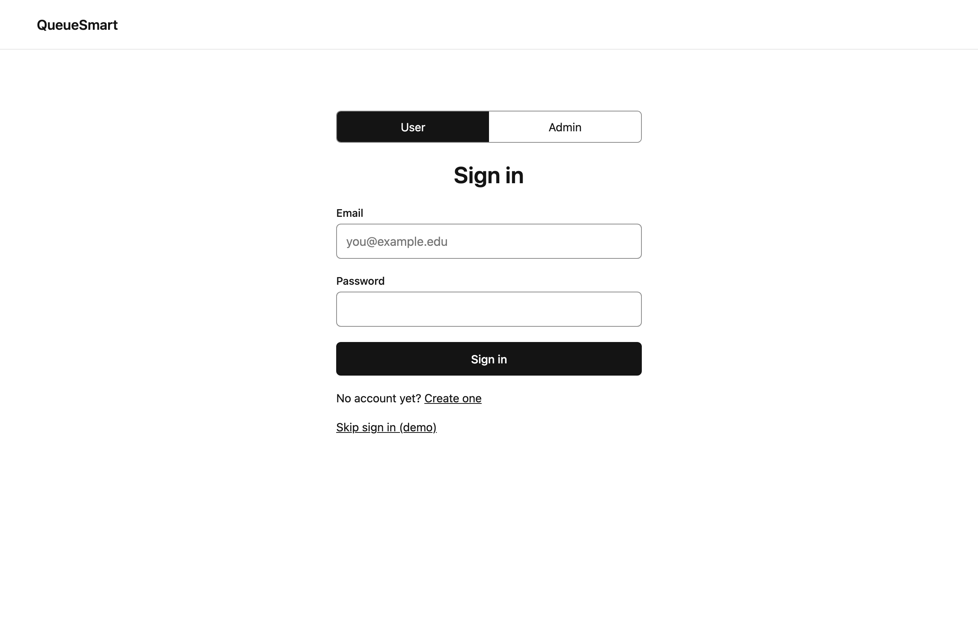
Figure 1 – User Sign In (User / Admin toggle at the top)
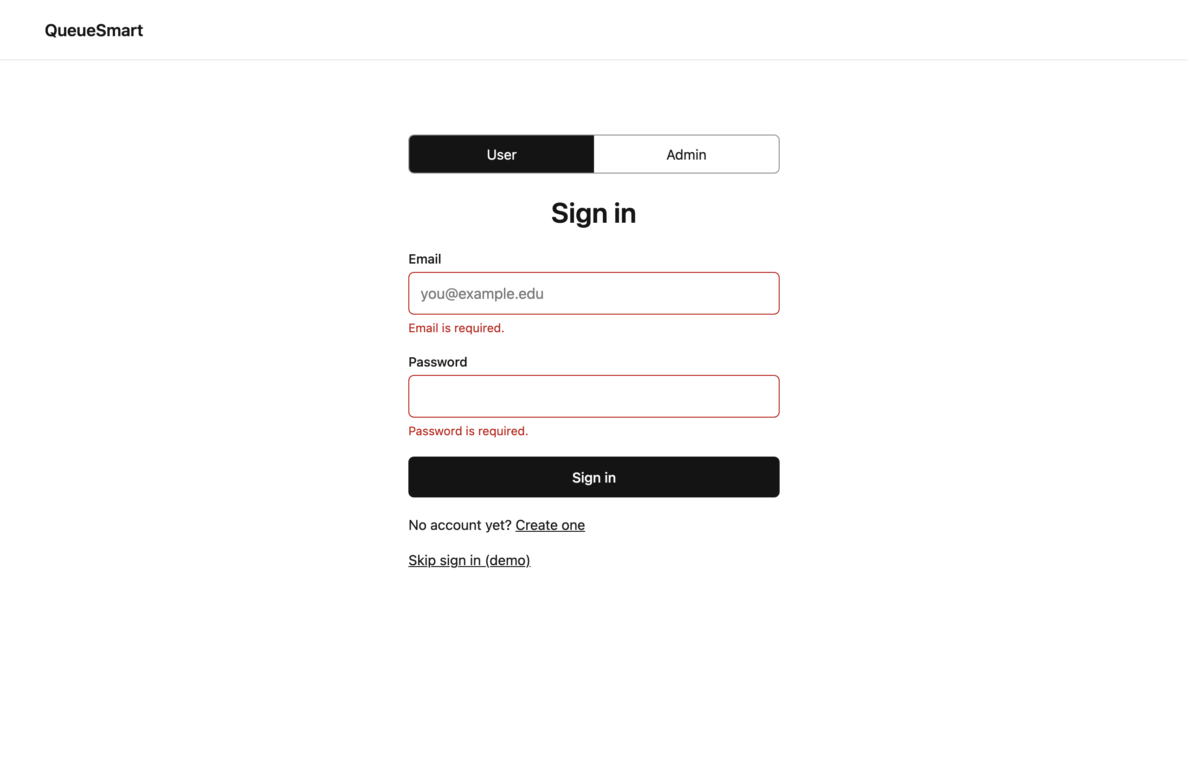
Figure 2 – User Sign In: required-field validation
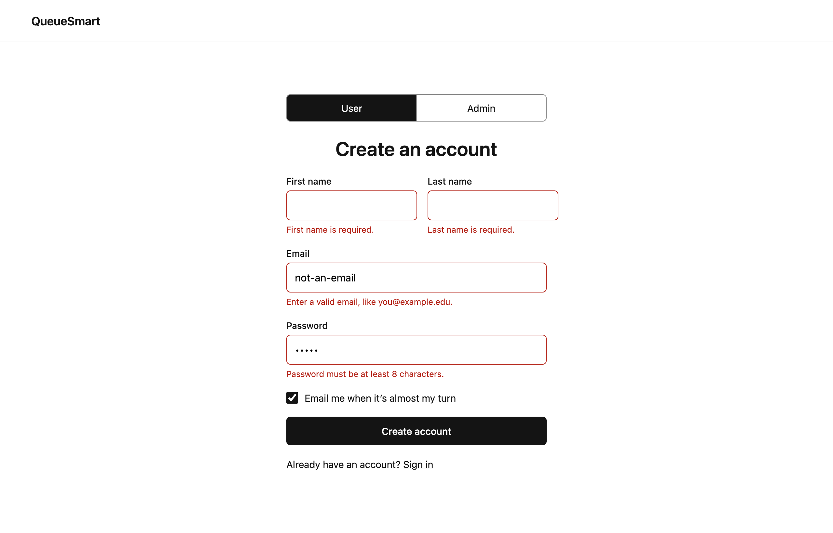
Figure 3 – User Registration: email format and password length validation
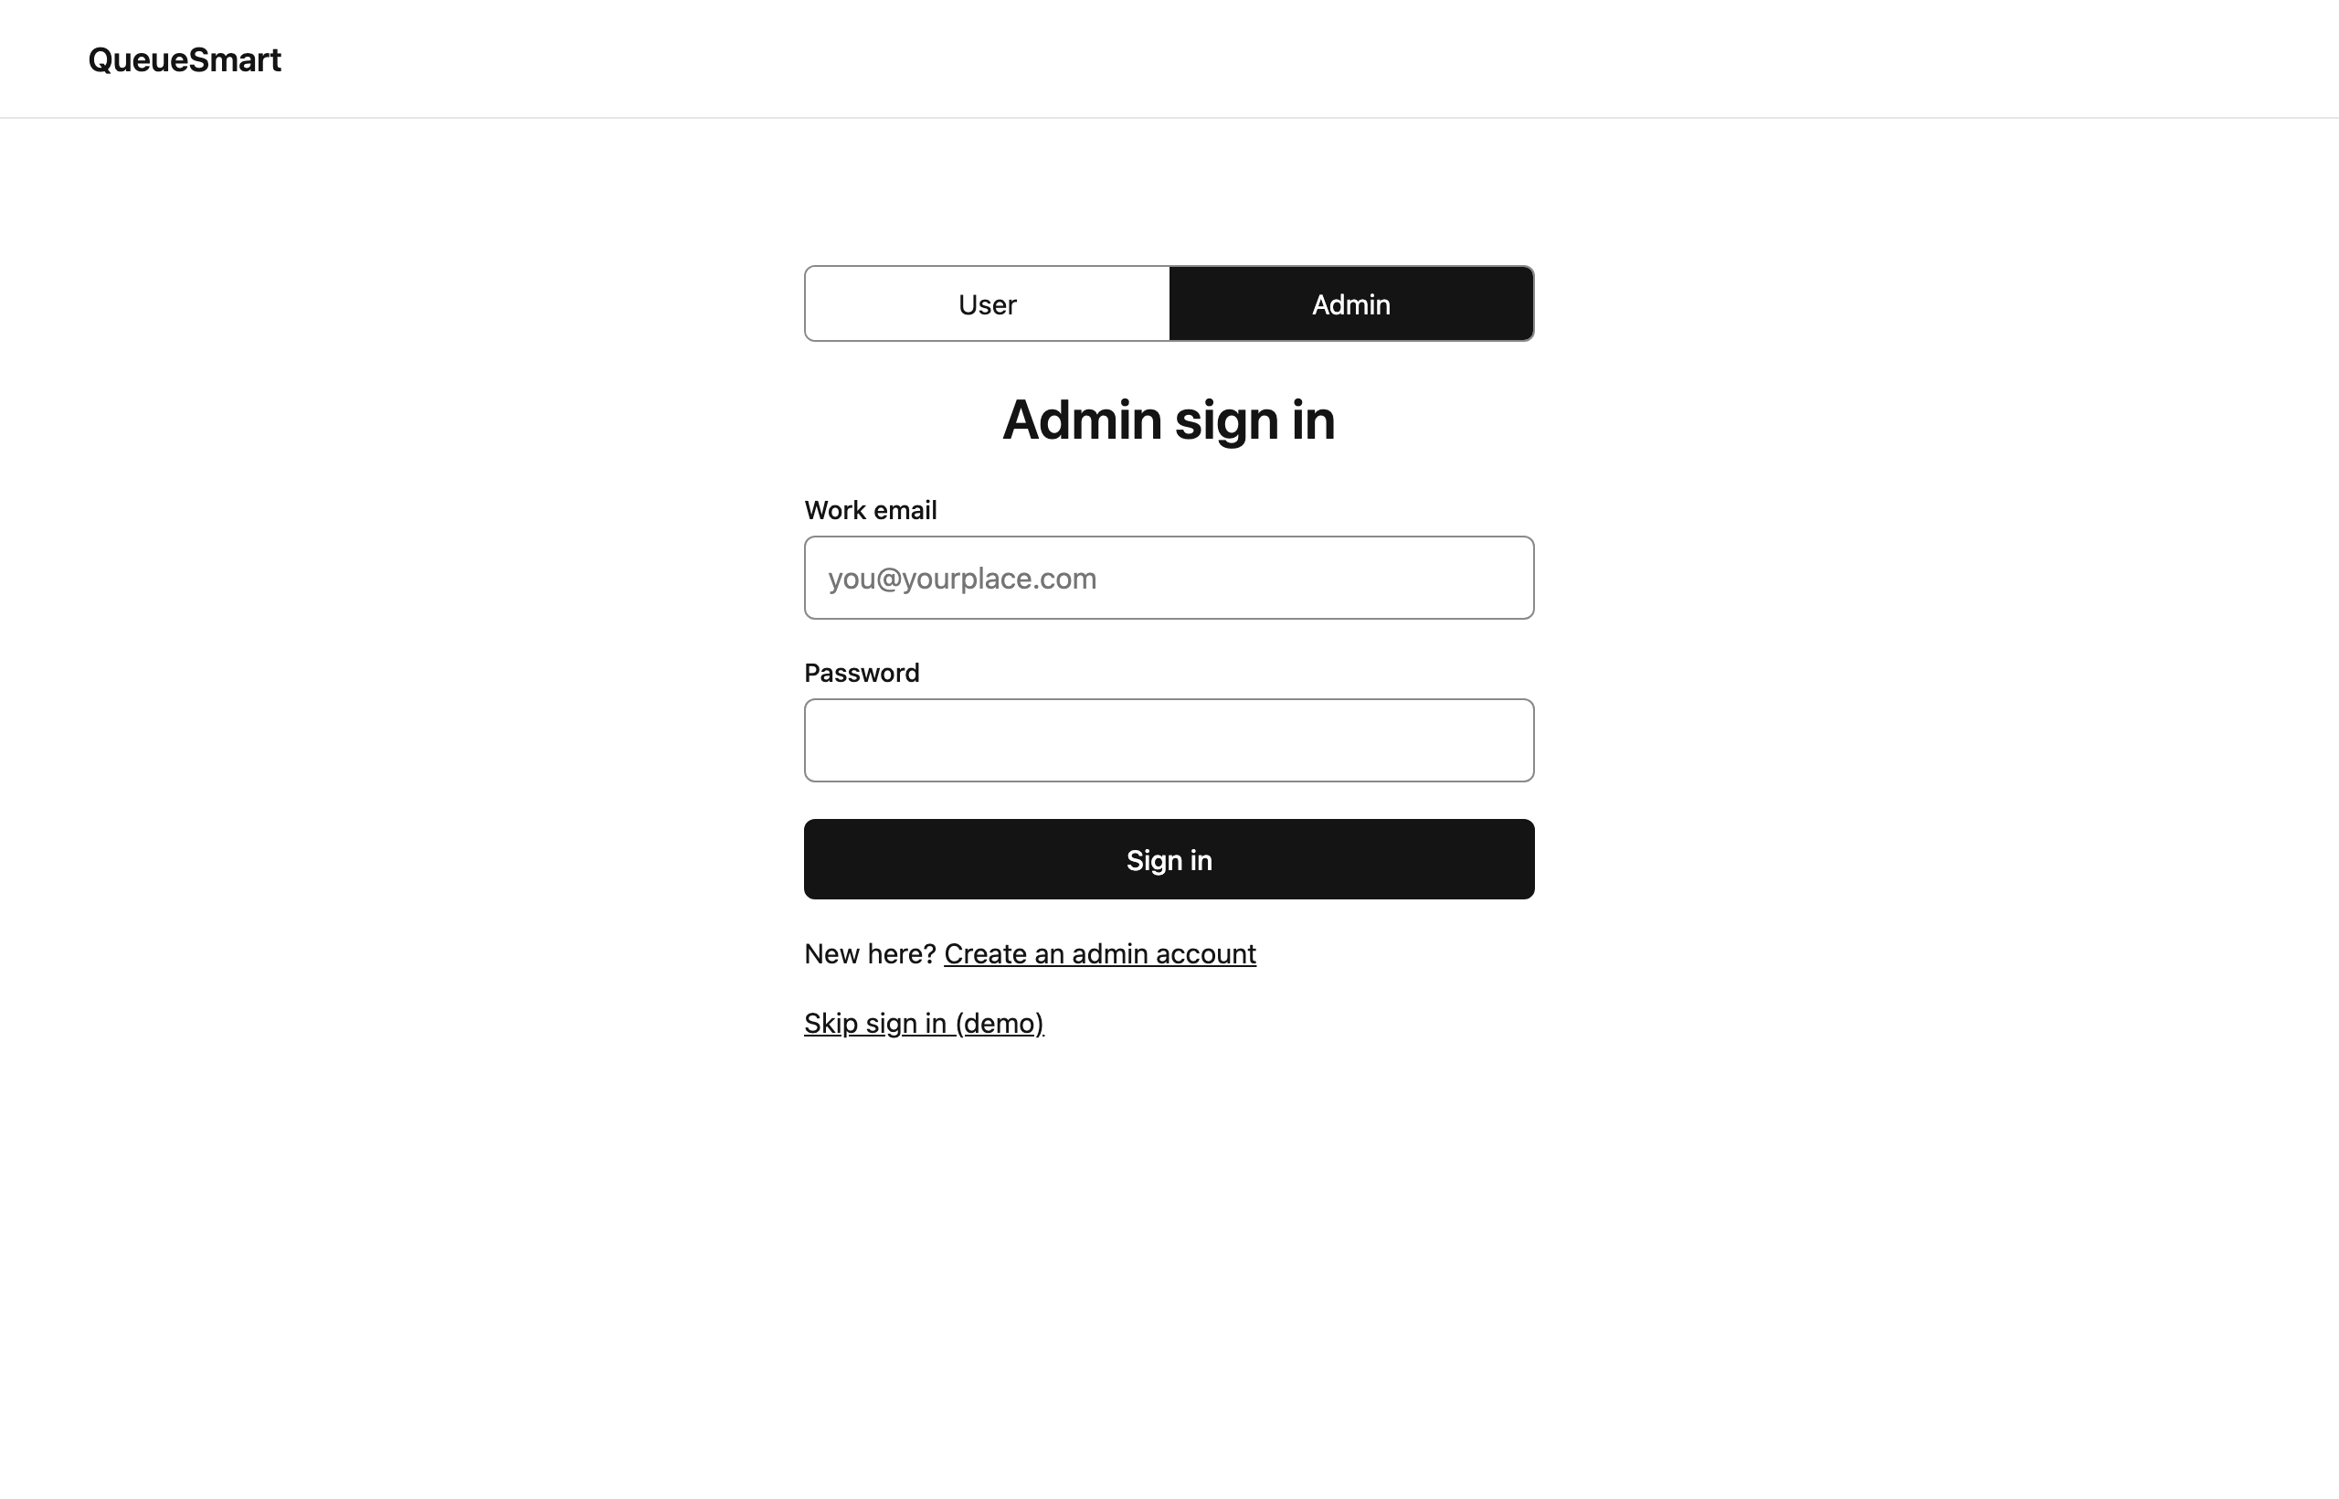
Figure 4 – Administrator Sign In
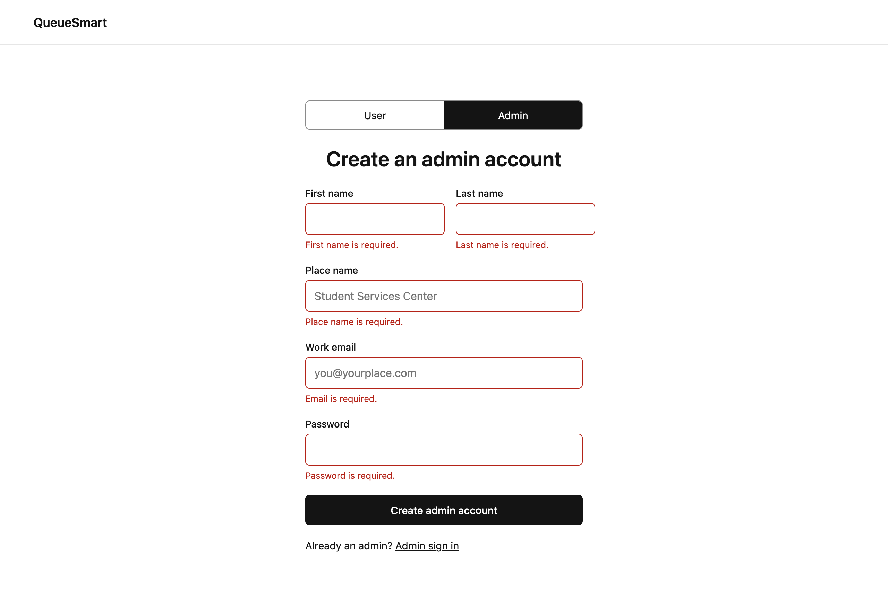
Figure 5 – Administrator Registration: validation errors

User Dashboard
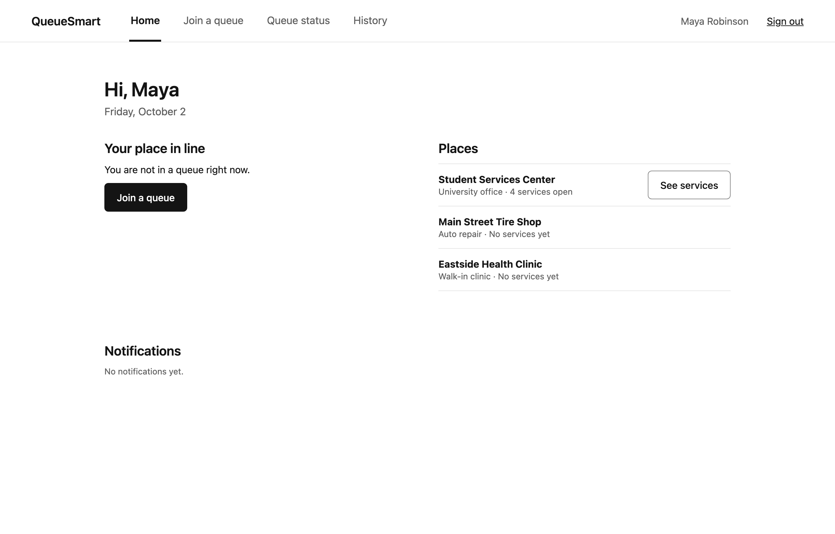
Figure 6 – User Dashboard: not in a queue yet, places to choose from
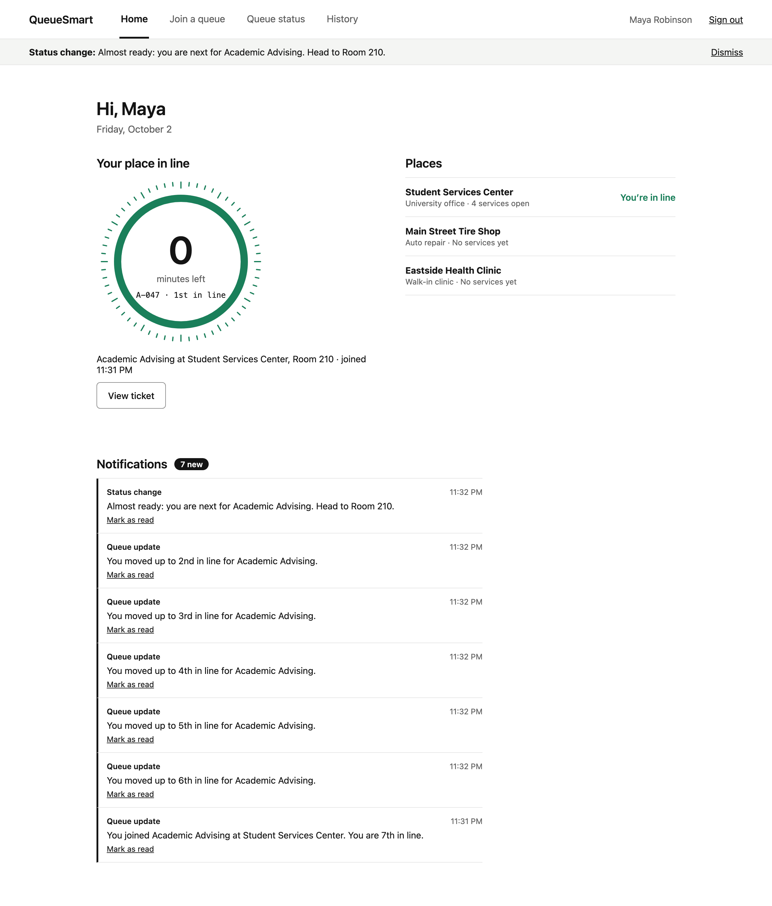
Figure 7 – User Dashboard: current queue status (wait wheel), places and notifications summary

Join Queue
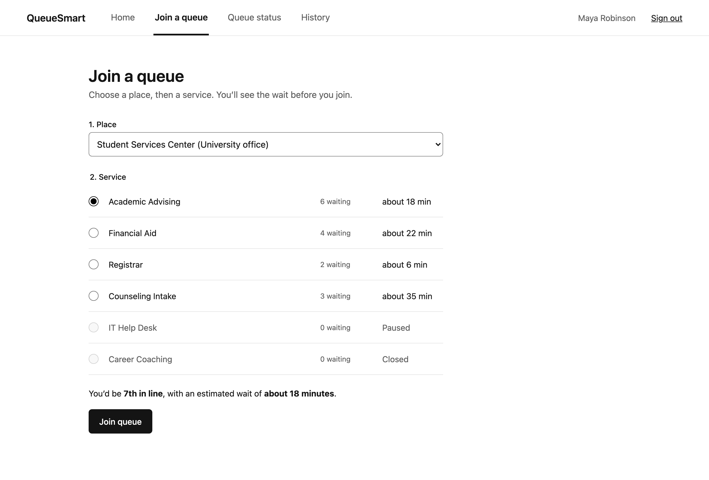
Figure 8 – Join Queue: choose a place and a service, see position and estimated wait before joining
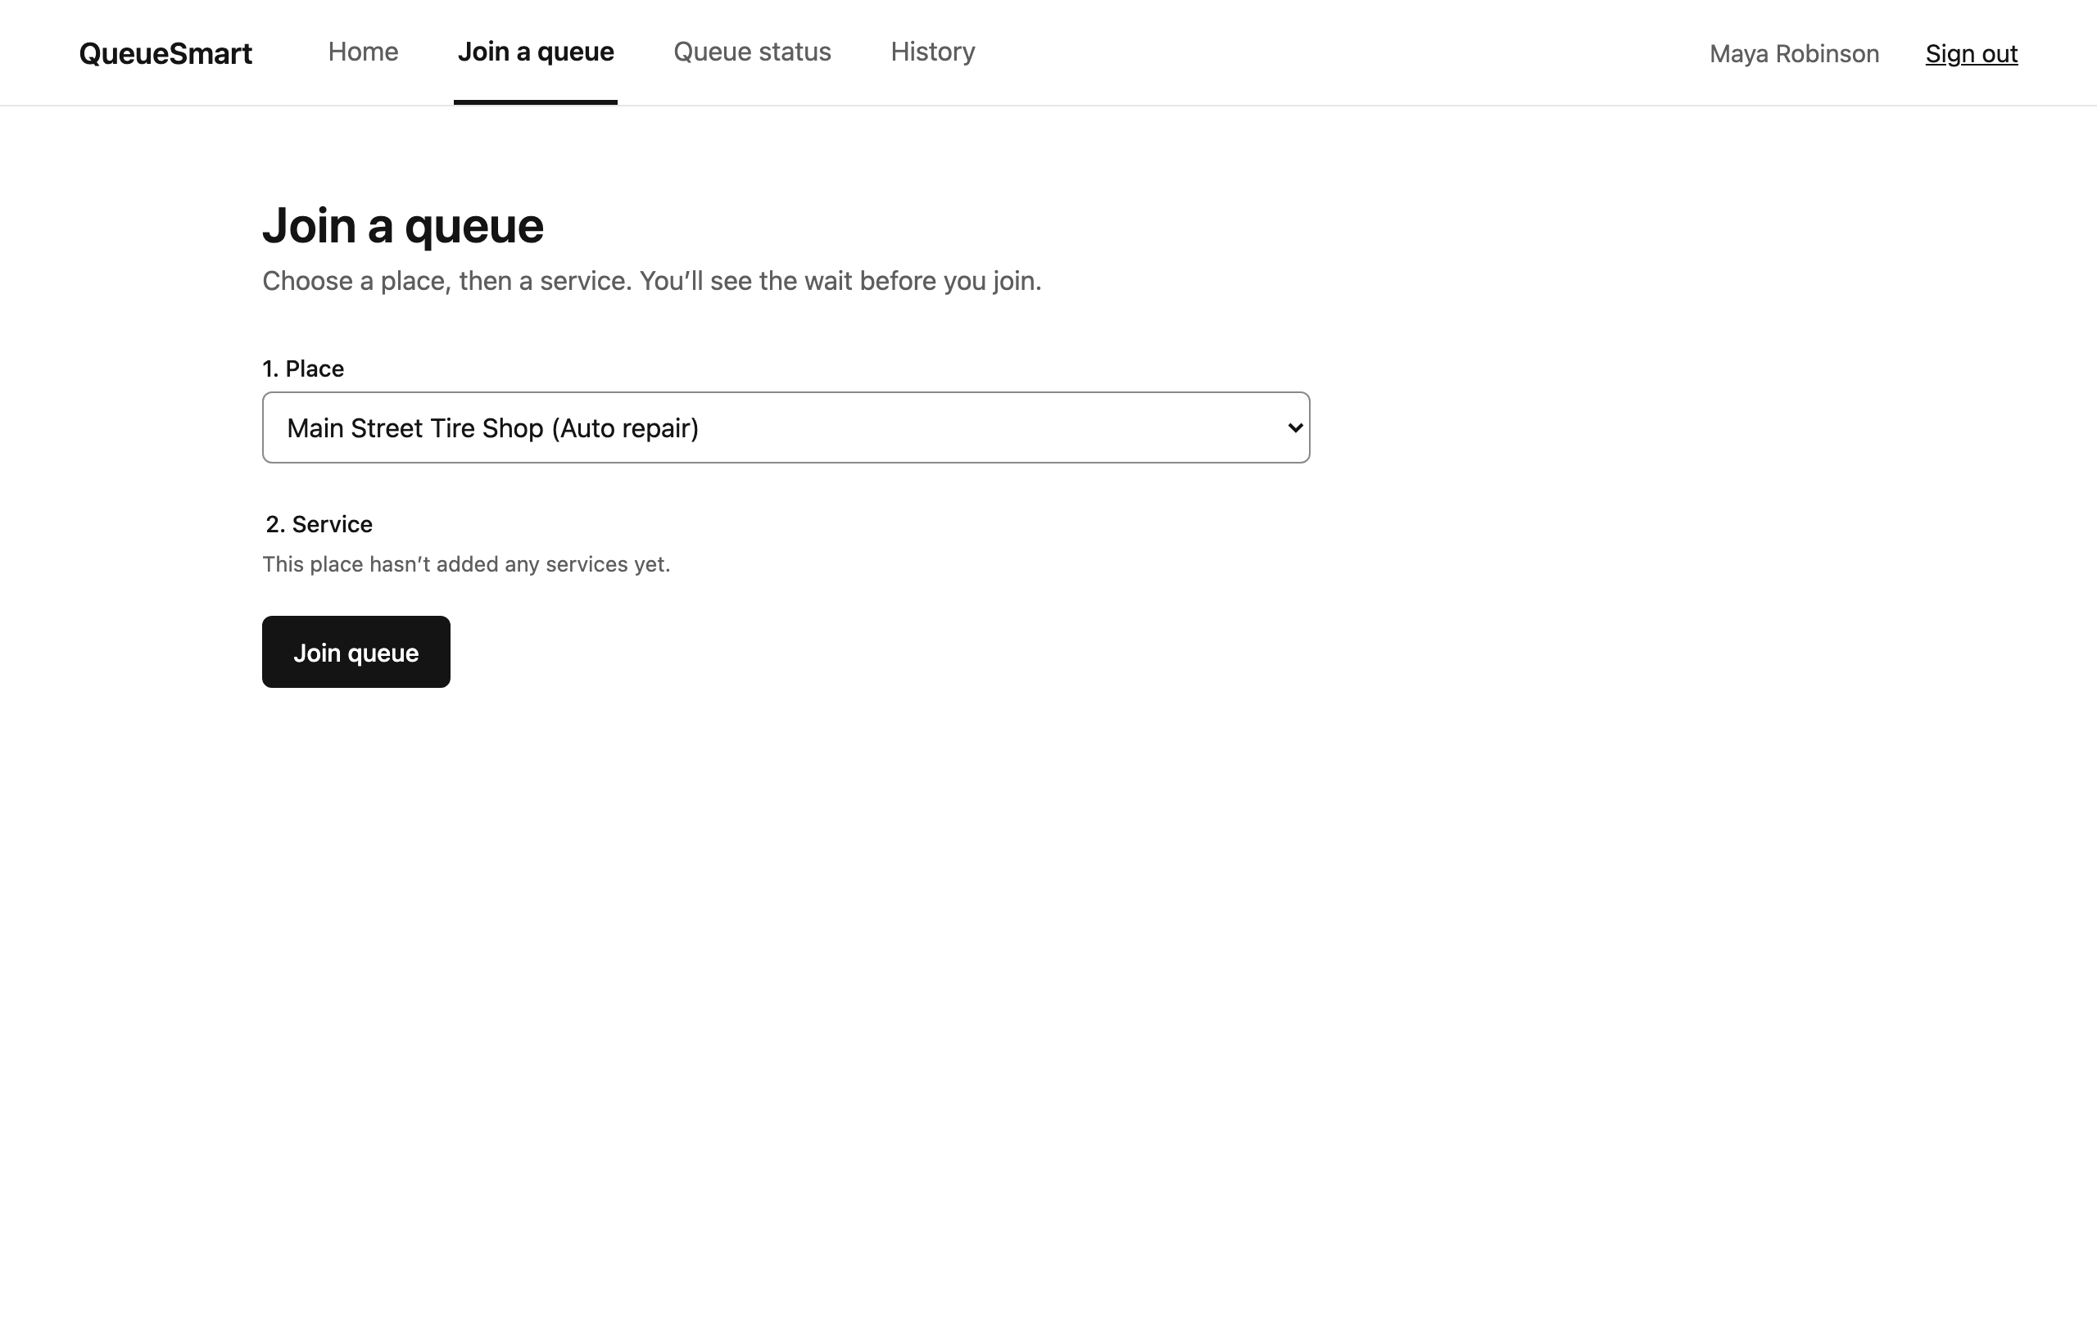
Figure 9 – Join Queue: a place that has not added services yet

Queue Status
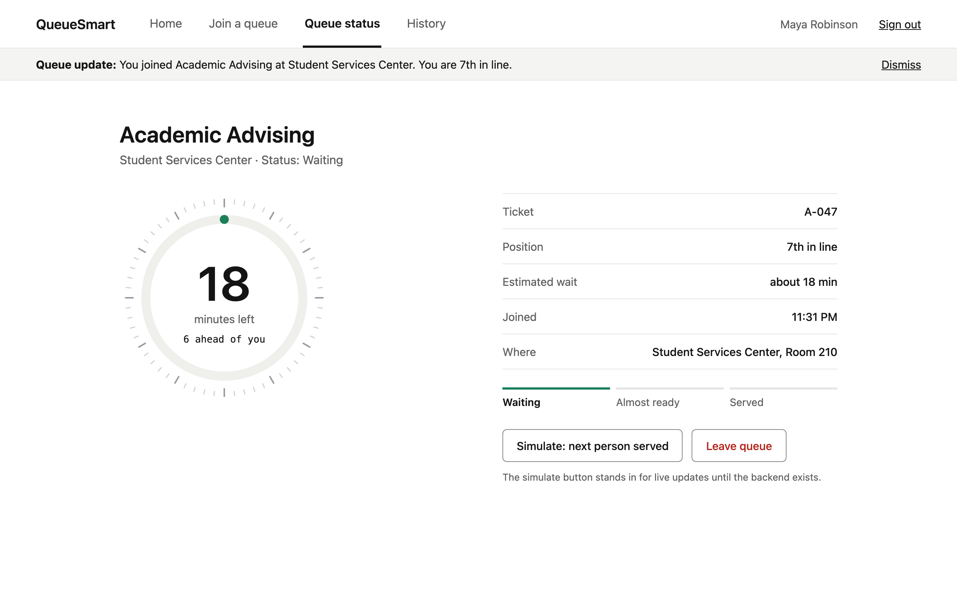
Figure 10 – Queue Status: position, estimated wait and status "Waiting"
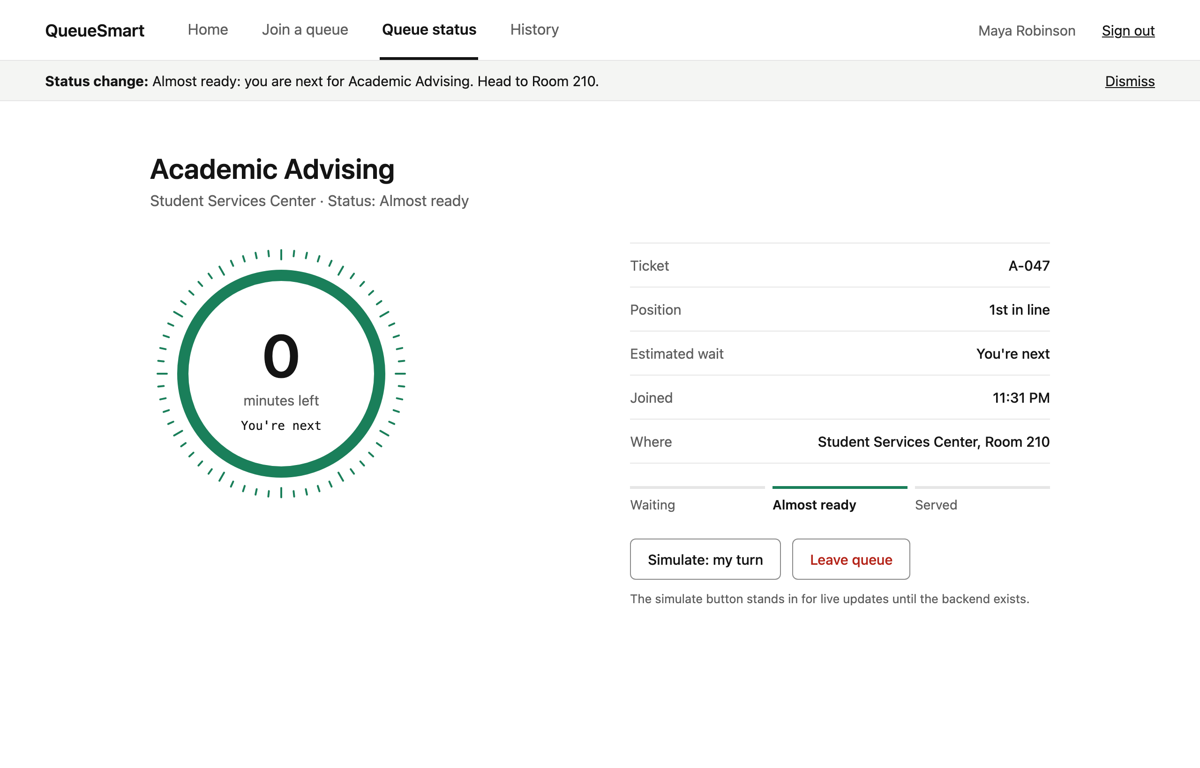
Figure 11 – Queue Status: status "Almost ready" with a status-change notification
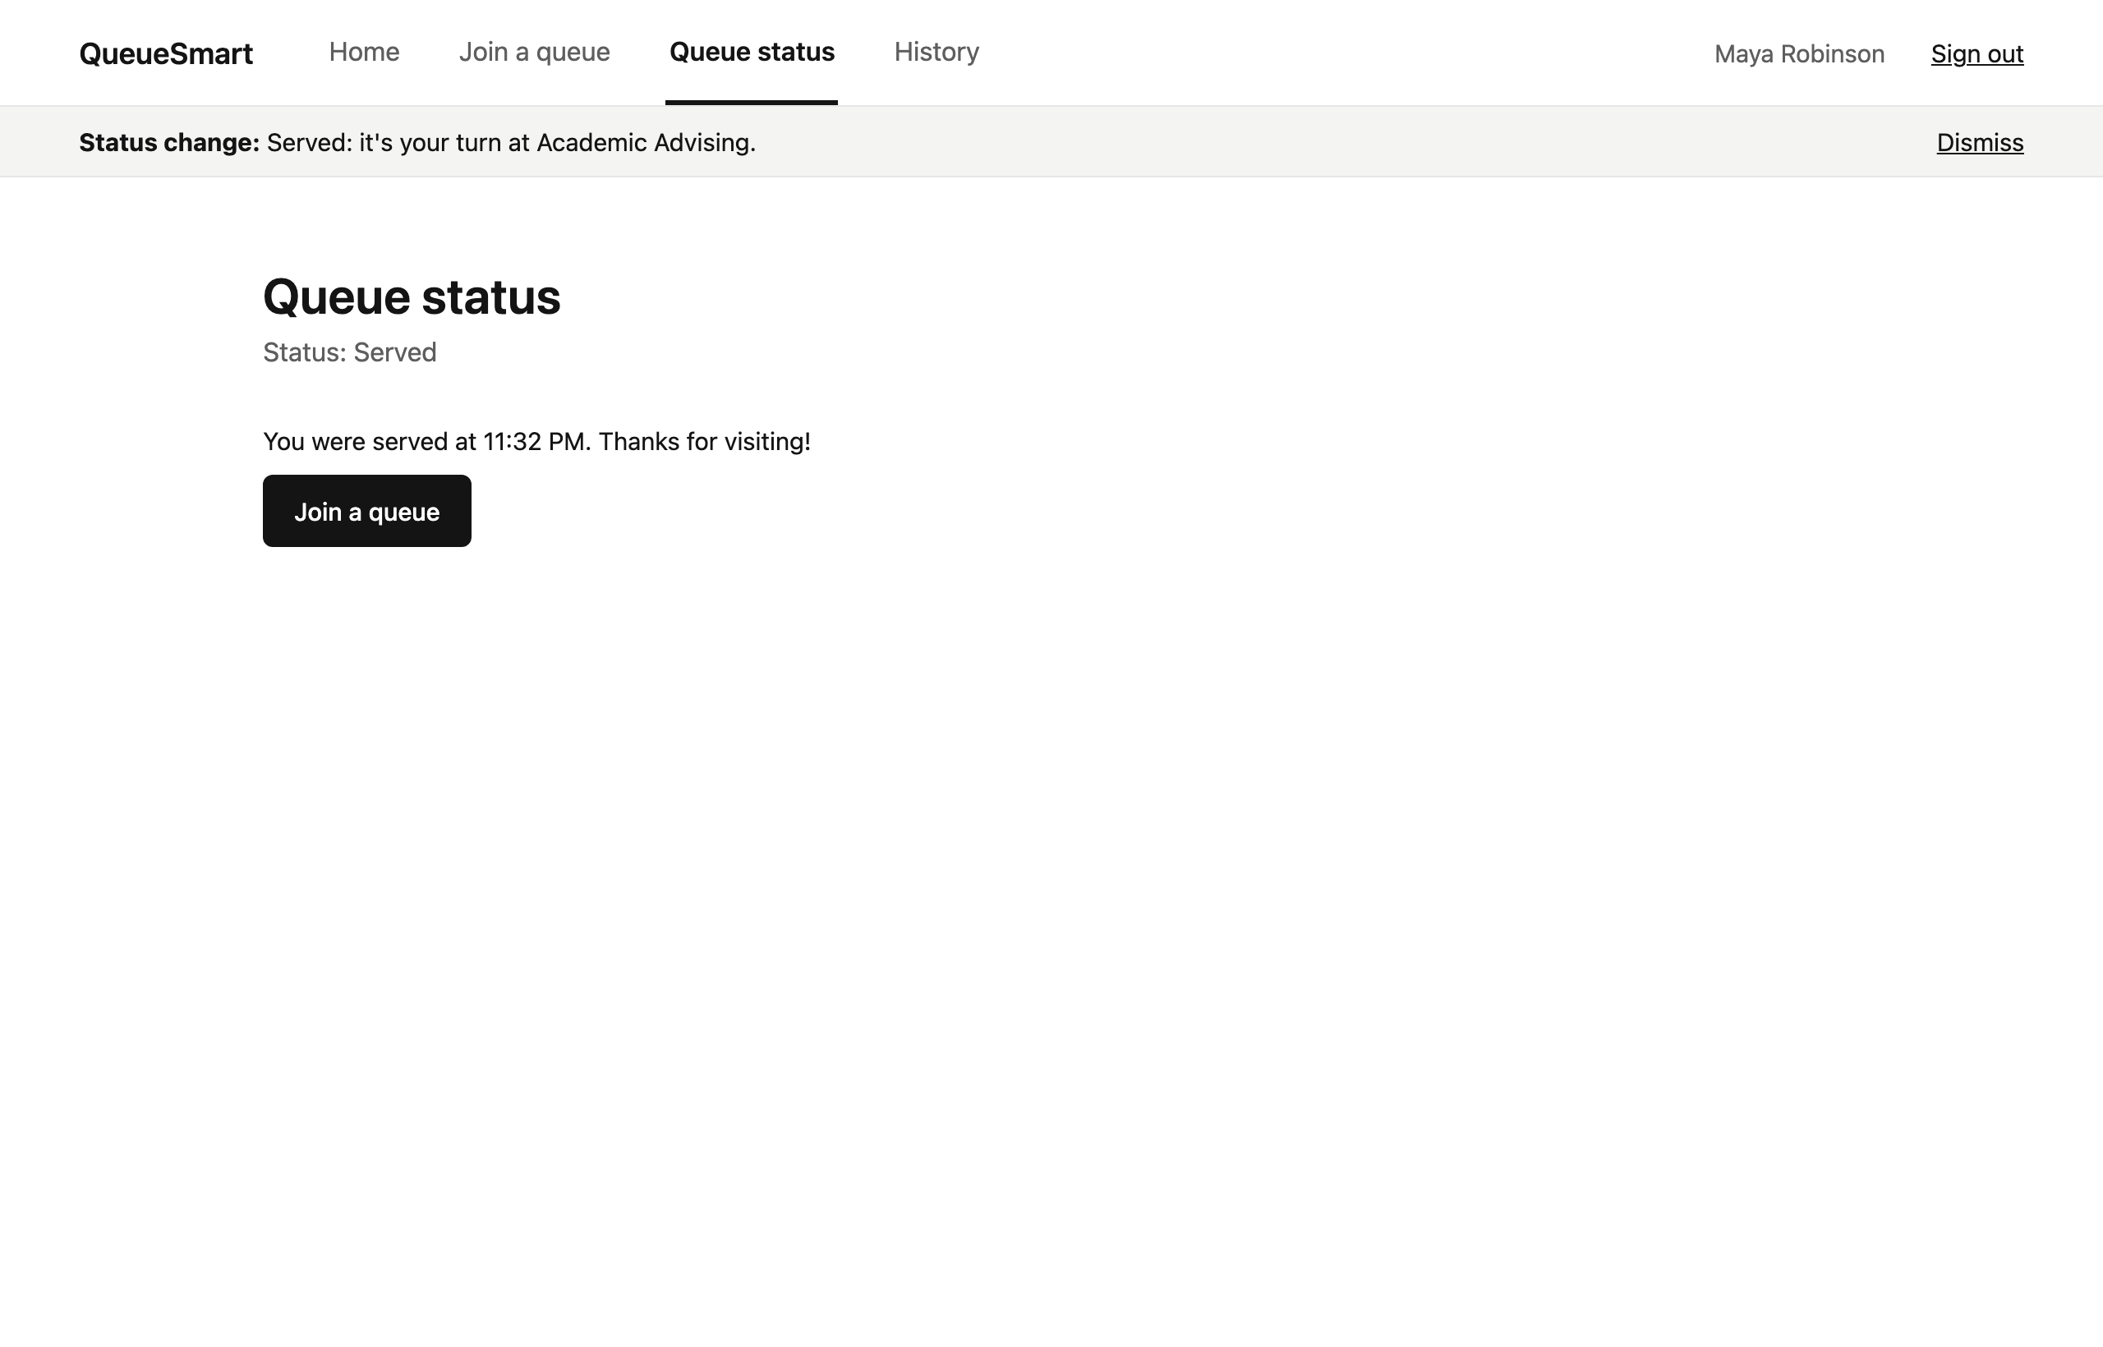
Figure 12 – Queue Status: status "Served"

History
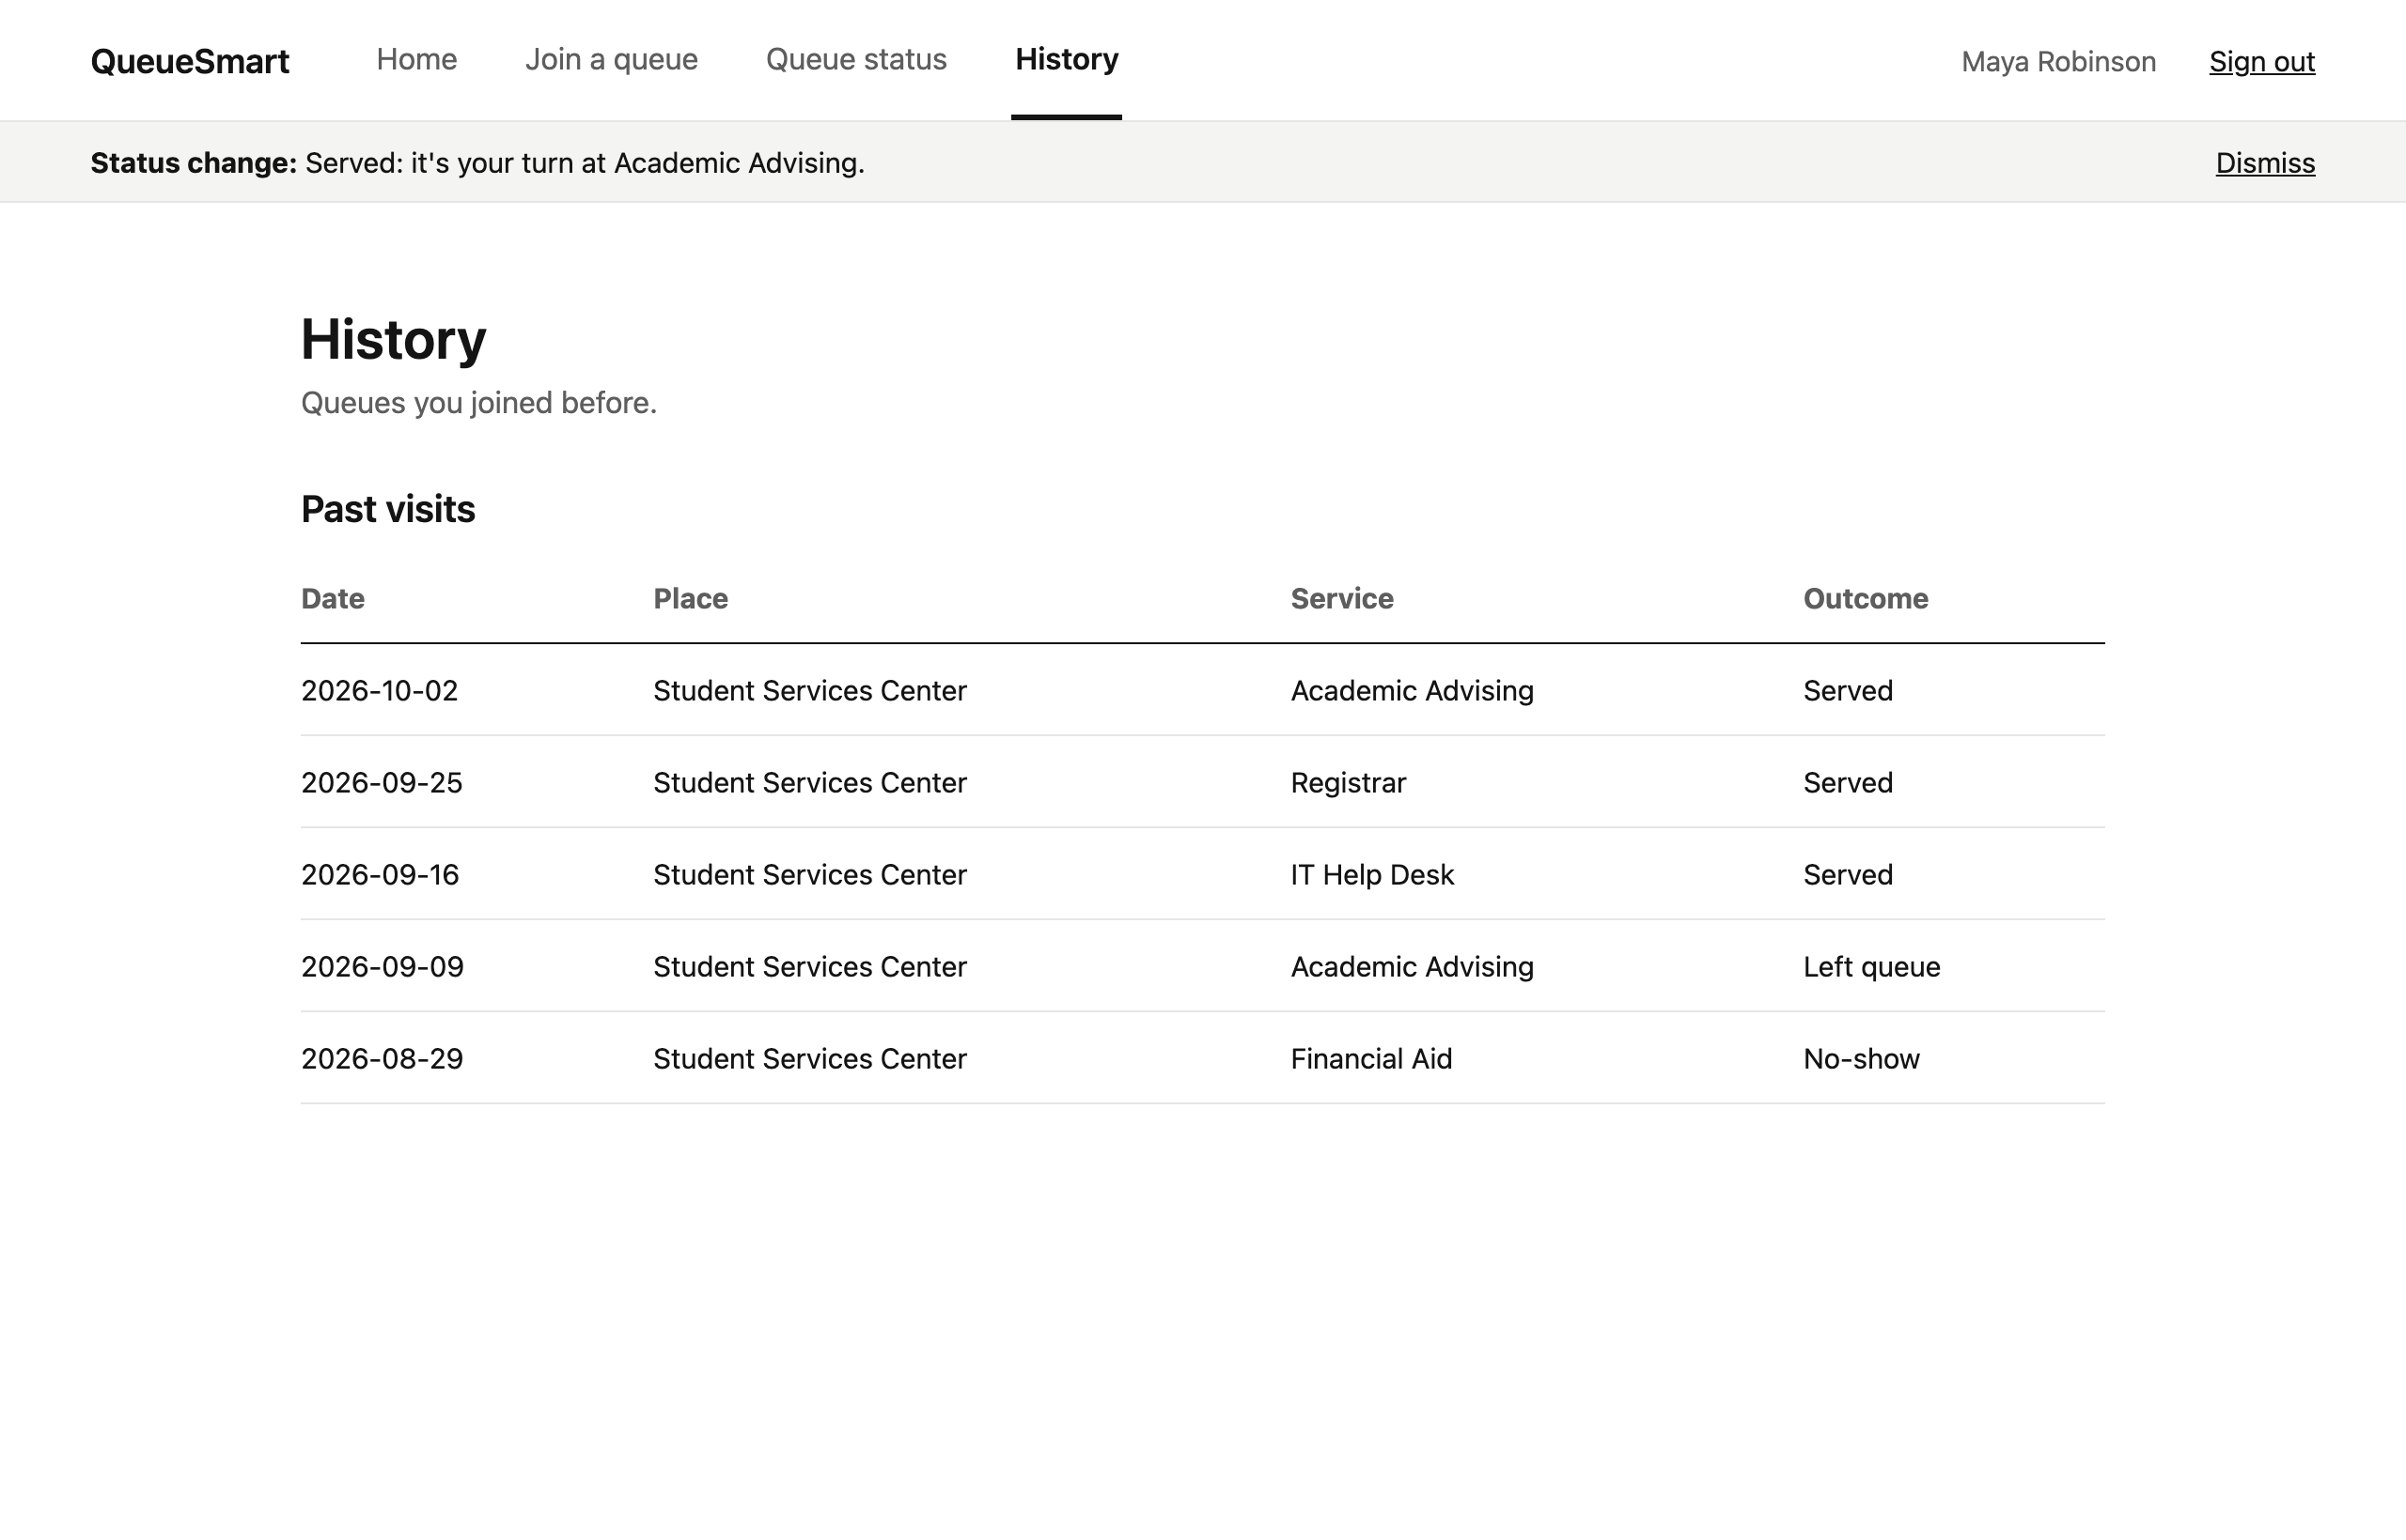
Figure 13 – History: date, place, service name and outcome

Admin Dashboard
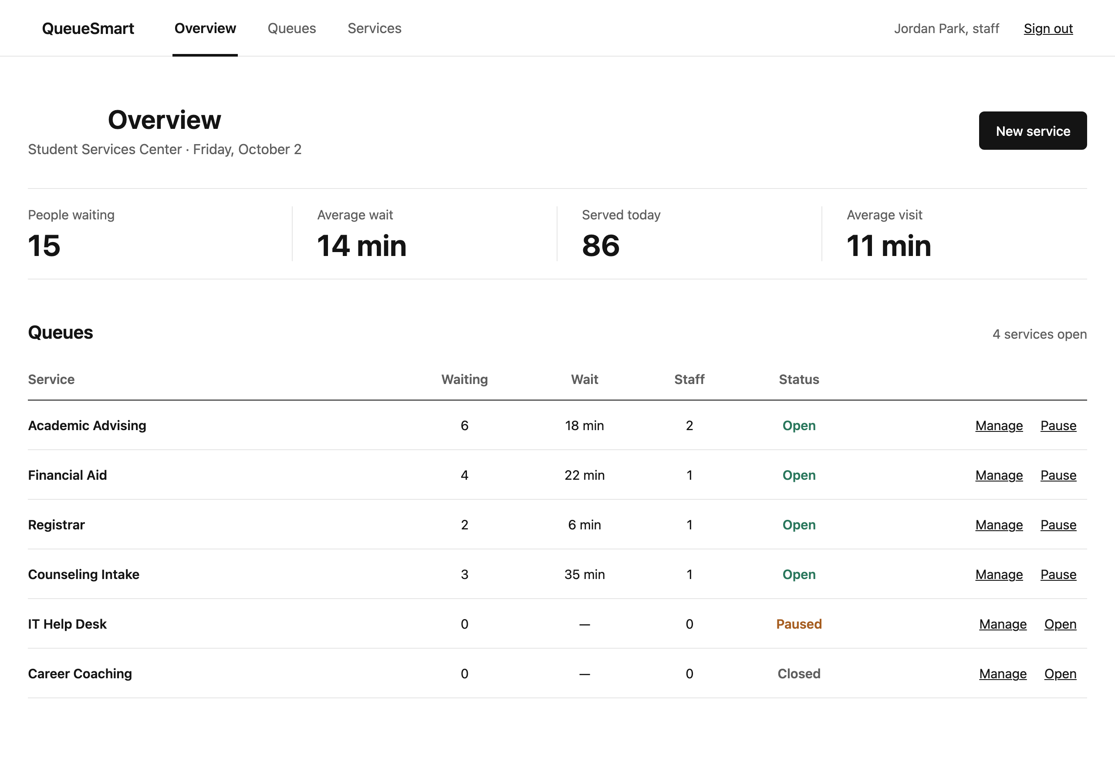
Figure 14 – Admin Dashboard: services, queue lengths and open/pause quick actions

Service Management
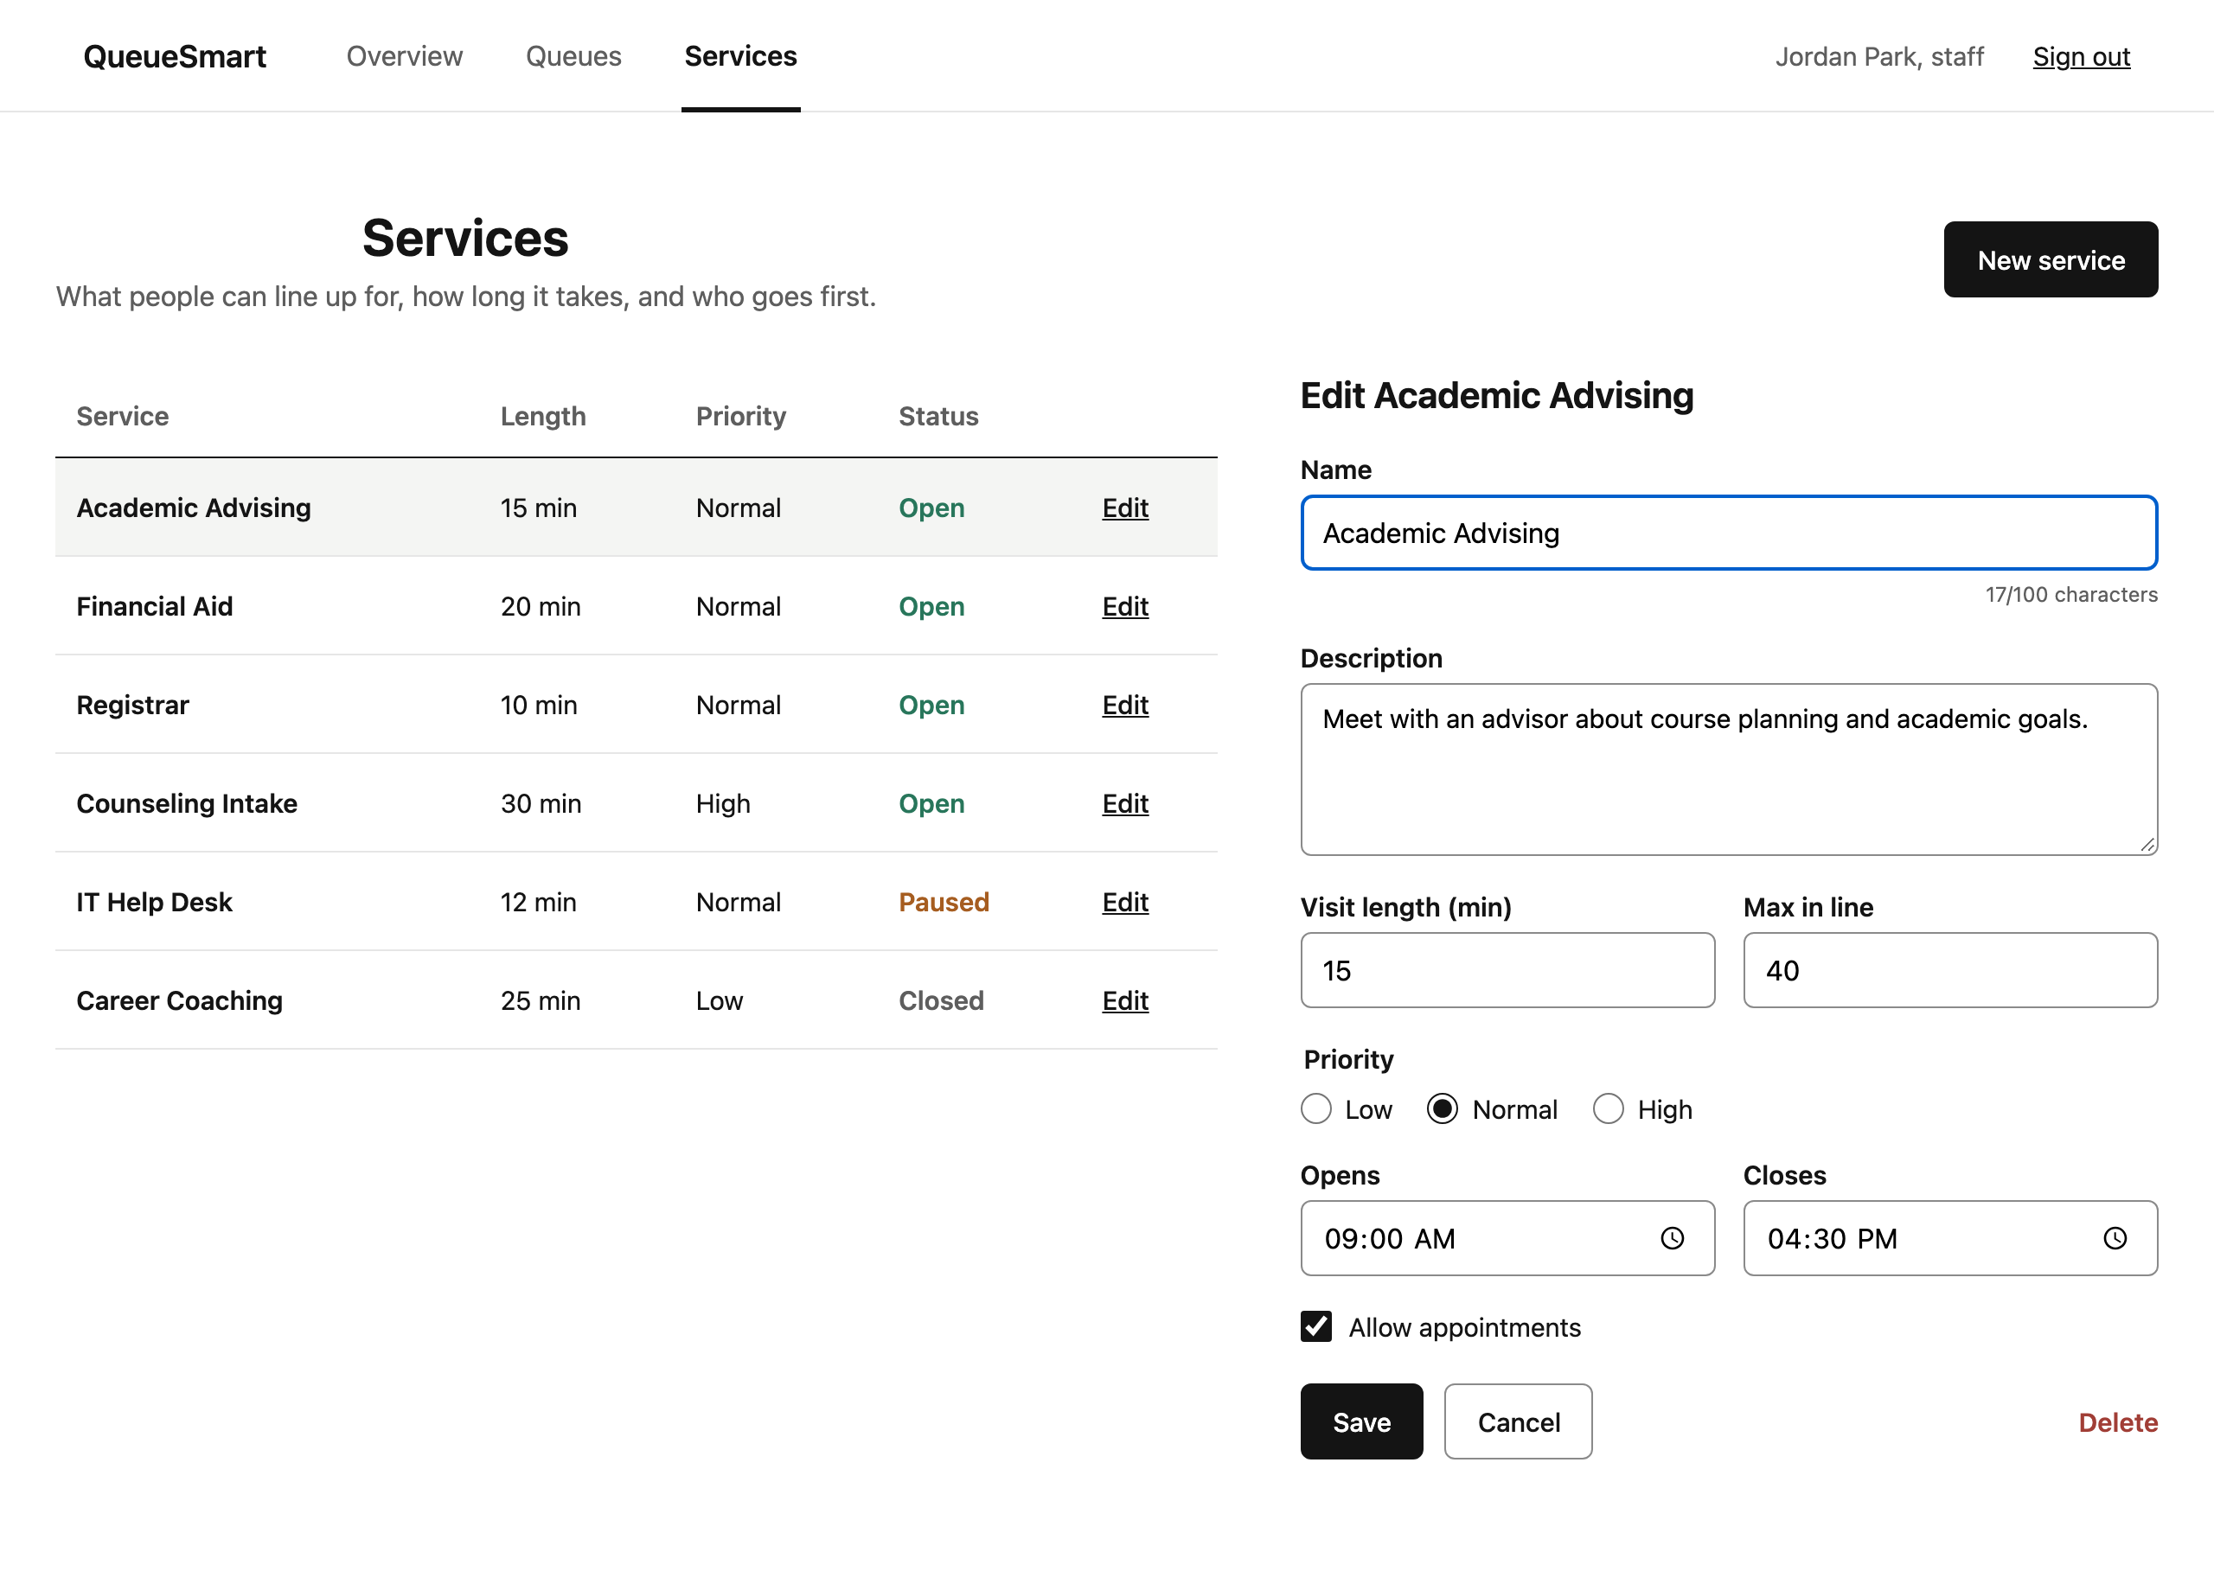
Figure 15 – Service Management: editing an existing service
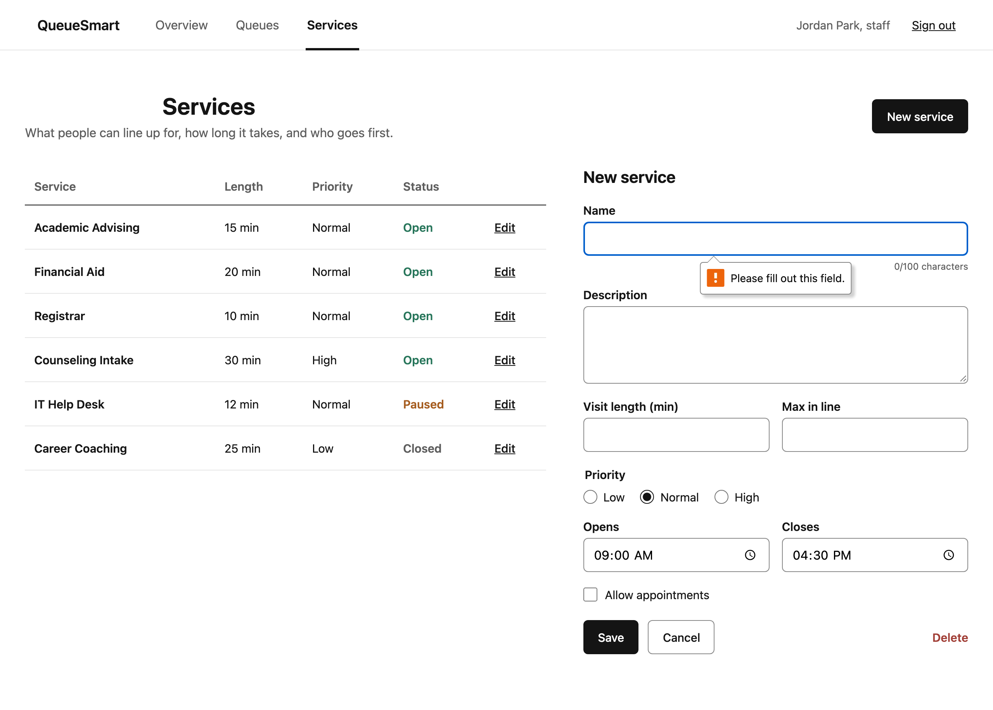
Figure 16 – Service Management: creating a new service (required-field validation)

Queue Management
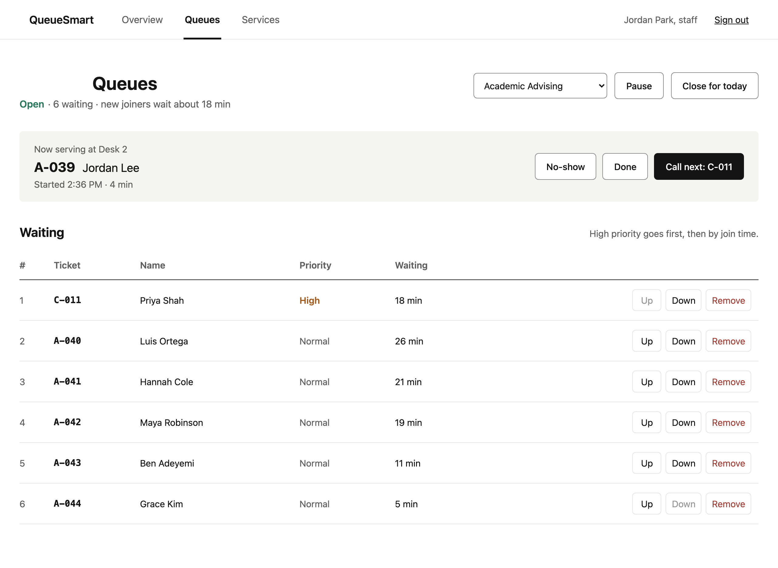
Figure 17 – Queue Management: queue for the selected service with reorder and remove
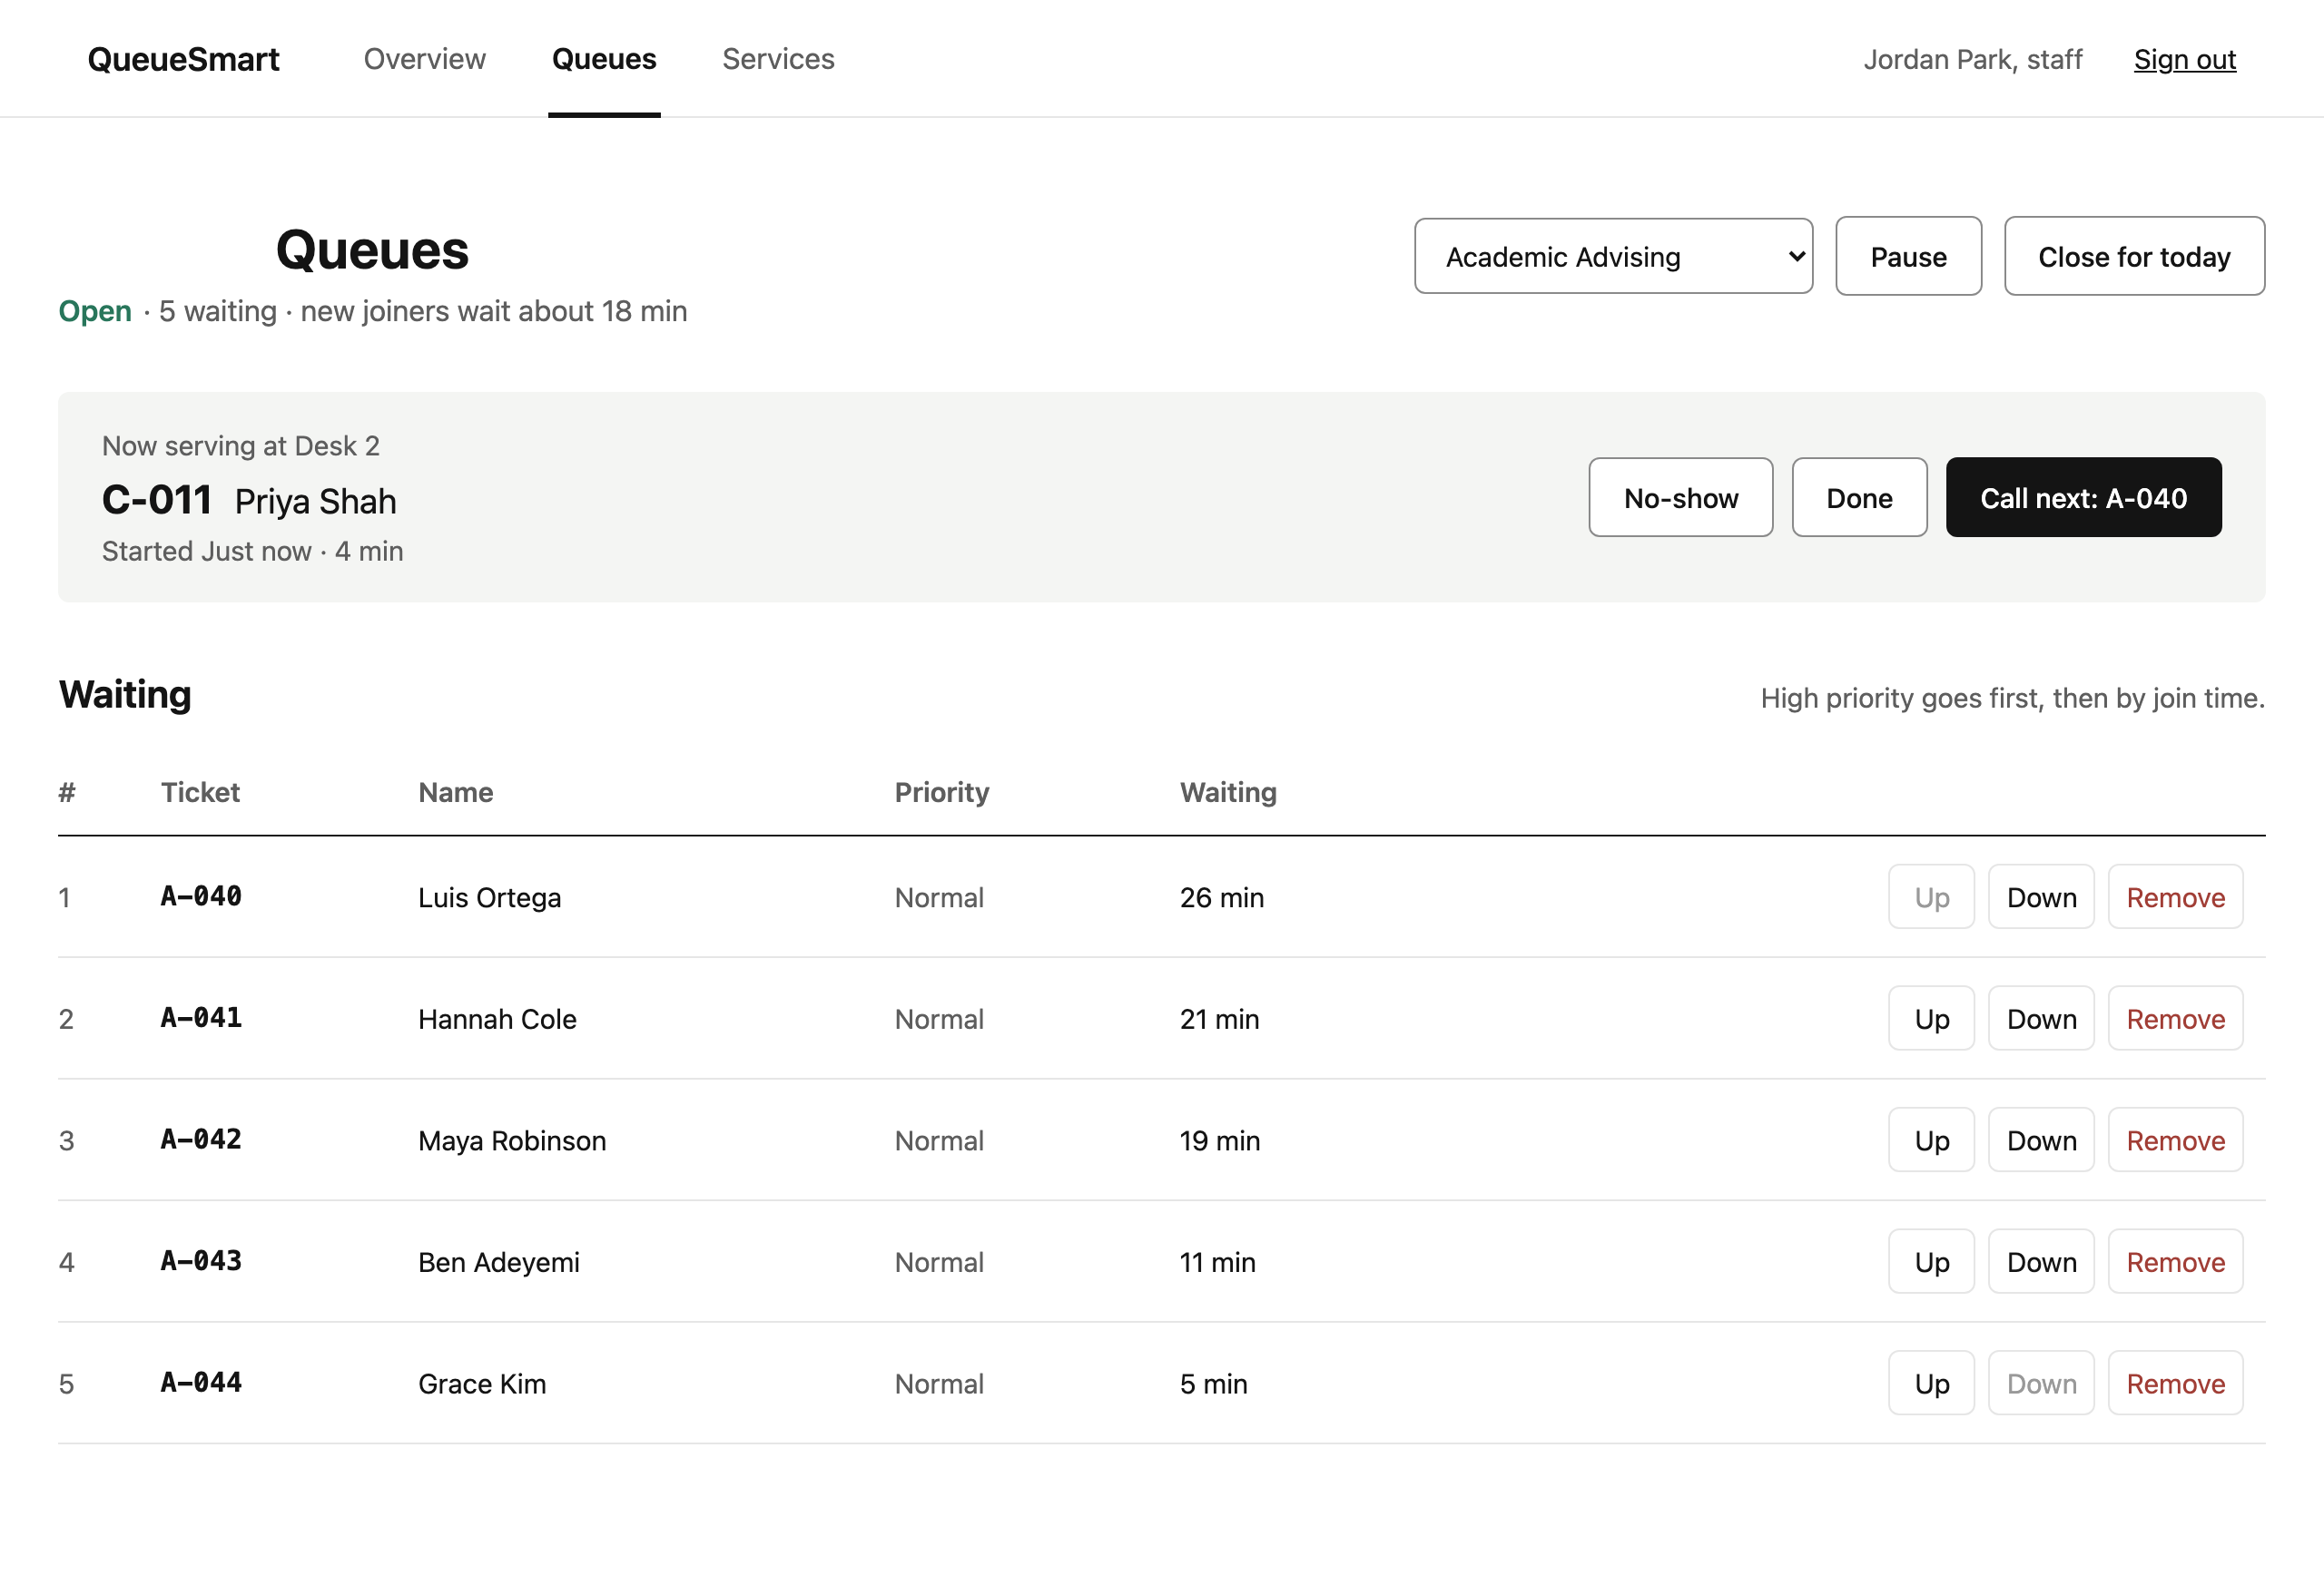
Figure 18 – Queue Management: after "Call next" (serve next user)

5. Team Contribution Table
# | Group Member Name | What is your contribution? | Discussion Notes
1 | Agah Duzenli | Set up the React + Vite project and Docker; built the user and admin sign in / create account screens, shared components and client-side validation; made the user screens consistent with the design; reviewed and merged pull requests. | Proposed the folder structure and shared components so the team could build screens in parallel. Added demo sign-in shortcuts and mock queue data until the A3 backend exists.
2 | Dang Nguyen | Built the administrator screens: Admin Dashboard, Service Management and Queue Management, plus admin navigation and styles. | Designed the admin workflow (overview → queues → services) around the A1 admin requirements.
3 | Derek F. Lihou | Built the user screens: User Dashboard, Join Queue, Queue Status and History, and the reusable DynamicTable component. | Built a generic table component so lists of data can be shown the same way on every screen.
4 | Skyler Tran | Built the in-app Notifications component for queue updates and status changes. | Notifications are in-app only for A2; email/SMS through the external Notifications Service (A1 diagram) is planned for later assignments.

