Integrate Zscaler with identity providers

(IdPs) such as Azure AD
COLLEGE NAME : Shri Nehru Maha Vidhyalaya College of Arts & Science.
TEAM ID: SWTID-2026-1943
Team Leader : AGALYA A
Email : 23bcaagalya@gmail.com
Team Member: AJAY P
Email : 23bcaajay@gmail.com
Team Member: DINESH KUMAR
Email : 23bcadineshkumar@gmail.com
Team Member: KEERTHANA R
Email :23snmvbcakeerthanar@gmail.com

Project Title

Integrate Zscaler with Identity Providers (IdPs) such as Azure AD

Overview of the project

- Integrating **Zscaler with Identity Providers (IdPs) such as Azure Active Directory (Azure AD)** enables organizations to implement secure, identity-based access to applications and internet resources.
- Zscaler is a cloud-based security platform that provides services like secure internet access and zero trust access to private applications without relying on traditional VPNs.
- An Identity Provider like Azure AD is responsible for authenticating users and managing their identities, including enforcing policies such as Single Sign-On (SSO) and Multi-Factor Authentication (MFA).
- When Zscaler is integrated with Azure AD, user authentication is handled by the IdP using protocols such as **SAML**.
- When a user tries to access a resource, Zscaler redirects the authentication request to Azure AD, which verifies the user’s credentials and sends a secure authentication response back to Zscaler.
- Based on this identity information, Zscaler applies security policies and grants appropriate access.
- This integration improves security by enabling a **Zero Trust model**, simplifies access through SSO, centralizes identity management, and enhances user experience while ensuring that only authenticated and authorized users can access corporate resources.

Abstract

- The integration of Zscaler with Identity Providers (IdPs) such as Azure Active Directory (Azure AD) plays a significant role in enhancing modern cybersecurity frameworks through identity-based access control.
- As organizations increasingly adopt cloud services and remote work models, traditional network security approaches are becoming less effective.
- Zscaler, a cloud-native security platform, works with IdPs like Azure AD to implement a Zero Trust security model that verifies user identity before granting access to applications or internet resources. Through protocols such as Security Assertion Markup Language (SAML) and automated provisioning methods like SCIM, this integration enables secure Single Sign-On (SSO), centralized identity management, and enforcement of Multi-Factor Authentication (MFA). By authenticating users through Azure AD and applying security policies through Zscaler, organizations can ensure that only authorized users gain access to critical resources.
- This approach improves security, simplifies user access, and enhances operational efficiency. Overall, integrating Zscaler with identity providers provides a scalable and secure solution for protecting enterprise networks and applications in a cloud-first environment.

Use case Scenarios
- Use Case: Secure Remote Workforce Access
Employees working from home or remote locations access company resources through Zscaler. The user authenticates using Azure AD with Single Sign-On (SSO) and Multi-Factor Authentication (MFA).
Output:
Secure and seamless access to corporate applications and internet resources from any location while maintaining strong identity verification and security policies.
- Use Case: Secure Access to Private Applications (Zero Trust Access)
Employees need access to internal applications hosted within the organization. Zscaler Private Access (ZPA) works with Azure AD to authenticate the user and grant application-level access without using a VPN.
Output:
Users gain secure and direct access to specific internal applications while preventing unauthorized network access, supporting the Zero Trust security model.
- Use Case: Centralized Identity and Access Management
Administrators manage users, roles, and groups in Azure AD and apply access policies in Zscaler based on these identities.
Output:
Simplified user management, consistent access control, and improved security through centralized identity management.
- Use Case: Secure SaaS and Internet Access Control
Organizations allow employees to use cloud-based applications such as Microsoft 365 or Salesforce. Azure AD authenticates users while Zscaler monitors and controls internet traffic and SaaS usage.
Output:
Secure and controlled access to SaaS applications with protection against threats, data leaks, and unauthorized usage.
- Use Case: Enhanced Security with Multi-Factor Authentication (MFA)
Users must verify their identity using an additional authentication factor such as a mobile app or OTP when logging in through Azure AD.
Output:
Stronger authentication process that reduces the risk of unauthorized access and protects sensitive organizational data.

TITLE:
OWASP TOP 10
OVERVIEW:
The OWASP Top 10 is a standard awareness document published by the Open Web Application Security Project (OWASP) that identifies the most critical security risks to web applications. It is designed to help developers, security professionals, and organizations understand common vulnerabilities that attackers often exploit. The OWASP Top 10 highlights major risks such as Broken Access Control, Cryptographic Failures, Injection, Insecure Design, Security Misconfiguration, Vulnerable and Outdated Components, Identification and Authentication Failures, Software and Data Integrity Failures, Security Logging and Monitoring Failures, and Server-Side Request Forgery (SSRF). These vulnerabilities can allow attackers to gain unauthorized access, steal sensitive data, modify information, or even take full control of a system. For example, Injection attacks occur when malicious code is inserted into a program, while Broken Access Control allows users to access resources they are not authorized to use. Similarly, Cryptographic Failures happen when sensitive data such as passwords or credit card information is not properly encrypted. The OWASP Top 10 serves as a guideline for improving application security by encouraging organizations to adopt secure coding practices, proper configuration, regular updates, and continuous monitoring. By understanding and addressing these risks, developers can build more secure and reliable web applications and reduce the chances of cyberattacks.
Rank | Vulnerability
1 | Broken Access Control
2 | Cryptographic Failures
3 | Injection
4 | Insecure Design
5 | Security Misconfiguration
6 | Vulnerable and Outdated Components
7 | Identification and Authentication Failures
8 | Software and Data Integrity Failures
9 | Security Logging and Monitoring Failures
10 | Server-Side Request Forgery

S.NO |  | Vulnerability | CWE/CVE NO
1. |  | Improper Limitation of a Pathname to a Restricted directory (‘Path Traversal’) | CWE-22
2. | J2EE Misconfiguration: Data Transmission Without Encryption. |  | CWE-5
3. | Unimplemented or Unsupported Feature in UI |  | CWE-447
4. | Weak encoding for password. |  | CWE-261
5. | Improper input validation |  | CWE-20
6. | Incorrect Privilege Assignment |  | CWE-266
7. | Improper Authentication |  | CWE-287
8. | Missing support for Integrity check |  | CWE-353
9. | Insufficient logging |  | CWE-778
10. | Unchecked return value |  | CWE-252

REPORT:
1.Vulnerability Name : Improper Limitation of a Pathname to a Restricted directory (‘Path Traversal’)
CWE NO : CWE-22
OWASP Category : Broken Access Control
Description: Path Traversal is a security vulnerability that occurs when a web application does not properly control user input used in file paths. This allows attackers to access files and folders outside the restricted directory by using special characters like ../ to move up the directory structure. For example, an attacker might try to access sensitive files such as system configuration files that should not be available to users. This can lead to unauthorized access to important data and system files. To prevent path traversal attacks, developers should validate user input, restrict file access, and use secure coding practices.
Business Impact : Path Traversal attacks can cause serious problems for organizations. Attackers may gain access to sensitive business data, customer information, or internal system files, which can lead to data breaches, financial loss, and damage to the organization’s reputation. It can also result in legal penalties, loss of customer trust, and operational disruptions if important systems or data are compromised.

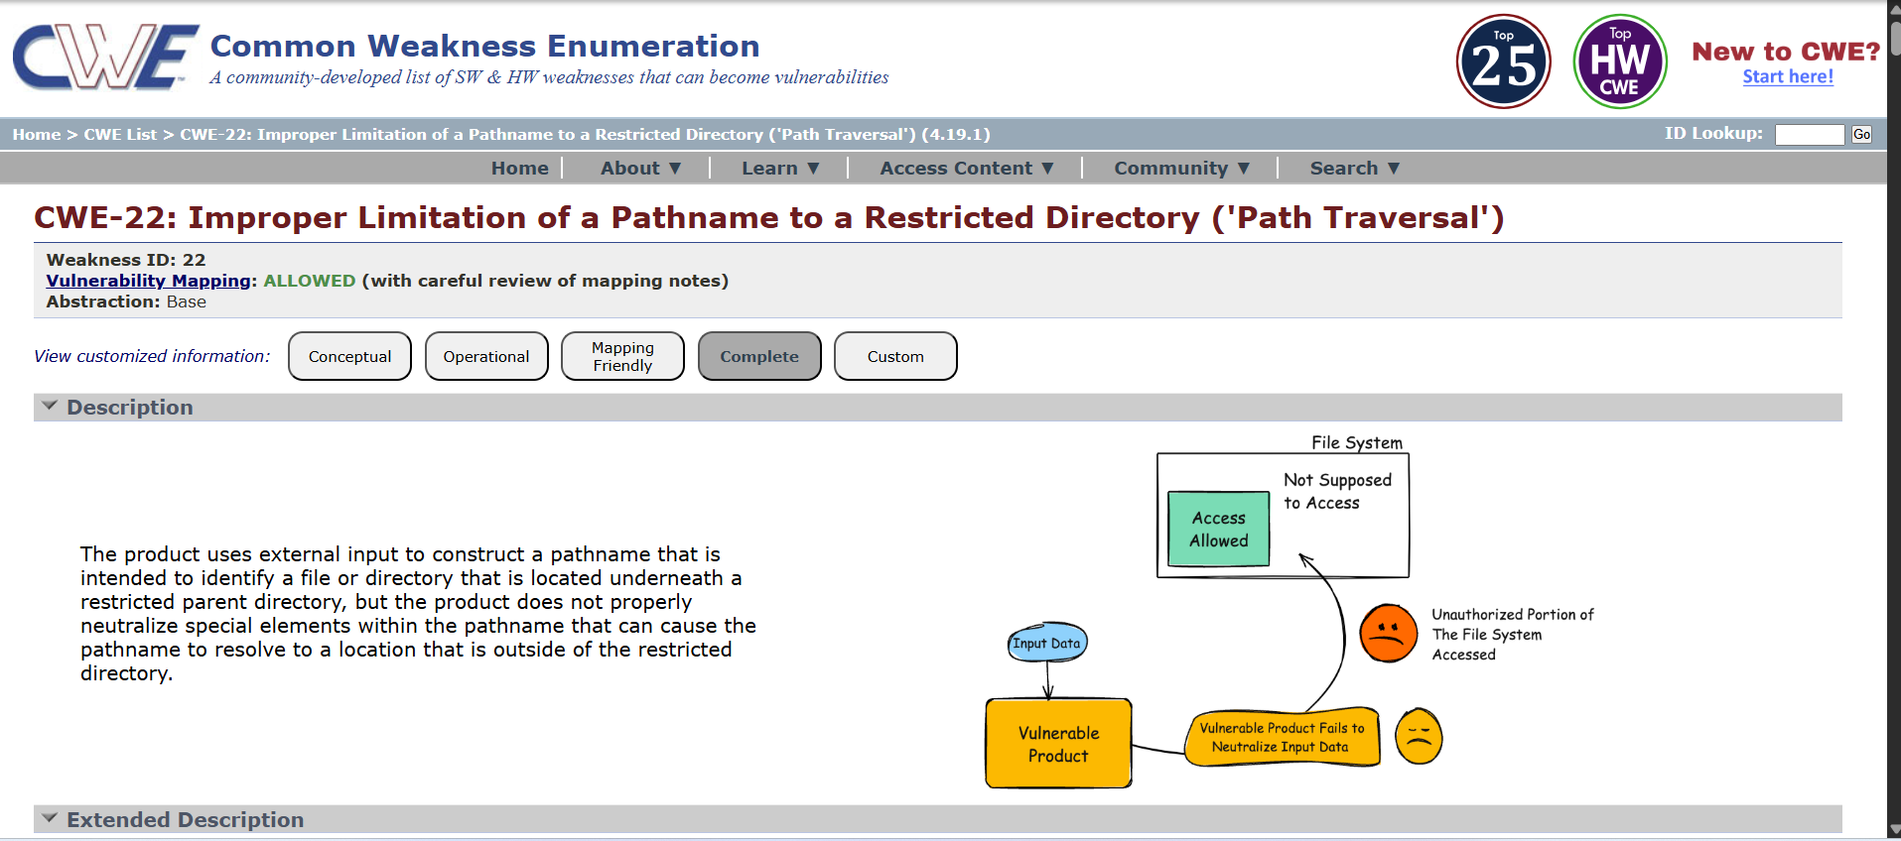

2) Vulnerability Name : J2EE Misconfiguration: Data Transmission Without Encryption.
CWE NO :CWE-5
OWASP Category: Security Misconfiguration
Description: J2EE Misconfiguration: Data Transmission Without Encryption (CWE-5) occurs when a J2EE (Java 2 Platform, Enterprise Edition) application transmits sensitive data over a network without using encryption. This usually happens when the application uses HTTP instead of HTTPS or does not implement secure protocols like SSL/TLS. As a result, information such as usernames, passwords, personal data, or financial details can be intercepted by attackers while it is being transmitted between the client and the server.
Business Impact : If sensitive data is transmitted without encryption, attackers can capture confidential information, leading to data breaches, unauthorized account access, and identity theft. For organizations, this can result in financial losses, legal and regulatory penalties, reputational damage, and loss of customer trust. It may also expose internal systems and increase the risk of further cyberattacks.
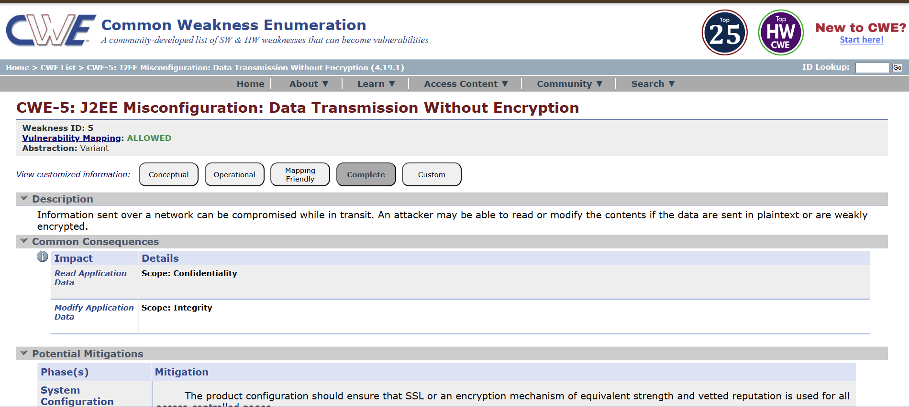
3) Vulnerability Name : Unimplemented or Unsupported Feature in UI
CWE NO: CWE-447
OWASP Category: Software supply chain Failures
Description: Unimplemented or Unsupported Feature in UI is a vulnerability that occurs when a user interface displays a feature or option that is not fully implemented or supported by the system. When users try to use this feature, the application may behave unexpectedly, produce errors, or reveal system information. Attackers may exploit these incomplete features to discover system weaknesses, hidden functions, or sensitive information.
Business Impact : This issue can lead to system instability, information leakage, or potential security vulnerabilities. Attackers may use the exposed information to perform further attacks on the system. For businesses, it can result in poor user experience, reduced customer trust, security risks, and potential financial or reputational damage if the system is exploited. 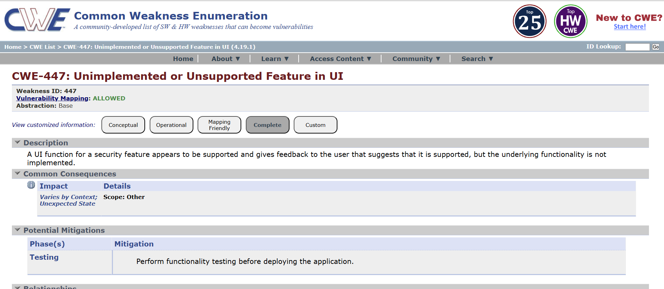4) Vulnerability Name : Weak Encoding for password
CWE NO : CWE-261
OWASP Category: Cryptography failures
Description: Weak Encoding for Password is a security vulnerability that occurs when an application stores or transmits passwords using weak or reversible encoding methods instead of strong hashing algorithms. In such cases, passwords may be easily decoded or cracked by attackers using simple tools or techniques. This means that if the database or system is compromised, attackers can quickly obtain users’ passwords and access their accounts.
Business Impact : This vulnerability can lead to unauthorized access to user accounts and sensitive information. Attackers may steal customer data, perform fraudulent activities, or misuse the system. For businesses, this can result in data breaches, financial losses, damage to reputation, loss of customer trust, and possible legal or compliance issues
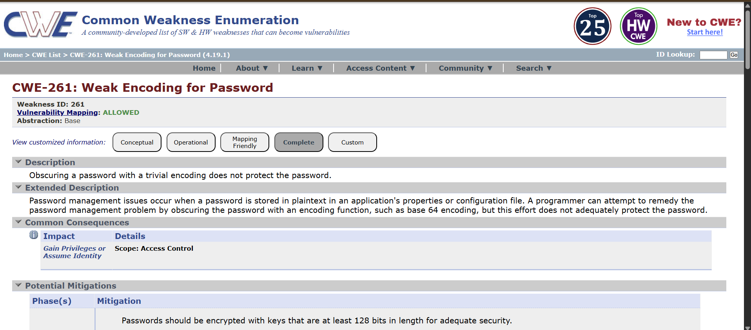
5) Vulnerability Name : Improper input validation
CWE NO : CWE-20
OWASP Category: Injection
Description: Improper Input Validation occurs when an application does not properly check or validate the data entered by users before processing it. This allows attackers to provide malicious or unexpected input that the system accepts and executes. Such inputs may include harmful scripts, commands, or invalid data that can manipulate the application or exploit system vulnerabilities.
Business Impact : This vulnerability can lead to unauthorized access, data manipulation, and system compromise. Attackers may exploit the system to steal sensitive information, disrupt services, or perform malicious activities. For businesses, this can result in data breaches, financial losses, operational disruption, and damage to reputation and customer trust.
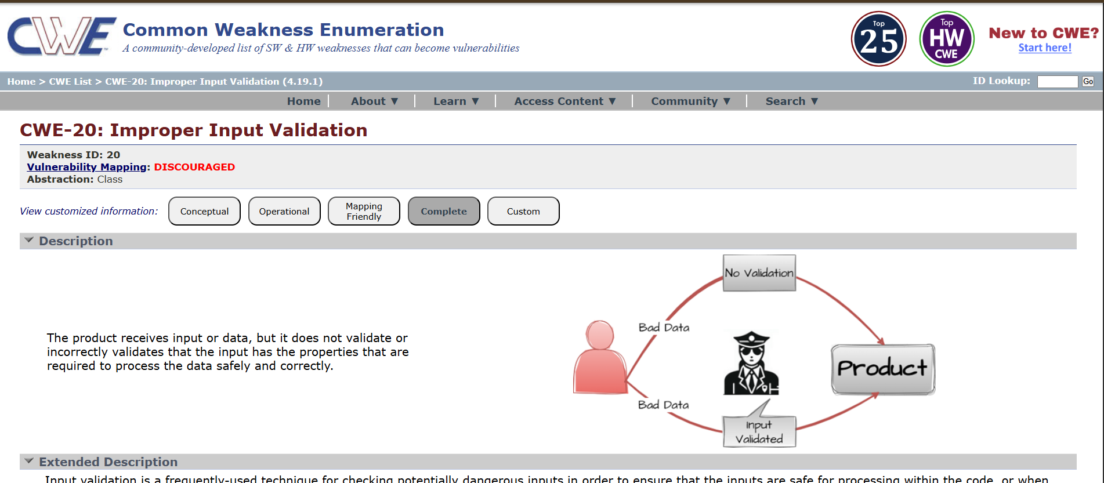
6) Vulnerability Name : Incorrect Privilege Assignment
CWE NO : CWE-266
OWASP Category: Insecure Design
Description: Incorrect Privilege Assignment occurs when a system gives users more permissions or access rights than they actually need. This can happen due to poor configuration or improper role management. As a result, normal users may gain administrative or higher-level privileges, allowing them to access, modify, or control sensitive parts of the system
Business Impact : This vulnerability can lead to unauthorized access to confidential data, system misuse, or malicious activities. Attackers or internal users may exploit these excessive privileges to modify data, disrupt services, or steal sensitive information. For businesses, this can cause data breaches, financial losses, operational disruption, and damage to reputation and customer trust.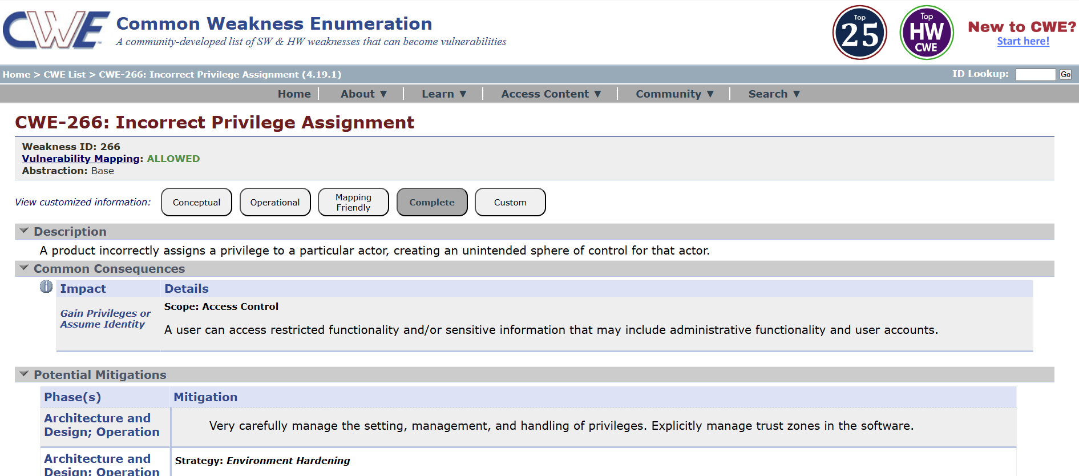
7) Vulnerability Name : Improper Authentication
CWE NO : CWE-287
OWASP Category: Authentication Failures
Description: Improper Authentication occurs when an application does not correctly verify the identity of users before granting access to the system. This can happen due to weak authentication mechanisms such as poor password policies, missing authentication checks, or insecure login processes. As a result, attackers may bypass the authentication system and gain unauthorized access to user accounts or sensitive system resources.
Business Impact : This vulnerability can lead to unauthorized access to confidential data and user accounts. Attackers may perform malicious actions such as data theft, account takeover, or system misuse. For businesses, this can result in data breaches, financial losses, loss of customer trust, and damage to the organization’s reputation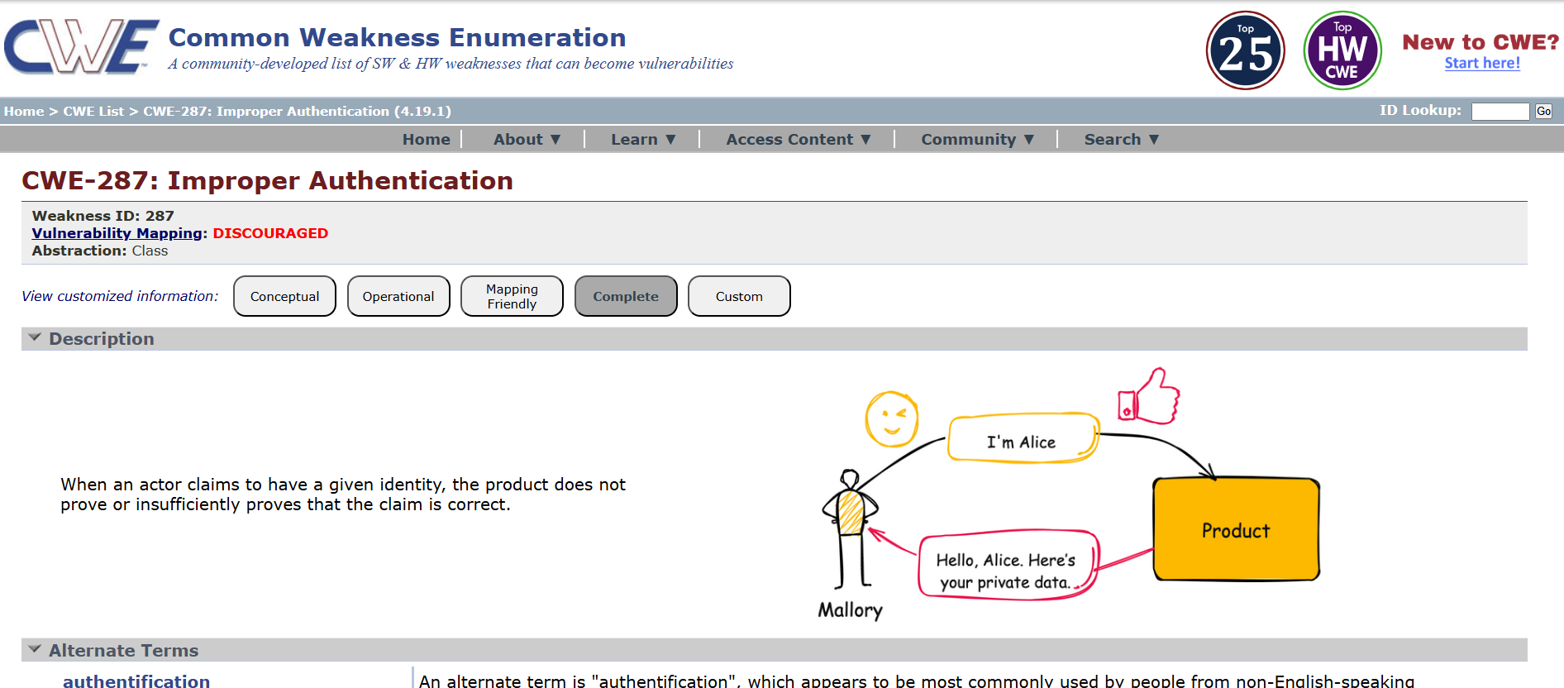
8) Vulnerability Name : Missing support for Integrity check
CWE NO : CWE-353
OWASP Category: Software or data integrity failures
Description: Missing Support for Integrity Check occurs when a system does not verify whether data has been modified, corrupted, or tampered with during storage or transmission. Without integrity checks such as hashing, checksums, or digital signatures, attackers may alter files or data without being detected by the system.
Business Impact : This vulnerability can lead to unauthorized modification of data, software, or transactions. Attackers may change important information, inject malicious code, or manipulate system operations. For businesses, this can result in data corruption, financial losses, security breaches, and damage to reputation and customer trust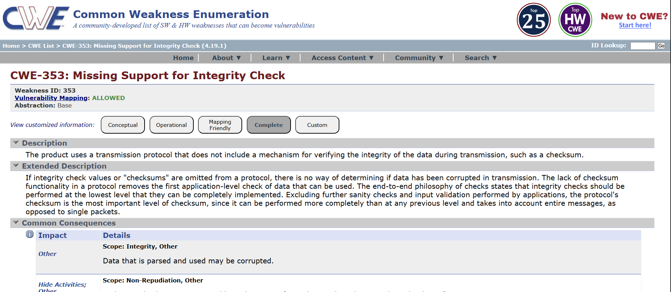
9) Vulnerability Name : Insufficient logging
CWE NO: CWE-778
OWASP Category: Security logging and alerting failures
Description: Insufficient Logging occurs when a system does not properly record important events or activities such as user logins, errors, or security-related actions. Without adequate logging, it becomes difficult to detect suspicious activities, investigate incidents, or track unauthorized access within the system.
Business Impact : This vulnerability can make it hard for organizations to identify and respond to security attacks or system misuse. Attackers may perform malicious activities without being detected. For businesses, this can lead to delayed incident response, data breaches, financial losses, and damage to the organization’s reputation. 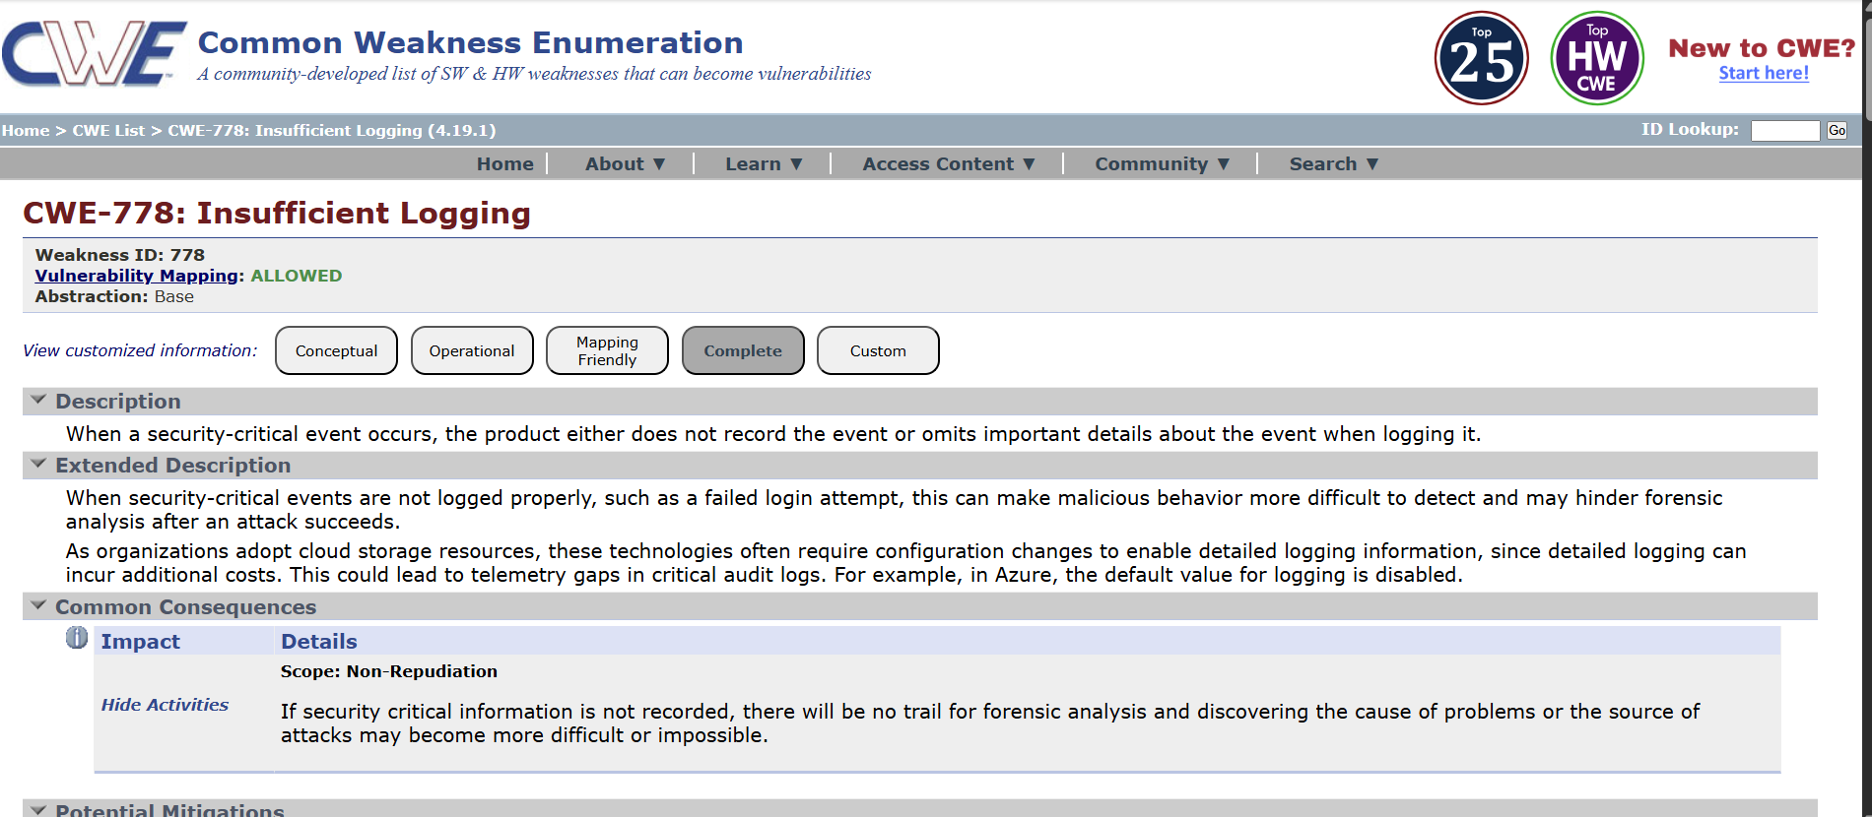
10) Vulnerability Name : Unchecked return value
CWE NO : CWE-252
OWASP Category: Mishandling and Exceptional handling
Description: Unchecked Return Value (CWE-252) occurs when a program does not check the return value of a function or method to verify whether the operation was successful or failed. Many functions return a value that indicates the result of the operation. If the program ignores this return value, it may continue execution even when an error has occurred, which can lead to unexpected behavior or security vulnerabilities.
Business Impact : This vulnerability can cause system errors, application crashes, or security weaknesses because failures are not detected or handled properly. Attackers may exploit these situations to disrupt services, manipulate system operations, or gain unauthorized access. For businesses, this can result in service interruptions, operational issues, financial loss, and damage to reputation. 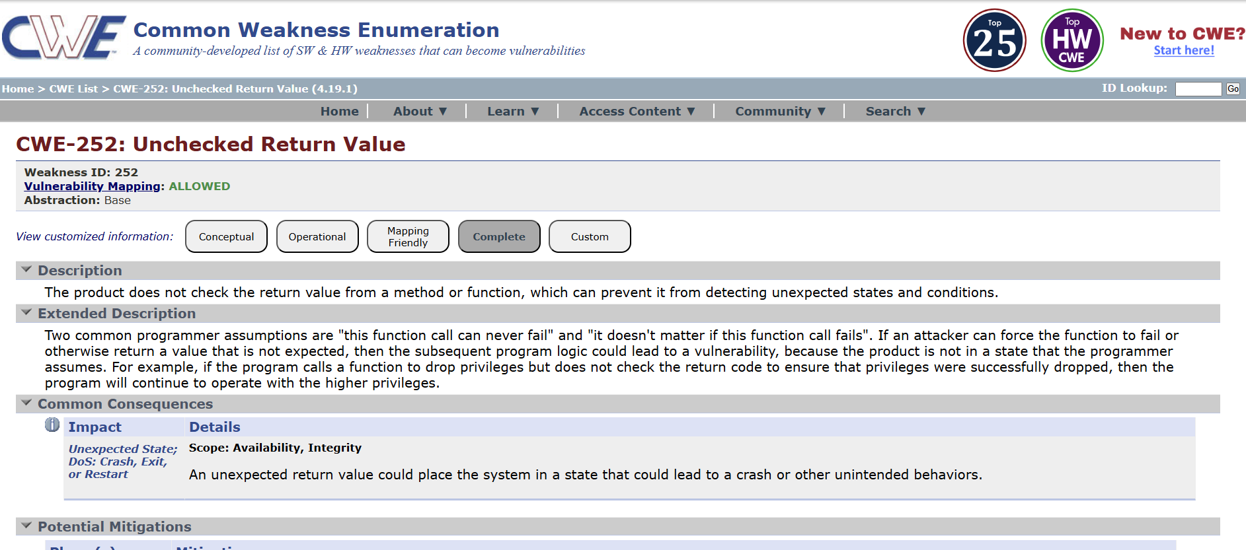

Bussiness Impact: • Attackers may intercept long HTTPS sessions and recover sensitive data.
• Information such as session cookies or authentication tokens could be exposed.
• This may lead to session hijacking or unauthorized access to user accounts TITLE: NESSUS SCAN
OVERVIEW:
Nessus is a widely used vulnerability scanning tool developed by Tenable. It is used by security professionals to identify security weaknesses, misconfigurations, and vulnerabilities in computers, networks, servers, and applications. Nessus works by scanning systems and comparing them with a large database of known vulnerabilities to detect potential security risks.
During a Nessus scan, the tool checks for issues such as outdated software, missing security patches, weak configurations, open ports, and known security vulnerabilities. It uses thousands of plugins to test systems and identify problems that attackers could exploit. After the scan is completed, Nessus generates a detailed report that lists the vulnerabilities found, their severity levels (Critical, High, Medium, Low), and recommendations for fixing them.
Importance of Nessus Scan:
Nessus scanning helps organizations improve their security posture by identifying risks before attackers can exploit them. It allows security teams to prioritize vulnerabilities, apply patches, and strengthen system security. Regular Nessus scans are an important part of vulnerability management and cybersecurity practices.
S.NO | Vulnerability Name | Severity | Plugins
1. | Nessus SYN Scanner | INFO | 11219
2. | Service Detection | INFO | 29642
3. | J Query Detection | INFO | 106658
4. | Additional DNS Hostname | INFO | 46180
5. | Device type | INFO | 54615
6. | SSL Version 2 and 3 Protocol Detection | CRITICAL | 2007
7. | Apache Tomcat SEoL (7.0.x) | CRITICAL | 171351
8. | SSL DROWN Attack Vulnerability (Decrypting RSA with Obsolete and Weakened eNcryption | MEDIUM | 89058
9. | SSL/TLS Diffie-Hellman Modulus <= 1024 Bits (Logjam) | LOW | 83875
10. | SSL Medium Strength Cipher Suites Supported (SWEET32 | HIGH | 42873

REPORT:
1)Vulnerability: Nessus SYN Scanner
Severity: INFO
Plugin: 11219
Description: The Nessus SYN Scanner plugin performs a TCP SYN scan to identify open TCP ports on a target host.
It sends a SYN packet to a port and analyzes the response:
- SYN/ACK → Port is open
- RST → Port is closed
- No response / filtered → Port may be filtered by a firewall
This method is commonly called a “half-open scan” because the TCP connection is not fully established. Nessus uses it to quickly detect running services and exposed ports on the target system.
Solution: Since this plugin is informational, it mainly reports network discovery results, but reviewing exposed services is still important for security.
Bussiness Impact: This is not a vulnerability by itself, but it indicates that:
- The scanner successfully identified open ports and services.
- Unnecessary or exposed services may increase the attack surface.
- Attackers could use similar scanning techniques to discover services and potential entry points.
- If critical services are exposed (e.g., SSH, FTP, databases), they could be targeted for exploitation
2)Vulnerability: Service Detection
Severity: INFO
Plugin: 29642
Description: This plugin identifies services running on open ports of the target system. Nessus analyzes responses from the ports to determine the type of service and sometimes the version (for example: HTTP, SSH, FTP, SMTP).
Solution: • Review the detected services and ensure they are necessary.
• Disable or close unused services and ports.
• Update and patch services regularly.
• Use firewalls or access controls to restrict service access to trusted users or networks.
Bussiness Impact: This is not a vulnerability, but it shows which services are exposed on the network. Attackers could use this information to identify potential targets for attacks if the services are outdated or misconfigured.
3)Vulnerability: J Query Detection
Severity: INFO
Plugin: 106658
Description: This plugin detects the presence of the jQuery JavaScript library on the web application. It identifies the version of jQuery being used by analyzing the website’s source code
Solution: • Check the detected jQuery version.
• If it is outdated, upgrade to the latest stable version of jQuery.
• Regularly update third-party libraries used in the application.
• Monitor security advisories for new vulnerabilities affecting jQuery.
Bussiness Impact: This is informational, but if the detected jQuery version is outdated, it may contain known security vulnerabilities. Attackers could exploit these vulnerabilities to perform attacks such as Cross-Site Scripting (XSS) or other client-side attacks
4)Vulnerability: Additional DNS Hostname
Severity: INFO
Plugin: 46180
Description: This plugin reports additional DNS hostnames that resolve to the same IP address as the scanned target. It means the server may be hosting multiple domains or subdomains on the same system.
Solution: Review the listed DNS hostnames to ensure they are expected and authorized.
Remove unused or unnecessary DNS records.
Apply proper security controls and updates to all hosted domains and services.
Bussiness Impact: This is not a vulnerability, but it reveals other hostnames associated with the server. Attackers could use this information to discover additional websites or services hosted on the same server and target them for attacks
5)Vulnerability:Device type
Severity: INFO
Plugin: 54615
Description: The Device Type plugin identifies the type of device running at the scanned IP address. Nessus analyzes network responses and determines whether the device is a server, workstation, router, firewall, printer, or other network device.
Solution: verify that the detected device type is correct and expected.
Ensure the device is properly secured and updated.
Apply appropriate security configurations based on the device type (e.g., firewall rules, access controls, firmware updates).
Bussiness Impact: This is informational only and does not indicate a vulnerability. However, knowing the device type helps security teams understand the network environment and identify which devices may require security controls or monitoring
6)Vulnerability: SSL Version 2 and 3 Protocol Detection
Severity: CRITICAL
Plugin:2007
Description: The scan detected that the server supports SSLv2 and/or SSLv3 protocols. These are outdated and insecure encryption protocols that have known vulnerabilities (such as POODLE attack). Attackers can exploit these weaknesses to decrypt sensitive data or perform man-in-the-middle attacks.
Solution: • Disable SSLv2 and SSLv3 protocols on the server.
• Enable only secure protocols such as TLS 1.2 and TLS 1.3.
• Update the web server or SSL/TLS configuration.
• Use strong cipher suites and follow modern security standards.
Bussiness Impact: • Sensitive information (login credentials, session cookies, or personal data) could be intercepted or decrypted.
• Attackers may perform Man-in-the-Middle (MITM) attacks.
• This can lead to data breaches, compliance violations, and loss of customer trust.
7)Vulnerability: Apache Tomcat SEoL (7.0.x)
Severity: CRITICAL
Plugin: 171351
Description: The scan detected that the server is running Apache Tomcat version 7.0.x, which has reached End of Life (EoL). This means the vendor no longer provides security updates or patches for this version. As a result, any newly discovered vulnerabilities will not be fixed, leaving the system exposed.
Solution: Upgrade Apache Tomcat to a supported version such as Tomcat 9.x, 10.x, or later.
- Apply the latest security patches and updates.
- Regularly monitor vendor advisories for new vulnerabilities and updates.
- After upgrading, rescan the system to verify the vulnerability is resolved.

Bussiness Impact: • The server may contain known or future unpatched vulnerabilities.
• Attackers could exploit these weaknesses to gain unauthorized access, execute remote code, or compromise the web application.
• This may lead to data breaches, system compromise, service disruption, and compliance issues.

8)Vulnerability: SSL DROWN Attack Vulnerability (Decrypting RSA with Obsolete and Weakened eNcryption
Severity: MEDIUM
Plugin: 89058
Description: The scan detected that the server is vulnerable to the DROWN attack, which occurs when a server supports the obsolete SSLv2 protocol or shares the same private key with another server that supports SSLv2. Attackers can exploit this weakness to decrypt secure HTTPS connections, even if modern TLS protocols are used.
Solution: • Disable SSLv2 completely on all servers.
• Ensure the server only supports secure protocols such as TLS 1.2 and TLS 1.3.
• Update and patch the web server and SSL/TLS libraries (e.g., OpenSSL).
• Avoid reusing the same SSL private key on servers that support weak protocols.
• After applying fixes, run another vulnerability scan to confirm the issue is resolve
Bussiness Impact: • Attackers may decrypt sensitive encrypted traffic such as login credentials or personal data.
• This can lead to Man-in-the-Middle (MITM) attacks.
• It may result in data breaches, loss of confidentiality, and compliance violations

9)Vulnerability: SSL/TLS Diffie-Hellman Modulus <= 1024 Bits (Logjam)

Severity: LOW
Plugin: 83875
Description: The scan detected that the server supports weak Diffie-Hellman (DH) key exchange parameters with a modulus size of 1024 bits or less. This vulnerability is known as the Logjam attack. Attackers may exploit weak DH parameters to downgrade the connection and decrypt secure communications.
Solution: • Configure the server to use strong Diffie-Hellman parameters (2048 bits or higher).
• Disable weak cipher suites that use small DH key sizes.
• Enable modern TLS protocols such as TLS 1.2 or TLS 1.3.
• Update the web server and cryptographic libraries (e.g., OpenSSL) to the latest versions.
• After applying changes, restart the server and perform a new vulnerability scan to confirm the issue is resolved
- Bussiness Impact: Attackers may intercept and decrypt encrypted SSL/TLS traffic.
- Sensitive information such as login credentials, session cookies, and confidential data could be exposed.
- This can lead to Man-in-the-Middle (MITM) attacks, data breaches, and loss of data confidentiality.
10)Vulnerability: SSL Medium Strength Cipher Suites Supported (SWEET32
Severity: HIGH
Plugin: 42873
Description: The scan detected that the server supports medium-strength SSL/TLS cipher suites, specifically 64-bit block ciphers such as 3DES. These ciphers are vulnerable to the SWEET32 attack, which allows attackers to exploit the small block size and potentially recover sensitive information from encrypted sessions
Solution: • Disable weak and medium-strength cipher suites, especially 3DES.
• Configure the server to allow only strong cipher suites (e.g., AES-GCM).
• Enable modern TLS protocols such as TLS 1.2 and TLS 1.3.
• Update the web server and SSL/TLS libraries to the latest versions.
• Re-run the vulnerability scan after applying the changes to verify the fix.
.

TITLE:
Integrate Zscaler with Identity Providers (IdPs) such as Azure AD, Okta, Active Directory for seamless Authentication and Authorization.
Overview:
Integrating Zscaler with Identity Providers (IdPs) such as Azure Active Directory (Azure AD), Okta, and Active Directory (AD) allows organizations to implement secure, identity-based access to internet and cloud applications. This integration ensures that users are authenticated through a trusted identity system before gaining access, while Zscaler enforces security policies based on user identity, role, and group membership. Below are the key aspects of this integration explained with detailed headings.

1. Centralized Identity Management
When Zscaler is integrated with an Identity Provider, user identities are managed centrally through platforms like Azure AD, Okta, or Active Directory. Instead of maintaining separate user databases, organizations can leverage their existing directory services.
This centralized approach simplifies user administration because user accounts, roles, and permissions are maintained in one place. Any updates—such as adding a new employee, changing roles, or removing access—are automatically reflected in Zscaler policies through directory synchronization. This reduces administrative overhead and improves consistency in access control.

2. Single Sign-On (SSO) for Seamless User Access
One of the major benefits of integrating Zscaler with IdPs is the implementation of Single Sign-On (SSO). With SSO, users authenticate once with their identity provider and can then access multiple applications and services without repeatedly entering their credentials.
For example, when a user attempts to access the internet or a cloud application through Zscaler, they are redirected to the configured IdP (such as Azure AD or Okta) for authentication. Once verified, the user gains access according to the organization’s policies. This improves user experience while maintaining strong authentication controls.

3. Secure Authentication Using Standard Protocols
Zscaler integration with IdPs typically relies on widely accepted authentication protocols such as SAML (Security Assertion Markup Language), OAuth, and OpenID Connect (OIDC).
These protocols allow secure communication between Zscaler and the Identity Provider. When a user logs in, the IdP verifies the credentials and sends a secure authentication token to Zscaler. Zscaler then validates this token and allows access based on predefined security rules. Using standardized protocols ensures compatibility and strong security across different platforms.

4. Role-Based Access Control (RBAC) and Policy Enforcement
By integrating with IdPs, Zscaler can enforce identity-based security policies using attributes such as user roles, department, and group membership.
For instance, an organization may allow finance department users to access financial systems while restricting access for other departments. Similarly, administrators can apply different web access policies for employees, contractors, or remote workers. This Role-Based Access Control (RBAC) ensures that users only access resources relevant to their responsibilities, reducing security risks.

5. Multi-Factor Authentication (MFA) for Enhanced Security
Identity providers like Azure AD and Okta support Multi-Factor Authentication (MFA), which adds an extra layer of security to the authentication process.
With MFA enabled, users must verify their identity using additional factors such as a mobile authentication app, SMS code, or biometric verification. When integrated with Zscaler, this ensures that even if a password is compromised, unauthorized users cannot easily gain access to the organization’s network or cloud services.

6. Improved Security Visibility and Compliance
Integrating Zscaler with IdPs provides enhanced security visibility and auditing capabilities. All authentication events and access activities can be logged and monitored through both the identity provider and Zscaler platforms.
Security teams can track which users accessed specific applications, detect suspicious login attempts, and generate detailed audit reports for compliance requirements. This visibility helps organizations quickly identify and respond to potential security threats.

7. Simplified User Provisioning and Deprovisioning
User lifecycle management becomes much easier with IdP integration. When a new employee joins the organization, their account can be automatically provisioned through the identity provider and synced with Zscaler.
Similarly, when an employee leaves the organization, disabling the account in the IdP immediately revokes their access to Zscaler-protected resources. This automation reduces the risk of unauthorized access due to inactive or forgotten accounts.

Conclusion
Stage 1: establishes the conceptual foundation of the project, explaining the importance of identity-driven security and the role of Zscaler and Azure AD in implementing it. This stage provides the necessary understanding of how the integration works and prepares the groundwork for the next stages, where the practical configuration, implementation steps, and testing of the integration can be explored in more detail
Stage 2:The Nessus vulnerability scan successfully identified several security findings on the target system, including informational, medium, high, and critical severity issues. The scan revealed configuration weaknesses such as support for outdated SSL protocols (SSLv2 and SSLv3), weak cipher suites, and weak Diffie-Hellman parameters, which could allow attackers to perform Man-in-the-Middle (MITM) attacks or decrypt sensitive communications.
Additionally, the system was found to be running Apache Tomcat 7.0.x, which has reached End of Life (EoL) and no longer receives security updates. This increases the risk of unpatched vulnerabilities and potential exploitation. Informational findings such as service detection, device type, DNS hostnames, and jQuery detection provide useful insights into the system environment and help security teams understand the exposed services and technologies used.
By analyzing the results of the Nessus scan and implementing the recommended solutions—such as upgrading outdated software, disabling weak encryption protocols, and strengthening security configurations—organizations can significantly reduce their attack surface and improve overall system security. Regular vulnerability scanning and timely remediation are essential for maintaining a strong cybersecurity posture
Stage 3 :of the project focused on the core components and operational benefits of integrating Zscaler with Identity Providers (IdPs) such as Azure AD, Okta, and Active Directory to enable seamless authentication and authorization. This stage explained how identity-based security mechanisms work together to provide secure and efficient access to enterprise resources.
Through this stage, it was demonstrated that centralized identity management allows organizations to manage users, roles, and permissions from a single identity platform while synchronizing this information with Zscaler. This reduces administrative complexity and ensures consistent access control across applications and services. The implementation of Single Sign-On (SSO) further improves the user experience by allowing users to authenticate once and securely access multiple resources without repeated login prompts.
The use of secure authentication protocols such as SAML, OAuth, and OpenID Connect (OIDC) ensures reliable and standardized communication between Zscaler and the identity provider. These protocols allow the identity provider to authenticate users and securely pass identity information to Zscaler, which then enforces the appropriate security policies.
Additionally, the integration supports Role-Based Access Control (RBAC), enabling administrators to define policies based on user roles, departments, or group memberships. This ensures that users are granted access only to the resources required for their responsibilities. The addition of Multi-Factor Authentication (MFA) further strengthens security by requiring multiple verification factors, reducing the risk of unauthorized access even if user credentials are compromised.
Stage 3 also highlighted the importance of security visibility, compliance monitoring, and automated user lifecycle management. By combining identity provider logs with Zscaler’s security monitoring, organizations gain better insight into user activity and potential threats while simplifying processes such as user provisioning and deprovisioning.
Overall, Stage 3 demonstrates how integrating Zscaler with modern identity providers creates a secure, scalable, and user-friendly access management framework. This approach aligns with the Zero Trust security model, ensuring that every access request is verified and authorized before granting access to organizational resources, thereby strengthening the overall cybersecurity posture of the organization.

Future Scope:
Stage1:
involves transforming the conceptual framework into a fully implemented, scalable, and secure identity-based access system. By expanding the integration capabilities, strengthening security controls, and implementing automation and monitoring features, organizations can build a robust Zero Trust security architecture that effectively protects enterprise applications, data, and users in modern cloud-based environments.
Stage2: To further enhance system security and vulnerability management, the following steps can be considered in the future:
- Regular Vulnerability Scanning
Conduct periodic Nessus scans to continuously identify new vulnerabilities and ensure that previously identified issues remain resolved.
- Automated Patch Management
Implement automated patch management systems to quickly apply security updates to operating systems, applications, and servers.
- Upgrade and Modernization
Replace outdated software and frameworks (such as older server versions or libraries) with modern and supported technologies.
- Security Monitoring and Logging
Deploy Security Information and Event Management (SIEM) tools and monitoring systems to detect suspicious activities in real time.
- Penetration Testing
Perform regular penetration testing to simulate real-world attacks and identify vulnerabilities that automated scanners may miss.
- Security Awareness and Training
Train system administrators and developers on secure configuration practices and vulnerability management.
- Implementation of Security Standards
Follow industry security frameworks such as ISO 27001, NIST, or CIS benchmarks to maintain strong security controls.
Implementing these improvements will help organizations maintain a proactive security strategy, reduce risks, and protect critical systems and sensitive data from cyber threats.

Stage3:
The project focuses on the key operational components of integrating Zscaler with Identity Providers (IdPs) such as Azure AD, Okta, and Active Directory, including centralized identity management, Single Sign-On (SSO), secure authentication protocols, Role-Based Access Control (RBAC), Multi-Factor Authentication (MFA), security monitoring, and automated user provisioning. While these capabilities establish a strong identity-based security framework, there are several opportunities for further enhancement and expansion in the future.
One important future direction is the implementation of advanced Zero Trust security policies. Organizations can extend the integration by applying context-aware access controls, where access decisions are based not only on user identity but also on factors such as device health, geographic location, network risk level, and user behavior. This helps create a more dynamic and intelligent access control system that adapts to potential threats in real time.
Another area of future development is the integration with Security Information and Event Management (SIEM) platforms such as Splunk, Microsoft Sentinel, or IBM QRadar. By forwarding authentication logs and access events from both Zscaler and the identity provider to a SIEM system, organizations can perform deeper security analysis, detect anomalies, and respond to potential cyber threats more effectively.
The project can also be expanded by implementing automated identity lifecycle management using provisioning standards such as SCIM (System for Cross-domain Identity Management). This allows automatic creation, updating, and removal of user accounts and permissions across systems, reducing manual administrative effort and minimizing the risk of unauthorized access due to outdated accounts.
Additionally, future enhancements may include integration with more cloud services and enterprise applications, ensuring that all organizational resources follow the same identity-based access control model. Expanding support for various SaaS platforms and internal applications will help create a unified and consistent security environment.
Another promising area is the adoption of AI-driven security analytics and user behavior monitoring. By analyzing login patterns, access behavior, and network activity, advanced systems can detect unusual actions and automatically trigger additional authentication steps or restrict access when suspicious behavior is detected.
Overall, the future scope of Stage 3 involves transforming the existing integration into a fully automated, intelligent, and scalable Zero Trust security ecosystem. By incorporating advanced access controls, automation, security analytics, and broader application integration, organizations can further strengthen their cybersecurity posture while maintaining a seamless and secure user access experience.
Topics Explored:
OWASP 10 , Scanning ,Vulnerability, Awareness, Centralized Identity Management, Single Sign-On (SSO) for Seamless User Access, Secure Authentication Using Standard Protocols, Role-Based Access Control (RBAC) and Policy Enforcement, Improved Security Visibility and Compliance.
Tools Explored:
Zscaler, Nessus, OWASP 10.

