Greeting AI Agent

Submitted by:
Agalya M
Course / Department:
Electronics and Communication Engineering
College Name:
V.S.B. Engineering College
Date:
19/01/2026

Greeting AI Agent

Abstract
- This project implements a simple Greeting AI Agent using Python.
- It interacts with the user, answers basic questions, and demonstrates AI-like behavior using conditional logic.
- The project is beginner-friendly and helps understand Python programming, input/output handling, and decision-making concepts.

Introduction
- Artificial Intelligence (AI) is a technology that enables machines to think and act like humans.
- A Greeting AI Agent is a simple program that interacts with users by responding to questions and greetings politely.
- This project demonstrates a beginner-level AI agent using Python 3.14.

Tools and Technologies Used
- Programming Language: Python 3.14
- IDE / Editor: Visual Studio Code (VS Code)
- Libraries Used: datetime
- Operating System: Windows Laptop

Problem Statement
- Many beginners who learn Python write programs that only display output on the screen.
- These programs do not interact with the user.
- To learn programming better, it is important to understand how a program:
- Takes input from the user
- Makes decisions using if–else statements
- Gives a proper reply based on the input
- There is a need for a simple interactive program that shows these concepts in an easy way.
- This project solves this problem by creating a basic Greeting AI Agent using Python.

Objectives
- To understand user input and output in Python
- To implement decision making using if-else conditions
- To create a simple AI-like conversational agent
- To improve logical thinking and programming skills
- To build confidence in creating interactive programs

Scope of the Project
- Suitable for beginners in Python
- Can be used for mini projects or academic submissions
- Can be extended to advanced AI concepts in the future
- Runs on any system with Python installed
- Useful for college presentations and demonstrations

System Architecture
User → Input → Python Program → Decision Logic → Output
Explanation:
- User types a message
- Program reads the input
- Conditions check the input
- Appropriate response is generated
- Output is displayed to the user

Algorithm
- Start
- Display greeting message
- Take input from the user
- Check input using conditional statements
- Respond based on predefined rules
- Repeat steps 3–5 until input = exit
- Stop

Code (Python)

print("=== GREETING AI AGENT ===")
print("Type 'exit' to stop the program")
print("Agent: Hello! Welcome. How can I help you today?")

while True:
user_input = input("\nYou: ").lower()

if user_input == "exit":
print("Agent: Thank you for chatting with me. Goodbye!")
break

elif "hi" in user_input or "hello" in user_input:
print("Agent: Hello! Nice to meet you!")

elif "how are you" in user_input:
print("Agent: I am fine. What about you?")

elif "fine" in user_input or "good" in user_input:
print("Agent: That's good!")

elif "what is ai" in user_input or "define ai" in user_input:
print("Agent: AI stands for Artificial Intelligence. It allows machines to think and act like humans.")

elif "what is greeting" in user_input:
print("Agent: A greeting is a polite way of saying hello to someone.")

elif "your name" in user_input:
print("Agent: My name is Greeting AI Agent.")

elif "who created you" in user_input:
print("Agent: I was created using Python programming.")

elif "date" in user_input:
from datetime import date
print("Agent: Today's date is", date.today())

elif "time" in user_input:
from datetime import datetime
print("Agent: Current time is", datetime.now().strftime("%H:%M:%S"))

else:
print("Agent: I am still learning. Please ask a simple basic question.")

Code Screenshot

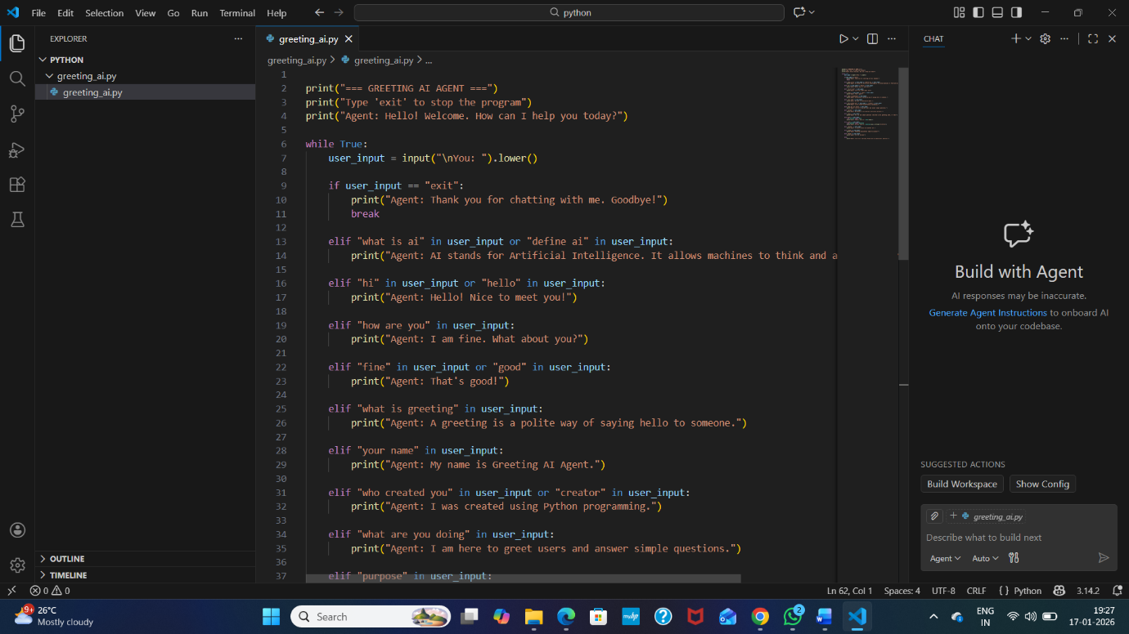
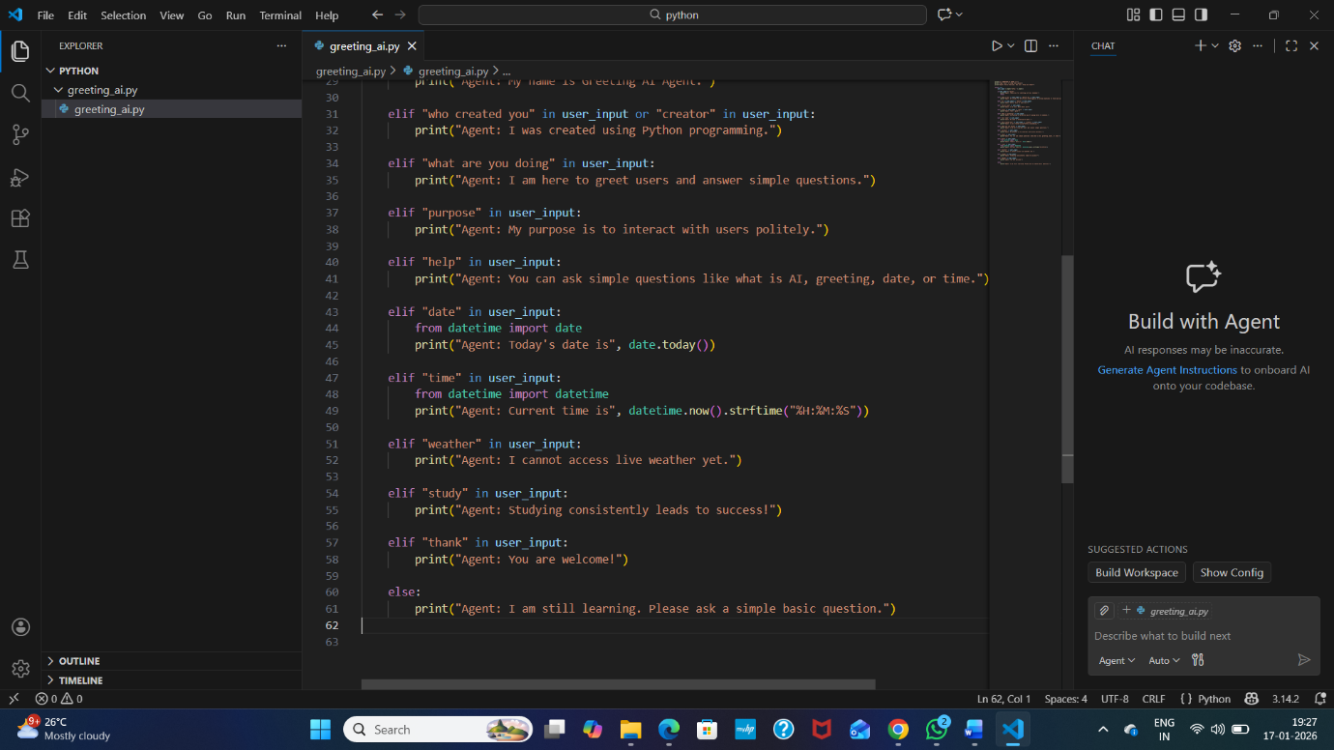
Output Screenshot

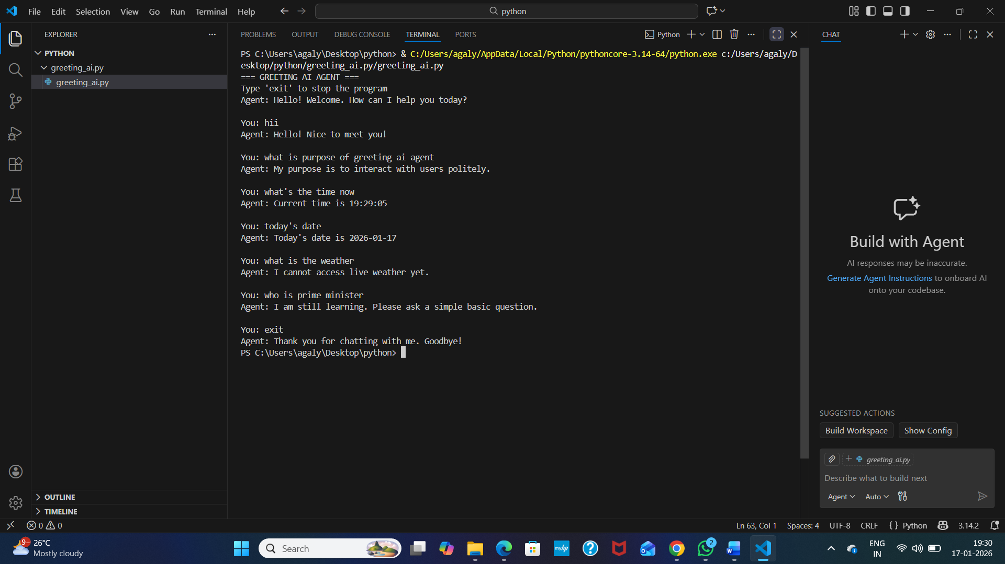

Conclusion
- The Greeting AI Agent project successfully demonstrates how Python can be used to build an interactive program.
- It helps beginners understand input handling, conditional logic, and basic AI concepts.
- Although the agent is simple, it forms a strong foundation for learning advanced AI and chatbot development.

Future Enhancements
- Add voice input and output
- Integrate real-time weather API
- Use machine learning for smarter replies
- Convert into a web or mobile application
- Store conversation history

