**MEDICAL INVENTORY MANAGEMENT**

College Name: Tiruppur Kumaran College For Women

College Code: bru3j

TEAM ID: NM2025TMID28420

TEAM MEMBERS

Team LeaderName: AGALYA. M

Email: agal4312@gmail.com

Team Member 1: THAMRIN NISHA .R

Email: thamrinnnisha@gmail.com

Team Member 2:FATHIMA. K

Email: fathima31687@gmail.com

Team Member 3: SANTHIYA. S

Email: gowthamchocoboy123@gmail.com

**ABSTARCT**

The CRM Application for Medical Inventory Management is a a-based solution designed to streamline healthcare inventory operations, including medical supply management, inventory tracking, order processing, and compliance reporting. By creating custom object, fields, record types, and roles within Salesforce, the system delivers efficient, secure, and user-friendly functionality. This project was developed to give healthcare teams hands-on experience in comprehensive inventory oversight, improving patient care through optimal stock availability and automated workflows.

The Medical Inventory Management System is a robust software solution built to simplify and automate the tracking, ordering, and replenishment of medical devices and consumables across hospitals, clinics, and ambulatory services. The solution enables accurate inventory control, reduces manual errors, supports regulatory compliance, and facilitates seamless fulfillment and reporting.

**As a team We have learned,**

Real Time Salesforce Project Implementation

Data Modelling for Medical Products

Creating Custom Applications and Objects

User Interface Customization for Healthcare Users

Defining Object Relationships (Product–Location–Supplier)

Field Dependencies and Validation Rules (Expiry Dates, Lot Numbers)

Record Types for Different Inventory Activities (Acquisition, Usage, Disposal)

Automation Flows for Stock Updates and Alerts

Approval Processes (Purchase Orders, Replenishments)

Reports & Dashboards for Inventory Analytics

Formula Fields for Calculations (Stock Levels, Expiry Tracking)

**Project Overview**

This Salesforce project is designed to manage medical inventory for healthcare organizations, enabling efficient tracking of medical supplies, products, and devices across different locations (clinics, warehouses, ambulances). The solution automates stock updates, manages supplier data, facilitates procurement, and ensures compliance with health standards.

**Objectives**

Streamline inventory tracking and fulfillment for medical products.

Ensure product availability and prevent stock-outs or overstock situations.

Automate supplier, purchase, and replenishment workflows.

Facilitate real-time analytics for inventory levels and movement.

Meet regulatory compliance regarding medical device traceability.

**Objects & Components:**

List Salesforce standard/custom objects: Product, Inventory, Supplier, Purchase Order, Inventory Transaction, Location, Contact.

Describe configuration for each object (fields for product name, SKU, quantity, supplier details, and warehouse location).

* By clicking this link <https://developer.salesforce.com/signup>
* Enter the details

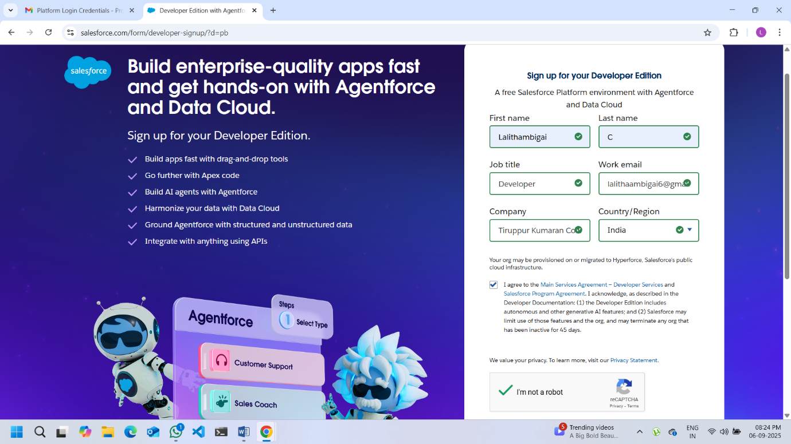

* Check your email and reset your password

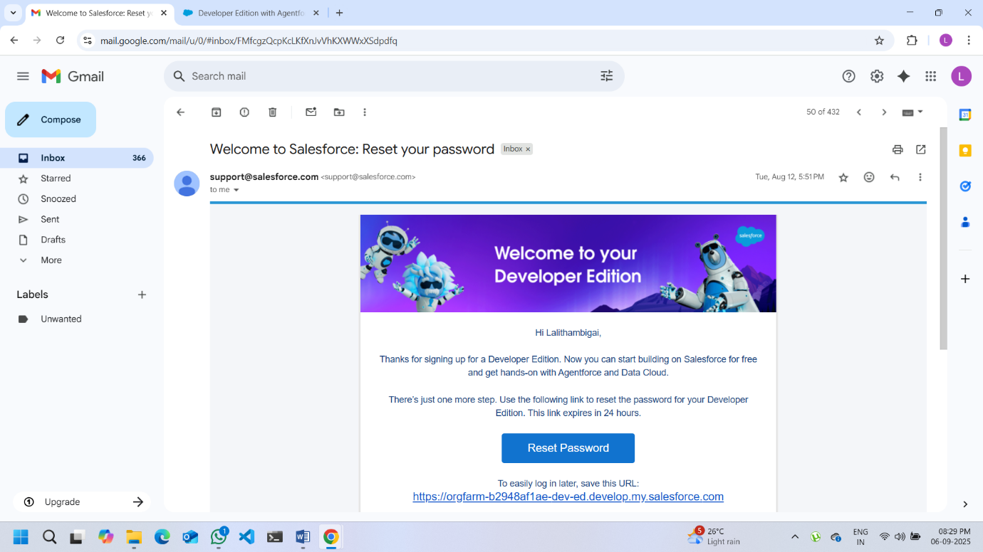

* By clicking the login link given in your email, you are edirected to setup page
* Setup page >>Object Manager >>New >>Custom Object>>(Product,Supplier,Order Items,Inventory Transactions,Purchase Order)

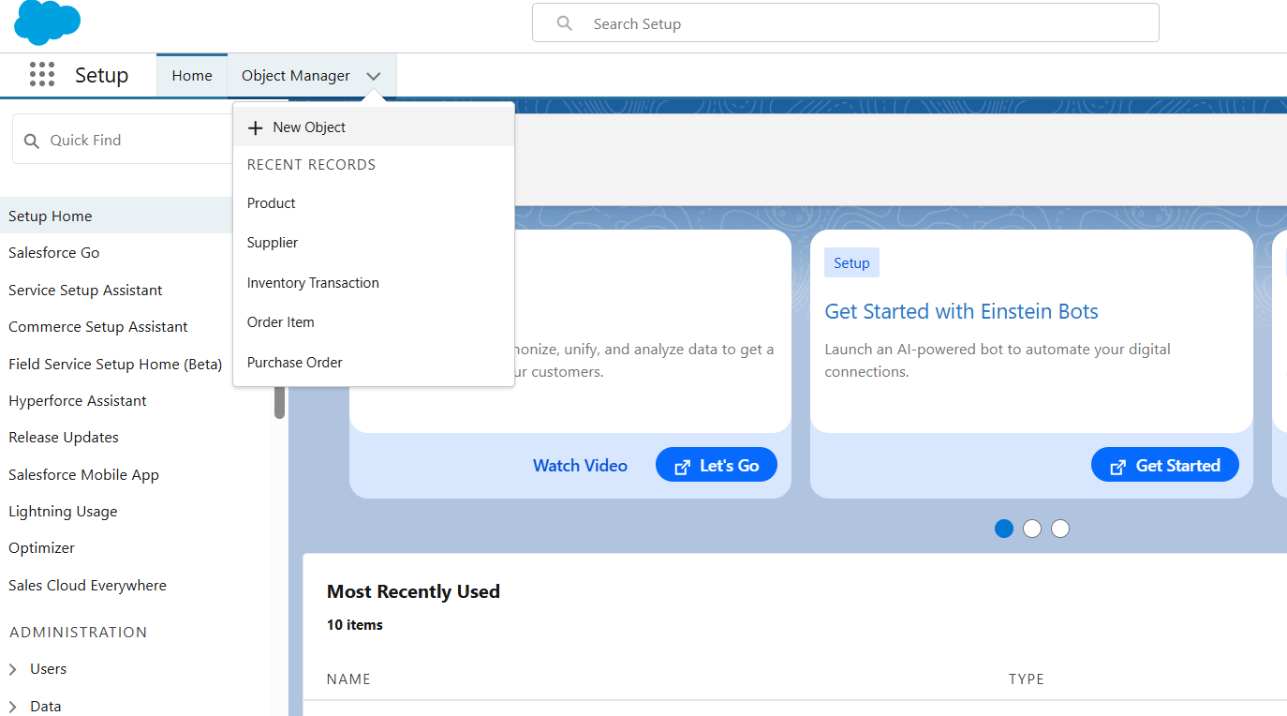

* Quick Find >> Tabs >> Custom Object Tab(New)
* Create the required TabStyle or the Objects that we are created

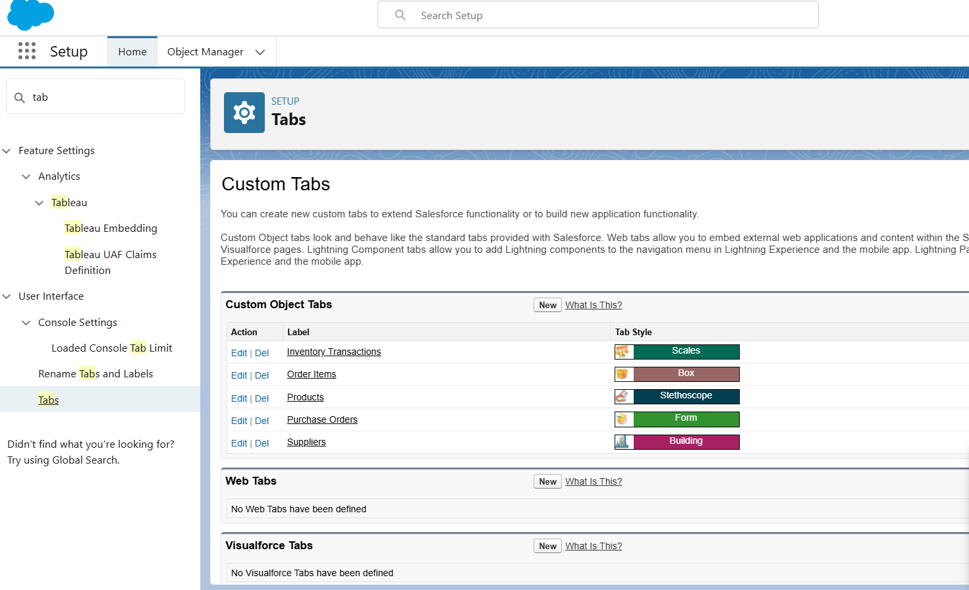

* Quick find >> App Manager >>New Lightning App >>App Name(Medical Inventory Management) >> Upload the image >>Save

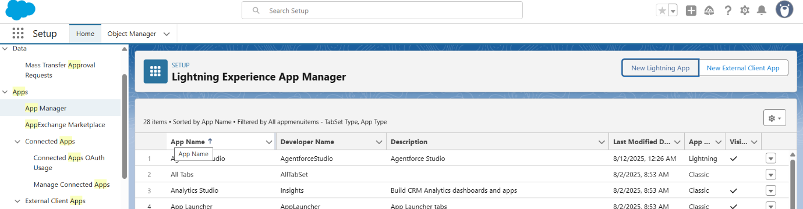

* Click on the AppLauncher
* Search for the name that you have created

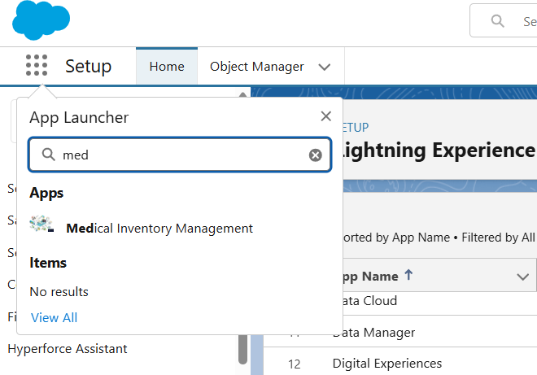

* As Shown in the below Tabular Column
* Create the Required Fields for the objects

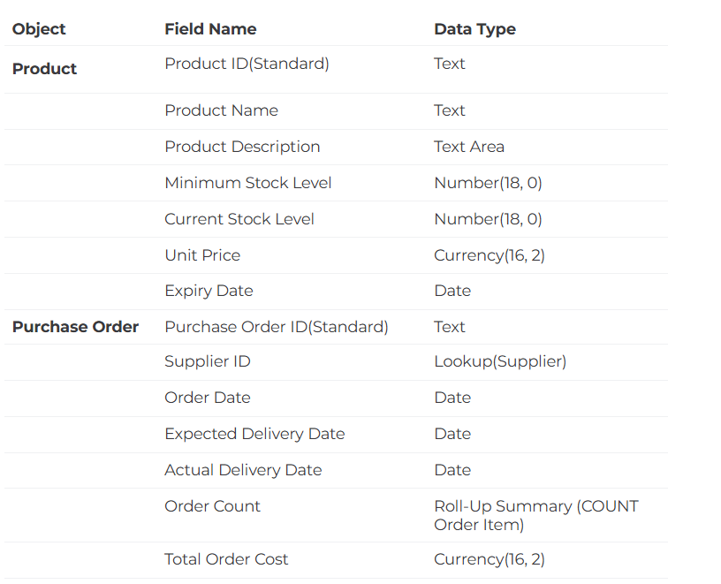

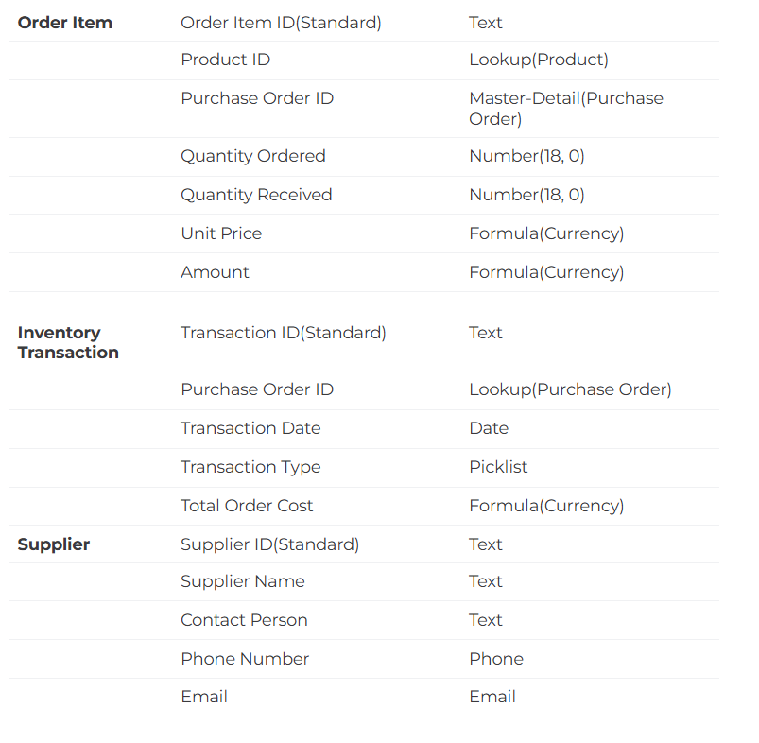

* Object Manager >>Product >> Page Layout >>Drag the fields given below

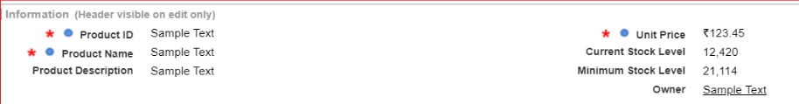

* Object Manager >>Purchase Order >>Page Layout >> Drag the fields

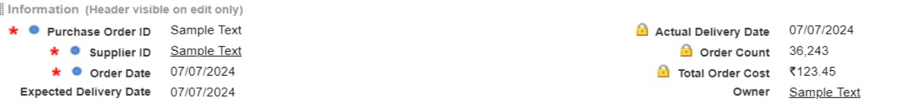

* Object Manager >>Order Item >>Page Layout >> Drag the fields

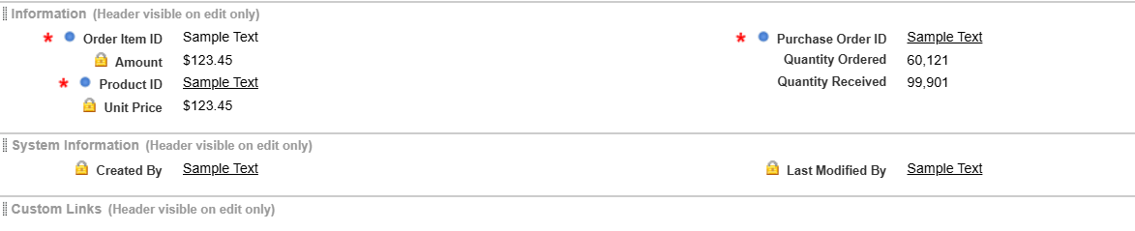

* Object Manager >>Inventory Transaction >>Page Layout >> Drag the fields

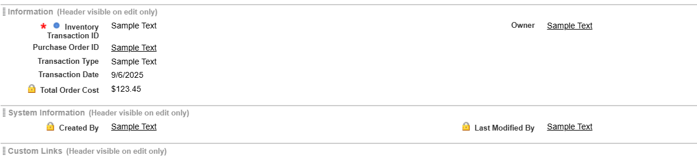

* Object Manager >> Supplier >>Page Layout >> Drag the fields

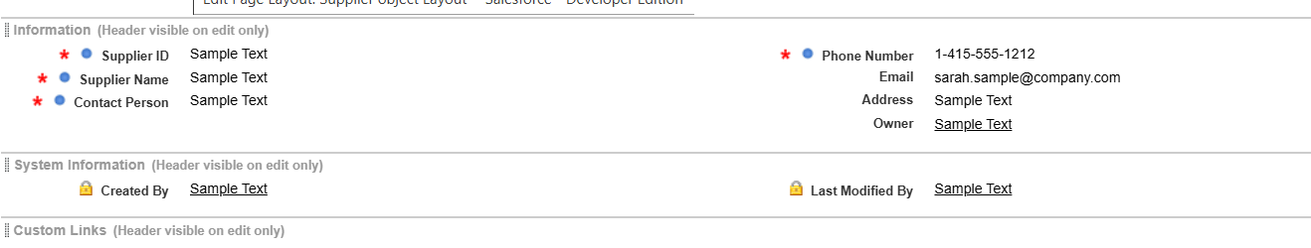

* Object Manager >>Product >>Compact Layout>>Move the (Product Name,Unit Price,Current Stock Level) fields to Selected Fields

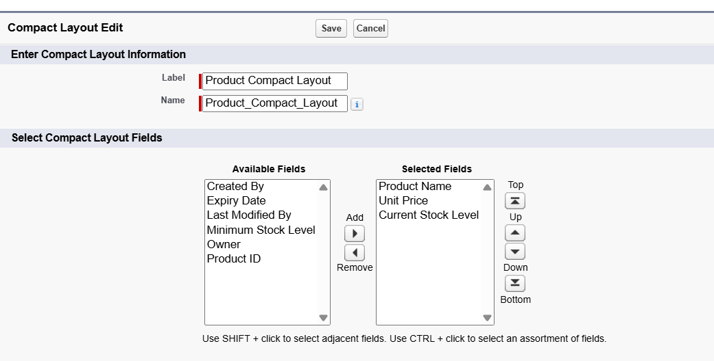

* Object Manager >>Purchase Order >> Compact Layout>>Move the (Purchase Order ID,Order Date,Total Order Cost,Supplier ID) ) fields to Selected Fields

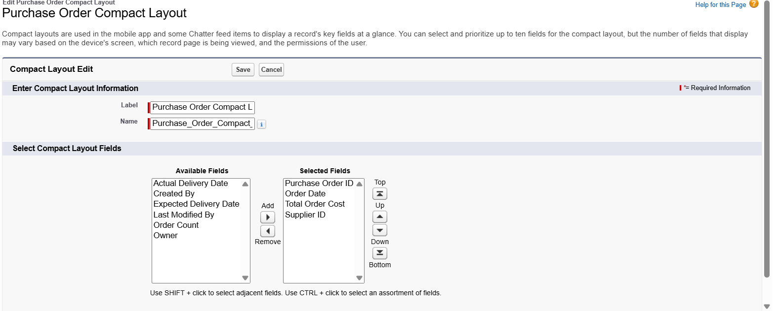

Validation, Approval, Automation:

Briefly describe how validation rules prevent incorrect data entry (e.g., negative stock values, expired products).

Overview of approval workflows for reorder requests and purchase approvals.

List automation flows, such as record-triggered flows to update delivery dates, autofill delivery fields, and calculate total costs with Apex triggers.

* Object Manager >>Purchase Order >>Validation Rule

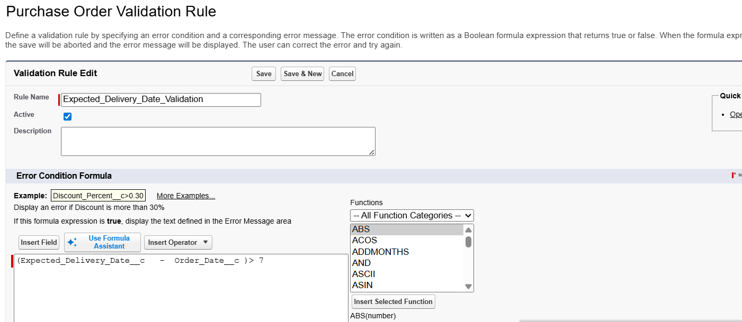

* Quick Find >>Profiles >> Clone (Standard User)>>Edit>>Save

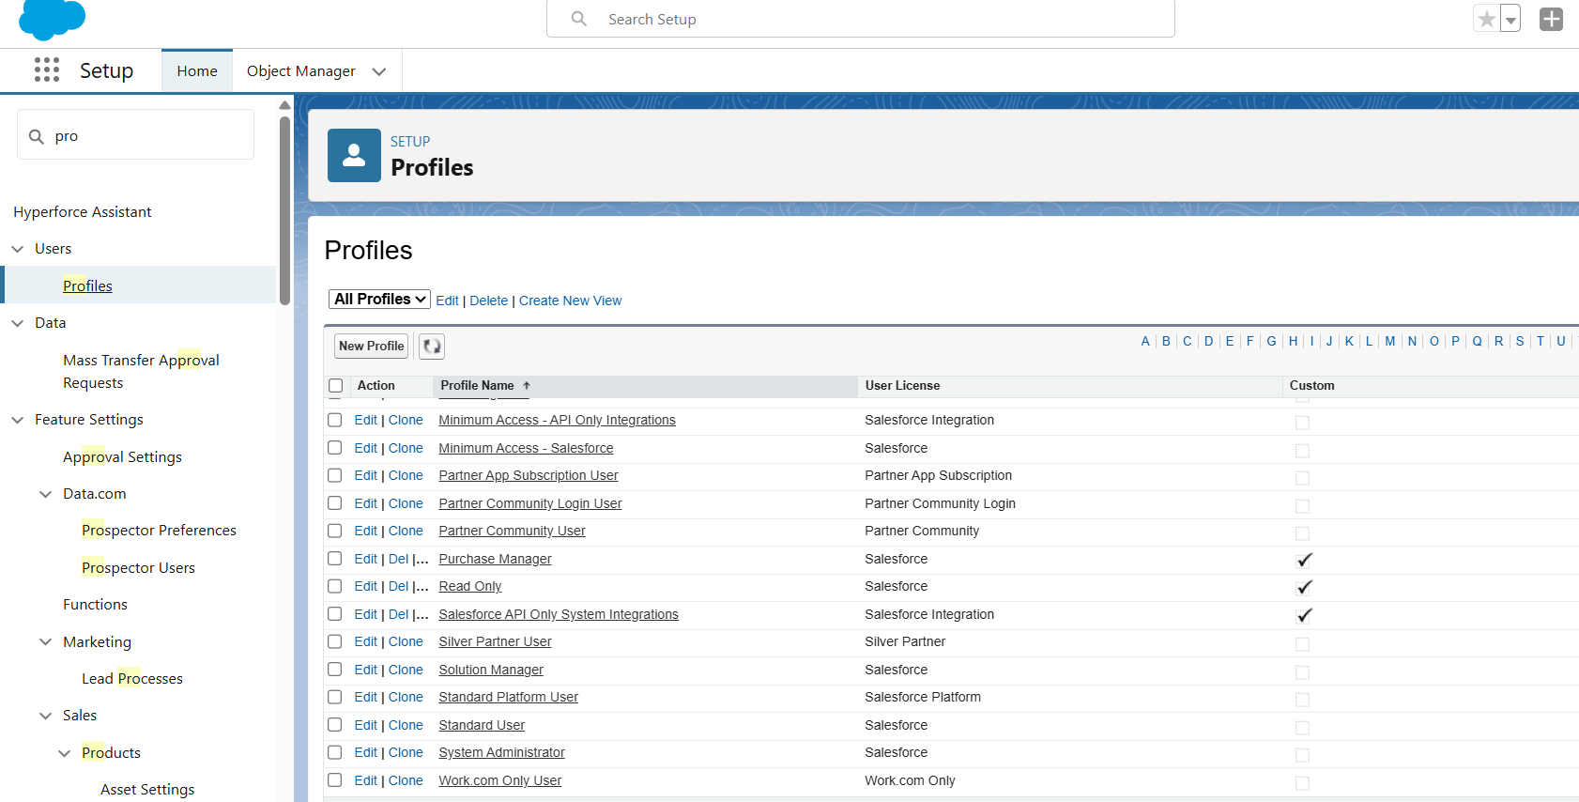

* Quick Find >>Roles >>Setup Roles>>Edit the roles Page >>Save

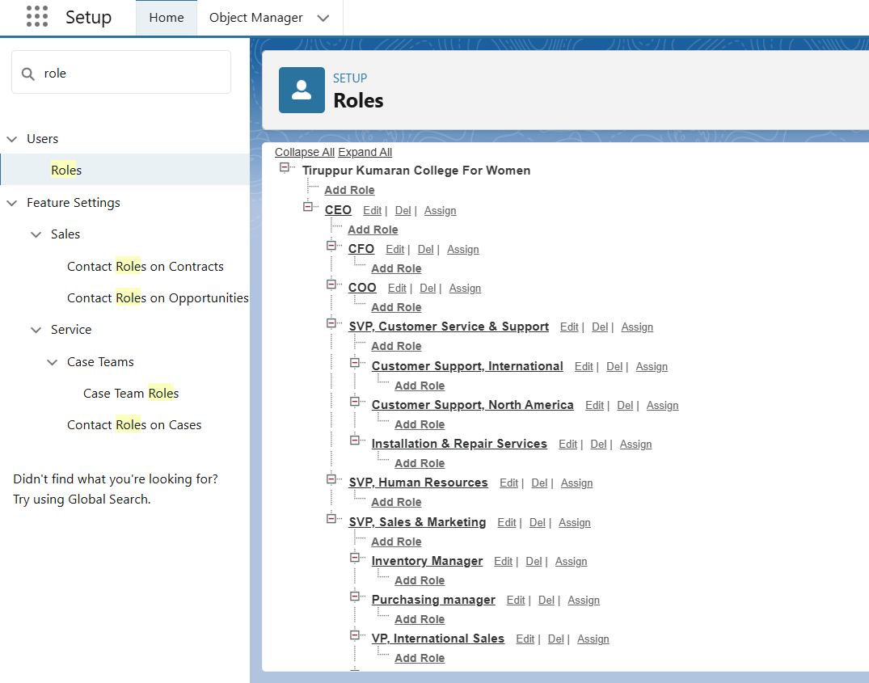

* Quick Find >>Permission Sets>>New >>Give the Label Name>> Save

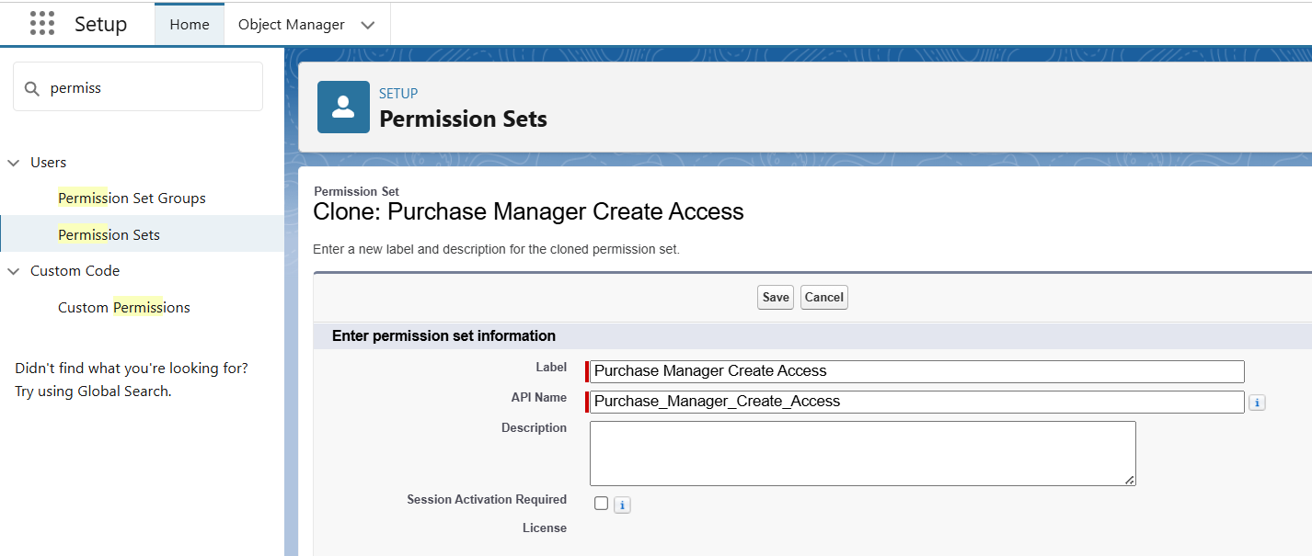

* Quick find >>Flows >> Start >>Edit The Record Page(Get Recors,Assignments,Update Record) >> Activate the flow

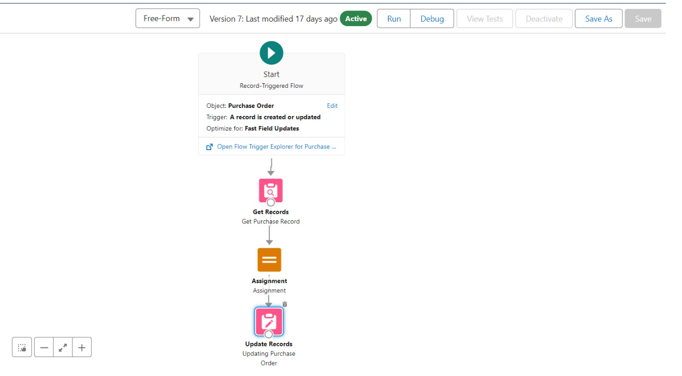

* Click on the Setup gear icon >> developer console
* File >>New >>Apex Class>> CalculateTotalAmountHandler
* File >>New >>ApexTrigger>>CalculateTotalAmountTrigger (TriggerName),Order_Item__c (objectname)

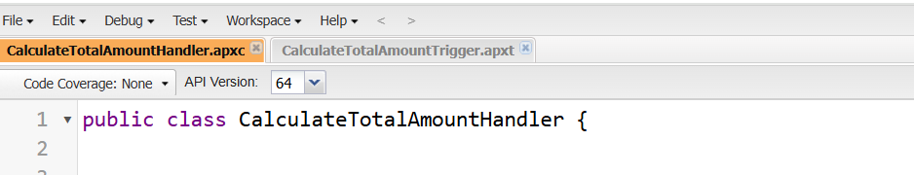

* App Launcher>>Medical Inventory App >>Reports Tab >>New report >>Create the following Reports
  + - Purchase Order Based On Suppliers
    - Complete Purchase Details Report

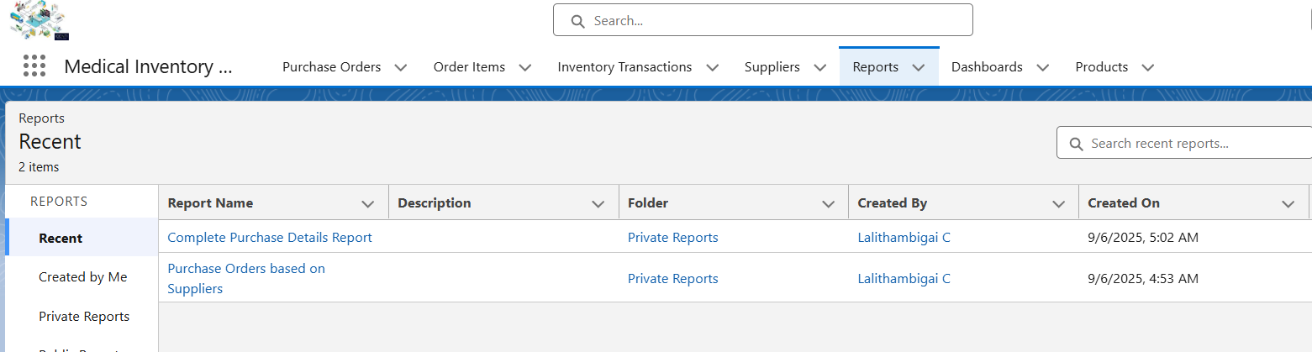

* Medical Inventory App >> Dashboard Tab>>New Dahboard >>Click on (+Widget) >> Charts or Tables >> Required Style

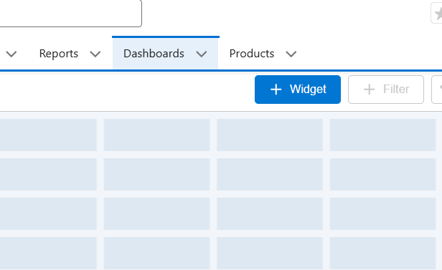

* Field Name ( Medical Inventory Dashboard) >> Click on Save

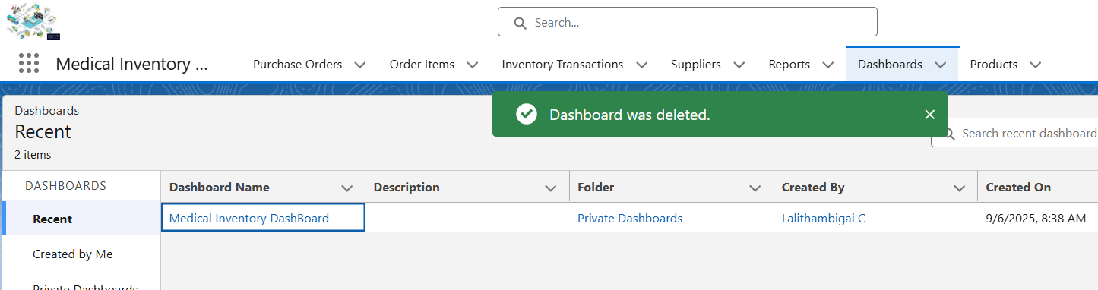

**Conclusion**

The Salesforce medical inventory management project centralizes healthcare stock oversight, reduces human error, and supports patient care by ensuring critical medical supplies are always available when needed.