**Cancer Vision: Advanced Breast Cancer Prediction with Deep Learning**

K.Balachandran, 3rd Year, Department of Biomedical Engineering,

Karpaga Vinayaga College of Engineering & Technology,

Chinna Kolambakkam, Madhuranthagam(T.k), Chengalpattu (D.t)-603308

**Introduction**

Breast cancer can develop when breast cells replicate abnormally. It is now a worldwide issue that concerns people’s safety all around the world. Every day, women die from breast cancer, which is especially common in the United States. Mammography, CT, MRI, ultrasound, and biopsies may all be used to detect breast cancer. Histopathology (biopsy) is often carried out to examine the image and discover breast cancer. Breast cancer detection at an early stage saves lives. Deep and machine learning models aid in the detection of breast cancer. The aim of the research work is to encourage medical research and the development of technology by employing deep learning models to recognize cancer cells that are small in size. For histological annotation and diagnosis, the proposed technique makes use of the BreCaHAD dataset. Color divergence is caused by differences in slide scanners, staining procedures, and biopsy materials. To avoid overfitting, we used data augmentation with 19 factors, such as scale, rotation, and gamma. The proposed hybrid dilation deep learning model is of two sorts. It illustrates edges, curves, and colors, and it improves the key traits. It utilizes dilation convolution and max pooling for multi-scale information. The proposed dilated unit processes the image and sends the processed features to the Alexnet, and it can recognize minute objects and thin borders by using the dilated residual expanding kernel model. An AUC of 96.15 shows that the new strategy is better than the old one.

 patch-wise classifier evaluates multiple unique parts of the image at various magnification levels, before selecting how to categorize the full image. The results of this processing will be combined with the results of processing the whole picture patches in the following step to produce an image-wise classification. This classification will be determined by the total number of image patches under development. To accurately categorize histology photographs into one of the various required classifications, first, one must find the key components of the images and then study these features. Only then will it be possible to properly label the pictures. The data supplied describe the nucleus characteristics, texture, and overall tissue architecture. The shape, color, and structure of the nucleus can be used to identify and distinguish cancer cells from healthy ones. Normal cells can be identified by the absence of specific characteristics. This stage is critical for distinguishing between benign and malignant cells (e.g., density or variability). A fundamental understanding of tissue architecture is required to distinguish between in situ and metastatic carcinomas. The categorization method is used to generalize learned traits over a wide range of spatial sizes, from glands to cell nuclei.

 Early detection has been shown to have a high association with public awareness , and both variables can dramatically reduce death rates. If a patient’s prognosis is positive and they obtain an accurate diagnosis, they have a far greater chance of fully recovering. It is, therefore, critical to develop effective technologies that can increase the rate of early diagnosis and reduce death rates

he use of computerized image inspection and machine learning algorithms has recently become practical. A decade ago, digital pathology used microscopes with cameras to digitally scan complete tissue samples. Recent advances in image analysis and processing power have assisted in the incorporation of computer-aided diagnostic (CAD) systems into pathology lab operations. These tools were made to help pathologists find, diagnose, and predict illnesses. In terms of diagnosis and prognosis, DL-based CAD systems have made major contributions to the growth of the medical business. Data from radiology, pathology, cardiology, pharmacology, cancer, and genomes are analyzed by these systems. In recent decades, more sophisticated systems based on machine learning principles have been used to diagnose cancer. Immunohistochemistry is one such approach. There has been a substantial increase in the number of times this strategy has been deployed. Since it is beneficial in cancer prediction and prognosis, DL is generally recognized as one of these approaches. The higher diagnostic accuracy of DL can aid in the improvement of mammograms, ultrasounds, and digital breast tomosynthesis (DBT). Because it provides a better degree of precision than other approaches, DL is used in the treatment of breast cancer (BrC). There has been a flood of scientific articles pertaining to BrC during the last several years. Deep learning is used in several contexts in all these studies. Deep learning algorithms are able to automate the BrC diagnosis procedure, which is riddled with flaws and errors. Despite the large number of BrC classification review studies that have been conducted thus far, only a small number of them can offer guidance to future researchers

Automatic biological data analysis may help pathologists make early or on-the-spot diagnoses. These strategies assist pathologists in reducing their workload by isolating and screening out non-cancerous regions. They also assist pathologists in detecting breast cancer early, which reduces fatalities. An assessment of the research paradigm, strategy, or framework is required. In a validated system, performance measurements for segmentation and classifiers may be employed. As a result, two datasets must be used for training and testing. The system must be evaluated on a separate dataset to prevent memorization.

**Proposed Methodology**

**Data Augmentation**

The model’s initial goal is to deal with overfitting concerns caused by the restricted number of photos used in the training phase. To address this, we employ data augmentation as the first step, so that we may make use of rotation, scaling, shift, and gamma correction with various parameters. Breast Cancer Histopathological Image Classification (BreakHis) includes 2480 benign photos and 5429 malignant images, whereas Breast Cancer Histopathological Annotation and Diagnosis (BreCaHAD) includes 162 breast cancer images. Techniques such as flipping, rotating, shifting, scaling, and gamma are all valuable. The parameters tested for augmentation are shown in [Table 1](https://www.ncbi.nlm.nih.gov/pmc/articles/PMC9600132/table/diagnostics-12-02505-t001/). In the top row of Figure 1, a histology picture from the dataset is shown, followed by a strain normalized image and a rotational image. The second row shows a flipped image with gamma values between 0.3 and 1.2.

An external file that holds a picture, illustration, etc.
Object name is diagnostics-12-02505-g005.jpg

Figure 1 Data Augmentation Results

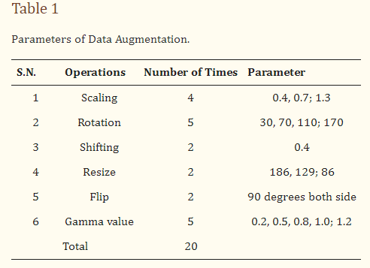

### Hybrid Dilation Deep Learning Model

Histology images were utilized to evaluate the correctness of the pre-models. Using this technology, cancer cells are captured and differentiated.. The missing pixels are then dilated and the Hadamard product is used to connect the input result to the entirely connected layers. The technology improves the accuracy, while broadening the receptive field. To extract features, dilated convolution is employed. Dropout and overfitting are reduced when data are normalized in bulk. Excellent results in terms of localization and mitotic centroid measurement are achieved. All cancer cells need high-resolution images. The suggested architecture makes use of fewer than half of the network layers shown in the picture. Batch normalization of a simplified symmetric skip network is carried out. The proposed model has the highest AUC (96.15). In addition, 3 × 3 convolution aided in the identification of micro-cells.

An external file that holds a picture, illustration, etc.
Object name is diagnostics-12-02505-g006.jpg

Figure 2 The Proposed Hybrid Dilation Deep Learning Model.

In this section, we present some of the most pressing issues and solutions. In the absence of visuals, convolutional neural networks overfit, impairing detection. The model provides two preprocessing processes for extending the dataset. First and foremost, it combines BreakHis and BreCaHAD. The dataset is then rotated, shifted, gamma-flipped, and scaled. While the degree of malignancy remains the same, the manifestation of the disease is altered. This method improves photographs by adjusting the contrast without affecting the image data.

Many histology images with the same label may have different pixel intensity levels. This has an adverse effect on performance. This problem has been solved by the proposed feature extraction module, which takes the input image and performs the convolution procedure. Those used in histopathology frequently have a slightly greater resolution and cover a significantly larger area than images used in other imaging disciplines. A typical pathology slide’s resolution can exceed 100,000 pixels wide and 100,000 pixels deep, when scanned at high magnification. This is possibly the most distinguishing feature of histology photos. Because clinical annotations, such as written reports, apply to the entire picture or collections of images rather than specific locations within the image, it may be difficult to precisely match a search “query” with the relevant section of the image. Therefore, it may also be difficult to locate the region of the image that matches the “query” that was entered in the search field. This is demonstrated by the fact that a tumor in a pathology imaging study may be just one hundred pixels wide, or around one millionth of the whole picture area. Even if a medical specialist, researcher, or medical student found the photos using a text-based search, physical inspection would still be required to diagnose the lesion. One must complete this stage before proceeding to any other form of analysis. Real-world pathology cases, such as those in many other professions, typically involve multiple photographs. The text labels that are given may not be specific enough for the illness subtype that is of interest.

Reverse image search, also known as content-based image retrieval, looks for images that are visually “similar”. This strategy might be applied to address concerns outside of medicine. A clinician may opt to search a database for identical lesions as part of the diagnostic procedure to confirm whether a given trait of interest is suggestive of a benign or malignant histologic mimic, such as basal cell carcinoma. This approach can be used to determine if a worrying discovery is a benign or malignant histologic mimic. The doctor may assess the affected location to determine whether the characteristic of concern is a benign or malignant histologic mimic. Examples of technology that may have applications outside of the medical area include “search by photo” for common images, visual search for retail products, and various tools for faces and art. Analogous research exists in the medical imaging-related subfields of pathology and radiology. Models were created for each application in early CBIR systems that relied on machine learning. So, in order to install these technologies, it was necessary to collect labeled data for each application, which took a significant amount of time. Dimensionality reduction has two components, Fx and Fy. Fx then goes through average pooling to obtain smaller Fx (avg) and max pooling Fy (max) values to obtain a better value, which is then combined to make the feature map.

Feature maps are dilated with a dilation value of 4 to increase the receptive field of the architecture. As the dilation value increases, the receptive field grows, and the dilation mechanism multi-scales the features. The features are then obtained by performing element-wise multiplication of the input image and the feature map. The feature is then aggregated with the features generated by global average pooling and maximum pooling, followed by fully connected layers and dilation, and the weighted sum of these two blocks is used to retain the features of both long and short regions, enhancing the essential elements, while suppressing the useless information. As a result, the pixels can be observed more clearly. Furthermore, the cancer cell may be detected more precisely.

Expansion convolution searches for items while minimizing complexity (Perone, Calabrese & Cohen-Adad, 2018). Dilation broadens the network rather than increases the size of the filters at all levels. The filter depth may be calculated using the formula (2d + 1) × (2d + 1). The four receptive fields for d = 1, 2, 3 are 3 × 3, 5 × 5, 7 × 7, and 9 × 9. In addition, (x, y) = I (x + s × I y + s × j) denotes the dilated convolution (7). D(x, y) is a sparse dilated convolution filter with the input parameter I(x, y). When s = 1, dilation and standard convolution provide identical results. Dilation widens the receptive field without increasing the number of parameters. It also makes the process easier because dilation only adds a convolution operation to the process.

**Results**

### Trial and Evaluation of Models

There are 70 and 30 training and testing datasets, respectively. In addition, we update both the training and enriched data in 80/20 splits. The experimental data sets are summarized in. [Table 2](https://www.ncbi.nlm.nih.gov/pmc/articles/PMC9600132/table/diagnostics-12-02505-t002/) contains image information for both datasets. [Table 3](https://www.ncbi.nlm.nih.gov/pmc/articles/PMC9600132/table/diagnostics-12-02505-t003/). They are used to configure the network and choose hyperparameters. The proposed model is used for object recognition. Convolution was applied after max pooling to increase the receptive field, as shown in below figure.

An external file that holds a picture, illustration, etc.
Object name is diagnostics-12-02505-g007.jpg

Figure2: Receptive Field Growth Layer vs. Receptive Field Number: (**a**) Stride (S) = 1, dilation 1, 1, 2, 2, 2 (**b**) S = 2, dilation 1, 1, 2, 2, 2 (**c**) S = 3, dilation 1, 1, 2, 2, 2 (**d**) S = 4, dilation 1, 1, 2, 2, 2.

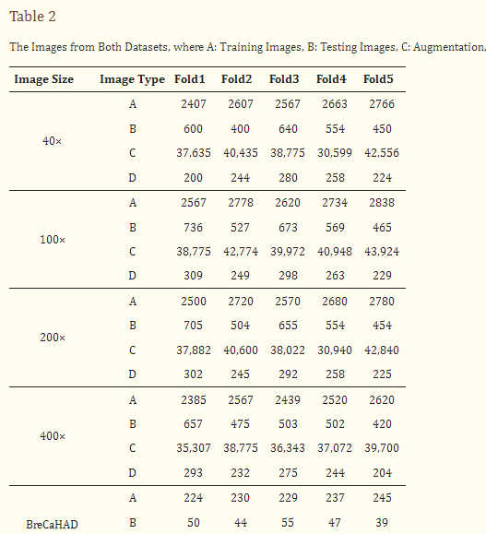

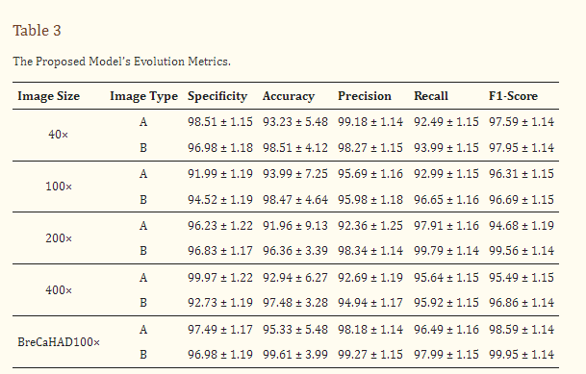

### Testing

TensorFlow 2 and Keras 2.4 are used in this Python 3.9 model. It has two Nvidia GeForce GTX 2070 GPUs, as well as a 16 MB cache. A dilated convolution model with many scales is used for object identification. Convolution was applied after max pooling to increase the receptive field (Figure 3). Dilated convolutions are the most dominant. The proposed multi-scale extended convolution model is better at predicting pixels for both malignant and benign tumors than the previous model.

BreakHis comprises 7909 actual samples (photos) from 82 people, including 2480 benign and 5429 malignant photographs, as well as 162 BreCaHAD breast cancer images. There were 153,349 parameters in the 7909 BreakHis samples and 3078 BreCaHAD images. The sections that follow compare the results of binary and multiclass classification. This model excels at identifying small details. Convolution was used to enhance the receptive field after max pooling. Instead, dilated convolution is used in the suggested model. The suggested model differentiates normal and malignant cells. Other convolution layers, as well as stochastic units for downsampling and upsampling, are used in the new model.

Better specificity, accuracy, precision, recall, and F1-score are shown in [Table 3](https://www.ncbi.nlm.nih.gov/pmc/articles/PMC9600132/table/diagnostics-12-02505-t003/). The proposed model has a 98.60 percent accuracy for BreCaHAD and a 98.41 percent accuracy for BrekHis in the model with enhanced images, where A is the original picture and B is the enhanced image.

The receiver operating characteristic curve of the BreaKHis dataset was enlarged 40 times (1–5). These cell numbers indicate that the cells are in good health and indicate 90/10, 80/20, and 70–30 percentiles. RESNet50 and ResNeXt-101 models were used. ResNeXt101 outperformed ResNet50 on the provided datasets ([Table 4](https://www.ncbi.nlm.nih.gov/pmc/articles/PMC9600132/table/diagnostics-12-02505-t004/)). The accuracy, sensitivity, and precision of the model are exceptional. The VGG19 and VGG16 demonstrated the top five testing error rates of 8.9 percent and 9.2 percent, respectively. Their performance is evaluated in this section. Units such as the ghost unit and stochastic upsampling were proposed. The proposed model, which is derived from a network, discovers missing and minor properties. It was brightened and contrasted using adaptive histogram equalization. By integrating the two datasets (BreCaHAD and BreakHis), overfitting was reduced (BreCaHAD and BreakHis). This model improves the precision of the tip, contour, and color. These tools were used to analyze BreakHis and BreCaHAD data. Its small dataset hinders further study; however, it improves model accuracy. Small deviations are identified without the need for additional complexity. The detection of small cells improves network performance. The attributes are extracted algorithmically. Extra variables are not needed to distinguish malignant from normal cells and Figure 4 shows the malignant image segmented by units. Our suggested technique is ideal for detecting breast cancer. It can properly identify breast cancer at a low processing cost. Our method can also identify a variety of disorders.

An external file that holds a picture, illustration, etc.
Object name is diagnostics-12-02505-g008.jpg

Figure 3 Detection of Breast Cancers. (**a**) Input H&E Image (**b**) image after gaussian smoothing (**c**) It is the gradient magnitude it is determining in which direction the change in intensity is pointing (**d**) Gradient in the X direction (**e**) It is the non-maximum suppression for the detection of edges of cancerous cells (**f**) Image with minor contours and features.

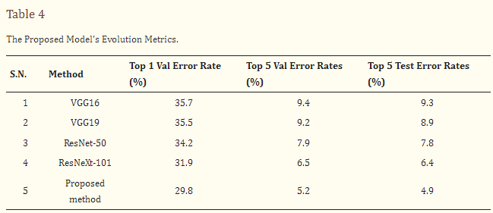

**Conclusion**

Every day, women die from breast cancer in the United States. The aim of the research work is to encourage medical research and the development of technology by employing deep learning. The proposed hybrid dilation deep learning model is of two sorts. It utilizes dilation convolution and max pooling for multi-scale information. Cancer is now the main cause of mortality in almost every country. Between 2005 and 2015, the global cancer incidence increased by 33%. Breast cancer is the world’s sixth most deadly illness. Early identification and public awareness have the potential to significantly decrease mortality. Advances in image analysis and processing power have assisted in the incorporation of CAD systems into pathology lab operations. They also assist pathologists in detecting breast cancer early, which reduces fatalities. Image augmentation increases the number of pictures in a dataset, removing overfitting difficulties caused by dataset size constraints. Flipping, rotating, shifting, scaling, and gamma are all useful techniques. Our main contribution is the use of deep learning to recognize breast tumors in histopathology photographs and the proposed model achieved this with better accuracy. A pathologist must examine the photographs to determine if they are benign or cancerous. The layered design of the CNN model detects cancer and convolution searches for objects, while keeping the complexity to a minimum. Dilation broadens the network rather than enlarging the filters. Adding a convolution operation to the equation makes the process easier, which also makes the process faster. We can evaluate the findings of this study using multi-classification breast cancer detection tasks, rather than the more common binary assessments. It is critical to use primary data while carrying out additional research to better validate the efficacy of BC detection. The application of the CNN technique to the analysis of a wide range of data, such as gene expression data and image data from MRI scans, is a key outcome of this study.