Student ID: 103615452

Name: Agampreet Singh

# Setup Screenshot

# Task 2 Screenshot

# Task 3 Screenshot

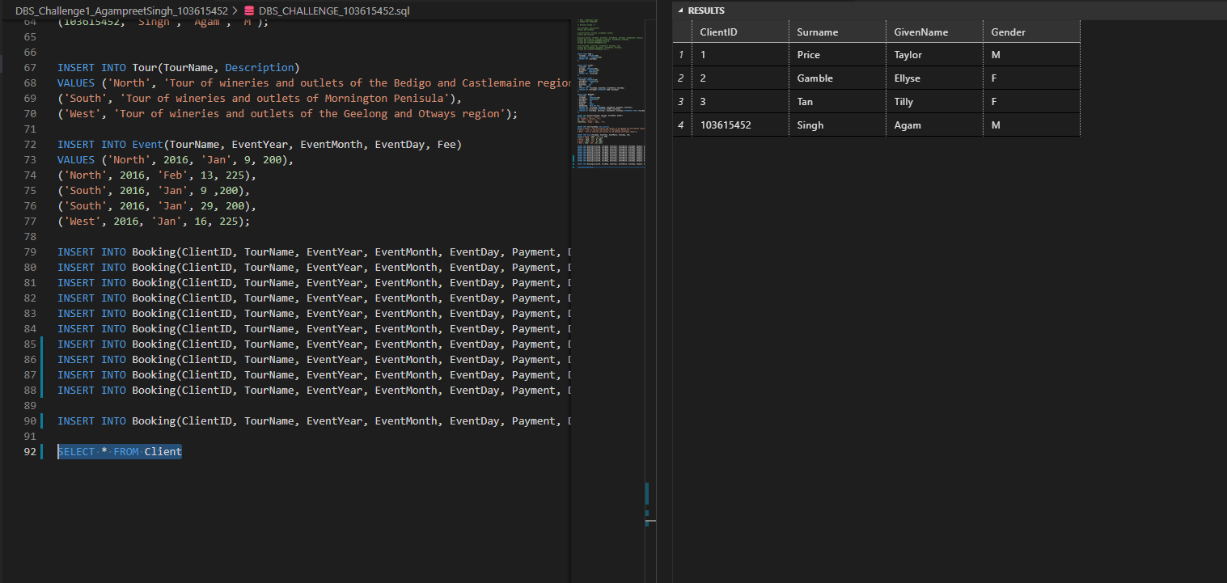

# Task 4 Screenshot

# Task 5 Screenshot

# Task 6 Screenshot