**Learners-Acadmey App.**

**Welcome Page :**

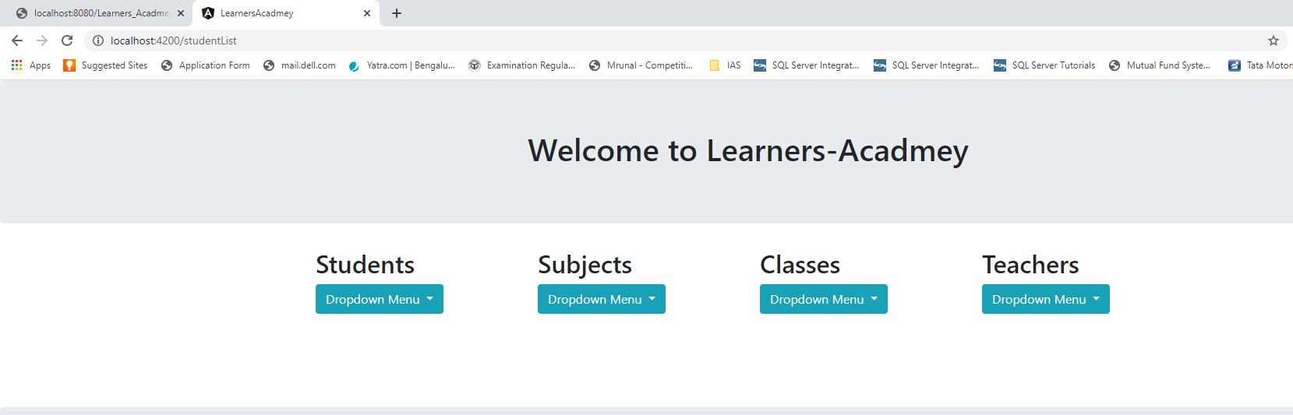

**All Student List :**

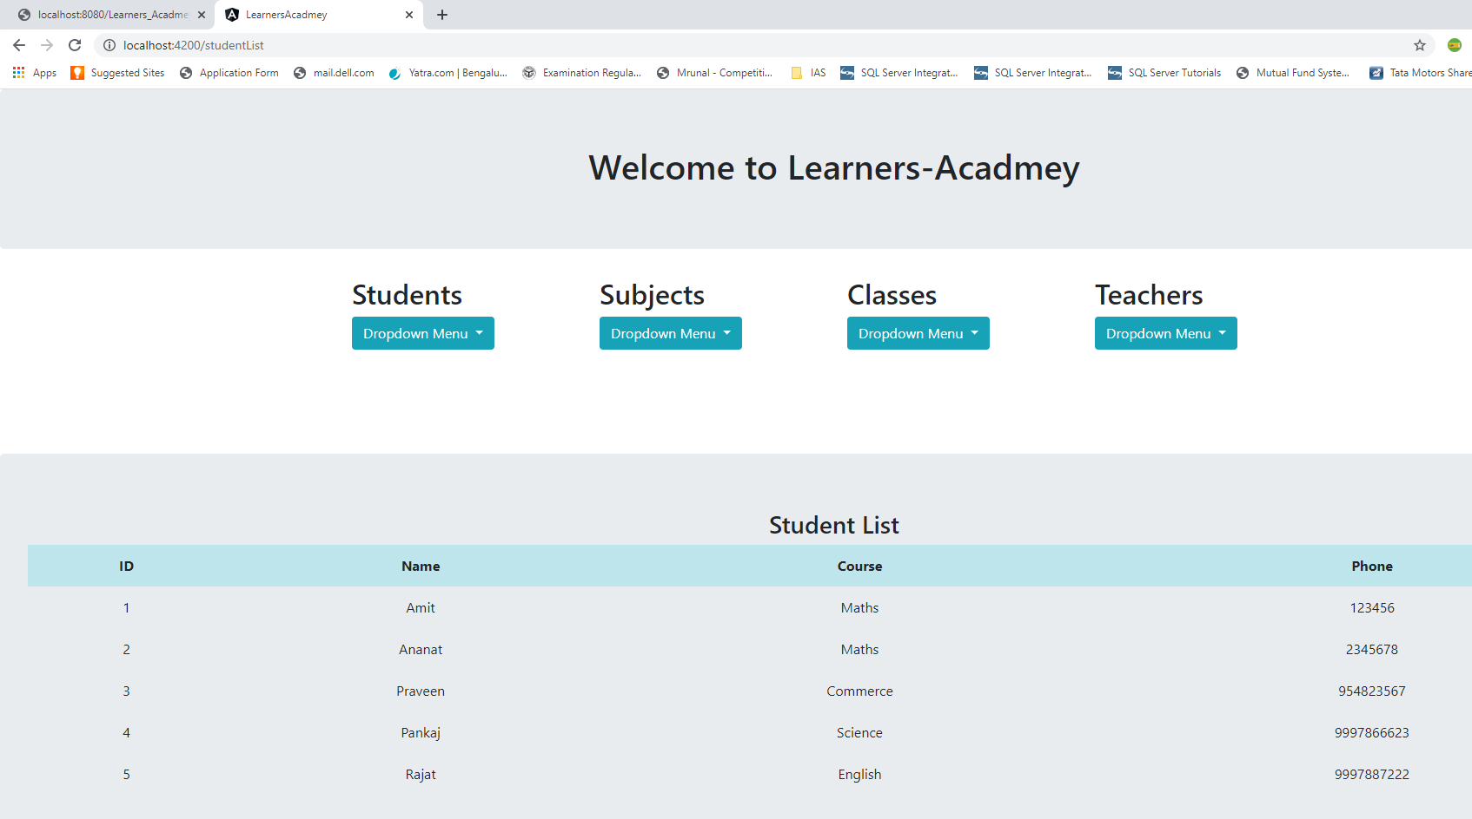

**Add Student :**

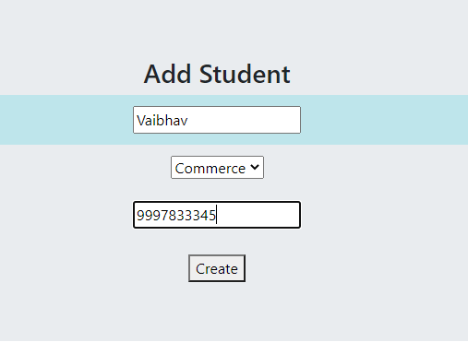

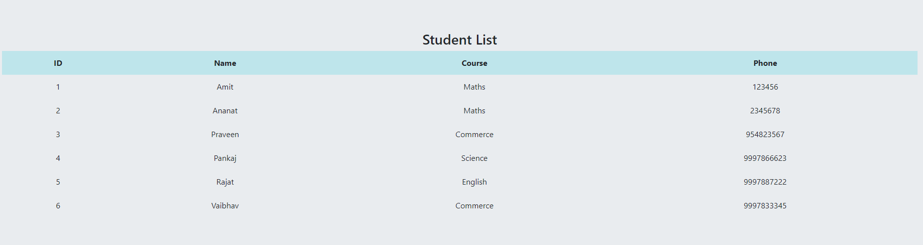

**Update Student:**

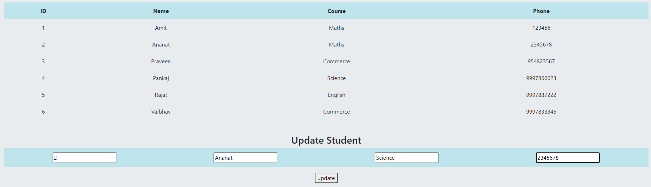

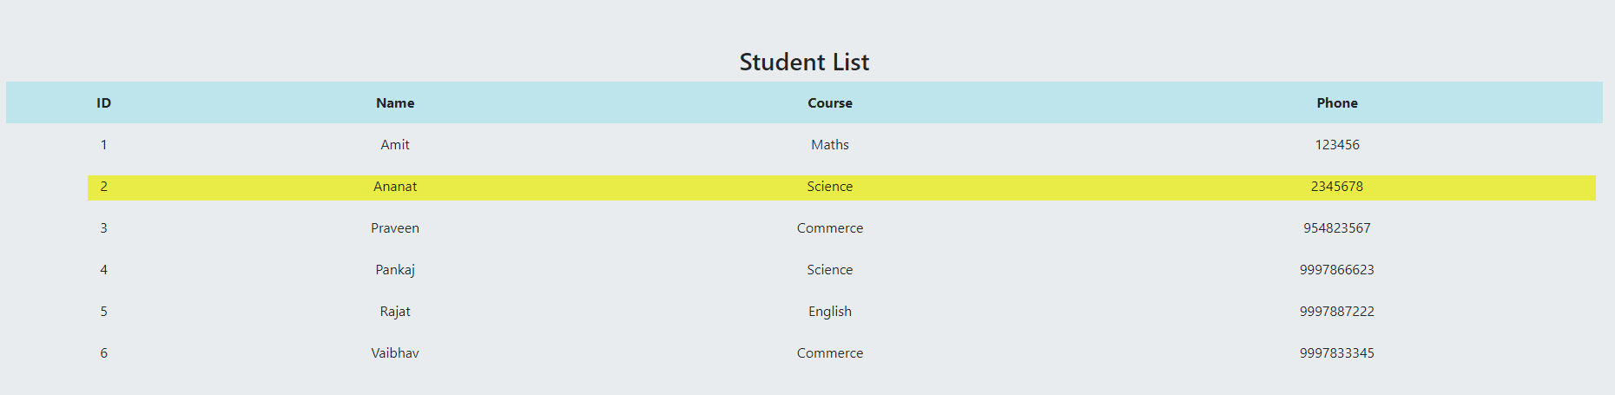

**Search Student by Id:**

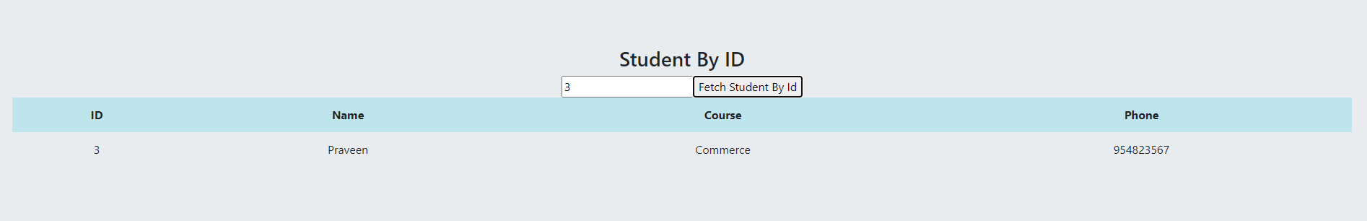

**Delete Student By Id :**

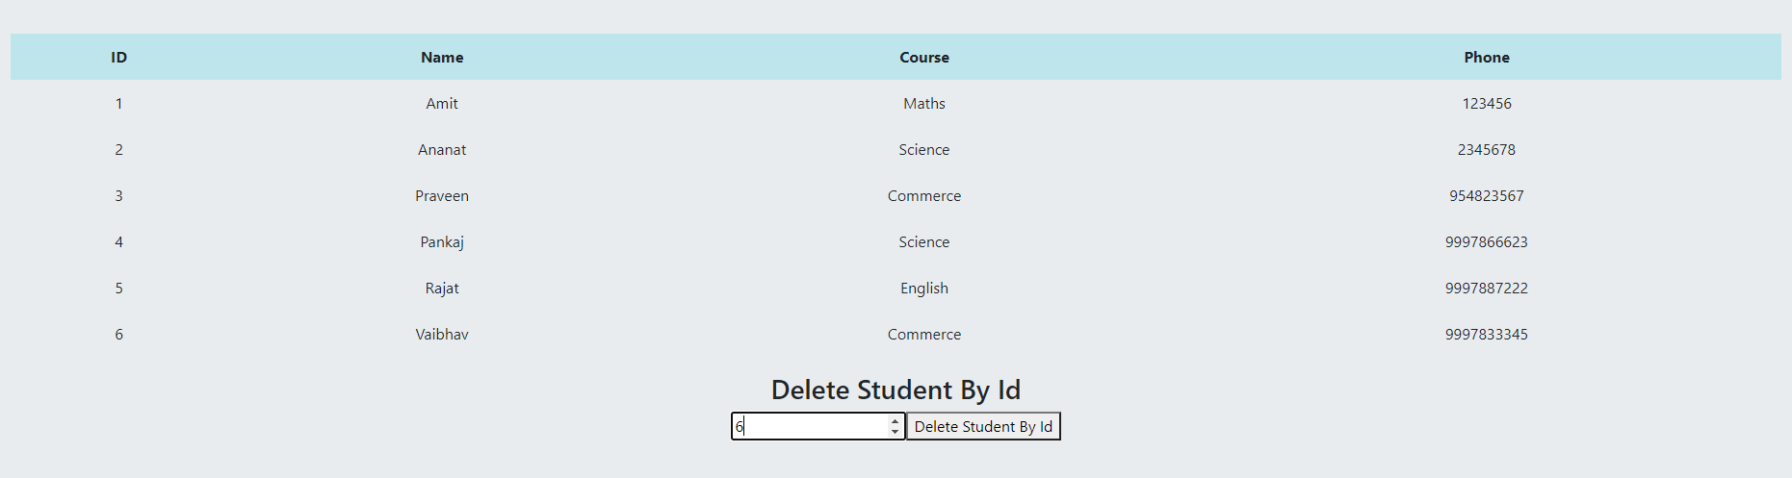

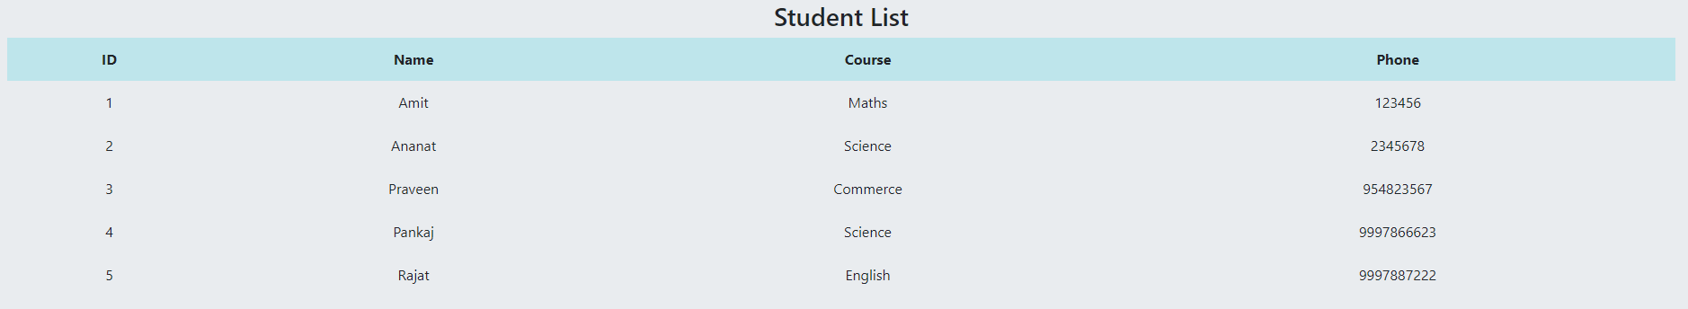

**Add Class :**



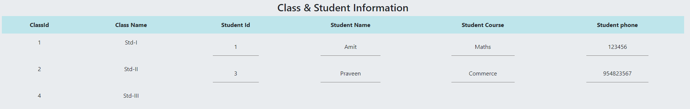

**Update Class:**

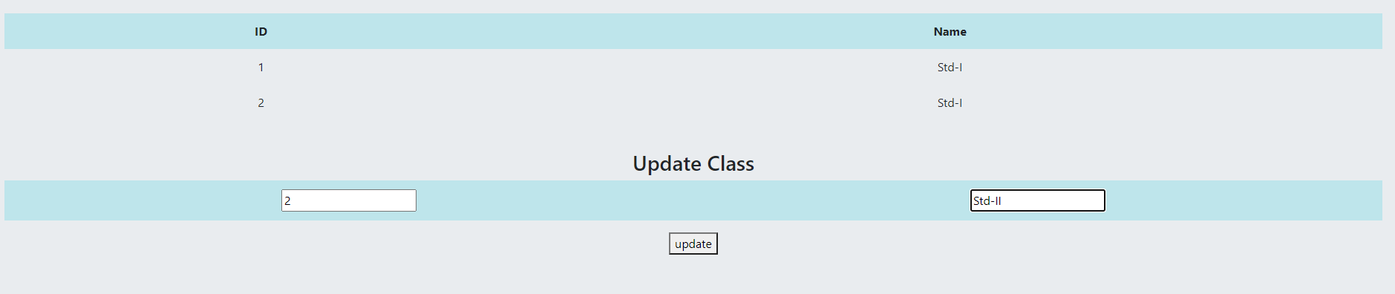



**Search Class by Id :**





**Update Class & Student Information :**

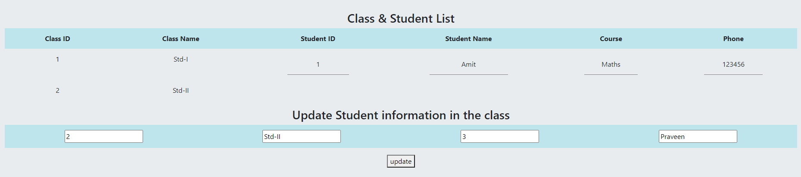

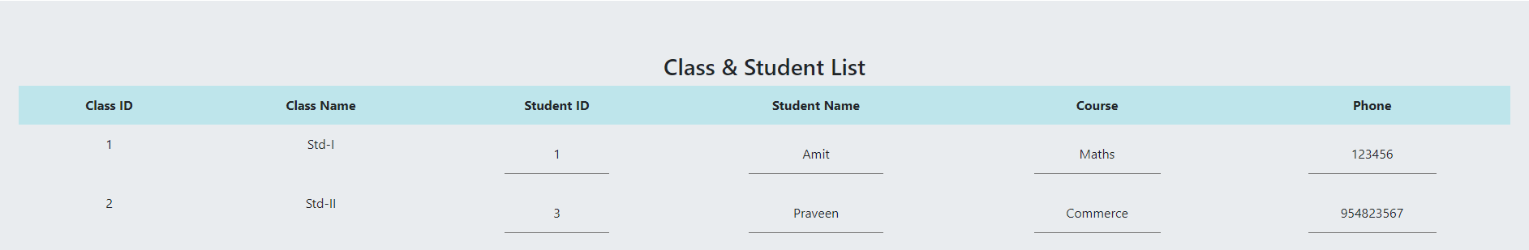

**Update Class & Subject Information :**

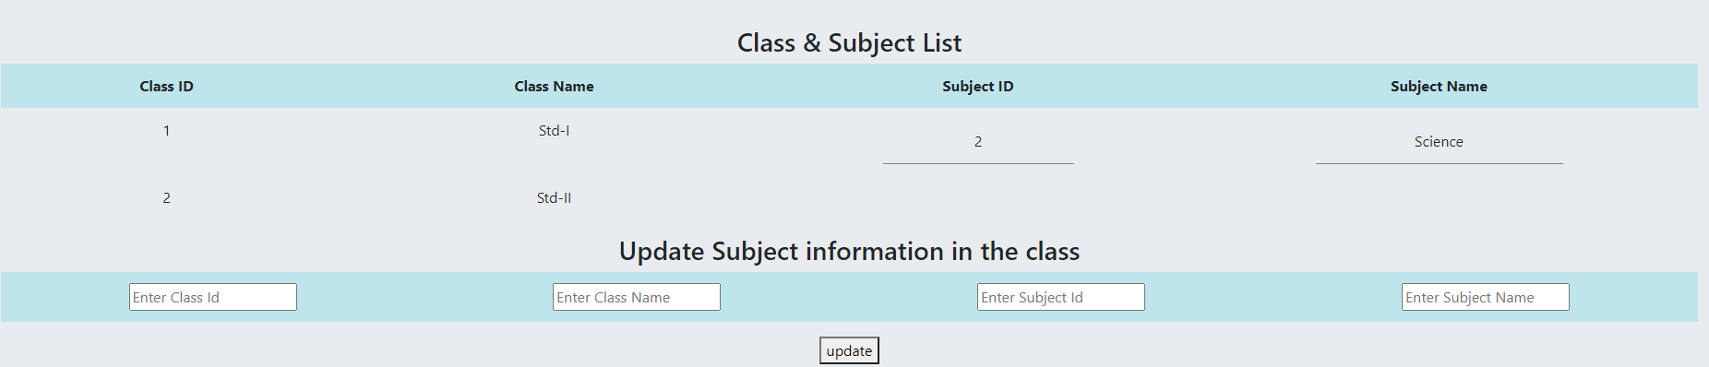

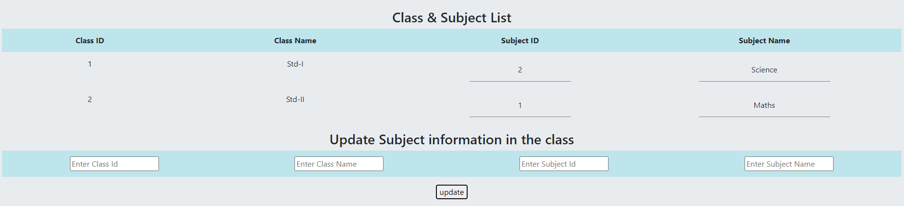

**Delete Class by Id :**

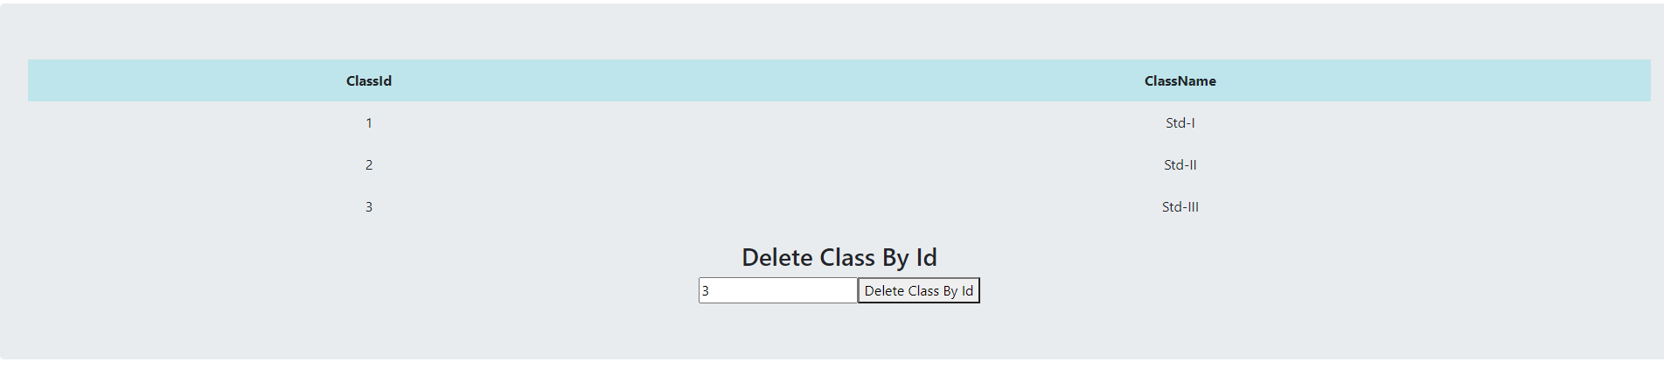



**All Teacher List :**

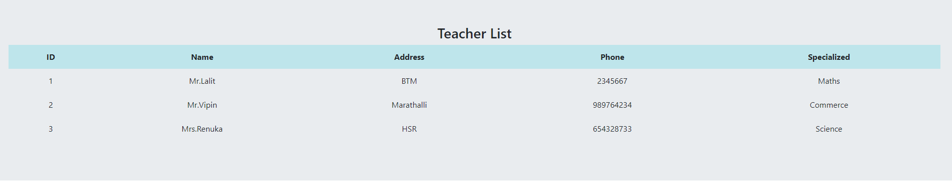

**Update teacher :**

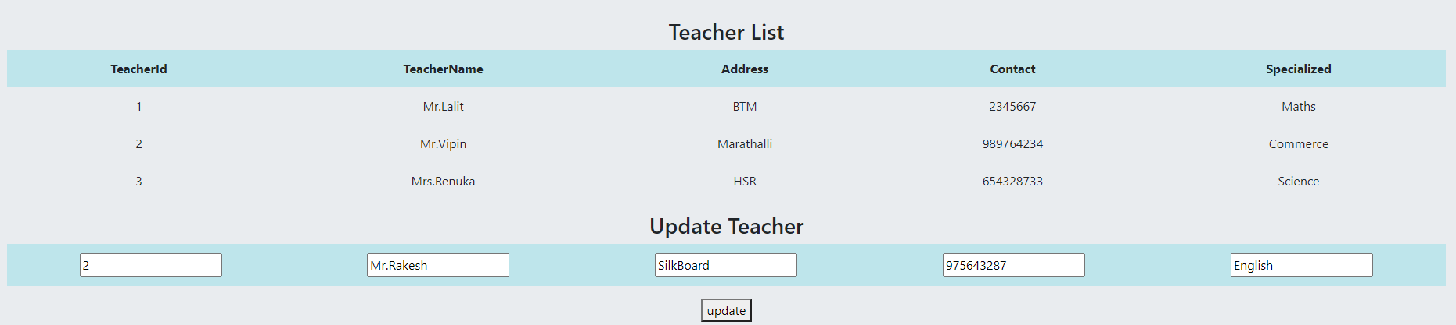

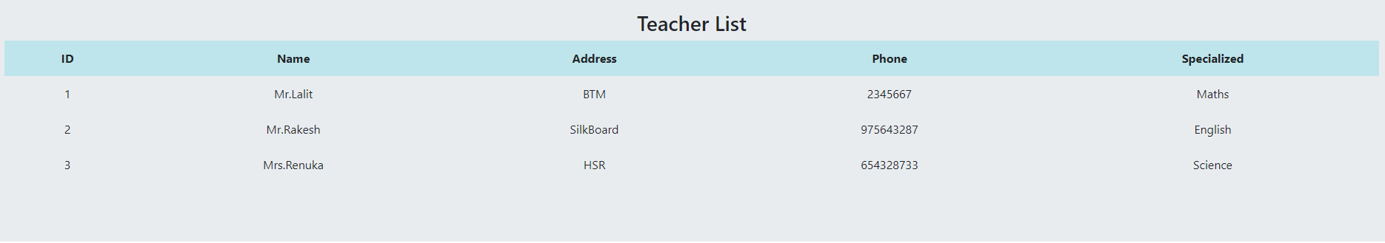

**Search teacher by Id :**

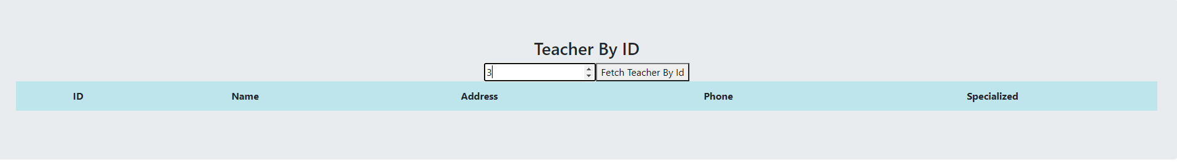

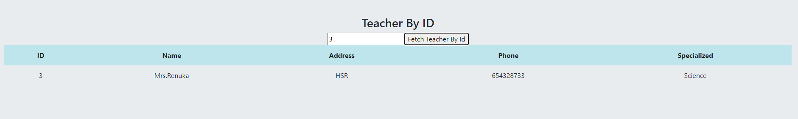

**Update Teacher and Student Information**

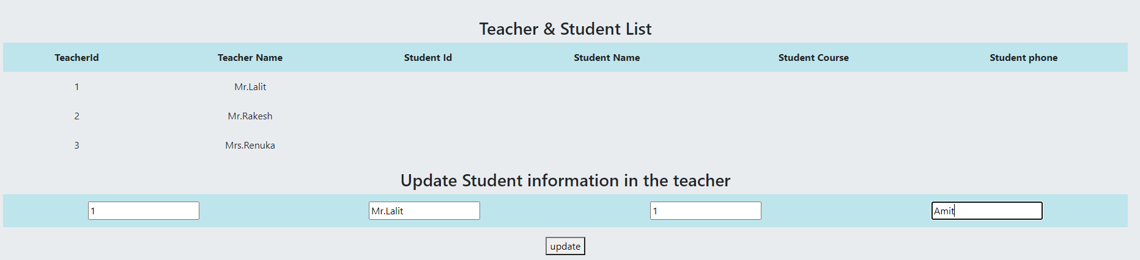

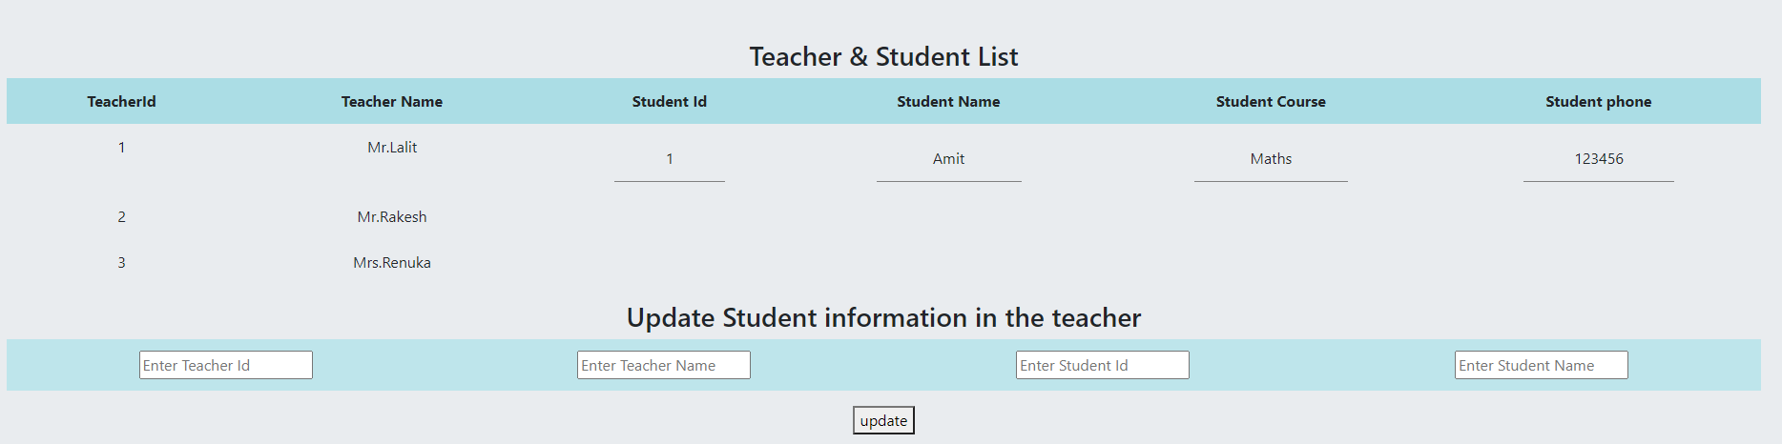

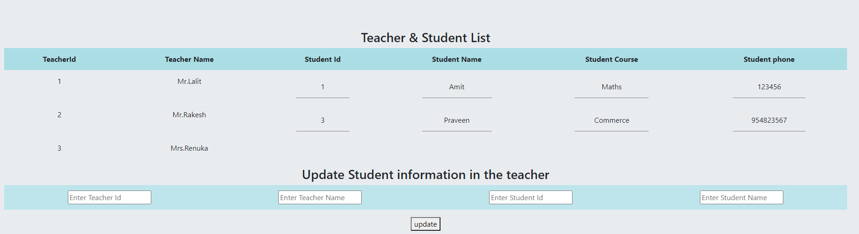

**All Subject List :**

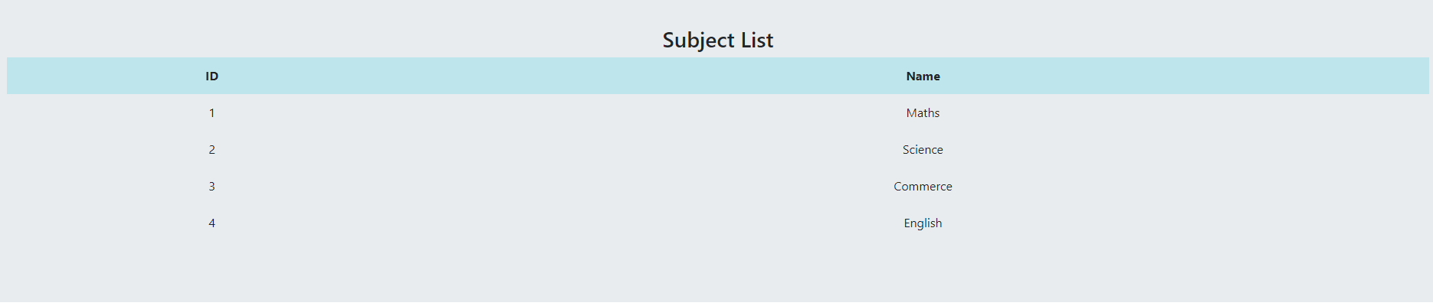

**Update Subject**

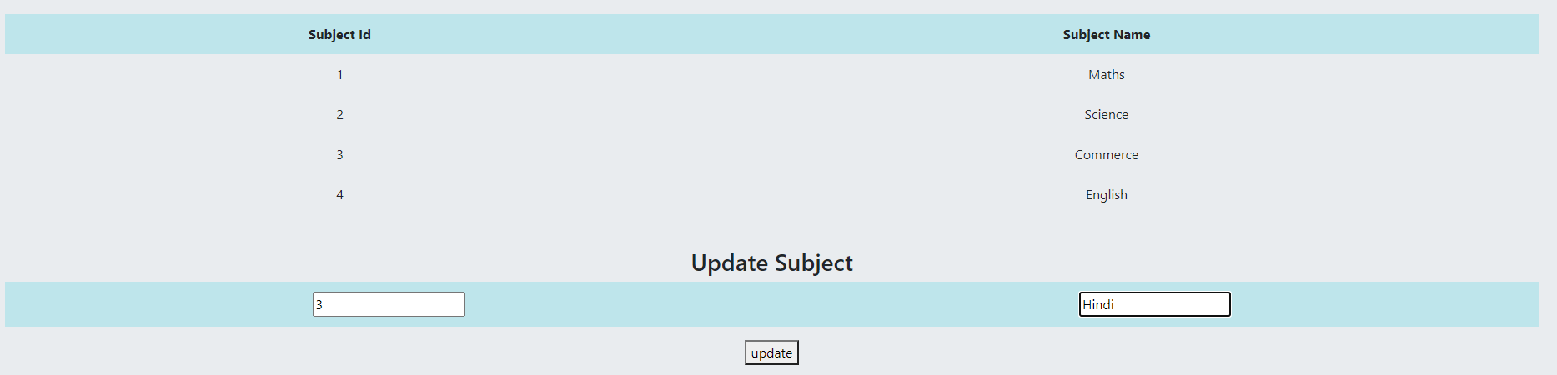



**Add Subject :**



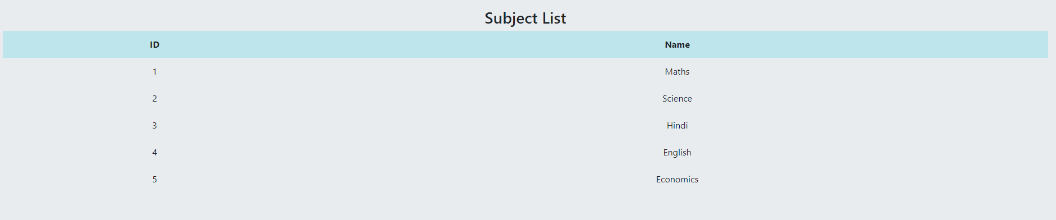

**Search Subject by Id :**





**Update Teacher & Subject Information :**

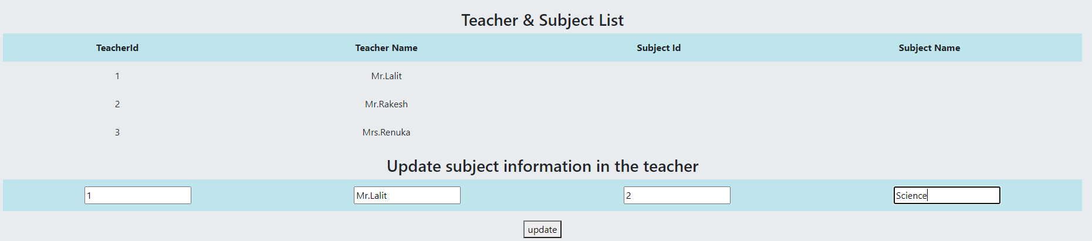

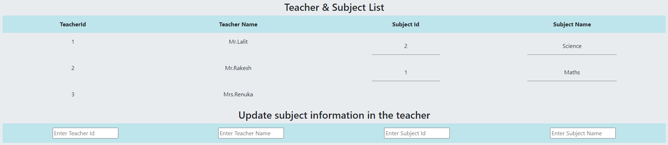

**Delete Subject by Id :**

