PHYS 450 Technical Report 01

Prism spectrometer and Dispersion of Light

Agam Chopra

Diana Forbes

Yifeng Wang

Tues 2:30 – 5:15 PM

*02/25/20*

1. Objective

The purpose of this lab is to demonstrate that the values of n(λ), the index of refraction for a given wavelength, can be measured with high precision if the angles of deviation are measured carefully. In this lab we will use an optical spectrometer, which is a light source, collimator, prism, and telescope setup as shown in Fig 2.1.1., to demonstrate this phenomenon.

1. Procedure
   1. Initial Setup

In this experiment, we used an American Optical (AO) prism spectrometer containing 3 main parts as shown in figure 2.1.1. These parts are:

* Collimator containing an adjustable slit and lens where the light enters the equipment.
* Prism table that holds the prism and scales for angular measurements.
* Telescope that rotates about the central axis of the equipment.

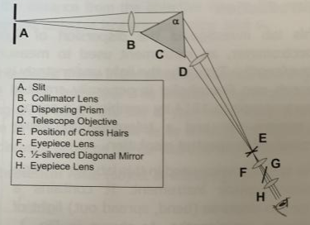 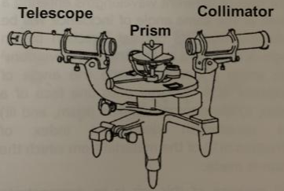

**Fig 2.1.1**: Schematic layout of a prism spectrometer(left) and line drawing of the actual setup used in this experiment(right).

* 1. Spectrometer Alignment

Note: In this experiment, our equipment was pre calibrated.

* We checked if the telescope was focused at a distant object in the room and that the crosshairs were in focus and properly aligned.
* We then carefully removed the prism from the table and adjusted the telescope position to point straight at the collimator.
* We took the “0” reading of the measuring equipment. In our experiment, the 0 arcmin value on the Vernier scale was aligned with the 360° value of the circular scale.
* The VL screw was tightened and data acquisition was initiated.
  1. Angle of Minimum Deviation

Note: The purpose of this part of the experiment was to measure the angle of minimum deviation for the spectral lines of helium, which was then used to calibrate the data of 2.4.

* Keeping the setup untouched from 2.2, a Helium lamp was placed in front of the collimator slit and turned on.
* The prism was placed on the prism table such that the light from the collimator bisect the **apex angle α = 60°.**
* The prism was moved ∼0.5 cm towards the left half of the table till the light from the collimator was able to hit the right prism face.
* The telescope was moved is clockwise direction until the He spectrum was observed as shown in Fig 2.3.1.
* For each clearly visible spectral line, we measured 5 values of the angle of minimum deviation using the circular scale and Vernier scale setup. This was done by moving the telescope clockwise and anticlockwise over the observed spectral line until the apparent motion of the observed line ceased right before the change in the direction of their apparent motion.

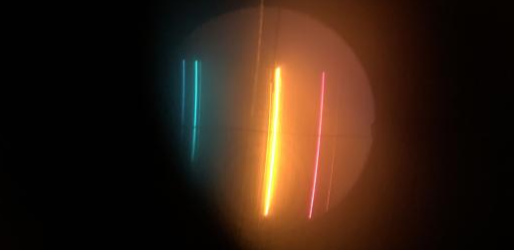

**Fig 2.3.1**: Image of the observed spectral lines of Helium.

* 1. Chromatic Resolving Power of a Prism
* The Helium vacuum tube was carefully replaced with a Mercury tube in the lamp apparatus.
* We calculated the resolving power needed to resolve the Mercury doublets at **λ1 = 576.96 nm** and **λ2 = 579.07 nm** using **Eq. 16 and Eq. 17** in page 65 of the Lab Manual.
* We recorded 5 separate minimum angles of deviation for both the spectral lines using the observation techniques mentioned in 2.3.
* We then changed the angle of incidence and observed the effects on the doublet as we reached the maximum angle of deviation.
* We then replaced the Mercury lamp with a sodium lamp using similar observational techniques.
* After hours of careful adjustments to the apparatus and with the help of my TA, I was able to partially observe the Sodium doublet as shown in Fig. 2.4.1.

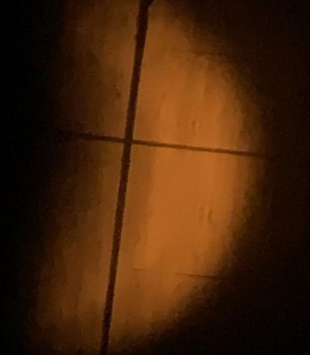

**Fig 2.4.1**: Blurry image of the Sodium doublet.

1. Observations, Data & Error Analysis

*Note: For this experiment, I assumed the observed data to be completely uncorrelated.*

* 1. Angle of Minimum Deviation



**Table 3.1.1**: Observed data for angle of minimum deviation(δ) for Helium spectral lines.



**Table 3.1.2**: Calculated values for data analysis.

* Systematic error = ±1arcmin = ±0.167, observed from the equipment.
* Statistical error (std.dev. /√N) = s/√5, where s2 = variance of the data which I calculated using the equation given in the Analysis section of the lab manual in page 61.
* Δ(δ) was calculated using equation (5) in page 61 of the lab manual.
* δ av was calculated by averaging the 5 observed δ values for the respective spectral line.
* n(λ) was calculated using equation (4) in page 59 of the lab manual.
* Δ(n) was calculated using the final equation given in the Analysis section of the lab manual in page 61.

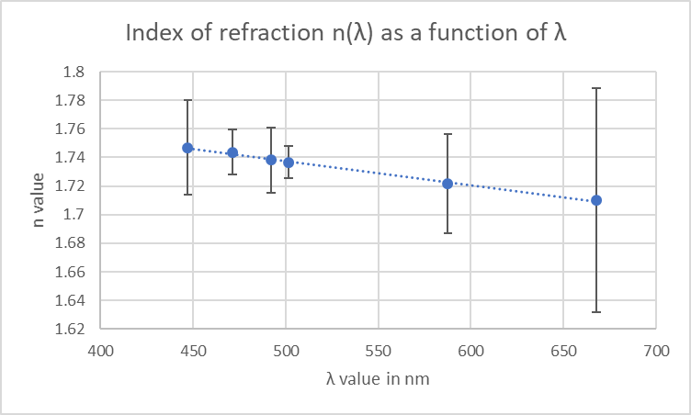 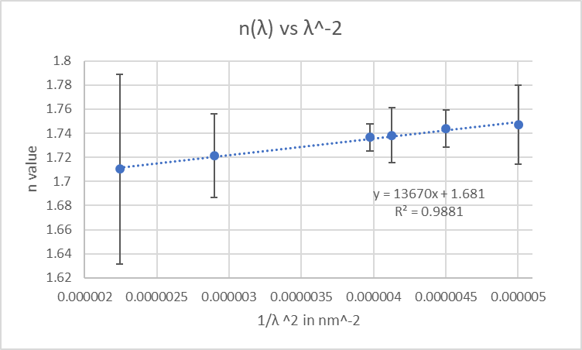

**Fig 3.1.1**: Index of refraction *n* as a function of *λ(top),* Index of refraction *n* vs *λ-2(bottom) where y = n and x = λ-2.*

Using Equation 6 on page 62 of the lab manual, we can say that from our observed values, C1 = 1.681 and C2= 13670 nm2 for the 2-term Cauchy expansion. Using Equations 10 and 11 from Appendix F of the Lab Manual, ΔC1= and ΔC2= .

Using the corrected equation 7 at page 62 of the lab manual, we get the Abbe number(V) equal to 20.69448. Since V<50, the prism must be made of flint glass. From the glass map given in *Optical Glass: Edmund Optics. (n.d.). Retrieved from* [*https://www.edmundoptics.com/knowledge-center/application-notes/optics/optical-glass*](https://www.edmundoptics.com/knowledge-center/application-notes/optics/optical-glass), our prism might be N-SF66 from Fig.3.1.2.

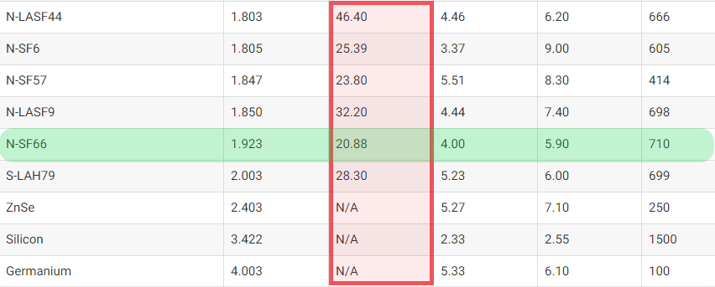

**Fig 3.1.2**: Type, n, Abbe Number, Density(g/cm3), Thermal Exp. Coeff, Max operating temp in Celsius.

* + 1. Chromatic Resolving Power of a Prism

We measured the base of the prism B = 3.5 ± 0.1 cm.



**Table 3.2.1**: Observed angles of min. deviation for Hg doublet.

* Clearly, the δ value of both spectral lines in Table 3.2.1 appear to be almost identical which means that there must be some error made, probably accidentally tampering the telescope zoom, that changed the hindered the equipment’s resolving ability.
* From Equation 17 at page 65 of the Lab Manual and the Cauchy relation as calculated in 3.1, the maximum resolving power **Rmax** ≈ 4955.
* Using **R** = 273.44, λ = (576.96 + 579.07)/2 nm, and Equation 16 at page 65, we get an estimate of b∼5.8 nm. This condition was not achieved in our measurement of the doublet but as b -> B, we observed the doublets to resolve in the eyepiece getting further apart and blurred as the prism approached the infinite magnification condition.
* From Equation 15 at page 64 of the Lab Manual, b = B, D = 0.5mm, ∆λ = 2|576.96 - 579.07| = 2.11 nm, ∆δmin ≈ 0.021 ≈ λ0/D.
* Then, ∆λmin = 0.11665 nm < ∆λ = 2.11 for helium doublet. This means that the Mercury doublet can be resolved.

During the experiment, we observed that when the prism approached grazing emergence condition, θ = 90°, the image of the spectral lines got extremely magnified and blurry and started curving till a blob of light covered the eyepiece presumably infinite magnification of the image assuming the prism to be a perfect prism.

Using Equations 18, 19, and 15 of Experiment 4 of the lab manual, and considering the grazing emergence condition θ = 90°, we can conclude that **Rmax = 100 λ0/∆λ**.

* + 1. Sodium Doublet

I used similar techniques to set up the sodium experiment and the following image was captured close to the grazing emergence condition of the prism. Due to time constraints, I was unable to take any clear observations or do any data analysis for this section.

I was able to do some image processing on the original picture captured with my phone camera on the extreme left of Fig 3.2.1 and progressively recover a sharper image.

I did this by writing a C++ program to magnify the “average” vertical pixel brightness. Due to time constraints and easier visual analysis, I wrote the code to process only black and white(greyscale) images as seen in Figure 3.2.1. Clearly, we can observe 2 distinct spectral lines whose brightness values are labeled ABCDE in Fig 3.2.1.

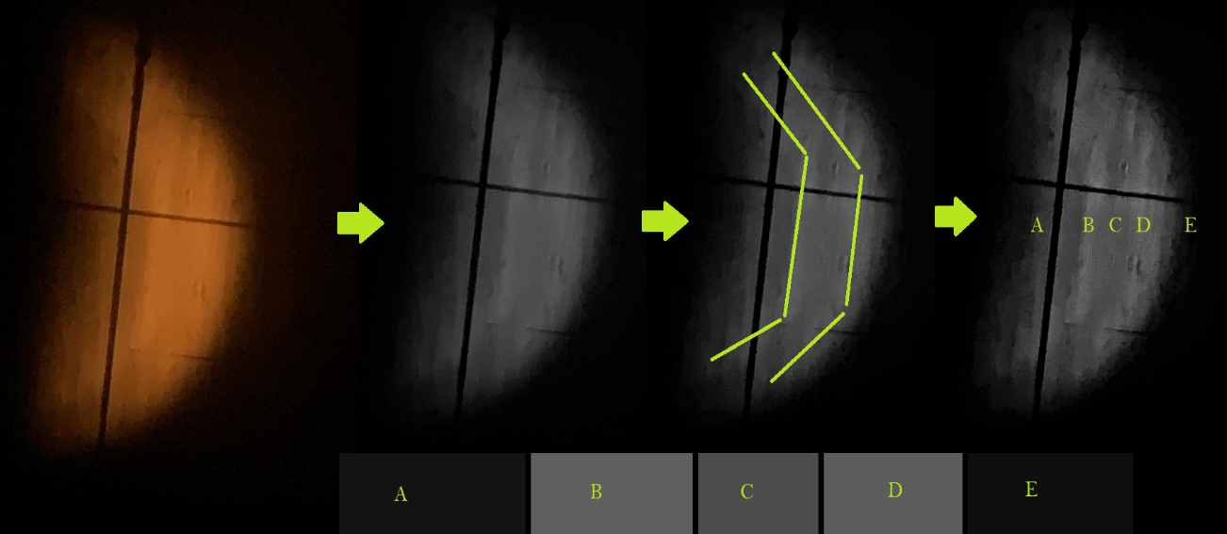

**Fig 3.2.1**: Image analysis of Sodium doublet observed.

1. Discussion

For the most part, our experiment was consistent with what we expected from the theory behind the experiment. Except for the resolving issues we had for the mercury doublet, all our values seemed to be consistent and agreed with each other. We found out that the prism used was N-SF66 which is a flit glass prism with Abby number≈20. As we approached the grazing emergence condition, θ = 90°, the image approached infinite magnification, which makes me think that the prisms used in this experiment are of extremely good quality since microscopic imperfections will hamper the infinite magnification condition. We were able to observe the Magnesium and Sodium doublet with some time-consuming tinkering of the apparatus.

1. Conclusion

In summary, in this experiment, we were able to gather necessary data for the spectral lines of Helium and use that information to predict what type of prism we were using and calculate the desired outcomes for the mercury doublet part of the experiment. We observed the Mercury doublet and that as we moved closer to the grazing condition, the image got magnified and blurry. At the end, I was able to obtain a blurry image of the Sodium doublet that is hard to notice as it is but with some careful image analysis techniques, we were successfully able to observe the doublet.

Resources Used:

* *Optical Glass: Edmund Optics. (n.d.). Retrieved from* [*https://www.edmundoptics.com/knowledge-center/application-notes/optics/optical-glass*](https://www.edmundoptics.com/knowledge-center/application-notes/optics/optical-glass)
* *Phys 450 Lab Manual Spring 2020*