PHYS 536 LAB 4

Agam Chopra







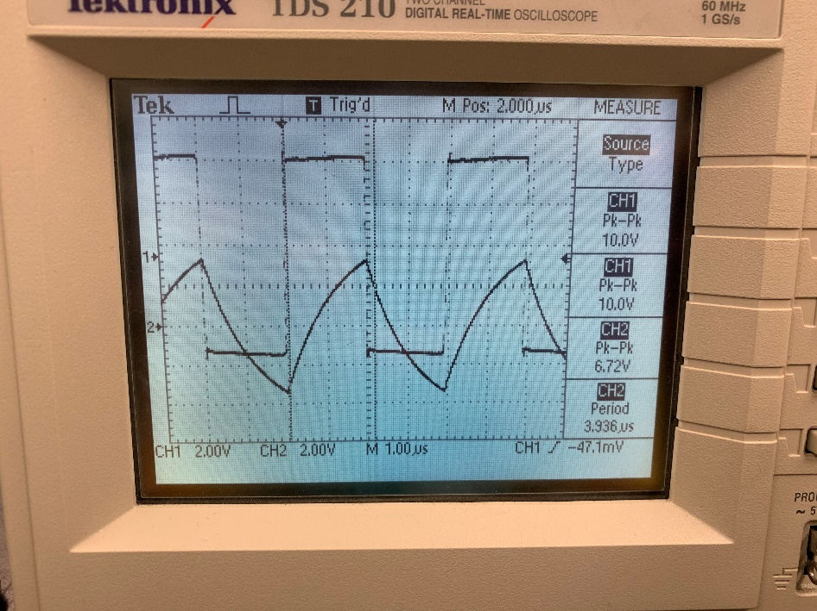

Circuit A

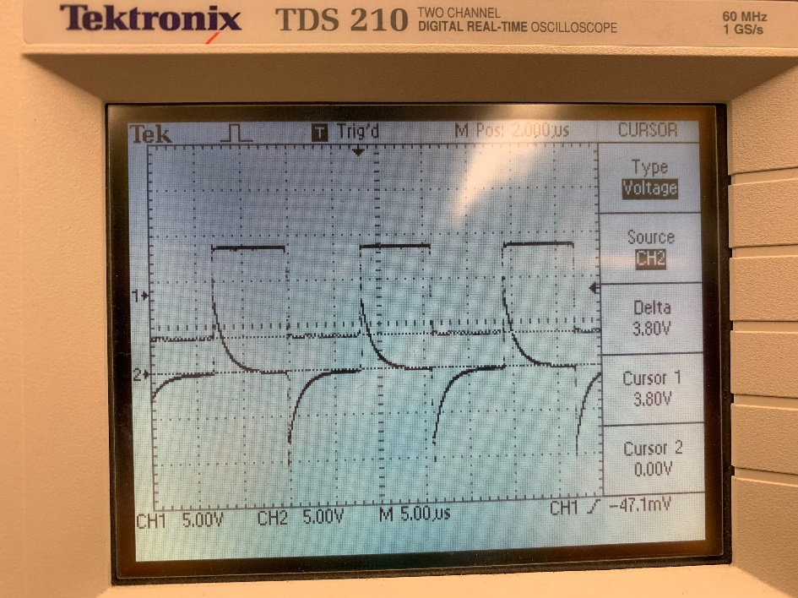

Circuit B