**Experiment -1.2**

**Student Name: Agamjyot Singh Maan UID: 22BDO10049**

**Branch: CSE (Devops) Section/Group: 22BCD-1\A**

**Semester: 4th Date of Performance: 17/01/24**

**Subject Name: Git and Git Hub Subject Code: 22CSH-293**

1. **Aim/Overview of the practical:**

Creating branches with GitHub and merging with the main branch.

1. **Task to be done:**

Create branch of a repository and make changes and merge the file into main branch.

1. **Steps for experiment/practical:**

**1. Create a New Branch:**

Navigate to your GitHub repository on the web.

Make a folder and write and write a code, here we wrote

“#include <iostream>

using namespace std;

int main() {

int a, b, sum;

cout << "Enter the value of a and b: ";

sum = a + b;

cout << a << " + " << b << " = " << sum;

return 0;

}”

Then click on the "Branch: main" button near the top left of the page.

In the text box that appears, type a name for your new branch and press Enter.

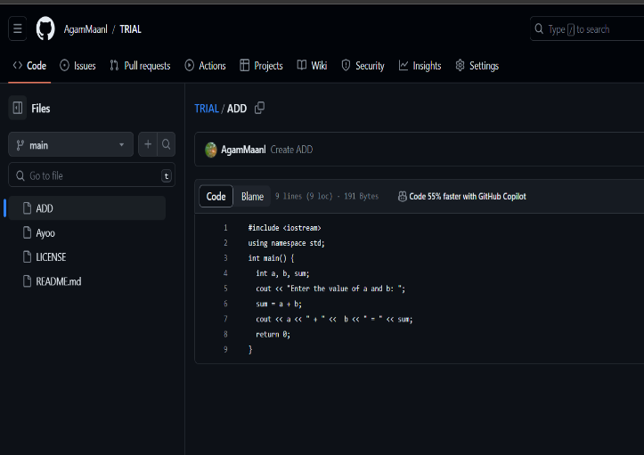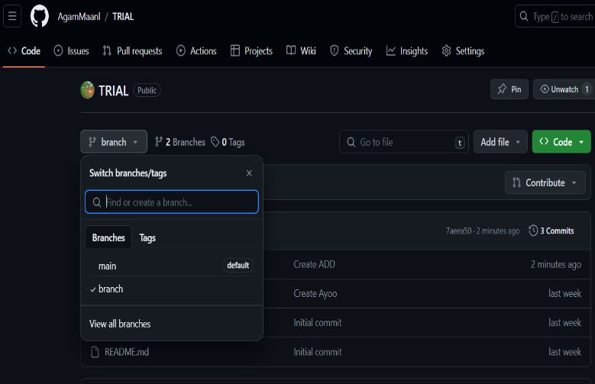

**2. Make Changes:**

Navigate to the newly created branch by clicking on the branch name dropdown and selecting your branch**.**

Make changes to your code or add new files, like here we did this

“#include <iostream>

using namespace std;

int main() {

int a, b, sub;

cout << "Enter the value of a and b: ";

sub = a - b;

cout << a << " - " << b << " = " << sub;

return 0;

}”

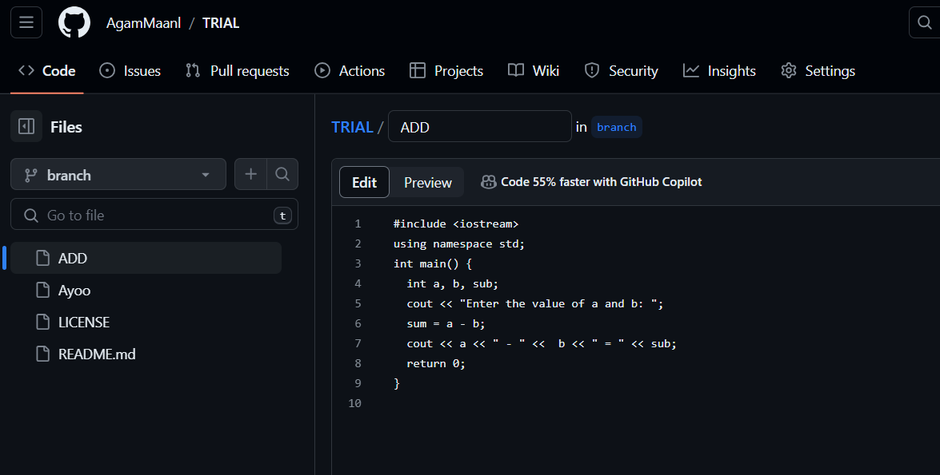

Scroll down to the "Changes" section.

Enter a commit message in the "Commit changes" section.

Click on the "Commit changes" button.

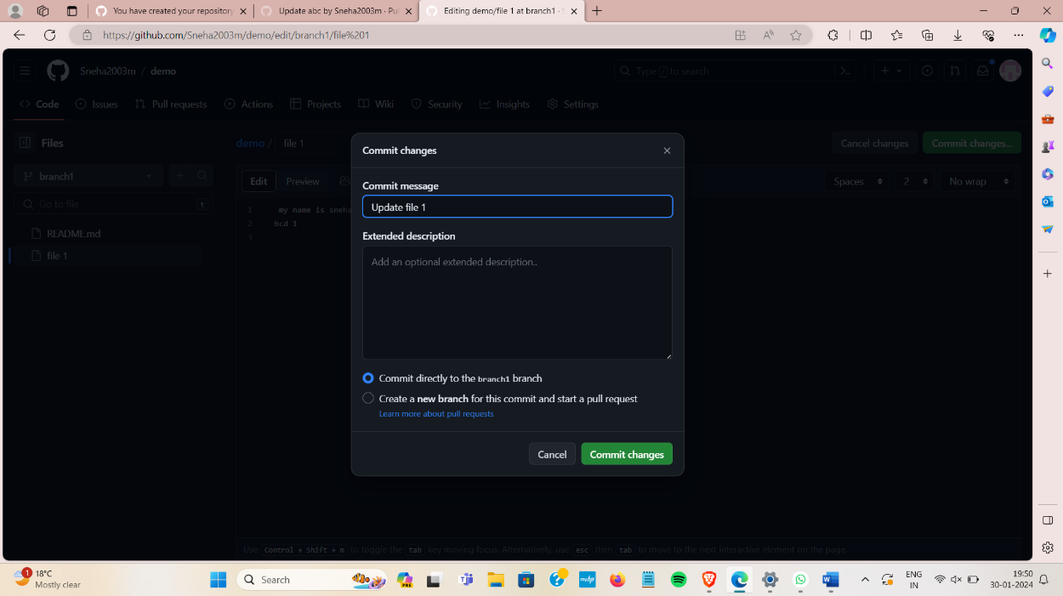

**3. Create a Pull Request:**

Once you've committed your changes to the new branch, GitHub will display a message with a "Compare & pull request" button.

Click on the "Compare & pull request" button.

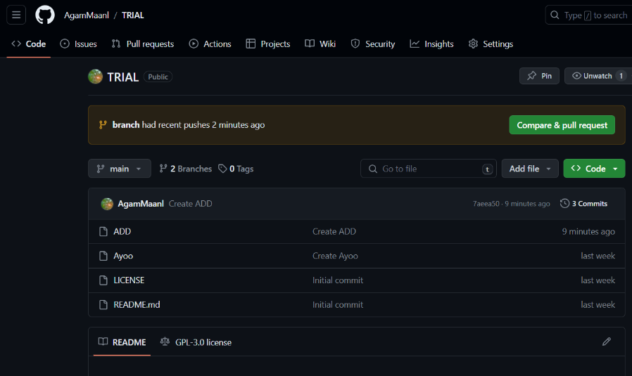

**4.**Click on the "Create pull request" button.

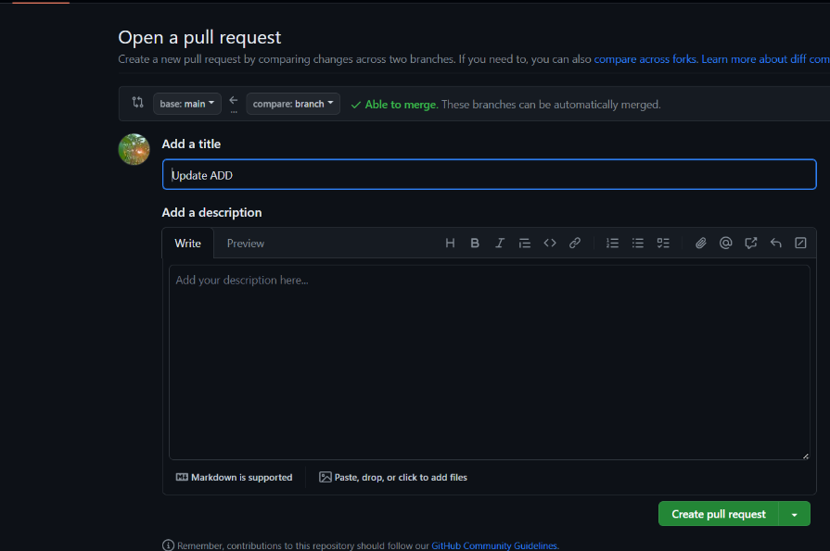

**5. Merge the Pull Request:**

After the pull request is reviewed and approved, you can merge it.

Click on the "Merge pull request" button.

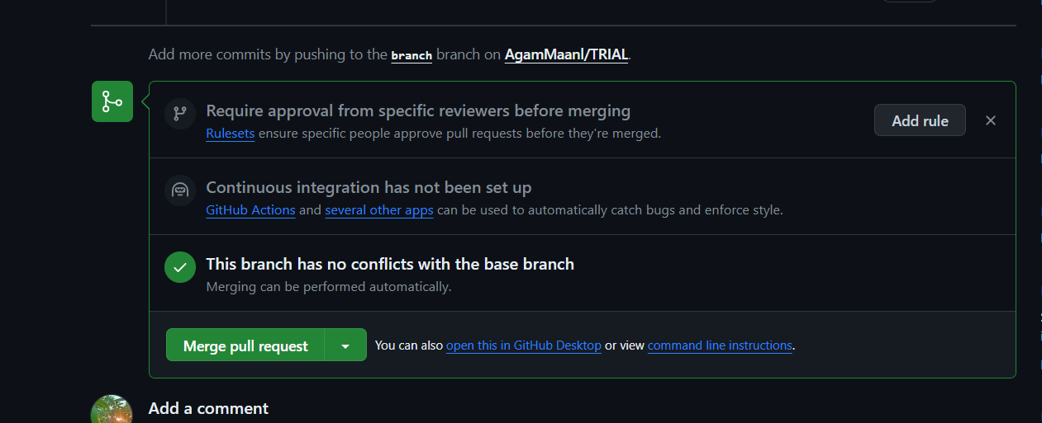

**6. Confirm the Merge:**

After the pull request has been merged, GitHub will ask for your confirmation to finalize the merge.

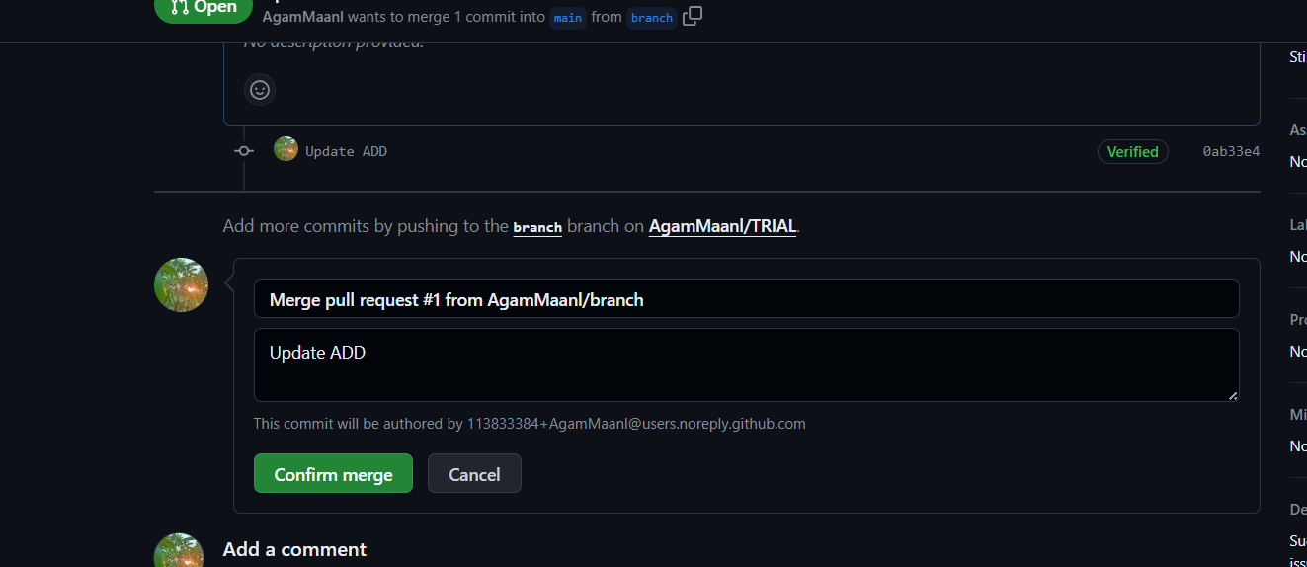

7. We can see the changes from by going to pull request then file changed

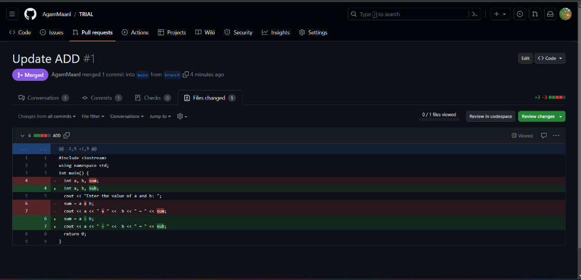

**From Creating Branch On GitBash:**

**1.** Create a new folder naming on desktop

**2.** Initialize the git using *“git init”*  command.

**3.** Create a new file using “vi name.txt”

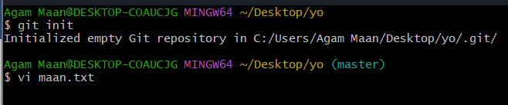

1. Edit file and add content to it by typing ‘a’ first then edit the content afterwords press ESC then type ‘:x or :wq’ to save and quit

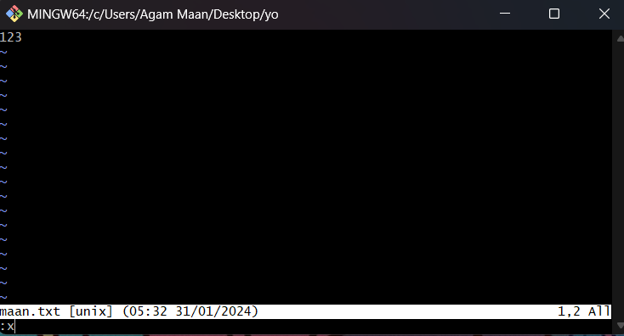

**5.** Put the file in staging area using “git add file_name.txt”

**6.** Commit this file using “git commit -m “message"

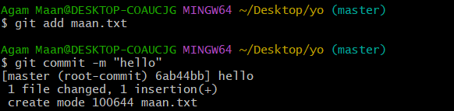

**7.** Create a new branch using code “git checkout -b branch_name”

**8.** Open and Edit file using “vi file name” and add content to it.

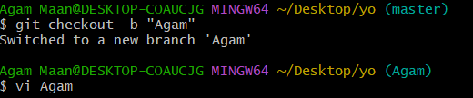

**9.** Put the file in staging area using “git add file name”

**10.** Commit this file using “git commit -m “message””

**11.** Move to master branch using “git checkout master”

**12.** Merge the branch using code “ git merge Agam”

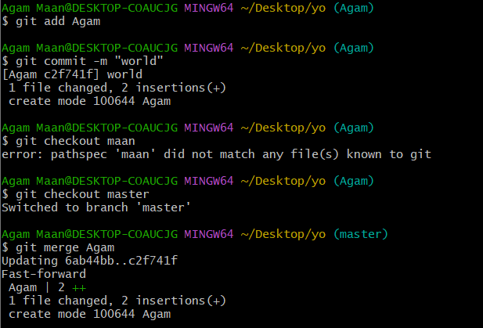



**13.** Show the status of file using “git status”.

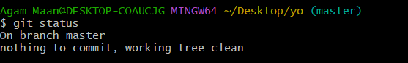

**Learning outcomes (What I have learnt):**

1.Grasping Git Bash Commands 2.Employing GitHub Repository URL 3.Establishing a Local Copy through Git Bash 4.Exploring Directories 5.Linking Local and Remote Repositories

**Evaluation Grid (To be created as per the SOP and Assessment guidelines by the faculty):**

|  |  |  |  |
| --- | --- | --- | --- |
| Sr. No. | Parameters | Marks Obtained | Maximum Marks |
| 1. |  |  |  |
| 2. |  |  |  |
| 3. |  |  |  |
|  |  |  |  |