**Experiment -1.3**

**Student Name:Agamjyot Singh Maan UID: 22BDO10049**

**Branch: CSE (Devops) Section/Group: 22BCD-1\A**

**Semester: 4th Date of Performance: 01/02/24**

**Subject Name: Git and Git Hub Subject Code: 22CSH-293**

1. **Aim/Overview of the practical:**

To create and explore pull request in git bash.

1. **Task to be done:**

Create branch of a repository and make changes and merge the file into main branch.

1. **Steps for experiment/practical:**

1.Launch Git Bash within your local directory.2.Initialize Git for version control.3.Clone the repository to your local machine.4.Navigate into the repository directory.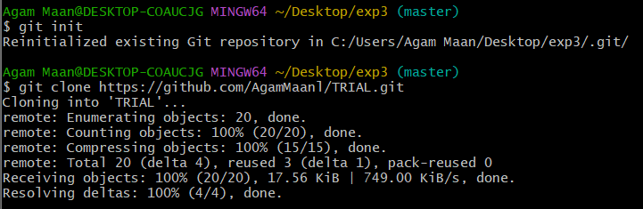

5.Create a branch.

6.Make changes in the branch.

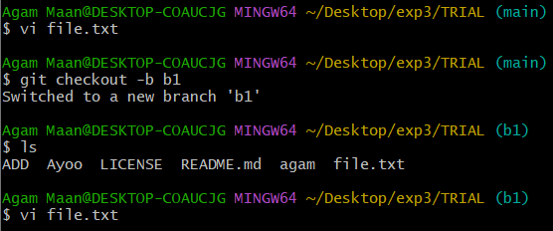

7.Put the branch in the staging area. 8.Commit the changes made on branch.

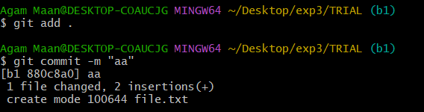

9.Push the changes to the git hub.

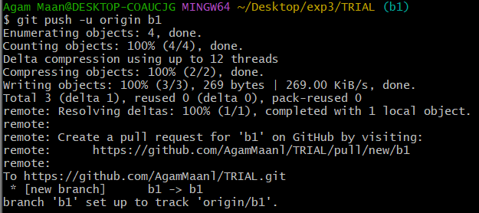

10. Head over to GitHub and go to the repository where you made the changes.

11. Switch to the branch and make some updates.

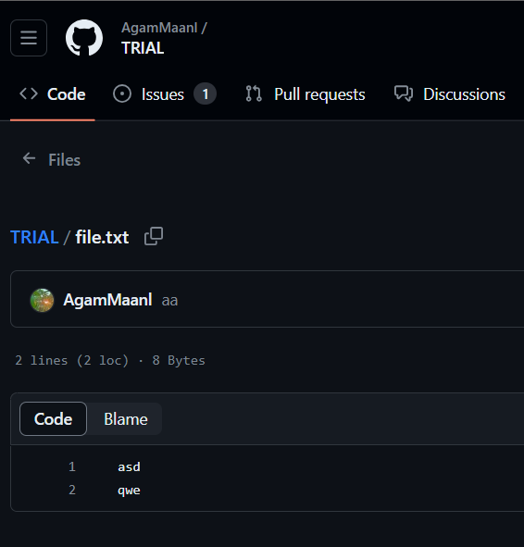

12.Commit the changes.

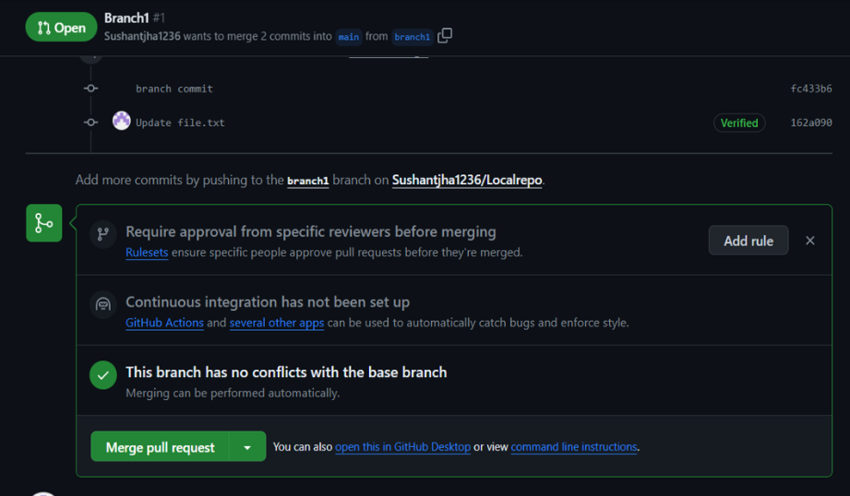

13. Go back to the main branch.

14. Return to your local machine.

15.Pull the repository to it.

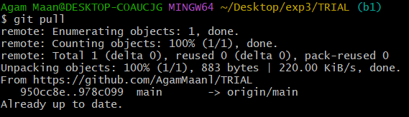

16.Review the changes made.

17. Check git status.

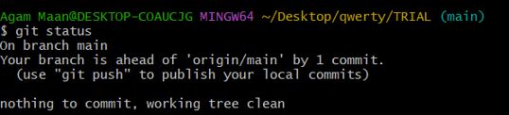

**Learning outcomes (What I have learnt):**

**1.** Understanding Git Workflow

**2.** Collaborative Workflows

**3**. Proficiency in Version Control.

**4.** Committing changes.

**5.** Utilizing the Staging Area

**Evaluation Grid (To be created as per the SOP and Assessment guidelines by the faculty):**

|  |  |  |  |
| --- | --- | --- | --- |
| Sr. No. | Parameters | Marks Obtained | Maximum Marks |
| 1. |  |  |  |
| 2. |  |  |  |
| 3. |  |  |  |
|  |  |  |  |