1 How To Use This Document
Highly regulated industries, such as banking and insurance, must comply with government regulations for model validation before a model can be put into production. This includes creating robust model development documentation. DataRobot automates the generation of model documentation, expediting the process required for regulatory compliance and following best practice for reducing model risk.
This document is split into two components: those sections that are automatically produced by DataRobot and those that require further input by the user. The sections in blue italicized font include specific instructions for the documenter and require additional user input of organization-specific information, such as business use cases, data sources, and implementation details. Once the sections are complete, remove the instructions. The remaining sections in non-blue italicized font are automatically populated by DataRobot and require no further input.
Copyright ©2025, DataRobot, Inc.


Table of Contents
- 1 How To Use This Document
- 2 DataRobot Model Development Documentation
- 3 Executive Summary and Model Overview
- 3.1 Model Stakeholders
- 3.2 Model Development Purpose and Intended Use
- 3.3 Model Description and Overview
- 3.4 Overview of Model Results
- 3.5 Model Interdependencies
- 4 Model Data Overview
- 4.1 Feature Association
- 4.2 Data Source Overview and Appropriateness
- 4.3 Input Data Extraction, Preparation, and Quality & Completeness
- 4.4 Data Assumptions
- 4.5 Personal Data Detection
- 5 Model Theoretical Framework and Methodology
- 5.1 Model Development Overview
- 5.2 Model Assumptions
- 5.3 Model Methodology
- 5.3.1 One-Hot Encoding Task
- 5.3.2 Median Value-Based Numeric Imputation (V2 with quick median algorithm)
- 5.3.3 Standardize task based on median removal and scaling to standard deviation or mean absolute deviation
- 5.3.4 Ridit transformer
- 5.3.5 Document-Term Matrix
- 5.3.6 Elasticnet Classifier model based on block coordinate descent with Wordcloud
- 5.4 Literature Review and References
- 5.5 Alternative Model Frameworks and Theories Considered
- 5.6 Variable Selection
- 5.6.1 DataRobot Quantitative Analysis
- 5.6.2 Expert Judgement and Variable Selection
- 5.6.3 Final Model Variables
- 5.6.3.1 Model Features and Summary Statistics
- 5.6.3.2 Data Quality Handling Report
- 6 Model Performance and Stability
- 6.1 Model Validation Stability
- 6.1.1 Data Partitioning Methodology
- 6.2 Model Performance (Sample Scores)
- 6.3 Sensitivity Testing and Analysis
- 6.3.1 Lift Chart
- 6.3.2 Key Relationships
- 6.3.3 Sensitivity Analysis (Partial Dependence)
- 6.3.4 Accuracy (Receiver Operating Characteristic)
- 7 Model Implementation and Output Reporting
- 7.1 Version Control
2 DataRobot Model Development Documentation
A key component of effective model risk management is sufficiently detailed documentation for model development, implementation, and use, so that reasonable parties unfamiliar with a model can understand how the model operates, its limitations, and its key assumptions. Additionally, model documentation should contain enough detail for an independent party (e.g., independent model validation) to replicate all aspects of the underlying modeling process.
The purpose of this document is not to be prescriptive in format and content, but rather to serve as a guide in creating sufficiently rigorous model development, implementation, and use documentation. The documentation should provide enough evidence to show that the components of the model work as intended, the model is appropriate for its intended business purpose, and that it is conceptually sound.
3 Executive Summary and Model Overview
3.1 Model Stakeholders
Describe the model's purpose and its intended business use. Describe all stakeholders of this model, including their role, line-of-business, and team. This should include stakeholders of model ownership, model development, model implementation, and model risk management.
Model Owner(s): The individual who owns the business risk addressed by the model and provides approval for the model to be used within the line-of-business or enterprise function.
Model Developer(s): The individual responsible for building new models with DataRobot or maintaining existing models.
Model User(s): Those teams who will use the model output as part of their ongoing business operations.
Model Validator(s): The validators are responsible for independent model review and approval prior to its first use.
3.2 Model Development Purpose and Intended Use
Describe the model's purpose, including a summary of the business need for this particular model. Concisely describe how the model will be used to address this business problem. Furthermore, describe with great precision all model uses covered by this document. These descriptions will address this statement made in regulatory guidance, FRB SR-11-7, "Even a fundamentally sound model producing accurate outputs consistent with the design objective of the model may exhibit high model risk if it is misapplied or misused."
3.3 Model Description and Overview
The particular model referenced in this document: Elastic-Net Classifier (L2 / Binomial Deviance). This model was developed in a project created with v7aa0459369beef8a of DataRobot. This model is denoted within DataRobot by the Project ID: 69138057ba8225bf9a07d211 and the Model ID: 691380b9f14a234666a2a3b4. The project was created on 2025-11-11 18:28:39.
The model development workflow process (i.e., the model blueprint) is detailed in the figure below.
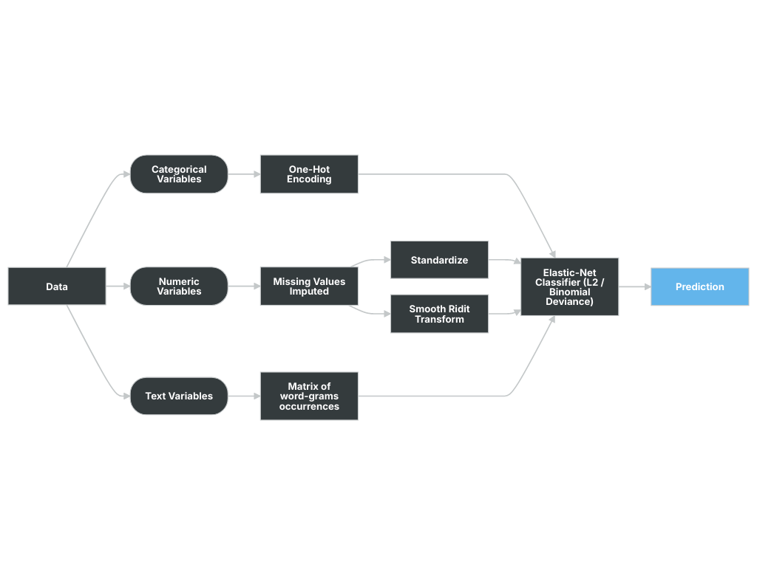
A Blueprint represents the high-level end-to-end procedure for fitting the model, including any preprocessing steps, algorithms, and post-processing. It illustrates the many steps involved in transforming input predictors and targets into a model. Each element (or, “node”) in a blueprint can represent multiple steps.
The following elements connect to create the blueprint:
- One-Hot Encoding
- Missing Values Imputed
- Standardize
- Smooth Ridit Transform
- Matrix of word-grams occurrences
- Elastic-Net Classifier (L2 / Binomial Deviance)
3.4 Overview of Model Results
DataRobot runs performance testing during the model development process to evaluate model results and reliability. The validation, cross-validation, and holdout (if applicable) out-of-sample performance scores are presented below, as well as the number of observations for each partition. The performance metric used for this project was LogLoss and the project included a total of 10,000 observations. An asterisk (*) next to a score, whether validation or holdout, indicates that DataRobot used in-sample predictions to derive the score. (In-samples predictions are those that include data from the validation or holdout partitions due to sample size used to build the model.)
Scoring Type | Score (LogLoss)
holdout | 0.6132
validation | 0.6115
3.5 Model Interdependencies
Understanding interdependent relationships allows for enhanced understanding and improved ability to manage and aggregate model risk. Explain how this model is interconnected with other models in the model inventory--that is, the relative direction with regard to the model's position in the receiving input/sending output role. In addition to the directional relationship, also provide a brief description of each interconnected model.
4 Model Data Overview
4.1 Feature Association
DataRobot’s Feature Association Matrix is populated by default by features from DataRobot’s Informative Features feature list. The Feature Association Matrix provides information on association strength between pairs of numeric and categorical features that are visually denoted by the opacity of the color (that is, num/cat, num/num, cat/cat, where lighter shades indicate weaker association and vice versa) and feature clusters. Clusters, families of features denoted by color on the matrix, are features partitioned into groups based on their association structure.
Some of the noted benefits of the Feature Association Matrix include:
- Understand the strength and nature of associations within the data;
- Detect families of pairwise association clusters; and,
- Identify clusters of high-association features prior to model building.
The Feature Association Matrix lists up to the top 50 features, selected by Importance Score, on both the X and Y axes, where the intersection of a feature pair provides an indication of their level of association. By default, the matrix displays by the Mutual Information values and sorts by the cluster.
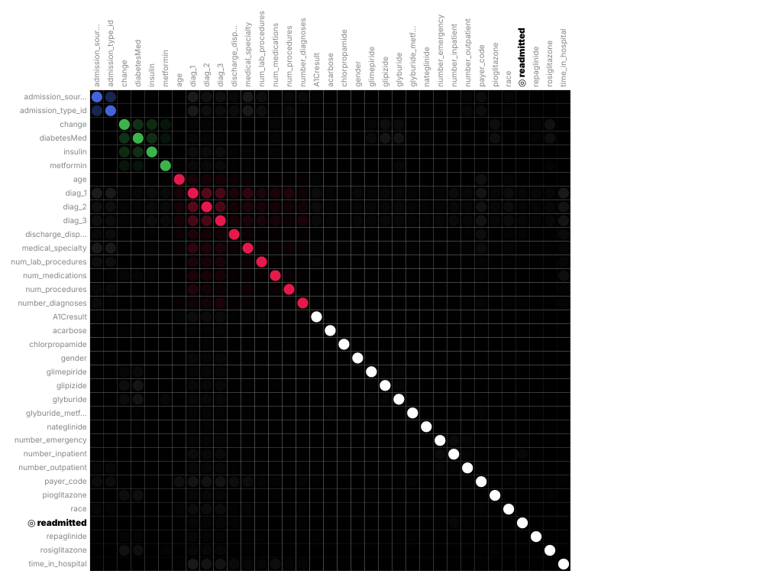
The following are some general takeaways from looking at the matrix above:
- Each dot represents the association between two features (a feature pair), where the opacity of the color denotes the pair-wise strength of association.
- Each cluster is represented by a different color.
- The opacity of color indicates the level of association 0 to 1, between the feature pair. Levels are measured by the set metric, either mutual information or Cramer’s V.
- Shaded gray dots indicate that the two features, while showing some association, are not in the same cluster.
- White dots represent features that were not categorized into a cluster.
- The target feature, if present, is indicated by two small concentric circles next to the feature name.
4.2 Data Source Overview and Appropriateness
Explain how the data is suitable and relevant for the business problem and model use. For example:
Describe how, and from where, the data was obtained.
Provide a detailed description of the data source and its relevance to the business problem being addressed by this model.
Assess whether the data used for model development is appropriate given the populations to which the model will be applied.
If the model development and model implementation data sources differ, provide a detailed explanation justifying the use of different data sources.
4.3 Input Data Extraction, Preparation, and Quality & Completeness
Provide a detailed description of the data extraction and preparation process, and discuss any analysis conducted to confirm the data are complete and of sufficient quality (e.g., data validation). Include a detailed description of the data extraction process, hierarchical by extraction and preparation stage, and calling sequence. Provide data extraction code (e.g., SQL, Spark, etc.) in the Appendix.
Review and comment on any data weaknesses and limitations and their probable potential effects on the model. For example, data truncation, extraction timing, through-the-cycle data, and data exclusions could potentially cause unintended effects on the model.
4.4 Data Assumptions
Comment on data assumptions, the potential effects on the model, and any mitigating data controls. For example, assumptions related to data truncation, extraction timing, through-the-cycle data, reliability of source system, manual data overrides or imputation, and data exclusions could potentially cause unintended effects on the model.
4.5 Personal Data Detection
The feature list used to develop this model has not been scanned for the presence of Personal Data.
5 Model Theoretical Framework and Methodology
5.1 Model Development Overview
DataRobot simplifies model development by performing a parallel heuristic search for the best model or ensemble of models, based on both the characteristics of the data and the prediction target. While some machine learning techniques tend to consistently outperform others, it is rarely possible to say in advance which will perform best for a given business problem. Therefore, during the modeling process, DataRobot develops dozens of independent challenger models, exposes the details of how these models were built and how they perform, and enables the user to select the best model for the particular business problem being addressed.
The fundamental workflow within DataRobot for model development is as follows:
- Rapid Data Ingestion: User creates a modeling dataset that includes the prediction target and loads into DataRobot
- Target Selection: User selects the prediction target; DataRobot detects whether the target is categorical or continuous. If the target is categorical, DataRobot selects and builds classification blueprints. If the target is continuous, DataRobot selects and builds regression blueprints. DataRobot also selects an optimization performance metric based on the type of supervised learning problem, which can also be changed by the user
- Automated Data Preparation: DataRobot analyzes the input data and automatically performs advanced preprocessing steps that are discussed in detail in this document. DataRobot also automatically partitions the input dataset into learning, validation and holdout dataset; these can also be defined by the user.
- DataRobot uses information about the selected target variable and predictors to define a set of candidate blueprints for analysis. It then trains models for each blueprint and ranks them on the model Leaderboard based on an out-of-sample validation accuracy score.
- Transparent Model Evaluation and Selection: DataRobot has built-in diagnostic tools to assess model accuracy and performance. Once DataRobot has trained and tested models, users can access them from the Leaderboard. From there, users can review model accuracy and, using built-in model diagnostic tools, understand how each independently built model performs. DataRobot provides many metrics for evaluating model accuracy, such as AUC, Log-Loss and RMSE. DataRobot's Leaderboard actively tracks performance of candidate models using out-of-sample data for comparison purposes.
- Model Deployment and Monitoring: Once the final model is selected, DataRobot provides efficient solutions for deployment (i.e., model implementation) and monitoring. These features enable the model owner to effectively manage model controls in accordance with Model Risk Management standards and policies.
5.2 Model Assumptions
This section should include model limitations, potential effects, and any mitigating controls in place. Limitations come in part from weaknesses in the model due to its various shortcomings, approximations, and uncertainties. Regulatory guidance refers to limitations as "...a consequence of assumptions underlying a model that may restrict the scope to a limited set of specific circumstances and situations." This section should include model limitations, potential effects, and any mitigating controls in place. Also include details here about the implementation of the models, what data will be used for scoring and why it is reasonable to think that the training data and the scoring data will be similar.
Machine learning methods can produce more accurate predictive models than traditional statistical regression methods because they are more flexible and rely less on statistical assumptions. For instance, ordinary least squares regression requires that the Gauss Markov assumptions are supported, which ensures that the model is unbiased and efficient.
Traditional statistical regression techniques rely on formal hypothesis testing for variable significance and feature selection (e.g., t-test, p-value, standard error). These hypothesis tests tend to have distributional and independence assumptions that may not be supported by the data. Machine learning methods, on the other hand, offer more flexibility in defining the model structure, which typically results in better model performance. Because machine learning includes methods that do not rely on formal hypothesis testing to demonstrate model validity, and because heuristic-style feature selection methods (e.g., stepwise selection) are not used in most machine learning approaches, no such distributional assumptions are required. In this case, the only assumption being made is that the model training data is representative of the future scoring data. Of course, these assumptions must be closely monitored and tracked by the model's ongoing performance monitoring process.
A common limitation of machine learning methods is the potential for overfitting. Overfitting occurs when the model is trained too closely to the underlying training data and does not perform well out-of-sample. DataRobot utilizes a robust cross-validation and holdout methodology to ensure model performance is sound, reducing the risk of overfitting.
5.3 Model Methodology
The modeling workflow consists of the following elements, which connect to create the blueprint:
- One-Hot Encoding
- Missing Values Imputed
- Standardize
- Smooth Ridit Transform
- Matrix of word-grams occurrences
- Elastic-Net Classifier (L2 / Binomial Deviance)
The following subsections include details for each node of the modeling blueprint.
5.3.1 One-Hot Encoding Task
This transformer will do binary one-hot (aka one-of-K) coding. One boolean-valued feature is constructed for each of the possible string values that the feature can take. For inputs with only 2 unique values, only one boolean-valued feature will be constructed
This encoding is needed for feeding categorical data to many estimators, notably linear models and SVMs.
Type | Name | Description | Best Searched
int | card_max | An integer that specifies the maximum number of unique values. values: [1, 99999] | 50000
int | card_min | An integer that specifies the minimum number of unique values. values: [1, 99999] | 1
bool | drop_cols | drop_cols, If True, drop last level of each feature values: [False, True] | False
select | flag | flag, If all, add highcat-cols to metadata values: ['None', 'all'] | None
int | max_features | If the total number of categories created across all features exceeds this value, the top max_features most frequent categories will persist. All others will be either thrown out or grouped. A value of None disables the limit. values: [1, 999999] | None
int | min_support | The minimum number of records for a category to be represented in one hot encoding. If a category has fewer counts it will be grouped with other small cardinality values. values: [1, 99999] | 10
5.3.2 Median Value-Based Numeric Imputation (V2 with quick median algorithm)
For a numeric feature, impute rows of missing values with median value (V2).
Impute missing values on numeric variables with their median and create indicator variables to identify records that were imputed. A quick median algorithm (based on np.partition) is implemented to compute median feature value.
Imputation strategy:
A numeric feature is imputed with the median value if there are enough finite values in the feature samples used to train a numeric imputation task (e.g., > t, default: 50) and there are rows with NaN or infinite values in the samples to be imputed.
After imputation, the imputed numeric features will be scaled if the argument S is set to True. The feature will use scaled rounding (i.e., rounding to a logarithmic scale).
Imputation indicator:
The indicator column (0, 1) is added to indicate imputed rows if the numeric feature is imputed with : 1) the median value and with at least one row with NaN and 2) at least two unique values.
Example:
An imputation task is initialized with t=2.
Input numeric features of this task:
feature0, feature1, feature2, feature3
1, 2, np.nan, np.nan
2, 3, np.nan, 18
3, 2, np.nan, 16
4, 1, 13, 14
20, 1, 45, 46
Output numeric features of this task:
feature0, feature1, feature2, feature2-mi, feature3, feature3-mi
1, 2, 45, 1, 18, 1
2, 3, 45, 1, 18, 0
3, 2, 45, 1, 16, 0
4, 1, 13, 0, 14, 0
20, 1, 45, 0, 46, 0
In the imputation output, median value imputation is run on feature2 and feature3. The feature2-mi is the indicator column for the imputation on feature2. The feature3-mi is the indicator column for the imputation on feature3.
Type | Name | Description | Best Searched
bool | scale_small | True if small values (range of the numeric variable is <= 1) are to be scaled. values: [False, True] | False
int | threshold | Minimum number of required finite elements in a column to impute the data onto NaNs and INFs. values: [1, 99999] | 10
5.3.3 Standardize task based on median removal and scaling to standard deviation or mean absolute deviation
Standardize features by removing the median and scaling to unit standard deviation or the mean absolute deviation.
Centering and scaling happen independently on each feature based on relevant statistics from samples in the training set.
Standardization of a dataset is a common requirement for many machine learning estimators. These estimators might behave badly if the distribution of individual feature does not align with standard, normally distributed data.
For instance, many elements used in the objective function of a learning algorithm (such as the RBF kernel of Support Vector Machines or the L1 and L2 regularizers of linear models) assume that all features are centered around 0 and have variance in the same order. If variance of one feature has a larger order of magnitude than others, it might dominate the objective function and make the estimator unable to learn from other features correctly as expected.
Type | Name | Description | Best Searched
string | scale_type | Type of scaling, either standard deviation (std, the default) or mean absolute deviation (mad). values: ['std','mad'] | std
float | sparsity_threshold | Threshold of sparsity conversion. If sparsity level is higher than the threshold, the matrix is converted to a sparse format. values: [0, 1] | 0.25
5.3.4 Ridit transformer
For a numeric feature, transform it to a ridit score based on percentile rank. The percentile score will be further adjusted to an interval between -1 and 1. The transformer can be configured to skip binary feature and date/time derived features. If the sparsity is higher than the sparsity_threshold, data will be centered to the median and the output will be a sparse matrix.
The ridit transform is an extension of Bross’ (1958) RIDIT scoring method, which suggests the use of Ridit analysis for data that are ordered but not on an interval scale, such as injury categories. Bross’ (1958) RIDIT’s procedure is as follows: from a reference population with the same categories (of injury, for example), determine a “ridit” or score for each category. This category score is the percentile rank of an item in the reference population and is equal to the number of items in all lower categories plus one-half the number of items in the subject category, all divided by the population size. By definition, the mean of Bross ridit calculated for the reference population will always be 0.5.
The ridit transform extends the Bross ridit method by applying the method to numerical values and normalizing the score such that the mean calculated for the reference population will always be 0 and the score will be in the interval [-1,1].
Intuitively, the ridit transform can be interpreted to be an adjusted percentile score.
Ridit transform is not smooth and variable mapping is not continuous at the bin boundaries. DataRobot developed a “smooth” version of Ridit mapping, where the mapping inside of each bin is set to linearly increase to reach the other bin’s starting value. The middle point in the bin corresponds to the value of the original Ridit algorithm, and the mean of the distribution is still equal to 0.5. By using such approach, the mapping is continuous and predictions are consistent for the data values close to the boundary values.
Type | Name | Description | Best Searched
bool | skip_bins | If True, ridit transform will skip binary columns. values: [False,True] | True
bool | skip_date_features | If True, ridit transform will skip extracted features from the date column. values: [False,True] | False
float | sparsity_threshold | If sparsity level is higher than the parameter, the matrix is converted to a sparse format. values: [0, 1] | 0.25
5.3.5 Document-Term Matrix
A document-term matrix is a method for creating numeric features from a text column. These numeric features are generated based on the terms (i.e., tokens) present in the original text column.
There are various methods for determining how to create numeric features. In general, for a column containing text, DataRobot generates an additional column for each term in the original column. Then, for each row, the column value is based on whether the term was present in that row. In the binary (or occurrences) method, this value is either 1 (the term occurs in the row) or 0 (the term does not occur). In the count (or frequency) method, the column value is the count of the number of times the term appears in the original text row.
Several parameters affect the terms generated from a text feature. For example, the text can be separated by character (for example ‘cat’ will become three terms: ‘c’, ‘a’, and ‘t) or by word (for example ‘cat dog’ will become two terms: ‘cat’ and ‘dog’). Word or character n-grams can also be used, which creates terms based on groups of n consecutive words or characters (for example, 2-grams based on the characters of ‘cat’ would return the terms ‘ca’ and ‘at’).
You can exclude common terms that have little meaning. Words like ‘the’, ‘a’, and ‘is’ could be given large weight in a document-term matrix because of their high frequency, while not actually helping in creating predictive columns. These terms are commonly referred to as ‘stop_words’ and can be removed from consideration when creating a matrix by setting stop_words to True. You can also remove words based on their frequency: if they appear too often (more than max_df) or not often enough (less than min_df).
Another method of mitigating the impact of high-frequency, low-value terms is by reducing a term’s impact by weighting it. There are several weighting methods. A very common method is to use the tf-idf transform: term-frequency-inverse document-frequency. This method, weighs the frequency of a term in the text column by the inverse of the log of the total number of rows over how often the term appears across all rows. For example, if in a 10-row dataset the term appeared in a specific row 3 times and was in 2 of the total 10 rows, it would be given a value of 3 * log(10 / 2) for that specific row in the associated column.
Type | Name | Description | Best Searched
select | analyzer | When set to ‘word’, tokens are generated based on word n-grams. When set to ‘char’, character n-grams are used. values: ['word', 'char'] | word
bool | binary | When True, features are generated using the binary method: 1 if a term occurs and 0 if it does not. When False, features are based on the frequency of a term (how often the term is found in the document). values: [False, True] | True
select | language | Language to use in stemmers, lemmatizers (when available), and stop words. Note that not all languages support all preprocessing methods. English supports both stemming and stop words; Japanese does not support stemming. When the default word tokenizer is Japanese, it is strongly recommended that you leave all other parameters at their default values (in particular tokenizer, stop_words, and stemmer) as mixing Japanese and English preprocessing will result in model errors. values: ['arabic', 'english', 'chinese', 'danish', 'dutch', 'finnish', 'french', 'german', 'hindi', 'hungarian', 'italian', 'norwegian', 'portuguese', 'romanian', 'russian', 'spanish', 'swedish', 'japanese', 'turkish', 'other'] | english
bool | lowercase | When True, convert all characters to lowercase before tokenizing. values: [False, True] | True
float or int | max_df | Maximum document frequency. If a token is in more than this number of documents, it will not be included. For floating-point values, the parameter represents a proportion of documents. For integer values, the parameter represents absolute document counts. values: {'float': [0.0, 1.0], 'int': [1, 99999]} | 0.5
multi | max_features | Maximum number of features to generate. values: [1, 1e30] or None | 200000
int | max_ngram | Maximum value of n-grams to generate. values: [0, 99] | 2
float or int | min_df | Minimum document frequency. If a token is in less than this number of documents, it will not be included. For floating-point values, the parameter represents a proportion of documents. For integer values, the parameter represents absolute document counts. values: {'float': [0.0, 1.0], 'int': [1, 99999]} | 2
int | min_ngram | Minimum value of n-grams to generate. values: [0, 99] | 1
select | norm | Normalization used in the rows of the matrix. values: [None, 'l1', 'l2'] | l2
bool | smooth_idf | Smooth idf adjusts idf by adding one to the document frequencies, as if an extra document was seen containing each term in the corpus. When use_idf is set to False, this parameter has no effect. values: [False, True] | True
select | stemmer | NLTK word stemmer, which reduces words to their ‘stem’ so that they are not treated as separate words. For example, ‘running’ becomes ‘run’. Only considered when analyzer=’word’. Can stem English, and some other languages. Cannot stem Japanese. Highly recommended to set to None if language=’japanese’. Note that stemmers are not supported for GAM models, so do not change this preprocessing parameter from the default if the main model is a GAM or a GA2M. values: [None, 'snowball', 'lancaster', 'porter', 'wordnet'] | None
select | stop_words | When True, stop words are removed in the vectorizer. DataRobot has several built-in, static lists of stop words; content is dependent on the language parameter. For example if stop_words=True and language=”english”, DataRobot removes English stop words. If stop_words=True and language=”french”, DataRobot removes French stop words. Note that not all languages support stop words. Also note that stop word removal often makes models less accurate and should be considered carefully. All of DataRobot’s text models are capable of dropping unneeded coefficients, which allows them to customize lists of stop words for the task at hand. This tuning often benefits from being able to analyze all words, even those that would be included on usual stop word lists. The wordcloud insight visualization has an option to hide stop words, which is usually preferable to removing them from the model completely. The language is specified in the language parameter. It is highly recommended to set to False if language=’japanese’. values: {'select': [False, True]} | None
bool | sublinear_tf | When True, use sublinear term frequency (1 + log(tf)). values: [False, True] | False
select | tokenizer | NLTK word tokenizer, used to create terms for generating the matrix. Only considered when analyzer=’word’. If None, uses the default scikit-learn vectorizer, unless language=’japanese’, in which case ‘tiny-segmenter-jp’ is selected. See http://www.nltk.org/api/nltk.tokenize.html. values: [None, 'space', 'wordpunct', 'tweet', 'treebank', 'tiny-segmenter-jp', 'mecab'] | sklearn_tokenizer
bool | use_idf | When True, inverse document frequency (idf) is used. values: [False, True] | False
5.3.6 Elasticnet Classifier model based on block coordinate descent with Wordcloud
Generates wordclouds for insight models
Logistic is a class of generalized linear models that uses the binomial distribution to fit regression models to a binary (0/1) response variable. It is probably the most widely used binary classification models and is a good baseline by which to judge the performance of other classifiers. Logistic regression is notable in that it tends to produce well-calibrated classification probabilities without the need for post-processing.
The Elastic Net is an extension of logistic regression where the optimizer makes an attempt to find a parsimonious model, by having a preference for simpler models. A simpler model is defined as having coefficients with smaller absolute values as well as fewer non-zero coefficients. This can help the model deal with co-linear variables, and can also produce models that are less prone to overfitting and generalize better to new data. This “preference for simpler models” is formally defined as “regularization,” and the degree of regularization for non zero coefficients as well as the absolute value of the size of the coefficients are the 2 major meta parameters that control the model.
ElasticNet is a linear regression model trained with L1 and L2 prior as regularizer. This combination allows for learning a sparse model where few of the weights are non-zero like Lasso, while still maintaining the regularization properties of Ridge.
Elastic-net is useful when there are multiple features which are correlated with one another. Lasso is likely to pick one of these at random, while elastic-net is likely to pick both.
A practical advantage of trading-off between Lasso and Ridge is it allows Elastic-Net to inherit some of Ridge’s stability under rotation.
Based on lightning CDClassifier
Type | Name | Description | Best Searched
select | beta_transform | beta_transform is a parameter used for blenders. If beta_transform is set to ‘blender’, coefficients are non-negative and are all in [0, 1]. Very large weight of the penalty term will get you the average blender. values: ['id', 'blender'] | id
multi | enet_alpha | The ElasticNet mixing parameter, with 0 <= alpha <= 1. For alpha = 0 the penalty is an L2 penalty. For alpha = 1 it is an L1 penalty. For 0 < alpha < 1, the penalty is a combination of L1 and L2. ‘auto’ grid of 11 numbers spaced evenly from 0.0 to 1.0 values: {'floatgrid': [0, 1], 'select': ['auto']} | 0.0
multi | enet_lambda | The weight for the penalty term ‘auto’ searches a grid of 50 numbers spaced evenly on a log10 scale from 3.16e-07 to 3.16e-01 values: {'floatgrid':[1e-10,1e10],'select':['auto']} | 0.018858632787726478
bool | fit_alpha_scaler | If it is set to True, the weight of the penalty term is scaled. A weight of 1 would lead to an intercept only model and a weight of 0 won’t apply any penalty. With this parameter set to True, a penalty > 1 would not make sense any more. values: [False, True] | True
bool | fit_intercept | whether to calculate the intercept for this model. If set to false, no intercept will be used in calculations (e.g. data is expected to be already centered). values: [False, True] | True
select | loss | The loss function to be used. values: ['log'] | log
int | max_iter | The maximum number of iterations values: [1, 1e6] | 100
int | random_state | The seed of the pseudo random number generator to use. values: [0, int(1e9)] | 1234
float | sigma | Constant used in the line search sufficient decrease condition. values': [0, 1e-6] | 1e-06
float | tol | The tolerance for the optimization: if the updates are smaller than tol, the optimization code checks the dual gap for optimality and continues until it is smaller than tol. values: [1e-10, 1e10] | 0.0001
bool | warm_start | When set to True, reuse the solution of the previous call to fit as initialization, otherwise, just erase the previous solution. values: [False, True] | False
5.4 Literature Review and References
- Suits, Daniel B. “Use of dummy variables in regression equations.” Journal of the American Statistical Association 52.280 (1957): 548-551. http://www.jstor.org/stable/2281705?seq=1
- [1] Acuna, Edgar, and Caroline Rodriguez. “The treatment of missing values and its effect on classifier accuracy.” Classification, Clustering, and Data Mining Applications. Springer Berlin Heidelberg, 2004. 639-647. https://link.springer.com/chapter/10.1007/978-3-642-17103-1_60
- [2] Feelders, Ad. “Handling missing data in trees: Surrogate splits or statistical imputation?” Principles of Data Mining and Knowledge Discovery. Springer Berlin Heidelberg, 1999. 329-334. http://citeseerx.ist.psu.edu/viewdoc/download?doi=10.1.1.36.7991&rep=rep1&type=pdf
- Marquardt, Donald W. “Comment: You should standardize the predictor variables in your regression models.” Journal of the American Statistical Association 75.369 (1980): 87-91. https://doi.org/10.1080/01621459.1980.10477430
- Bross, I. D. J. [1958]. “How to Use Ridit Analysis.” Biornetrics- 14, pg. 18-38. https://doi.org/10.2307/2527727
- Brockett, Patrick L., and Arnold Levine. “On a characterization of ridits.” The Annals of Statistics (1977): 1245-1248. https://projecteuclid.org/download/pdf_1/euclid.aos/1176344010
- Luhn, Hans Peter. A statistical approach to mechanized encoding and searching of literary information. IBM Journal of research and development 1.4 (1957): 309-317.
- Blondel, Mathieu, Kazuhiro Seki, and Kuniaki Uehara. “Block coordinate descent algorithms for large-scale sparse multiclass classification.” Machine Learning 93.1 (2013): 31-52. http://www.mblondel.org/publications/mblondel-mlj2013.pdf
- Hosmer Jr, David W., and Stanley Lemeshow. “Applied logistic regression” John Wiley & Sons, 2004.
- Harrell, Frank E. “Regression modeling strategies: with applications to linear models, logistic regression, and survival analysis.” Springer Science & Business Media, 2013. http://biostat.mc.vanderbilt.edu/tmp/course.pdf
5.5 Alternative Model Frameworks and Theories Considered
As stated by regulatory guidance, comparison with alternative theories and approaches provides guidance for final model selection and is a fundamental component of a sound modeling process.
DataRobot develops dozens of alternative models, exposes the details of how these models were built and how they perform, and enables the user to select the best model for the particular business problem being addressed.
During the model development process, DataRobot considered the following alternative models. The final model was selected based on model performance as well as an analysis of model diagnostics and expert business judgment.
The performance metric used for this project was LogLoss. The model types considered during the model selection process included the following models, which are sorted by the Holdout score.
Model Name | Validation Score | Cross Validation Score | Holdout Score | Sample Percentage
Light Gradient Boosted Trees Classifier with Early Stopping | 0.6056 | N/A | 0.609 | 64.0
Elastic-Net Classifier (mixing alpha=0.5 / Binomial Deviance) | 0.6089 | N/A | 0.6111 | 64.0
Light Gradient Boosting on ElasticNet Predictions | 0.6074 | N/A | 0.6121 | 64.0
Generalized Additive2 Model | 0.6105 | N/A | 0.6162 | 64.0
Keras Slim Residual Neural Network Classifier using Training Schedule (1 Layer: 64 Units) | 0.6354 | N/A | 0.6247 | 64.0
RandomForest Classifier (Gini) | 0.6271 | N/A | 0.6268 | 64.0
5.6 Variable Selection
The model's variable selection process includes a balance of quantitative analysis and key domain knowledge about the underlying business problem (i.e., expert judgment). The subsections below describe:
- DataRobot Quantitative Analysis: Key components related to variable selection that are automated by DataRobot.
- Expert Judgment and Variable Selection: Summary of the expert judgment used during the variable selection process.
- Final Model Variables: Final feature list chosen.
5.6.1 DataRobot Quantitative Analysis
A feature list is a defined set of features (variables) that DataRobot can use for modeling. DataRobot automatically creates three feature lists (described below) for each project. Users, however, can create customized feature lists that contain a subset of the total feature set, and use the new list to train new, alternative models. The default feature lists are described below:
- Informative Features (default): Features that pass a "reasonableness" check that determines whether they contain useful information. For example, DataRobot excludes features it determines are low information, such as a column containing all ones, duplicate columns, or a feature with too few values. The Informative Features list is sorted by each feature's correlation with the target variable.
- Raw Features: All features (variables) in the dataset, including those excluded from the Informative Features list.
- Univariate Selection: Features that meet a certain threshold for non-linear correlation with the selected target. DataRobot calculates, for each entry in the Informative Features list, the feature's individual relationship against the target.
Users also have the option to create user-defined feature transformations, which can then be included in a feature list for model exploration and to determine relative feature importance. Importance is measured using the information content of the variable; the calculation is done independently for each feature in the dataset. Features are then ranked on the Project Data from most to least important. This score represents a measure of predictive power using only that variable to predict the target. The score is measured using the project's accuracy metric that is defined by either the user (e.g., LogLoss) or the default assigned by DataRobot.
5.6.2 Expert Judgement and Variable Selection
This section should include additional detail regarding the variable selection process and any expert judgment used during feature selection.
5.6.3 Final Model Variables
Below are two tables. The first contains a list of the final set of model feature variables, as well as summary statistics for the Elastic-Net Classifier (L2 / Binomial Deviance) model. The second table contains a detailed analysis of missing values.
The Model Features and Summary Statistics table provides a brief overview of the summary statistics of model features. This includes Feature Name, variable type (Var Type), number of unique values (Unique), Number of missing values (Missing), Mean, Standard Deviation (Std Dev), Median, Minimum Value (Min), Maximum Value (Max) and Assessment of target leakage risk (Target Leakage).
5.6.3.1 Model Features and Summary Statistics
Feature Name | Var Type | Unique | Missing | Mean | Std Dev | Median | Min | Max | Target Leakage
race | Categorical | 5 | 180 | N/A | N/A | N/A | N/A | N/A | Low
gender | Categorical | 2 | 0 | N/A | N/A | N/A | N/A | N/A | Low
age | Categorical | 10 | 0 | N/A | N/A | N/A | N/A | N/A | Low
weight | Categorical | 7 | 7676 | N/A | N/A | N/A | N/A | N/A | Low
admission_type_id | Categorical | 6 | 574 | N/A | N/A | N/A | N/A | N/A | Low
discharge_disposition_id | Categorical | 21 | 374 | N/A | N/A | N/A | N/A | N/A | Low
admission_source_id | Categorical | 9 | 761 | N/A | N/A | N/A | N/A | N/A | Low
time_in_hospital | Numeric | 14 | 0 | 4.43 | 3.019 | 4.0 | 1.0 | 14.0 | Low
payer_code | Categorical | 15 | 4257 | N/A | N/A | N/A | N/A | N/A | Low
medical_specialty | Categorical | 52 | 3286 | N/A | N/A | N/A | N/A | N/A | Low
num_lab_procedures | Numeric | 108 | 0 | 43.11 | 19.52 | 44.0 | 1.0 | 120.0 | Low
num_procedures | Numeric | 7 | 0 | 1.404 | 1.706 | 1.0 | 0.0 | 6.0 | Low
num_medications | Numeric | 68 | 0 | 15.609 | 8.44 | 14.0 | 1.0 | 81.0 | Low
number_outpatient | Numeric | 20 | 0 | 0.28 | 1.079 | 0.0 | 0.0 | 36.0 | Low
number_emergency | Numeric | 12 | 0 | 0.12 | 0.69 | 0.0 | 0.0 | 42.0 | Low
number_inpatient | Numeric | 11 | 0 | 0.39 | 0.86 | 0.0 | 0.0 | 10.0 | Low
diag_1 | Categorical | 436 | 2 | N/A | N/A | N/A | N/A | N/A | Low
diag_2 | Categorical | 398 | 48 | N/A | N/A | N/A | N/A | N/A | Low
diag_3 | Categorical | 426 | 164 | N/A | N/A | N/A | N/A | N/A | Low
number_diagnoses | Numeric | 9 | 0 | 7.026 | 2.015 | 7.0 | 1.0 | 9.0 | Low
max_glu_serum | Categorical | 3 | 7460 | N/A | N/A | N/A | N/A | N/A | Low
A1Cresult | Categorical | 3 | 6705 | N/A | N/A | N/A | N/A | N/A | Low
metformin | Categorical | 4 | 0 | N/A | N/A | N/A | N/A | N/A | Low
repaglinide | Categorical | 4 | 0 | N/A | N/A | N/A | N/A | N/A | Low
nateglinide | Categorical | 3 | 0 | N/A | N/A | N/A | N/A | N/A | Low
chlorpropamide | Categorical | 3 | 0 | N/A | N/A | N/A | N/A | N/A | Low
glimepiride | Categorical | 4 | 0 | N/A | N/A | N/A | N/A | N/A | Low
glipizide | Categorical | 4 | 0 | N/A | N/A | N/A | N/A | N/A | Low
glyburide | Categorical | 4 | 0 | N/A | N/A | N/A | N/A | N/A | Low
pioglitazone | Categorical | 4 | 0 | N/A | N/A | N/A | N/A | N/A | Low
rosiglitazone | Categorical | 4 | 0 | N/A | N/A | N/A | N/A | N/A | Low
acarbose | Categorical | 3 | 0 | N/A | N/A | N/A | N/A | N/A | Low
insulin | Categorical | 4 | 0 | N/A | N/A | N/A | N/A | N/A | Low
glyburide_metformin | Categorical | 3 | 0 | N/A | N/A | N/A | N/A | N/A | Low
change | Categorical | 2 | 0 | N/A | N/A | N/A | N/A | N/A | Low
diabetesMed | Categorical | 2 | 0 | N/A | N/A | N/A | N/A | N/A | Low
readmitted | Boolean | 2 | 0 | 0.4 | 0.49 | 0.0 | 0.0 | 1.0 | N/A
diag_1_desc | Text | 436 | 2 | N/A | N/A | N/A | N/A | N/A | N/A
diag_2_desc | Text | 398 | 48 | N/A | N/A | N/A | N/A | N/A | N/A
diag_3_desc | Text | 426 | 164 | N/A | N/A | N/A | N/A | N/A | N/A
The last column in this table is an assessment of target leakage risk. DataRobot automatically tests for target leakage on a per-feature basis during the Autopilot process. Target leakage, sometimes called data leakage, occurs when a model is trained using a dataset that includes information that would not be available at the time of prediction. This can produce overly optimistic model performance results during training, given a feature will near-completely describe the target (e.g., the number of late payments on a loan as a predictor for loan default at loan application date.)
DataRobot tests for target leakage risk using Alternating Conditional Expectation (ACE) to measure the association between each feature and the target; the ACE score is normalized using the project optimization metric so that its value is in the range [0,1]. If above a certain threshold (see below), DataRobot will create a new feature list with those features flagged and possibly removed, and the user is notified by a banner in the user interface during modeling. Notably, because the definition of target leakage is directly tied with prediction time and not strength of association between a feature and the target, it's possible for DataRobot to not identify all sources of target leakage. Therefore, to reduce the risk for potential target leakage in the feature list, it's important to apply subject matter expertise.
The thresholds for target leakage risk are based on a normalized ACE score:
- High risk: > 0.975, flagged and removed
- Moderate risk: > 0.85, flagged but not removed
- Low risk: < 0.85, no action
The following table provides a summary of missing values. It includes the name of the feature, its type, a summary of the missing value count (both number of rows and as a percentage), and information on the type of imputation applied to the feature.
5.6.3.2 Data Quality Handling Report
Feature Name | Var Type | Missing Count | Missing Percentage | Imputation Name | Imputation Description
weight | Categorical | 6132 | 96 | One-Hot Encoding | Missing indicator treated as feature
max_glu_serum | Categorical | 5943 | 93 | One-Hot Encoding | Missing indicator treated as feature
A1Cresult | Categorical | 5368 | 84 | One-Hot Encoding | Missing indicator treated as feature
payer_code | Categorical | 3391 | 53 | One-Hot Encoding | Missing indicator treated as feature
medical_specialty | Categorical | 2649 | 41 | One-Hot Encoding | Missing indicator treated as feature
admission_source_id | Categorical | 631 | 10 | One-Hot Encoding | Missing indicator treated as feature
admission_type_id | Categorical | 466 | 7 | One-Hot Encoding | Missing indicator treated as feature
discharge_disposition_id | Categorical | 301 | 5 | One-Hot Encoding | Missing indicator treated as feature
race | Categorical | 150 | 2 | One-Hot Encoding | Missing indicator treated as feature
diag_3 | Categorical | 130 | 2 | One-Hot Encoding | Missing indicator treated as feature
diag_2 | Categorical | 36 | 1 | One-Hot Encoding | Missing indicator treated as feature
diag_1 | Categorical | 2 | 0 | One-Hot Encoding | Missing values treated as infrequent
gender | Categorical | 0 | 0 | One-Hot Encoding | Missing values ignored
age | Categorical | 0 | 0 | One-Hot Encoding | Missing values ignored
metformin | Categorical | 0 | 0 | One-Hot Encoding | Missing values ignored
repaglinide | Categorical | 0 | 0 | One-Hot Encoding | Missing values treated as infrequent
nateglinide | Categorical | 0 | 0 | One-Hot Encoding | Missing values ignored
chlorpropamide | Categorical | 0 | 0 | One-Hot Encoding | Missing values ignored
glimepiride | Categorical | 0 | 0 | One-Hot Encoding | Missing values treated as infrequent
glipizide | Categorical | 0 | 0 | One-Hot Encoding | Missing values ignored
glyburide | Categorical | 0 | 0 | One-Hot Encoding | Missing values ignored
pioglitazone | Categorical | 0 | 0 | One-Hot Encoding | Missing values treated as infrequent
rosiglitazone | Categorical | 0 | 0 | One-Hot Encoding | Missing values treated as infrequent
acarbose | Categorical | 0 | 0 | One-Hot Encoding | Missing values treated as infrequent
insulin | Categorical | 0 | 0 | One-Hot Encoding | Missing values ignored
glyburide_metformin | Categorical | 0 | 0 | One-Hot Encoding | Missing values treated as infrequent
change | Categorical | 0 | 0 | One-Hot Encoding | Missing values ignored
diabetesMed | Categorical | 0 | 0 | One-Hot Encoding | Missing values ignored
time_in_hospital | Numeric | 0 | 0 | Missing Values Imputed | Imputed value: 4
num_lab_procedures | Numeric | 0 | 0 | Missing Values Imputed | Imputed value: 44
num_procedures | Numeric | 0 | 0 | Missing Values Imputed | Imputed value: 1
num_medications | Numeric | 0 | 0 | Missing Values Imputed | Imputed value: 14
number_outpatient | Numeric | 0 | 0 | Missing Values Imputed | Imputed value: 0
number_emergency | Numeric | 0 | 0 | Missing Values Imputed | Imputed value: 0
number_inpatient | Numeric | 0 | 0 | Missing Values Imputed | Imputed value: 0
number_diagnoses | Numeric | 0 | 0 | Missing Values Imputed | Imputed value: 7
6 Model Performance and Stability
6.1 Model Validation Stability
To find patterns in a dataset from which it can make predictions, an algorithm must first learn from a historical example – typically from a historical dataset that contains the output variable you want to predict. However, if a model is trained too closely on its training data then it may be overfit. Overfitting is a modeling error that occurs when a model is too closely fit to training data and therefore performs poorly on out-of-sample data (data that was not used to train the model). Overfitting generally results in an overly complex model that explains idiosyncrasies and random noise in the training data, rather than the underlying trends that the model was intended to capture. To avoid overfitting, the best practice is to evaluate model performance on out-of-sample data. If the model performs very well on in-sample data, (the training data) but poorly on out-of-sample data, that may be an indication that the model is overfit.
DataRobot uses standard modeling techniques to validate model performance and ensure that overfitting does not occur. DataRobot used a robust model k-fold cross-validation framework to test the out-of-sample stability of a model's performance. In addition to cross-validation partitioning, DataRobot uses a holdout sample to further test out-of-sample model performance and ensure the model is not overfit.
The following procedure was used during development to insure that overfitting did not occur:
- DataRobot set aside 20.0% of the training data as a holdout dataset. This dataset is used to verify that the final model performs well on data that has not been touched throughout the training process.
- For further model validation, the remainder of the data is divided into 5 cross validation partitions. To compensate for the overhead when working with large datasets, DataRobot first trains models on a smaller part of the data and uses only one cross-validation fold to evaluate model performance. Then, for the highest performing models, DataRobot increases the subset sizes. This results in only the best model being trained on the total cross-validation partition. For those models, DataRobot completes 5-fold cross-validation training and scoring. As a result, the mean score of complete model cross-validation is calculated across all folds. Those models that did not perform well will not have a cross-validation score. Instead, because they only had a "one-fold" validation, their score is reported in the Validation column.
The following figure summarizes the CV process used by DataRobot, where the blue denotes 80.0% of the data available for training, which is then divided into 5-folds for cross-validation and and red denotes the holdout sample.
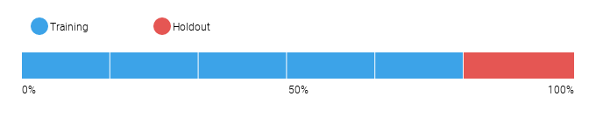
6.1.1 Data Partitioning Methodology
Because the distribution of the target in a binary classification project may be imbalanced, the modeling partitions were randomly selected using a stratified sample to preserve the distribution of the target for each partition.
6.2 Model Performance (Sample Scores)
As an additional layer of model validity, DataRobot not only evaluated the statistical metrics underlying the model, but also performed testing on out-of-sample records.
The performance metric used for this project was LogLoss. The model performance results are presented below for out-of-sample testing:
Scoring Type | Score (LogLoss)
holdout | 0.6132
validation | 0.6115
6.3 Sensitivity Testing and Analysis
6.3.1 Lift Chart
The Lift Chart sorts and groups numeric feature values into equal sized bins, depicting how well a model segments the target population and how capable it is of predicting the target. This helps the user to visualize model accuracy for each bin. The chart is sorted by predicted values -- lowest to highest predictions, for example -- which provides transparency to the model performance for different ranges of values of the target variable. Looking at the Lift Chart, the left side of the curve indicates where the model predicted a low score on one section of the population while the right side of the curve indicates where the model predicted a high score. The model Lift Chart is presented in the figure below.
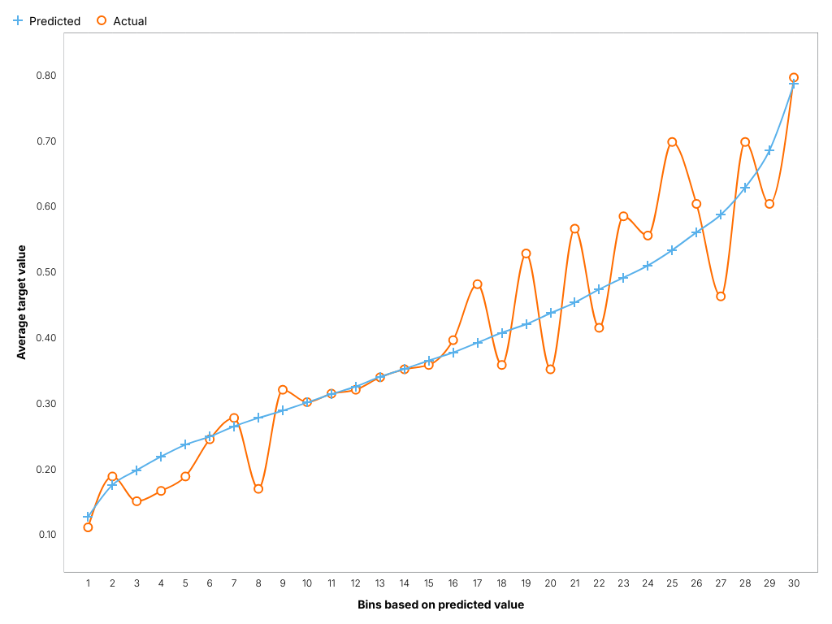
The points on the Lift Chart indicate the average percentage in each bin. The "Predicted" blue line displays the average prediction score for the rows in that bin. The "Actual" orange line displays the actual percentage for the rows in that bin. In general, the steeper the Actual line is, and the more closely the Predicted line matches the actual line, the better the model. A close relationship between these two lines is indicative of the predictive accuracy of the model; a consistently increasing line is another good indicator of satisfactory model performance.
6.3.2 Key Relationships
Feature Impact, which is available for all model types, works by altering input data and observing the effect on a models score. This technique is sometimes called Permutation Importance. The Feature Impact for a given column measures how much worse a models error score would be if DataRobot made predictions after randomly shuffling that column (while leaving other columns unchanged). DataRobot normalizes the scores so that the value of the most important feature column is first and the other subsequent features are normalized to it.
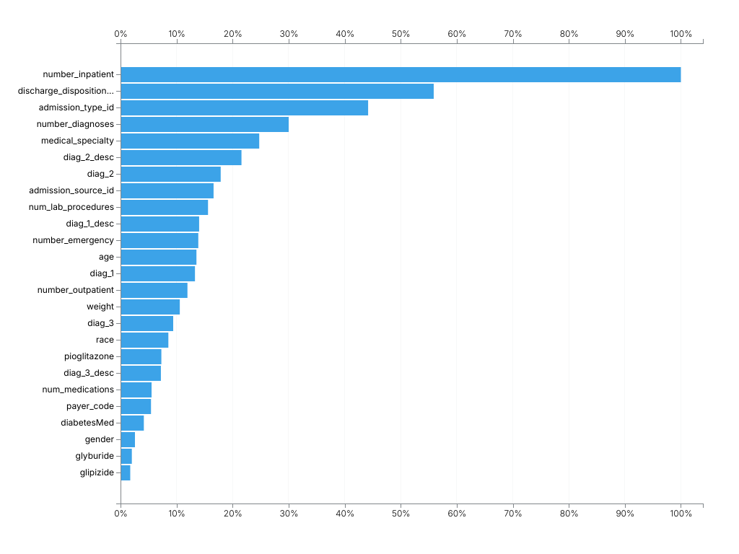
Feature Name | Impact Normalized | Impact Unnormalized
number_inpatient | 1.0 | 0.0236
discharge_disposition_id | 0.5589 | 0.0132
admission_type_id | 0.4419 | 0.0104
number_diagnoses | 0.3001 | 0.0071
medical_specialty | 0.2475 | 0.0058
diag_2_desc | 0.2158 | 0.0051
diag_2 | 0.1788 | 0.0042
admission_source_id | 0.166 | 0.0039
num_lab_procedures | 0.1561 | 0.0037
diag_1_desc | 0.1403 | 0.0033
number_emergency | 0.1388 | 0.0033
age | 0.1355 | 0.0032
diag_1 | 0.1329 | 0.0031
number_outpatient | 0.1194 | 0.0028
weight | 0.1058 | 0.0025
diag_3 | 0.094 | 0.0022
race | 0.0854 | 0.002
pioglitazone | 0.0729 | 0.0017
diag_3_desc | 0.072 | 0.0017
num_medications | 0.0554 | 0.0013
payer_code | 0.0544 | 0.0013
diabetesMed | 0.0416 | 0.001
gender | 0.0257 | 0.0006
glyburide | 0.0202 | 0.0005
glipizide | 0.0173 | 0.0004
A1Cresult | 0.0122 | 0.0003
num_procedures | 0.0121 | 0.0003
change | 0.0114 | 0.0003
metformin | 0.008 | 0.0002
repaglinide | 0.0049 | 0.0001
glimepiride | 0.0047 | 0.0001
rosiglitazone | 0.0035 | 0.0001
nateglinide | 0.0002 | 0.0
acarbose | 0.0002 | 0.0
chlorpropamide | 0.0001 | 0.0
time_in_hospital | -0.0003 | -0.0
glyburide_metformin | -0.0016 | -0.0
max_glu_serum | -0.0073 | -0.0002
insulin | -0.0472 | -0.0011
6.3.3 Sensitivity Analysis (Partial Dependence)
In the case of linear regression, users can gain considerable insight into the structure and interpretation of the model by examining its coefficients. For more complex models like support vector machines, random forests, or the blenders considered here, no comparably simple parametric description is available, making the interpretation of these models more difficult. To address this difficulty for his gradient boosting machine, Friedman (2001) proposed the use of partial dependence plots. Partial dependence plots show the average partial relationship between a set of predictors and the predicted response. The partial dependence plots below capture the top features in our model, as measured by Feature Impact.
number_inpatient
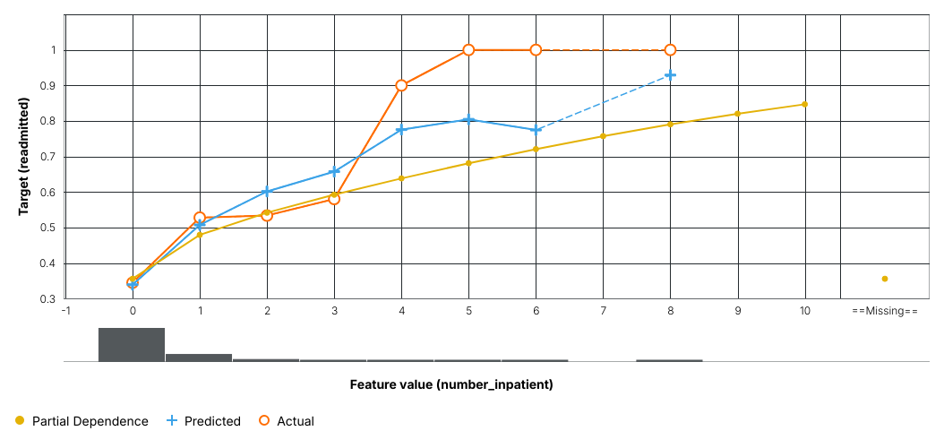
discharge_disposition_id
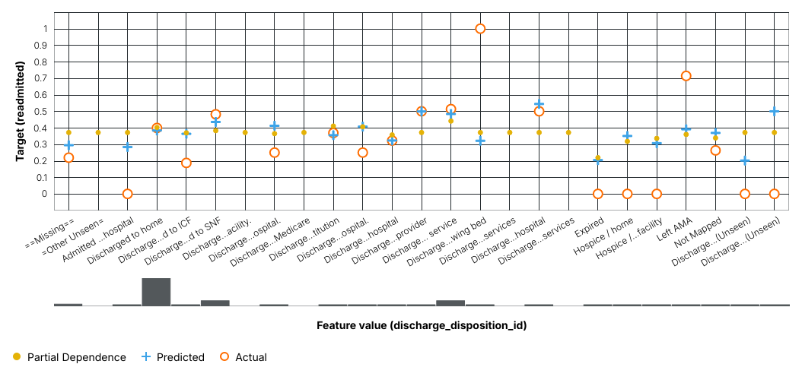
admission_type_id
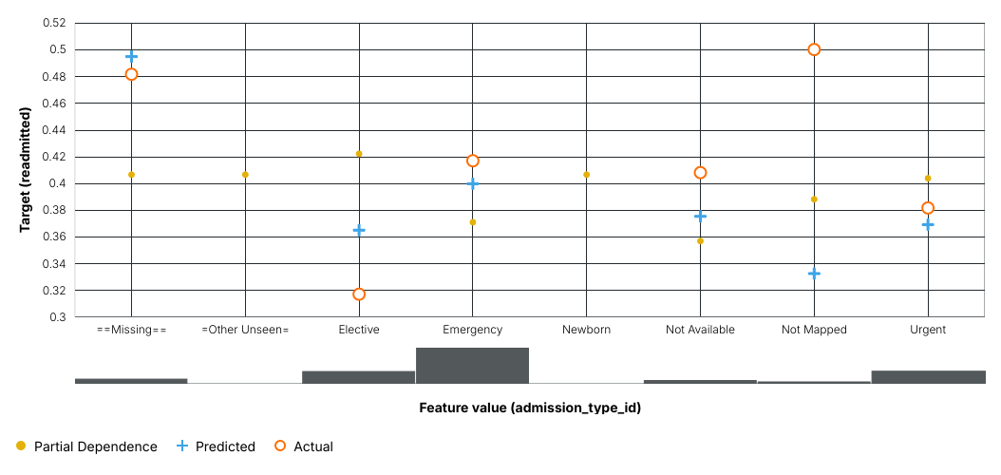
The orange circles depict, for the selected feature, the average target value for the aggregated feature values. The blue crosses depict, for the selected feature, the average prediction for a specific value. From the graph you can see that DataRobot also averages the predicted feature values. Comparing the actual and predicted points can identify segments where model predictions differ from observed data. This typically occurs when the segment size is small. In those cases, for example, some models may predict closer to the overall average.
The yellow partial dependence data points depict the marginal effect of a feature on the target variable after accounting for the average effects of all other predictive features. It indicates how, holding all other variables constant, the value of this feature affects prediction. DataRobot holds constant the values of all columns in the sample except the feature of interest. The value of the feature of interest is then reassigned to each possible value, calculating the average predictions for the sample at each setting. These values help determine how the value of each feature affects the target. The shape of the yellow data points describes the model's view of the marginal relationship between the selected feature and the target.
6.3.4 Accuracy (Receiver Operating Characteristic)
A confusion matrix is a table that reports true versus predicted values. The name "confusion matrix" refers to the fact that the matrix makes it easy to see if the model is confusing two classes (consistently mislabeling one class as another class). The table below presents key sensitivities that support the creation of a confusion matrix.
F1 Score | True Positive Rate | False Positive Rate | True Negative Rate | Positive Predictive Value | Negative Predictive Value | Accuracy | Matthews Correlation Coefficient
0.6184 | 0.8449 | 0.5833 | 0.4167 | 0.4876 | 0.8035 | 0.5865 | 0.276
Where the values reported are:
- F1 Score: A measure of the model's accuracy, computed based on precision and recall.
- True Positive Rate: Sensitivity or recall. The ratio of true positives (correctly predicted as positive) to all actual positives.
- False Positive Rate: Fallout. The ratio of false positives to all actual negatives.
- True Negative Rate: Specificity. The ratio of true negatives (correctly predicted as negative) to all actual negatives.
- Positive Predictive Value: Precision. For all the positive predictions, the percentage of cases in which the model was correct.
- Negative Predictive Value: For all the negative predictions, the percentage of cases in which the model was correct.
- Accuracy: The percentage of correctly classified instances.
- Matthews Correlation Coefficient: Measure of model quality when the classes are of very different sizes (unbalanced).
The Receiver Operating Characteristic (ROC) Curve allows the user to explore classification, performance, and statistics related to a selected model at any point on the probability scale. Because choosing the best model can be based on a number of parameters, it is important to understand whether the classification performance of a particular model meets predetermined specifications. The ROC Curve plots the true positive rate against the false positive rate for a given data source. The two important characteristics of the curve to consider are the area under the curve (AUC) and the shape of the curve. The AUC is a metric for binary classification that considers all possible thresholds and summarizes performance in a single value.
Below is the ROC curve for this model based on holdout.
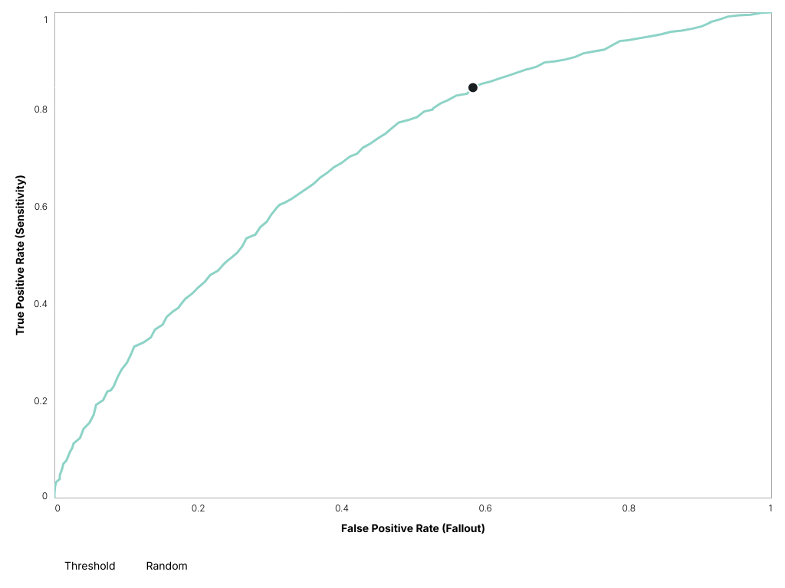
The Prediction Distribution graph shown below illustrates the distribution of actual distribution density in relation to the threshold (a dividing line for interpretation of the graph). Every prediction to the left of the dividing line is classified as false and every prediction to the right of the dividing line is classified as true. Therefore, this graph illustrates how well the model discriminates between prediction classes.
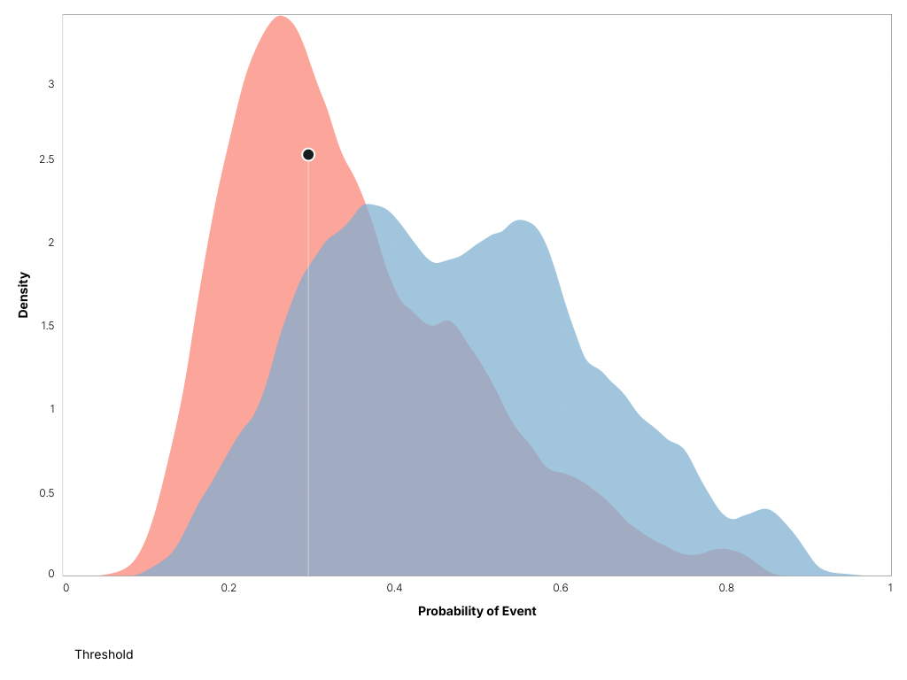
7 Model Implementation and Output Reporting
7.1 Version Control
DataRobot handles model and project version control automatically by tagging each model on the Leaderboard with a unique Model ID. The Model ID represents a single instance of a model type, feature list, sample size, and set of tuning parameter values. DataRobot also maintains unique Project IDs for each project, allowing accessibility to all models built for the project dataset. DataRobot's version control allows for reproducibility and traceability of the models it creates, which greatly increases the auditability of the model development process.
Users may also export Scoring Code for a DataRobot model in Java. You can download both a pre-compiled .jar file (with all dependencies included), plus the source code. Scoring Code is easy to deploy, test, and maintain on a variety of platforms, and you can inspect the generated Java code for complete transparency. DataRobot Scoring Code employs advanced features to ensure that predictions computed using generated Java code are the same as predictions computed inside DataRobot.

