Boxify: Customer Churn & Retention Analysis Report
Insights, Optimization & Growth Strategy
Prepared By: Agamya Jain

1. Executive Summary
Boxify, an online subscription-based lifestyle box service, conducted a detailed churn analysis using subscriber data from the past three years (984 active + churned customers after filtering short/ineligible records).
The overall churn rate stands at 17.4%, resulting in ₹1.21 million in lost revenue. Average Customer Lifetime Value (CLV) is ₹12.60K, average engagement score is 60.02, and average subscription duration for active customers is 20.02 months.
Monthly plans drive the majority of churns (141 cases, ~68% of total churned), while annual plans show much stronger retention (only 16 churned). While 36–50 shows the highest churn volume, the 50+ segment exhibits the highest churn rate (19.5% – 52 churned out of 266), followed by 36–50 (18.1%). Geographically, Chennai and Hyderabad each account for 29 churned customers (top locations).
Low engagement strongly predicts churn — customers with scores significantly below 60 are at much higher risk. By targeting monthly subscribers, low-engagement users, and high-churn age/location segments with personalized retention tactics, Boxify can realistically reduce churn by 5–10% in the next 6 months, potentially recovering ₹60K–₹120K in annual revenue while increasing average subscription lifetime.

2. Business Background & Problem Statement
Boxify operates as a premium subscription box service delivering curated lifestyle products. The company’s growth depends on high customer lifetime value (CLV) and long-term retention. However, management has identified a "Retention Gap" where a significant portion of new subscribers cancel before completing 6 months of service.
The Core Challenge:
- Revenue Erosion: ₹1.21M lost due to churn, impacting the budget for customer acquisition.
- Early Lifecycle Churn: High cancellation volume in the first quarter of subscription.
- Segment Imbalance: Certain age groups (36-50) and locations show disproportionately higher churn counts.
Management requires a data-driven strategy to identify high-risk segments and deploy personalized retention tactics to protect the company's profitability.

3. Data Overview & Methodology
The analysis used subscriber records including Customer ID, Join Date, Cancel Date, Age, Gender, Location, Subscription Type, Total Spent (proxy for CLV), Boxes Received, Engagement Score, Churn Status, Subscription Months, Age Group, and Subscription Days. Only eligible customers (≥30 days of subscription) were included.
Key KPIs evaluated:
- Churn Rate: 17.4%
- Revenue Lost: ₹1.21M
- Average CLV: ₹12.60K
- Average Engagement (active): 60.02
- Average Subscription Months (active): 20.02 (calculated as of 28th February 2026 for active customers)
Data preparation involved date parsing, currency cleaning, segment derivation, and aggregation. Techniques included trend analysis, segment comparisons, correlation assessment (engagement vs churn), and distribution visuals.
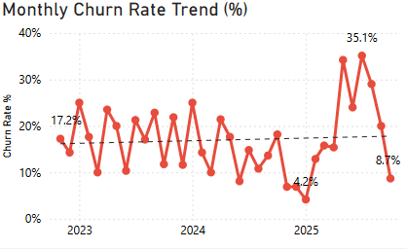
Assumptions made:
- Dataset represents complete relevant customer history.
- Only customers with ≥30 days subscription were considered.
- Churn measured only at end of subscription cycle.
- Total Spent used directly for revenue and CLV calculations.
- No missing transactions or major data gaps.
- Engagement score is a reliable proxy for interaction quality.
- Churn patterns are stable enough for segment-based targeting.
- Customer lifetime value correlates with subscription months/duration.
- For active customers, subscription days/months are calculated as of 28th February 2026.

4. KPI Performance Dashboard
The following KPIs represent the current health of Boxify’s subscriber base as of the latest reporting period.
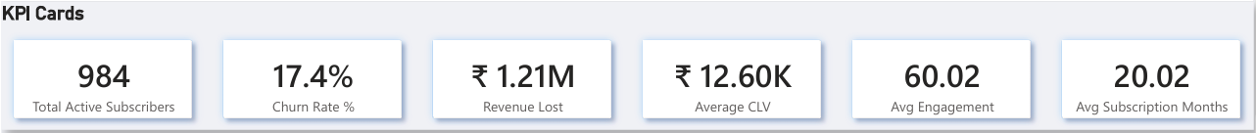

5. Exploratory Data Analysis (EDA)

5.1 Demographic Segmentation (Age & Gender)
Age is a significant predictor of churn behavior at Boxify.
- The 36-50 Segment: This group has the highest volume of churned customers (81 individuals), representing the most critical recovery opportunity.
- Gender Split: Female subscribers account for 107 cancellations, slightly higher than their male counterparts at 95.
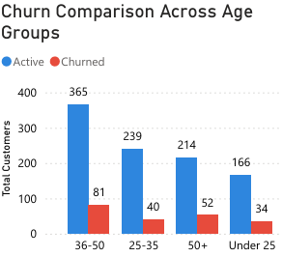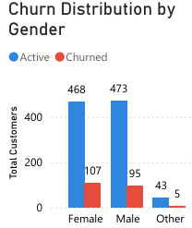

5.2 Subscription & Revenue Impact
The subscription type is the strongest leading indicator of loyalty.
- Monthly Risk: 141 out of 207 total churned customers were on monthly plans.
- Annual Stability: Only 16 annual subscribers churned, demonstrating significantly stronger retention compared to monthly subscribers.
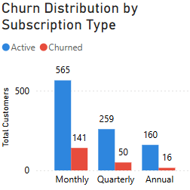

5.3 Behavioral & Geographic Analysis
- Engagement Threshold: There is a "Danger Zone" for customers with engagement scores below 40. These users are significantly more likely to cancel.
- Regional Hotspots: Chennai (29) and Hyderabad (29) lead in total cancellations, suggesting potential regional competition or service delivery issues.
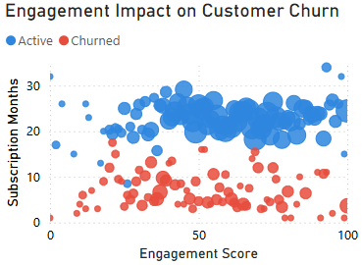
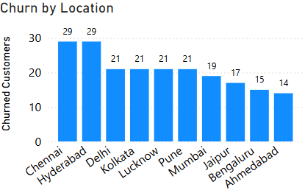

6. Business Insights & Findings
1. The Monthly "Commitment Gap": Subscribers on monthly plans view the service as a trial rather than a habit, leading to high turnover in the first 90 days.
2. Engagement as a Leading Indicator: Lower engagement scores are strongly associated with churn behavior.
3. High-Value Churn: The 36-50 age bracket contains our highest-spending customers; losing them has a disproportionate impact on CLV.
4. Geographical Churn: Chennai and Hyderabad show disproportionate location-based churn.
5. Churn has caused ₹1.21M in revenue loss; even modest reductions yield significant savings.

7.Strategic Recommendations

I. Quick Wins vs Long-Term Strategies to Reduce Churn

A. Quick Wins (0–3 Months)
These initiatives require minimal structural change and can deliver immediate impact.
1. Automated Re-Engagement Triggers
- Launch automated email/SMS nudges for users with engagement score < 40.
- Trigger reminders for inactive users after 7–10 days of no interaction.
- Use personalized subject lines and limited-time incentives.
Expected Impact: Immediate engagement recovery and early churn prevention.
2. Upgrade Incentives for Plan Migration
- Offer 15% discount for Monthly → Annual upgrades.
- Use in-app banners + one-click upgrade links.
- Target customers completing 3 billing cycles.
Rationale: Monthly plans account for highest churn and shortest lifetimes.
Locking customers into annual plans stabilizes revenue.
3. Loyalty & Milestone Rewards
- Launch “Boxify Rewards” for customers reaching a 6-month milestone.
- Offer loyalty points for consistent engagement.
- Provide small monthly bonuses for high engagers.
Objective: Help customers cross the early churn hurdle (first 6 months).
4. Reminder & Reactivation Campaigns
- Target low-engagement users with reminders.
- Offer 15–25% next-box discount for at-risk customers.
- Include short feedback survey to identify dissatisfaction drivers.

B. Medium to Long-Term Structural Strategies (3–12 Months)
These initiatives create sustainable retention improvement.
1. Subscription Plan Optimization Strategy
Current State:
Monthly plans contribute the majority of churn.
Strategy:
- Tier 1 (Annual): Heavy promotion + best discounts
- Tier 2 (Quarterly): Mid-tier incentives
- Tier 3 (Monthly): Auto-upgrade nudges after Month 3
Implementation:
Email journeys, in-app nudges, personalized renewal messaging.
2. Personalized Box Customization
- Enable customers to select preferences.
- Use engagement data for product matching.
- Introduce subscription pause option instead of cancellation.
Impact: Reduces churn caused by product dissatisfaction.
3. Dynamic Pricing & Engagement-Based Reward Tiers
- Offer engagement-based benefits (badges, streaks, perks).
- Implement dynamic offers for declining engagement users.
Goal: Increase average engagement by 10–15%.
4. Customer Feedback Integration
- Embed feedback forms before cancellation confirmation.
- Monthly NPS tracking.
- Rapid action on recurring complaints.

II. Engagement Strategies for High-Risk Customers
High-risk customers are defined as:
- Engagement score < 40
- Monthly subscribers
- 50+ age group
- High-churn locations (e.g., Chennai, Hyderabad)

A. Segment-Based Targeting
1. 50+ Age Group
- Simplified onboarding experience
- Dedicated customer support
- Periodic satisfaction calls
2. High-Churn Locations (Chennai / Hyderabad)
- Regional promotional campaigns
- Logistics & delivery performance audit
- Location-based referral incentives
3. At-Risk Monthly Subscribers
- Early intervention after 2–3 months
- 15–25% retention discount
- Personalized plan upgrade messaging

B. Value-Based Customer Strategy
Segment 1: High-Value Active Customers
- Offer VIP perks (exclusive boxes, early access).
- Invite to referral program (₹500 credit per referral).
Segment 2: At-Risk Customers
- Trigger discount + engagement push.
- Provide personalized product recommendations.
- Offer pause option instead of cancellation.

8. Predicting Churners
Using simple rules:
- If Engagement < 40
- Subscription Type = Monthly
- Age 36–50
- Duration < 6 months
→ Customers meeting 3 or more risk conditions show significantly higher churn probability and should be flagged for intervention..
→ For advanced analysis, may Implement logistic regression model in Python or Power BI ML integration.

9. Conclusion
By focusing on migrating monthly subscribers to longer-term plans and proactively engaging users with low interaction scores, Boxify is well-positioned to reduce its churn rate to about 10%. These actions could recover approximately ₹60K–₹120K annually based on current churn levels and stabilize the subscriber base for future expansion.

