Crude Oil Trading Performance & Supply Chain Analysis
SQL and Power BI Analysis of Trading Activity
Domain | Oil & Gas — Crude Oil Trading | Focus | Trading Performance, Supply Contribution & Regional Analysis
Tools | MySQL, Power BI, DAX | Project Type | Data Analyst Portfolio Project
Author | Agamya Jain | Analysis Period | January 2023 – August 2024
Project Background: This portfolio project analyzes a transaction-level crude oil trading dataset covering January 2023 to August 2024. The analysis combines buyer, supplier, and transaction data to understand trading contribution across participants, crude types, regions, and time. SQL was used for data preparation and analytical queries, while Power BI was used to build an interactive dashboard for business-focused analysis.
1. Project Overview
The project evaluates crude oil trading performance across buyers, suppliers, crude types, buyer regions, supplier regions, and time. A consolidated transaction-level dataset was prepared using SQL joins between transaction, buyer and supplier tables. The resulting dataset was used as the Power BI source, while separate SQL queries were used to answer the defined business questions.
Objectives
- Analyze overall trading performance using transaction count, traded quantity, calculated revenue and average price.
- Identify the buyers and suppliers contributing the most in terms of traded quantity and calculated revenue.
- Compare crude types using traded quantity, calculated revenue, and average price.
- Evaluate buyer- and supplier-region concentration and distribution.
- Identify notable changes in trading activity, traded quantity, and average price over time.
2. Data & Analytical Approach
Dataset Overview
Item | Description
Source dataset | Consolidated SQL output used as the Power BI source
Transactions | 200 transaction records
Time period | January 2023 – August 2024
Buyer data | Buyer/company and buyer region
Supplier data | Supplier/company and supplier region
Transaction fields | Buyer, supplier, crude type, quantity, price and date
Analytical revenue | Project-defined revenue = (quantity × price per barrel) / 7.33
SQL Preparation
A dedicated SQL preparation query joins the transaction table with buyer and supplier master data to create one consolidated analytical dataset. The join preserves transaction-level detail while bringing in buyer names, supplier names, and their respective regions.
Revenue Calculation
The project defines calculated revenue as: Revenue = (quantity MT × price_per_barrel) / 7.33. This metric is used consistently in SQL analysis and Power BI.
Power BI Measures
Core measures include Total Transactions, Total Quantity, Average Price and Calculated Revenue. The dashboard presents these KPIs together with buyer, supplier, crude-type, regional and monthly views.
3. Business Questions
- Q1. Which buyers and suppliers contribute the most to crude oil trading activity in terms of traded quantity and calculated revenue?
- Q2. Which crude oil types have the greatest commercial contribution, and how do pricing levels differ?
- Q3. Which buyer and supplier regions account for the largest share of trading activity?
- Q4. How does crude oil trading activity change over time, and which periods show notable changes?
- Q5. What is the overall trading performance in terms of transactions, quantity, average price, and calculated revenue?
4. Key KPIs
KPI | Result
Total Transactions | 200
Total Quantity Traded | 15.19M MT
Calculated Revenue | $186.44M
Average Price | $88.90/bbl
5. Results & Key Findings
1. Buyer concentration
Finding: Bharat Petroleum was the largest buyer with 1.71M MT and $20.86M in calculated revenue. The top five buyers contributed 47.31% of total quantity and 47.14% of calculated revenue.
Interpretation: Trading activity is meaningful across multiple buyers, but a relatively small group accounts for nearly half of overall activity.
2. Supplier concentration
Finding: Saudi Aramco was the largest supplier with 1.80M MT and $22.39M in calculated revenue. The top five suppliers contributed 47.88% of total quantity and 46.16% of calculated revenue.
Interpretation: The supply side also shows concentration among the largest contributors, although activity remains distributed across several suppliers.
3. Crude type: traded quantity vs calculated revenue
Finding: WTI had the highest traded quantity at 3.15M MT, while Dubai Crude generated the highest calculated revenue at $39.68M. Dubai Crude also had a higher average price of $93.92/bbl compared with WTI at $89.65/bbl.
Interpretation: The highest traded quantity does not automatically produce the highest calculated revenue; price level also influences commercial contribution.
4. Regional concentration
Finding: India was the largest buyer region with 5.12M MT and $61.19M in calculated revenue, representing 33.67% of total quantity and 32.82% of total revenue. The largest supplier region, the USA, represented 12.67% of total quantity and 12.72% of total revenue.
Interpretation: Buyer activity is more geographically concentrated than supplier activity in this dataset.
5. Peak trading period
Finding: April 2023 recorded the highest monthly trading activity: 19 transactions, 1.33M MT, and $17.16M in calculated revenue.
Interpretation: The peak was supported by both transaction count and traded quantity rather than by price alone.
6. Price vs volume
Finding: June 2024 recorded the highest monthly average price at $104.03/bbl, but only 0.33M MT of traded quantity and $4.70M in calculated revenue.
Interpretation: A high average price alone does not guarantee high calculated revenue when traded quantity is low.
6. Power BI Dashboard
The interactive Power BI dashboard consists of three pages designed to examine crude oil trading performance from executive, participant, regional and time-based perspectives.
Page 1 — Executive Overview
Presents total transactions, traded quantity, calculated revenue, and average price. It also highlights the monthly calculated-revenue trend, the top five buyers by traded quantity, and crude-type share by quantity. This page provides a high-level view of trading performance.
Figure 1. Power BI Executive Overview.
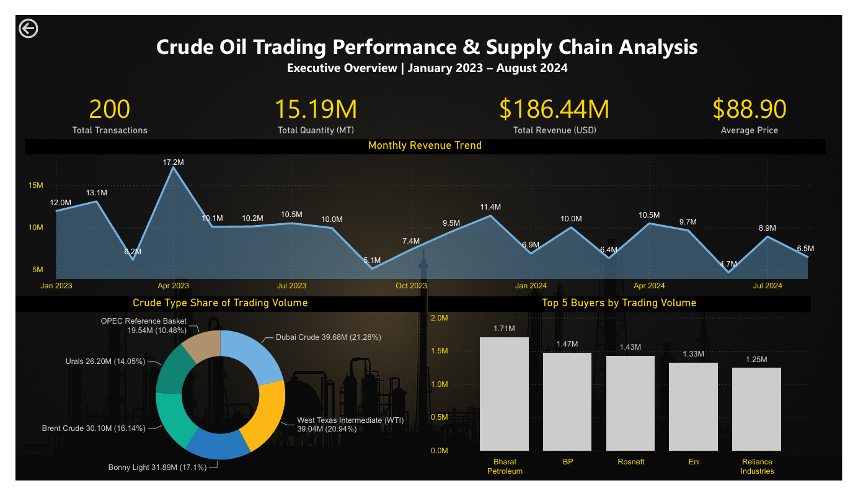
Page 2 — Buyer & Supplier Performance
Compare buyers and suppliers using traded quantity and calculated revenue. Buyer, buyer-region, supplier and supplier-region slicers allow users to explore participant contributions and examine how trading activity is distributed across entities.
Figure 2. Buyer & Supplier Performance.
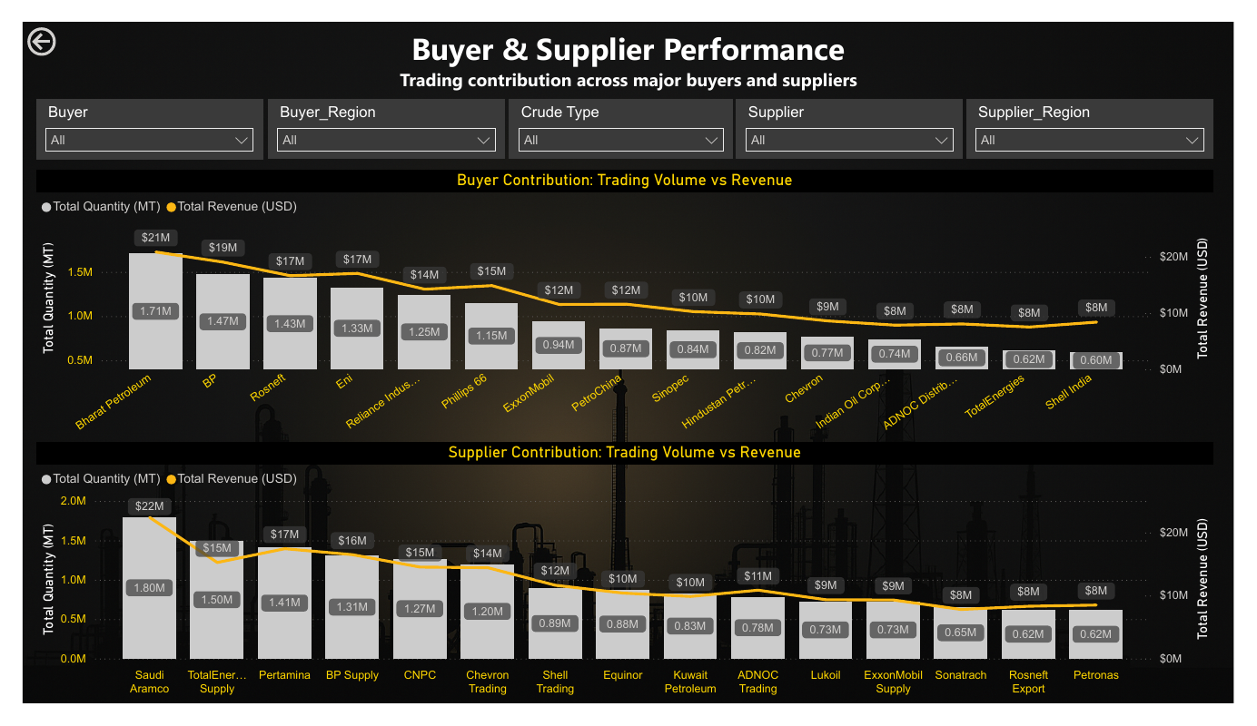
Page 3 — Crude, Regional & Trend Analysis
Examines buyer- and supplier-region contributions, monthly traded quantity alongside average price, and crude-type performance. This page helps identify differences between quantity and revenue contribution, regional concentration, and changes in trading activity over time.
Figure 3. Crude, Regional, & Trend Analysis.
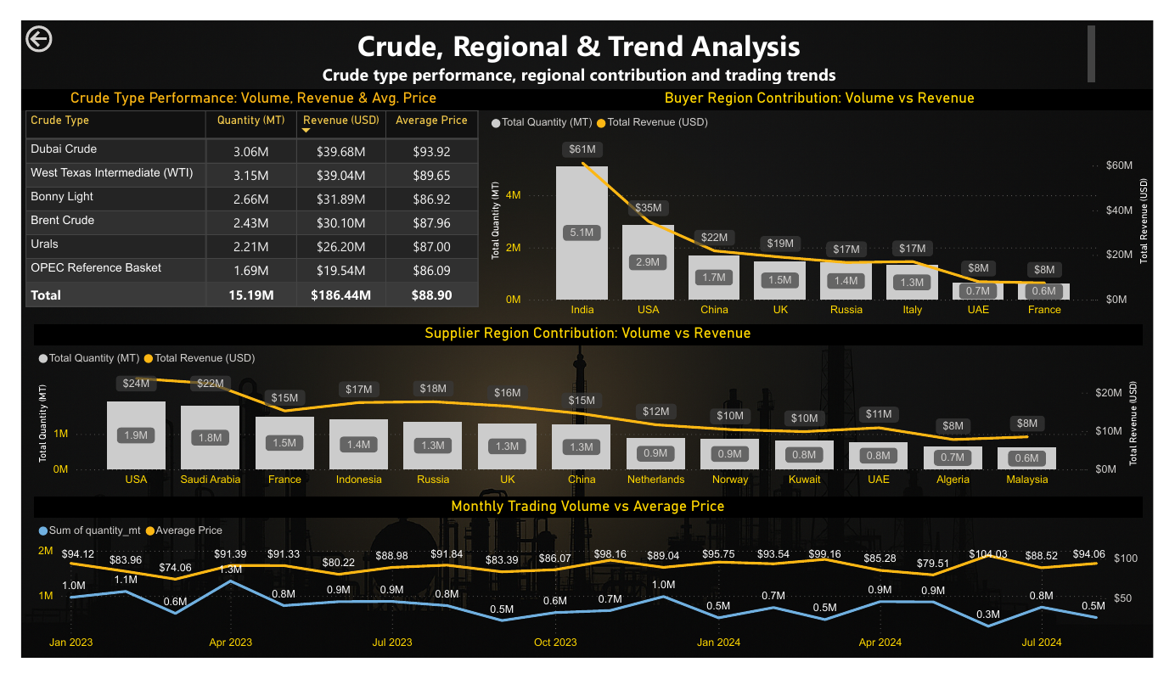
Dashboard interpretation
The dashboard compares traded quantity with calculated revenue and monthly quantity with average price so that performance is not judged using a single metric. Calculated revenue is a project-defined measure and should not be interpreted as profit.
7. Business Recommendations
1. Manage participant concentration
Strengthen relationships with high-contribution buyers and suppliers while maintaining alternatives to avoid excessive dependence on a limited group of participants.
2. Evaluate crude mix using multiple metrics
Compare crude types using traded quantity, calculated revenue and average price together rather than relying on traded quantity alone.
3. Monitor geographic concentration
Maintain supplier-region diversification while evaluating opportunities to broaden the buyer market beyond the highly concentrated Indian market.
4. Track price and quantity jointly
Monitor average price alongside traded quantity because high pricing does not necessarily translate into high calculated revenue when trading activity is low.
8. Constraints, Assumptions & Limitations
- The analysis covers January 2023 to August 2024 and is based on 200 transactions.
- Revenue is a project-defined calculated metric using quantity, price per barrel, and a 7.33 conversion factor.
- The dataset does not contain operating costs, transportation costs, procurement costs, profit margins, contract terms, lead times or supplier quality measures.
- The analysis therefore evaluates trading activity, calculated revenue, quantity, pricing, participant contribution, regional distribution and trends—not profitability or operational efficiency.
- Recommendations are limited to patterns directly supported by the available data.
9. Conclusion
The analysis provides a transaction-level view of crude oil trading performance across participants, crude types, regions, and time. The strongest patterns are the concentration of activity among leading buyers and suppliers, the difference between traded-quantity leadership and calculated-revenue leadership across crude types, stronger geographic concentration on the buyer side, and the importance of considering price and quantity together. The dashboard and SQL analysis therefore support business-oriented interpretation of trading activity while remaining appropriately limited to the fields available in the dataset.
10. Technology Used & Portfolio Note
Technology | Purpose
MySQL | Data preparation, joins and business-question analysis
Power BI | Interactive dashboard, KPI reporting and visual analysis
DAX | Calculated measures for quantity, revenue, transactions and average price
Portfolio Note: This project is a portfolio adaptation focused on demonstrating SQL data preparation and analysis, Power BI dashboard development, DAX-based KPI calculation, and business insight generation. The calculated revenue metric and conclusions are specific to the supplied project dataset.

