Executive Summary
FashionWave Retail conducted a comprehensive sales performance analysis to identify profitability drivers, customer behavior trends, and growth opportunities. The analysis evaluated transaction-level sales data across multiple stores, product categories, and customer segments.
The study revealed that discounts significantly reduce profit margins despite driving transaction volume. Additionally, weekend sales underperform in total revenue despite demonstrating higher average order values, indicating untapped premium customer potential. Product category analysis identified Accessories as the primary profit driver, while Clothing requires cost optimization strategies. Customer segmentation analysis showed that returning customers generate approximately 70% of total revenue, highlighting the importance of retention and loyalty programs.
By implementing strategic discount optimization, targeted weekend marketing initiatives, and category expansion strategies, FashionWave Retail can improve profitability while maintaining sustainable sales growth.

Business Background & Problem Statement
FashionWave Retail operates as a multi-category fashion retailer offering clothing, footwear, and accessories. The competitive retail environment requires continuous monitoring of pricing strategies, product mix, and customer engagement methods to maintain profitability and market share.
The company faced key challenges including declining profit margins due to aggressive discounting, inconsistent sales performance across weekdays and weekends, and imbalance in profitability across product categories. Management required data-driven insights to optimize business strategy and identify high-impact revenue opportunities.

Data Overview & Methodology
The analysis used historical point-of-sale transaction data including invoice details, product categories, discount percentages, revenue, cost, and customer segmentation information. Key performance metrics evaluated included revenue, net profit, profit margin, average order value (AOV), and discount impact.
Data preparation involved cleaning duplicate records, standardizing categorical variables, and deriving new metrics such as profit margin and customer segmentation indicators. Analytical techniques included trend analysis, category profitability comparison, customer segmentation analysis, and financial impact modeling.

Exploratory Data Analysis
Sales trend analysis indicated consistent weekday dominance in overall revenue generation. However, weekend transactions demonstrated higher average order values, suggesting stronger purchasing intent among weekend shoppers.
Discount analysis showed that approximately 60% of transactions involve discounts with an average discount level above 12%. Although discounts increase sales volume, they significantly reduce overall profit margins, highlighting the need for targeted discount strategies instead of blanket promotions.

Product & Category Performance Analysis
Accessories emerged as the highest-performing category in terms of profit contribution and margin performance. The category demonstrated strong customer demand and consistent repeat purchases.
Footwear maintained stable performance with strong unit sales and healthy margins, presenting opportunities for cross-selling with accessories.
Clothing showed comparatively lower profit margins due to higher sourcing and production costs. The category requires cost restructuring and strategic price optimization to improve overall profitability.
The analysis also identified low-performing products generating minimal profit contributions. Rationalizing these products can improve inventory efficiency and shelf-space utilization.

Customer Segmentation & Behavior Analysis
Customer segmentation revealed that returning customers contribute approximately 70% of total revenue, demonstrating strong brand loyalty and repeat purchase behavior. These customers typically exhibit higher purchase frequency and larger basket sizes.
New customers contribute the remaining 30% of revenue and provide significant long-term growth potential. Improving onboarding experience, personalized marketing campaigns, and referral programs can improve conversion rates from new to returning customers.

Key Findings & Insights
1. Discount-driven sales reduce profitability despite increasing volume.
2. Weekend shoppers demonstrate higher spending behavior but represent lower overall revenue share.
3. Accessories category drives the majority of profit and should be expanded.
4. Clothing category requires cost and pricing optimization strategies.
5. Returning customers are the primary revenue source and require loyalty-focused engagement strategies.

Actionable Recommendations
• Implement tiered discount strategies based on product performance and customer segments.
• Introduce weekend experiential marketing events and targeted digital promotions.
• Expand high-margin accessory product lines and bundle with footwear offerings.
• Conduct cost optimization and supplier evaluation for clothing category.
• Launch loyalty reward programs and personalized marketing campaigns to retain high-value customers.

Financial Impact Estimation
Strategic implementation of optimized discount policies can improve overall profit margins by approximately 3–5%. Weekend sales improvement initiatives can generate incremental revenue growth through targeted promotional campaigns and extended store engagement activities.
Customer retention programs can increase customer lifetime value and reduce acquisition costs, contributing to long-term profitability and business stability.

Conclusion & Future Scope
The FashionWave Retail Sales Analysis highlights the importance of balancing pricing strategies, category optimization, and customer engagement initiatives to drive sustainable business growth. The insights derived from this study provide actionable recommendations that can significantly enhance profitability and operational efficiency.
Future analytical initiatives may include predictive demand forecasting, inventory optimization modeling, and customer churn prediction using advanced analytics and machine learning techniques.

Key Business Insights
- Weekend Sales Gap
Weekend sales are only 52.1% of weekday sales. This is a Critical Opportunity. Weekend traffic is 1.9x lower than weekdays, indicating underutilization of weekend demand potential.
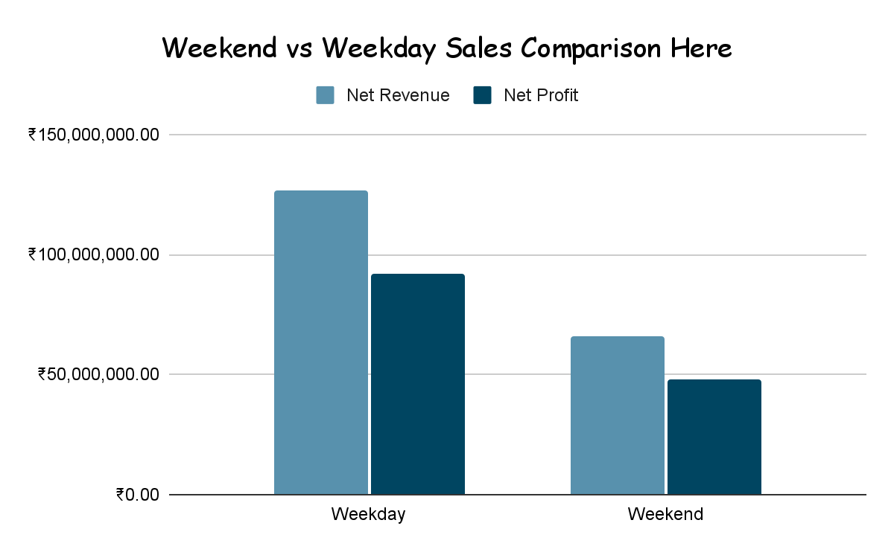
- Discount Effectiveness Problem
No-discount sales have 75.4% profit margin vs less than 65% for >20% discounts. Heavy discounting erodes profitability. Each 1% additional discount reduces margin by ~0.5 percentage points.
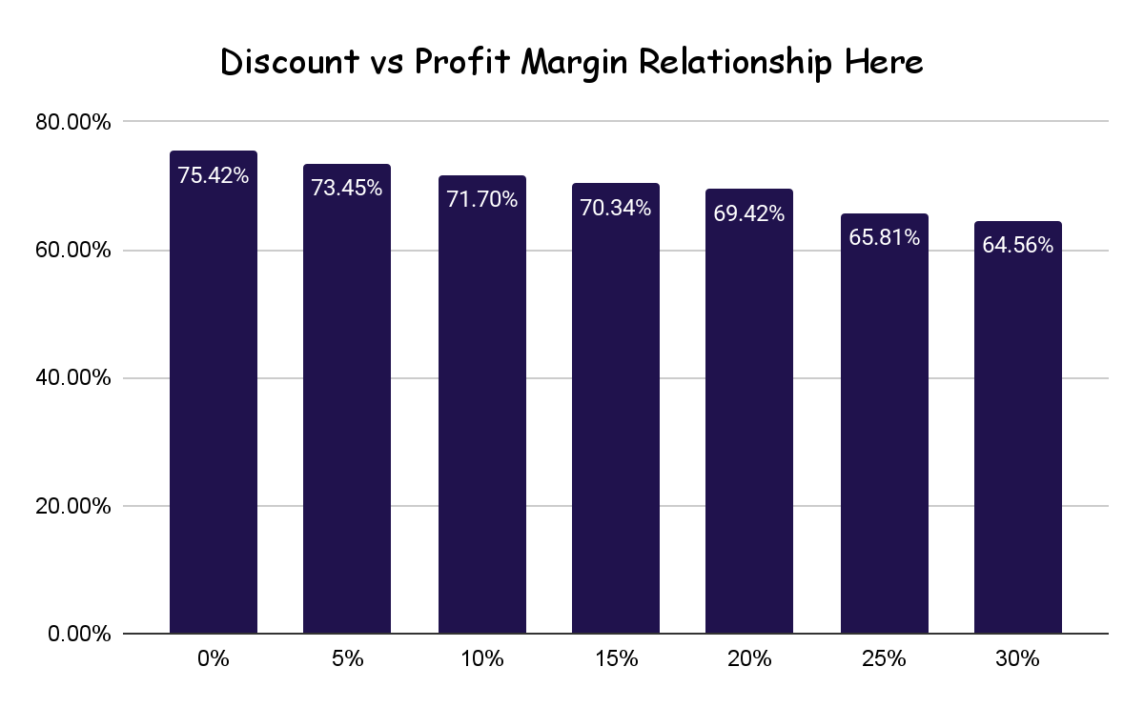
- Clothing Category Underperformance
Clothing profit margin is only 58.7% vs 73-79% for Accessories/Shoes. This suggests pricing issues, cost problems, or poor product mix. Needs immediate strategic review.
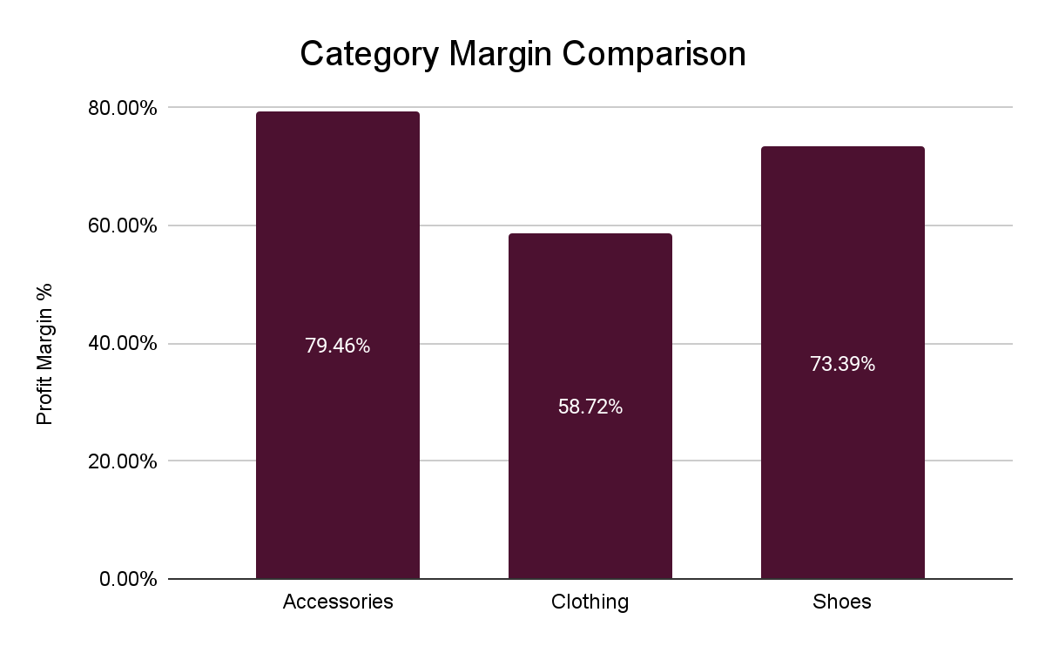
- Star Products Identified
Top 3 products (PRD0045, PRD0052, PRD0059) generate ₹2.1M+ profit each. Accessories category has 13 products in top 15 performers. Focus expansion on these high-performers.
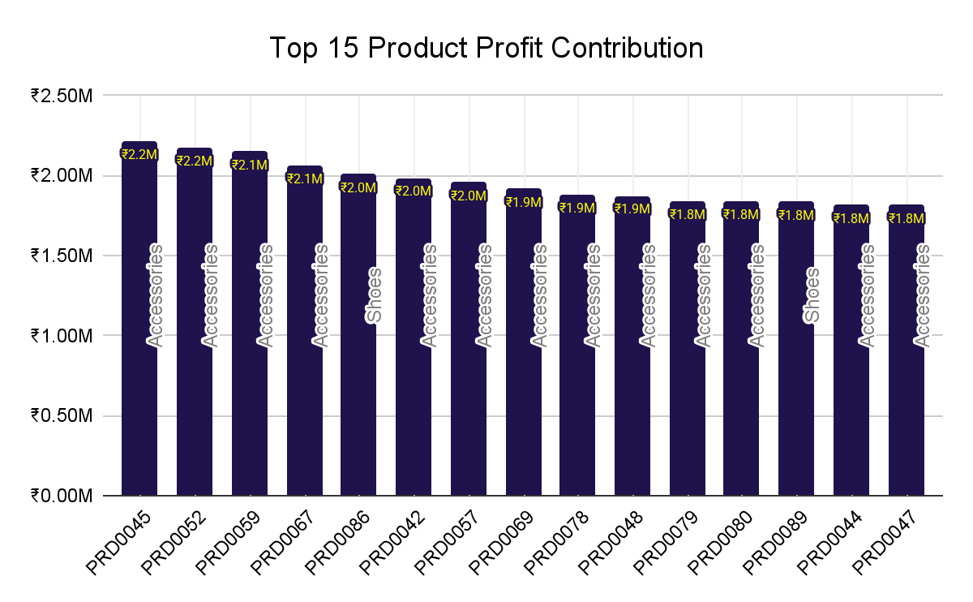
- Store Performance Variance
Top store (STR018) generates ₹4.97M vs bottom store (STR037) at ₹2.26M, reflecting a 54.6% performance gap. Store-level optimization can unlock ₹20M+ additional annual profit.
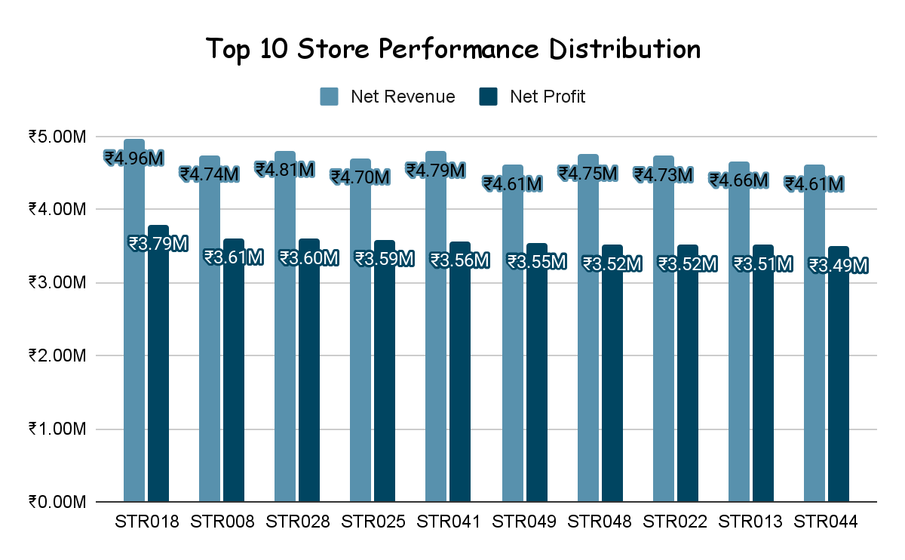

Strategic Recommendations & Business Strategy
1. Discount Optimization Strategy
CURRENT STATE: 60% of sales use discounts (avg 12.4%), eroding 5%+ margin points
POLICY RECOMMENDATION:
• Tier 1 (Best performers): 0% discount - maintain premium positioning
• Tier 2 (Strong performers): Max 5% discount for volume - ₹15M+ revenue products
• Tier 3 (Growing): Max 10% discount - bundling strategy
• Tier 4 (Underperformers): Max 15% discount - clearance only
EXPECTED IMPACT: +3% profit margin (+₹5.8M quarterly) | -2% volume | +1.8% AOV
IMPLEMENTATION:
→ Shift from blanket discounts to strategic promotions
→ Replace price cuts with loyalty rewards (double points, exclusive access, bundles)
→ Use tiered discounts by customer type (New: 10%, Returning: 5%)
→ Track discount elasticity by product/category quarterly
2. Weekend Sales Growth Initiative
CURRENT STATE: Weekend revenue is only 52% of weekday; Gap of ₹60.8M.
ROOT CAUSES:
→ Likely lower store traffic on weekends
→ Potential reduced staffing or hours
→ Possible lower customer engagement/awareness
15% GROWTH TARGET ACTIONS:
1. Experiential Marketing: Weekend pop-up events, product launches, demo stations
2. Digital Promotion: Weekend-only email campaigns (Fri/Sat mornings) with loyalty incentives
3. Staffing Optimization: Increase sales staff on Sat/Sun (data shows higher AOV on weekends: ₹15,162 vs ₹11,924)
4. Event Calendar: Monthly "Fashion Nights," "Sale Saturdays," "Sunday Family Shopping"
5. Influencer Partnerships: Weekend brand collaborations and social media campaigns
6. Extended Hours: Test extended hours on Sat/Sun for top 10 performing stores
FINANCIAL IMPACT:
• Current weekend sales: ₹66.1M
• 15% growth target: +₹9.9M in quarterly revenue
• Estimated profit increase: +₹7.2M (72% margin)
• Annual impact: +₹28.8M revenue, +₹21.6M profit
3. Product & Category Optimization
ACCESSORIES (₹65.6M profit | 79.5% margin) - EXPAND ⭐
→ Dominate with 5,147 transactions | 13 of top 15 products are accessories
→ Action: Increase SKU mix by 20%, expand in all 50 stores
→ Target: +10% revenue growth by next quarter
SHOES (₹47.6M profit | 73.4% margin) - MAINTAIN & GROW
→ Strong performer with solid 16,113 units sold
→ Action: Cross-sell with accessories, create bundle offerings
→ Target: +8% revenue growth through bundles
CLOTHING (₹26.7M profit | 58.7% margin) - TURNAROUND NEEDED ⚠️
→ Lowest margin (almost 20 points below Accessories), profit drag
→ Action:
- Audit cost structure (likely manufacturing/sourcing issue)
- Test 5-10% strategic price increases on premium lines
- Consider category bundling (Clothing + Accessories)
- Evaluate supplier consolidation opportunities
→ Target: Improve margin to 55% (from 43%) = +₹3.2M quarterly profit
BOTTOM 10 PRODUCTS - DISCONTINUE/REPOSITION
→ 10 products averaging ₹363K profit each
→ Action: Offer buyout deals, bundle with star products, or discontinue
→ Impact: Frees up shelf space and capital for high-performers
4. Customer Segmentation & Loyalty Strategy
SEGMENT 1: HIGH-VALUE RETURNING CUSTOMERS (70% of revenue)
→ 10,562 customers | ₹136.8M revenue | ₹99.4M profit (71% of total)
→ Action: VIP loyalty program with:
- Birthday discounts (5-10%, non-stacked)
- Exclusive early access to new products
- Tiered rewards (₹50K: 5% back, ₹100K: 7% back in store credit)
SEGMENT 2: NEW CUSTOMERS (30% of revenue)
→ 4,438 customers | ₹56.2M revenue | ₹40.6M profit
→ Action: Acquisition & onboarding program:
- Welcome offer: 10% discount on first purchase (approved)
- Email nurture series: exclusive content, style tips, product education
- Referral rewards: Both referrer & new customer get 5% store credit

