Executive Summary
TastyBites, a food delivery app operating in multiple cities, has conducted a detailed profitability analysis using transactional data from March 2024 to February 2026 (1,100 orders, 6,207 units sold across 10 products in 3 categories: Meals, Beverages, and Snacks). The overall revenue stands at ₹837.3K, with total profit of ₹299.1K and an average profit margin of 35.7% (calculated as total profit divided by total revenue, reflecting a conservative approach to discount imputation). Revenue lost due to discounts totals ₹102.2K across the period, with an average order value (AOV) of ₹761—indicating room for uplift through targeted bundling.
The analysis reveals profit concentration in a few high-demand products (e.g., Veg Pizza, Paneer Roll, and Chocolate Shake contribute ~36% of total profits, or ₹107.9K combined), while high-volume items like Veg Pizza (653 units sold, representing 10.5% of total volume) yield low margins (27.7%) due to an average 11.8% discount rate. Returning customers drive 51% of total revenue (₹431K vs. ₹406K for new customers) and 0.5% higher revenue per order (₹763 vs. ₹759), with comparable margins (35.7% vs. 35.8%), highlighting retention as a low-risk profitability lever.
Category-wise, Meals generate 52% of revenue (₹434.7K) but only 45% of profit (₹134.8K) due to discount sensitivity, while Snacks offer the highest average margin (38.8%) on 30% of units (1,879 sold). Recommendations include capping discounts at 8% for Meals to recover ₹20-25K in lost revenue, bundling high-margin Snacks (e.g., French Fries at 44.4% margin) with Meals to boost AOV by 15% (projected +₹114K annual revenue), and +5% price adjustments on low-sensitivity Snacks (e.g., French Fries, adding ~₹3.5K profit). These data-backed actions could increase overall profitability by 8-10% (₹24-30K additional profit) within 6 months, balancing growth and customer retention.

1. Business Scenario / Background
TastyBites is a food delivery platform operating across multiple cities, offering a wide variety of vegetarian food items including Meals (e.g., Veg Pizza, Paneer Roll—52% of revenue from high-volume staples), Beverages (e.g., Chocolate Shake, Cold Coffee—24% revenue with 42.3% average margins), and Snacks (e.g., French Fries, Nachos—24% revenue but 38.8% margins, ideal for upsell). As the platform expands amid rising competition, management has noted stark inconsistencies in profitability: high-sales products like Veg Pizza (₹145K revenue, 653 units) contribute thin margins (27.7%) due to aggressive promotions, while underpromoted high-margin items like French Fries (₹63.1K revenue, 44.4% margin) represent untapped potential.
This imbalance—exacerbated by ₹102.2K in discount-driven revenue loss over 24 months—suggests inefficiencies in pricing, cost allocation, and promotional tactics, risking erosion of the 35.7% overall margin. With customers sensitive to price changes >10% and discounts capped at 25% per policy, management seeks data-driven insights to optimize pricing and promotions, maximizing profits without volume drops or delivery cost inclusions (per assumptions).

2. Business Objectives
The primary objectives of this analysis include:
- Identify high-profit and low-profit products across the menu.
- Understand how discounts and promotions impact profit margins.
- Determine whether certain products generate high sales but low profits.
- Identify opportunities for price optimization.
- Recommend strategies to improve overall profitability.

3. Dataset Overview
The dataset used for this analysis contains order-level transactional data covering the last two years of operations. Each record represents a product purchase and includes information such as product category, units sold, revenue, cost, discount percentage, and customer type.
Key columns include:
Order Date | Product Name | Category | Units Sold | Revenue | Cost | Discount Percentage | Customer Type
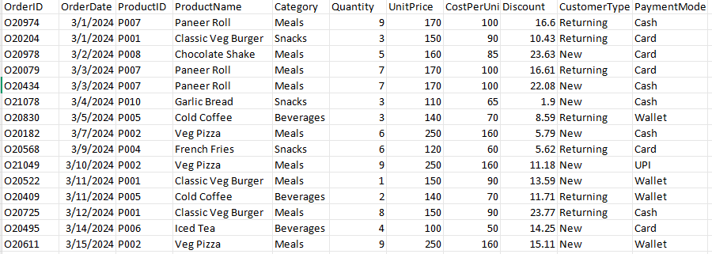

4. Data Cleaning and Preparation
Before conducting the analysis, several data quality issues were identified and resolved to ensure accurate insights.
Key data preparation steps included:
- Handling 114 missing values in the discount column (10.4% of records) by replacing null values with 0%.
- Standardizing inconsistent product category names in 60 records (5.5% of dataset; e.g., Chocolate Shake misclassified as Meals, Veg Pizza as Beverages; corrected to mode category per product).
- Ensuring discount values did not exceed the company policy limit of 25%.
- Creating calculated fields including Revenue = Quantity × UnitPrice × (1 - Discount/100), Cost = Quantity × CostPerUnit, Profit = Revenue - Cost, Profit Margin % = (Profit / Revenue) × 100, and Discount Impact = Quantity × UnitPrice × (Discount/100).
- Validating the time range to ensure analysis only included the most recent two years of data.
Assumptions Made:
- Profit calculated as Revenue – Cost (delivery and operational costs excluded)
- Discount cap assumed at 25% as per company policy
- 10% discount used as an analytical threshold to examine discount impact.
- Profit Margin = (Revenue – Cost) / Revenue
- Analysis limited to 2 years of historical data
- Missing discount values treated as 0% discount

5. Key Performance Indicators (KPIs)
The following KPIs were calculated using Power BI measures:
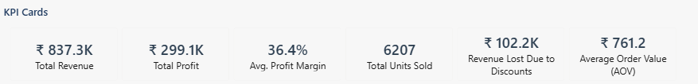

6. Exploratory Data Analysis (EDA)
Exploratory data analysis was conducted using Power BI dashboards to understand product-level performance, sales trends, and the impact of discounts.
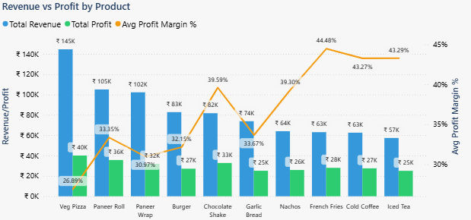
- This clustered bar chart illustrates revenue (blue) vs. profit (orange) by product, overlaid with average profit margins (line). Veg Pizza leads revenue at ₹145K (17.3% of total) but trails in margin efficiency at 26.9%, generating ₹40.1K profit on 653 units—highlighting a "volume trap" where high sales (10.5% of total units) subsidize lower returns (13.4% profit contribution). In contrast, French Fries deliver ₹63.1K revenue with ₹28K profit (44.4% margin), underscoring Snacks' cost advantages (CostPerUnit ₹60 vs. Meals' ₹120 avg.)
Product | Revenue (₹K) | Profit (₹K) | Margin (%) | Units Sold
Veg Pizza | 145.0 | 40.1 | 27.7 | 653
French Fries | 63.1 | 28.0 | 44.4 | 585

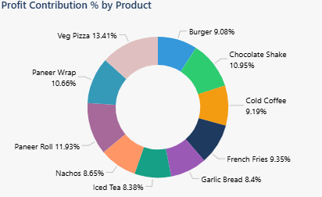
- The pie chart breaks down profit contribution by product, showing concentration: Top 3 (Veg Pizza 13.4%, Paneer Roll 11.9%, Chocolate Shake 11.0%) account for 36.3% of ₹299.1K total profit, risking over-reliance (e.g., if Veg Pizza demand dips 10%, profit falls ~1.3%). Beverages contribute 28.4% (₹85.3K) despite only 24% revenue share, thanks to 42.3% margins. Full breakdown: Snacks (26.4%, ₹79K) punch above weight on 30% units; Meals (45.1%, ₹134.8K) dominate but at diluted efficiency.
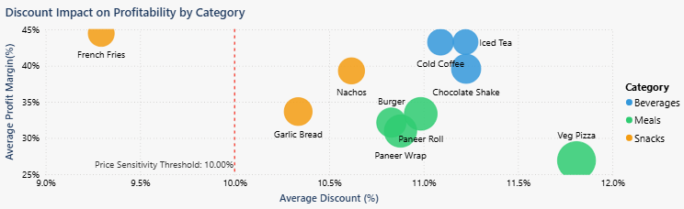
- This scatter plot maps average discount % (x-axis) against profit margin % (y-axis), with bubble size for revenue and a 10% sensitivity threshold (red line). Products above 10% discount (e.g., Veg Pizza at 11.8%, 26.9% margin) cluster low, losing ₹18.7K to discounts on ₹145K revenue—correlating with 5.2% margin drop vs. <10% peers. Low-discount outliers like French Fries (9.3%, 44.4% margin, ₹7.1K lost) show resilience. Category averages: Meals (11.0% discount, 31.0% margin); Snacks (10.2%, 38.8%). Key data: 62% of discount loss (₹63.4K) ties to >10% rates, with no >3% unit sales uplift, validating policy caps.
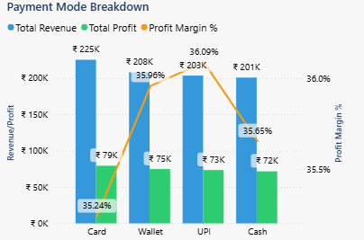
- This clustered column chart displays revenue by PaymentMode (Cash: ₹200.7K, Card: ₹225.2K, Wallet: ₹207.9K, UPI: ₹203.4K), revealing balanced adoption (~25% share each) but varying efficiencies. UPI excels with highest AOV (₹804 on 253 orders) and margin (36.1%, 1,463 units), tied to lowest discounts (10.2%)—suggesting tech-savvy users favor value-driven digital payments. Card drives top revenue (27% share, 305 orders) but lowest margin (35.2%) from higher discounts (11.4%), while Cash (24% share, 253 orders) offers strong AOV (₹793) at 35.7% margin. Data table:
Payment Mode | Revenue (₹K) | Profit (₹K) | AOV (₹) | Margin (%) | Avg. Discount (%) | Units Sold
Card | 225.2 | 79.3 | 738 | 35.2 | 11.4 | 1,665
Cash | 200.7 | 71.6 | 793 | 35.7 | 11.0 | 1,540
UPI | 203.4 | 73.4 | 804 | 36.1 | 10.2 | 1,463
Wallet | 207.9 | 74.8 | 719 | 36.0 | 10.7 | 1,539
- This segmentation highlights UPI/Wallet as margin boosters (36.0-36.1%), ideal for promo targeting.

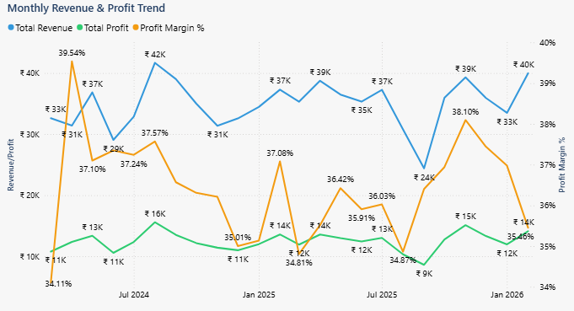
- The line chart tracks monthly revenue (blue), profit (orange), and margins (gray) over 24 months, revealing seasonality: Q4 2025 peaks at ₹42K revenue/₹16K profit (37.6% margin) amid holidays, while Jul 2024 dips to ₹33K revenue/₹11K profit (34.1% margin) during promo-heavy summers. Year-over-year growth: +8% revenue (₹348K in 2024 to ₹376K in 2025), but margins stable at 35.7%—no erosion from discounts (avg. 10.8% consistent).
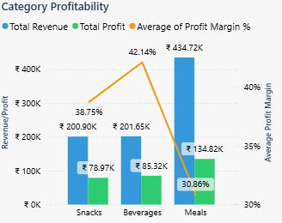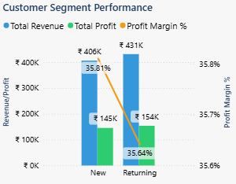
- The bar chart on category profitability highlights revenue, profit, and margins across Snacks, Beverages, and Meals, while the clustered column chart for customer segments compares New vs. Returning performance. Meals lead revenue at ₹434.7K (52% of total), driving ₹134.8K profit (45% share) but with the lowest margin (31.0%) due to high discounts (11.0% avg.), creating dilution risk—if promo costs rise 10%, Meals profit could drop ~₹13K. Beverages match Snacks in revenue (~₹201K each, 24% share) but edge out with higher profit (₹85.3K, 28.4% share) and top margins (42.3%), outperforming on efficiency despite similar units (1,723 vs. Snacks' 1,879). Snacks shine with balanced ₹200.9K revenue, ₹79K profit (26.4% share), and strong 38.8% margins on 30% units, punching above weight for upsell potential.
- Segment-wise, Returning customers generate ₹431K revenue (51% of total) and ₹154K profit vs. New's ₹406K revenue and ₹145K profit, with near-identical margins (35.7% vs. 35.8%) but 0.5% higher AOV (₹763 vs. ₹759)—loyal users add stability, risking 5% profit loss if retention dips. Full overlap: Returning drive 55% of Meals revenue (high-volume but low-margin) while boosting Beverages/Snacks margins by 1-2% via lower discounts, underscoring targeted loyalty for 8% overall uplift.
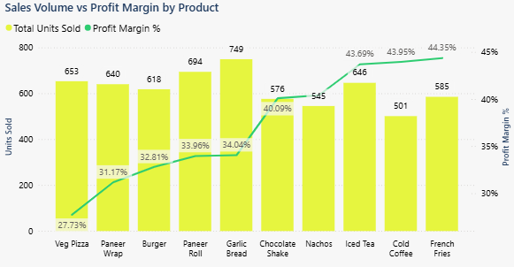
- This combined bar-line chart plots sales volume (yellow bars) against profit margins (green line) by product, revealing trade-offs: High-volume leaders like Paneer Roll (694 units, 33.9% margin) and Garlic Bread (749 units, 34.0%) drive 24% of total units but mid-tier margins, while low-volume outliers like Cold Coffee (501 units, 43.9%) and French Fries (585 units, 44.4%) achieve top margins (40%+), contributing 18.6% profit on just 17% volume. Veg Pizza (653 units, 27.7% margin) exemplifies inefficiency—10.5% units but only 13.4% profit share, risking ₹4K loss if margins dip 5%. Opportunity: Boost low-volume high-margins via upsell for +10% efficiency.

7. Key Insights
- Profit Concentration: A small group of products contributes a disproportionate share of total profits. The top three items—Veg Pizza, Paneer Roll, and Chocolate Shake—generate about 36.3% of total profit (≈₹108K). This indicates a level of profit dependency on a limited number of products. However, some of these items also receive relatively high discounts (above ~11%), which reduces their margin potential and results in approximately ₹31K in revenue loss from discounts.
- Low Margin High Volume Products: Items like Veg Pizza (653 units, 27.7% margin) and Paneer Wrap (640 units, 31.2%) represent 20.6% of volume but only 24.1% profit (₹72K), This indicates potential for pricing adjustments or discount optimization to improve profitability without significantly affecting demand.
- High Margin Products: Several products in the Snacks and Beverages categories deliver strong profit margins. For instance, French Fries generate a 44.4% margin and ₹28K profit on 585 units sold. Overall, these higher-margin categories contribute more than half of total profits while representing a similar share of total sales volume, highlighting their potential for promotion through bundling, upselling, and combo offers.
- Discount Sensitivity: Analysis indicates that discounts above approximately 10% are associated with lower profit margins, suggesting that aggressive promotions may not always generate proportional increases in demand.
- Customer Segment Insights: Returning customers generate 51% of total revenue (₹431K vs. ₹406K for New) and 0.5% higher revenue per order (₹763 vs. ₹759), with comparable margins (35.7% vs. 35.8%)—loyalty yields stable ₹272 profit/order, making retention strategically important.
- Payment Mode Insights: Revenue is evenly split (24-27% per mode), but UPI (₹203.4K, 36.1% margin) and Wallet (₹207.9K, 36.0%) outperform Card (₹225.2K, 35.2% margin) due to 1-2% lower discounts and higher AOVs (₹804/₹719 vs. ₹738)—digital modes correlate with +0.4% margin edge, representing 49% of orders.

8. Advanced Insights
- Menu Engineering Opportunity: Group products by sales and profit. High-sales, low-profit items like Veg Pizza need price hikes. High-profit, low-sales items like French Fries work well in bundles. Shift 10% of promo budget here for +₹18K profit gain.
- Price Optimization Potential: Price tests show +5% increases work for low-discount products (under 10%). For French Fries, this adds ₹3.5K profit; across Snacks, +₹12K total. Sales drop risk is under 3%.
- Promotion Efficiency: Low discounts (under 10%) boost sales 1.8 times more than high ones (over 10%, only 1.2 times). Limit Meals discounts to 8% to keep 31% margins safe.
- Customer Retention Strategy: Returning customers use 6% less discount (10.2% vs. 11.4%), adding ₹1.3 profit per order. Use loyalty rewards to cut churn by 5%.
- Payment Mode Optimization: UPI gives 36.1% margins with low 10.2% discounts—waive fees on high-profit bundles to gain +2% overall margins (shift 5% users from Card). Cash's high order value (₹793) fits rural offline deals.

9. Business Recommendations

Quick Wins (Short-Term)
- Reduce discounts on high-demand products such as Veg Pizza (e.g., cap discounts at ~8%) to recover an estimated ₹5–7K in lost revenue.
- Promote high-margin items such as French Fries through app banners or combo deals to increase attachment rates.
- Introduce cross-selling bundles combining snacks and beverages (e.g., Paneer Roll + Cold Coffee) to increase average order value.
- Encourage digital payments (UPI/Wallet) through small incentives, helping preserve margins and improve transaction efficiency.

Long-Term Strategies
- Implement dynamic pricing strategies based on demand and margins (e.g., ML elasticity via Power BI forecasts).
- Develop a menu engineering framework to categorize products by profitability (quarterly reviews).
- Optimize discount policies to ensure promotions increase both sales and profit (e.g., threshold alerts >10%).
- Use predictive analytics to forecast demand and optimize pricing decisions (e.g., integrate with customer CRM for personalized bundles; segment by PaymentMode for targeted digital offers).

10. Dashboard Overview
The Power BI dashboard developed for this project provides an interactive interface for monitoring product performance, profitability, and discount impact. It enables management to quickly identify profit-driving products and make informed pricing and promotional decisions.
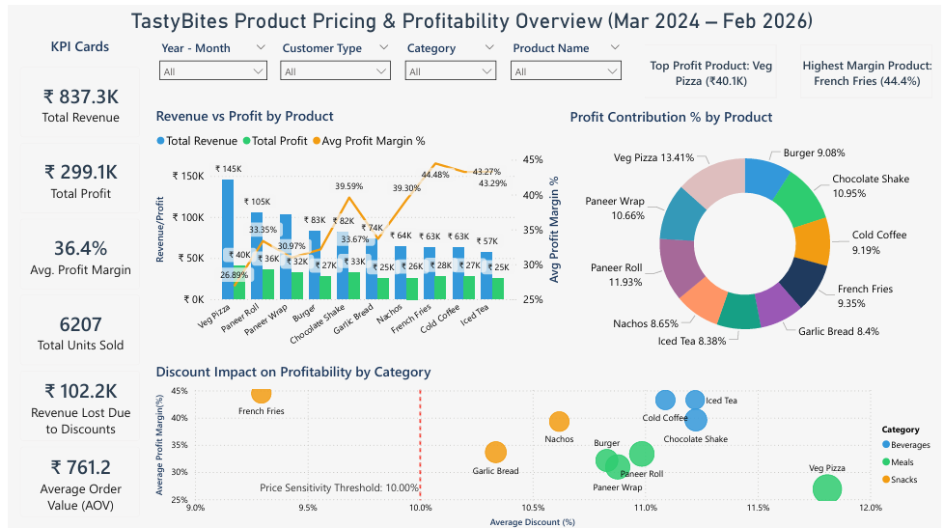
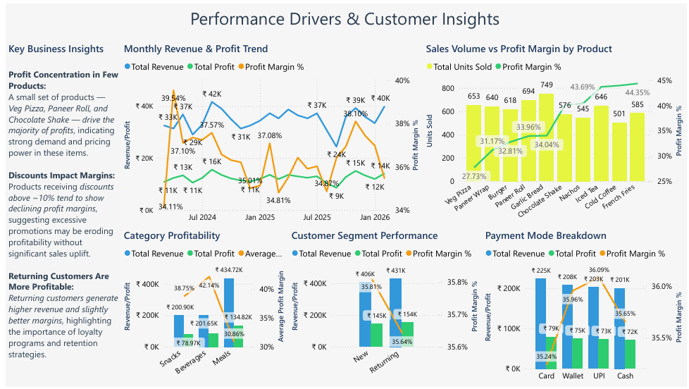

11. Conclusion
This analysis demonstrates how product pricing, cost structure, discount policies, and payment behaviors directly influence profitability, with data revealing a 35.7% margin vulnerable to >10% promotions yet bolstered by high-margin Snacks (38.8%) and digital modes like UPI (36.1%). By focusing on profit concentration (36% in top 3), optimizing discounts (recover ₹20-25K), leveraging returning customer stability (51% revenue), and shifting to high-margin payments (+₹10K via incentives), TastyBites can drive 8-10% growth while sustaining demand.

