AltTab

AltTab is a small application created in C++ and Win32, is an alternative for windows native task switcher (Alt+Tab / Alt+Shift+Tab).
Use Alt+Tab / Alt+Shift+Tab to bring the main AltTab window.



System Requirements
Operating System: Windows 7 or later (64-bit only)
Processor: Intel Core i3 or later
RAM: 2GB of RAM.
Display: Minimum resolution of 1024x768 pixels

Features
- Find the right window faster (filter windows using search string), uses fuzzy string matching algorithm (no need to type the exact search string).
- Switch between windows of the same application using Alt + ` (Grave Accent / Backtick, the key right above the Tab on a US English keyboard layout).
- Terminate a process or all processes either normally or forcefully using keyboard shortcuts.
- Provided configuration/setting INI file & UI to change font style, background color, window transparency, width and height.
- Exclude processes.
- Alt + Ctrl + Tab: displays AltTab window and remains open even Alt key is released.

Switch between windows of the same application using Alt+(Accent/Backtick)
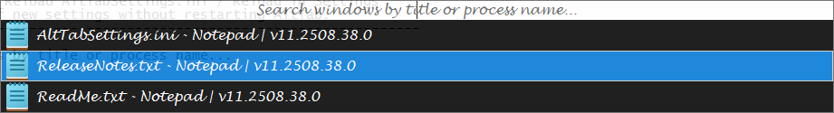
Define similar processes as one group to switch between these processes using Alt + Backtick.
Ex: Processes notepad.exe and notepad++.exe are displayed in Alt + Backtick window if notepad.exe and notepad++.exe are defined as similar processes.
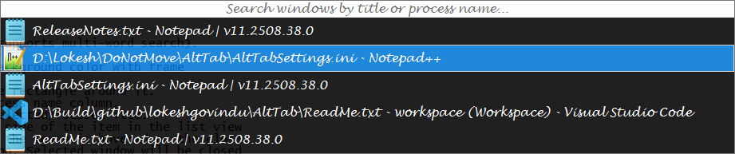

Keyboard Shortcuts
The below keyboard shortcuts work in Alt + Tab, Alt + Backtick, Alt + Ctrl + Tab and Alt + Ctrl + Backtick.
Key | Description
Home / PageUp | Move selection to first row
End / PageDown | Move selection to last row
Up / Down | Move selection to previous / next row
Del | Close currently selected window
Shift + Del | Terminate currently selected process
Accent / Backtick (`) | Move selection to the next window of the currently selected application
Shift + Accent / Backtick (`) | Move selection to the previous window of the currently selected application
AlphaNumeric | Filter windows while typing, can delete last type character using backspace.  Search string is displayed on static control.
F1 (FunctionKey) | Display help file
F2 (FunctionKey) | Display settings dialog

Context Menu on window item (ListView)
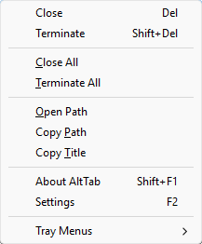
Menu | Description
Close | Close currently selected window
Terminate | Terminate currently selected process
Close All | Close all windows
Terminate All | Terminate all processes
Open Path | Open the file explorer of the selected process file path
Copy Path | Copy the selected process path to clipboard
About AltTab | Open about dialog
Settings | Open settings dialog

Tray Menu
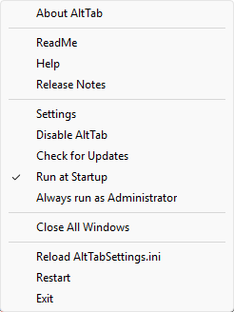
This menu can be accessed from the System Tray icon and context menu on search string edit control in AltTab window as shown below.
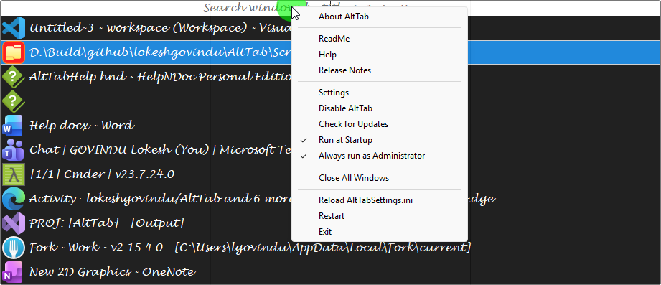
Menu | Description
About AltTab | Display AltTab about dialog box
ReadMe | ReadMe
Help | Show help document
Release Notes | Show release notes
Settings | Show settings dialog
Disable AltTab | Disable AltTab (no hotkeys work until AltTab is enabled)
Check for Updates | Check for updates
Run at Startup | Set AltTab to run at startup (windows log on)
Run as Administrator | Please go through the below information
Close All Windows | Close all windows
Reload AltTabSettings.ini | Reload the AltTab applications settings (useful when settings are modified manually)
Restart | Restart AltTab application
Exit | Exit AltTab

Run as Administrator
- If Run at Startup is enabled
  - On pressing Run as Administrator user will be asked to Always run AltTab as Administrator. As shown in the picture below:
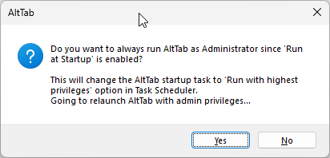
  - Upon selecting Yes, application will be restarted with administrator privileges (UAC dialog will popup). This will create a task in Task Scheduler with Run with highest privileges option. And the same will be reflected in Tray Context Menu as shown below:

  - Autorun task for AltTab in Task Scheduler
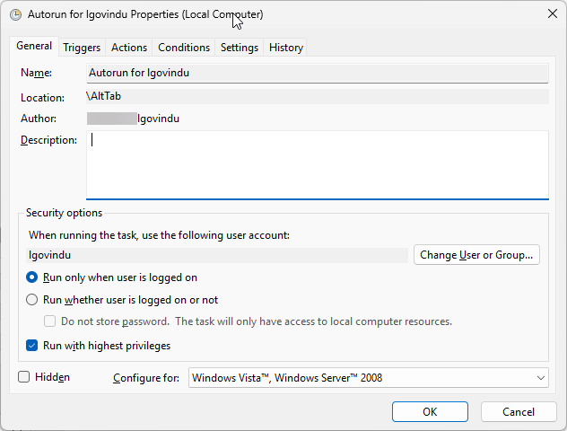
- UAC prompt will be displayed If Run at Startup is disabled.
- If the application is running with administrator privileges and Run at Startup is not checked, then Run as Administrator will be disabled because application is already running with administrator privileges and can’t revoke and can’t restart without administrator privileges from the elevated process. So, user must exit the application and restart with non-elevated mode.
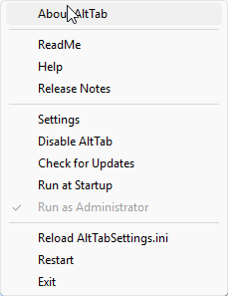

Configuration INI File
Used to read/write the settings of application.

Settings Dialog
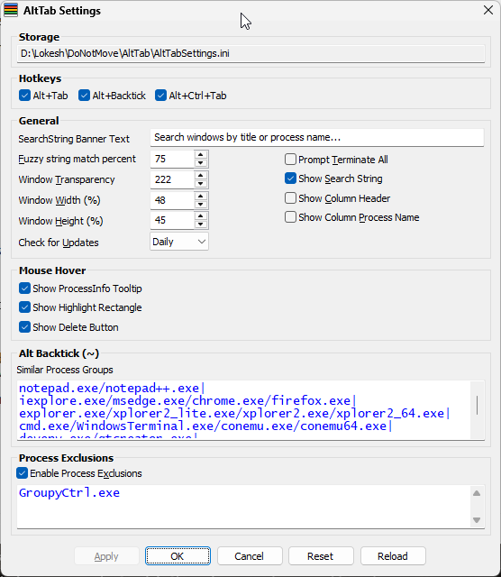
Setting | Description
Storage | AltTab settings INI file path.
Hotkeys Group
Alt+Tab | Enable or disable Alt+Tab hotkey
Alt+Backtick | Enable or disable Alt+Backtick hotkey
Alt+Ctrl+Tab | Enable/disable Alt+Ctrl+Tab hotkey, which displays AltTab window and remains open even Alt key is released
General Group
Fuzzy string match percent | Fuzzy name match percent between search string and process name/title.  100 % means exact match (uses native string search algorithm)  80 % would cause "files" to match "filas" and so on ...  Reference: Approximate string matching, Levenshtein distance  Note:  If string match percent is NOT 100%, search uses approximate string-matching algorithm, this is significantly slow compared to native string search.
Window Transparency | Indicate the degree of transparency.  0 – makes the window invisible  255 – makes it opaque
Window Width (%) | Main window width w.r.t percentage of screen width.
Window Height (%) | Main window maximum height w.r.t percentage of screen height.  If there are more number of processes which exceeds the WindowHeight to accommodate all the tasks, then resize the window to WindowHeight according scroll bar presence.
Check for Updates | How frequently check for updates.  Available Options: Startup / Daily / Weekly / Never. Default: Weekly  Startup At startup  Daily For every 24 hours since the last run  Weekly For every 7 days since the last run  Never Never check for updates
Prompt Terminate All | Prompt for confirmation before terminating.
Show Search String | Show search string control in AltTab window.
Show Column Header | Show column header for listview in AltTab window.
Show Column Process Name | Add the process name column to listview in AltTab window.
Mouse Hover Group
Show ProcessInfo Tooltip | Displays the process information (Ex: Title, Path, Description, Company Name and Process ID) in the tooltip as shown below:  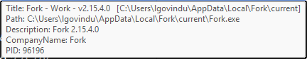
Show Highlight Rectangle | Displays a rectangle thin line on the mouse hover item as shown below:
Show Delete Button | Displays a delete button on the mouse hover item as shown below:  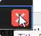
Alt Backtick Group
Similar Process Groups | Define similar processes as one group to switch between these processes using Alt + Backtick / Alt + Shift + Backtick.  - Processes in a process group are separated by forward slash (/) and process groups are separated by Pipe/Vertical Bar (|).  - A file/process name can't contain any of the following characters: \ / : * ? " < > |  Defaults: notepad.exe/notepad++.exe|iexplore.exe/msedge.ese/  chrome.exe/firefox.exe|explorer.exe/xplorer2_lite.exe/  xplorer2.exe/xplorer2_64.exe|cmd.exe/WindowsTerminal.exe/conemu.exe/conemu64.exe
Process Exclusions Group
Process Exclusions | Given process names are excluded in AltTab window
Other Settings
Reset | Reset settings to default settings.
Reload | Reload settings from AltTabSettings.ini file.  Use this button if you have modified the settings in the INI file manually and want to reload it without restarting the application.  Alternative method: AltTab TrayMenu Reload AltTabSettings.ini

