**Web API Documentation**

|  |  |  |  |
| --- | --- | --- | --- |
| No. | HTTP Method | Route | Description |
| 1. | GET | api/talents | Retrieve all data |
| 2. | GET | api/talents/{id:int:min(1)} | Retrieve data based on id |
| 3. | POST | api/talents | Create/add new data |
| 4. | PUT | api/talents/{id:int} | Update/edit existing data. |
| 5. | DELETE | api/talents/{id:int} | Delete/remove data. |

**Postman testing result**

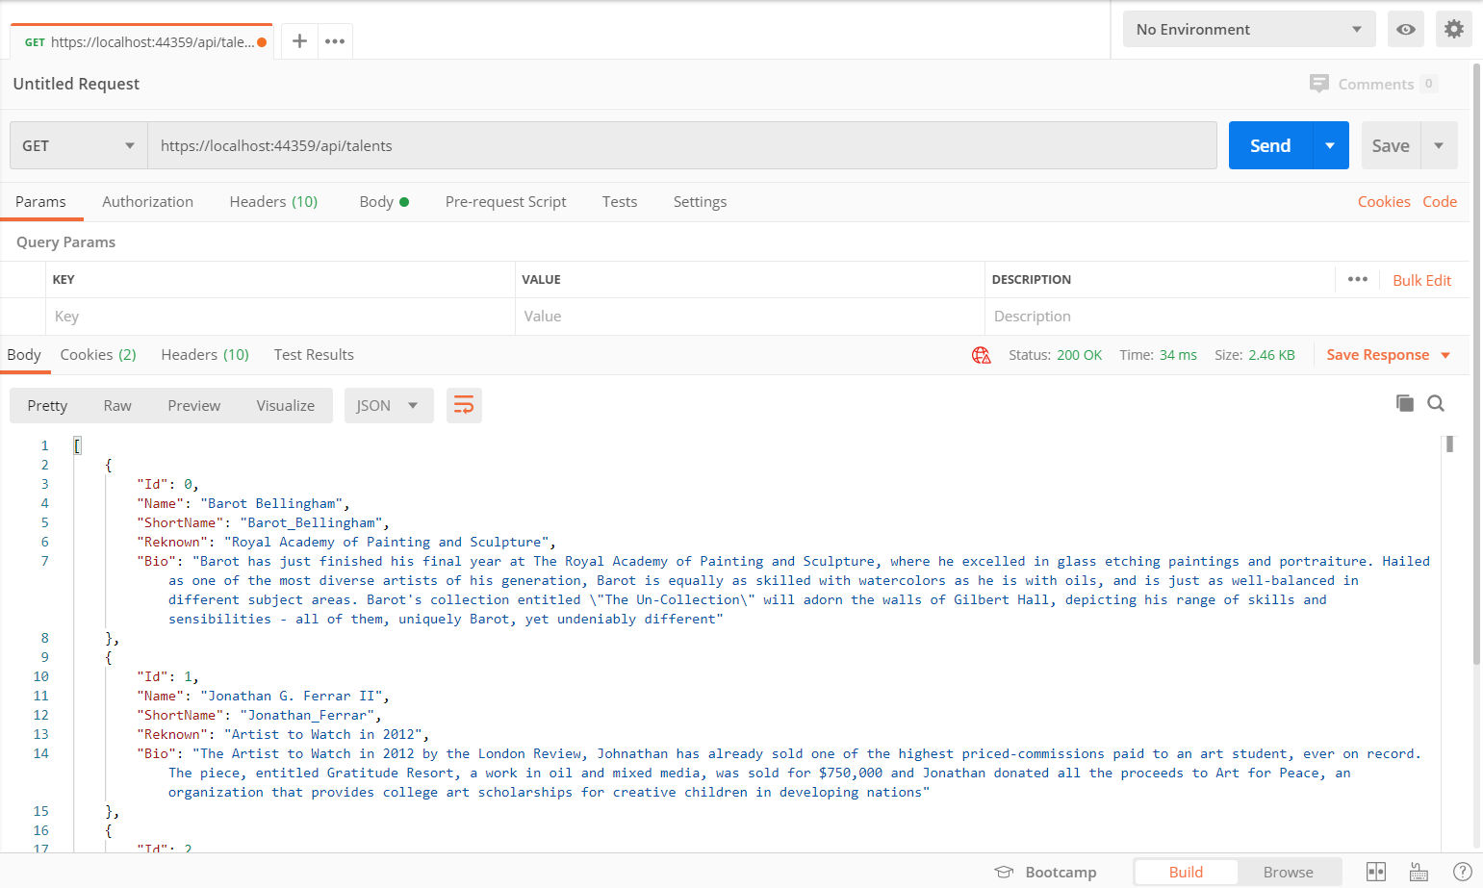

**Sequence Diagram**

