**Web API Documentation**

|  |  |  |  |
| --- | --- | --- | --- |
| No. | HTTP Method | Route | Description |
| 1. | GET | api/v3/products | Retrieve all data |
| 2. | GET | api/v3/products/{id:int:min(1)} | Retrieve data based on id |
| 3. | GET | api/v3/products?category={category} | Retrieve data based on category |
| 4. | POST | api/v3/products | Create/add new data |
| 5. | PUT | api/v3/products/{id:int} | Update/edit existing data. |
| 6. | DELETE | api/v3/products/{id:int} | Delete/remove data. |

**Under-posting**

Postman result

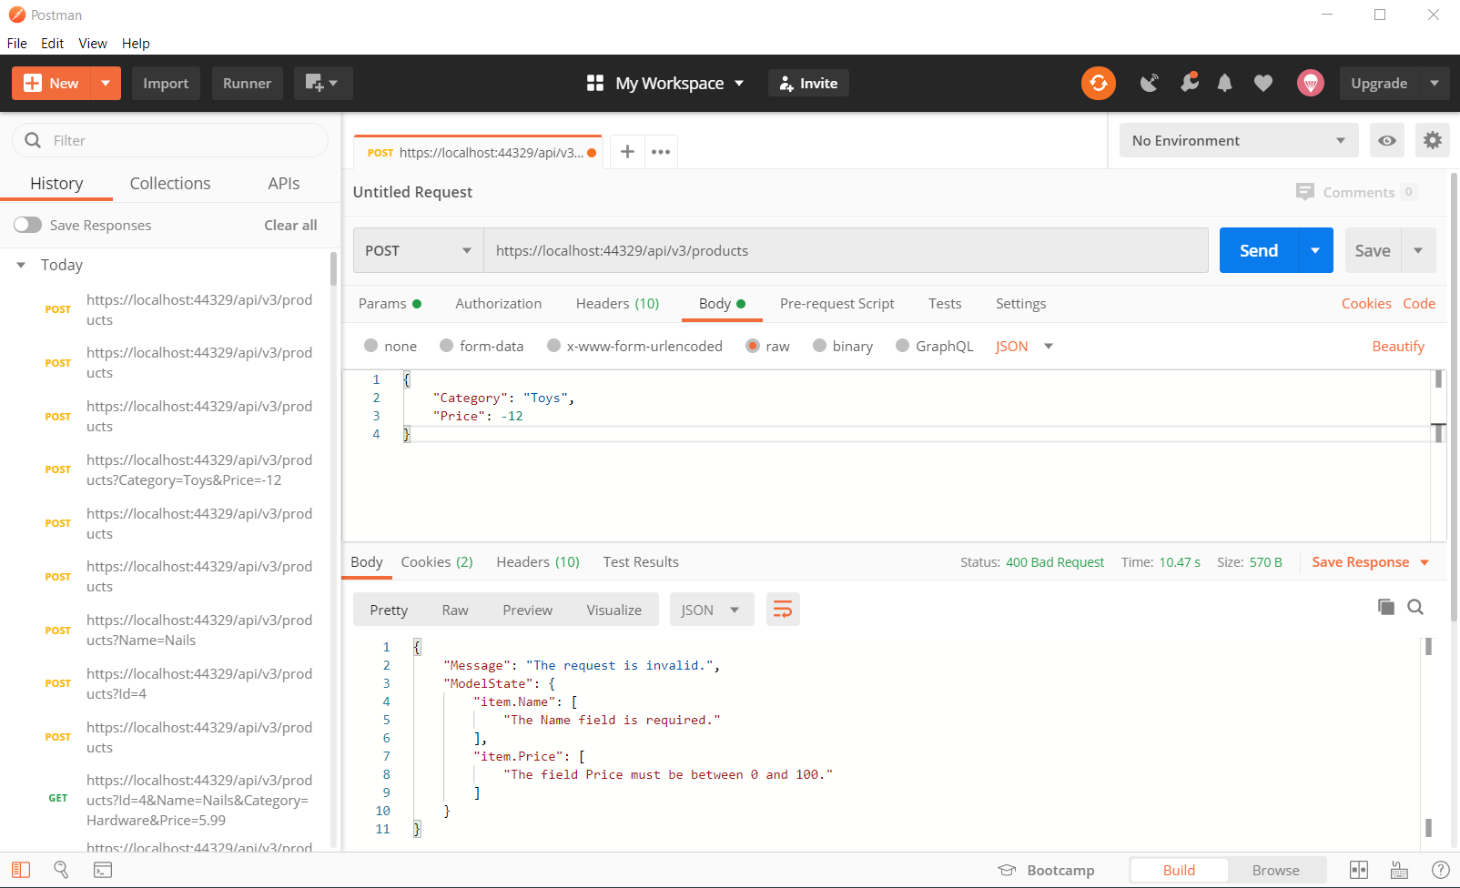

Debugging

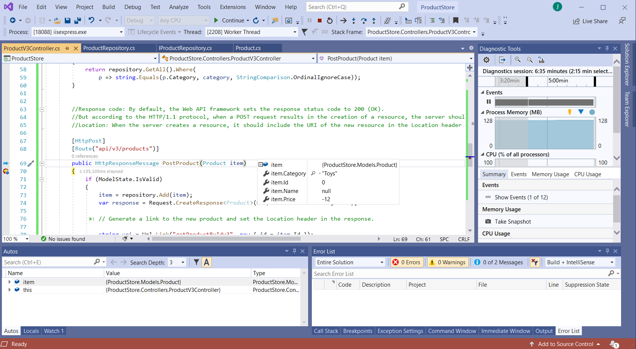

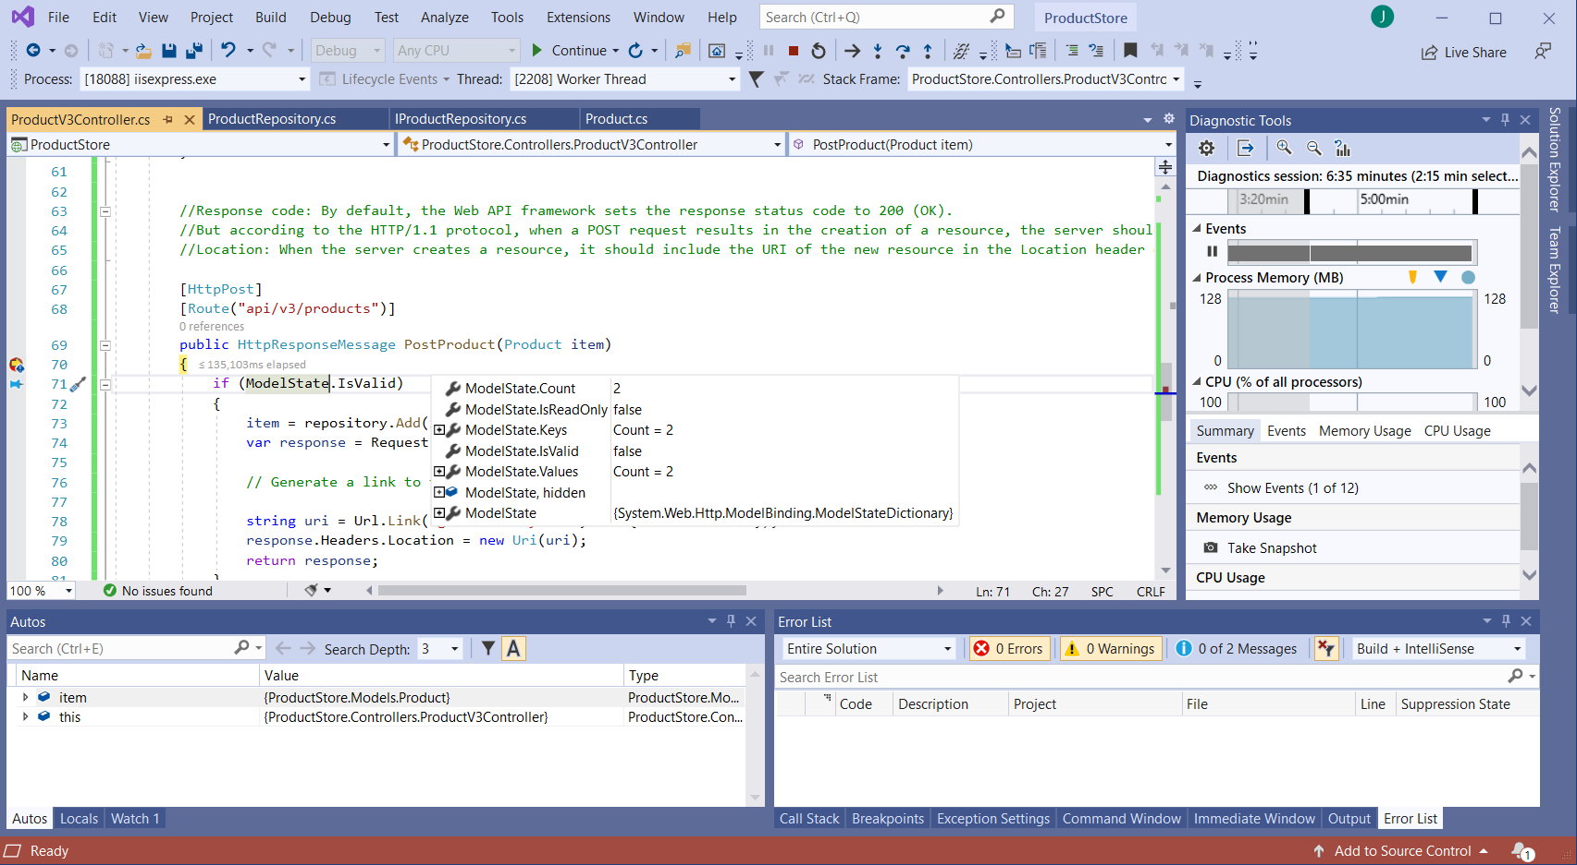

**Over-posting**

(Error: Overposting keeps going through. ModelState is valid even though it should not be.)