QuaLIS LIMS

Method Statement for Script Execution

V1.0.6

Created: 24-SEPT-2021

]

Script Version: v1.0.6

Introduction:
The objective of the document is to provide procedure for Execution of the Test case script for QuaLIS -LIMS application.

Method to execute the script in Test enviornment

Prerequisites
Note: For Server Only (must be installed before running the application)
- JDK or JRE 8.
- Google Chrome Version 87.0.4280.20 (Official Build) (64-bit) or above.
- Notepad ++ v 6.5.3.

Folder Creation
Create the Folder Named “Automation Testing” in PC/Laptop

QuaLIS LIMS Test Execution
- Go to the following directory “QuaLIS_LIMS”
- Find the LIMS.properties file
- Open the LIMS.properties file in Notepad++
- Refer the below image

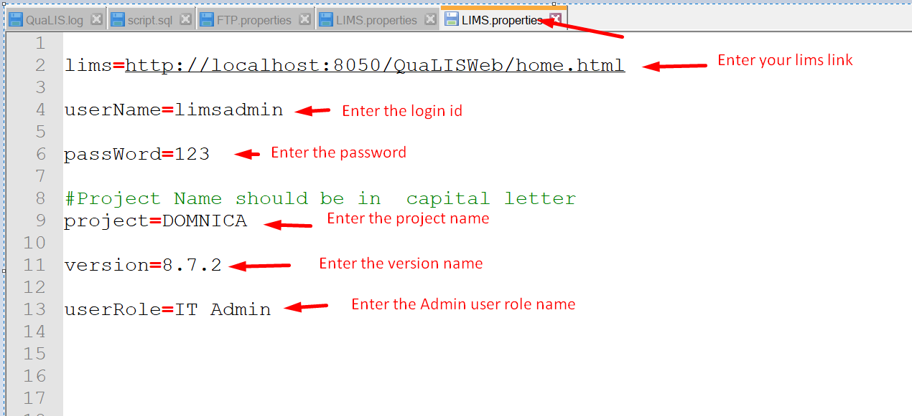

- Enter your LIMS application link in lims value
- Enter your login ID in user name value
- Enter your password in password value
- Save the LIMS.properties file
- Go to the following directory “QuaLIS_LIMS”
- Find the FTP.properties file
- Open the FTP.properties file by Notepad++
- Enter the FTP User name
- Enter the FTP password
- Enter the FTP host value
- Enter the FTP path value
- Enter the FTP port value
- Save the FTP.properties file
- Go to the following directory “QuaLIS_LIMS”
- Double click the “Run here” file to execute the selenium script

- It will open the GUI mode of the script header as QuaLIS
- Click the button to execute the different script

Document Approval
Version | Release | Prepared By | Date
1.0.6 | 7 | R.Murali  ATE186 | 24-September-2021

