QuaLIS LIMS

Method Statement for Script Execution

V1.0.2

Created: 17-SEPT-2021

]

Script Version: v1.0.2

Introduction:
The objective of the document is to provide procedure for Execution of the Test case script for QuaLIS -LIMS application.

Method to execute the script in Test enviornment

Prerequisites
Note: For Server Only (must be installed before running the application)
- JDK or JRE 8.
- Google Chrome Version 87.0.4280.20 (Official Build) (64-bit) or above.
- Notepad ++ v 6.5.3.

Folder Creation
Create the Folder Named “Automation Testing” in PC/Laptop

QuaLIS LIMS Test Execution
- Go to the following directory “QuaLIS_LIMS”
- Find the config.properties file
- Open the config.properties file in Notepad++
- Refer the below image

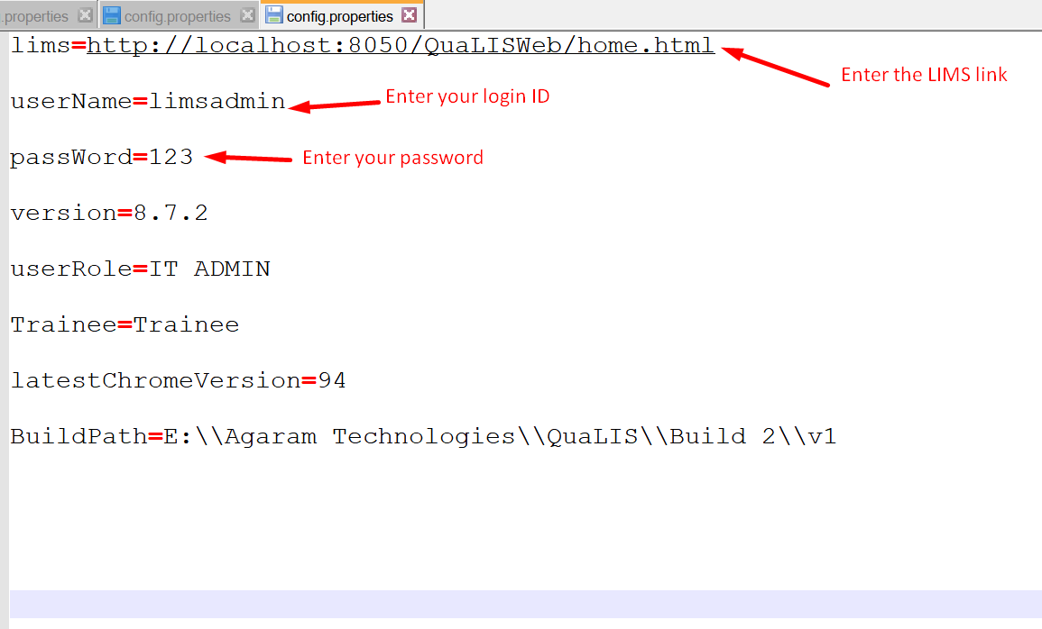

- Enter your LIMS application link in lims value
- Enter your login ID in user name value
- Enter your password in password value
- Save the config.properties file
- Go to the following directory “QuaLIS_LIMS”
- Find the “Run here” window patch file
- Double click the “Run here” file to execute the selenium script

Script Features:

Open the new Chrome Browser

Browser opened in Incognito mode

Launch the LIMS application in browser automatically

Document Approval
Version | Release | Prepared By
1.0.2 | 3 | R.Murali  ATE186

