QuaLIS LIMS

Method Statement for Script Execution

V1.0.3

Created: 17-SEPT-2021

]

Script Version: v1.0.3

Introduction:
The objective of the document is to provide procedure for Execution of the Test case script for QuaLIS -LIMS application.

Method to execute the script in Test enviornment

Prerequisites
Note: For Server Only (must be installed before running the application)
- JDK or JRE 8.
- Google Chrome Version 87.0.4280.20 (Official Build) (64-bit) or above.
- Notepad ++ v 6.5.3.

Folder Creation
Create the Folder Named “Automation Testing” in PC/Laptop

QuaLIS LIMS Test Execution
- Go to the following directory “QuaLIS_LIMS”
- Find the config.properties file
- Open the config.properties file in Notepad++
- Refer the below image

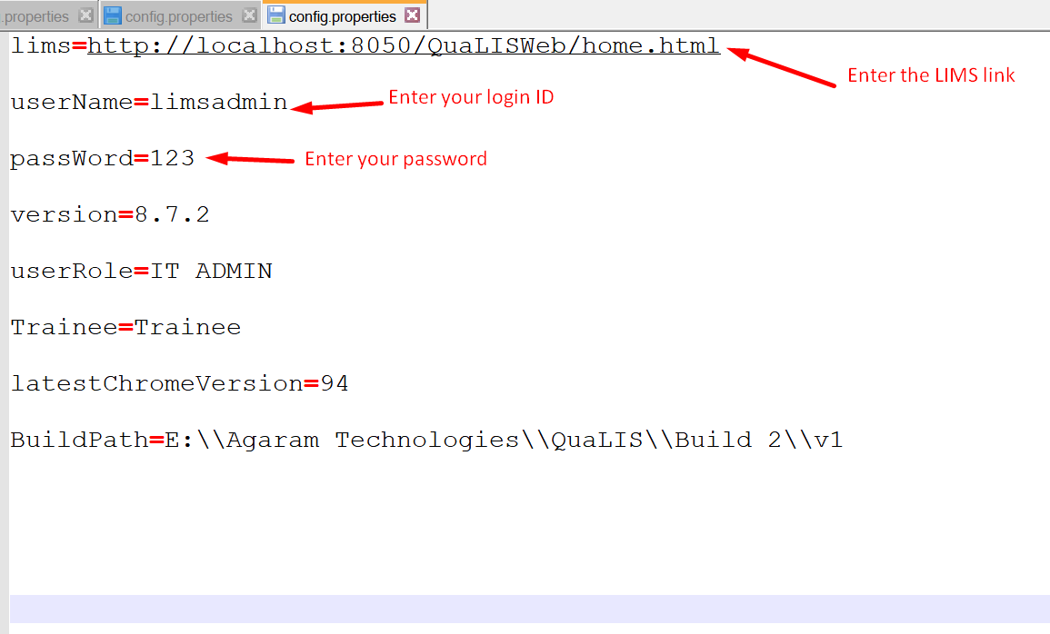

- Enter your LIMS application link in lims value
- Enter your login ID in user name value
- Enter your password in password value
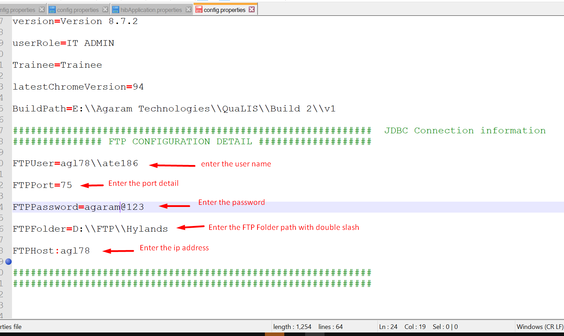
- Enter the FTP User detail
- Enter the FTP Port detail
- Enter the FTP Password detail

- Enter the Password detail
- Enter the host detail
- Enter the Ftp folder detail
- Save the config.properties file
- Go to the following directory “QuaLIS_LIMS”
- Find the “Run here” window patch file
- Double click the “Run here” file to execute the selenium script

Script Features:
- Launch the browser in Incognito mode
- Launch the LIMS application
- Login into the application
- Add the FTP detail
- Set default the FTP detail
- Test connection the FTP detail
- Add the designation detail
- Add the department detail
- Add the country detail
- Add the Section detail
- Add the lab detail
- Add the User role detail
- Enable to the Approval flow
- Enable to the Result entry flow
- Copy the Password policy detail
- Approve the Password policy detail
- Add the Users detail
- Assign the User role to the Users detail
- Add the Department detail to the site in Organization screen
- Add the Lab detail to the Department in Organization screen
- Add the Section detail to the Lab in Organization screen
- Add the Users detail to the Lab in Organization screen
- Add the Container type detail in Container type screen
- Add the Unit detail in Unit screen
- Add the Storage Condition detail in Storage Condition screen
- Add the Storage Location detail in Storage Location screen
- Add the Sample Category detail in Sample Category screen
- Add the Sample type detail in Sample type screen
- Add the Training Category detail in Unit screen
- Add the Technique detail in Unit screen
- Schedule the Training detail in Training and Certification Screen
- Add the Participant to the Training in Training and Certification Screen
- Invite the participant in Training and Certification Screen
- Conduct the Training in Training and Certification Screen

Note:
- Exceptions are not handled the in the program, So The Script may getting error and stopped if any bug faced in the LIMS
- It is recommended to have good network when the script is used for Testing the server hosted LIMS application, Due to network issue the button may not display and exception occurs during execution

Document Approval
Version | Release | Prepared By | Date
1.0.3 | 4 | R.Murali  ATE186 | 17-SEPT-2021

