**Exercise 1: Control Structures**

**Scenario 1:Discount interest rates for customers above 60**

BEGIN

FOR cust IN (SELECT CustomerID FROM Customers WHERE MONTHS_BETWEEN(SYSDATE, DOB)/12 > 60) LOOP

UPDATE Loans

SET InterestRate = InterestRate - 1

WHERE CustomerID = cust.CustomerID;

END LOOP;

COMMIT;

END;

/

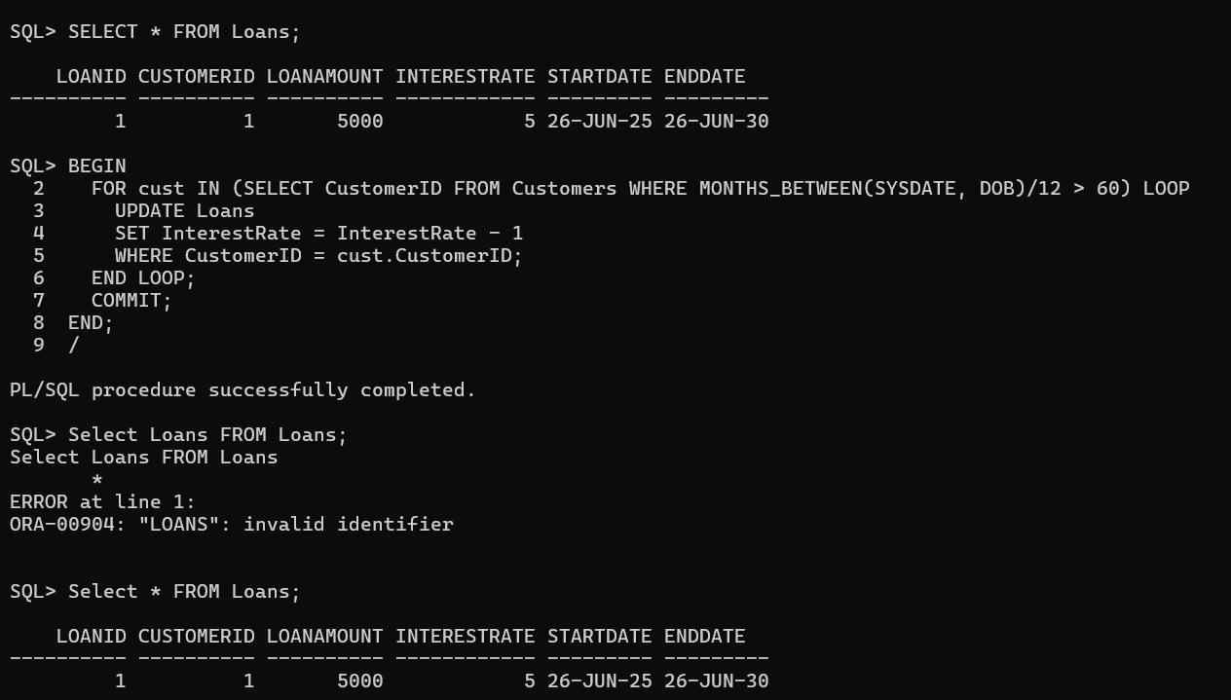

**Scenario 2: Set IsVIP flag**

BEGIN

FOR cust IN (SELECT CustomerID FROM Customers WHERE Balance > 10000) LOOP

UPDATE Customers

SET Balance = Balance, -- just to trigger update

LastModified = SYSDATE

WHERE CustomerID = cust.CustomerID;

-- Assuming IsVIP column exists

END LOOP;

COMMIT;

END;

/

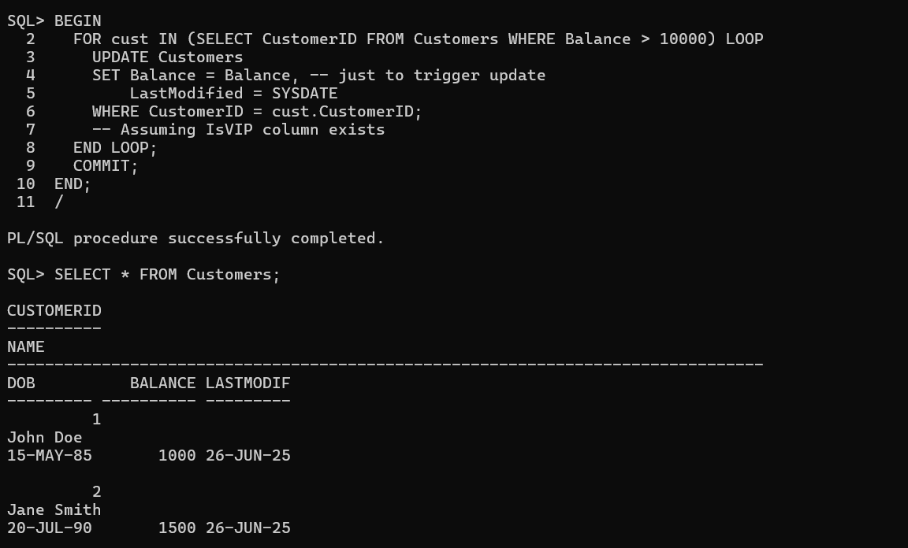

**Scenario 3: Loan reminders**

BEGIN

FOR loan_rec IN (

SELECT c.Name, l.DueDate

FROM Loans l JOIN Customers c ON l.CustomerID = c.CustomerID

WHERE l.EndDate BETWEEN SYSDATE AND SYSDATE + 30

) LOOP

DBMS_OUTPUT.PUT_LINE('Reminder: Loan for ' || loan_rec.Name || ' is due on ' || TO_CHAR(loan_rec.DueDate, 'DD-Mon-YYYY'));

END LOOP;

END;

/

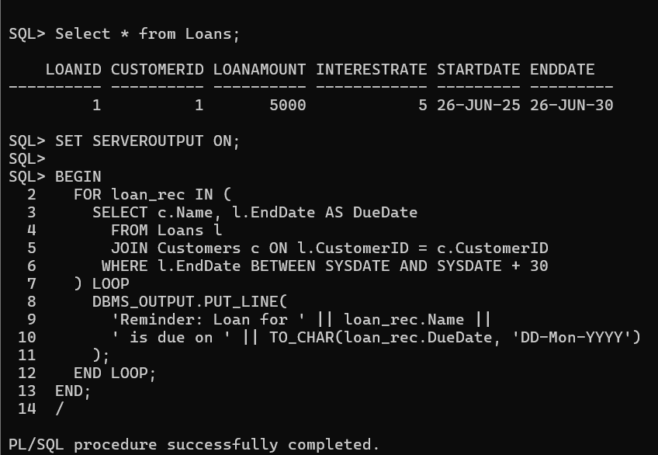

**Exercise 3: Stored Procedures**

**Scenario 1: Process monthly interest**

CREATE OR REPLACE PROCEDURE ProcessMonthlyInterest IS

BEGIN

UPDATE Accounts

SET Balance = Balance + (Balance * 0.01)

WHERE AccountType = 'Savings';

COMMIT;

END;

/

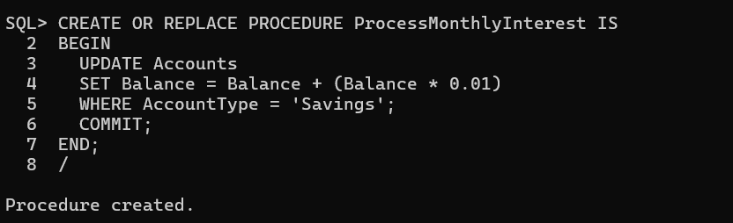

**Scenario 2: Employee bonus**

CREATE OR REPLACE PROCEDURE UpdateEmployeeBonus(p_dept VARCHAR2, p_bonus_percent NUMBER) IS

BEGIN

UPDATE Employees

SET Salary = Salary + (Salary * p_bonus_percent / 100)

WHERE Department = p_dept;

COMMIT;

END;

/

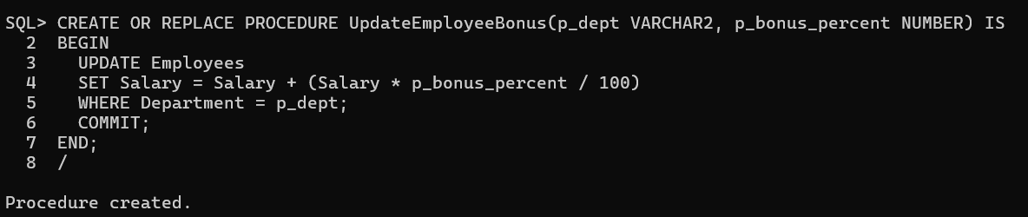

**Scenario 3: Transfer funds**

CREATE OR REPLACE PROCEDURE TransferFunds(p_from NUMBER, p_to NUMBER, p_amt NUMBER) IS

v_balance NUMBER;

BEGIN

SELECT Balance INTO v_balance FROM Accounts WHERE AccountID = p_from;

IF v_balance >= p_amt THEN

UPDATE Accounts SET Balance = Balance - p_amt WHERE AccountID = p_from;

UPDATE Accounts SET Balance = Balance + p_amt WHERE AccountID = p_to;

COMMIT;

ELSE

DBMS_OUTPUT.PUT_LINE('Error: Insufficient balance.');

ROLLBACK;

END IF;

END;

/

