Commonly Used Distributions
This chapter discusses a few commonly used distributions of continuous random variables.

1 Normal or Gaussian distribution
The Gaussian distribution is of great importance in the fields of probability and statistics. Moreover, it is one of the most frequently used distributions in engineering problems. A Gaussian random variable X ~ N(μ, σ) is defined by two parameters, the mean μ and the standard deviation σ. Its PDF is as follows:
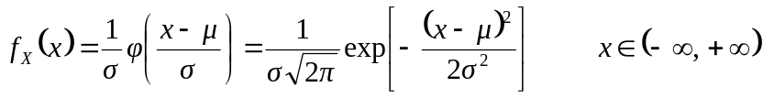 | (1)
where φ(.) denotes the standard normal PDF associated with the standard normal random variable U ~ N(0, 1):
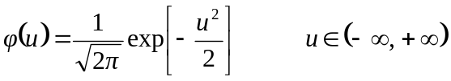 | (2)
The CDF of X ~ N(μ, σ) is as follows:
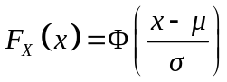 | (3)
where Φ(.) denotes the standard normal CDF:
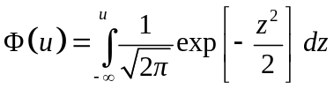 | (4)
The PDF of the normal distribution is symmetric around the mean value. Quantitative representations of the normal PDF and CDF are shown in Figure 1.

2 Lognormal distribution
A lognormal random variable X ~ LN(λ, ζ) is a two-parameter random variable, with the following PDF and CDF, respectively:
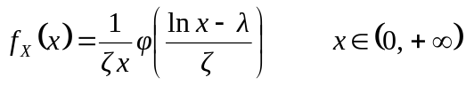 | (5)
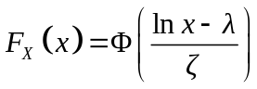 | (6)

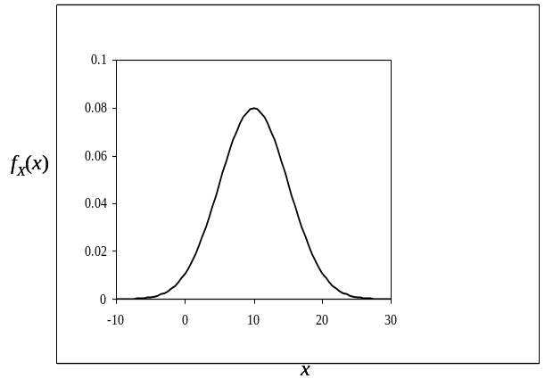 | 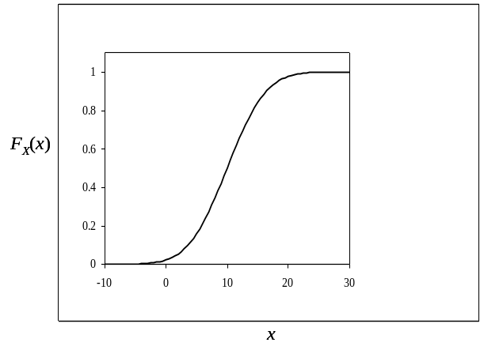
(a) | (b)
Figure 1. The PDF (a) and CDF (b) of a normal random variable with μ = 10 and σ = 5.
Hence, the natural logarithm of X is a Gaussian random variable, i.e. lnX ~ N(λ, ζ). The mean and standard deviation of X are expressed in terms of the parameters λ, ζ as:
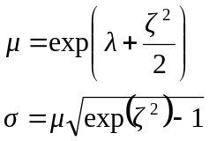 | (7)
Conversely, the parameters λ, ζ are expressed in terms of μ, σ as follows:
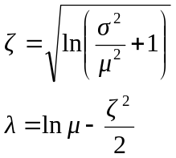 | (8)
The lognormal distribution is an asymmetric distribution. It is usually applied for the description of variables that can only take positive values or in the case when experimental data sets exhibit a significant skewness. In Figure 2 the PDF of a lognormal random variable is compared to the one of a normal random variable with the same mean and standard deviation.
With the addition of a third parameter x₀, defining a lower bound in the support of x, the shifted lognormal random variable X ~ LN(λ, ζ, x₀) can be defined with the following PDF and CDF, respectively:
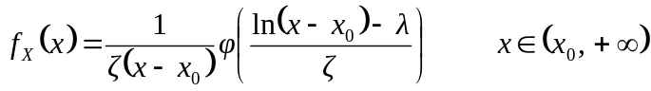 | (9)
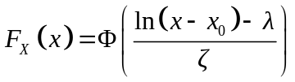 | (10)
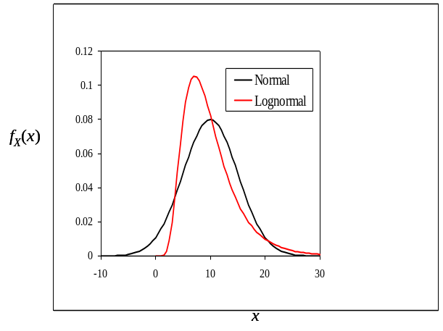
Figure 2. The lognormal PDF compared to the normal PDF for μ = 10 and σ = 5.

3 Uniform distribution
A uniform random variable X ~ U(a, b) is defined by the following PDF:
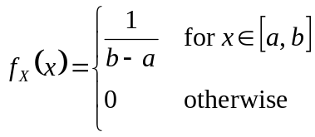 | (11)
whereby b > a. Its CDF is:
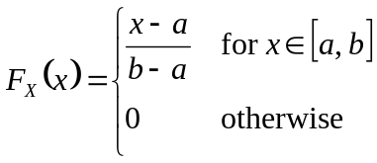 | (12)
Its mean and standard deviation are expressed in terms of a, b as follows:
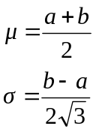 | (13)
Its skewness coefficient is γ = 0 and its kurtosis coefficient is κ = 1.8.
The uniform distribution assumes the same probability density for any value in the interval
[a, b]. It can be used for the conservative probabilistic description of quantities for which bounds are given, but no specific trend can be assumed.

4 Beta distribution
A Beta-distributed random variable X ~ Bet(q, r, a, b) is a four-parameter random variable with the following PDF and CDF, respectively:
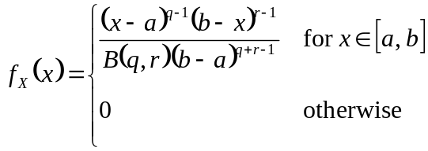 | (14)
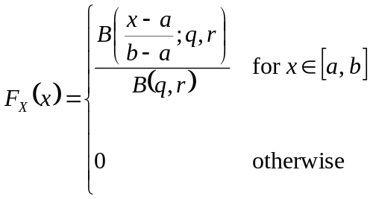 | (15)
whereby b > a and B(q, r), B(x; q, r) are the Beta function and incomplete Beta function respectively, defined as follows:
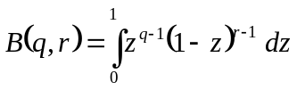 | (16)
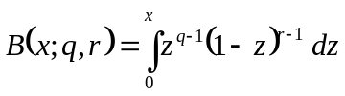 | (17)
The mean and standard deviation are expressed as follows:
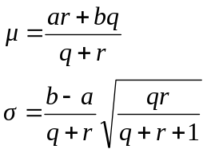 | (18)
The Beta distribution is a very flexible distribution that can be used for the probabilistic description of bounded quantities. Figure 3 shows the Beta PDF for two different random variables with the same mean and standard deviation, but different bounds.
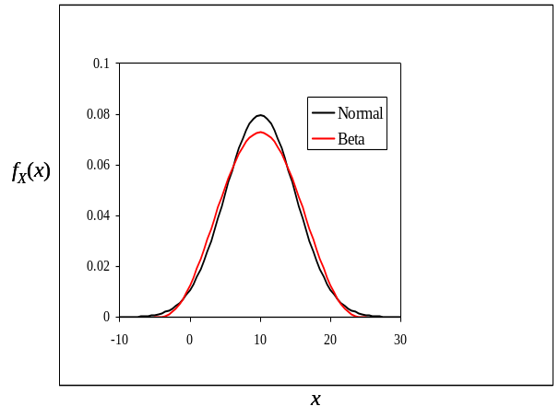 | 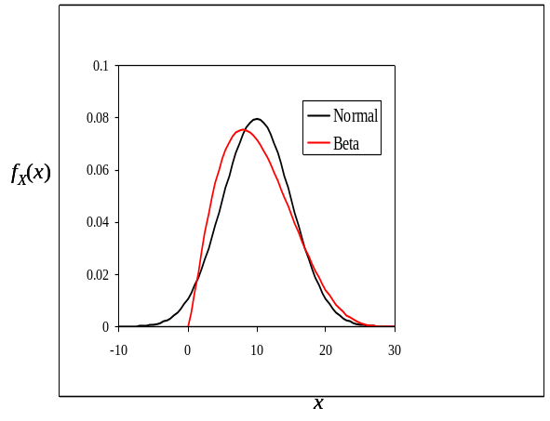
(a) | (b)
Figure 3. The Beta PDF compared to the normal PDF for μ = 10 and σ = 5 and bounds
(a) a = -5, b = 25 and (b) a = 0, b = 30.

5 Gumbel distribution
A random variable X follows a Gumbel or type I largest value distribution, i.e. X ~ Gmb(u, α), if its CDF has the following form:
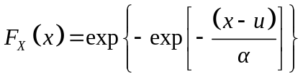 | (19)
Its PDF is as follows:
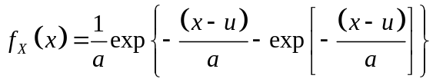 | (20)
Its mean and standard deviation are expressed in terms of u, α as follows:
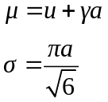 | (21)
where γ ≈ 0.577 is Euler’s constant.
The Gumbel distribution, derived from extreme value theory, models the distribution of the maximum value among a number of samples of any distribution with an exponential tail (e.g. the Gaussian distribution). It is commonly used for the modeling of environmental loads, such as winds and earthquakes.

6 Weibull distribution
A random variable X follows a Weibull distribution, i.e. X ~ Wbl(u, k), if its CDF has the following form:
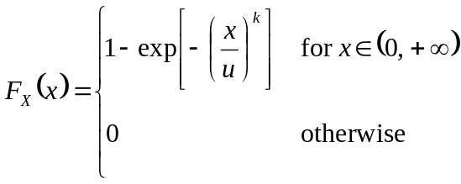 | (22)
Its PDF is as follows:
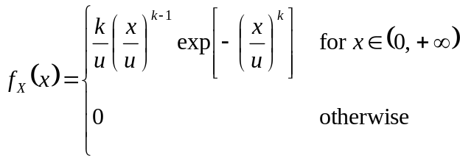 | (23)
Its mean and standard deviation are expressed in terms of u, α as follows:
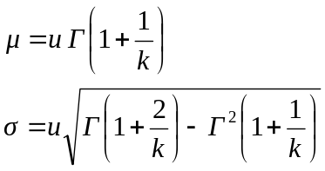 | (24)
where Γ(.) is the Gamma function, defined as:
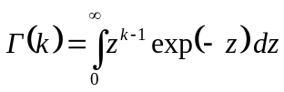 | (25)
The Weibull distribution is identical to the type III smallest value distribution with a zero lower bound. Like the Gumbel distribution, it is derived from extreme value theory. It can be used to model the distribution of the minimum value of samples from most of the commonly used distributions with a zero lower bound. The PDFs of a Gumbel and a Weibull random variable with the same mean and standard deviation are shown in Figure 4.
The special case of a Weibull distribution with k = 2 results in a one-parameter distribution, called Rayleigh distribution Ray(u). The Rayleigh distribution is commonly used for the probabilistic description of peaks in a narrow-banded stationary Gaussian process. For example, maximum wave heights can be modeled by a Rayleigh distribution.
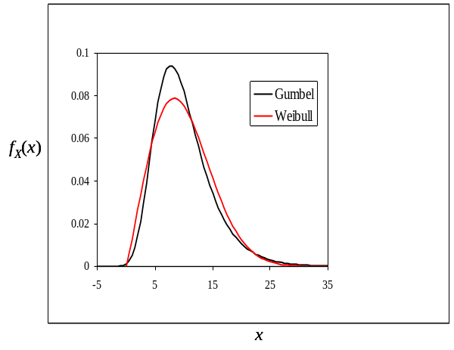
Figure 4. PDFs of commonly used extreme value distributions for μ = 10 and σ = 5.

