**Level 4: Fundamentals of Databases / Introduction to Databases**

**Assessment 2: PRACTICAL TEST 2023**

Student Id:77356692 Student Name: Tarun Agarwal

**TASK 1**

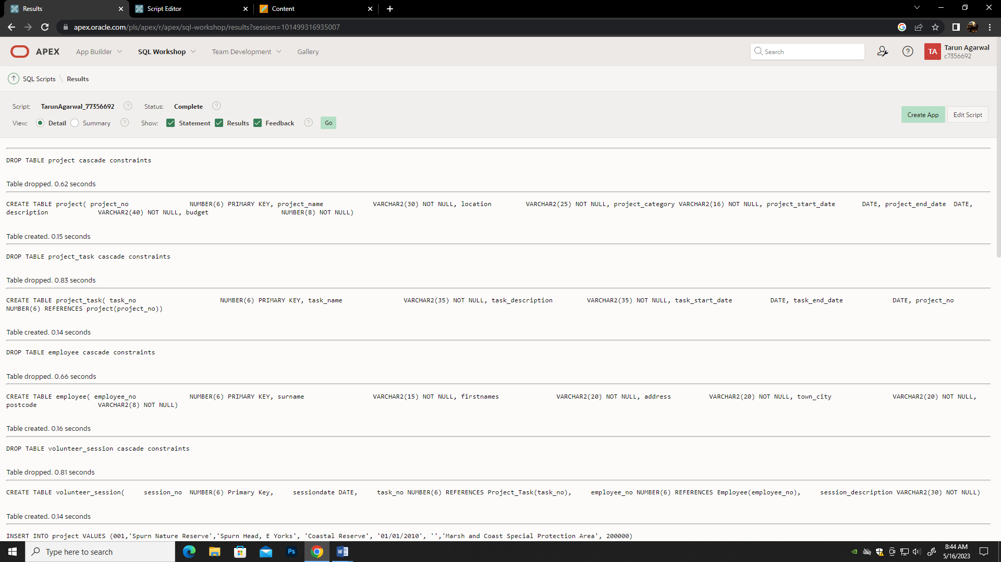

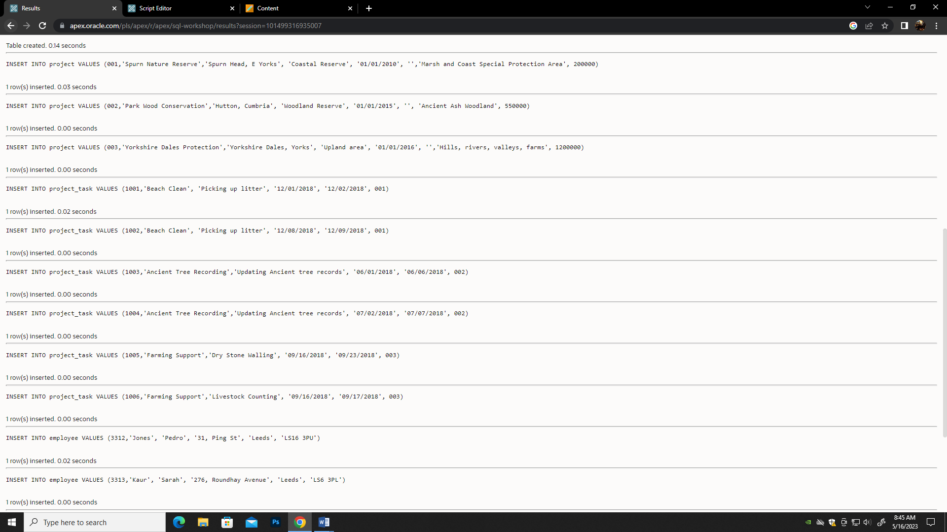

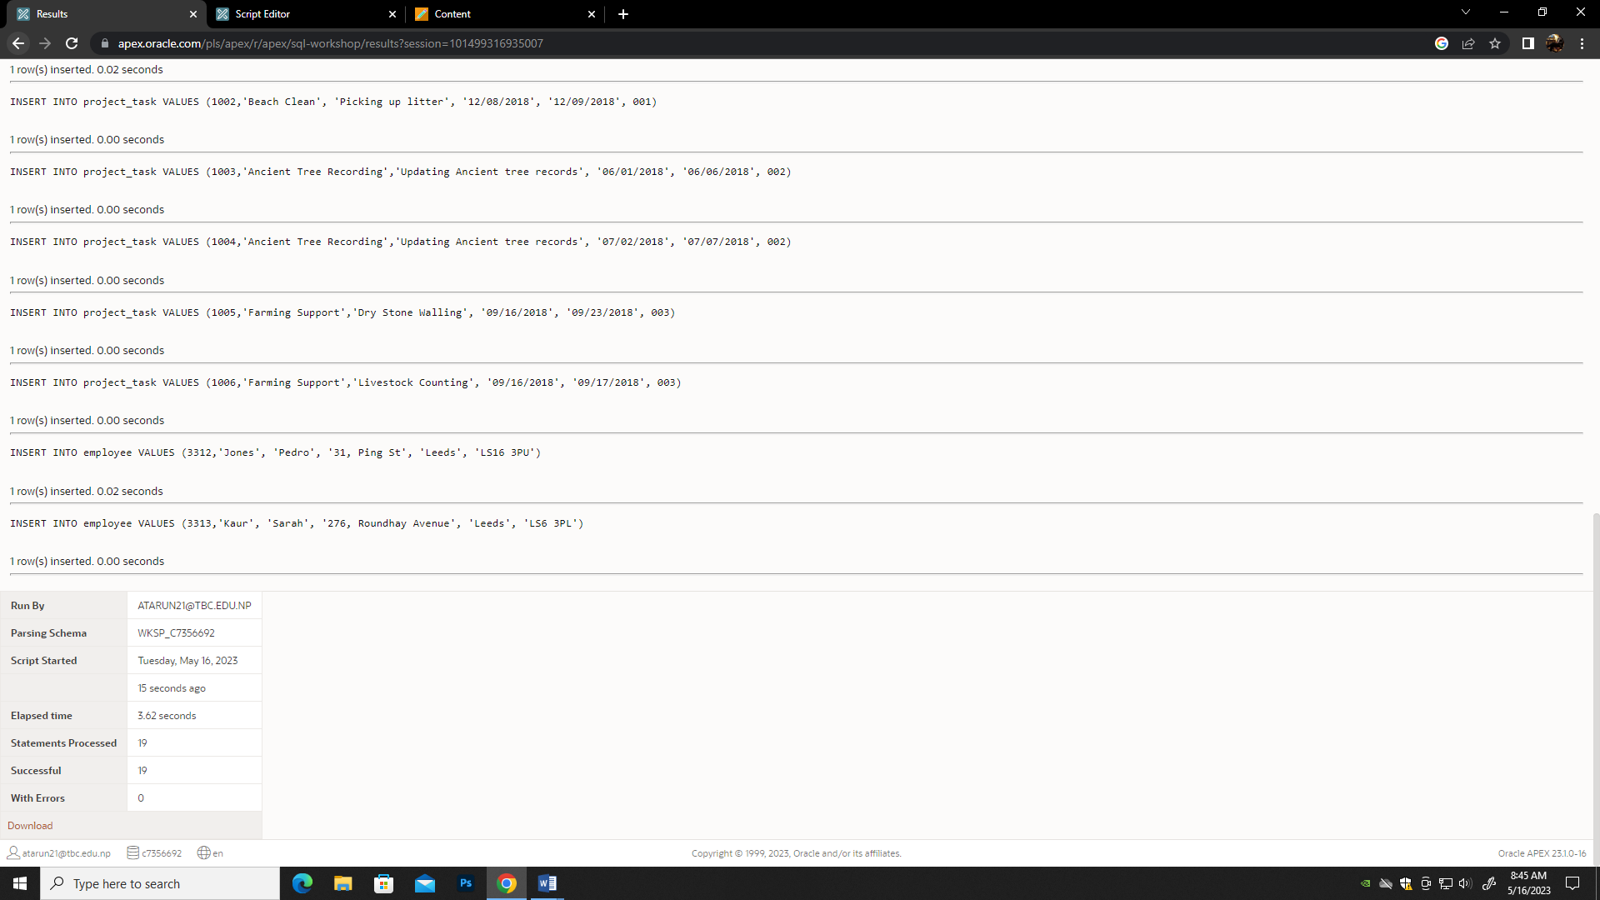

**TASK 2**

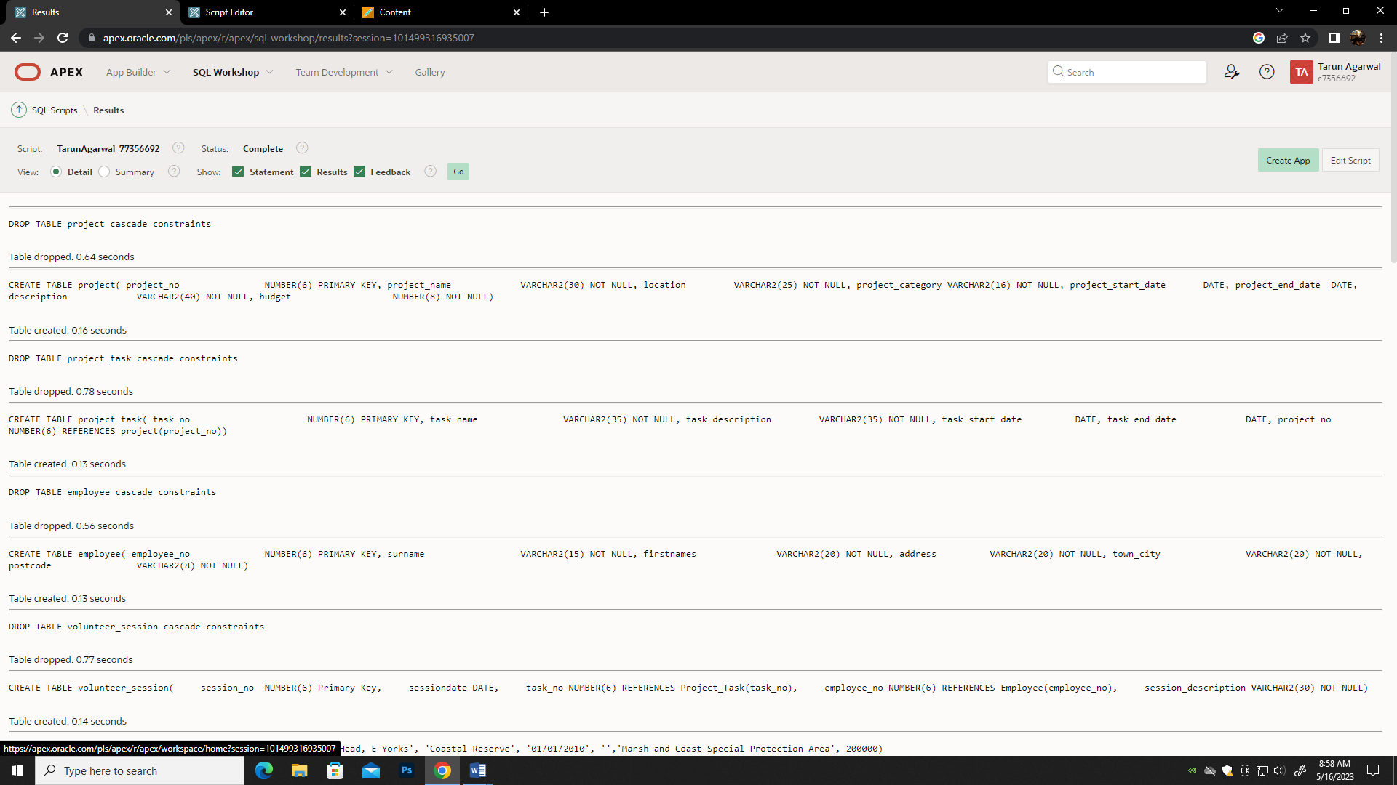

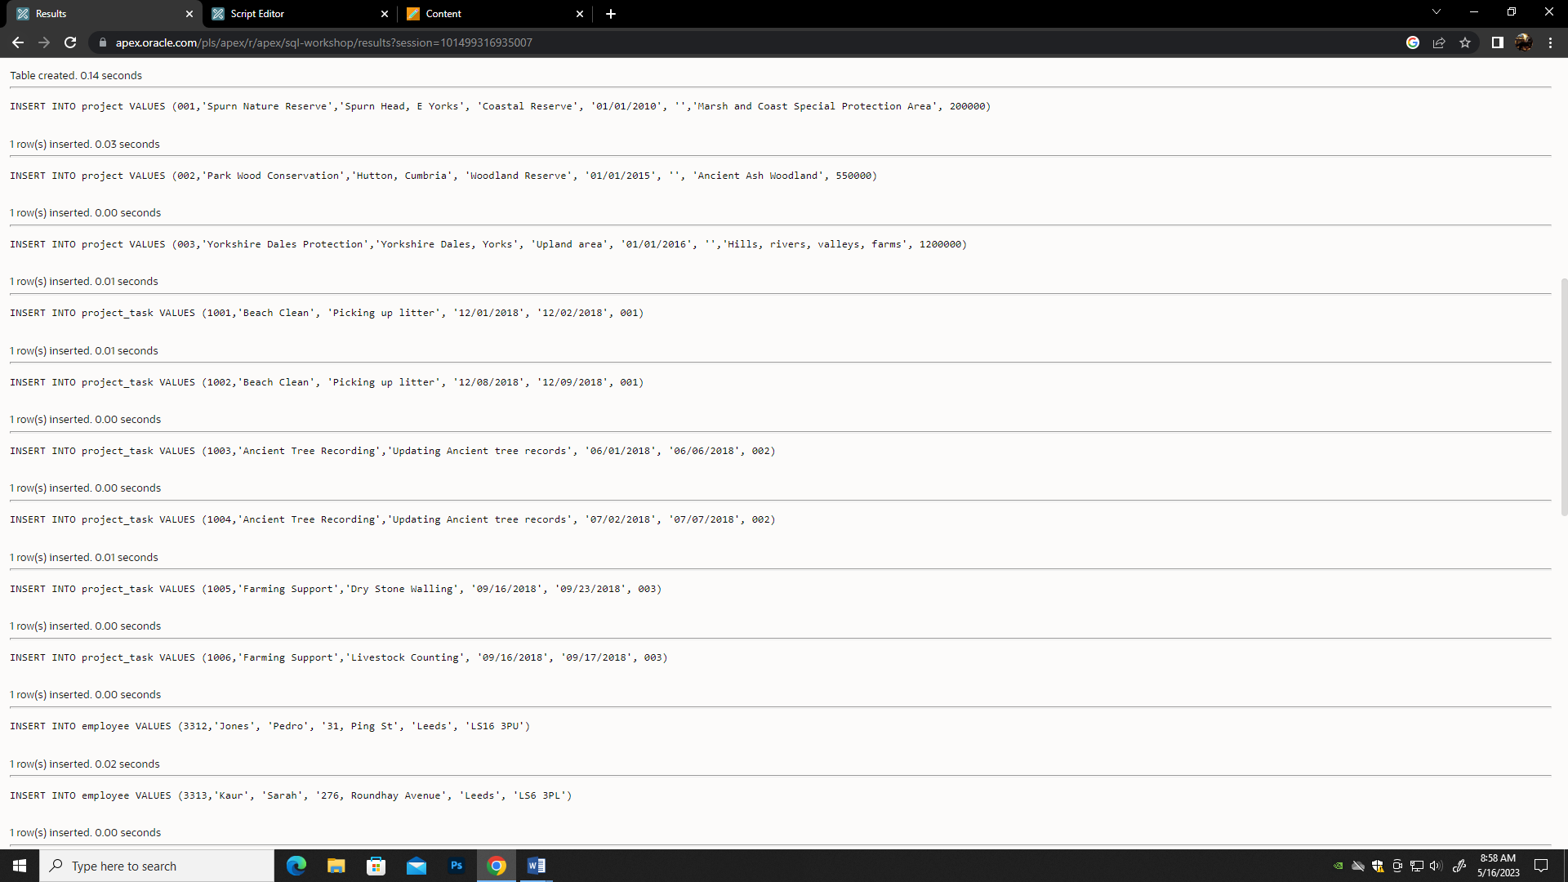

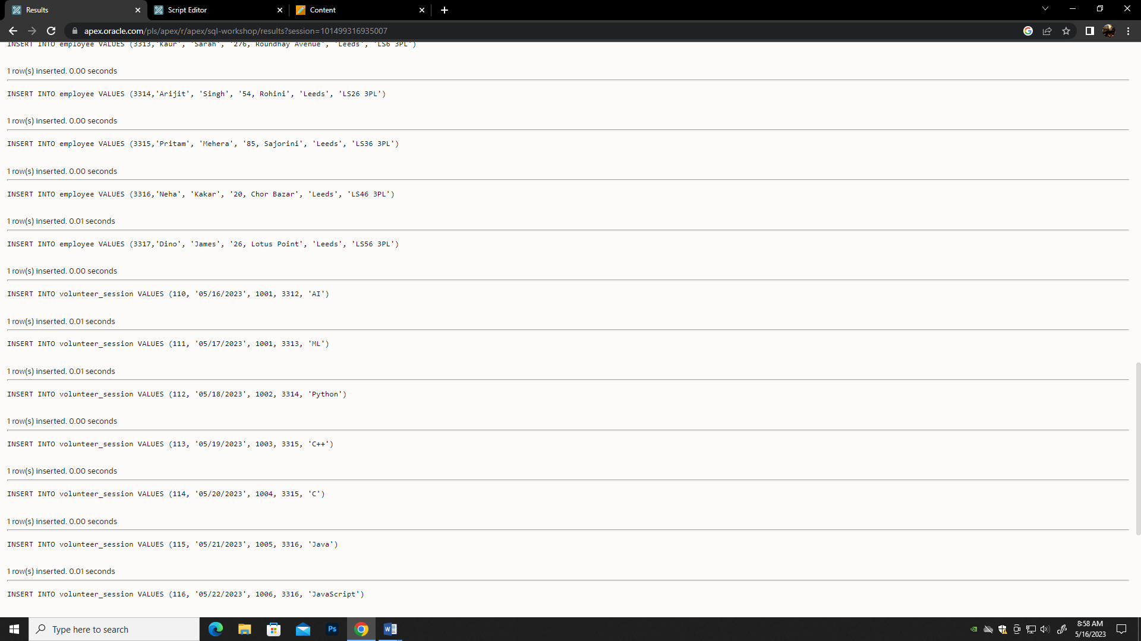

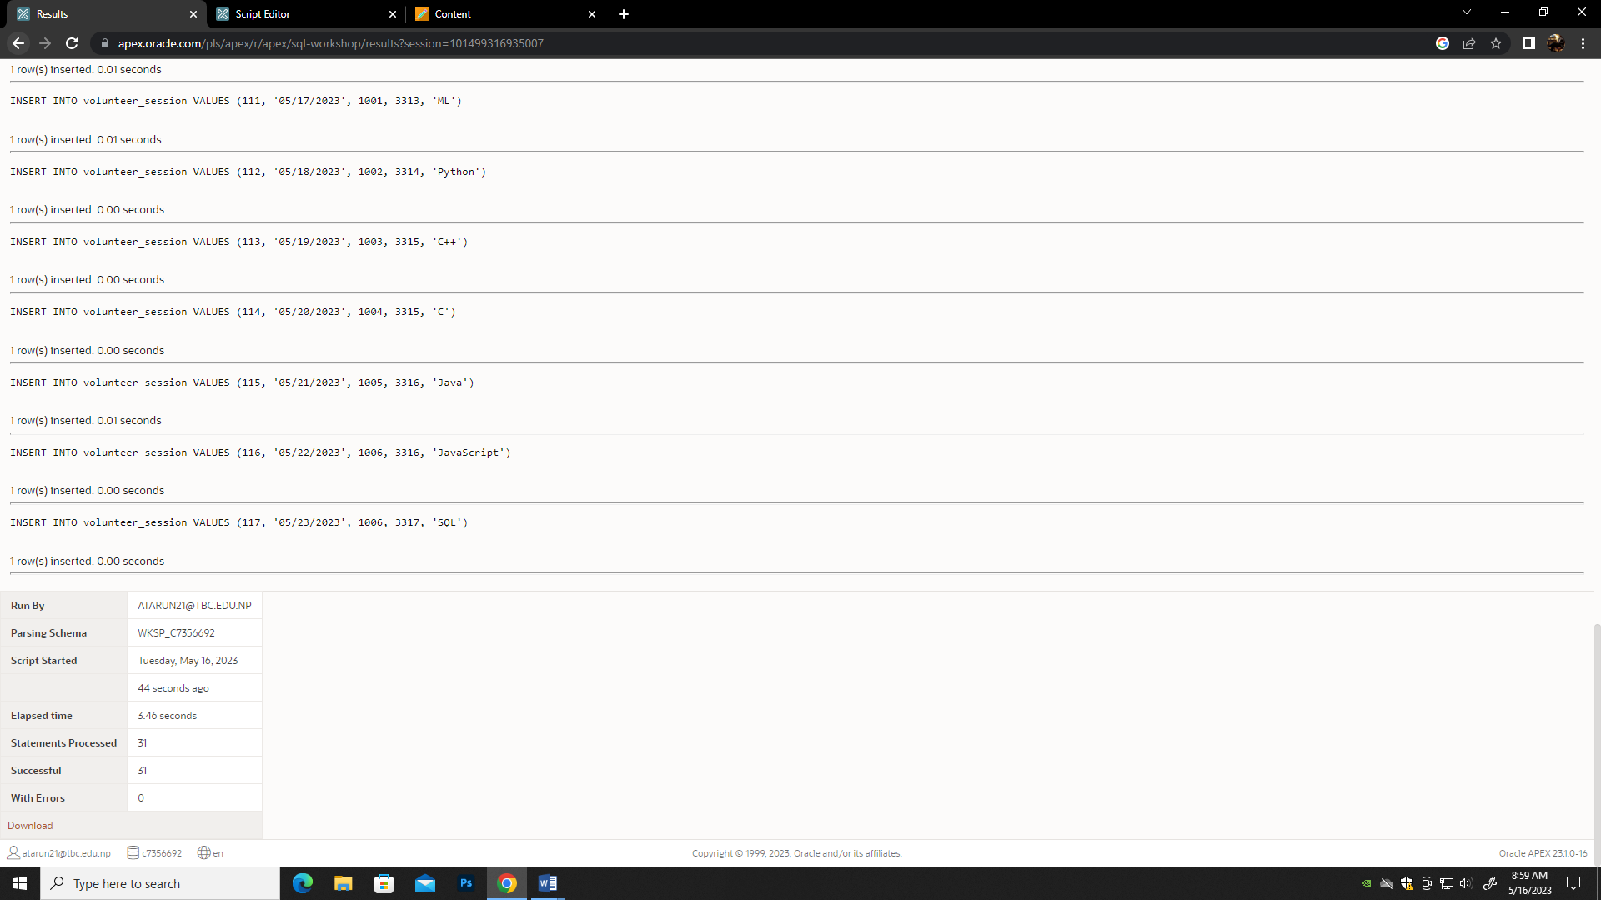

**TASK 3**

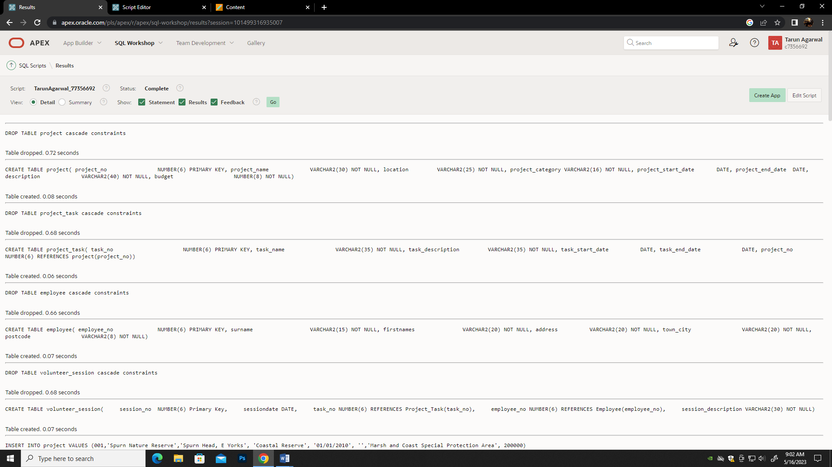

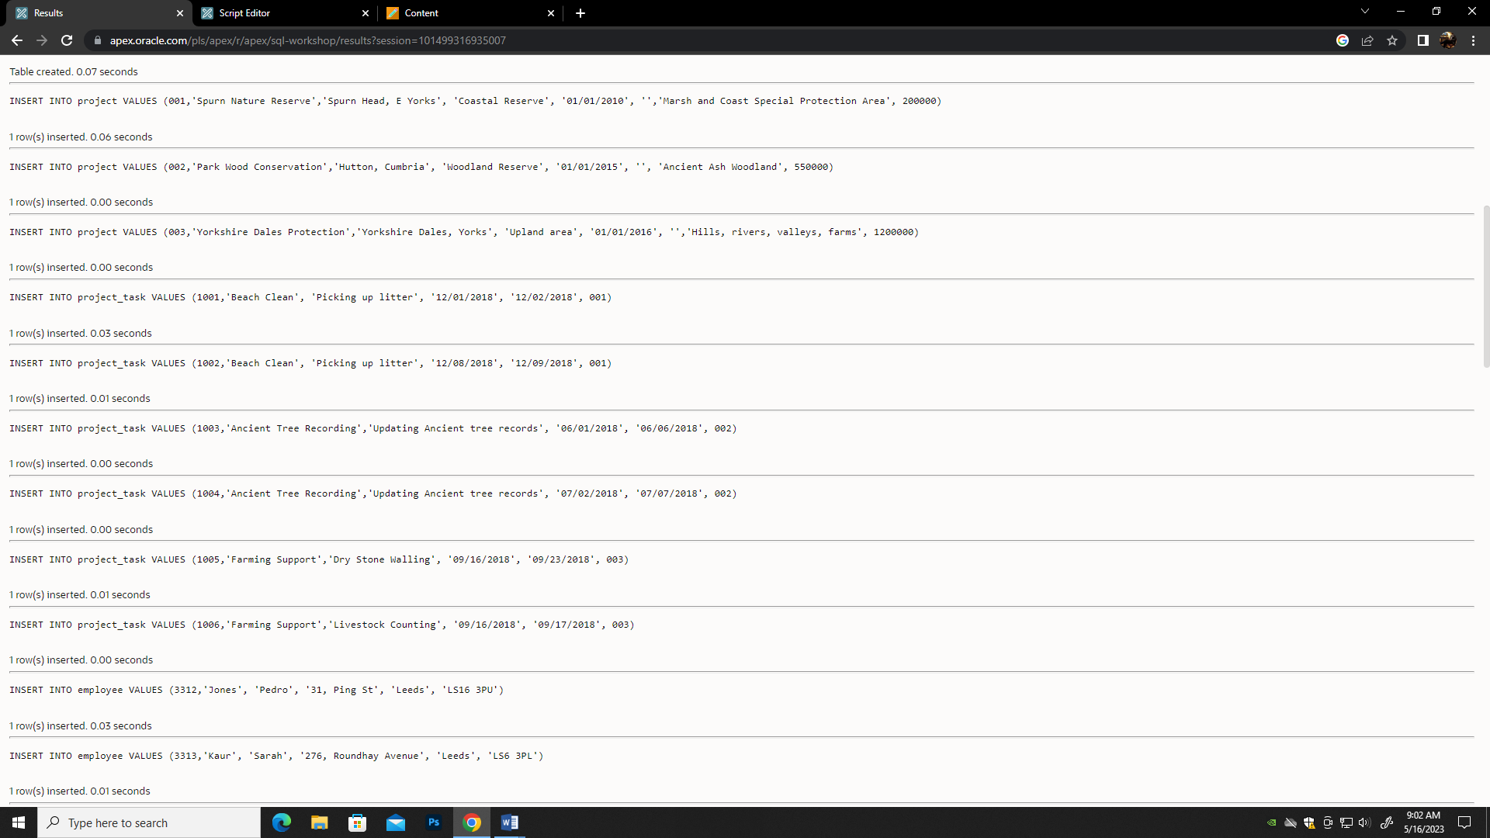

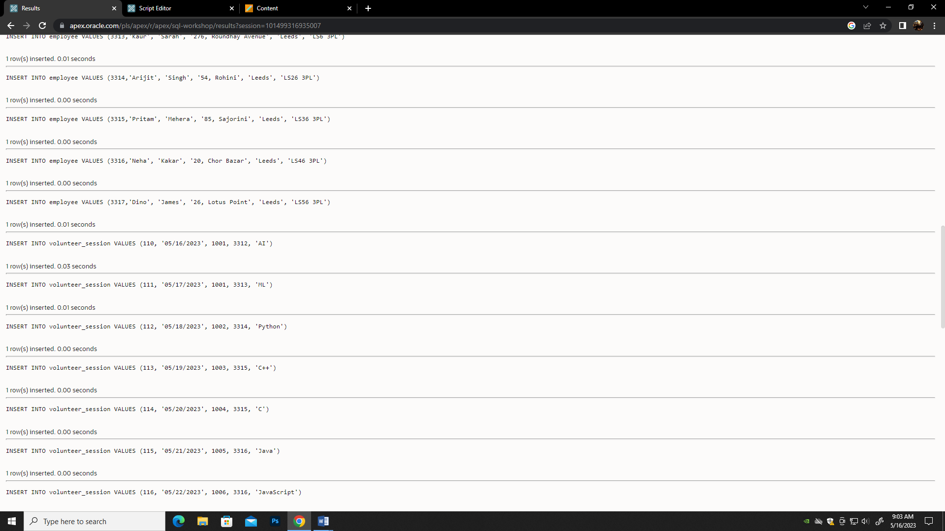

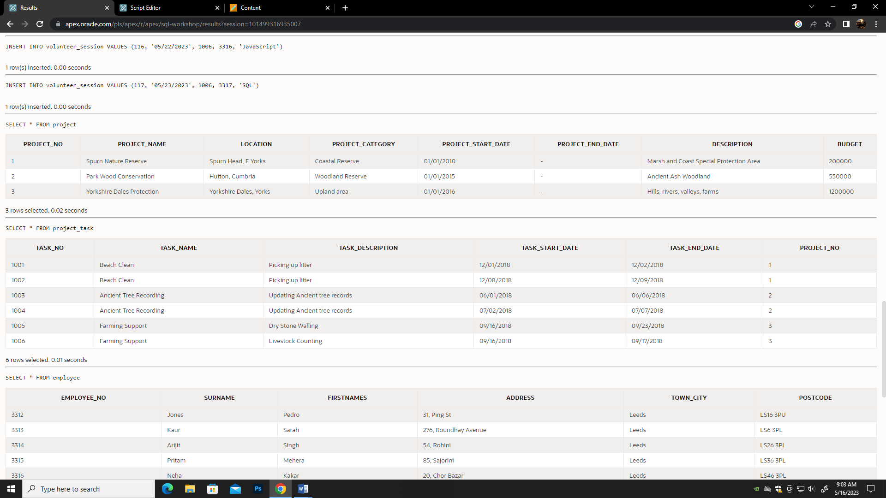

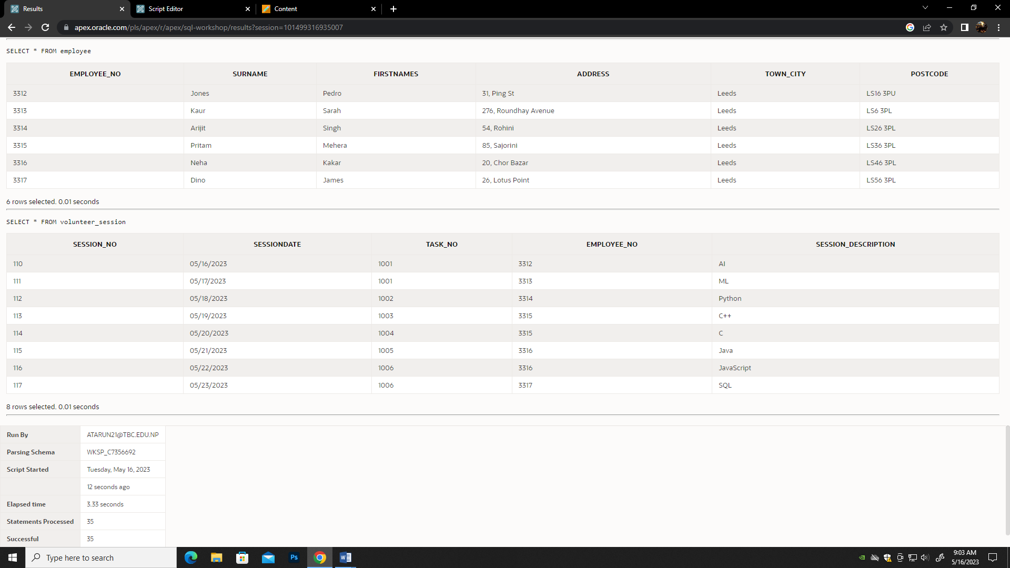

**TASK 4a**

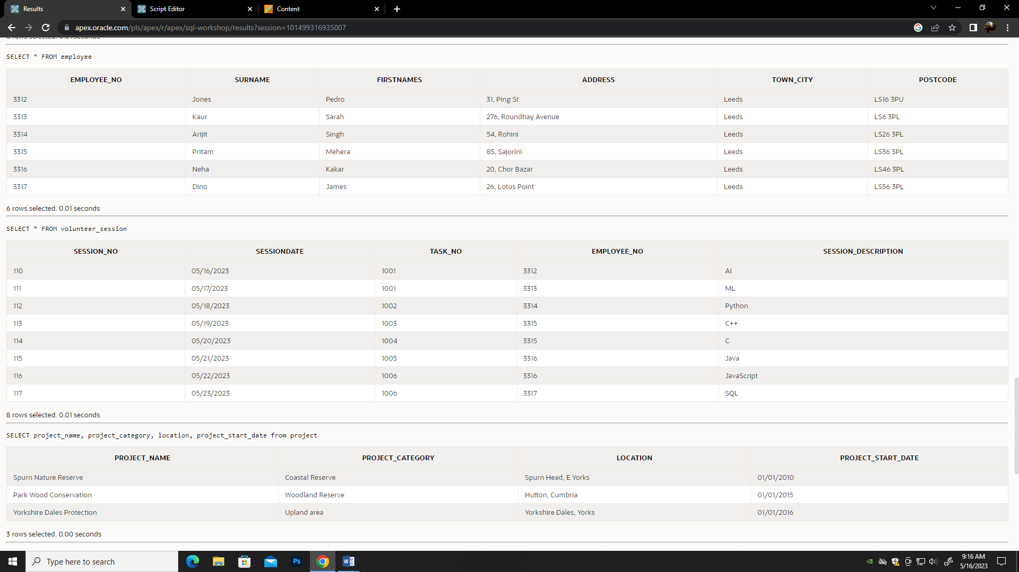

**TASK 4b**

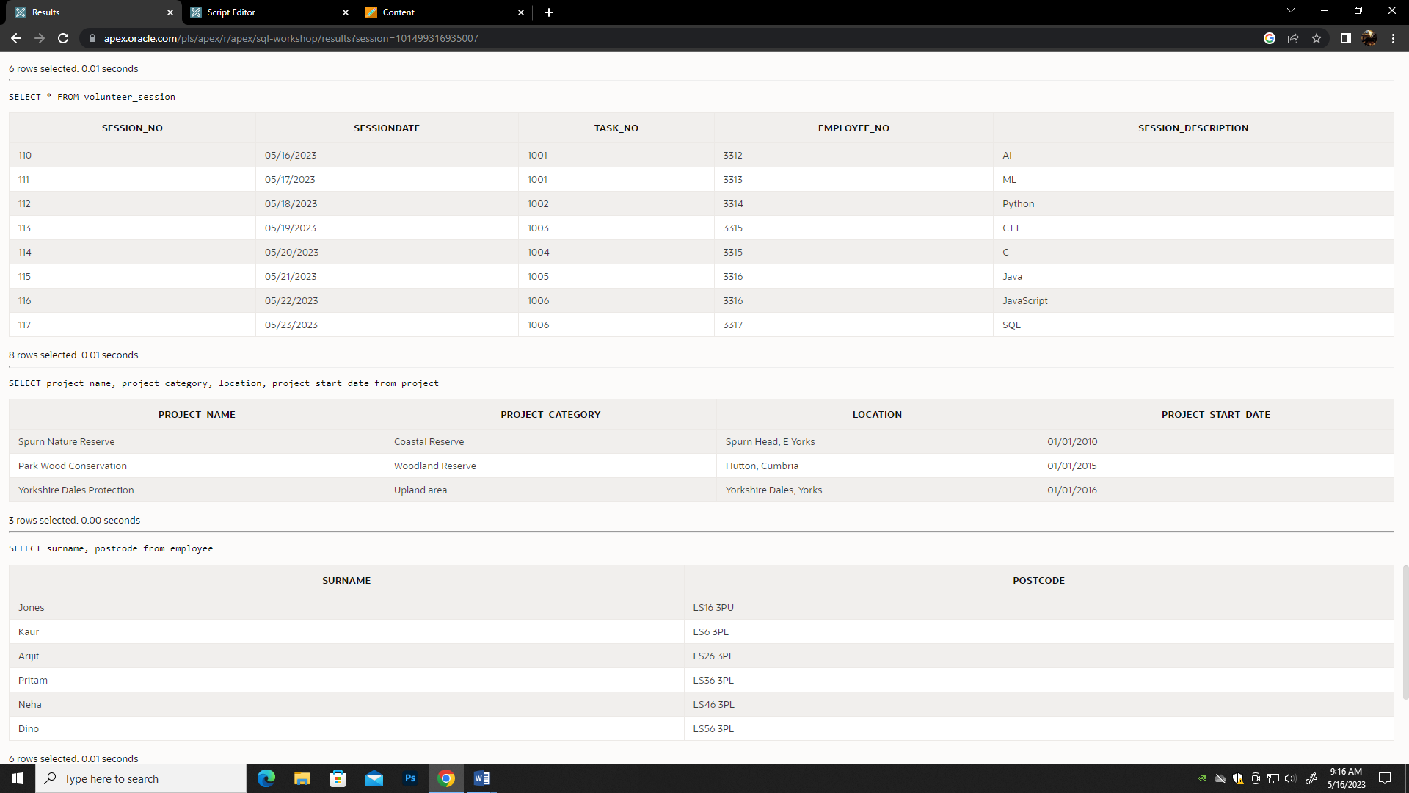

**TASK 4c**

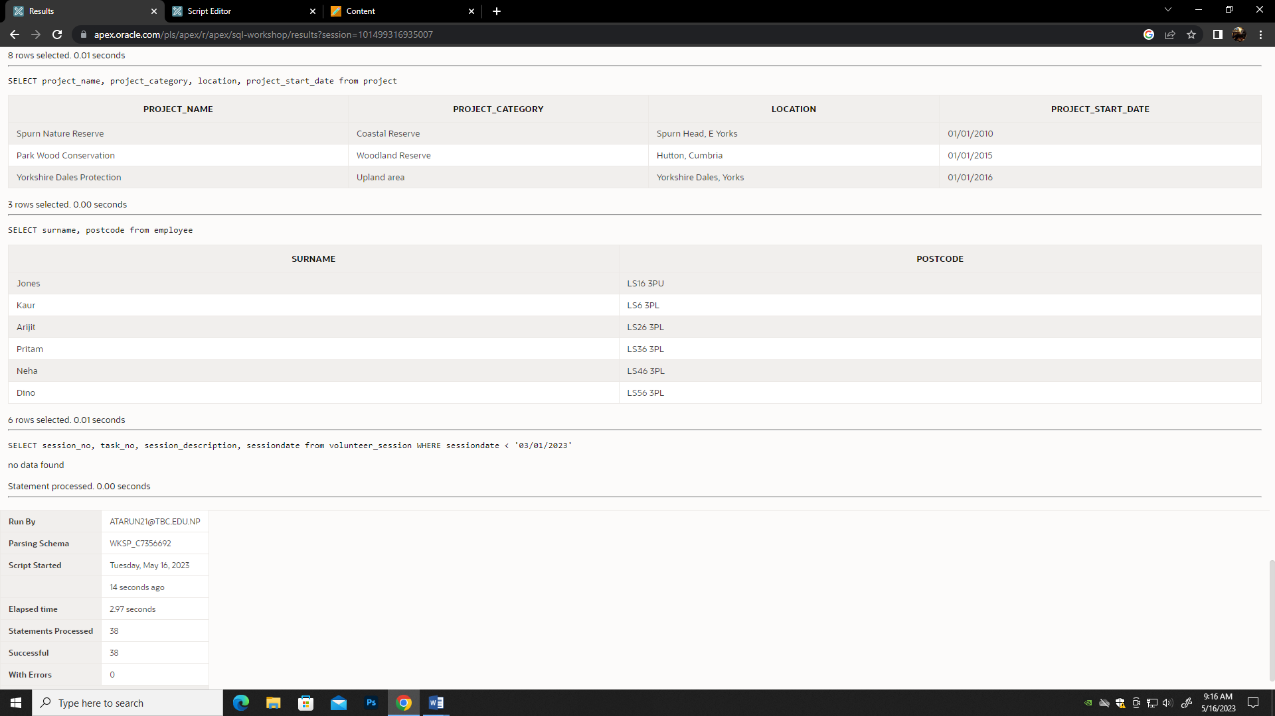

**TASK 5a**

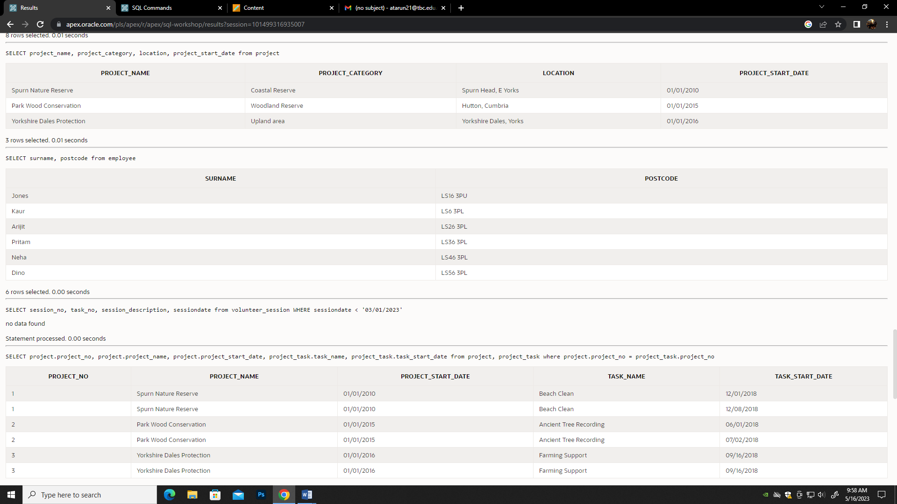

**TASK 5b**

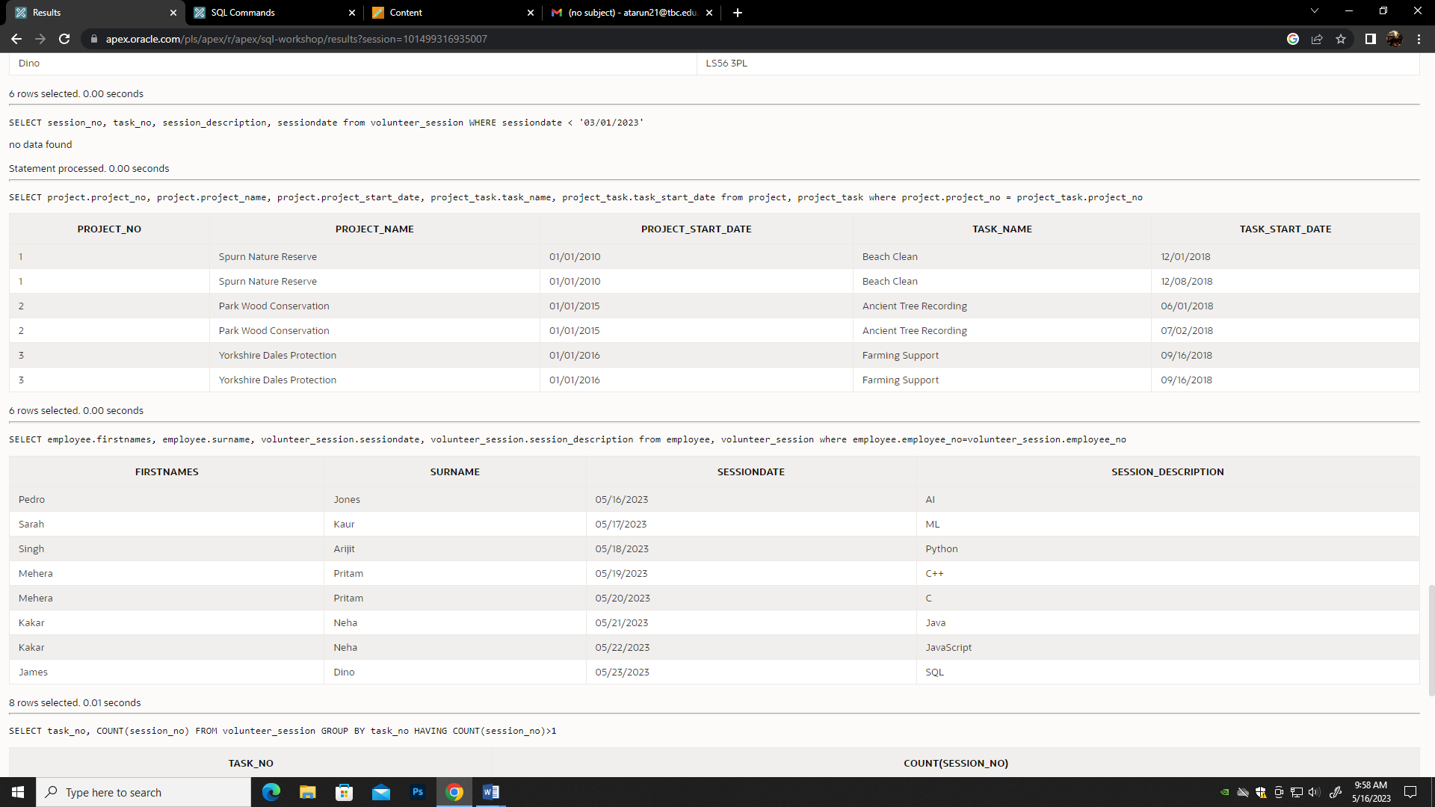

**TASK 5c**

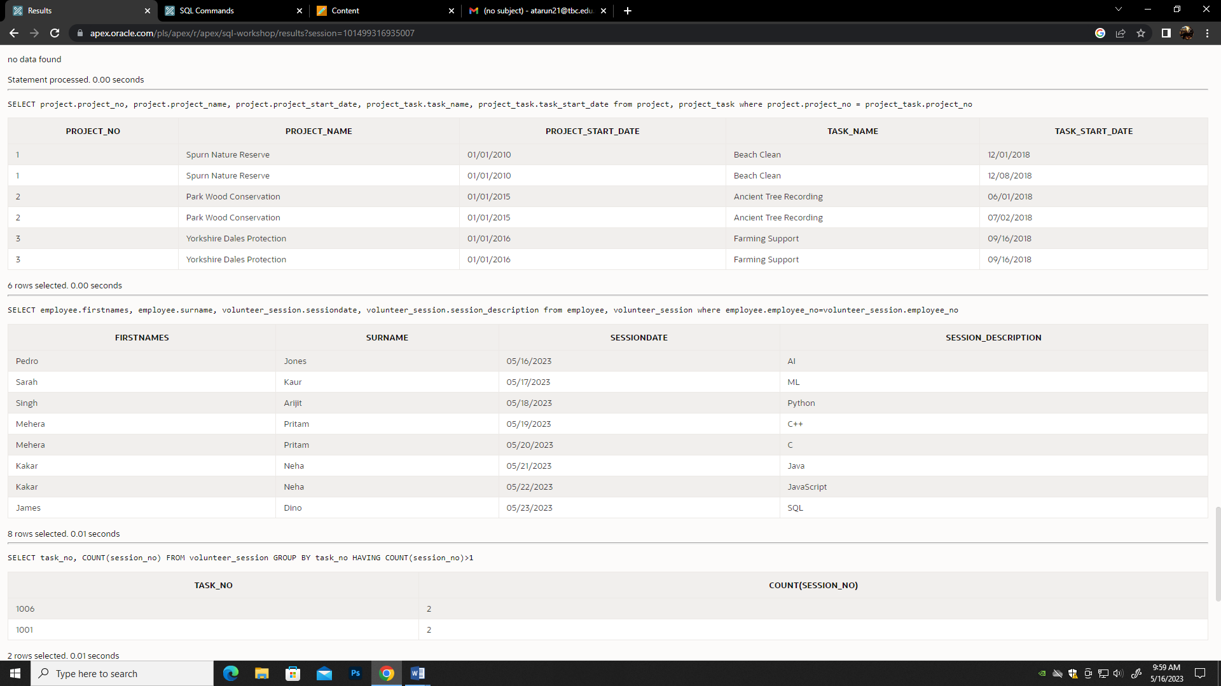

**TASK 5d**

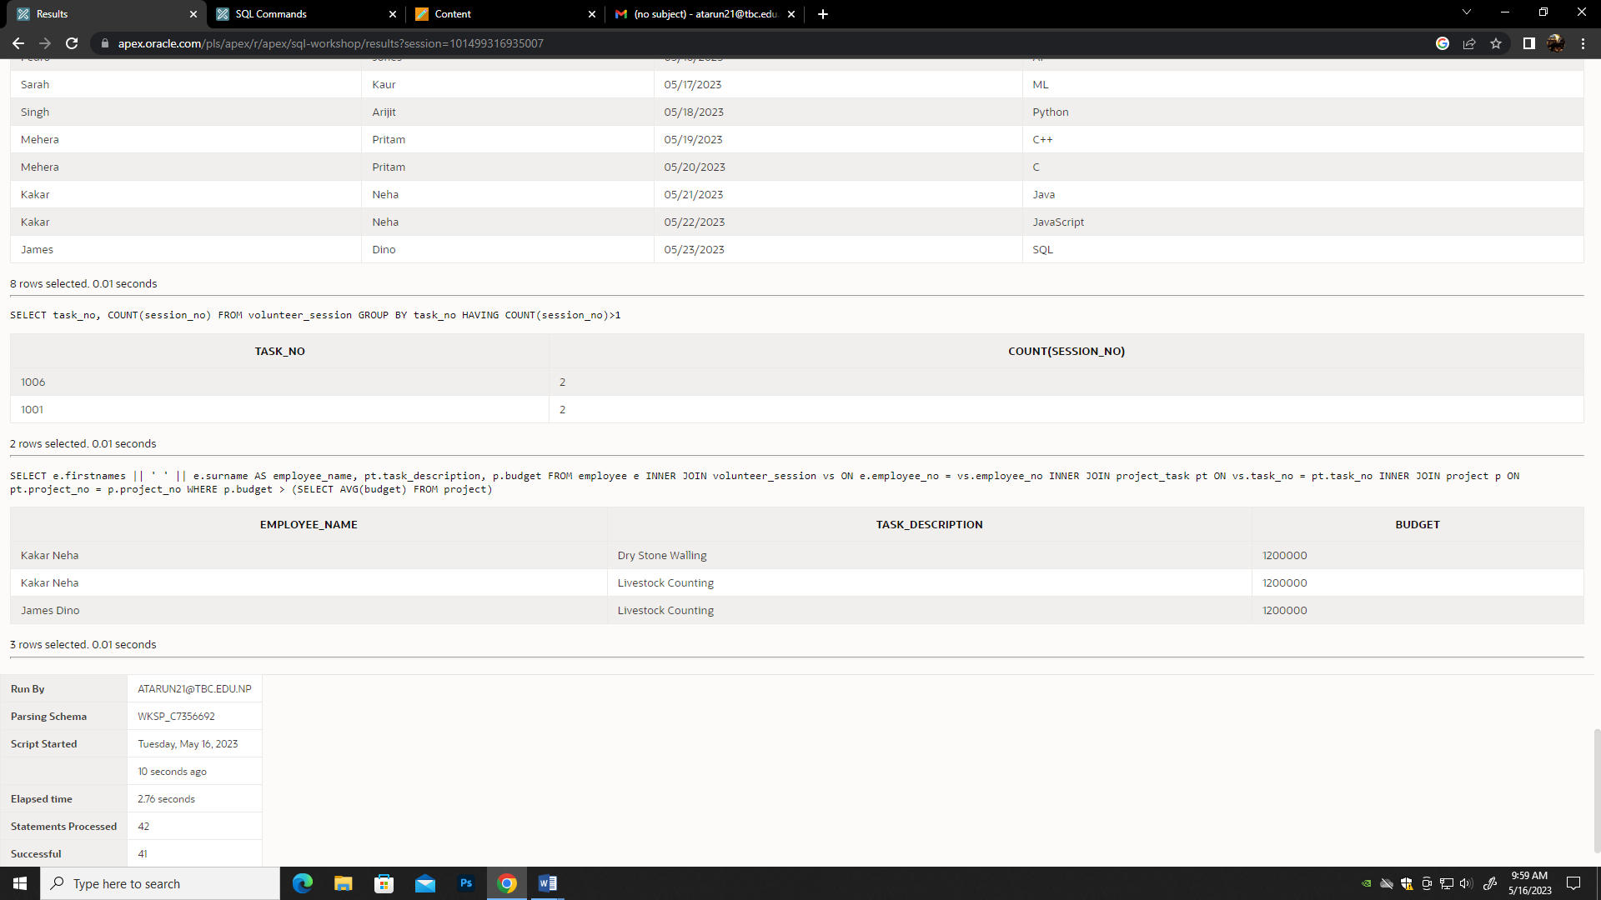

**TASK 6a**

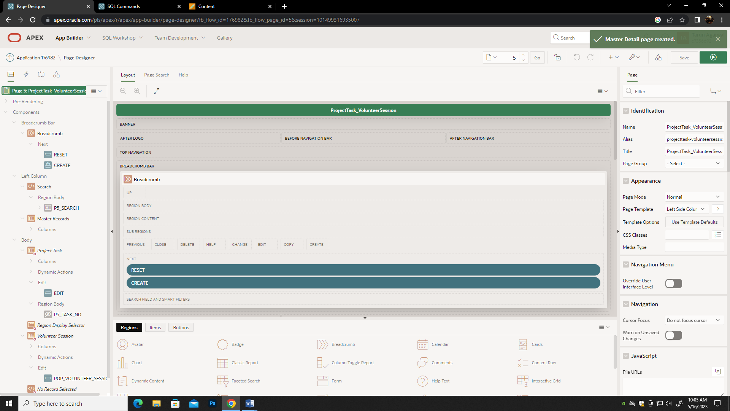

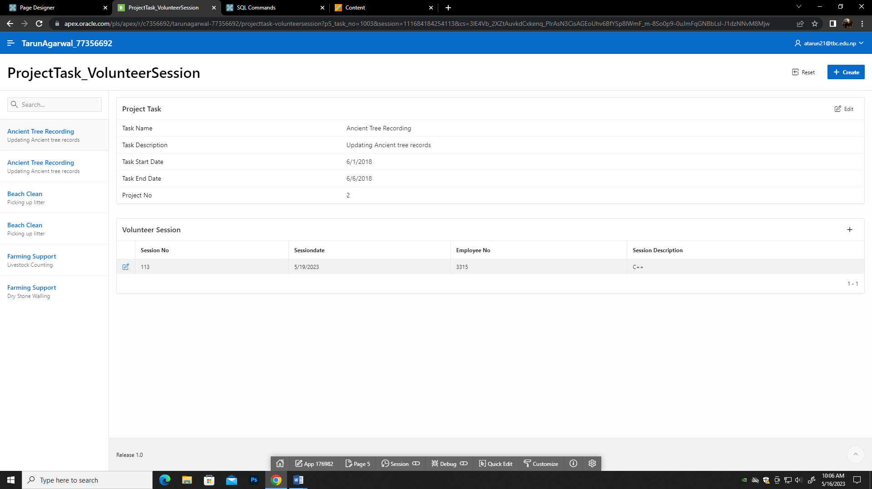

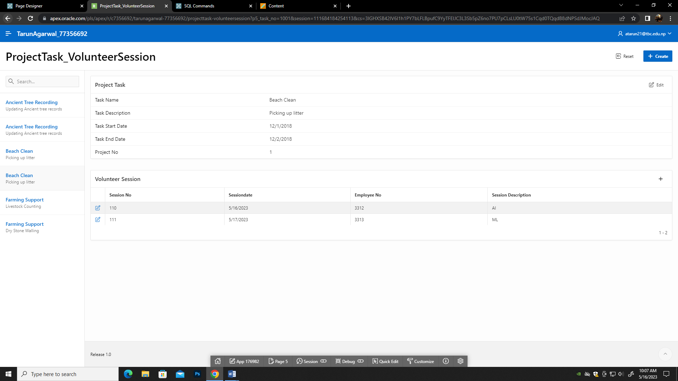

**TASK 6b**

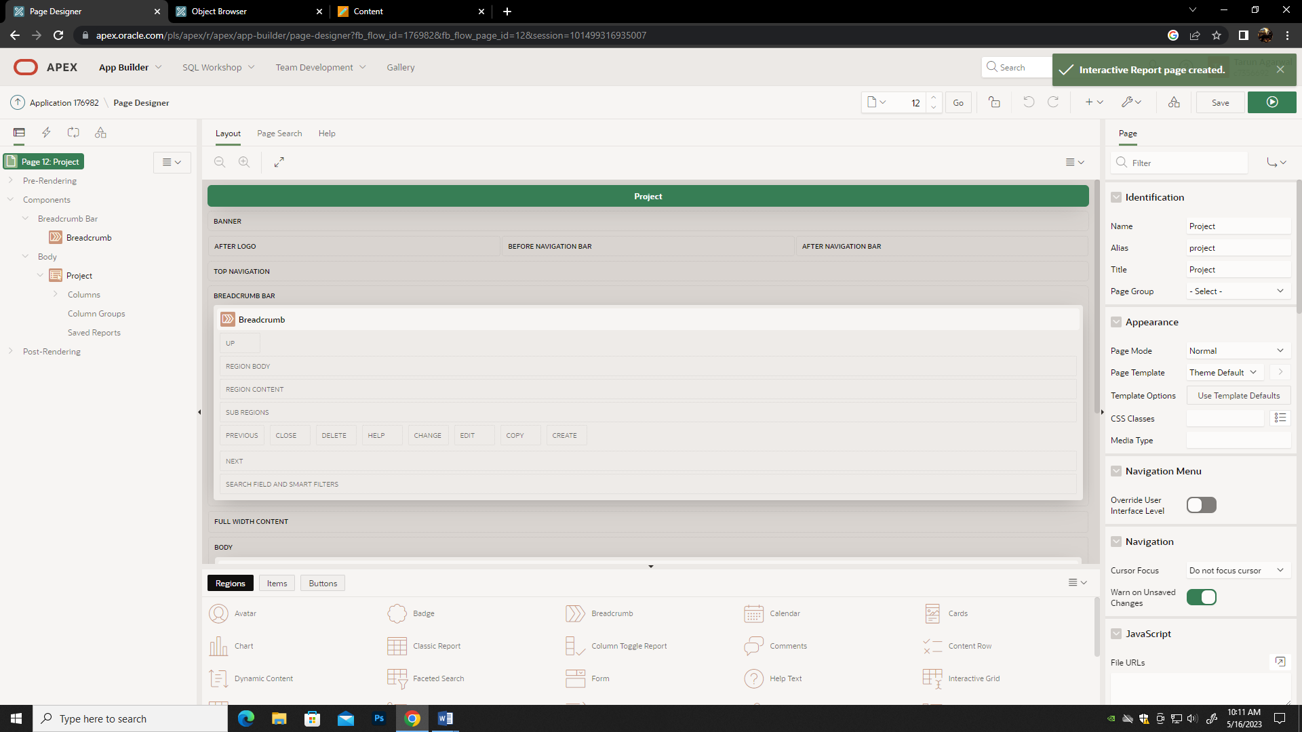

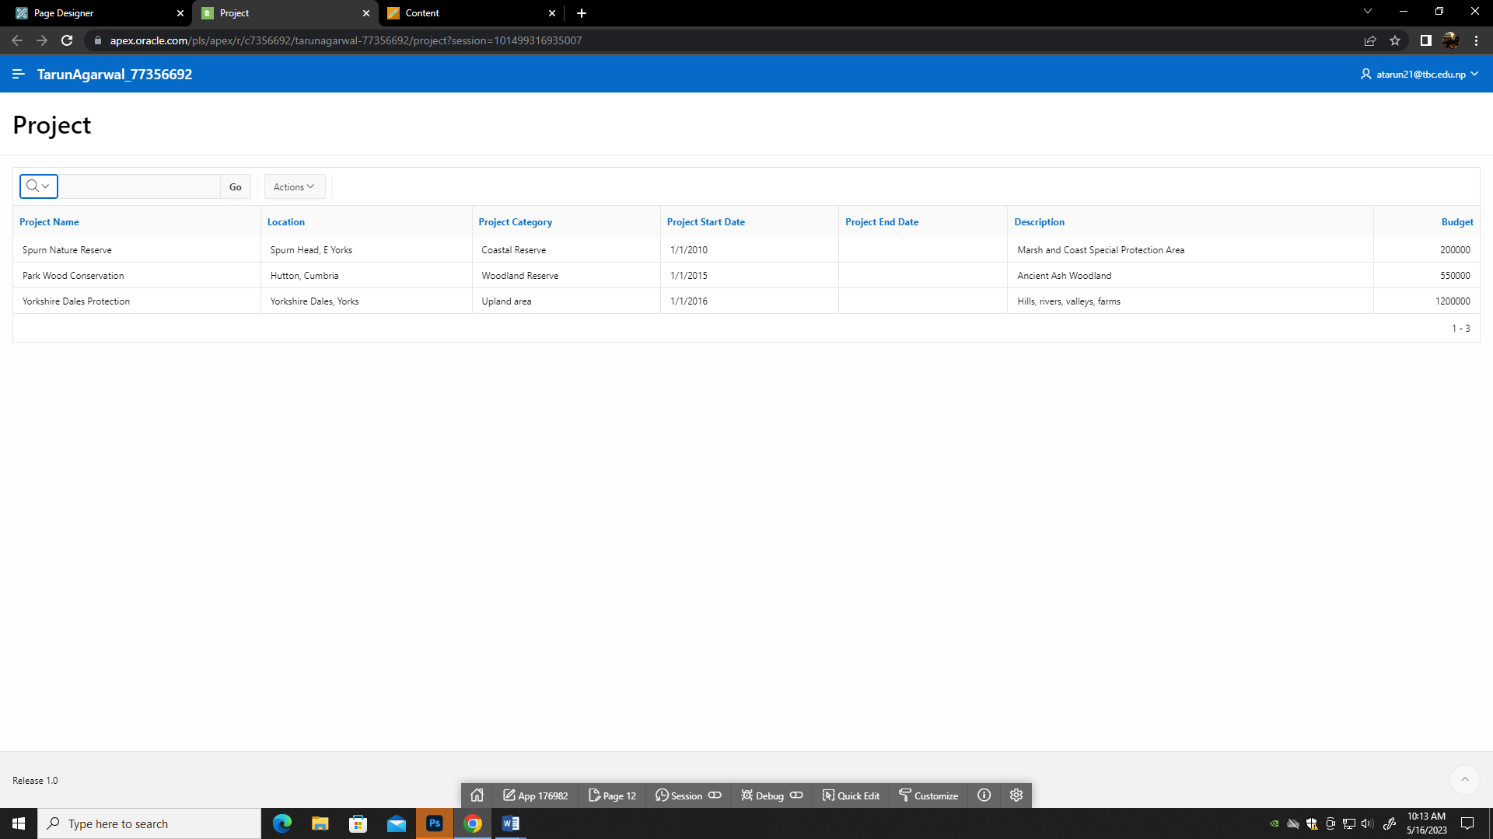

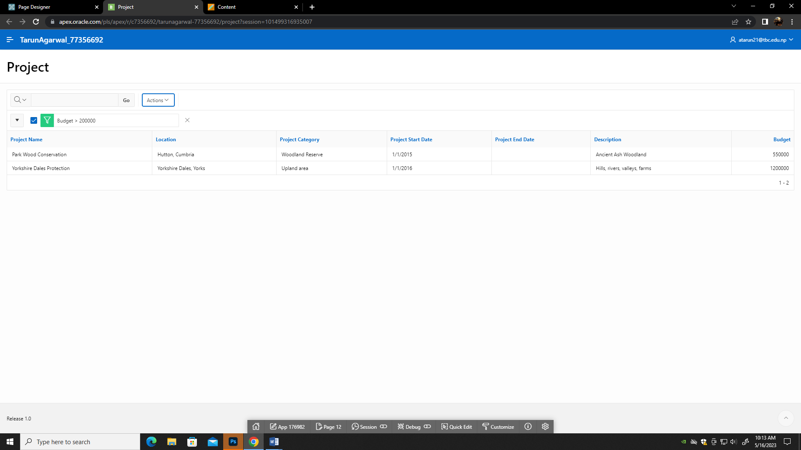

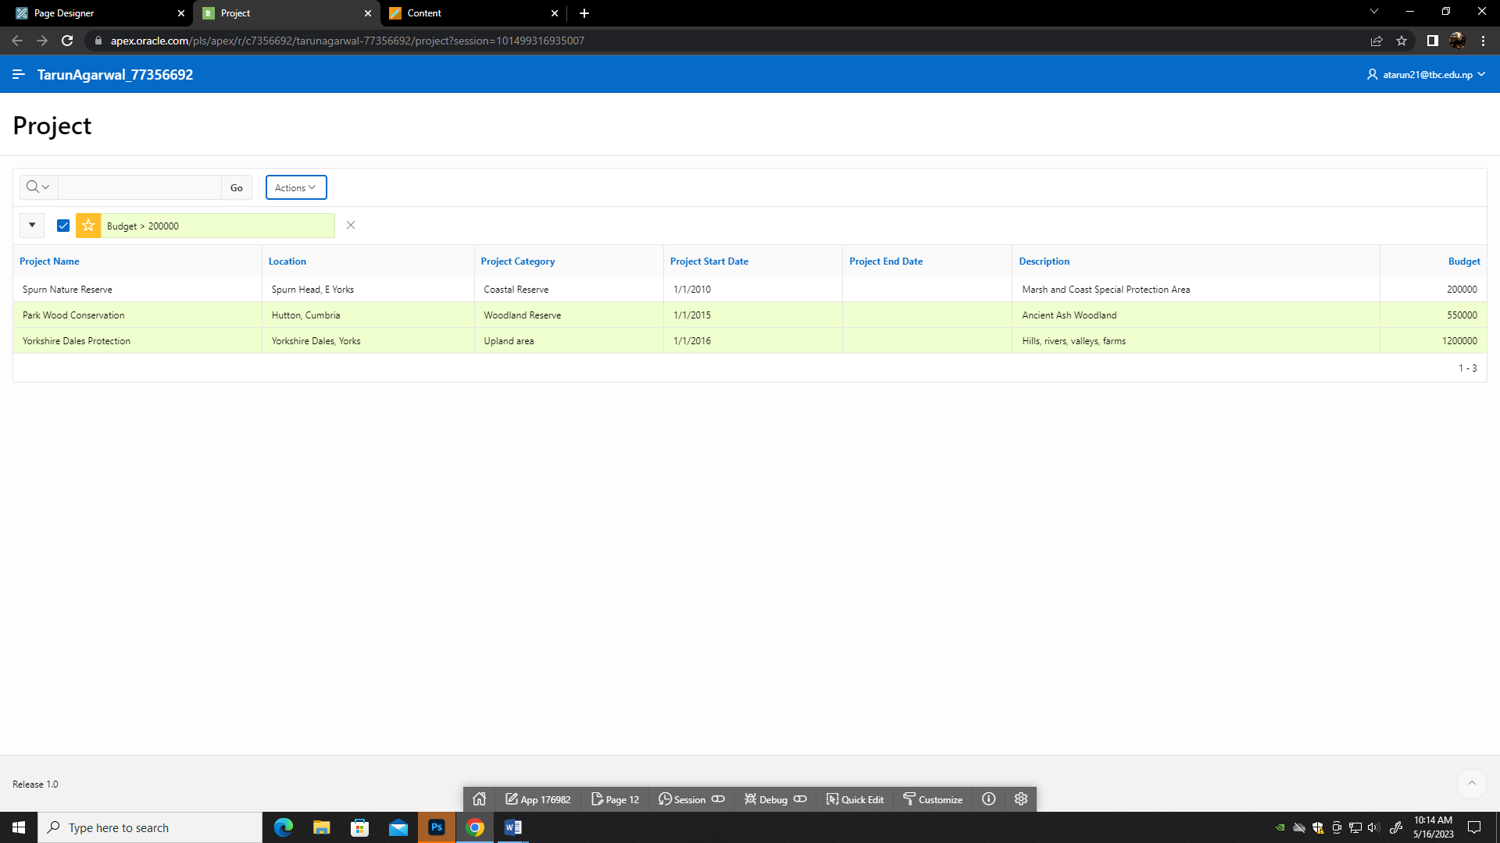

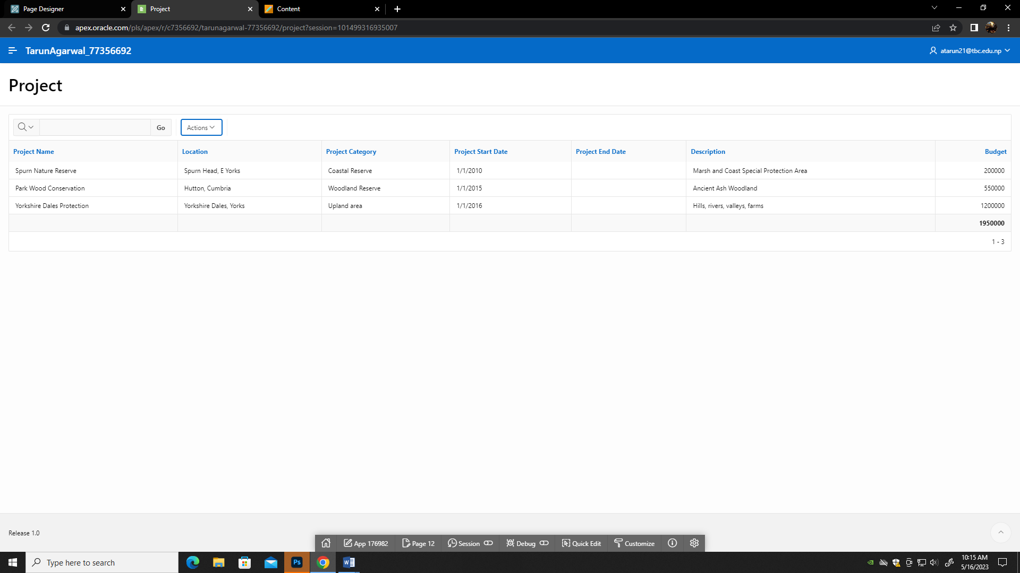

**APPENDIX**

DROP TABLE project cascade constraints;

CREATE TABLE project(

project_no NUMBER(6) PRIMARY KEY,

project_name VARCHAR2(30) NOT NULL,

location VARCHAR2(25) NOT NULL,

project_category VARCHAR2(16) NOT NULL,

project_start_date DATE,

project_end_date DATE,

description VARCHAR2(40) NOT NULL,

budget NUMBER(8) NOT NULL);

--create the project_task table

DROP TABLE project_task cascade constraints;

CREATE TABLE project_task(

task_no NUMBER(6) PRIMARY KEY,

task_name VARCHAR2(35) NOT NULL,

task_description VARCHAR2(35) NOT NULL,

task_start_date DATE,

task_end_date DATE,

project_no NUMBER(6) REFERENCES project(project_no));

--create the employee table

DROP TABLE employee cascade constraints;

CREATE TABLE employee(

employee_no NUMBER(6) PRIMARY KEY,

surname VARCHAR2(15) NOT NULL,

firstnames VARCHAR2(20) NOT NULL,

address VARCHAR2(20) NOT NULL,

town_city VARCHAR2(20) NOT NULL,

postcode VARCHAR2(8) NOT NULL);

--create the volunteer_session table

DROP TABLE volunteer_session cascade constraints;

CREATE TABLE volunteer_session(

session_no NUMBER(6) Primary Key,

sessiondate DATE,

task_no NUMBER(6) REFERENCES Project_Task(task_no),

employee_no NUMBER(6) REFERENCES Employee(employee_no),

session_description VARCHAR2(30) NOT NULL);

--Insert data into project table

INSERT INTO project VALUES (001,'Spurn Nature Reserve','Spurn Head, E Yorks', 'Coastal Reserve', '01/01/2010', '','Marsh and Coast Special Protection Area', 200000);

INSERT INTO project VALUES (002,'Park Wood Conservation','Hutton, Cumbria', 'Woodland Reserve', '01/01/2015', '', 'Ancient Ash Woodland', 550000);

INSERT INTO project VALUES (003,'Yorkshire Dales Protection','Yorkshire Dales, Yorks', 'Upland area', '01/01/2016', '','Hills, rivers, valleys, farms', 1200000);

--Insert data into Project_Task table

INSERT INTO project_task VALUES (1001,'Beach Clean', 'Picking up litter', '12/01/2018', '12/02/2018', 001);

INSERT INTO project_task VALUES (1002,'Beach Clean', 'Picking up litter', '12/08/2018', '12/09/2018', 001);

INSERT INTO project_task VALUES (1003,'Ancient Tree Recording','Updating Ancient tree records', '06/01/2018', '06/06/2018', 002);

INSERT INTO project_task VALUES (1004,'Ancient Tree Recording','Updating Ancient tree records', '07/02/2018', '07/07/2018', 002);

INSERT INTO project_task VALUES (1005,'Farming Support','Dry Stone Walling', '09/16/2018', '09/23/2018', 003);

INSERT INTO project_task VALUES (1006,'Farming Support','Livestock Counting', '09/16/2018', '09/17/2018', 003);

--Insert data into employee table

INSERT INTO employee VALUES (3312,'Jones', 'Pedro', '31, Ping St', 'Leeds', 'LS16 3PU');

INSERT INTO employee VALUES (3313,'Kaur', 'Sarah', '276, Roundhay Avenue', 'Leeds', 'LS6 3PL');

INSERT INTO employee VALUES (3314,'Arijit', 'Singh', '54, Rohini', 'Leeds', 'LS26 3PL');

INSERT INTO employee VALUES (3315,'Pritam', 'Mehera', '85, Sajorini', 'Leeds', 'LS36 3PL');

INSERT INTO employee VALUES (3316,'Neha', 'Kakar', '20, Chor Bazar', 'Leeds', 'LS46 3PL');

INSERT INTO employee VALUES (3317,'Dino', 'James', '26, Lotus Point', 'Leeds', 'LS56 3PL');

--Insert data into volunteer_session table

INSERT INTO volunteer_session VALUES (110, '05/16/2023', 1001, 3312, 'AI');

INSERT INTO volunteer_session VALUES (111, '05/17/2023', 1001, 3313, 'ML');

INSERT INTO volunteer_session VALUES (112, '05/18/2023', 1002, 3314, 'Python');

INSERT INTO volunteer_session VALUES (113, '05/19/2023', 1003, 3315, 'C++');

INSERT INTO volunteer_session VALUES (114, '05/20/2023', 1004, 3315, 'C');

INSERT INTO volunteer_session VALUES (115, '05/21/2023', 1005, 3316, 'Java');

INSERT INTO volunteer_session VALUES (116, '05/22/2023', 1006, 3316, 'JavaScript');

INSERT INTO volunteer_session VALUES (117, '05/23/2023', 1006, 3317, 'SQL');

--Selecting Query from all Tables from SQL

SELECT * FROM project;

SELECT * FROM project_task;

SELECT * FROM employee;

SELECT * FROM volunteer_session;

--Selecting Specific Columns from table Task 4

SELECT project_name, project_category, location, project_start_date from project;

SELECT surname, postcode from employee;

SELECT session_no, task_no, session_description, sessiondate from volunteer_session WHERE sessiondate < '03/01/2023';

--Selecting Specific Columns from multiple table Task 5

SELECT project.project_no, project.project_name, project.project_start_date, project_task.task_name, project_task.task_start_date from project, project_task where project.project_no = project_task.project_no;

SELECT employee.firstnames, employee.surname, volunteer_session.sessiondate, volunteer_session.session_description from employee, volunteer_session where employee.employee_no=volunteer_session.employee_no;

SELECT task_no, COUNT(session_no) FROM volunteer_session GROUP BY task_no HAVING COUNT(session_no)>1;

SELECT e.firstnames || ' ' || e.surname AS employee_name, pt.task_description, p.budget FROM employee e INNER JOIN volunteer_session vs ON e.employee_no = vs.employee_no INNER JOIN project_task pt ON vs.task_no = pt.task_no INNER JOIN project p ON pt.project_no = p.project_no WHERE p.budget > (SELECT AVG(budget) FROM project);