Name: Prerna Agarwal

Admission No.: U22EE030

Sub.: MPMC Lab

Exp No.: 1.1

**AIM:** Write an assembly language program to add two signed 8-bit numbers stored in internal memory locations 30H and 31H and store the final result in internal memory locations 40H and condition (A-B)>0

**SOFTWARE USED:** Keil mVision5

**HARDWARE REQUIRED:** NA

**ALGORITHM:**

1. Start the program execution at memory location 0000h (denoted by ORG 0000h).
2. Load the hexadecimal value 0Ah into the accumulator (A register).
3. Load the hexadecimal value 0Ch into register B at memory location 31H.
4. Do 2’s complement of negative number such that value stored in register A.
5. Add the contents of register B to the accumulator (A) and store the result in the accumulator (A).
6. Move the result from the accumulator (A) to the internal RAM memory location 40h.
7. Terminate the program execution (END).

**CODE:**

org 0000h

MOV A, 30h

MOV B, 31h

CPL A

ADD A,#01H

ADD A,B

MOV 40H,A

END

OUTPUT:

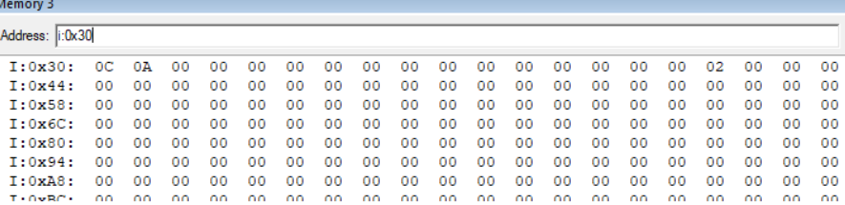

Entering values in memory location 30H

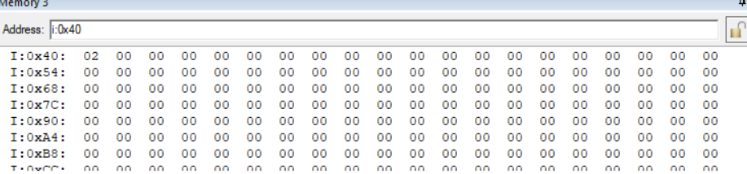

After Code Execution

CONCLUSION:

The program adds two signed 8-bit numbers stored in 30h and 31h memory locations. The result is stored in 40h, which is 02 (positive) as the following condition (A-B) > 0. It demonstrates handling basic arithmetic and carry operations in 8051 assembly.

Name: Prerna Agarwal

Admission No.: U22EE030

Sub.: MPMC Lab

Exp No.: 1.2

**AIM**: Write an assembly language program to add two signed 8-bit numbers stored in internal memory locations 30H and 31H and store the final result in internal memory locations 40H and condition (A-B) <0

**SOFTWARE USED:** Keil mVision5

**HARDWARE REQUIRED**: NA

**ALGORITHM:**

1. Start the program execution at memory location 0000h (denoted by ORG 0000h).
2. Load the hexadecimal value 0Ah into the accumulator (A register).
3. Load the hexadecimal value 0Ch into register B at memory location 31H.
4. Do 2’s complement of negative number such that value stored in register B because number is negative.
5. Add the contents of register B to the accumulator (A) and store the result in the accumulator (A).
6. Again Do 2’s complement of result obtained which is sored in register A.
7. Move the result from the accumulator (A) to the internal RAM memory location 40h.
8. Terminate the program execution (END).

**CODE:**

org 0000h

MOV A, 30h

MOV B, 31h

CPL B

ADD B,#01H

ADD A,B

CPL A

ADD A,#01H

MOV 40H,A

END

**OUTPUT:**

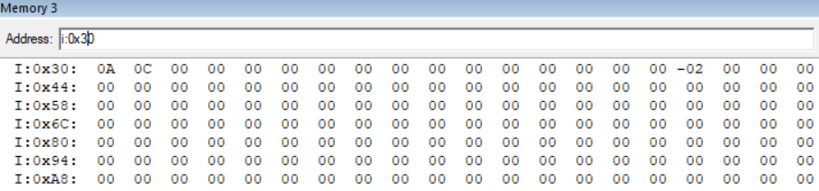

Entering values in memory location 30H

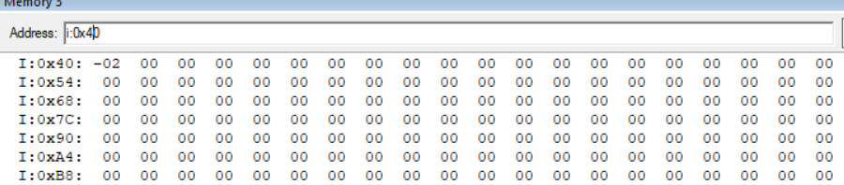

After Code Execution

**CONCLUSION:**

The program adds two signed 8-bit numbers stored in 30h and 31h memory locations. The result is stored in 40h, which is -2 as following condition (A-B) < 0 .It demonstrates handling basic arithmetic and carry operations in 8051 assembly.

Name: Prerna Agarwal

Admission No.: U22EE030

Sub.: MPMC Lab

Exp No.: 1.2

**AIM**: Write an assembly language program to add two signed 8-bit numbers stored in internal memory locations 30H and 31H and store the final result in internal memory locations 40H and condition (-A -B) both numbers are negative.

**SOFTWARE USED:** Keil mVision5

**HARDWARE REQUIRED**: NA

**ALGORITHM:**

1. Start the program execution at memory location 0000h (denoted by ORG 0000h).
2. Load the hexadecimal value 07h into the accumulator (A register).
3. Load the hexadecimal value -03h into register B at memory location 31H.
4. Do 2’s complement of number 07 such that value stored in register S because we ake i as negative.
5. Now save this in another register r2 and copy the value in B to A.
6. As I passed -3 so assembler already converts in 2’s complement whether I wrote instruction for 2’s or not.
7. Add the contents of register B to the accumulator (A) and store the result in the accumulator (A).
8. Move the result from the accumulator (A) to the internal RAM memory location 40h.
9. Terminate the program execution (END).

**CODE:**

org 0000h

MOV A, 30h

MOV B, 31h

CPL A

ADD A,#0H

MOV R2,A

MOV A,B

CPL A

ADD A,#01H

ADD A,B

MOV 40H,A

END

**OUTPUT:**

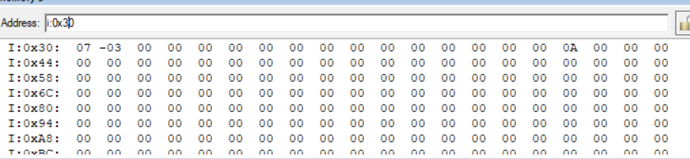

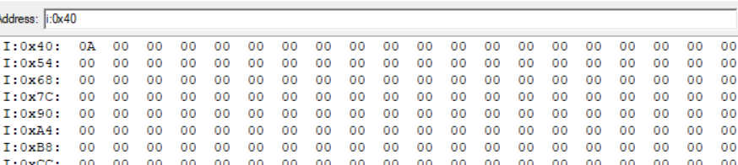

**CONCLUSION:**

The program adds two signed 8-bit numbers stored in 30h and 31h memory locations. The result is stored in 40h, which is 10 = A in hex as following condition (-A-B) .It demonstrates handling basic arithmetic and carry operations in 8051 assembly.