A data-driven framework for diabetic peripheral neuropathy risk prediction using foot thermograms

1st Amaresh A M
Department of Computer Science and Engineering, JSS Science and Technology University, Mysuru, India
Email: amaresham@jssstuniv.in
4th Jayanth S
Department of Computer Science and Engineering, JSS Science and Technology University, Mysuru, India
Email: Jayanth7m@gmail.com
2nd Agasthya Samyak Jnan
Department of Computer Science and Engineering, JSS Science and Technology University, Mysuru, India Email: agasthyasamyakjnan5577@gmail.com
5th Prajwal T P
Department of Computer Science and Engineering, JSS Science and Technology University, Mysuru, India
Email: prajwaltp06@gmail.com
3rd Arvind Ningombam
Department of Computer Science and Engineering, JSS Science and Technology University, Mysuru, India
Email: ningombamarvind@gmail.com

Abstract—Some of important consequences of diabetes includes Diabetic Peripheral Neuropathy, which can lead to foot ulcers, impaired mobility, and amputation if not detected early. This work proposes a hybrid machine learning based framework for DPN risk assessment using plantar thermal images from the INAOE dataset and its Kaggle mirrors. Deep convolutional features extracted from a pretrained MobileNetV2 model are combined with handcrafted thermal distribution features to capture both spatial patterns and physiological temperature variations. The fused feature representation is used to train an ordinal regression model based on XGBoost to predict neuropathy risk levels categorized as Low, Medium, and High. Experimental evaluation demonstrates strong predictive performance with robust ordinal accuracy and low error metrics. A lightweight desktop application is also developed to enable real-time, low-cost clinical screening. The proposed approach offers an accessible and scalable solution for early DPN risk stratification.
Keywords—Diabetes, Diabetic Peripheral Neuropathy, Diabetic Foot, plantar thermal image, INAOE Thermal dataset, MobileNetV2, XGBoost

Introduction
Diabetic neuropathy causes long-term health issues and is main reason for ulcers in feet, infection, and amputations in diabetic patients. Diabetic foot cases have been increasing globally, causing increased healthcare costs and decline in quality of life of patients. [12], [19]. Identifying neuropathic changes soon is quite important to avoid ulcer complications in diabetic feet patients.
The early physiological symptoms of diabetic foot complications is abnormal thermal distribution on plantar surface. Inflammation and microvascular issues related to neuropathy often come as localized temperature spikes and asymmetrical thermal patterns between left and right feet [17], [18]. Clinical studies have shown that monitoring foot skin temperature can help reduce ulcers [1], [15]. Thermography modality of medical imaging is a preferred non-invasive method for diagnosing such plantar thermal patterns in a reliable manner [2]-[4], [14].
Manual temperature measurements or predefined difference thresholds are main aspects in current clinical methods but these methods might not help fully understand complicated thermal distributions within thermograms that indicate neuroapthy. Recent works used machine learning based tools to find ulcers early and found good results [7], [8]. Feature engineered indices like Thermal Change Index (TCI) also found that structured thermal descriptors help in identifying diabetic conditions early and are also useful for understanding and identifying symptoms of upcoming neuropathy and ulcer related complications [6].
Many limitations are present in existing studies like many approaches focus on binary ulcer detection rather than graded neuropathy risk stratification and others depend on clinically calibrated temperature thresholds or require specialized hardware configurations. So, there is a need for frameworks capable of stratifying neuropathy risk using thermographic data and help clinicians and patients understand about their diabetic condition in a better way.
In our work, we present a data-driven Thermal Risk Score (TRS) framework for diabetic neuropathy stratification using plantar thermogram images, where Thermal Risk Score is formulated as a composite index using three key thermal quantities: global mean thermal intensity, temperature variability, and entropy-based texture complexity. Mean thermal intensity reflects overall temperature elevation associated with inflammatory activity and variability tells us about distribution of thermal values over the plantar surface. Entropy tells us about distributional irregularity. This helps us finding thermal patterns often observed in neuropathic situations and these features were inspired by thermographic asymmetry and feature-based analysis in previous studies [1], [2], [6].
In this work we are using unsupervised clustering through K-Means clustering to group subjects to three increasing risk categories which is different from methods used in clinical thresholding systems.
This helps adjust system for diagnosis of the same depending on demography of a region. This framework remains lightweight and is suitable for medical screening applications. Established machine learning methods and augmentation methods were used to improve robustness and generalization [9]-[11].

Related Work

Diabetic neuropathy related foot ailments have already been studied widely. Their rate of occurrence among diabetic patients is high and there are high chances of them leading to ulcers and amputations and such foot disease cases are well documented. This shows that there is need for early identification strategies [12], [19]. Many international committees have provided many rules, regulations and recommendations for better handling diabetic foot problems [13], [20].

Lavery et al. [1] demonstrated that consistent monitoring of plantar skin temperature significantly helped take measures to reduce ulcers and findings established clinical importance of temperature asymmetry and localized thermal elevation as useful indicators. Bharara et al. [14] and Yavuz et al. [15] further support role of plantar temperature monitoring in avoiding diabetic foot problems.

We preferred thermographic imaging as the input for our work because its an easy, contactless and economic method to assess diabetic foot as compared to other methods for the same. Bagavathiappan et al. [2] showed that plantar thermal patterns relate to diabetic neuropathy, showing thermal imaging modality to be a promising tool for detecting such patterns. Balbinot et al. [3] confirms consistent results with standardized acquisition protocols for thermal images. Also, van Netten et al. [4] investigated identifying diabetic foot problems through thermographic imaging which showed its feasibility in clinical screening. A Foot thermogram database for study diabetic foot problems was given by Hernández-Contreras et al. [5].

Khandakar et al. [6] proposed the Thermal Change Index (TCI) which mixes temperature-based descriptors with statistical classification algorithms and their work shows that engineered thermal indices diabetic and non-diabetic identify with strong interpretability. Thus, their study inspired composite feature modeling of thermograms in this work.
Castillo-Morquecho et al. [7] used machine learning based techniques with thermography for diabetic foot assessment and highlighted importance of using multiple thermal descriptors. A comprehensive review of machine learning-aided thermal imaging systems by Wu et al. [8] showed shift of manually engineered features towards more hybrid approaches.

Using deep learning image models like MobileNetV2 [9] make for efficient systems, keeping good representational power for lightweight screening systems.

Also, current studies have limitations like many thermography-based method do just ulcer detection but not measuring probable neuropathy risk. Clinically calibrated temperature thresholds are used in some systems that may not generalize in all acquisition methods.

Some deep learning systems give good classification accuracy without using interpretable thermal characteristics [8]. There remains a need for lightweight, interpretable, and data-driven frameworks for categorizing risk levels without depending over strict temperature limits.

In deep learning-based approaches, we usually have less understanding on what features contribute to different indicators of diabetic foot problems. Systems that combine many features together, they help us interpret these features in a better way.

Many augmentation techniques on dataset improve generalization while using limited medical datasets [11]. XGBoost [10] like ensemble models showed strong performance in structured feature classification.

This study proposes a Thermal Risk Score (TRS) framework for neuropathy risk prediction based on clinical relevance of plantar thermography [1]-[4], and composite thermal feature modeling approaches [6].

Global mean intensity, temperature variability, and entropy are included in proposed system which all together is then converted to a composite score. Risk categories are done using unsupervised clustering enabling adjustments to demographic anomalies.
This work tries to bridge the gap from deep learning-based models to conventional thermal asymmetry-based monitoring by proposing a lightweight system that combines both image and thermal features for better risk assessment.

Materials and Methods

A. Dataset Description
Plantar thermograms from the publicly available IEEE Dataport plantar thermogram dataset and its Kaggle mirror version were used in this work. The source dataset has bilateral thermal foot images divided into non-diabetic (control) and diabetic subjects. The split distribution is:
- Training set: 720 Control, 724 DM
- Validation set: 170 Control, 252 DM
After applying the augmentation pipeline independently to both subsets, the dataset expanded to:
- 21,660 training images
- 6,330 validation images
Only thermographic image data were used. No clinical metadata were used.

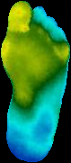

Fig. 1. Samples from Augmented Dataset (a) Normal Foot (b) Diabetic Foot

B. Overall System Architecture
The proposed system follows a multi-stage hybrid framework combining deep learning and interpretable thermographic modeling. The pipeline consists of Image preprocessing and augmentation, CNN-based deep feature learning, Statistical thermal feature extraction, Feature fusion, XGBoost classification, Thermal Risk Score (TRS) computation, K-Means based risk stratification.

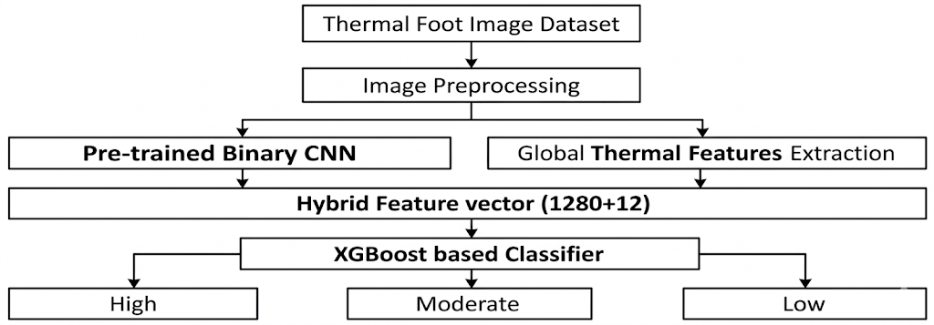
Fig. 2. Overall System Architecture

C. Dataset Processing
Images were adjusted to a standard resolution and pixel values were adjusted to the [0,1] range. Images were loaded in RGB format (3-channel input) for CNN training. For statistical feature extraction images were converted using OpenCV routines like Grayscale conversion for entropy and texture metrics and HSV conversion, where the V-channel was used as a temperature intensity proxy for TRS computation. No manual segmentation or region masking was applied.
Augmentation was applied after the train–validation split using the custom scripts doing operations that include, Rotational transformations, Horizontal and vertical flips, Spatial perturbations, Controlled intensity variations. This augmentation increased the training data by approximately 15× per original image. All experiments were conducted on the fully augmented dataset.

D. CNN-Based Deep Feature Extraction
A deep learning convolution-based network was trained for two-class segregation between control and diabetic thermograms. RGB thermographic images and normalized pixel values were fed as input.

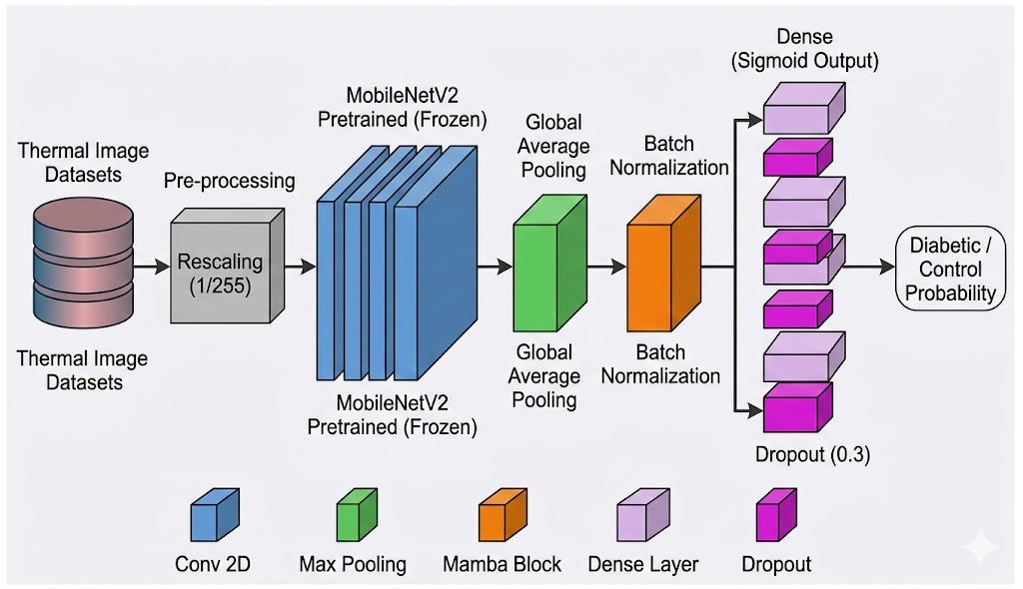

Fig. 3. CNN backbone Architecture

E. Statistical Thermal Feature Extraction:
In parallel to CNN processing, interpretable thermal descriptors were derived from images. Using OpenCV transformations, descriptors like Mean intensity (μ), Standard deviation (σ), Entropy (H) and additional statistical descriptors from grayscale images, and Mean temperature proxy, Temperature variability, Asymmetry measures, Hotspot-related descriptors From HSV (V-channel) of images. Global thermal distribution, variability, and structural irregularities are captured by manually engineered features which will be given as input to proposed system.

F. Hybrid Feature Fusion and XGBoost Classifier
A hybrid feature vector was made out of features given by CNN and manually engineered thermal features by concatenating them together and a XGBoost classifier model was trained on this hybrid feature vector for predicting neuropathic risk.

G. Thermal Risk Score (TRS) Formulation
The Thermal Risk Score (TRS) is calculated by using a weighted equation of the mean, standard deviation, and entropy of the thermograms as follows:

$$\begin{matrix} & \text{TRS}=0.4⋅μ+0.3⋅σ+0.3⋅H & & \text{(1)}\end{matrix}$$
where:
- $μ$is mean temperature value of the foot surface,
- $σ$is standard deviation in temperature over foot surface,
- $H$ is entropy showing thermal irregularity over foot surface.

Using Standard Scaler Thermal Risk Scores were converted to normal distribution before clustering was done.

H. K-Means clustering to divide data samples to risk categories
Unsupervised clustering was applied to TRS values of thermogram samples by using K-Means clustering. This was done with cluster count set to 3, random state set to 42, and initialization value of 20. Three clusters obtained were interpreted as Low, Medium and High Risk and categories were assigned based on cluster centroids, enabling data-driven stratification.

Results and Discussion

A. Experimental Setup
All experiments were conducted on the fully augmented dataset consisting of 21,660 training images and 6,330 validation images. The validation set remained strictly unseen during training.
All models were built and trained keeping same runtime environment using Google Colab setup and Tesla T4 graphical processing unit with 16 gigabytes of video memory and 128 gigabytes of system memory and Jupyter notebooks for building training scripts. TensorFlow and NumPy frameworks were mainly used for building and training these CNN backbones. The CNN learns hierarchical representations of thermal patterns without manual feature engineering. The trained CNN does Deep feature extraction for hybrid modeling.
Performance was evaluated using classification and regression-based error metrics and confusion matrices to assess both predictive reliability and TRS consistency.

B. CNN Baseline Performance
Various CNN models were first trained for binary classification between Control and Diabetic thermograms.
The models were examined based on various standard classification metrics and results are provided in Table I.
Out of all the models, MobileNetV2 was the best performer and was selected for this system implementation. As shown in Fig. 4, this model shows strong classification results, indicating deep convolutional features effectively capture thermal pattern differences.

TABLE I. PERFORMANCE COMPARISON OF DIFFERENT CNN MODELS FOR MEDICAL IMAGE CLASSIFICATION

CNN Models | Accuracy | Precision | Recall | F1-Score | AUC | NPV | Loss
EfficientNet-B0 (with Norm) | 0.79510 | 0.79246 | 0.88995 | 0.83838 | 0.85461 | 0.80048 | 0.49847
EfficientNet-B0 | 0.89747 | 0.91625 | 0.91164 | 0.91394 | 0.96825 | 0.86999 | 0.25848
EfficientNet-B1 | 0.88705 | 0.93036 | 0.87646 | 0.90260 | 0.95431 | 0.83135 | 0.26242
MobileNetV2 | 0.91453 | 0.92340 | 0.93439 | 0.92886 | 0.97824 | 0.90100 | 0.25391

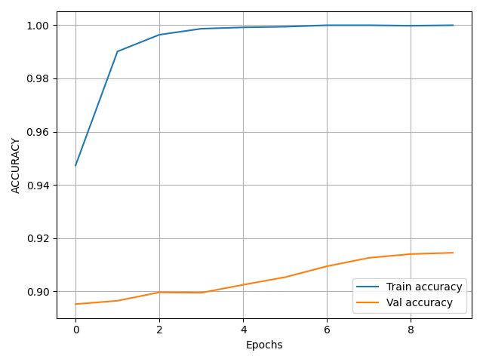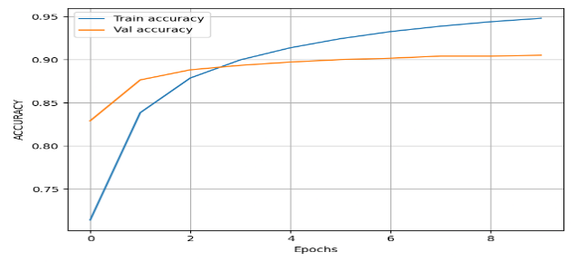

Fig. 4. Accuracy Plots of (a) Training (b) Fine Tuning of MobileNetV2 based Classifier Model.

C. Hybrid CNN + XGBoost Performance
Deep features derived by the CNN were fused to statistical thermal descriptors and classified using XGBoost.

TABLE II. CONFUSION MATRIX AND PERFORMANCE METRICS FOR PROPOSED HYBRID SYSTEM

Real / Predicted | Low | Medium | High
Low | 1489 | 545 | 13
Medium | 200 | 2224 | 172
High | 18 | 679 | 990

Root Mean Square Error (RMS) | 0.473100
Mean Absolute Error (MAE) | 0.357319
Ordinal Accuracy (±1 tolerance) | 0.995102

The hybrid model consistently demonstrates improved stability and reduced prediction error compared to the CNN-only baseline. Using entropy and temperature variability improves sensitivity to small thermal irregularities that may not be fully understood by deep features only. The advantage of using learned deep features with meaningful thermal statistical features is backed by the lower RMSE and MAE metric values.

D. Thermal Risk Score (TRS) Distribution Analysis
The Thermal Risk Score was computed for all thermal images using (1).
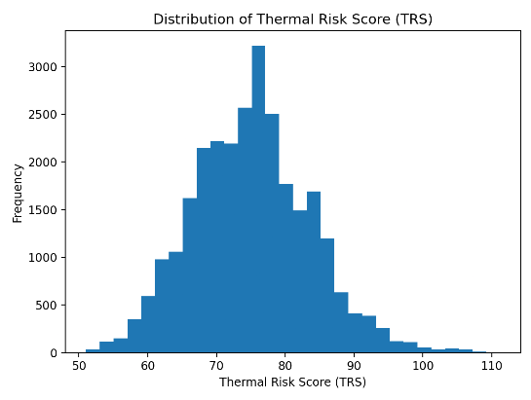
Fig. 5. Thermal Risk Score Distribution of Dataset Images

This TRS distribution shows clear difference among control and diabetic samples as illustrated in Fig. 5. Diabetic thermograms are showing higher TRS values and relate to elevated thermal and structural changes. This shows that neuropathic thermal changes can be seen as measurable numerical changes.

E. K-Means Clustering for Risk Stratification
The K-Means clustering technique was used on Thermal Risk Score values. The cluster count was set to three. As shown in Fig. 6. The centroids of clusters showed values that were steadily increasing with increasing thermal abnormality. Early thermal abnormalities usually occur before diabetic ulcers and clustering based on TRS-values of thermal images provides graded risk representation which helps to track neuropathy condition.

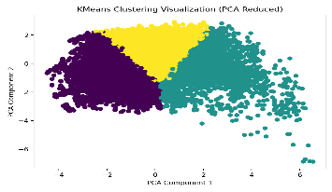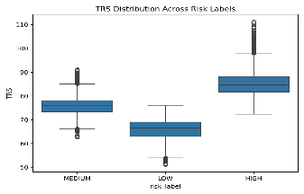

Fig. 6. K-Means clustering for risk stratification (a) Scatter plot showing clusters (b) Box plot showing cluster distributions

This proposed framework uses data-driven modeling for finding risk boundaries from intrinsic thermal distributions. This increases its adaptability over different acquisition setups.

Conclusion

This paper presents a Model-based Thermal Risk Score (TRS) framework for Diabetic Neuropathy classification using infrared thermograms of the sole of the foot of patients. Instead of performing a simple binary classification or using predefined temperature thresholds, this work integrates deep learning, image feature extraction and unsupervised clustering to enable a structured risk classification.
Upon analyzing and evaluating the model with the augmented dataset, it is clear that the thermal images themselves do not provide enough information for performing reliable classification. Integrating thermal features extracted from the images with the deep features improves the quality of the prediction. This provides a better understanding and reliable model compared to CNN only models. The framework thus adapts to the underlying patterns within the datasets. Since the proposed system enables continuous risk representation instead of a binary classification, it can be proposed for monitoring the progression of the neuropathic changes.
This study is limited to thermal images only and does not consider other biomarkers and conditions of the patients. The Clustering based risk interpretation is affected by the dataset distribution and may require further calibration. Overall, the framework shows that combining deep learning enables diabetic neuropathy risk classification using non-invasive thermal imaging of the sole of the foot.

References

- L. A. Lavery, D. G. Armstrong, D. P. Wunderlich, J. Tredwell, and A. J. M. Boulton,
“Home monitoring of foot skin temperatures to prevent ulceration,”
Diabetes Care, vol. 27, no. 11, pp. 2642–2647, 2004
- S. Bagavathiappan, J. Philip, T. Jayakumar, et al.,
“Correlation between plantar foot temperature and diabetic neuropathy: a case study using infrared thermal imaging,”
Journal of Diabetes Science and Technology, vol. 4, no. 6, pp. 1386–1392, 2010.
- L. F. Balbinot, M. A. Canani, L. H. Robinson, et al.,
“Repeatability of infrared plantar thermography in diabetes patients: a pilot study,”
Journal of Diabetes Science and Technology, vol. 7, no. 5, pp. 1130–1137, 2013.
- L. R. J. J. van Netten, J. J. van Baal, L. Liu, et al.,
“Infrared thermal imaging for automated detection of diabetic foot complications,”
Journal of Diabetes Science and Technology, vol. 7, no. 5, pp. 1122–1129, 2013.
- D. Hernández-Contreras, H. Peregrina-Barreto, J. Rangel-Magdaleno, and F. Renero-Carrillo,“Infrared thermography dataset for diabetic foot analysis,” IEEE DataPort, 2019. [Online]. Available: IEEE DataPort.
- A. Khandakar, M. E. H. Chowdhury, M. B. I. Reaz, et al.,
“Thermal change index based diabetic foot thermogram image classification using machine learning techniques,”
Sensors, vol. 22, no. 5, 1793, 2022.
- R. Castillo-Morquecho, E. Guevara, J. L. Ramirez-GarciaLuna, et al.,
“Digital infrared thermography and machine learning for diabetic foot assessment,”
Journal of Diabetes & Metabolic Disorders, vol. 23, 2024.
- L. Wu, R. Huang, X. He, L. Tang, and X. Ma,
“Advances in machine learning-aided thermal imaging for early detection of diabetic foot ulcers: a review,”
Biosensors, vol. 14, no. 12, 2024.
- M. Sandler, A. Howard, M. Zhu, A. Zhmoginov, and L.-C. Chen,
“MobileNetV2: Inverted residuals and linear bottlenecks,”
in Proc. IEEE Conference on Computer Vision and Pattern Recognition (CVPR), 2018, pp. 4510–4520.
- T. Chen and C. Guestrin,
“XGBoost: A scalable tree boosting system,”
in Proc. ACM SIGKDD International Conference on Knowledge Discovery and Data Mining, 2016, pp. 785–794.
- C. Shorten and T. M. Khoshgoftaar,
“A survey on image data augmentation for deep learning,”
Journal of Big Data, vol. 6, no. 60, 2019.
- A. J. M. Boulton, L. Vileikyte, G. Ragnarson-Tennvall, and J. Apelqvist,
“The global burden of diabetic foot disease,”
The Lancet, vol. 366, no. 9498, pp. 1719–1724, 2005.
- J. Apelqvist, K. Bakker, W. H. van Houtum, et al.,
“International consensus and practical guidelines on the management and prevention of the diabetic foot,”
Diabetes/Metabolism Research and Reviews, 2000.
- A. Bharara, J. Cobb, and D. G. Armstrong,
“Plantar foot temperature monitoring in the diabetic population: a review,”
Journal of Diabetes Science and Technology, vol. 1, no. 4, pp. 564–571, 2007.
- J. Yavuz, W. L. Smith, and L. A. Lavery,
“Temperature monitoring to assess, predict, and prevent diabetic foot complications,”
Current Diabetes Reports, vol. 15, no. 9, 2015.
- D. G. Armstrong, L. A. Lavery, and S. A. Harkless,
“Validation of a diabetic wound classification system,”
Diabetes Care, vol. 21, no. 5, pp. 855–859, 1998.
- M. Goyal, D. Reeves, S. Rajbhandari, et al.,
“Evaluation of thermal imaging in diabetic foot ulceration,”
Diabetes Care, 2010.
- L. Seixas, M. Nery, and C. P. Monteiro,
“Relationship between skin temperature and tissue characteristics in diabetic patients,”
Physiological Measurement, 2019.
- B. Jeffcoate and K. Harding,
“Diabetic foot ulcers,”
The Lancet, vol. 361, no. 9368, pp. 1545–1551, 2003.
- International Working Group on the Diabetic Foot (IWGDF),
“Guidelines on the prevention and management of diabetic foot disease,”
IWGDF Guidelines, 2019.

