A data-driven thermal risk score framework for diabetic peripheral neuropathy stratification using infrared foot thermograms

1st Amaresh A M
Department of Computer Science and Engineering, JSS Science and Technology University, Mysuru, India
Email: amaresham@jssstuniv.in
4th Jayanth S
Department of Computer Science and Engineering, JSS Science and Technology University, Mysuru, India
Email: Jayanth7m@gmail.com
2nd Agasthya Samyak Jnan
Department of Computer Science and Engineering, JSS Science and Technology University, Mysuru, India Email: agasthyasamyakjnan5577@gmail.com
5th Prajwal T P
Department of Computer Science and Engineering, JSS Science and Technology University, Mysuru, India
Email: prajwaltp06@gmail.com
3rd Arvind Ningombam
Department of Computer Science and Engineering, JSS Science and Technology University, Mysuru, India
Email: ningombamarvind@gmail.com

Abstract—Diabetic Peripheral Neuropathy (DPN) is a serious complication of diabetes that can lead to foot ulcers, impaired mobility, and amputation if not detected early. This work proposes a hybrid artificial intelligence framework for non-invasive DPN risk assessment using plantar thermal images from the INAOE dataset and its Kaggle mirrors. Deep convolutional features extracted from a pretrained MobileNetV2 model are combined with handcrafted thermal distribution features to capture both spatial patterns and physiological temperature variations. The fused feature representation is used to train an ordinal regression model based on XGBoost to predict neuropathy risk levels categorized as Low, Medium, and High. Experimental evaluation demonstrates strong predictive performance with robust ordinal accuracy and low error metrics. A lightweight desktop application is also developed to enable real-time, low-cost clinical screening. The proposed approach offers an accessible and scalable solution for early DPN risk stratification.
Keywords—Diabetes, Diabetic Peripheral Neuropathy, Diabetic Foot, plantar thermal image, INAOE Thermal dataset, MobileNetV2, XGBoost

Introduction
Diabetic neuropathy is among the most prevalent and severe complications of diabetes mellitus, frequently leading to foot ulceration, infection, and lower-limb amputation. The global burden of diabetic foot disease continues to increase, contributing significantly to healthcare costs and reduced quality of life [12], [19]. Early identification of neuropathic changes is therefore critical to prevent ulcer progression and long-term morbidity.
One of the earliest physiological indicators of diabetic foot complications is abnormal thermal distribution in the plantar surface. Inflammatory processes and microvascular dysfunction associated with neuropathy often manifest as localized temperature elevations or asymmetrical thermal patterns between the left and right feet. Clinical studies have demonstrated that monitoring foot skin temperature can significantly reduce ulcer recurrence rates [1], [15]. Infrared thermography has emerged as a non-invasive, contactless imaging modality capable of capturing such plantar thermal variations with high repeatability and reliability [2]-[4], [14].
Traditional clinical approaches primarily rely on manual temperature measurements or predefined temperature difference thresholds. While effective, these methods may not fully capture complex spatial thermal distributions or subtle texture variations within thermograms. With the advancement of computational methods, machine learning (ML) and deep learning (DL) techniques have increasingly been applied to thermographic data for automated diabetic foot assessment. Feature-engineered indices such as the Thermal Change Index (TCI) demonstrated that structured thermal descriptors can effectively discriminate diabetic conditions [6]. More recent works have explored ML-based thermographic classification frameworks for early ulcer detection and risk prediction, reporting promising diagnostic performance [7], [8].
Despite these developments, several limitations persist in existing studies. Many approaches focus on binary ulcer detection rather than graded neuropathy risk stratification. Others depend on clinically calibrated temperature thresholds or require specialized hardware configurations. There remains a need for computationally efficient, adaptable, and scalable frameworks capable of stratifying neuropathy risk using standardized thermographic images.
In this work, we propose a data-driven Thermal Risk Score (TRS) framework for diabetic neuropathy stratification using plantar thermogram images. The TRS is formulated as a composite index integrating three key thermal characteristics: global mean thermal intensity, temperature variability, and entropy-based texture complexity. Mean thermal intensity reflects overall temperature elevation associated with inflammatory activity, while variability captures dispersion of thermal values across the plantar surface. Entropy quantifies distributional irregularity, enabling detection of heterogeneous thermal patterns often observed in neuropathic progression. These features are inspired by established thermographic asymmetry and feature-based analyses reported in prior studies [1], [2], [6].
Unlike clinically predefined threshold systems, the proposed method employs unsupervised clustering to stratify subjects into Low, Medium, and High-risk categories based on the distribution of extracted thermal features. This data-driven stratification approach avoids reliance on rigid temperature cutoffs while maintaining interpretability of contributing thermal descriptors. The computational framework remains lightweight and scalable, making it suitable for screening-oriented applications. Furthermore, established ML principles and augmentation strategies are incorporated to enhance robustness and generalization [9]-[11].

Related Work
Diabetic neuropathy and its associated foot complications have been extensively studied due to their high prevalence and risk of ulceration and amputation. The global burden of diabetic foot disease has been well documented, emphasizing the necessity of early detection and preventive strategies [12], [19]. Clinical guidelines such as those from the International Working Group on the Diabetic Foot (IWGDF) provide standardized recommendations for monitoring and management [20], highlighting the importance of non-invasive screening tools for risk assessment.
Thermal monitoring has emerged as an important biomarker for detecting early inflammatory changes associated with neuropathic progression. Lavery et al. [1] demonstrated that consistent monitoring of plantar skin temperature significantly reduced ulcer recurrence rates. Their findings established the clinical relevance of temperature asymmetry and localized thermal elevation as predictive indicators. Subsequent work by Bharara et al. [14] and Yavuz et al. [15] further reinforced the role of plantar temperature monitoring in preventing diabetic foot complications.
Infrared thermography provides a contactless method to capture detailed spatial temperature distributions. Bagavathiappan et al. [2] showed a significant correlation between plantar thermal patterns and diabetic neuropathy, supporting thermography as a viable diagnostic adjunct. Balbinot et al. [3] evaluated repeatability of plantar thermograms, confirming reliability under standardized acquisition protocols. Similarly, van Netten et al. [4] investigated automated detection of diabetic foot complications using infrared thermal imaging, demonstrating feasibility for clinical screening.
These foundational studies collectively establish that abnormal plantar thermal distribution, particularly inter-foot asymmetry and localized hotspots—serves as an early marker of neuropathic deterioration.
Beyond simple temperature thresholding, researchers have explored structured feature extraction from thermograms. Adam et al. [5] introduced a plantar thermogram database to facilitate computational studies in diabetic neuropathy. Feature-based approaches often incorporate global temperature statistics, regional analysis, and asymmetry measures.
Khandakar et al. [6] proposed the Thermal Change Index (TCI), combining temperature-based descriptors with machine learning classifiers such as Support Vector Machines and Random Forests. Their work demonstrated that engineered thermal indices can effectively discriminate diabetic and non-diabetic subjects with strong interpretability. This study provided an important foundation for composite feature modeling in thermographic analysis.
Castillo-Morquecho et al. [7] extended this direction by integrating machine learning techniques with digital infrared thermography for diabetic foot assessment. Their results highlighted the importance of combining multiple thermal descriptors rather than relying solely on single temperature thresholds. Wu et al. [8] provided a comprehensive review of machine learning-aided thermal imaging systems, emphasizing the transition from handcrafted features toward more automated and hybrid approaches.
These studies suggest that composite thermal representations—integrating intensity, variability, and spatial characteristics—can improve classification robustness compared to simple asymmetry-based rules.
The adoption of machine learning and deep learning techniques has significantly advanced automated medical image analysis. Convolutional neural networks (CNNs) have been widely used for feature extraction and classification tasks in biomedical imaging. Architectures such as MobileNetV2 [9] provide computational efficiency while maintaining representational power, making them suitable for lightweight screening systems.
Ensemble methods such as XGBoost [10] have also demonstrated strong performance in structured feature classification scenarios due to their scalability and robustness. Furthermore, data augmentation techniques play a crucial role in improving generalization when working with limited medical datasets [11]. These computational frameworks provide the methodological backbone for thermogram-based risk assessment systems.
However, fully end-to-end deep learning approaches often lack interpretability, which may hinder clinical adoption. Feature-based models, in contrast, offer greater transparency regarding contributing thermal descriptors.
Despite substantial progress, existing studies exhibit several limitations. Many thermography-based approaches primarily address binary ulcer detection rather than graded neuropathy risk stratification. Additionally, some systems depend on clinically calibrated absolute temperature thresholds, which may not generalize across imaging setups. While composite indices such as TCI [6] represent a step toward structured modeling, standardized frameworks for stratifying neuropathy risk levels remain limited.
Moreover, some deep learning systems emphasize classification accuracy without explicitly modeling interpretable thermal characteristics [8]. There remains a need for lightweight, interpretable, and data-driven frameworks capable of categorizing risk levels without reliance on rigid temperature cutoffs.
Motivated by the clinical relevance of plantar thermography [1]-[4], and inspired by composite thermal feature modeling approaches [6], this study proposes a Thermal Risk Score (TRS) framework for neuropathy stratification. Unlike purely threshold-based systems, the proposed approach integrates global mean intensity, temperature variability, and entropy-based texture complexity into a composite score. Risk categories are derived using unsupervised clustering rather than predefined clinical cutoffs, enabling exploratory yet interpretable stratification.
By combining clinically grounded thermal descriptors with data-driven grouping, this work aims to bridge the gap between simple asymmetry monitoring and fully opaque deep learning models. The proposed framework maintains computational efficiency while preserving interpretability of thermal features contributing to risk differentiation.

Materials and Methods

A. Dataset Description
This study utilizes plantar infrared thermograms derived from the publicly available IEEE Dataport plantar thermogram dataset, accessed through its Kaggle mirror version. The dataset consists of bilateral plantar thermal images categorized into Control and Diabetic (DM) subjects. The dataset was first partitioned prior to augmentation to prevent data leakage. The split distribution is:
- Training set: 720 Control, 724 DM
- Validation set: 170 Control, 252 DM
After applying the augmentation pipeline independently to both subsets, the dataset expanded to:
- 21,660 training images
- 6,330 validation images
Only thermographic image data were used. No demographic or tabular clinical metadata were incorporated.

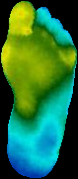

Fig. 1. Samples from Augmented Dataset (a) Normal Foot (b) Diabetic Foot

B. Overall System Architecture
The proposed system follows a multi-stage hybrid framework combining deep learning and interpretable thermographic modeling. The pipeline consists of Image preprocessing and augmentation, CNN-based deep feature learning, Statistical thermal feature extraction, Feature fusion, XGBoost classification, Thermal Risk Score (TRS) computation, K-Means based risk stratification.

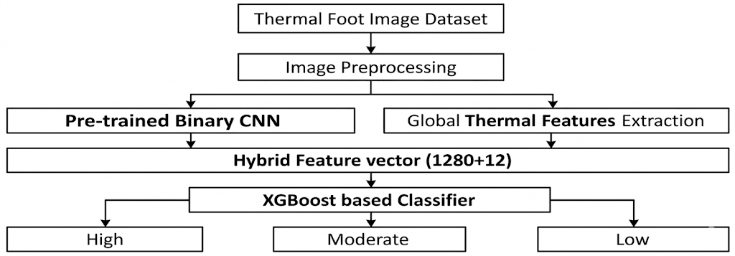
Fig. 2. Overall System Architecture

C. Data Preprocessing and Augmentation
Images were resized to a standardized spatial resolution and normalized by scaling pixel values to the [0,1] range. For CNN training, Images were loaded in RGB format (3-channel input). For statistical feature extraction images were converted using OpenCV routines like Grayscale conversion for entropy and texture metrics and HSV conversion, where the V-channel was used as a temperature intensity proxy for TRS computation. No manual segmentation or region masking was applied.
Augmentation was applied after the train–validation split using the custom scripts doing operations that include, Rotational transformations, Horizontal and vertical flips, Spatial perturbations, Controlled intensity variations. This augmentation increased the training data by approximately 15× per original image. All experiments were conducted on the fully augmented dataset.

D. CNN-Based Deep Feature Extraction
A convolutional neural network was trained for binary classification between Control and Diabetic thermograms. RGB thermographic images and normalized pixel values were fed as input.

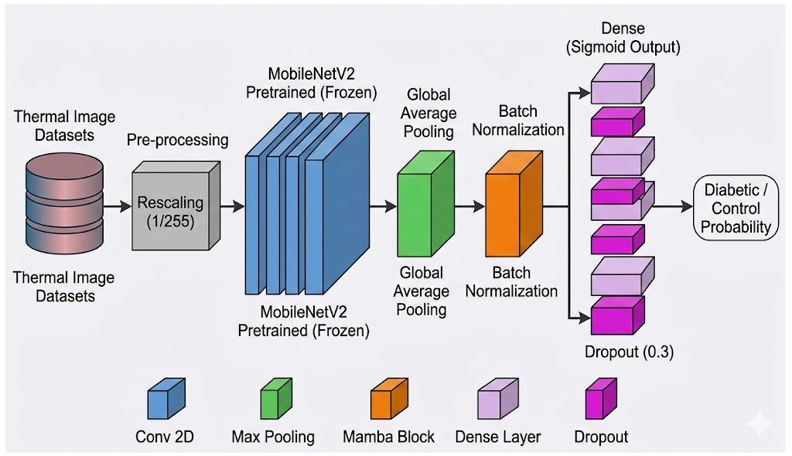

Fig. 3. CNN backbone Architecture

E. Statistical Thermal Feature Extraction:
In parallel to CNN processing, interpretable thermal features were extracted from each image. Using OpenCV transformations, features like Mean intensity (μ), Standard deviation (σ), Entropy (H) and additional statistical descriptors from grayscale images, and Mean temperature proxy, Temperature variability, Asymmetry measures, Hotspot-related descriptors From HSV (V-channel) of images. These handcrafted features capture global thermal distribution, variability, and structural irregularities.

F. Hybrid Feature Fusion and XGBoost Classifier
Deep features extracted from the CNN were concatenated with handcrafted thermal statistical features to form a hybrid feature vector. This fused representation was used to train an XGBoost classifier for diabetic classification. XGBoost was selected due to its robust handling of heterogeneous feature distributions, Strong performance on structured feature spaces and resistance to overfitting.

G. Thermal Risk Score (TRS) Formulation
The Thermal Risk Score (TRS) is computed using a weighted combination of the mean, standard deviation, and entropy of the thermal signal:

$$\begin{matrix} & \text{TRS}=0.4⋅μ+0.3⋅σ+0.3⋅H & & \text{(1)}\end{matrix}$$
where:
- $μ$is the mean temperature value of the region of interest,
- $σ$is the standard deviation, representing variability in temperature,
- $H$is the entropy, reflecting the thermal heterogeneity.

Prior to clustering, TRS values were standardized using Standard Scaler to normalize distribution.

H. Risk Stratification via K-Means Clustering
To move beyond binary classification, unsupervised clustering was applied to TRS values. K-Means clustering was performed with number of clusters set to 3, random state set to 42, and initialization value of 20. The three clusters were interpreted as Low Risk, Medium Risk and High Risk. Risk categories were assigned based on cluster centroids rather than predefined clinical thresholds, enabling data-driven stratification.

Results and Discussion

A. Experimental Setup
All experiments were conducted on the fully augmented dataset consisting of 21,660 training images and 6,330 validation images. The validation set remained strictly unseen during training.
All models were built and trained keeping same runtime environment using Google Colab setup and Tesla T4 graphical processing unit with 16 gigabytes of video memory and 128 gigabytes of system memory and Jupyter notebooks for building training scripts. TensorFlow and NumPy frameworks were mainly used for building and training these CNN backbones. The CNN learns hierarchical representations of thermal patterns without manual feature engineering. The trained CNN does Deep feature extraction for hybrid modeling.
Performance was evaluated using classification and regression-based error metrics and confusion matrices to assess both predictive reliability and TRS consistency.

B. CNN Baseline Performance
Various CNN models were first trained for binary classification between Control and Diabetic thermograms.
The models were assessed based on multiple standard classification metrics including Accuracy, Precision, Recall, F1-score, Negative Predictive Value (NPV) and many other metrics.
Out of all the models, MobileNetV2 had the best performance metrics and was selected for further system implementation of our hybrid model. As shown in Fig. 4, this model shows strong classification results, indicating deep convolutional features effectively capture thermal pattern differences.

TABLE I. PERFORMANCE COMPARISON OF DIFFERENT CNN MODELS FOR MEDICAL IMAGE CLASSIFICATION

CNN Models | Accuracy | Precision | Recall | F1-Score | AUC | NPV | Loss
EfficientNet-B0 (with Norm) | 0.79510 | 0.79246 | 0.88995 | 0.83838 | 0.85461 | 0.80048 | 0.49847
EfficientNet-B0 | 0.89747 | 0.91625 | 0.91164 | 0.91394 | 0.96825 | 0.86999 | 0.25848
EfficientNet-B1 | 0.88705 | 0.93036 | 0.87646 | 0.90260 | 0.95431 | 0.83135 | 0.26242
MobileNetV2 | 0.91453 | 0.92340 | 0.93439 | 0.92886 | 0.97824 | 0.90100 | 0.25391

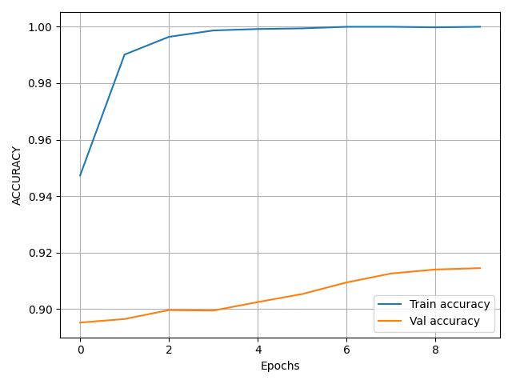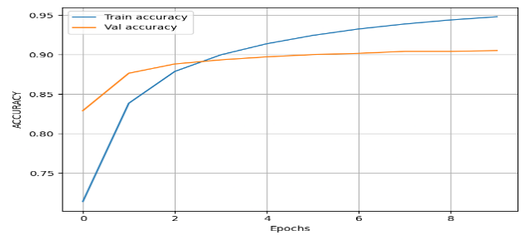

Fig. 4. Accuracy Plots of (a) Training (b) Fine Tuning of MobileNetV2 based Classifier Model.

C. Hybrid CNN + XGBoost Performance
Deep features extracted from the CNN were fused with statistical thermal descriptors and classified using XGBoost.

TABLE II. CONFUSION MATRIX AND PERFORMANCE METRICS FOR THE PROPOSED HYBRID MODEL

Real / Predicted | Low | Medium | High
Low | 1489 | 545 | 13
Medium | 200 | 2224 | 172
High | 18 | 679 | 990

Root Mean Square Error (RMS) | 0.473100
Mean Absolute Error (MAE) | 0.357319
Ordinal Accuracy (±1 tolerance) | 0.995102

The hybrid model consistently demonstrates improved stability and reduced prediction error compared to the CNN-only baseline. The inclusion of entropy and temperature variability enhances sensitivity to subtle thermal irregularities that may not be fully captured by deep features alone. Lower RMSE and MAE values indicate tighter prediction distributions. This validates the benefit of combining learned deep representations with interpretable thermographic statistics.

D. Thermal Risk Score (TRS) Distribution Analysis
The Thermal Risk Score (TRS) was computed for all samples using the weighted formulation given by (1).

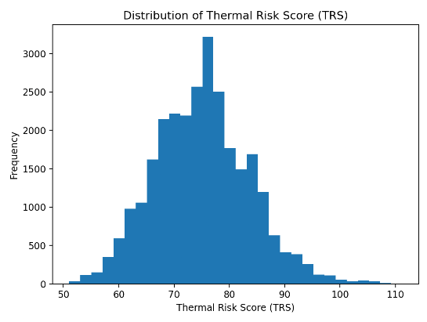
Fig. 5. Thermal Risk Score Distribution of Dataset Images

The TRS distribution exhibits distinguishable separation patterns between Control and Diabetic samples as illustrated in Fig. 5. Diabetic thermograms generally show higher TRS values, indicating elevated thermal variability and structural irregularity. This supports the hypothesis that neuropathic thermal alterations manifest as measurable statistical deviations.

E. Risk Stratification via K-Means Clustering
Unsupervised K-Means clustering with cluster count of 3 was applied to standardized TRS values to categorize risk levels. The three clusters were interpreted as Low Risk, Medium Risk and High Risk. As shown in Fig. 6, Cluster centroids reveal progressively increasing TRS magnitudes, indicating systematic escalation in thermal abnormality. Unlike binary classification, TRS-based clustering provides graded risk representation. This is particularly relevant for neuropathy progression monitoring, where early thermal irregularities may precede over diabetic ulcer formation.

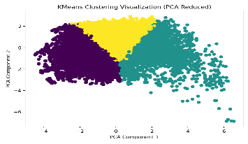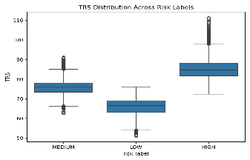
Fig. 6. Clustering via K-Means method for risk stratification (a) Scatter plot showing clusters (b) Box plot showing cluster distributions

Importantly, the proposed framework does not rely on fixed temperature thresholds. Instead, it employs data-driven modeling to identify risk boundaries from intrinsic thermal distributions. This enhances adaptability across different acquisition setups.

Conclusion
This study presented a data-driven Thermal Risk Score (TRS) framework for diabetic neuropathy stratification using infrared plantar thermograms. Unlike conventional approaches that rely solely on binary classification or predefined temperature thresholds, the proposed system integrates deep learning, statistical thermographic modeling, and unsupervised clustering to enable structured risk categorization.
The framework combines CNN-based feature learning with interpretable thermal descriptors, including mean intensity, standard deviation, and entropy. These descriptors are integrated into a weighted TRS formulation and standardized prior to K-Means clustering for multi-level risk stratification. This hybrid modeling approach allows both automated diabetic discrimination and graded neuropathy risk assessment within a unified pipeline.
Experimental evaluation on the augmented thermographic dataset demonstrated that infrared plantar images contain sufficient discriminatory thermal information for reliable classification. Furthermore, the integration of handcrafted thermal statistics with deep features improved prediction stability and provided enhanced interpretability compared to standalone CNN modeling.
The proposed TRS formulation enables continuous risk representation rather than binary categorization, making it suitable for monitoring progressive neuropathic changes. By avoiding fixed temperature cutoffs and instead employing data-driven clustering, the framework adapts to intrinsic thermal distribution patterns within the dataset.
However, this study is limited to thermographic imaging alone and does not incorporate multimodal clinical biomarkers or longitudinal patient tracking. Additionally, clustering-based risk interpretation depends on dataset distribution and may require recalibration for external cohorts.
Future work may explore Cross-dataset validation to assess generalizability, Integration of clinical metadata and laboratory parameters, Region-wise thermal segmentation for localized risk modeling, Transformer-based architectures for improved spatial attention, Longitudinal tracking of TRS progression for predictive monitoring. In summary, the proposed data-driven TRS framework demonstrates that combining deep learning with interpretable thermographic statistics enables robust and scalable diabetic neuropathy risk stratification using non-invasive infrared foot imaging.

References
- L. A. Lavery, D. G. Armstrong, D. P. Wunderlich, J. Tredwell, and A. J. M. Boulton,
“Home monitoring of foot skin temperatures to prevent ulceration,”
Diabetes Care, vol. 27, no. 11, pp. 2642–2647, 2004
- S. Bagavathiappan, J. Philip, T. Jayakumar, et al.,
“Correlation between plantar foot temperature and diabetic neuropathy: a case study using infrared thermal imaging,”
Journal of Diabetes Science and Technology, vol. 4, no. 6, pp. 1386–1392, 2010.
- L. F. Balbinot, M. A. Canani, L. H. Robinson, et al.,
“Repeatability of infrared plantar thermography in diabetes patients: a pilot study,”
Journal of Diabetes Science and Technology, vol. 7, no. 5, pp. 1130–1137, 2013.
- L. R. J. J. van Netten, J. J. van Baal, L. Liu, et al.,
“Infrared thermal imaging for automated detection of diabetic foot complications,”
Journal of Diabetes Science and Technology, vol. 7, no. 5, pp. 1122–1129, 2013.
- A. T. Adam, N. R. K. Iqbal, and M. A. M. S. Abeyratne,
“Plantar thermogram database for the study of diabetic neuropathy,”
Data in Brief, vol. 18, pp. 663–669, 2018.
- A. Khandakar, M. E. H. Chowdhury, M. B. I. Reaz, et al.,
“Thermal change index based diabetic foot thermogram image classification using machine learning techniques,”
Sensors, vol. 22, no. 5, 1793, 2022.
- R. Castillo-Morquecho, E. Guevara, J. L. Ramirez-GarciaLuna, et al.,
“Digital infrared thermography and machine learning for diabetic foot assessment,”
Journal of Diabetes & Metabolic Disorders, vol. 23, 2024.
- L. Wu, R. Huang, X. He, L. Tang, and X. Ma,
“Advances in machine learning-aided thermal imaging for early detection of diabetic foot ulcers: a review,”
Biosensors, vol. 14, no. 12, 2024.
- M. Sandler, A. Howard, M. Zhu, A. Zhmoginov, and L.-C. Chen,
“MobileNetV2: Inverted residuals and linear bottlenecks,”
in Proc. IEEE Conference on Computer Vision and Pattern Recognition (CVPR), 2018, pp. 4510–4520.
- T. Chen and C. Guestrin,
“XGBoost: A scalable tree boosting system,”
in Proc. ACM SIGKDD International Conference on Knowledge Discovery and Data Mining, 2016, pp. 785–794.
- C. Shorten and T. M. Khoshgoftaar,
“A survey on image data augmentation for deep learning,”
Journal of Big Data, vol. 6, no. 60, 2019.
- A. J. M. Boulton, L. Vileikyte, G. Ragnarson-Tennvall, and J. Apelqvist,
“The global burden of diabetic foot disease,”
The Lancet, vol. 366, no. 9498, pp. 1719–1724, 2005.
- J. Apelqvist, K. Bakker, W. H. van Houtum, et al.,
“International consensus and practical guidelines on the management and prevention of the diabetic foot,”
Diabetes/Metabolism Research and Reviews, 2000.
- A. Bharara, J. Cobb, and D. G. Armstrong,
“Plantar foot temperature monitoring in the diabetic population: a review,”
Journal of Diabetes Science and Technology, vol. 1, no. 4, pp. 564–571, 2007.
- J. Yavuz, W. L. Smith, and L. A. Lavery,
“Temperature monitoring to assess, predict, and prevent diabetic foot complications,”
Current Diabetes Reports, vol. 15, no. 9, 2015.
- D. G. Armstrong, L. A. Lavery, and S. A. Harkless,
“Validation of a diabetic wound classification system,”
Diabetes Care, vol. 21, no. 5, pp. 855–859, 1998.
- M. Goyal, D. Reeves, S. Rajbhandari, et al.,
“Evaluation of thermal imaging in diabetic foot ulceration,”
Diabetes Care, 2010.
- L. Seixas, M. Nery, and C. P. Monteiro,
“Relationship between skin temperature and tissue characteristics in diabetic patients,”
Physiological Measurement, 2019.
- B. Jeffcoate and K. Harding,
“Diabetic foot ulcers,”
The Lancet, vol. 361, no. 9368, pp. 1545–1551, 2003.
- International Working Group on the Diabetic Foot (IWGDF),
“Guidelines on the prevention and management of diabetic foot disease,”
IWGDF Guidelines, 2019.

