AI ASSISTED CODING
ASSIGNMENT-6.1
( AI -Based Code Completion: Working with suggestions for classes, loops, conditionals)
2303A510E5
BATCH-27

Task Description #1: AI-Based Code Completion for Loops
Prompt:
“Generate Python code to print all even numbers between 1 and N using a loop.” AI-Generated Code
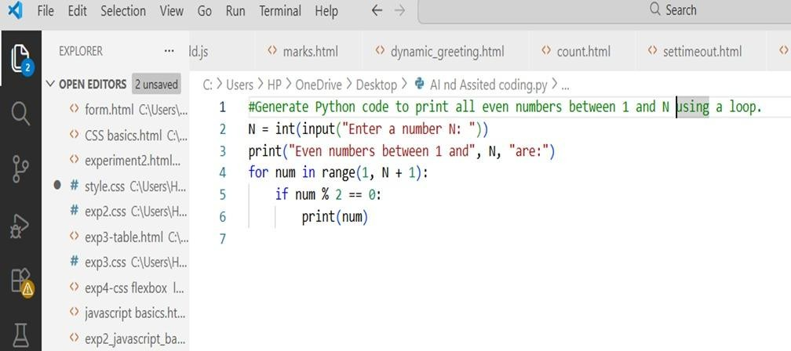
Output:
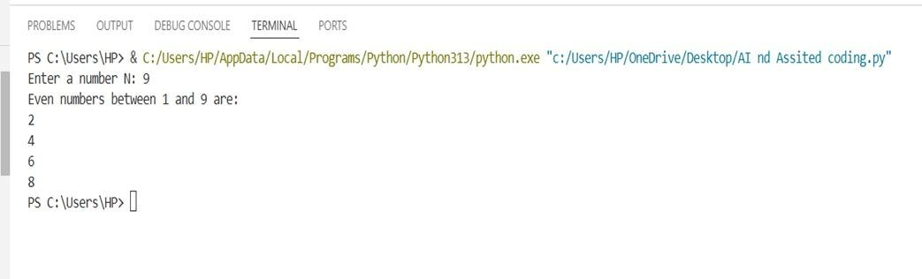
Loop Type Used
- for loop
Explanation
- input() takes the value of N
- range(1, N + 1) iterates from 1 to N
- i % 2 == 0 checks if the number is even
- Even numbers are printed

Task Description #2: Loop with Conditionals
Prompt:
“Generate Python code to count how many numbers in a list are even and odd.” AI-Generated Code
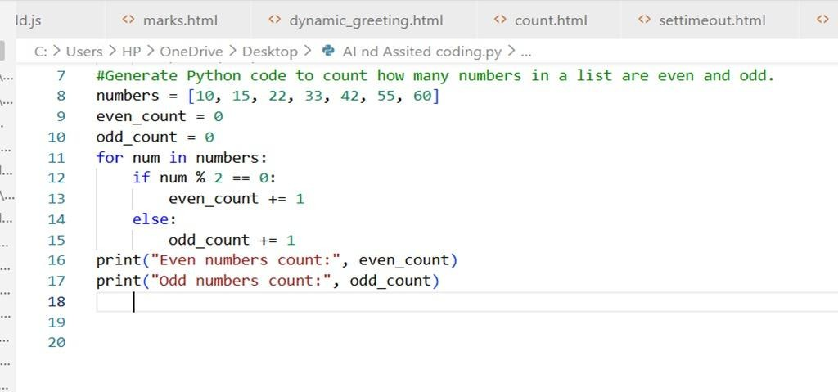
Output:
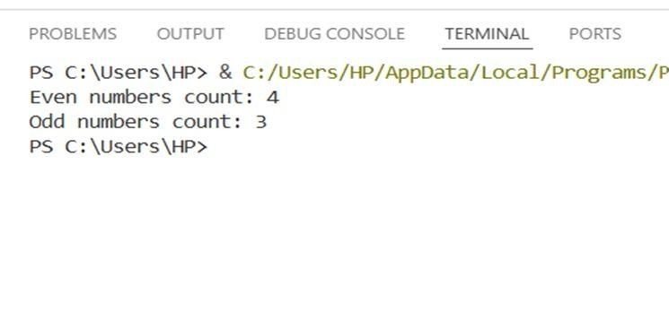
Explanation:
- Initialize counters
- Loop through the list
- Check even/odd using %
- Increment respective counter
- Print results

Task Description #3: Class Attributes Validation
Prompt:
“Generate a Python class User that validates age and email using conditional statements.” AI-Generated Code
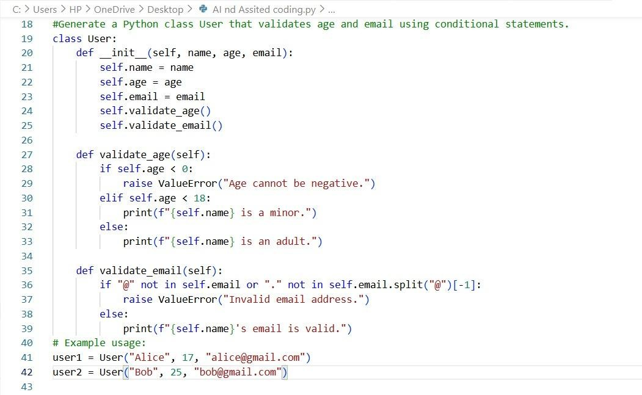
Output:
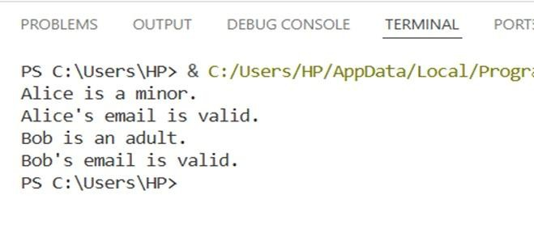
Justification
- Conditional statements validate both age and email.
- Handles valid and invalid cases effectively.
- Email validation is basic but functional.

Task Description #4: AI-Based Code Completion for Classes
Prompt:
“Generate a Python class Student with attributes (name, roll number, marks) and methods to calculate total and average marks.”
AI-Generated Code
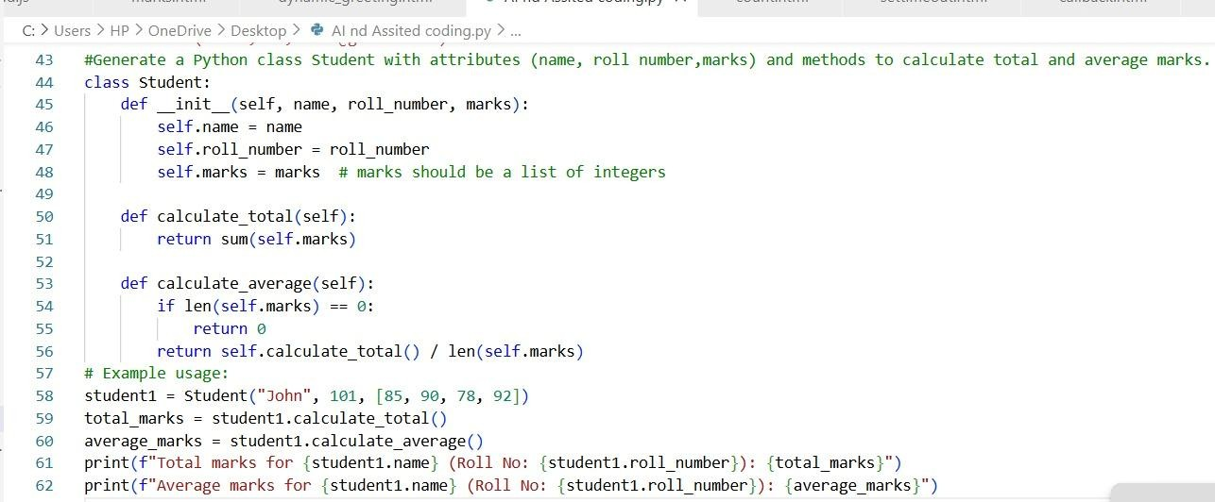
Output:
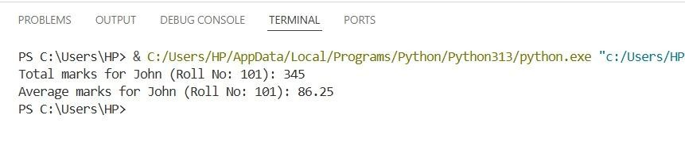
Explanation:
- Correct class structure
- Uses list of marks
- Methods are reusable

Task Description #5: AI-Assisted Code Completion Review
Prompt:
“Generate a Python program for a simple bank account system using class, loops, and conditional statements.”
AI-Generated code:
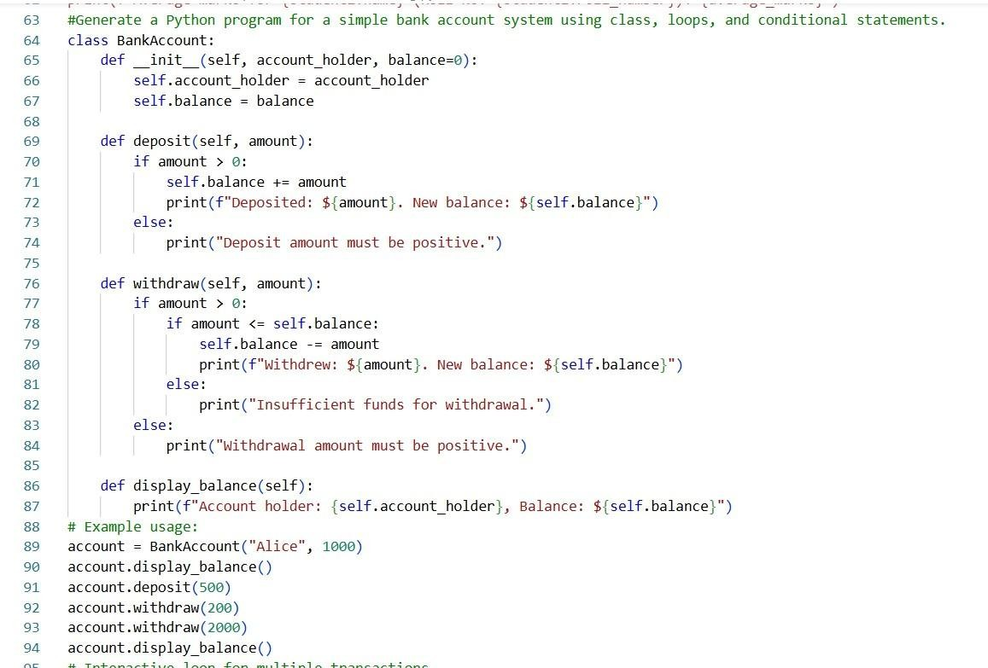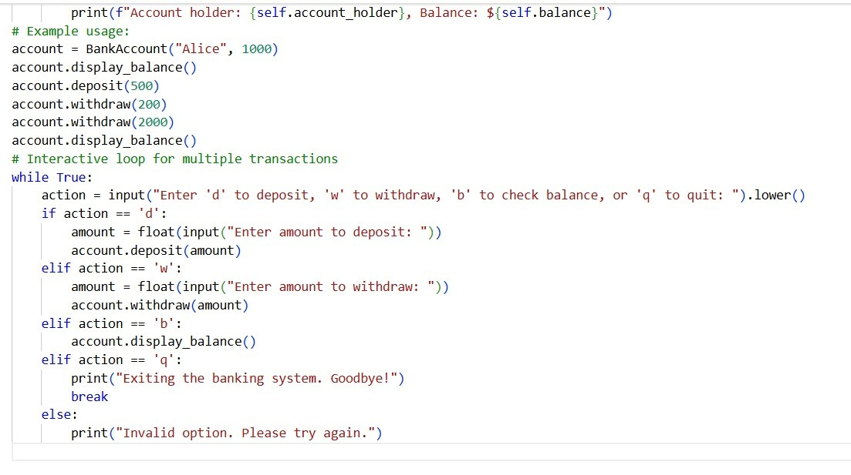

Output:
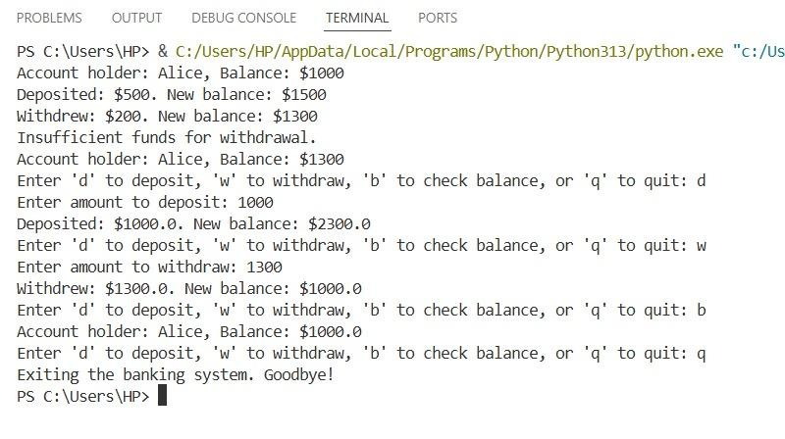
Explanation:
- The BankAccount class manages balance and banking operations.

- Methods are used for deposit, withdrawal, and balance display.

- A while loop creates a menu-driven system.

- Conditional statements handle user choices and validations.

- AI helped combine classes, loops, and conditionals into one program.

